EPIC GROUP • DATA × AI TEAM
GPRO Multi-Factory Data Automation
Project Overview & Consolidated Technical Summary
Desktop RPA flows · Cloud orchestration · Unattended bot · Data pipeline
Property | Value
Document type | Overall project summary (master document)
Scope | 3 desktop RPA flows, 2 cloud flows, unattended bot host, downstream ETL and dashboards
Factories | CIPL, GTL, PGCL, EGMCL7, JDL
Platform | Power Automate Desktop (Robin) + Power Automate cloud flows + SharePoint + SQL Server + Power BI / Fabric
Schedule | Hourly 07:00–22:00 and nightly 22:30, Saturday–Thursday (Friday off), Bangladesh time
Owner | Data × AI Team, EPIC Group
Version / Date | 1.0 — 07-Oct-2026
Classification | Internal — Confidential

1. Executive Summary
The project replaces the manual, daily download of production and quality reports from the G-PRO ERP with a fully automated, unattended pipeline. Software robots log into each factory portal, set the report filters, export the data to Excel, and save it with a standard name in SharePoint. From there, an ETL bot loads the data into a SQL Server warehouse that feeds the Power BI dashboards and KPIs.
What | Summary
Business problem | Analysts had to log into 5 factory portals and export dozens of reports by hand every day — slow, late and error-prone
Solution | 3 Power Automate Desktop robots, scheduled by 2 cloud flows, running unattended on a dedicated Windows Server bot
Coverage | 5 factories; 16 report types across quality, production, WIP, efficiency, attendance and bundle transactions
Frequency | Intraday hourly refresh (16 runs per day) plus a full end-of-day pull every night
Volume (all factories online) | ~49 files per hourly run, 82 files for Quality Daily, 44 files for Operational Daily — about 910 files per active day
Monitoring | Teams alerts for run failures (cloud) and for any individual file not produced (desktop)
Programme status (Oct-2026) | 150 of ~170 GPRO reports automated; 31 of 120 KPIs live

How to read this document
Sections 2–4 explain the big picture: architecture, schedule and orchestration. Sections 5–7 explain how the robots work. Sections 8–10 cover data output, monitoring and the unattended setup. Sections 11–13 cover reliability, known issues and operations. The detailed per-flow documents are listed in Section 14.
2. Solution Architecture
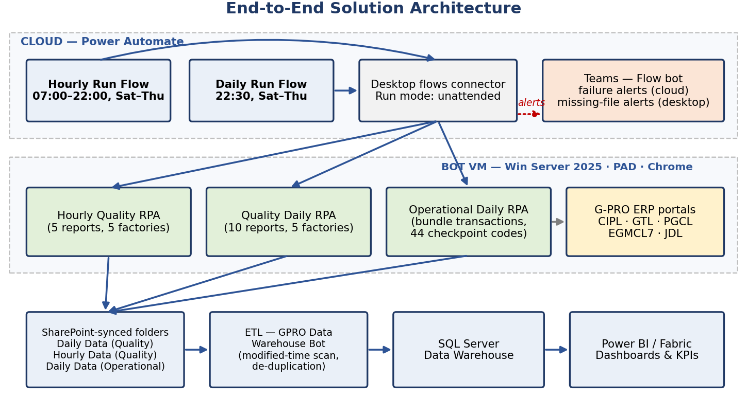
Figure 1 — End-to-end architecture: cloud scheduling, bot VM, ERP sources and the data pipeline
2.1 Layers
Layer | Role | Components
1. Orchestration (cloud) | Decides when the robots run, limits how long they can run, alerts on failure | Hourly Run Flow, Daily Run Flow, Desktop flows connector, Teams connector
2. Execution (bot VM) | Runs the robots with no user signed in | Windows Server 2025, Power Automate Desktop, Chrome + PAD extension, registered machine
3. Source systems | Provide the reports | G-PRO ERP portals (QCM and SDT modules, Syncfusion web UI) for 5 factories
4. Storage | Holds the exported files and syncs them to the cloud | SharePoint-synced folders: Daily Data (Quality), Hourly Data (Quality), Daily Data (Operational)
5. Data & analytics | Turns files into KPIs | ETL — GPRO Data Warehouse Bot → SQL Server → Power BI / Fabric
2.2 Component Inventory
Component | Type | Purpose
Hourly Run Flow (From 7am - 10pm) Except Friday | Cloud flow | Runs the EGMCL7 hourly robot, then the Hourly Quality robot, every hour
Daily Run Flow (10 pm) Except Friday | Cloud flow | Runs the Operational Daily robot, then the Quality Daily robot, every night
Quality Daily Data for All Factory | Desktop flow (63dc8422-…) | End-of-day quality and production reports
Quality Hourly Data for All Factory | Desktop flow (9c9964c0-…) | Intraday hourly quality and output reports
Operational Daily Data for All Factory | Desktop flow (8259025b-…) | End-of-day bundle transactions per checkpoint code
EGMCL7 Hourly RPA | Desktop flow (2235a8b4-…) | EGMCL7-specific hourly download (orchestrated by the hourly cloud flow; source not in scope of this summary)
Welcome Flow | Desktop subflow | Shared portal login
Bot VM | Windows Server 2025 24H2, PAD v2.69 | Unattended execution host
GPRO Data Warehouse Bot | ETL | Loads files into SQL Server and reports results to Teams
3. Schedule & Orchestration
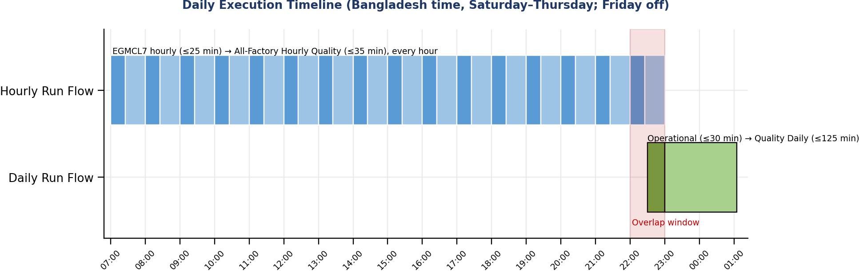
Figure 2 — Daily execution timeline (Saturday–Thursday)
Cloud flow | Trigger | Action 1 | Action 2 | Alerts
Hourly Run Flow | Every hour 07:00–22:00 (16 runs), Sat–Thu | EGMCL7 Hourly RPA — 25 min timeout, no retry, run video saved | Hourly Quality RPA — 35 min timeout, 3 retries × 30 s | One Teams alert per robot on Failed / TimedOut / Skipped
Daily Run Flow | 22:30, Sat–Thu | Operational Daily RPA — 30 min timeout, 2 retries × 1 min | Quality Daily RPA — 125 min timeout, 2 retries × 30 s | One Teams alert per robot on Failed / TimedOut / Skipped

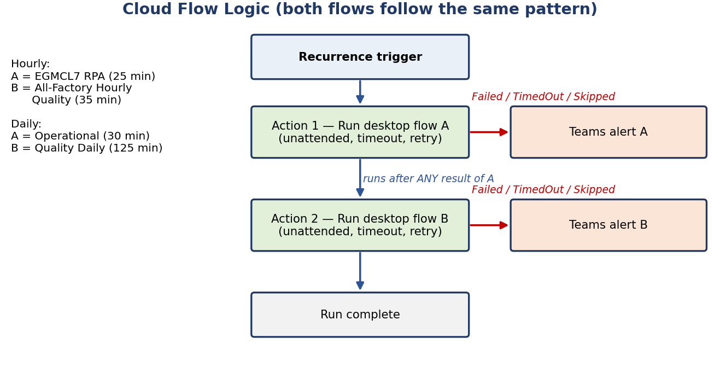
Figure 3 — Cloud flow logic: action 2 always runs, each robot alerts separately
3.1 Orchestration Rules
- Both flows use unattended run mode: Power Automate signs into the bot VM on its own and releases the session when finished.
- Action 2 runs after any result of action 1, so one robot failing never blocks the other.
- Each action has its own timeout. Time spent waiting in the machine queue counts toward it.
- Friday is excluded because it is the weekly non-production day.
- Both flows use the same Desktop flows connection (bot machine) and the same Teams connection (Flow bot chat).
4. Factories & Data Sources
Factory | Portal | Quality reports | Operational source | Notes
CIPL | ciplgpro.epicbd.com | Full suite | Bundle Transaction Summary Enquiry | 3 units (U1–U3)
GTL | gtlgpro.epicbd.com | Full suite | Bundle Transaction Enquiry (different layout) | 4 units (U1–U4)
PGCL | pgclgpro.epicbd.com | Full suite | Bundle Transaction Summary Enquiry | Single finishing / sewing department
EGMCL7 | egmcl7gpro.epicbd.com | Full suite + dedicated hourly robot | Bundle Transaction Summary Enquiry | Factory filter FTYU7_EGMCL; includes SEW-RIB stage
JDL | edliot.epicjordan.com | Full suite | Bundle Transaction Summary Enquiry | Factory filter FTYU1_EDLJD; DAY shift; includes CUT stage

Each factory has its own service account, report routes and filter lists (QC checkpoints, departments, WIP stages, checkpoint codes), loaded at the start of that factory's loop. Credentials are held in the flows and are not reproduced in this document.
5. How the Robots Work — Common Process
All three desktop flows follow the same structure, so a fault in one usually explains the others.
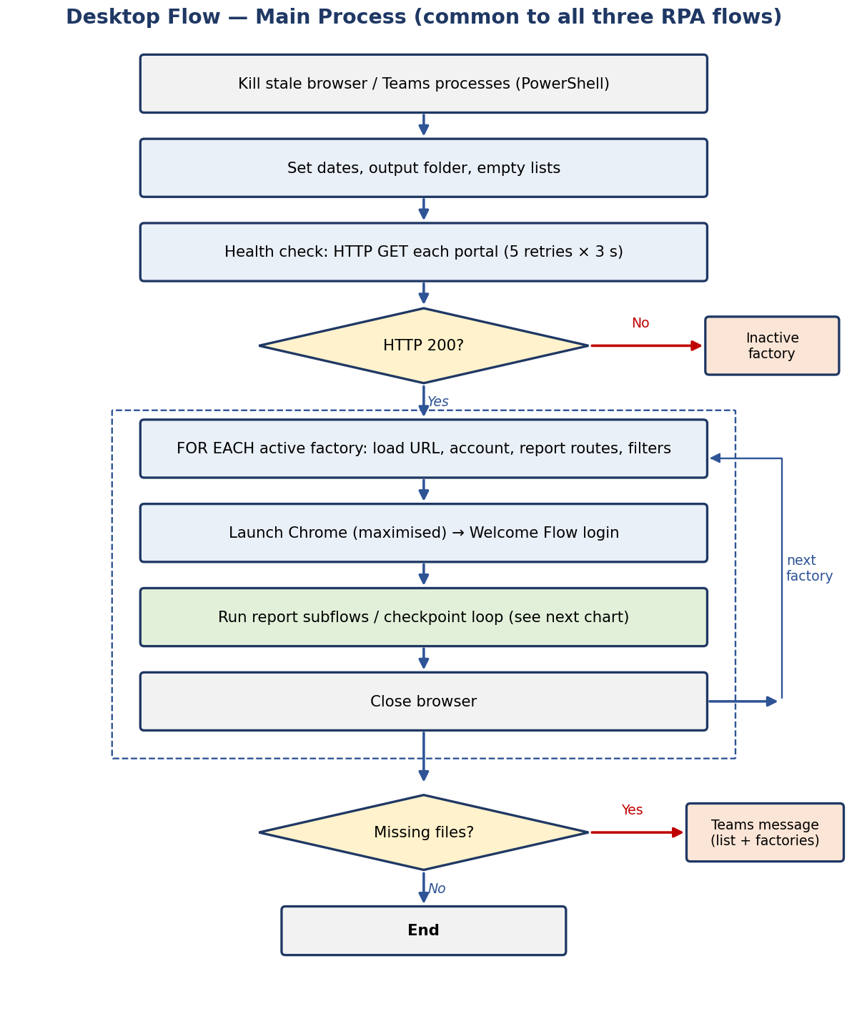
Figure 4 — Main process shared by all desktop flows
5.1 Step by Step
Step | What happens | Why
1. Clean start | PowerShell force-closes Chrome, Edge, other browsers and Teams | No leftover window or dialog from a previous run can block automation
2. Initialise | Today's date in two formats (filter: dd-MMM-yyyy; file name: dd-MMM-yyyy (hh tt)), output folder, empty tracking lists | Consistent filters and unique, sortable file names
3. Health check | HTTP GET to each portal, 30 s timeout, 5 retries × 3 s; status 200 = active | Offline portals are skipped instead of hanging the browser
4. Factory loop | For each active factory: load its URL, account, routes and filters | One robot serves all five factories
5. Login | Launch Chrome maximised → Welcome Flow types the username and password with the physical keyboard → confirm the portal logo | Real key events are needed for the portal to accept input; login is skipped if a session is already active
6. Extract | Run each report subflow or the checkpoint-code loop | See Section 6
7. Close | Wait 10 s, close Chrome (the hourly flow also force-kills Chrome per factory) | Clean state for the next factory
8. Report | If any expected file is missing, post one Teams message listing the active factories, closed portals and missing files | Problems are visible without watching the robot
6. How the Robots Work — Report Extraction
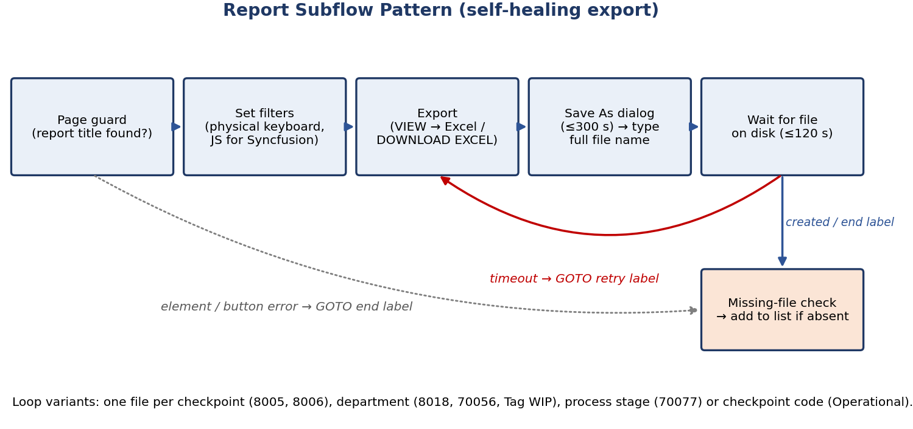
Figure 5 — Standard report subflow with self-healing retry
6.1 Techniques Used
Technique | Purpose
Page guard (IF report title is on the page) | Runs a subflow only when the correct report page is loaded
Physical-keyboard typing with unfocus | Fires real input events so filter fields and logins are accepted
JavaScript injection (Syncfusion EJ2 API) | Opens multiselects, sets checkpoint lists and ticks checkboxes directly; idempotent (does not untick)
AI-vision element repair | Re-locates input fields when the portal layout shifts slightly
Save As dialog with full path | Saves each file straight to the final folder under its standard name
Wait for file on disk + GOTO retry label | Confirms success by the actual file; re-triggers the export if it is late
Missing-file check at the end label | Any file not produced is added to the Teams missing-files list
Loops | One file per checkpoint, department, WIP stage or checkpoint code
6.2 File Naming Standard
Flow | Pattern | Example
Quality Daily / Hourly | <Factory>-<dd-MMM-yyyy (hh tt)>-<Report> for <Code>[ (<variant>)].<xls|xlsx> | GTL-07-Oct-2026 (02 PM)-Tag WIP By Dept ([U3] Sewing).xlsx
Operational Daily | <dd-MMM-yyyy>-(<Factory>)-<Checkpoint code>.xlsx | 07-Oct-2026-(EGMCL7)-905.xlsx
The ETL relies on these exact patterns to identify the factory, date, report and variant.
7. The Three Desktop Robots
Attribute | Quality Daily | Hourly Quality | Operational Daily
Desktop flow ID | 63dc8422-… | 9c9964c0-… | 8259025b-…
Triggered by | Daily Run Flow (2nd action) | Hourly Run Flow (2nd action) | Daily Run Flow (1st action)
Run time | ~22:30 onwards, nightly | Hourly 07:00–22:00 | 22:30, nightly
Cloud timeout / retry | 125 min / 2 × 30 s | 35 min / 3 × 30 s | 30 min / 2 × 1 min
Structure | Main + Welcome Flow + 11 report subflows (10 called) | Main + Welcome Flow + 6 subflows (5 called) | Main only (logic inline) + Welcome Flow
Data | End-of-day quality, production, WIP, efficiency, skills, attendance | Intraday DHU, efficiency, hourly output, lost time, WIP by department | Bundle transactions per checkpoint code
Files per run (all online) | 82 | 49 | 44
Output folder | DataFiles\Daily Data (Quality) | DataFiles\Hourly Data (Quality) | DataFiles\Daily Data (Operational)
7.1 Report Catalogue
Report | Module | What it captures | Daily | Hourly | Variants
2001 Top Defects by Line | QCM | Top defects per line for selected QC checkpoints | ✔ |  | Checkpoint list per factory
8005 Hourly DHU by Line | QCM | Defects per hundred units, hour by hour |  | ✔ | Per checkpoint
8006 Weekly DHU by Line | QCM | Weekly DHU trend | (not called) | (disabled) | Per checkpoint
8012 Kill Garment Summary | QCM | Rejected garments by colour | ✔
8015 Cutting QC | QCM | Cutting quality by size | ✔
8016 Kill Garment Details | QCM | Reject details with defects and grades | ✔
8018 Defect Summary by Operator | QCM | Defects per operator | ✔ |  | Per department
10006 Daily Employee Clock In/Out | SDT | Attendance log | ✔
30026 Daily Cutting Production | SDT | Cutting output across checkpoints | ✔
50000 Skill History by Employee | SDT | Operator skill history | ✔
70012 Employee Efficiency | SDT | Efficiency vs standard, defect quantity | ✔ | ✔
70045 Hourly Output by Checkpoint | SDT | Hourly output at end-line and finishing out |  | ✔
70056 Employee Lost Time | SDT | Non-productive time |  | ✔ | Per sewing department
70077 Process-Wise Production WIP | SDT | WIP by production stage | ✔ |  | Per stage
Tag WIP by Department | Enquiry | Bundle-tag WIP snapshot |  | ✔ | Per FIN / SEW department
Bundle Transactions | Enquiry | Bundle scans per checkpoint code | Operational |  | Per checkpoint code (8–9 per factory)
8. Data Pipeline & Outputs
Robot saves file → SharePoint sync → ETL scan (modified time) → Parse, de-duplicate, insert → SQL Server warehouse → Power BI / Fabric

ETL status | Meaning
IMPORTED | Rows inserted or updated
DUPLICATE_FILE / skipped | Already loaded — avoids double counting
EMPTY_FILE | File has no data rows
FAILED | File could not be parsed — logged for review
WARN (validation) | Row counts in the file and database differ

Current ETL observation (Oct-2026) | Detail
Scale | ~16,000 files found per run; runs take 1.6–2.9 hours
Failures | ~3,100–3,550 files per run, almost all 8018 Defect Summary and Tag WIP by Department — they download fine but fail at parsing (layout mismatch)
Working | 70077, 70012, 70045, 70056, 10006, 30026, 50000, 8005 import normally
Validation | Occasional row-count mismatch (e.g., 70012)
A related DHU dashboard automation (GPRO extract, Python ETL and Fabric semantic-model refresh for PGCL, CIPL, GTL and EGMCL) also runs unattended on the same VM every 10 minutes.
9. Monitoring & Notifications
Notification | Sent by | When | Content
Missing-file message | Desktop flow (Teams connector) | At the end of a run, only if at least one file is missing | Flow name, active factories, completion time, closed portals, missing file list, SharePoint folder link
Robot failure alert | Cloud flow | A robot action Failed, TimedOut or was Skipped | Which robot failed; prompt to rerun or download manually
ETL results | GPRO Data Warehouse Bot | Each file and each ETL run | Status, rows inserted/updated/skipped, run summary, reconciliation warnings
Platform email | Power Automate | Action failure with error detail | Failing action and full error text

No news is good news
A fully successful robot run sends no message. Silence means success only if the cloud run history shows the run happened.
10. Unattended Bot Infrastructure
10.1 Requirements
Requirement | Purpose
Dedicated bot service account | Owns and runs the flows independently of any person
Power Automate Premium | Cloud-triggered desktop flows, machine registration
Unattended RPA capacity (process licence) | Lets cloud flows start robots with no signed-in user
Microsoft 365 E3 or higher | Desktop Excel and Office apps for the bot profile
Registered machine | Bot VM registered and reachable from the Desktop flows connection
Chrome + Power Automate extension | Browser automation; 'Ask where to save each file' enabled
SharePoint / OneDrive sync | Output folders synced under the bot profile
10.2 Host Configuration Applied
Area | Setting
Power Automate Desktop | Updated to the latest version
Remote Desktop session limits | Active, idle and disconnected limits = Never (MaxIdleTime, MaxDisconnectionTime, MaxConnectionTime = 0)
Screen resolution | Fixed for unattended sessions so UI elements stay in place
Internet security | IE Enhanced Security off; Microsoft sign-in sites added to Trusted sites; required ActiveX settings enabled
Authentication | WebView2 runtime; UseMsalDesktopFeatures = 1; Web Account Manager re-registered
Scheduling | Moved from Windows Task Scheduler to Power Automate cloud flows (unattended)
10.3 Lessons Learned
The main blocker for unattended operation was Power Automate Desktop losing its sign-in after one to two days, which made runs fail at random steps. Updating PAD, applying the authentication and session settings above, and moving scheduling to the cloud stabilised the bot. If the problem returns, collect Desktop Log V2 and the machine-runtime diagnostic report, then reopen Microsoft support case 2607270030003101.
11. Reliability & Error Handling
Risk | Handled by | Layer
Factory portal down | Health check skips it and reports it as a closed portal | Desktop
Login field not accepted | Physical-keyboard typing, retries, AI-vision repair | Desktop
Dropdown or checkbox ignores clicks | JavaScript calls the Syncfusion control directly | Desktop
Report slow to generate | Save As wait up to 300 s; file wait 120 s; GOTO retry | Desktop
Single report fails | Jump to end label; file listed as missing; run continues | Desktop
Robot hangs or loops | Cloud action timeout ends the run and sends an alert | Cloud
One robot fails | Second robot still runs (run-after any result) | Cloud
Leftover browser windows | PowerShell kill at start (and per factory in the hourly flow) | Desktop
Session drop / sign-out | RDP limits off, PAD updated, authentication fixes | Host
12. Known Issues & Recommendations
# | Issue | Impact | Recommendation | Priority
1 | Cloud flows and the Teams connection are owned by a personal account | All runs and alerts stop if that account changes | Move ownership and connections to the bot service account | High
2 | Trigger concurrency = 20; hourly runs can use the whole hour | Overlapping runs queue and time out in a cascade | Concurrency = 1; total hourly timeout ≈ 50 min | High
3 | Daily flow at 22:30 overlaps the 22:00 hourly run | Operational (30 min) can time out while queued | Move the daily trigger to ~23:05 or end hourly at 21:00 | High
4 | Retry loops in robots have no counter | A stuck report can use up the cloud timeout | Add retry counters (e.g., max 3) | High
5 | Missing-file check sits inside the page guard | A report page that doesn't load is not reported as missing | Move the check outside the guard | High
6 | Portal passwords stored in plain text in the flows | Credential exposure | Sensitive variables / Key Vault; rotate the passwords | High
7 | 8018 and Tag WIP files fail in the ETL | Those KPIs are missing from the warehouse | Fix the ETL parsers for these layouts | High
8 | Operational GTL path waits without a time limit | Can loop until timeout | Add time limits to the waits | Medium
9 | Generic 'unknown reason' alerts; platform failure email off | Slow diagnosis | Add status, error and run link; turn on the flow failure notification | Medium
10 | Local folder purge disabled | Disk growth (~910 files per day) | Re-enable retention (keep 2 days locally) | Medium
11 | DHU flows share the same VM every 10 minutes | Capacity contention | Confirm machine groups; stagger the schedules | Medium
12 | QCM 8006 present but not executed | No weekly DHU file | Enable it in the daily flow or remove it | Low
13. Operations Runbook
13.1 Daily Checks
- Morning: check the Flow bot chat for failure alerts or missing-file messages from the night run.
- Check the Bot Testing chat for the ETL summary and FAILED files.
- Download any listed missing files manually and place them in the matching folder.
- Spot-check one dashboard KPI against G-PRO.
13.2 Troubleshooting
Symptom | First check
Both hourly alerts every hour | Monitor → Machines: machine online? PAD signed in? RDP session state
Both daily alerts exactly at 22:30 | Machine refused the run — same checks as above
Quality Daily alert around 01:00 | 125-minute timeout — look for a looping retry in the run log
Operational alert around 23:00 | Queued behind the 22:00 hourly run
'Failed to assume control of Chrome' | Power Automate extension for the bot profile; kill stale Chrome
Factory listed as closed | Portal down or network issue
File present but not in the dashboard | ETL status: FAILED / WARN / duplicate
13.3 Escalation Process
Level | Who | When
1 | Data × AI Team (flow owners) | Any alert — check the machine, session and run log; rerun or download manually
2 | EPIC IT | Server, account, licence or network issues
3 | Microsoft partner support | Platform issues the team cannot fix
4 | Microsoft Support | Sign-in recurrence — reopen case 2607270030003101 with logs
14. Related Documents
Document | Covers
RPA Flow Technical Documentation v2 (Quality Daily) | Every action, subflow, UI element and variable of the Quality Daily robot
Hourly Quality RPA Technical Documentation | The Hourly Quality robot in full detail
Operational Daily RPA Technical Documentation | The Operational Daily robot and its two portal paths
Cloud Flow & Unattended Setup Documentation v2 | Both cloud flows setting by setting, host configuration and failure analysis

Precedence
Where the detailed robot documents differ from the cloud flow export on schedule, order or timeout, the values in this summary and in the cloud flow document (taken from the exported definitions) are correct.

