* Welcome page:-

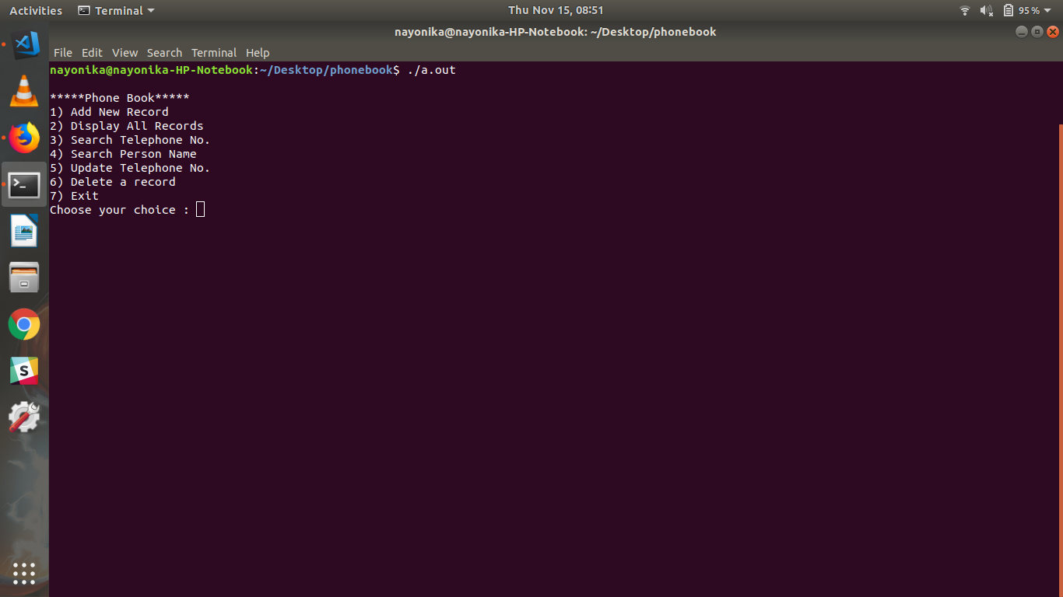

* Adding new record:-

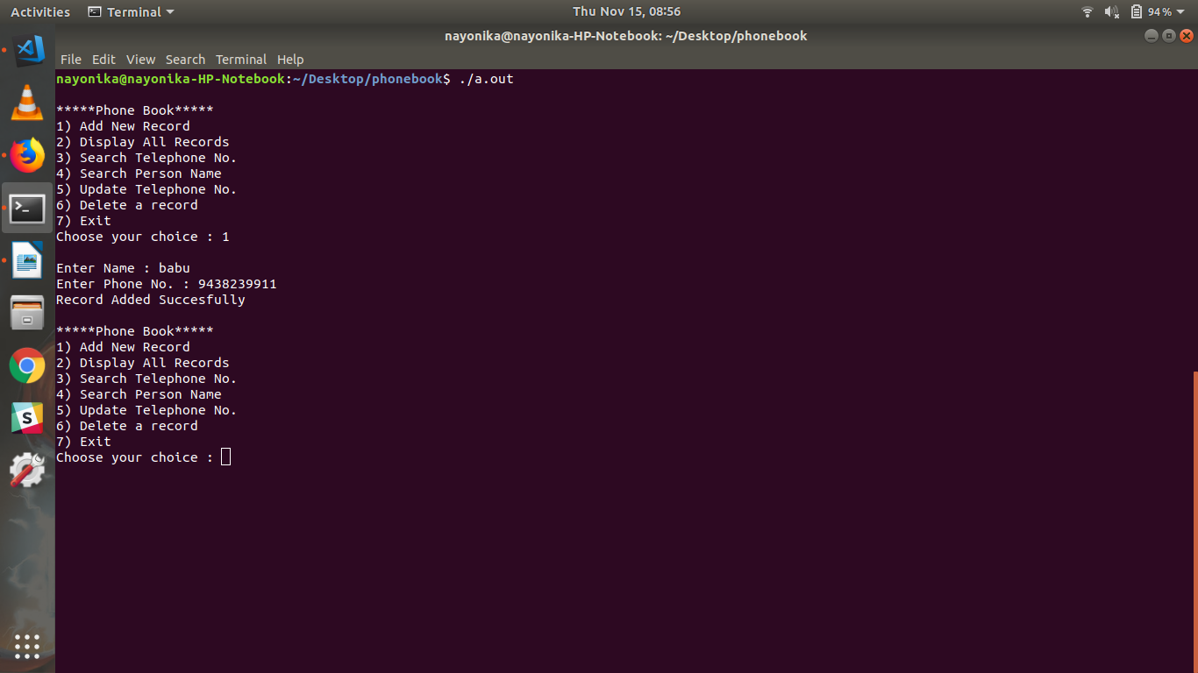

* Validation of the phone number:-

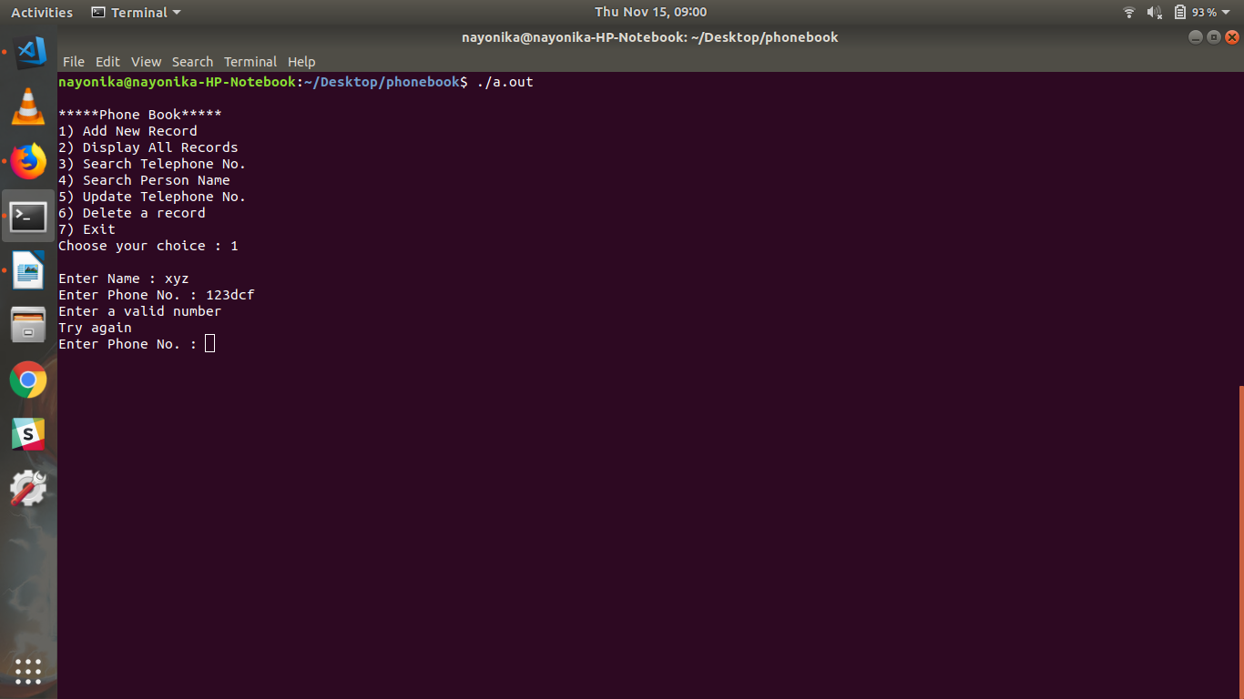

* Display all records in the phonebook

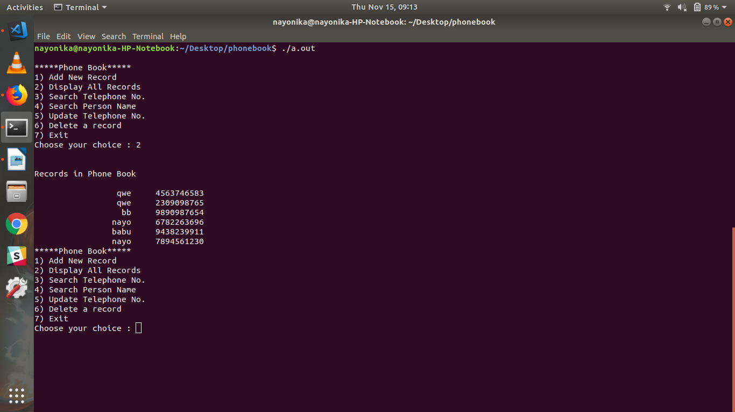

* Searching a record by name, and displaying appropriate message if record not found.

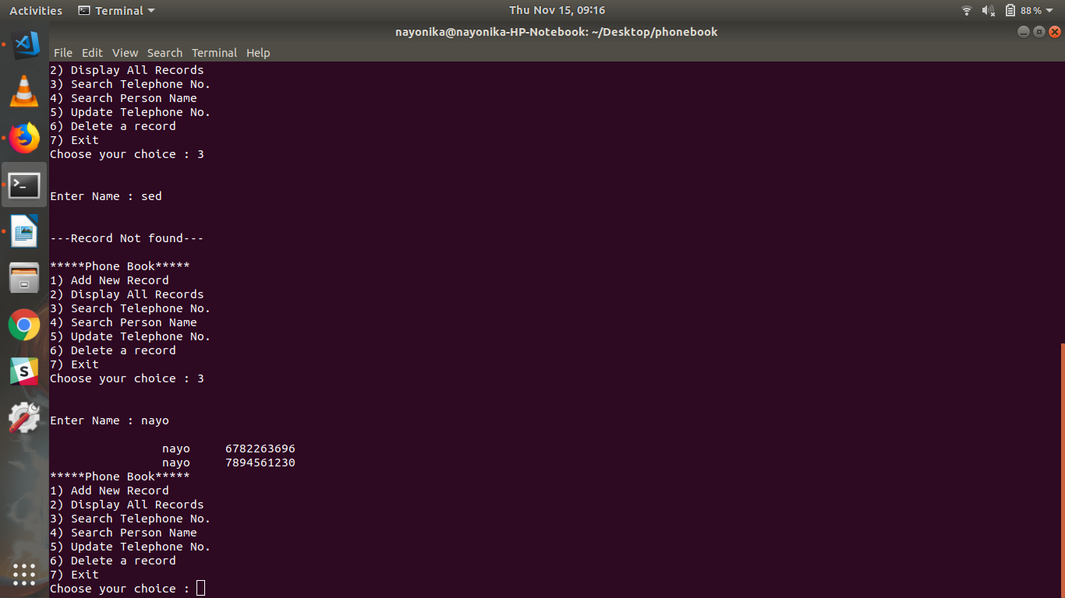

* Searching a record by phone number and displaying appropriate message if record not found.

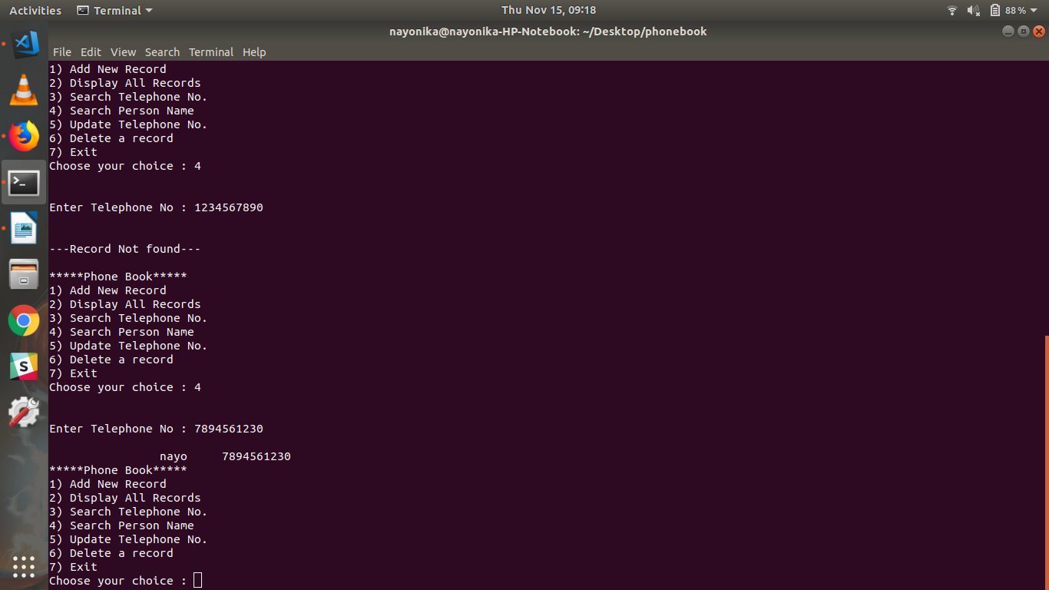

* Options to update telephone number or name.

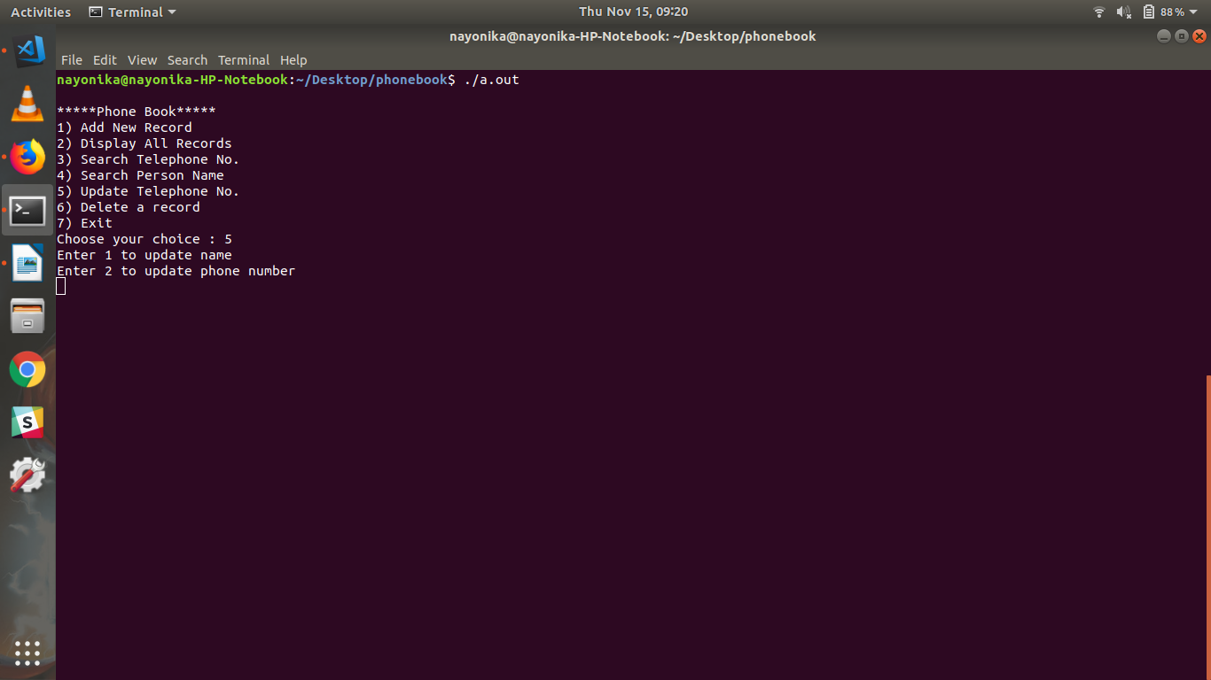

* Incase of multiple records with the same name in the phonebook,the same-name records are displayed and the user is asked to type the number to be deleted.

