AMERICAN INTERNATIONAL UNIVERSITY-BANGLADESH (AIUB)
Faculty of Science and Technology
Department of Computer Science

CSC 2210 - Object Oriented Programming 2
PROJECT ASSIGNMENT 01
SYSTEM DESIGN & REPORT

GYM AND FITNESS MANAGEMENT SYSTEM

Project Information | Details
Semester | Summer 2025-2026 / 2026 Submission
Section | ________________
Group No. | ________________
Supervisor | ________________
Prepared By | Project Group (member names and IDs to be inserted if required by instructor)

Submission package includes a GitHub-ready C# WinForms solution, SQL Server schema, diagrams, 17 UI mockups, README and this report.

CO2 / CO3 Rubric Mapping
Course Outcome / Criterion | Evidence in this Project
CO2 - Requirement Fulfilment | Three mandatory roles, domain-specific case study, all required marketplace features, matching navigation and database design.
CO2 - Validation | Required fields, email/password rules, rating 1-5 CHECK, stock/price/date constraints, two validation-state mockups.
CO2 - Verification | End-to-end flow from login -> role dashboard -> database-backed feature; SQL queries map to real tables and user stories.
CO3 - Organization | GitHub-ready structure with README, docs/diagrams, docs/screenshots and database/schema.sql.
CO3 - Database Representation | 12 tables, PK/FK/UNIQUE/CHECK, junction tables, 3NF explanation, JOIN/GROUP BY/HAVING/aggregates.
CO3 - GUI | 17 consistent WinForms-style mockups with visible titles, Back/Close/Logout paths, DataGridView lists and ComboBox filters.

Table of Contents
Chapter 1 - Introduction & Case Study 4
Chapter 2 - Functional Requirements & User Stories 6
Chapter 3 - UI Navigation Diagram 10
Chapter 4 - Database Design 11
Chapter 5 - SQL Script & Feature Queries 13
Chapter 6 - User Interface Design 15
Chapter 7 - Work Distribution 24
Chapter 8 - Conclusion & Future Work 24
Appendix A - Demo Accounts 25
Appendix B - Repository Structure 25
Appendix C - Requirement Checklist 25

Chapter 1 - Introduction & Case Study

1.1 Project Overview
Gym and Fitness Management System is a desktop marketplace application designed in C# Windows Forms with SQL Server integration. The platform connects customers with multiple gym and fitness businesses while a platform-level Super Admin manages marketplace quality and earns commission. The design deliberately follows exactly three login roles: Super Admin, Admin/Gym Owner and Customer. Trainer information is supported as a managed gym entity, not as a fourth login role.

1.2 Case Study
People who want to join a gym or buy fitness-related services often have to visit individual gym pages, call different businesses, compare prices manually, and ask separately about membership packages, personal training, group classes, supplements and accessories. Small gym owners also face problems because their membership offers, fitness services and products are often managed through disconnected spreadsheets, social media messages and handwritten records. This makes searching, stock tracking, sales reporting and customer feedback difficult. The Gym and Fitness Management System addresses these problems by acting as a single marketplace where approved fitness businesses can publish their offerings and customers can compare and purchase them from one place.
The platform has three actors. The Super Admin owns and moderates the marketplace. New gym businesses are approved or suspended by the Super Admin, who also manages master categories, sees platform-wide sales and commission, identifies low-rated gyms and moderates abusive reviews. The Admin is the owner of one gym or fitness centre. Each Admin can manage only the data belonging to that gym, including its profile, trainers, membership packages, services, products, stock, discounts, reviews and sales report. This separation is important because one business owner must never be able to view or change another business's private operational data. The Customer is the end user. Customers create accounts, browse items from every active gym, search and filter choices, read details and reviews, add items to a cart, checkout, view invoices and order history, and submit ratings from one to five with written feedback.
The main database entities are Users, Gyms, Categories, Trainers, Items, Offers, Carts, CartItems, Orders, OrderItems, Reviews and Payments. A User with the Admin role owns a Gym, while each Gym can list many Items and Trainers. Categories classify Items, and Offers provide time-limited discounts. A Customer owns a Cart, and the Cart contains Items through the CartItems junction table. When checkout succeeds, an Order is created. Because one Order can contain many Items and the same Item can appear in many different Orders, OrderItems is the mandatory junction table that stores quantity, transaction price, discount and subtotal. Customers can write Reviews for Items, and a paid Order has one Payment record.
Money enters the system when a Customer pays for products, services or membership packages. The order stores the total amount and the platform commission. Each Gym has a commission rate, set to ten percent in the sample data. The Gym Owner's earnings report therefore shows the business's share after platform commission, while the Super Admin dashboard reports total paid orders, gross sales and commission across the marketplace. This model allows customers to discover fitness options more easily, gives gym owners a structured business-management system, and gives the platform owner a clear revenue and moderation mechanism.

1.3 Three Mandatory Roles
Role | Meaning in This Domain | Core Responsibility
Super Admin | Platform owner | Approvals, moderation, categories, platform sales and commission
Admin | Gym / fitness centre owner | Manage only own gym data, items, trainers, inventory, offers and earnings
Customer | Buyer / member | Browse all approved gyms, cart, checkout, invoice, rating and review

Chapter 2 - Functional Requirements & User Stories

2.1 Functional Requirements

Super Admin Functional Requirements
- SA-FR01. The Super Admin shall log in using User ID/email and password and be routed to the Super Admin dashboard.
- SA-FR02. The Super Admin shall view all registered gym businesses and their owners.
- SA-FR03. The Super Admin shall approve pending gym businesses.
- SA-FR04. The Super Admin shall suspend a gym business and its owner account.
- SA-FR05. The Super Admin shall create and remove marketplace categories.
- SA-FR06. The Super Admin shall view platform-wide paid orders, gross sales and commission.
- SA-FR07. The Super Admin shall identify low-rated gyms using aggregated review data.
- SA-FR08. The Super Admin shall moderate abusive/inappropriate reviews by hiding them.
- SA-FR09. The Super Admin shall search/list platform data where relevant.
- SA-FR10. The Super Admin shall update profile and password information.

Admin / Gym Owner Functional Requirements
- AD-FR01. An Admin shall log in and be routed to the Gym Owner dashboard.
- AD-FR02. An Admin shall only access data for the gym mapped to the logged-in owner account.
- AD-FR03. An Admin shall update gym name, address and contact information.
- AD-FR04. An Admin shall create, read, update and delete products, services and membership packages.
- AD-FR05. An Admin shall manage trainers belonging to the gym.
- AD-FR06. An Admin shall view stock and receive a low-stock list when `StockQty <= MinStock`.
- AD-FR07. An Admin shall view sales details and net earnings after platform commission.
- AD-FR08. An Admin shall create date-bounded percentage discounts/offers.
- AD-FR09. An Admin shall view customer ratings and written reviews for its own gym.
- AD-FR10. An Admin shall update personal profile/password information.

Customer Functional Requirements
- CU-FR01. A Customer shall create an account with validated name, email and password.
- CU-FR02. A Customer shall log in and be routed to the Customer dashboard.
- CU-FR03. A Customer shall browse items from all approved gyms.
- CU-FR04. A Customer shall search by gym name, item name or keyword.
- CU-FR05. A Customer shall filter with dropdowns for category, item type and price range and may filter by location.
- CU-FR06. A Customer shall view item details, price, offer and existing reviews.
- CU-FR07. A Customer shall add items to a cart, change quantity by adding again, and remove cart lines.
- CU-FR08. A Customer shall checkout using a payment method and create a paid order.
- CU-FR09. Checkout shall reduce physical product stock while not reducing virtual service/membership availability.
- CU-FR10. A Customer shall view order history and an invoice-style order detail.
- CU-FR11. A Customer shall submit or update a 1-5 rating and written review.
- CU-FR12. A Customer shall view active discounts automatically in browse/details/cart calculations.
- CU-FR13. A Customer shall update profile/password information.

2.2 User Stories
Role-based login
As a registered user, I want to log in with my ID/email and password so that I am taken to the correct dashboard. The system hashes the entered password, validates it against `Users`, checks account status, reads `UserType`, and routes to Super Admin, Admin or Customer. Invalid or suspended accounts remain on the login screen with an error message.
Customer registration
As a new customer, I want to create an account so that I can buy fitness services and products. The form validates required fields, checks that the email looks valid and requires at least six password characters. A successful registration inserts a `Customer` record with active status.
Approve gym owner
As a Super Admin, I want to approve a pending gym so that a legitimate business can sell on the platform. I open Manage Gym Owners, select a pending gym, press Approve and the gym becomes Active. The owner account remains usable only when its status is Active.
Suspend gym owner
As a Super Admin, I want to suspend a gym and its owner so that policy violations can be controlled. Selecting a business and pressing Suspend updates the gym and the linked owner account. Suspended owners cannot log in and suspended gyms disappear from customer browsing.
Manage categories
As a Super Admin, I want to manage categories so that all gyms use a consistent classification. I can add a unique category name and description. Deletion is blocked by the database when a category is still referenced by an item.
Platform commission report
As a Super Admin, I want to see gross sales and platform commission so that I can measure marketplace performance. The report aggregates paid orders with `SUM`, `COUNT` and joins. Commission is stored per order and gym rates remain visible in the business table.
Low-rated gyms
As a Super Admin, I want to find low-rated gyms so that quality issues can be investigated. Review scores are grouped by gym and an SQL `HAVING` condition identifies averages below the threshold. Only visible reviews contribute to the result.
Review moderation
As a Super Admin, I want to hide abusive reviews so that the public marketplace remains appropriate. The review remains in the database for audit history, but `IsVisible` is set to false. Gym owners can only view reviews and cannot perform moderation.
Gym profile
As a Gym Owner, I want to edit my gym profile so that customers receive accurate information. The owner can update gym name, address and contact information. Every update targets the logged-in `GymId`, preventing access to another gym.
Item CRUD
As a Gym Owner, I want to manage products, services and memberships so that my current offerings appear in the marketplace. I choose a category and type, provide price, stock thresholds and description, and save. The grid refreshes after create/update/delete operations.
Trainer management
As a Gym Owner, I want to maintain trainer information so that customers can understand the expertise available at my gym. Trainers have name, specialization, phone, experience and availability. Trainer is a managed entity rather than a fourth system login role, preserving the required exactly-three-role model.
Low stock
As a Gym Owner, I want to see products at or below minimum stock so that I can restock before sales are lost. The inventory dashboard filters physical products with `StockQty <= MinStock`. Services and memberships are not treated as physical stock.
Gym sales report
As a Gym Owner, I want to see my own sales and net earnings so that I can evaluate the business. `OrderItems` is filtered by the owner gym's `GymId`. The report shows customer, item, quantity, unit price and subtotal, while net earnings subtract platform commission.
Create offer
As a Gym Owner, I want to create a timed discount so that I can attract customers. I select one of my items, enter a percentage and start/end dates. Validation prevents invalid percentages and end dates before start dates.
View reviews
As a Gym Owner, I want to read customer feedback so that I can improve service quality. The review list is restricted to items belonging to the current gym. The owner has no delete/hide button, separating business feedback from platform moderation.
Browse marketplace
As a Customer, I want to browse all active gyms so that I can compare choices. The browse query only returns available items from active gyms. Gym name, category, price, stock/location, rating and current discount are displayed in a `DataGridView`.
Search
As a Customer, I want to search by gym, item or keyword so that I can quickly find relevant fitness options. The application searches item name, gym name and description using a parameterized query. Clearing the search displays the full marketplace again.
Multi-filter browsing
As a Customer, I want dropdown filters so that I can narrow choices without typing complex queries. Category, item type and price range are ComboBoxes, with location as an additional text filter. All selected conditions are applied together in the SQL query.
Item details
As a Customer, I want to open an item and read details/reviews so that I can make an informed decision. The details screen shows gym, category, description, original price, active discount and final price. Existing visible customer reviews are shown below.
Add to cart
As a Customer, I want to add an item and quantity to my cart so that I can purchase multiple choices together. The system creates one cart per customer if needed. Adding the same item again increases its quantity instead of creating a duplicate cart line.
Remove from cart
As a Customer, I want to remove a selected cart line so that I can correct my purchase before payment. The selected `CartItemId` is deleted and the total is recalculated. The cart remains linked to only the logged-in customer.
Checkout
As a Customer, I want to pay for my cart so that an order is created. Checkout runs inside a SQL transaction, validates physical stock, calculates discounts and platform commission, inserts `Orders`, `OrderItems` and `Payments`, reduces product stock, clears the cart, and commits only when all operations succeed.
Order history and invoice
As a Customer, I want to view previous orders and invoice details so that I have a purchase record. The order history is filtered by the current customer. Selecting an order shows each item, gym, quantity and subtotal and calculates the total invoice amount.
Rating and review
As a Customer, I want to rate an item from 1 to 5 and write a comment so that I can share my experience. The database has a `CHECK` constraint for the rating range and a unique customer-item rule. Submitting again updates the existing review rather than duplicating it.
Profile and password
As any logged-in user, I want to update my profile and optionally change my password so that my account information remains current. Name is required and a new password must contain at least six characters. Passwords are stored as SHA-256 hashes rather than plain text.

Chapter 3 - UI Navigation Diagram
The application starts at sign up/login. After successful credential validation, a diamond decision node checks `UserType` and routes to exactly one of three dashboards. Every child screen has a Close/Back path and each dashboard has Logout -> Login. Customer purchase flow continues from browse to details/cart, checkout, payment and order history/invoice. Validation failures return to the relevant form without changing data.
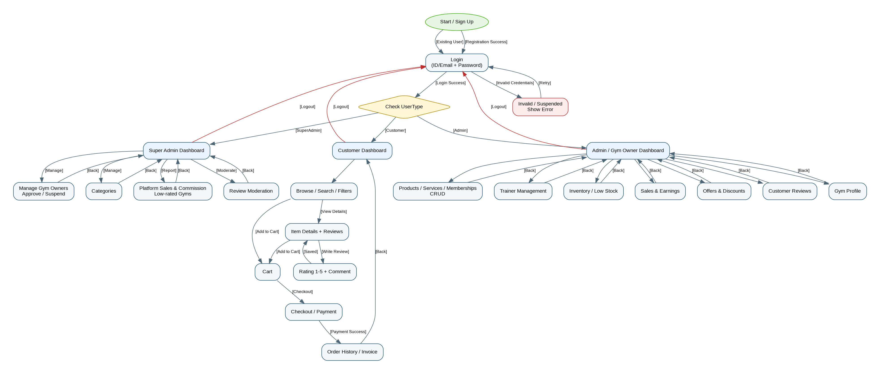
Figure 3.1 - Complete UI navigation with role-decision branch and labelled arrows.

Chapter 4 - Database Design

4.1 SQL Schema Diagram
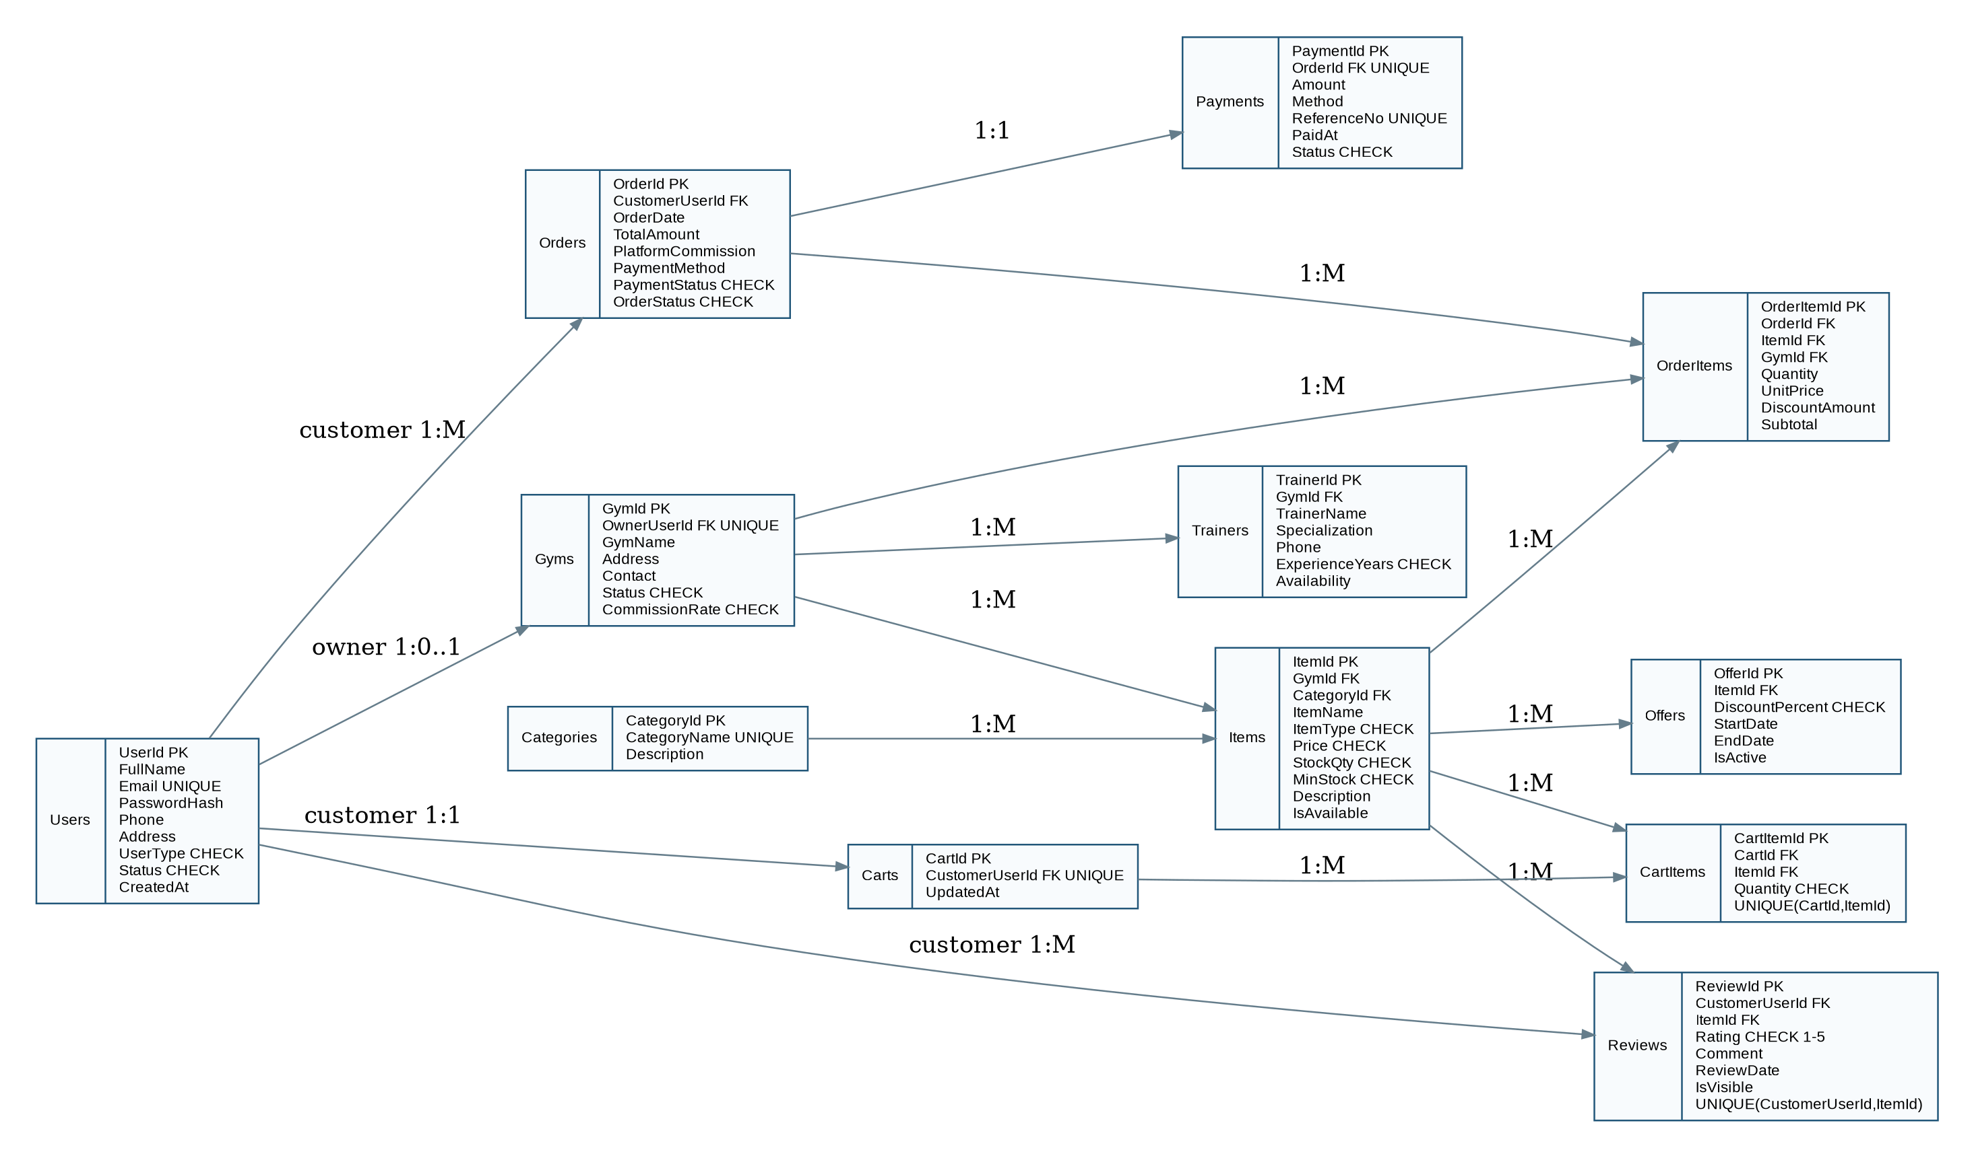
Figure 4.1 - SQL schema diagram showing PK/FK relationships and major constraints.

4.2 Table Descriptions
Table | Purpose | Important Constraints
Users | Stores all three login roles | UserId PK, Email UNIQUE, UserType CHECK, Status CHECK
Gyms | One business record per Admin owner | GymId PK, OwnerUserId FK UNIQUE, commission/status checks
Categories | Master item categories | CategoryId PK, CategoryName UNIQUE
Trainers | Gym trainer profiles | GymId FK, ExperienceYears CHECK
Items | Products/services/memberships | GymId FK, CategoryId FK, ItemType/price/stock checks
Offers | Date-bounded discounts | ItemId FK, discount/date checks
Carts | One active cart per Customer | CustomerUserId FK UNIQUE
CartItems | Cart-to-item junction | CartId FK, ItemId FK, UNIQUE pair, Quantity CHECK
Orders | Completed purchase header | CustomerUserId FK, total/commission/payment/order status
OrderItems | Mandatory order-to-item junction | OrderId/ItemId/GymId FKs; qty, price, discount, subtotal
Reviews | Customer ratings/comments | Rating CHECK 1-5, unique Customer+Item
Payments | Payment record | OrderId FK UNIQUE, amount/status/reference constraints

4.3 ER Diagram (Bonus Quality)
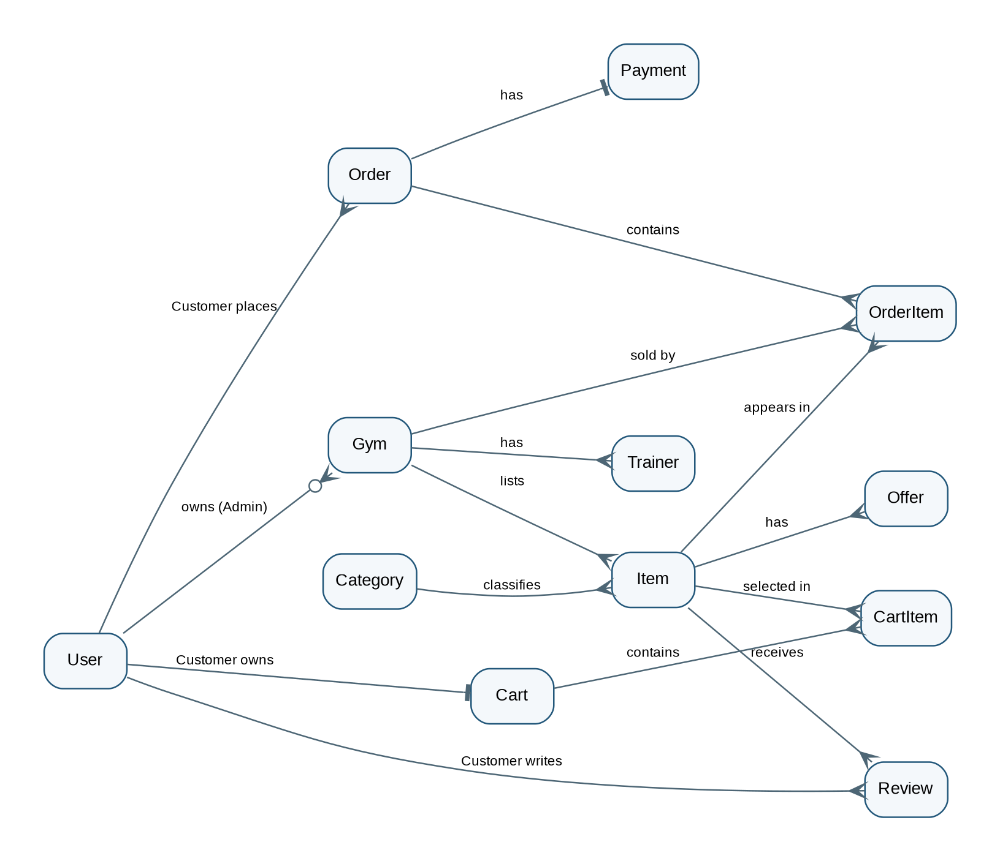
Figure 4.2 - Entity-relationship view of the marketplace model.

4.4 Normalisation to 3NF
First Normal Form: Every field stores one atomic value. Repeating lists such as cart items and order items are separated into child/junction tables.
Second Normal Form: Non-key attributes depend on the whole key. For example, transaction attributes such as `Quantity`, `UnitPrice`, and `Subtotal` belong to `OrderItems`, not to `Items` or `Orders` alone.
Third Normal Form: Transitive facts are separated. `GymName` is stored only in `Gyms` and referenced by `GymId`; `CategoryName` is stored only in `Categories`; owner details are stored in `Users`. This avoids update anomalies and duplicated descriptive data.

4.5 Data Isolation
Every Admin operational query is filtered by the logged-in `GymId`. Items, trainers, offers, stock, reviews and sales therefore return only records belonging to that owner. This prevents a Gym Owner from reading or modifying another Gym Owner's private data.

Chapter 5 - SQL Script & Feature Queries
The complete runnable file is `database/schema.sql`. It creates the database, tables, constraints, seed data and demonstration queries. The implementation uses parameterized ADO.NET queries in C# to avoid concatenating user input into SQL.

5.1 Login verification
SELECT u.UserId,u.FullName,u.UserType,g.GymId
FROM Users u LEFT JOIN Gyms g ON g.OwnerUserId=u.UserId
WHERE (u.Email=@id OR CAST(u.UserId AS varchar(20))=@id)
AND u.PasswordHash=@pw AND u.Status='Active';
This query directly supports the named system feature and references tables that appear in the schema diagram.

5.2 Search / Filter
SELECT i.ItemId,g.GymName,i.ItemName,i.ItemType,c.CategoryName,i.Price
FROM Items i JOIN Gyms g ON g.GymId=i.GymId
JOIN Categories c ON c.CategoryId=i.CategoryId
WHERE g.Status='Active' AND i.IsAvailable=1
AND (@q='' OR i.ItemName LIKE '%'+@q+'%' OR g.GymName LIKE '%'+@q+'%');
This query directly supports the named system feature and references tables that appear in the schema diagram.

5.3 Gym earnings - JOIN + GROUP BY + SUM
SELECT g.GymName, SUM(oi.Subtotal) GrossSales,
SUM(oi.Subtotal*(1-g.CommissionRate)) GymEarnings
FROM Gyms g JOIN OrderItems oi ON oi.GymId=g.GymId
JOIN Orders o ON o.OrderId=oi.OrderId AND o.PaymentStatus='Paid'
GROUP BY g.GymName,g.CommissionRate;
This query directly supports the named system feature and references tables that appear in the schema diagram.

5.4 Low-rated gyms - GROUP BY + HAVING + AVG
SELECT g.GymName,AVG(CAST(r.Rating AS decimal(5,2))) AverageRating
FROM Gyms g JOIN Items i ON i.GymId=g.GymId
JOIN Reviews r ON r.ItemId=i.ItemId AND r.IsVisible=1
GROUP BY g.GymName
HAVING AVG(CAST(r.Rating AS decimal(5,2))) < 3.5;
This query directly supports the named system feature and references tables that appear in the schema diagram.

5.5 Low stock alert
SELECT g.GymName,i.ItemName,i.StockQty,i.MinStock
FROM Items i JOIN Gyms g ON g.GymId=i.GymId
WHERE i.ItemType='Product' AND i.StockQty<=i.MinStock;
This query directly supports the named system feature and references tables that appear in the schema diagram.

5.6 Active offers
SELECT g.GymName,i.ItemName,o.DiscountPercent,o.StartDate,o.EndDate
FROM Offers o JOIN Items i ON i.ItemId=o.ItemId
JOIN Gyms g ON g.GymId=i.GymId
WHERE o.IsActive=1 AND SYSDATETIME() BETWEEN o.StartDate AND o.EndDate;
This query directly supports the named system feature and references tables that appear in the schema diagram.

Chapter 6 - User Interface Design
All mockups use one consistent blue/white/green visual language, visible screen titles, standardized buttons and grid layouts. Data lists use DataGridView-style tables and the customer filters use ComboBox-style dropdowns. Validation/error states are explicitly shown in the Sign Up and Checkout mockups.
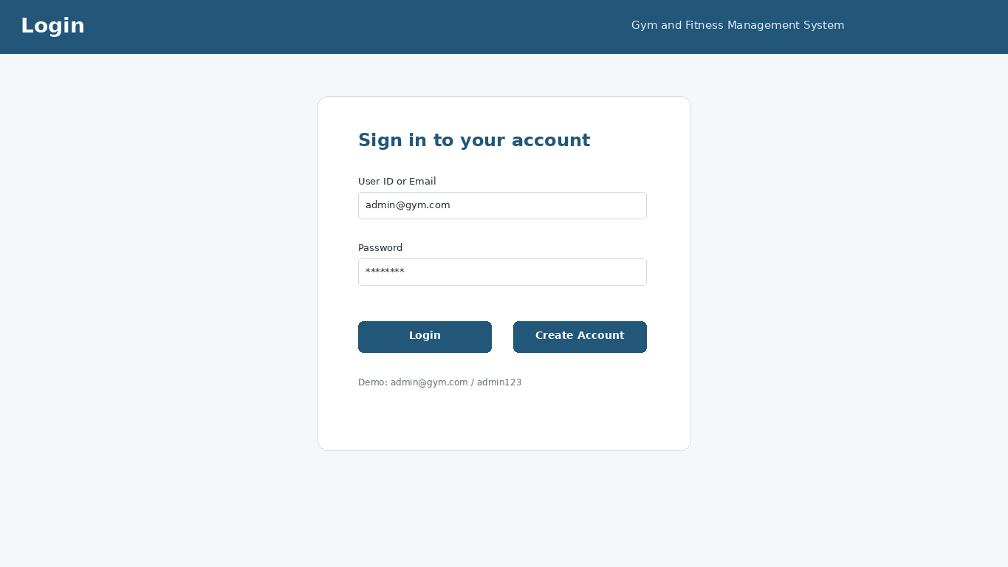
Login form - entry point for all three roles.
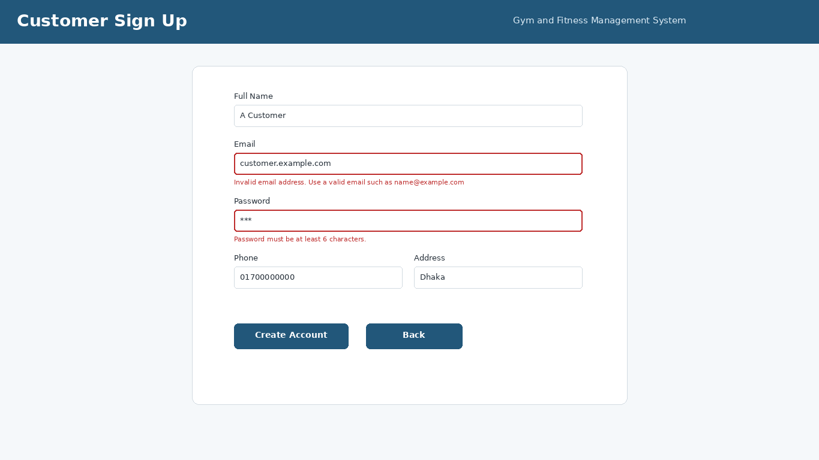
Customer sign-up form showing email and password validation states.

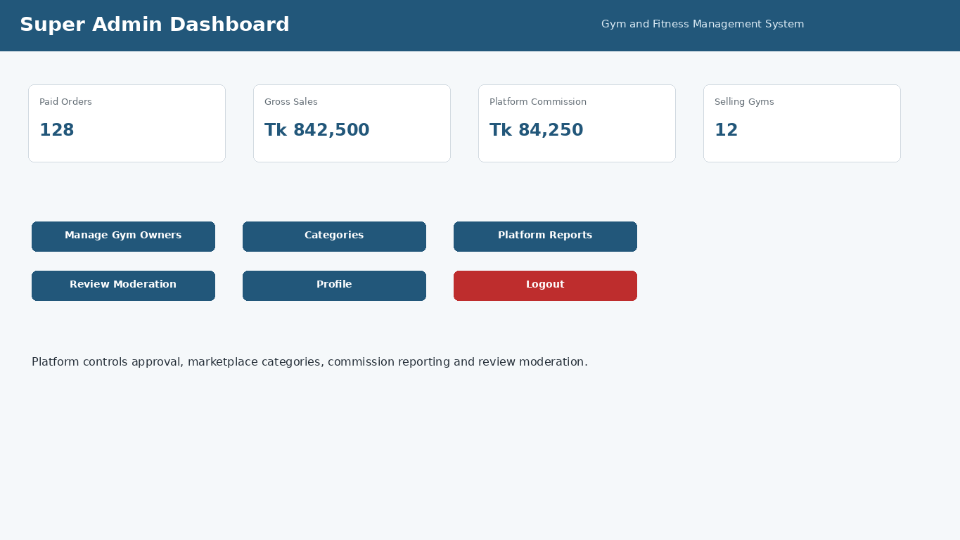
Super Admin dashboard with platform summary and control actions.
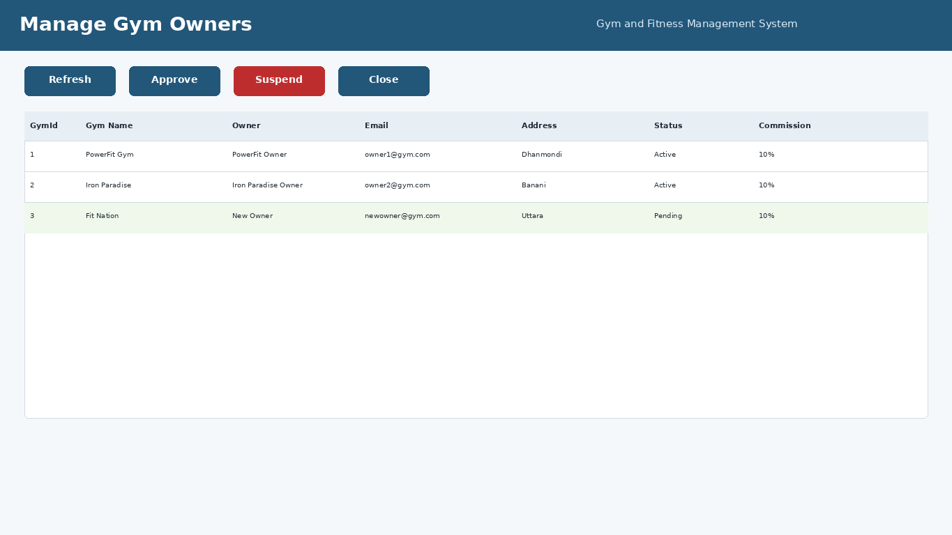
Super Admin - approve/suspend gym-owner businesses.

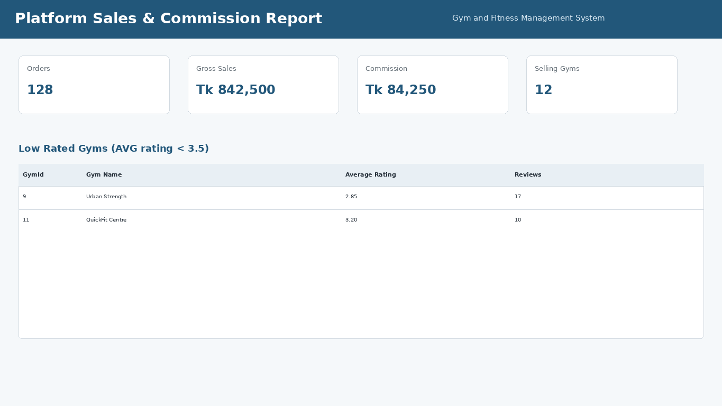
Platform sales, commission and low-rated gym report.
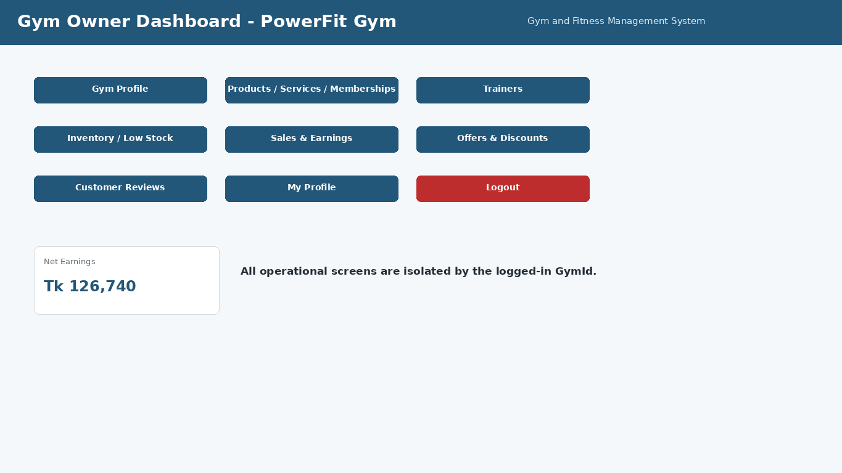
Admin/Gym Owner dashboard with data-isolated business modules.

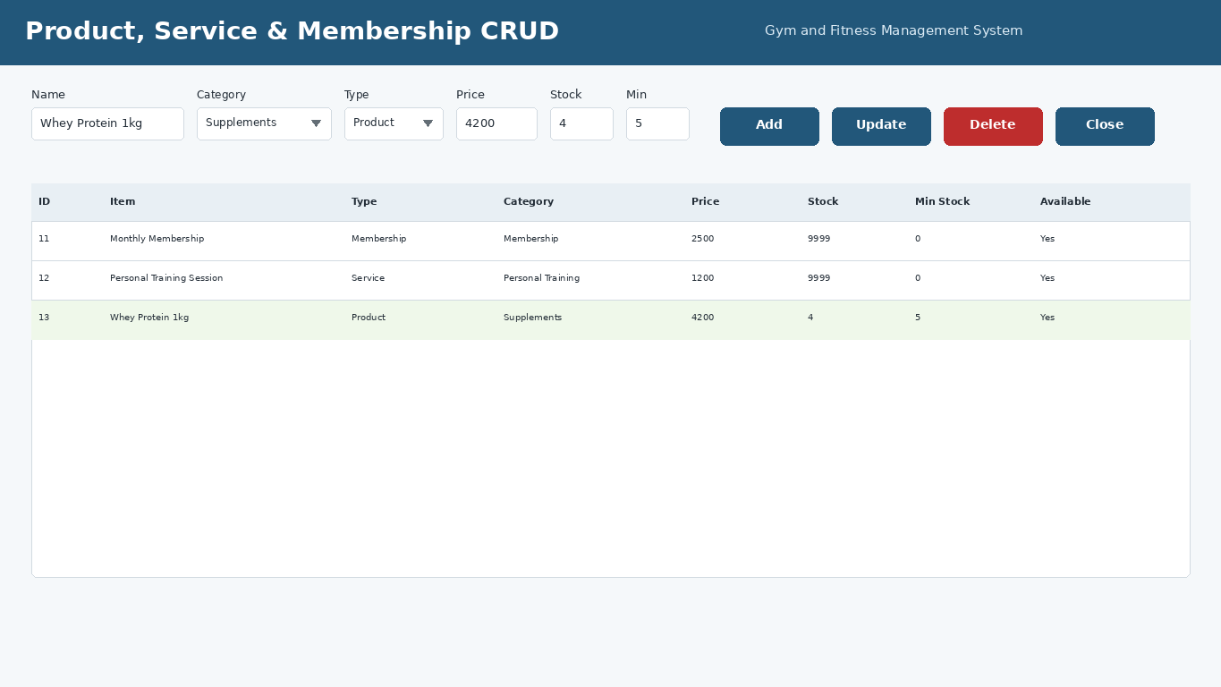
Admin product/service/membership CRUD using dropdowns and a data grid.
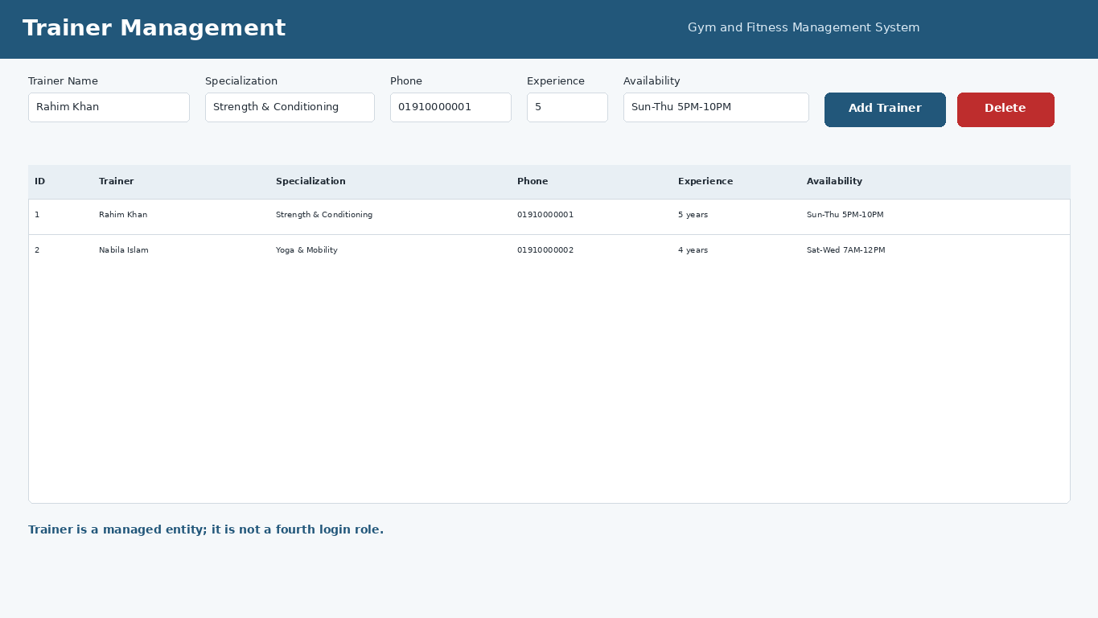
Admin trainer management. Trainer is an entity, not a fourth login role.

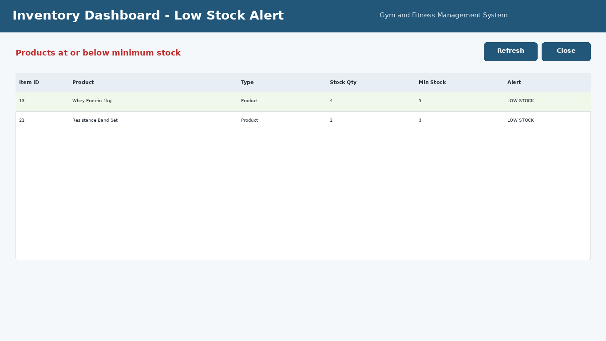
Inventory dashboard showing low-stock alert condition.
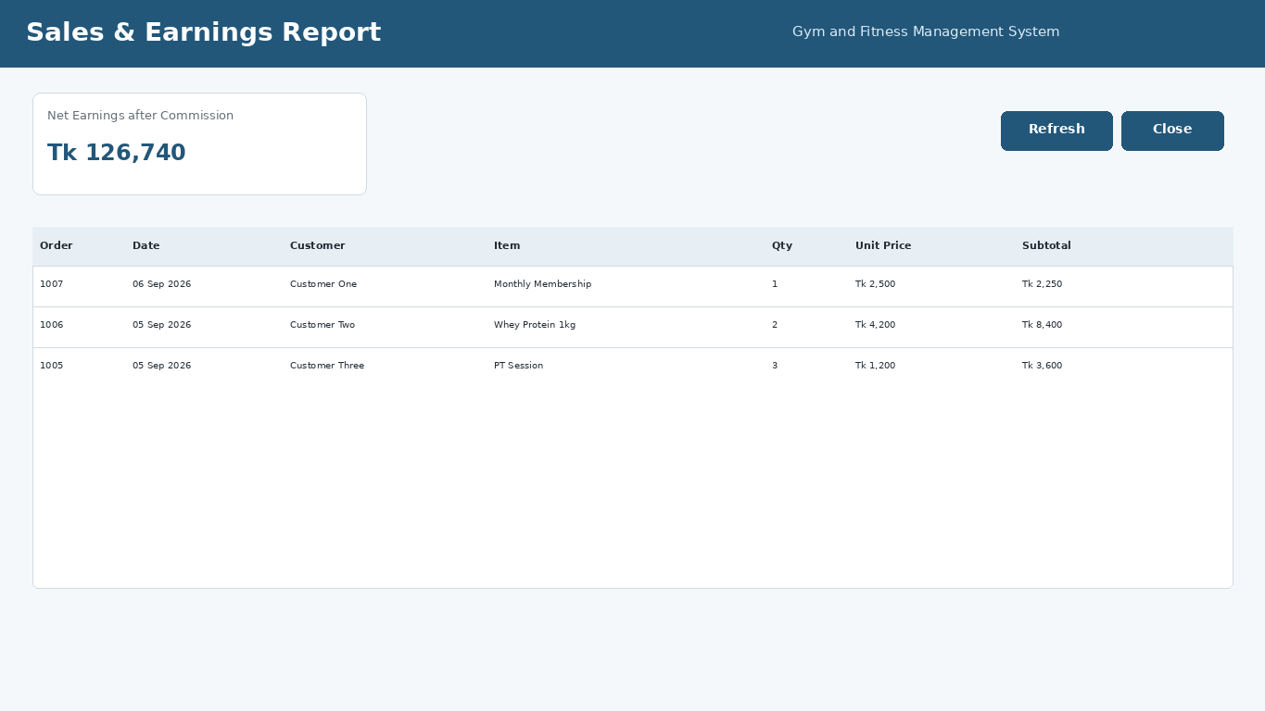
Gym-specific sales and net earnings report.

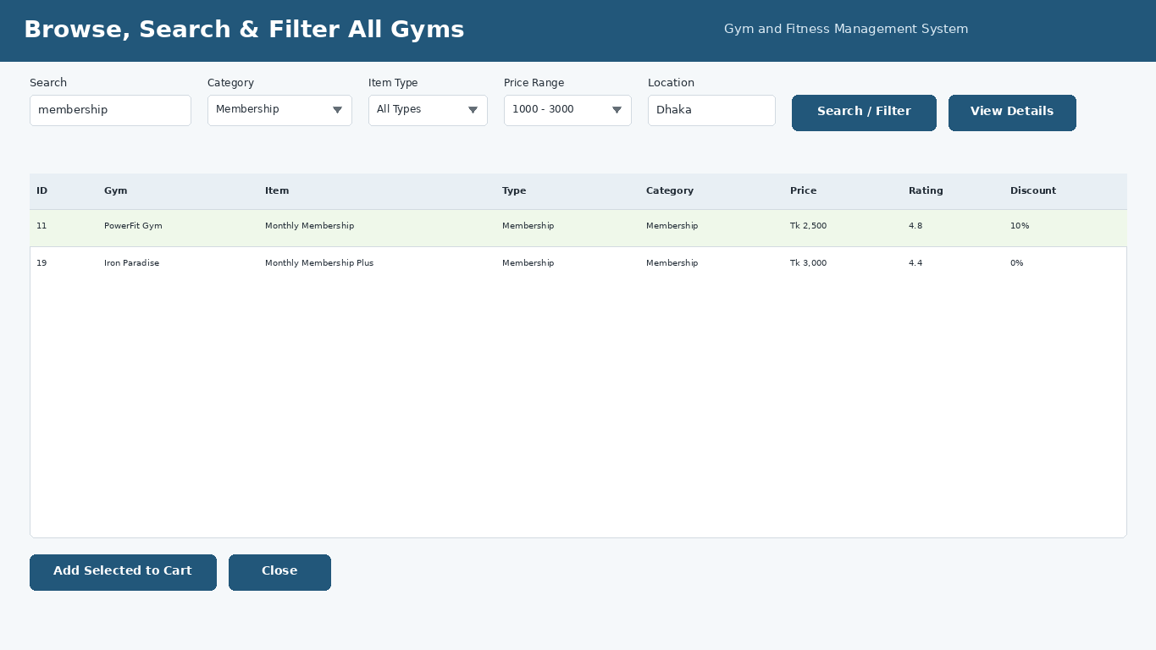
Customer marketplace browse/search with category, type, price and location filters.
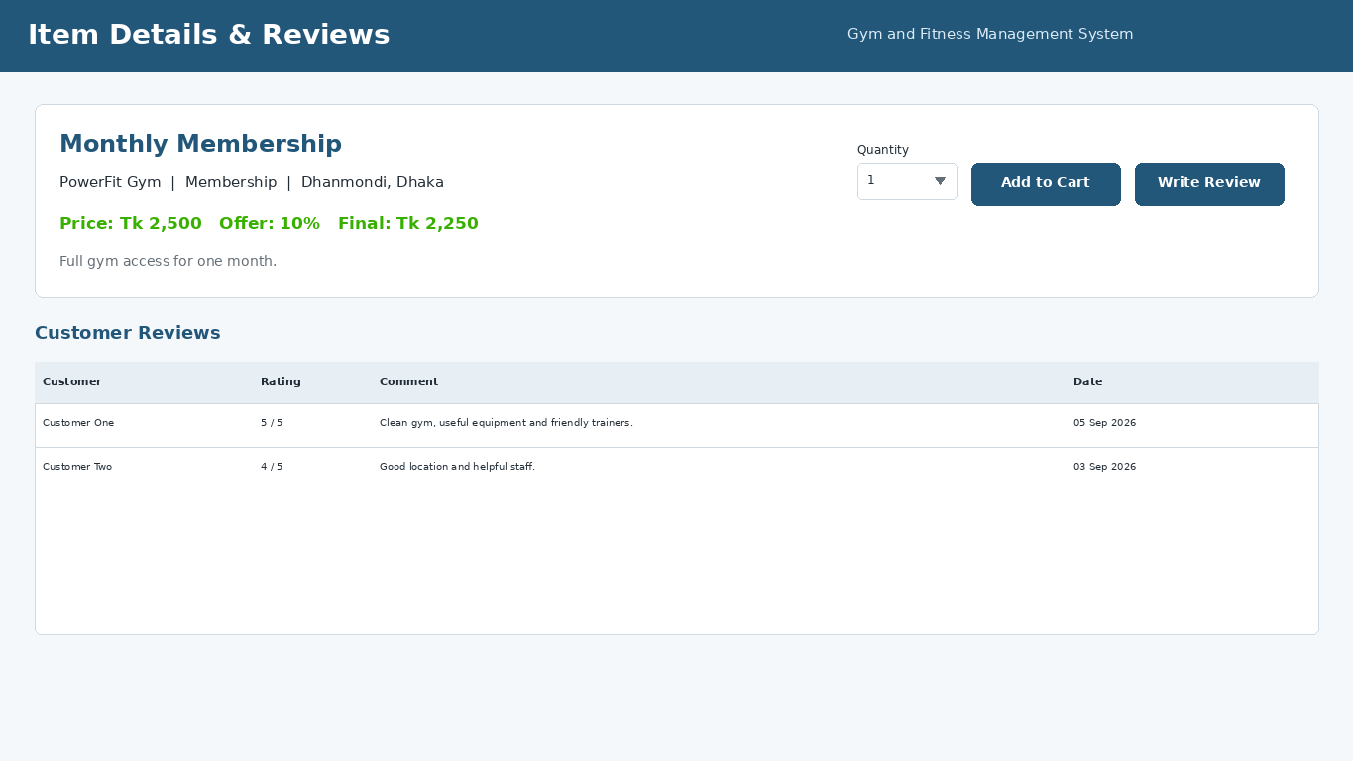
Customer item details with current offer and public reviews.

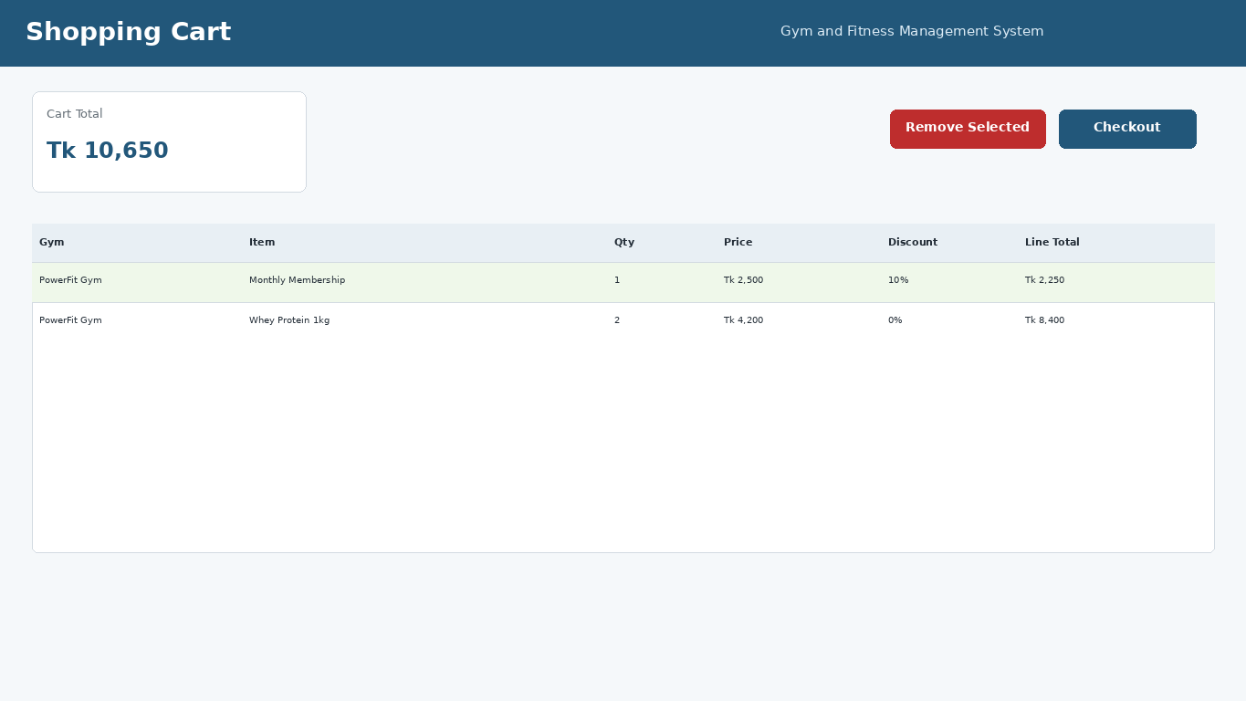
Customer cart with calculated line totals and checkout action.
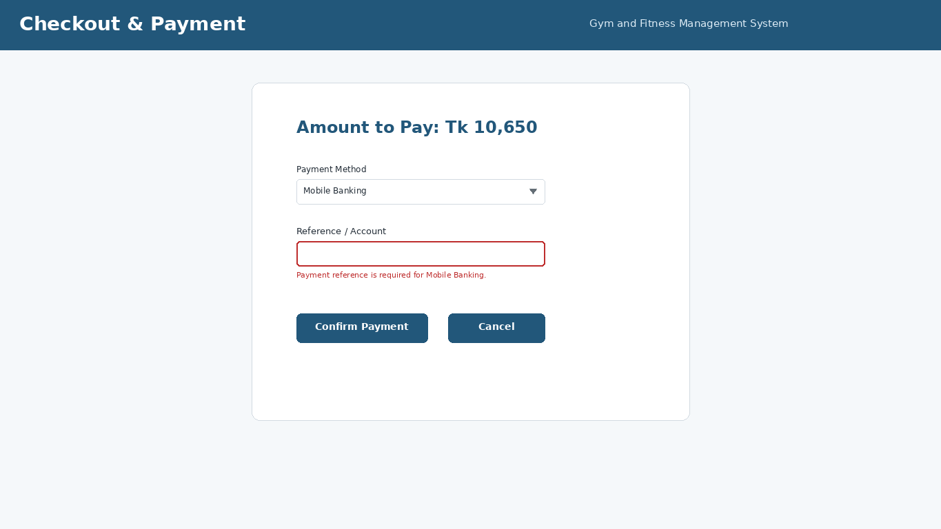
Checkout/payment mockup showing a validation/error state.

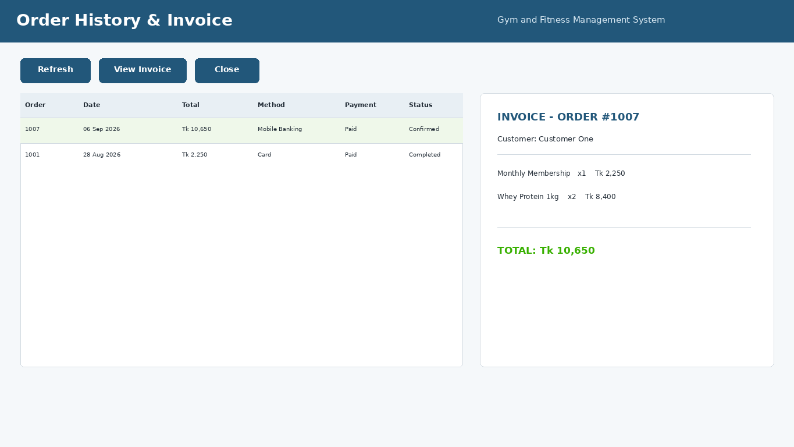
Order history with printable invoice-style detail.
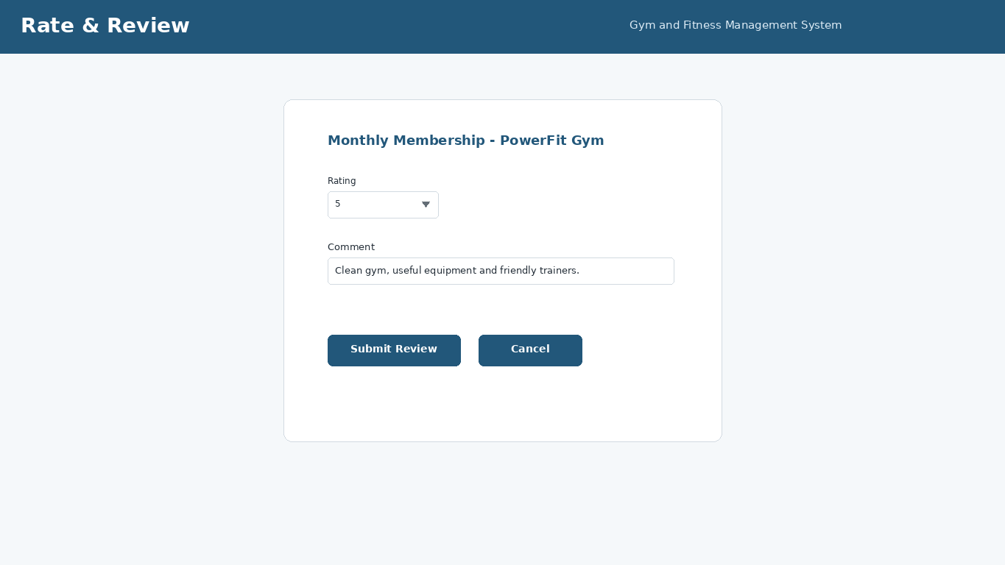
Customer 1-5 rating and written review form.

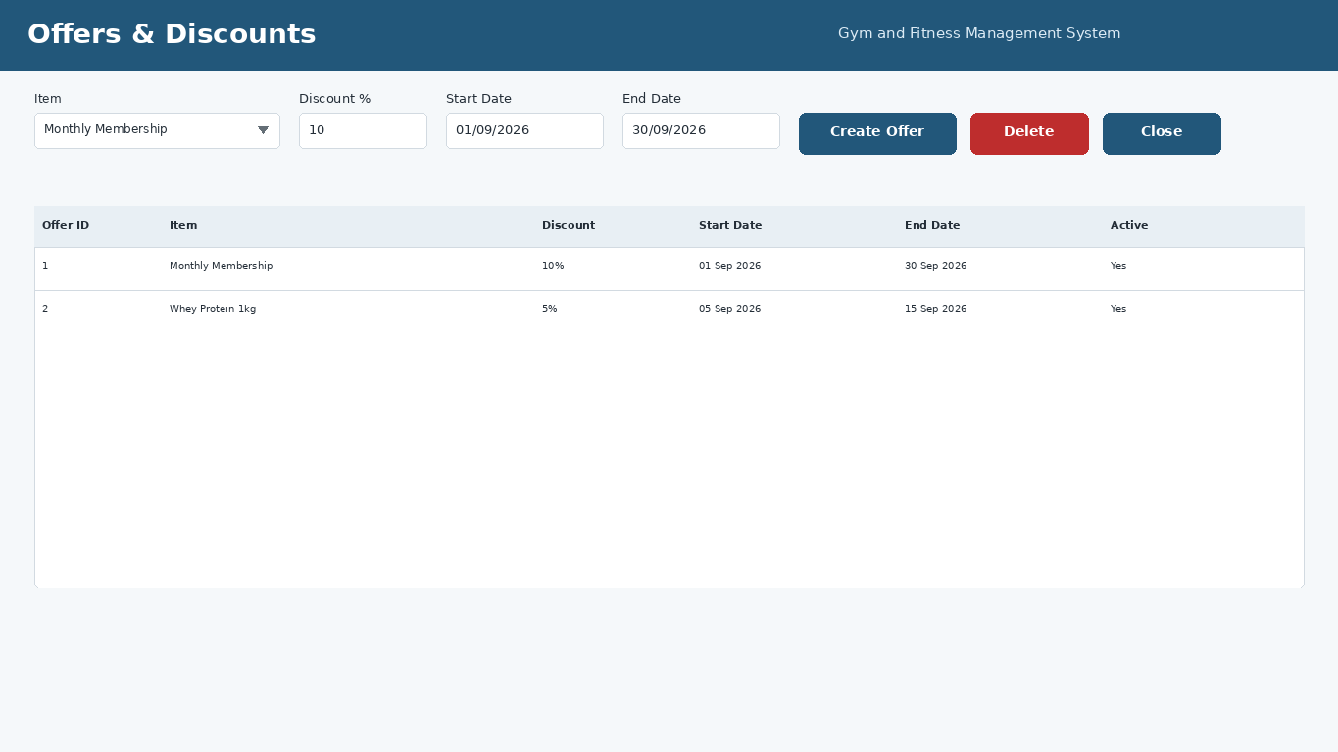
Admin date-bounded percentage offers/discounts management.

Chapter 7 - Work Distribution
The assignment requires a truthful contribution table and separate GitHub commits for all group members. Personal group details were not supplied in the chat, so the technical contribution plan is shown below without inventing student identities.
Member | Student ID | Suggested / Actual Contribution
Member 1 | __________ | Case study, functional requirements, Super Admin UI and report integration
Member 2 | __________ | Database schema, SQL queries, ER/schema diagrams and data validation
Member 3 | __________ | Admin/Customer UI mockups, navigation diagram and README/GitHub structure
Member 4 (if applicable) | __________ | Testing, consistency review, screenshots and final PDF proofread

Important: GitHub should contain genuine commits from each group member. Do not fabricate contribution history. The repository structure is already prepared so files can be committed by the appropriate contributors.

Chapter 8 - Conclusion & Future Work
The Gym and Fitness Management System design satisfies the required three-role marketplace model and aligns the case study, navigation, database, SQL queries and UI mockups around the same data flow. Super Admin controls the platform, Admin owners manage only their own gym, and Customers complete the full discovery-to-purchase-to-review journey. The database uses normalized tables, clear PK/FK relationships, the mandatory OrderItems junction table, business constraints and SQL aggregates required for reporting. The accompanying C# WinForms source also implements role routing and the main database-backed workflows as bonus-quality preparation for the later coding phase.

8.1 Future Work
- Add real online payment gateway integration instead of payment simulation.
- Add class/session scheduling and capacity reservations as an extension to the existing service item model.
- Add trainer assignment/booking history if the later coding assignment explicitly requires it.
- Generate PDF invoices directly from the application.
- Add dashboard charts, audit logging, password salting and role/permission hardening for production use.
- Deploy the SQL database to a hosted environment and add automated backup/restore.

8.2 Expected Challenges
The main implementation challenges are keeping gym-owner data isolated, keeping cart/order/stock changes transaction-safe, calculating discounts and commission consistently, validating all user input, and maintaining agreement between UI controls, database columns and SQL queries. The supplied design addresses these challenges by using GymId filters, SQL transactions, constraints, parameterized queries and one shared schema.

Appendix A - Demo Accounts
Role | Email | Password
Super Admin | admin@gym.com | admin123
Admin / Gym Owner | owner1@gym.com | owner123
Admin / Gym Owner | owner2@gym.com | owner123
Customer | customer1@gym.com | cust123

Appendix B - Repository Structure
Gym_and_Fitness_Management_System/
├── GymAndFitnessManagementSystem.sln
├── GymAndFitnessManagementSystem/
│ ├── Forms/
│ ├── Data/
│ ├── Models/
│ ├── Common/
│ └── App.config
├── database/schema.sql
├── docs/
│ ├── Project_Report.pdf
│ ├── diagrams/
│ └── screenshots/
└── README.md

Appendix C - Requirement Checklist
- Project domain: Gym & Fitness
- Exactly 3 login roles: Super Admin, Admin/Gym Owner, Customer
- Multi-gym marketplace concept
- Case study included in final report
- Functional requirements included
- User stories included
- UI navigation diagram included
- SQL schema diagram included
- ER diagram included as bonus-quality material
- Database is 3NF and has more than 6 tables
- PK, FK, UNIQUE and CHECK constraints used
- `OrderItems` junction table included
- SQL file includes sample data: 1 Super Admin, 2 Admins, 3 Customers
- SQL examples include JOIN, GROUP BY, HAVING, SUM, AVG, COUNT
- Search and at least 3 filters included
- Product/service/membership CRUD included
- Cart, checkout, invoice/order history included
- Rating 1-5 + written review included
- Offers/discounts included
- Low stock alert included
- Platform commission included
- Data isolation by GymId included
- 12+ UI mockups/screenshots included
- Validation states included in UI mockups/report
- GitHub-ready repository structure included
- Working role-routing C# source included as bonus implementation

