Naylor K Robinson
Cloud project brief overview:
This project is a production-grade DevOps pipeline built entirely on AWS. It demonstrates how enterprise companies like Target and Nike automate software deployments without manual intervention.
The infrastructure is provisioned with Terraform — no manual AWS console clicks. A Jenkins server running on EC2 acts as the CI engine, automatically triggered by every GitHub code push. Jenkins runs unit tests, security scans, builds a Docker image, and pushes it to AWS ECR. ArgoCD running inside an EKS Kubernetes cluster watches the GitOps repository and automatically deploys the new version the moment Jenkins updates the image tag.
The proof is a live screen recording. The app starts as a solid blue page (Version 1.0). After one git push, the full pipeline runs automatically and the app updates to University of Virginia Cavaliers branding — Navy and Orange — in under 2 minutes. No kubectl. No console clicks. Just Git.
Observability is handled by Prometheus, Grafana, and Loki running inside the cluster providing real-time metrics, dashboards, and log aggregation.

Project screenshots
Phase 1 – S3 bucket creation for terraform state file
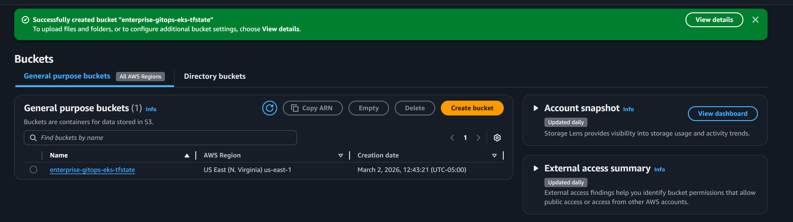

Phase 2 – Terraform Plan screenshot
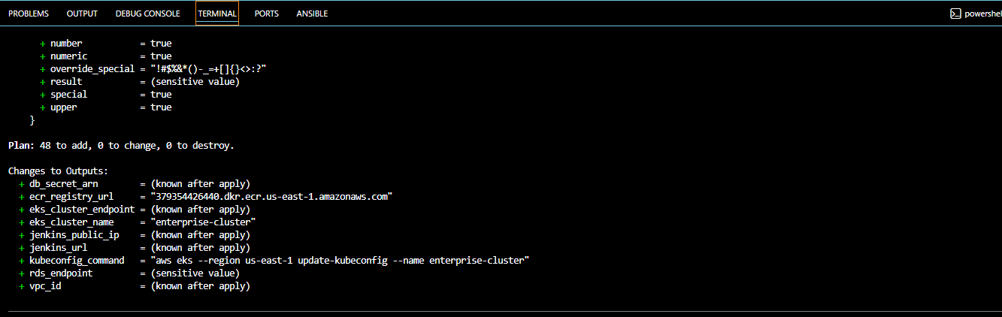

Phase 3 – Terraform script created Infrastructure no errors
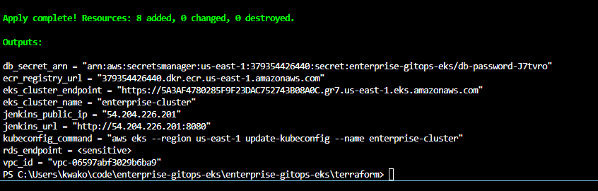
Phase 4 – Confirmation that we can run kubectl and get info on our nodes
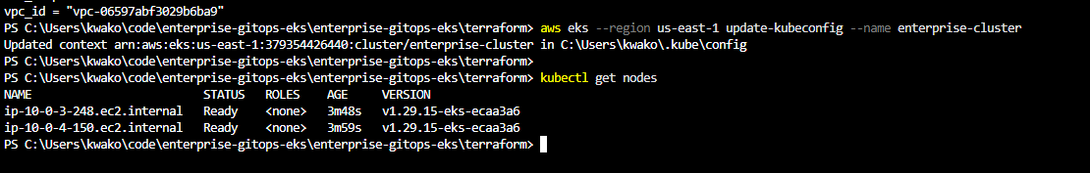

Phase 5 – Confirmation that Jenkins in running and it accessible at our public IP
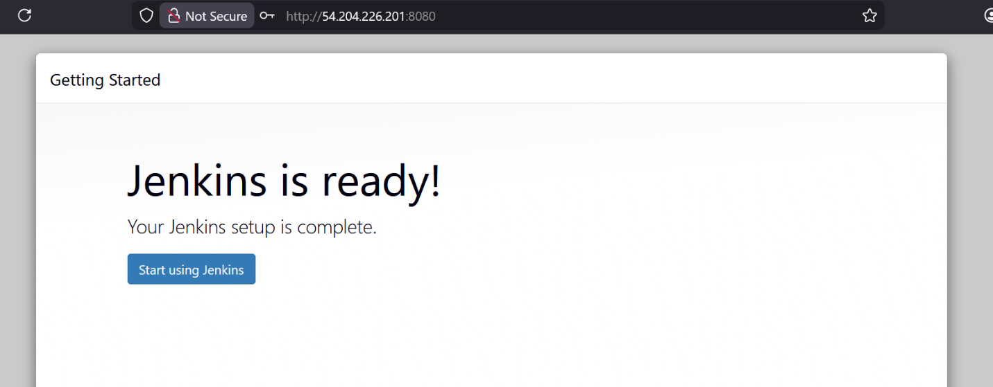
Phase 6 – Confirmation that GitHub has all necessary files for pipeline in the repository
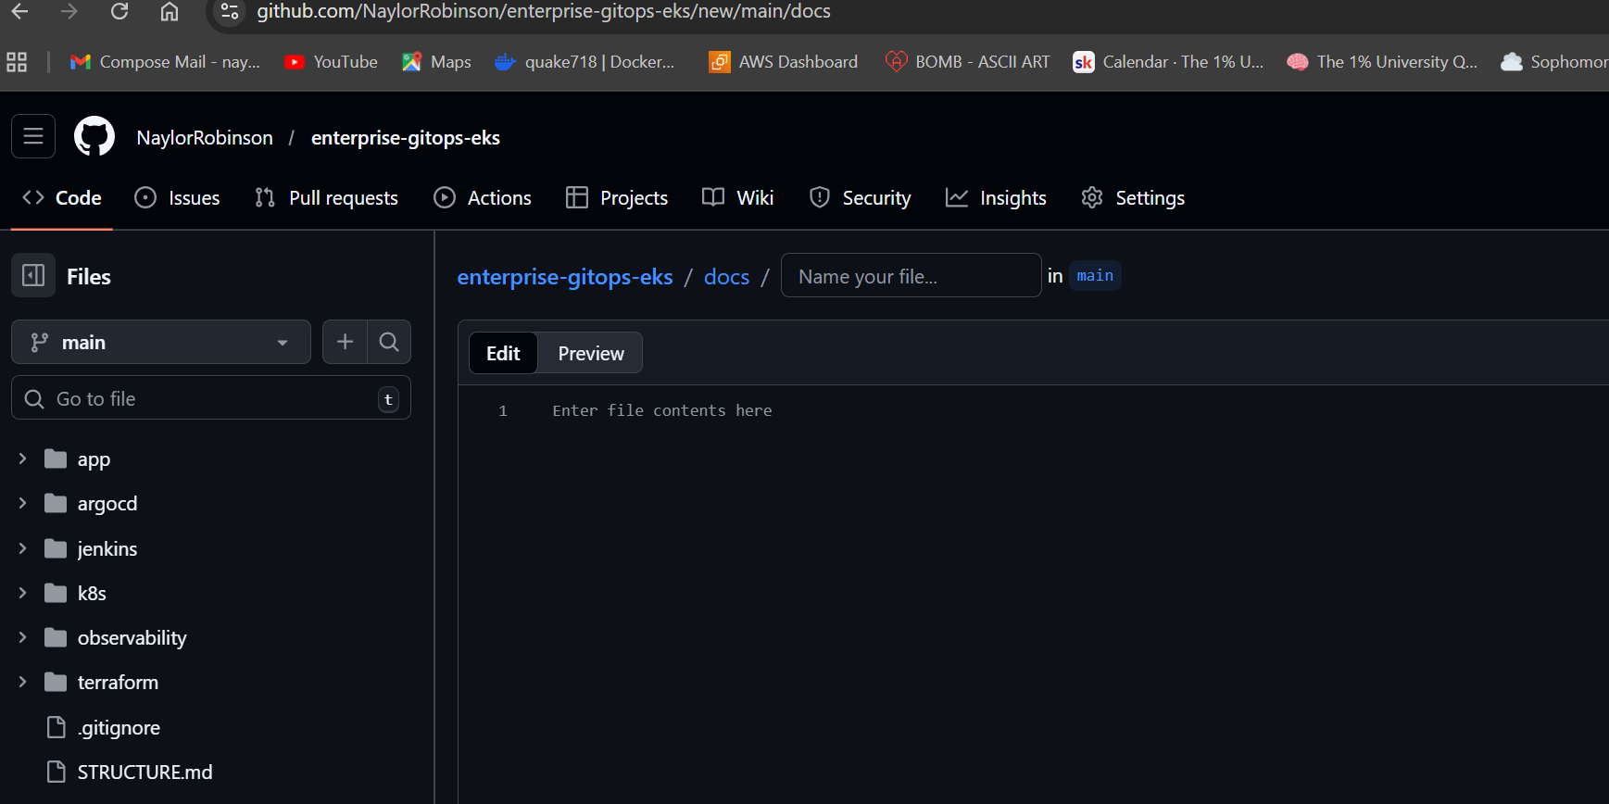
Phase 7 – Confirmation of Jenkins pipeline built
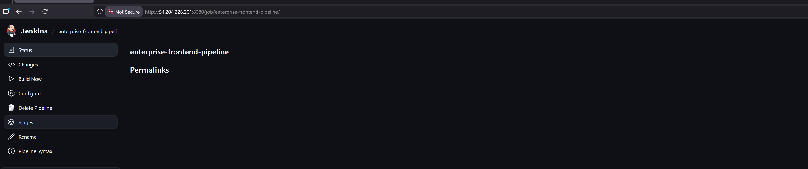

Phase 8 - Confirmation Argo CD is synched and healthy
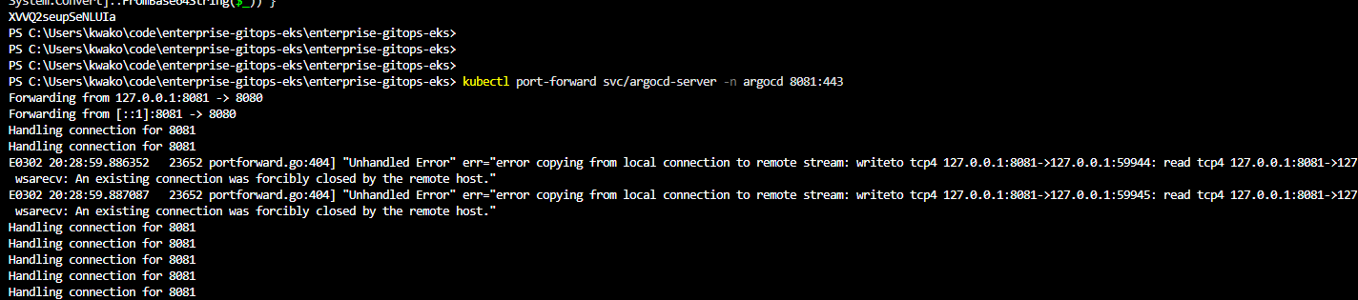
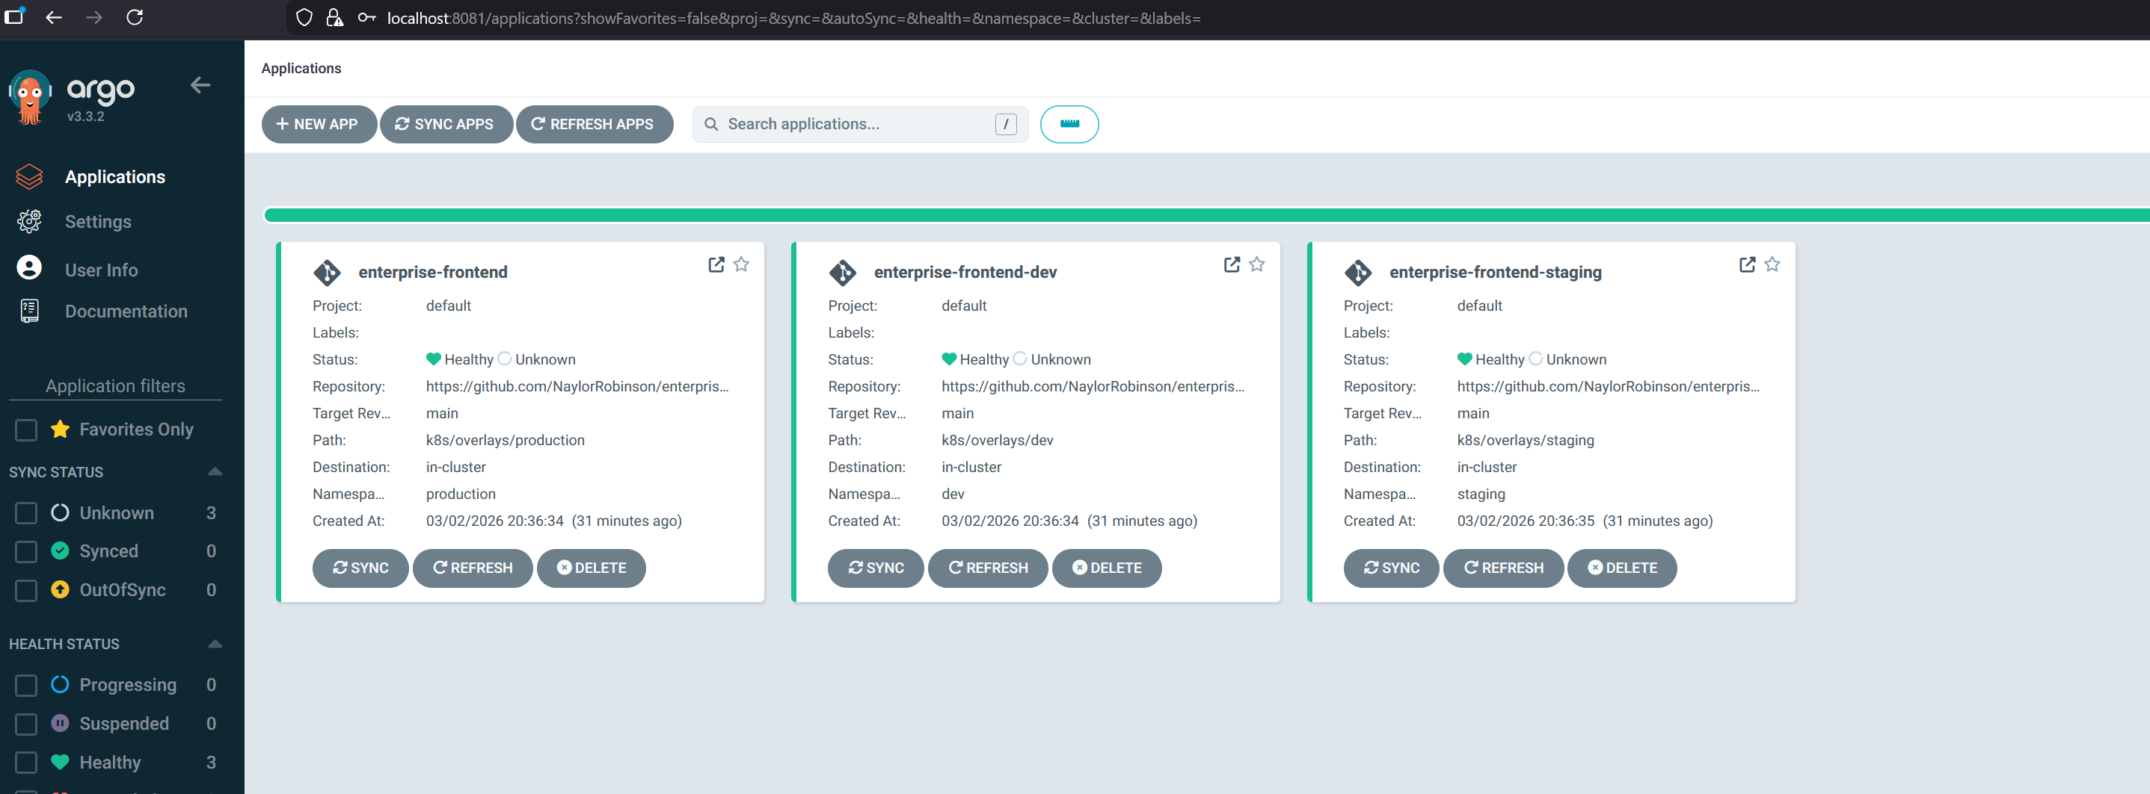

Phase 9 – Set up monitoring in Grafana to see live metricks of CPU usage, memory and pod counts. The cluster is running and being monitored
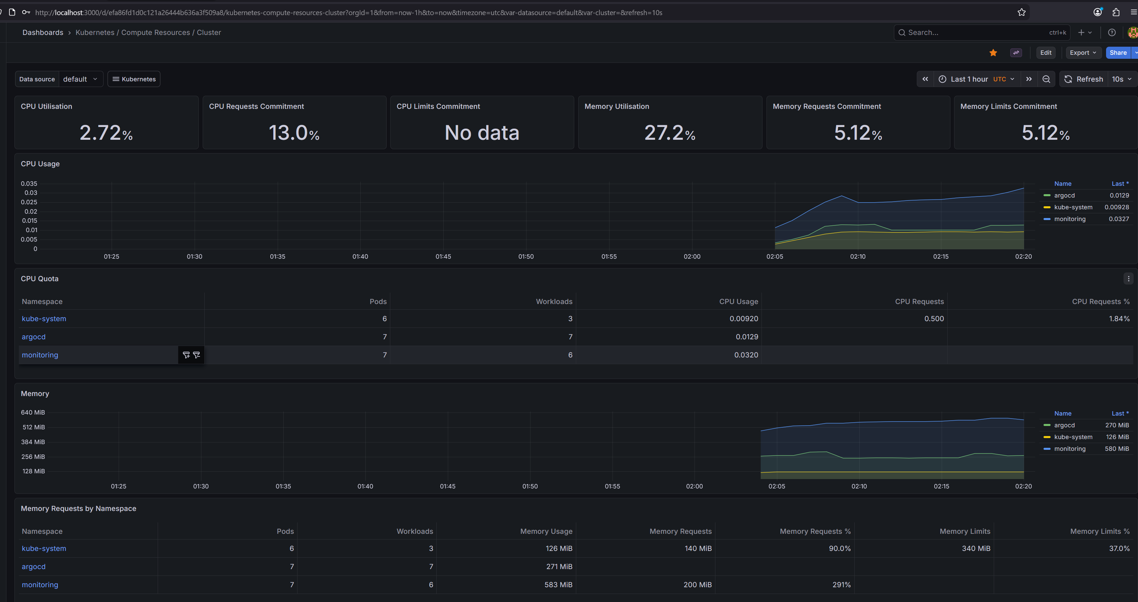
Phase 9 – Frontend ingress address
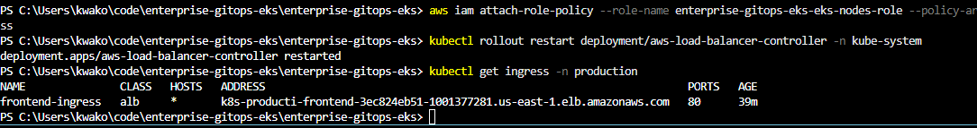

Phase 10 – Version 1 blue app is live (I wrote this html don’t laugh)
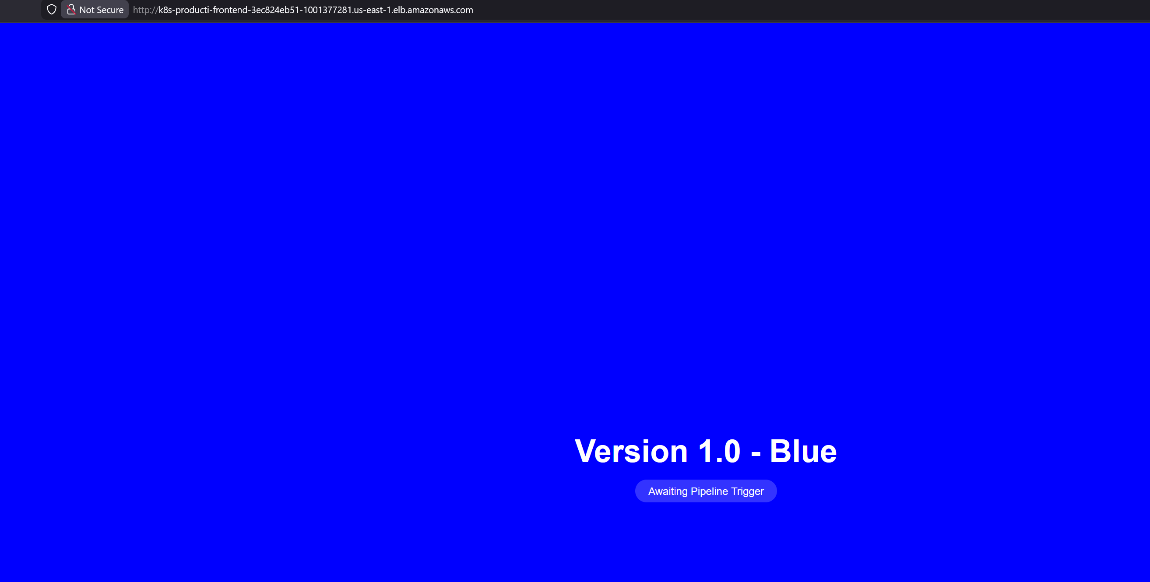

Phase 11 – Final Product
