**Spring 2024: CS5720**

**Neural Networks & Deep Learning - ICP-1**

NAME: PRIYANKA

STUDENT_ID:700756568

GITHUB LINK: [Nayudupriyanka/Neural-Networks (github.com)](https://github.com/Nayudupriyanka/Neural-Networks)

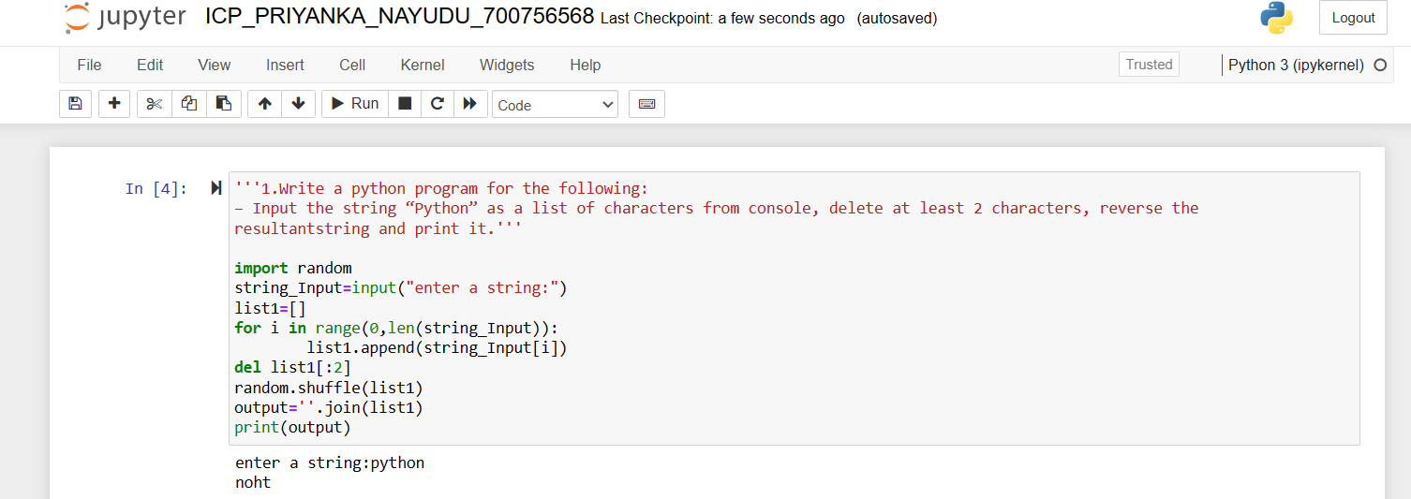

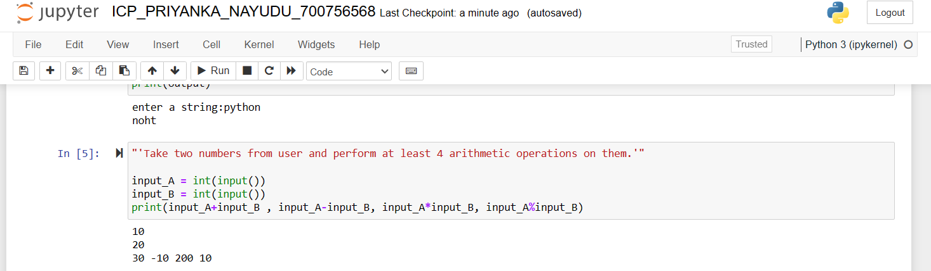

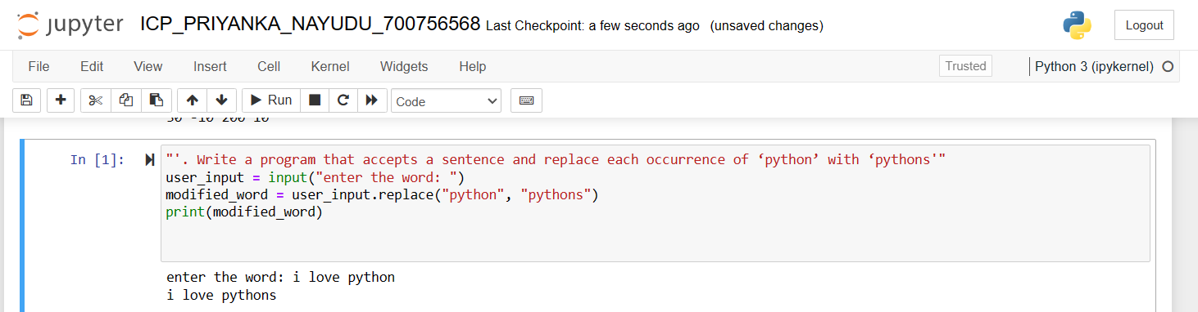

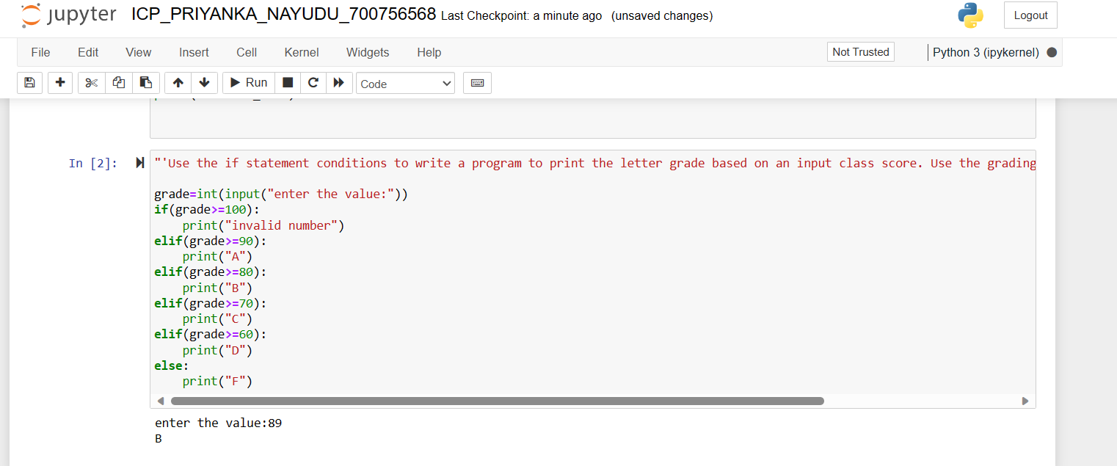

OUTPUT:







