Hello!

This is a README for my application Todo, using Flask and Mongodb.

This app is made to let you add, delete and update the status of any kind of task you want.

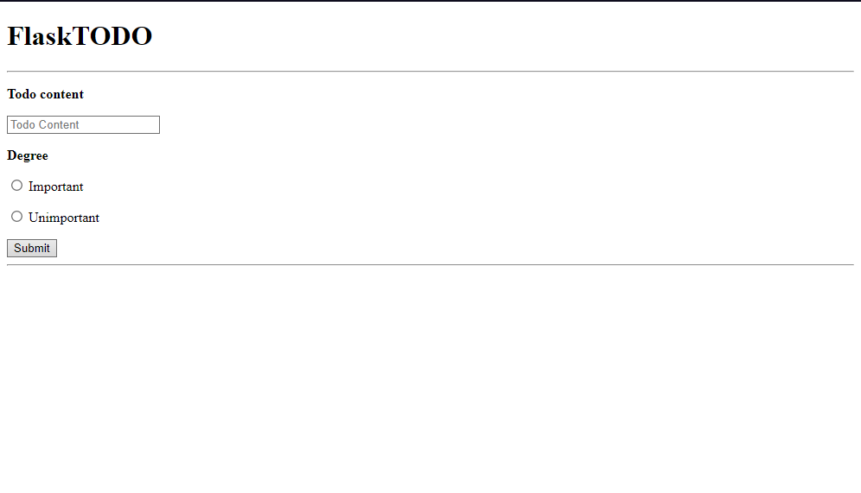

Here is where the submitted tasks will appear

Form to establish the task’s degree

Form to name the task

*The TODO app and its different sections of its UI*

Each task has two fields: their content, which is a string the user determines before submitting it, and their degree, which is also a string determined by either the radio button the user decides to check before submitting it, or the “Done” button (see the next part).

Once we have submitted a task, it will appear under the submitting form, like this:

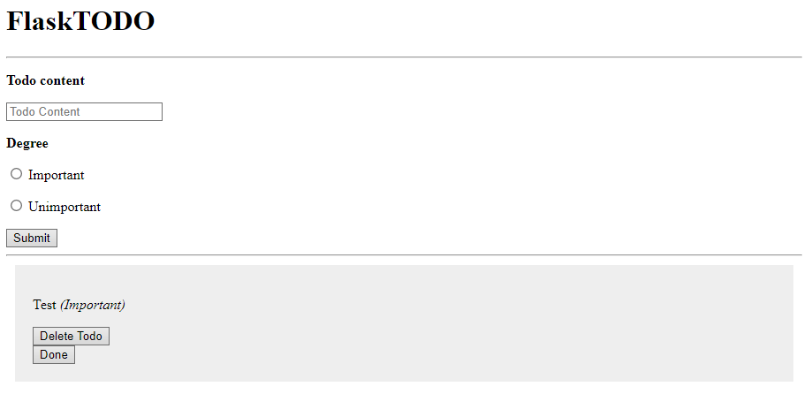

*The “Test” task displayed under the form*

As this screenshot shows, a submitted task comes with two different buttons:

-If the task is done but keeping it in the list is important, the “Done” button will update its degree with “Done”,

-If the task is done and the user wants to delete it, the “Delete Todo” button will delete the task from the collection, making it disappear from the list.

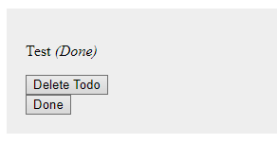

*The “Test” task after a click of the “Done” button*