🎓
AI CAMPUS ASSISTANT SYSTEM
Complete Project Report and Assignment No. 03
Smart Campus Management Platform with AI Integration

Technology | ASP.NET Core 8 MVC
Database | MongoDB 6+
AI Engine | Groq API — Llama 3.3 70B
Authentication | Cookie-based + BCrypt
Deployment | Docker + Docker Compose

1. Executive Summary
The AI Campus Assistant System is a full-stack, cloud-ready university management platform that integrates artificial intelligence directly into campus operations. Built with ASP.NET Core 8 MVC, MongoDB, and the Groq AI API (Llama 3.3 70B), the system provides three distinct role-based portals — Admin, Teacher, and Student — each with a dedicated feature set tailored to their daily responsibilities.

The platform eliminates manual, paper-based workflows by digitising academic management across departments: course scheduling, lecture delivery, assignment handling, grading, attendance tracking, fee management, and student complaints are all centralised in one secure, responsive web application. The integrated AI chatbot responds in both Urdu and English, making it accessible to a Pakistani university audience.

Key highlights:
- Three role-based dashboards (Admin, Teacher, Student) with RBAC enforced at every endpoint
- Groq-powered AI chatbot for students, AI teaching suggestions for teachers, and AI monitoring for admins
- Complete academic lifecycle: from course creation through grading and printable result cards
- Secure cookie-based authentication with BCrypt password hashing and CSRF protection
- Docker Compose deployment with auto-seeded MongoDB — zero manual setup

2. Project Overview

2.1 Problem Statement
Traditional university management systems rely on fragmented, manual processes: paper attendance, spreadsheet grades, in-person fee collection, and email-based communication. These inefficiencies create data silos, slow administrative response times, and leave students without real-time visibility into their academic progress.

The AI Campus Assistant System addresses these challenges with a unified digital platform that automates routine tasks, centralises institutional data, and introduces AI-powered assistance for students and teachers alike.

2.2 Objectives
- Provide a unified web-based platform for all campus stakeholders
- Digitise academic workflows: courses, lectures, assignments, grades, attendance
- Automate fee management with payment proof verification
- Enable real-time AI assistance in Urdu and English for students
- Give teachers AI-generated teaching improvement recommendations
- Allow administrators to monitor AI usage and manage all system entities
- Ensure secure, role-based access control throughout the entire application
- Enable containerised deployment for easy scalability and portability

2.3 Scope
The system covers the full academic lifecycle of a university semester, from initial course setup through final grade submission and result card generation. It includes communication tools (notifications, complaints) and financial management (fees, challans, payment verification), but does not include live video classes, external payment gateways, or mobile-native applications.

3. System Architecture

3.1 Architecture Pattern
The system follows the MVC (Model-View-Controller) architectural pattern on ASP.NET Core 8, providing a clean separation between data models, business logic, and the user interface. The persistence layer uses MongoDB, accessed through a singleton MongoDbContext and scoped MongoDbService, keeping all database operations out of controllers.

3.2 Layer Overview
Layer | Component | Responsibility
Presentation | Razor Views (.cshtml) | HTML rendering, Bootstrap 5 UI, form submission
Controller | AdminController, TeacherController, StudentController, AuthController | Route handling, input validation, ViewBag population
Service | MongoDbService, AuthService, GroqAiService, SeedDataService | Business logic, DB queries, AI API calls, data seeding
Data | MongoDbContext | MongoDB collections, index creation, connection management
Model | 17 C# model classes | Data shapes, BSON serialisation attributes, computed properties
External | Groq API (cloud) | LLM inference — Llama 3.3 70B Versatile

3.3 Authentication & Security
Authentication is implemented using ASP.NET Core Cookie Authentication. On successful login, the system issues an HTTP-only sliding-expiry cookie (8-hour session). Passwords are never stored in plaintext — BCrypt.Net (work factor 12) hashes all passwords at registration and during validation.

Security Measure | Implementation
Password hashing | BCrypt.Net-Next v4 — work factor 12
Session tokens | HTTP-only, SameSite=Lax, 8-hour sliding expiry
Role enforcement | [Authorize(Roles = "admin/teacher/student")] on all controllers
CSRF protection | [ValidateAntiForgeryToken] on all POST endpoints
API key storage | appsettings.json / .NET User Secrets / environment variables
File uploads | Allowed extension whitelist, unique filename generation

3.4 Dependency Injection Configuration
All services are registered in Program.cs with appropriate lifetimes:
- Singleton: MongoDbContext (one shared MongoDB connection pool per application)
- Scoped: MongoDbService, AuthService, GroqAiService, SeedDataService (per HTTP request)
- HttpClient: Registered via IHttpClientFactory for Groq API calls

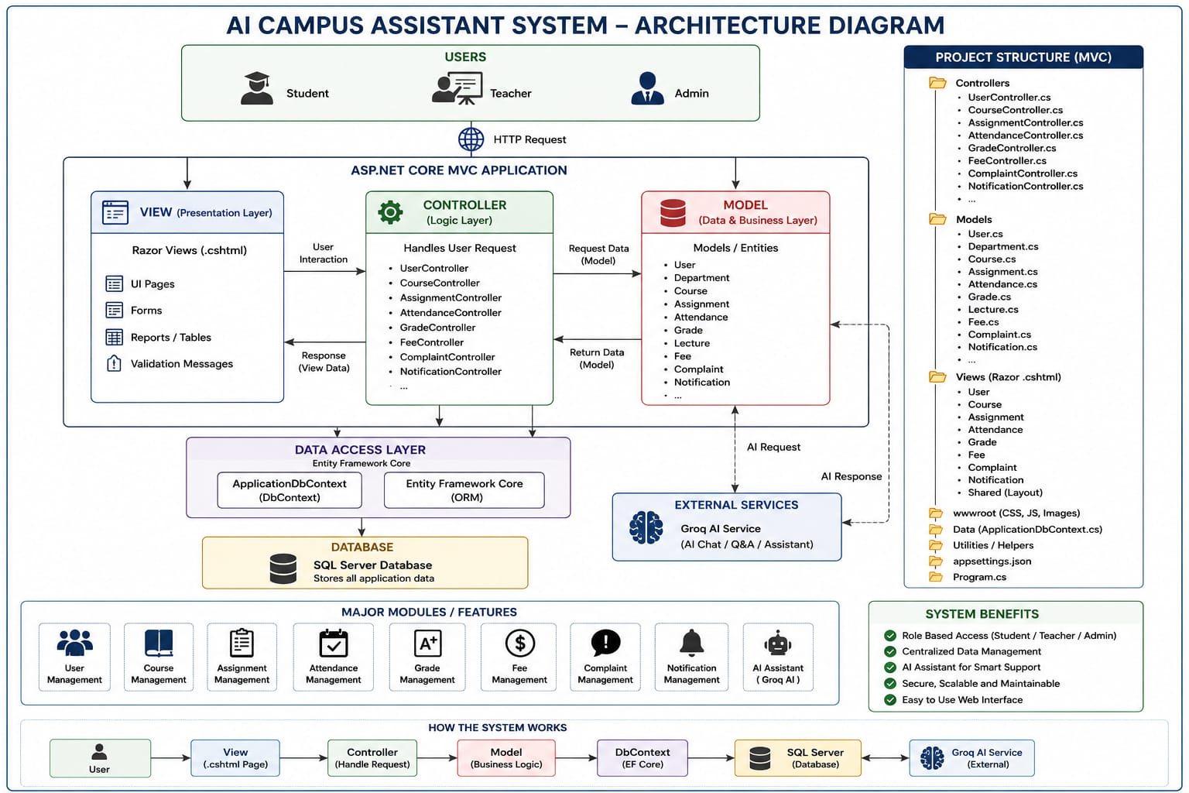

ER Diagram:

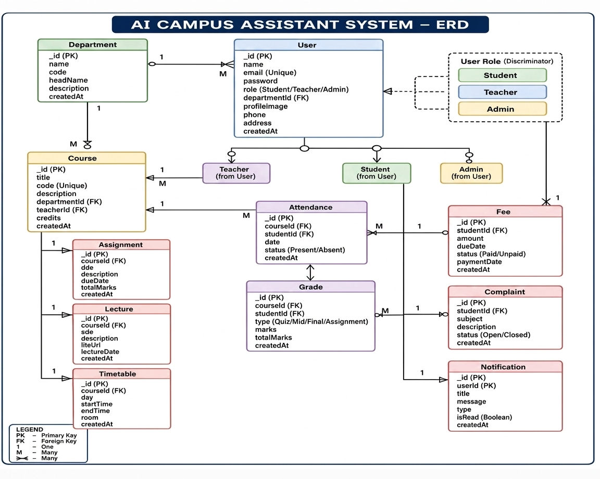

4. Technology Stack
Category | Technology | Version | Purpose
Backend Framework | ASP.NET Core MVC | 8.0 | Web framework, routing, middleware pipeline
Database | MongoDB | 6+ | NoSQL document store for all collections
MongoDB Driver | MongoDB.Driver | 3.9 | .NET SDK for MongoDB operations
AI / LLM | Groq API (Llama 3.3 70B) | Versatile | AI chat, teaching suggestions, content gen
Auth | Microsoft.AspNetCore.Authentication.Cookies | 8.0 | Session management, claims principal
Password Hashing | BCrypt.Net-Next | 4.0.3 | Secure password storage at bcrypt cost 12
Frontend | Bootstrap 5 + jQuery | 5.3 | Responsive UI, form validation, AJAX calls
Containerisation | Docker + Docker Compose | Latest | Multi-service orchestration
Runtime | .NET | 8.0 LTS | Cross-platform application runtime

5. Database Design

5.1 MongoDB Collections
The system uses 16 MongoDB collections stored in a database named AICampusDb. All primary keys use MongoDB's ObjectId (BSON) type, represented as strings in C#. The MongoDbContext creates compound indexes on startup for the most common query patterns.

Collection | Key Fields | Indexes | Purpose
Users | Id, Email, Role, DepartmentId | Unique on Email | All users — admin, teacher, student
Courses | Id, TeacherId, DepartmentId | Ascending TeacherId | Course definitions and assignments
Departments | Id, Name, HeadId | — | University departments
Timetables | Id, CourseId, TeacherId | — | Weekly class schedules
Lectures | Id, CourseId, Program, SemesterNo | Compound: CourseId + Program | Uploaded lecture materials
Assignments | Id, CourseId, TeacherId | — | Assignment definitions
AssignmentSubmissions | Id, AssignmentId, StudentId | — | Student submissions + grades
Attendances | Id, StudentId, CourseId, Date | Compound: StudentId + CourseId | Per-session attendance records
Grades | Id, StudentId, CourseId | Compound: StudentId + CourseId | Mid + Final + Assignment marks
fees | Id, FeeId, StudentId | Unique on FeeId (sparse) | Fee records per student/semester
feeRequests | Id, StudentId | — | Student fee queries
Notifications | Id, TargetRole, TargetUserId | — | Broadcast & targeted messages
Complaints | Id, UserId | — | Student complaints + admin replies
ChatQueries | Id, UserId | — | AI chat history for monitoring
Faqs | Id, Keywords, Category | — | FAQ entries for AI context
Semesters | Id, SemesterNo | — | Semester metadata

5.2 Grade Calculation Model
Grades are broken down into three weighted components that sum to 100 marks:

Component | Max Marks | Weight | Field
Mid-Term Exam | 30 | 30% | MidMarks
Final Exam | 50 | 50% | FinalMarks
Assignment Work | 20 | 20% | AssignmentMarks
Total | 100 | 100% | TotalMarks (computed)

Letter grades are auto-assigned: A+ (95–100), A (90–94), B+ (85–89), B (80–84), C (70–79), D (60–69), F (below 60).

6. Modules & Features

6.1 Authentication Module
The AuthController handles all login, registration, and logout operations. The default route is /Auth/Login, meaning unauthenticated users are always redirected to the login page first. After authentication, role-based redirect sends users to their respective dashboards.

- Login: email + password validation, BCrypt hash comparison, cookie issuance
- Register: password confirmation, minimum length check, unique email enforcement
- Logout: cookie invalidation via SignOutAsync
- Access denied: separate view for unauthorised role attempts

6.2 Admin Module
The AdminController is protected with [Authorize(Roles = "admin")] and contains the most comprehensive feature set. The dashboard uses Task.WhenAll() to run 11 database queries in parallel, ensuring fast load times even as data grows.

Feature | Endpoint | Description
Dashboard | /Admin/Dashboard | Live stats: student/teacher count, courses, complaints, fees
User Management | /Admin/Users, /CreateUser, /EditUser | CRUD for admin/teacher/student accounts; activate/deactivate
Departments | /Admin/Departments | Create and manage university departments
Courses | /Admin/Courses, /CreateCourse | Create courses, assign teachers, set program/semester
Timetable | /Admin/Timetable, /CreateTimetable | Schedule classes by day, time slot, room, program
Fee Management | /Admin/Fees, /CreateFee, /VerifyFee | Create fee records; review payment proofs; approve/reject
Fee Requests | /Admin/FeeRequests | Review and resolve student fee queries
Grades View | /Admin/Grades | Read-only view of all student grades system-wide
Result Card | /Admin/ResultCard/{id} | Print full semester result card for any student
Notifications | /Admin/Notifications, /CreateNotification | Broadcast to all/students/teachers or target one user
Complaints | /Admin/Complaints, /ResolveComplaint | View, respond to, and resolve student complaints
FAQs | /Admin/Faqs, /CreateFaq | Manage FAQ knowledge base used by AI chatbot
AI Monitor | /Admin/AiMonitor | Today's chat count, recent AI queries from all users

6.3 Teacher Module
The TeacherController is scoped to authenticated teachers. It retrieves data filtered to the logged-in teacher's courses and students, ensuring data isolation between faculty members.

Feature | Description
Dashboard | My courses, total assignments, lectures, upcoming timetable slots, notifications
Courses | View courses assigned by admin; course details and enrolled student count
Lectures | Upload PDF/DOCX/PPTX/XLSX lecture files per course and week number
Assignments | Create assignments with file attachments and due dates; manage active/inactive status
Grade Submissions | Review student assignment submissions; assign marks and written feedback
Grade Students | Enter Mid-Term, Final, and Assignment marks; auto-computed letter grade
Attendance | Mark present/absent/late per student per course per day; add optional remarks
Attendance Report | View per-student attendance percentage across all sessions recorded
Timetable | Personal teaching schedule filtered by teacherId
Notifications | Send announcements to enrolled students
AI Chat | Ask the campus AI assistant course-related or general questions
AI Suggestions | Generate 3–4 teaching improvement tips based on attendance and grade analytics
Content Generator | AI-generated quiz or assignment question sets for a selected course
Profile | Update name, phone, designation, and biography

6.4 Student Module
The StudentController provides students with a read-oriented portal to access their academic records, submit assignments, pay fees, communicate with administration, and interact with the AI chatbot.

Feature | Description
Dashboard | Semester overview: grades, attendance %, upcoming deadlines, fee status, notifications
Lectures | Browse and download lecture materials for enrolled program/semester
Assignments | View active assignments, download question files, submit work before deadline
Attendance | Per-course attendance records with present/absent/late status
Grades | Mid, Final, Assignment marks and letter grades per course
Result Card | Printable full-semester academic transcript
Timetable | Weekly class schedule for enrolled program/semester
Fee Management | View fee challan, check payment status, upload payment proof
Fee Challan | Download/print formatted fee challan with all applicable charges
Notifications | All announcements from admin and teachers (broadcast + targeted)
Complaints | Submit complaints with subject/description; track resolution status
Profile | Update personal contact information and biography
AI Chat | Bilingual (Urdu/English) campus AI assistant — queries logged for admin review

7. AI Integration

7.1 Groq API Overview
The system uses the Groq API with the llama-3.3-70b-versatile model for all AI features. Groq's inference hardware delivers significantly lower latency than comparable cloud LLM providers, making it suitable for real-time chat responses. The free tier is sufficient for typical university usage volumes.

Property | Value
API Endpoint | https://api.groq.com/openai/v1/chat/completions
Model | llama-3.3-70b-versatile
Max Tokens | 1,024 per response
Request Auth | Bearer token (GroqApiKey from configuration)
Fallback | Returns config instructions if API key is missing

7.2 AI Features
Student AI Chat (AskAsync)
Students can ask any academic or campus-related question. The system prompt identifies the AI as the university's campus assistant and instructs it to respond in the same language the user uses — automatically switching between Urdu and English. Optional FAQ context can be appended to enrich responses with institution-specific knowledge.

Teacher AI Suggestions (GetTeachingSuggestionsAsync)
Teachers can request AI-generated teaching improvement suggestions for any of their courses. The system sends the course name, total enrolled students, average attendance percentage, and average grade score to the AI, which returns 3–4 numbered, actionable recommendations in under 150 words.

Teacher Content Generator
A dedicated endpoint allows teachers to generate quiz questions, assignment prompts, or discussion topics for a selected course using the AI. Responses are formatted as structured question sets ready for classroom use.

Admin AI Monitor
The admin dashboard includes an AI usage monitor showing today's total chat query count and the most recent queries from all users across the system, enabling oversight of AI-assisted interactions.

7.3 AI Data Flow
- User submits question via the chat form (POST to /Student/AiChat or /Teacher/AiSuggestions)
- Controller calls GroqAiService.AskAsync(question, context)
- Service builds system prompt + user message payload
- HTTP POST to Groq API with Bearer token authentication
- Response parsed from choices[0].message.content
- ChatQuery record saved to MongoDB for admin monitoring
- AI answer returned to the view and displayed to the user

8. Project Structure

8.1 Solution Layout
Path | Contents
Controllers/ | AdminController.cs (~605 lines), AuthController.cs, StudentController.cs, TeacherController.cs
Data/ | MongoDbContext.cs (collections + indexes), SeedData.cs (initial test data)
Models/ | 17 C# model classes: User, Course, Department, Semester, Timetable, Attendance, Assignment, AssignmentSubmission, Lecture, Grade, Fee, FeeRequest, Notification, ChatQuery, FAQ, Complaint, ResultCard
Services/ | MongoDbService.cs (all DB queries), AuthService.cs (login/register), GroqAiService.cs (AI), SeedDataService.cs
Views/Admin/ | Dashboard, Users, Courses, Departments, Timetable, Fees, FeeRequests, Grades, ResultCard, Notifications, Complaints, Faqs, AiMonitor
Views/Teacher/ | Dashboard, Courses, Lectures, Assignments, Grades, Attendance, Timetable, Notifications, Profile, AiChat, AiSuggestions, ContentGenerator
Views/Student/ | Dashboard, Lectures, Assignments, Attendance, Grades, ResultCard, Timetable, Fees, FeeChallan, Notifications, Complaints, Profile, AiChat
Views/Shared/ | _LayoutAdmin.cshtml, _LayoutTeacher.cshtml, _LayoutStudent.cshtml, _ViewImports.cshtml
Views/Auth/ | Login.cshtml, Register.cshtml, AccessDenied.cshtml
wwwroot/uploads/ | assignments/, submissions/, lectures/, payment-proofs/ (runtime file storage)
Scripts/ | mongo-init.js (Docker MongoDB init), seed-faq.js (FAQ seed data)
Program.cs | DI registration, authentication setup, middleware pipeline, startup seed
appsettings.json | MongoDbSettings (connection string + DB name), GroqApiKey
Dockerfile | Multi-stage build — dotnet restore → publish → runtime image
docker-compose.yml | Two services: app (port 5000) + mongo (port 27017)

8.2 Key Service Methods
MongoDbService encapsulates all database operations. Notable methods grouped by domain:

- Users: GetAllUsersAsync, GetUserByIdAsync, CountUsersByRoleAsync, CreateUserAsync, UpdateUserAsync
- Courses: GetAllCoursesAsync, GetCoursesByTeacherAsync, GetCourseByIdAsync, CreateCourseAsync
- Grades: GetGradesByStudentAsync, GetGradesByCourseAsync, UpsertGradeAsync
- Attendance: GetAttendanceByStudentAsync, GetAttendanceByCourseAsync, SaveAttendanceAsync
- Fees: GetFeesByStudentAsync, GetAllFeesAsync, CreateFeeAsync, UpdateFeeStatusAsync
- AI: CountTodayChatQueriesAsync, GetAllChatQueriesAsync, SaveChatQueryAsync
9. Outputs Screenshort:

Login Page:

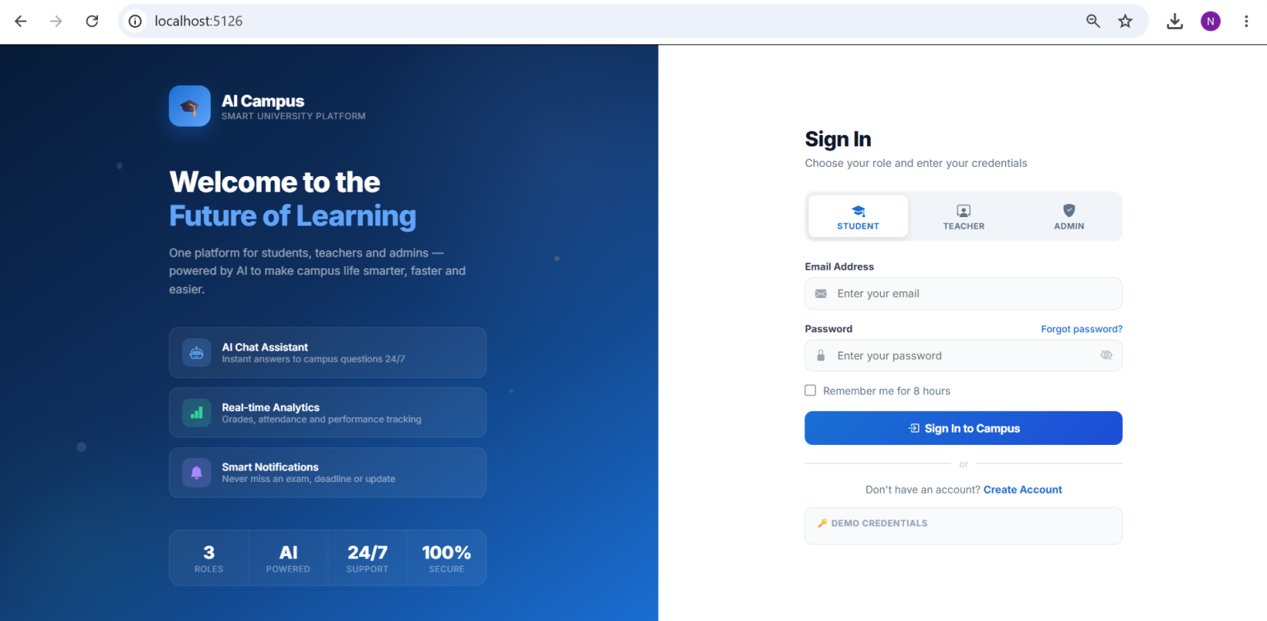

Admin Dashboard:

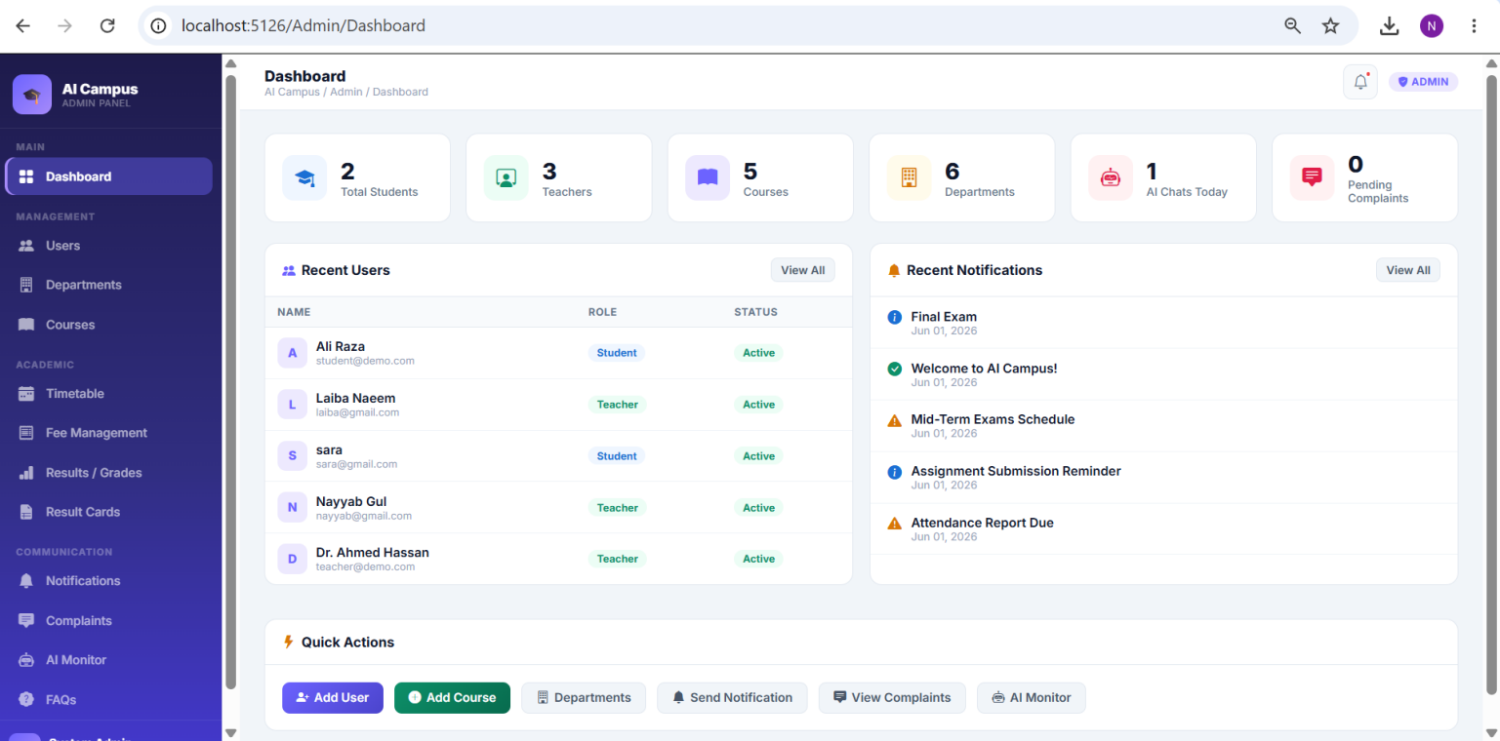

Student Dashboard:

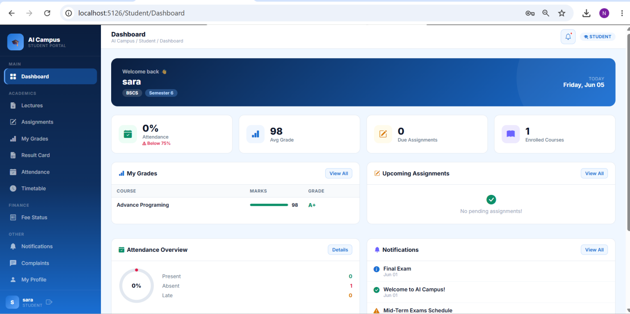

Teacher Admin:

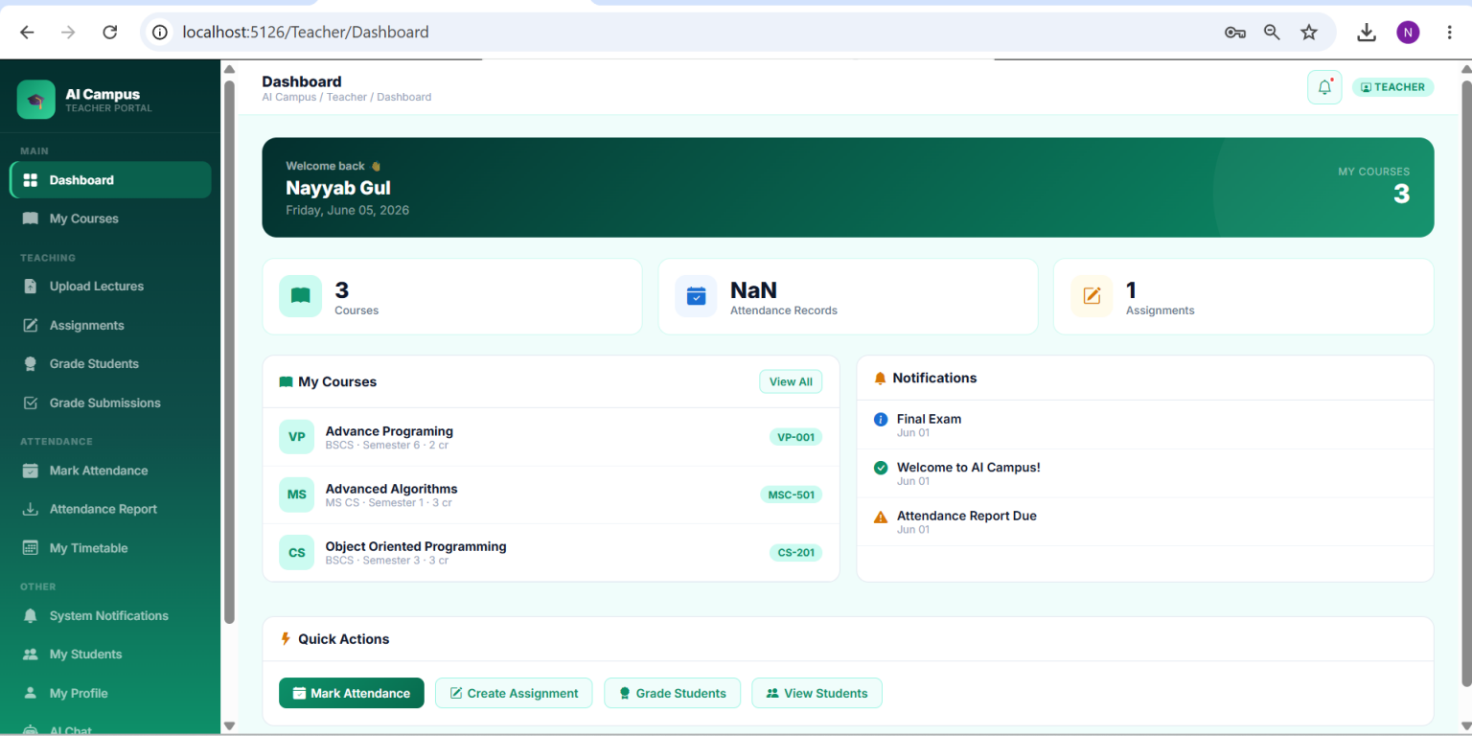

10. Deployment Guide

10.1 Docker Compose (Recommended)
The repository includes a docker-compose.yml that orchestrates two services: the ASP.NET Core application and a MongoDB instance. A mongo-init.js script initialises the database on first startup.

Step | Command / Action
1. Clone project | git clone <repo> && cd AI_Campus_Assistant_System
2. Set API key | Edit appsettings.json → add GroqApiKey: "gsk_..."
3. Start services | docker compose up --build
4. Access app | Open http://localhost:5000 in browser
5. First login | admin@campus.edu / Admin@123

10.2 Local Development
- Prerequisites: .NET 8 SDK, MongoDB 6+ running on port 27017
- Set connection string: MongoDbSettings:ConnectionString in appsettings.json or User Secrets
- Set Groq key: dotnet user-secrets set "GroqApiKey" "your_key"
- Run: dotnet run — app auto-seeds test data and starts on https://localhost:7xxx

10.3 Default Test Accounts

Role | Email | Password | Access Level
Admin | admin@campus.edu | Admin@123 | Full system access — all modules
Teacher | teacher@campus.edu | Teacher@123 | Course, grade, attendance, AI features
Student | student@campus.edu | Student@123 | Read access, submissions, AI chat, fees

Note: Change all default credentials immediately before deploying to a production or shared environment.

10.4 Environment Variables
For production deployment, pass secrets via environment variables rather than appsettings.json:
- GroqApiKey — Groq API secret key
- MongoDbSettings__ConnectionString — MongoDB connection string
- MongoDbSettings__DatabaseName — database name (default: AICampusDb).

11. Security Considerations

11.1 Authentication & Session
- Passwords hashed with BCrypt work factor 12 — each hash takes ~300ms on modern hardware, making brute-force attacks impractical
- Sessions use HTTP-only cookies — inaccessible to JavaScript, mitigating XSS session hijacking
- SlidingExpiration enabled — idle sessions expire after 8 hours automatically
- SecurePolicy set to SameAsRequest — enforces HTTPS cookies in production

11.2 CSRF Protection
Every form POST in the application includes an ASP.NET Core anti-forgery token. The [ValidateAntiForgeryToken] attribute on all POST controller actions rejects requests that do not supply a valid token, protecting against cross-site request forgery.

11.3 Authorisation
Role-based access control is enforced at the controller level using the [Authorize(Roles = "role")] attribute. A student accessing /Admin/Dashboard receives an HTTP 403 and is redirected to /Auth/AccessDenied. There is no client-side-only gate — all access decisions are made server-side.

11.4 File Upload Security
File uploads (lectures, assignments, submissions, payment proofs) are validated server-side against an allowed extension list (.pdf, .docx, .doc, .pptx, .ppt, .xlsx, .xls for academic files). Uploaded files are stored with GUID-based unique filenames to prevent directory traversal and filename collision attacks.

11.5 API Key Management
The Groq API key should never be committed to version control. The recommended approach is .NET User Secrets for development and environment variables for staging/production. The appsettings.json in the repository should contain only a placeholder value.

12. Testing & Troubleshooting

12.1 Common Issues
Issue | Cause | Resolution
App fails to start — MongoDB error | MongoDB not running or wrong connection string | Start MongoDB or update appsettings.json → MongoDbSettings:ConnectionString
AI chat returns 'not configured' | GroqApiKey missing or empty | Add key to appsettings.json or set as environment variable
Seed warning on startup | Data already exists — non-fatal | Safe to ignore; check console for ✅ Database seeded successfully
File upload fails | wwwroot/uploads/ not writable | Ensure app process has write permission; Docker handles this automatically
Port 5000 conflict | Another service using port 5000 | Change port mapping in docker-compose.yml
Login loop / access denied | Stale cookie or role mismatch | Clear browser cookies, restart app, verify role in Users collection
Grades not showing on result card | No grade record inserted for student+course | Teacher must enter grades via Teacher → Grade Students first

12.2 Log Locations
- Application logs: stdout (captured by Docker) — includes seed status, middleware errors
- MongoDB logs: docker logs <mongo_container_name>
- AI error details: returned inline in the chat response for debugging

13. Future Enhancements

13.1 Short-Term (Next Semester)
- Mobile-responsive PWA with push notifications for assignment deadlines
- Online payment gateway integration (JazzCash / EasyPaisa) for fee payments
- Email/SMS notifications via SendGrid or Twilio
- Multi-language UI toggle (Urdu interface for admin portal)
- Bulk import of students and courses via Excel/CSV upload

13.2 Medium-Term
- AI-powered plagiarism detection on assignment submissions
- Video lecture upload and streaming (AWS S3 / Azure Blob Storage)
- Parent/guardian portal with read-only access to student records
- Advanced analytics dashboard with charts: attendance trends, grade distributions, fee collection rates
- REST API layer for future mobile app integration

13.3 Long-Term
- Native Android/iOS mobile application
- Integration with biometric attendance hardware
- AI-generated personalised study plans based on grade analytics
- Multi-tenant architecture to support multiple university branches

14. Appendices

Appendix A — NuGet Package References
Package | Version | Purpose
MongoDB.Driver | 3.9.0 | MongoDB .NET SDK — all database operations
BCrypt.Net-Next | 4.0.3 | Password hashing with bcrypt algorithm
Microsoft.AspNetCore.Authentication.Cookies | 8.0 | Cookie-based session authentication
Microsoft.AspNetCore.Session | 8.0 | Server-side session middleware
Microsoft.Extensions.Http | 8.0 | IHttpClientFactory for Groq API calls

Appendix B — Groq API Free Tier Limits
As of mid-2025, the Groq free tier includes: 30 requests/minute, 6,000 requests/day, 500,000 tokens/day for Llama 3.3 70B. For a typical university with hundreds of daily active students, a paid plan or token caching strategy may be necessary in production.

Appendix C — MongoDB Collection Sizes (Estimated)
Collection | Estimated Records (500 students, 1 semester)
Users | ~520 (500 students + 15 teachers + 5 admins)
Courses | ~30–50 courses per semester
Attendances | ~30,000 (500 students × 30 courses × 2 sessions/week × 16 weeks ÷ 30 per course)
Grades | ~15,000 (500 students × 30 courses)
Assignments | ~90–150 (3 per course)
AssignmentSubmissions | ~75,000 (500 students × 150 assignments)
ChatQueries | Grows with AI usage — recommend monthly archiving

15. References
ASP.NET Core Documentation
https://docs.microsoft.com/aspnet/core⁠
Entity Framework Core
https://docs.microsoft.com/ef/core⁠
ML.NET Documentation
https://docs.microsoft.com/dotnet/machine-learning⁠
Azure Cognitive Services
https://azure.microsoft.com/services/cognitive-services⁠
ASP.NET Core SignalR
https://docs.microsoft.com/aspnet/core/signalr⁠
Groq AI (Llama 3.3 70B)
https://console.groq.com⁠

