PROJECT PROPOSAL

AI Smart Campus Assistant System
ASP.NET Core | MongoDB | Docker

Submitted To: Sir Uzair Hassan  Department of Computer Science | Session: 2023–2027  Date:11 May 2025
Group Members

Laiba Naeem (232201058) | Nayyab Gul (232201085)

1. Project Overview

The AI Smart Campus Assistant System is a comprehensive web-based platform designed to modernize and automate the academic environment of a university. The system leverages Artificial Intelligence to handle student queries, manage academic records, and streamline communication between students, teachers, and administrators — all within a single unified interface.
The platform is built using ASP.NET Core for the backend, MongoDB as the primary NoSQL database, and Docker for containerized deployment. This architecture ensures scalability, flexibility, and ease of deployment across different environments.
2. Objectives

- Provide AI-powered assistance to students for instant resolution of campus-related queries
- Automate repetitive academic operations such as fee inquiries, exam schedules, and timetable access
- Improve real-time communication between students, teachers, and administrative staff
- Centralize all academic data including courses, attendance, grades, and assignments in MongoDB
- Deploy the entire system in Docker containers for a consistent and portable environment
- Deliver a modern, scalable, and maintainable software system following best practices
3. Technology Stack

Component | Technology / Tool
Frontend / Backend | ASP.NET Core (MVC Web Application)
Database | MongoDB (NoSQL — all data stored here, no SQL Server)
Containerization | Docker (Web App + MongoDB containers)
AI Module | Rule-based Chatbot with MongoDB FAQ Knowledge Base
Version Control | Git / GitHub
IDE / Tools | Visual Studio 2022, MongoDB Compass, Postman

4. System Architecture Diagram

The diagram below shows how all three user roles, system modules, AI assistant, database, and deployment infrastructure connect together at a glance.

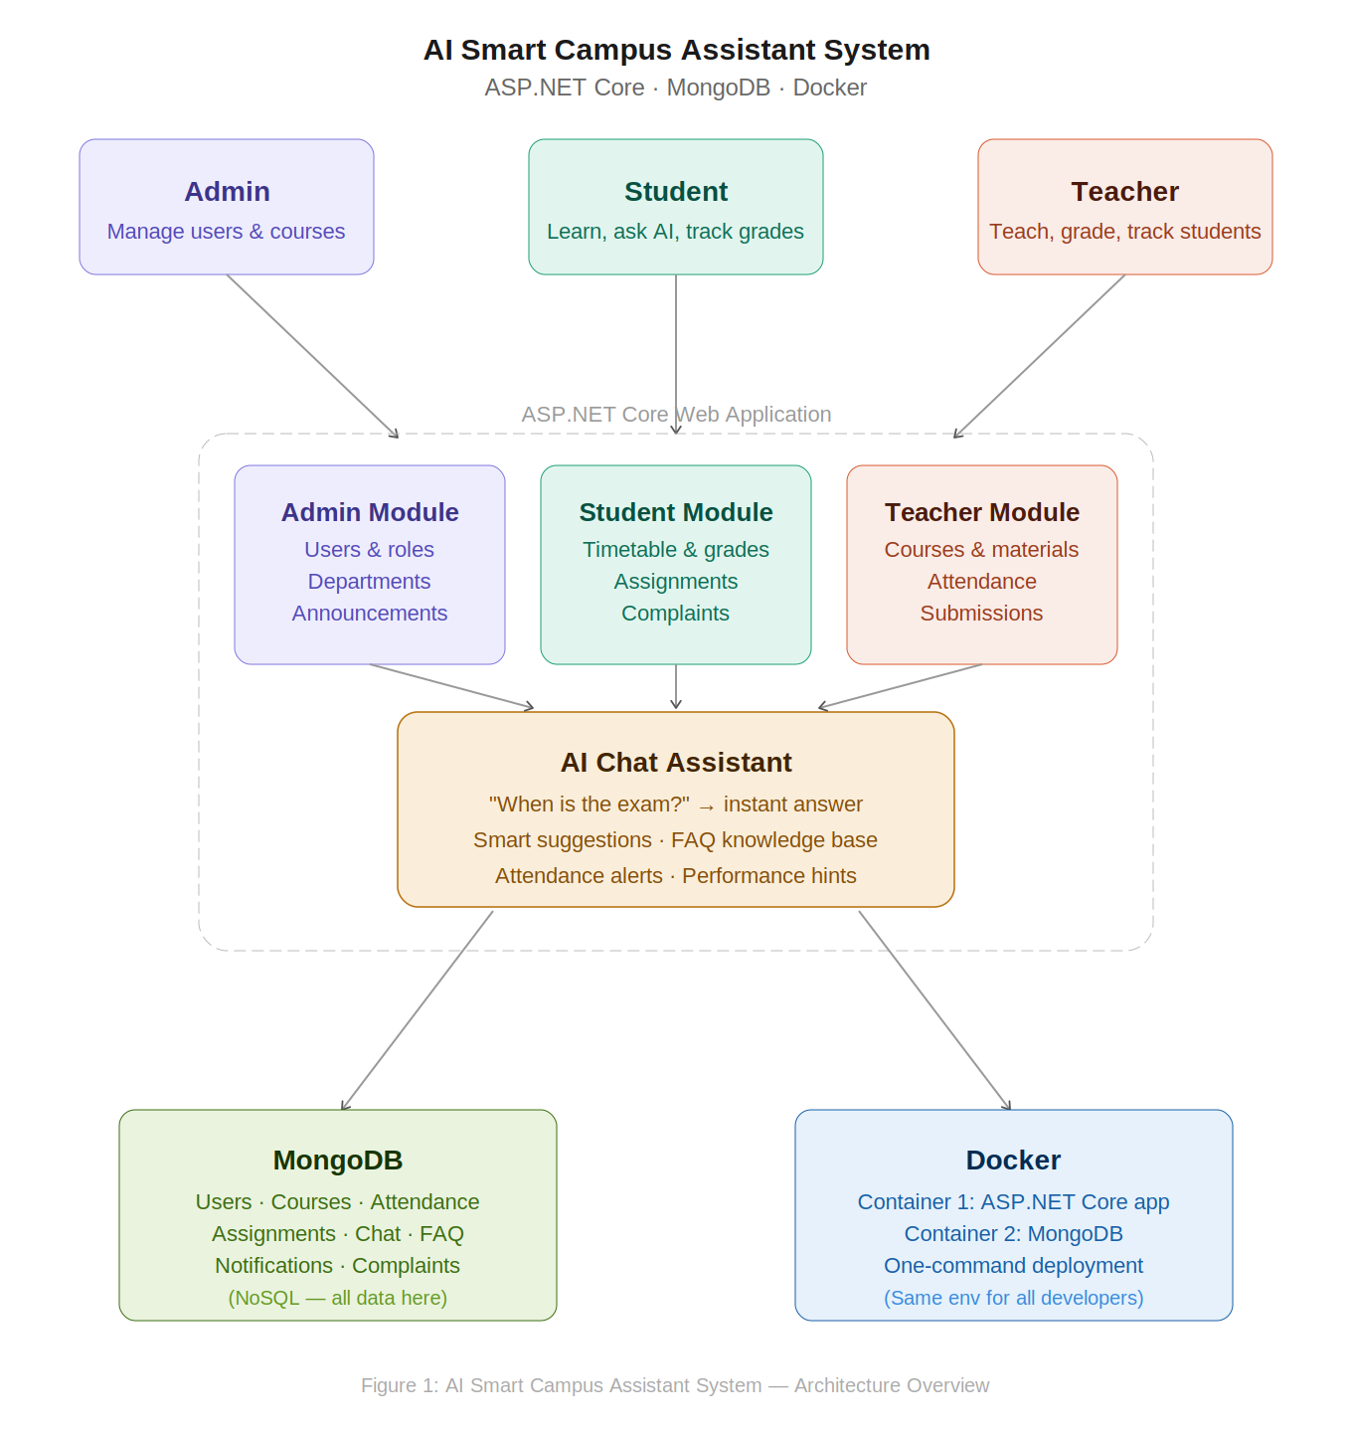

Figure 1: AI Smart Campus Assistant System — Architecture Overview

5. System Modules & Work Distribution

The system is divided into three core modules, each developed by one group member. All modules share a centralized MongoDB database.

Module 1 — Admin Module
- User Management: Add, update, and delete student and teacher accounts; assign roles
- Academic Management: Create departments, define courses, and assign teachers to courses
- Dashboard: Overview of total users, courses, and recent system activity
- Notification System: Send exam alerts, fee reminders, and general announcements
- AI Monitoring: Review student queries submitted to the chatbot and track FAQ trends

Module 2 — Student Module
- Authentication: Secure registration, login, and profile management
- Student Dashboard: View personal timetable, attendance record, and enrolled courses
- AI Chat Assistant (Main Feature): Ask campus questions and receive instant AI-powered responses (e.g., 'When is the exam?', 'What is the fee deadline?')
- Academic Tools: View assignments, download lecture materials, check grades
- Notifications: Receive deadline reminders and exam alerts
- Complaint System: Submit issues and track complaint status in real time

Module 3 — Teacher Module
- Course Management: View and manage assigned courses; upload lecture materials
- Assignment System: Create assignments, review and grade student submissions
- Attendance Management: Mark daily attendance and generate attendance reports
- Student Monitoring: Track individual student performance and identify at-risk students
- AI Assistance: Receive smart quiz suggestions and teaching recommendations
6. AI System Features

AI Feature | Description
Chatbot System | Answers student queries using predefined responses and FAQ data stored in MongoDB
Smart Suggestions | Recommends study materials and courses based on student performance
Smart Insights | Generates attendance alerts and academic performance hints for students
Query Tracking | Logs all student questions to help admin identify knowledge gaps and improve FAQs
7. Database Design (MongoDB Collections)

All application data is stored exclusively in MongoDB. No SQL Server is used. The following collections form the core database schema:

Collection | Key Fields / Purpose
Users | userId, name, email, passwordHash, role (admin/student/teacher), profileData
Courses | courseId, title, departmentId, teacherId, schedule, description
Attendance | attendanceId, studentId, courseId, date, status (present/absent)
Assignments | assignmentId, courseId, title, dueDate, submissions[]
Notifications | notifId, targetRole, message, type (alert/reminder), createdAt
Chat / AI Queries | queryId, studentId, question, response, timestamp
FAQ | faqId, keyword[], answer, category — used as AI knowledge base
Complaints | complaintId, studentId, subject, description, status, resolvedAt

8. Docker Architecture

The application is containerized using Docker with the following two containers:
- Container 1 — Web Application: Hosts the ASP.NET Core application; exposes HTTP/HTTPS ports
- Container 2 — MongoDB Database: Runs the MongoDB instance; linked internally to the web container
Docker ensures that all team members and the deployment server run an identical environment, eliminating 'works on my machine' issues and enabling one-command startup.
9. Expected Outcomes

- Students can access campus information instantly without waiting for human assistance
- Administrative workload is reduced through automation of routine queries and notifications
- Teachers gain powerful tools to monitor student progress and manage course content
- The AI chatbot continuously improves through logged queries and FAQ updates
- The system is production-ready, containerized, and deployable on any cloud or on-premises server
10. Conclusion
The AI Smart Campus Assistant System represents a complete, modern, and intelligent academic management solution. By combining the power of ASP.NET Core, MongoDB, and Docker with an AI-driven chatbot, this project addresses real-world problems faced by universities — from information overload to communication gaps.
The clear three-module division ensures balanced workload distribution among group members while keeping the system cohesive through a shared database and unified architecture. This project is designed to achieve high academic marks through its originality, technical depth, and practical value.

