

Lab Assignment # 02

Distributed Resource Allocation and

Submitted By:

Laiba Naeem (232201058)

Class:
BSCS VI-B

Submitted To:
Ma’am Taskeen

Subject:
Parallel and Distributed Computing Lab

Deadlock Detection using MPI

Apply and develop portable parallel and distributed programs using the Message Passing Interface (MPI)

1. Introduction and Objective
This laboratory assignment implements a distributed resource allocation system using MPI (mpi4py) in Python. The system demonstrates how multiple client processes can request, acquire, hold, and release shared resources managed by a central server process.

1.1 Objectives
- Design a client-server resource allocation model using MPI send/recv primitives.
- Simulate a realistic deadlock scenario involving circular-wait between two client processes.
- Implement the Resource Ordering technique to prevent deadlock from occurring.
- Analyse the performance and scalability limitations of the implemented solution.

M 1.2 Resource Table

Resource | Total Quantity | Role in Deadlock
R1 | 2 (1 in simulation) | Held by Client 1, Wanted by Client 2
R2 | 1 | Held by Client 2, Wanted by Client 1
R3 | 2 | General use; not involved in deadlock

2. Part A — Resource Allocation System (8 Marks)

2.1 Design
Rank 0 is the Resource Manager. All other ranks are Client Processes. Four MPI tags are used: TAG_REQUEST, TAG_RESPONSE, TAG_RELEASE, TAG_DONE.
- Server maintains available resource counts and an allocation map per client.
- Client requests resources, simulates work with time.sleep(), then releases.
- Server processes all messages in a loop until all clients send TAG_DONE.

2.2 Complete Source Code — part_a.py

from mpi4py import MPI
import time
import random

comm = MPI.COMM_WORLD
rank = comm.Get_rank()
size = comm.Get_size()

TAG_REQUEST = 1
TAG_RESPONSE = 2
TAG_RELEASE = 3
TAG_DONE = 4

INITIAL_RESOURCES = {"R1": 2, "R2": 1, "R3": 2}
RESOURCE_NAMES = list(INITIAL_RESOURCES.keys())

def resource_manager():
available = dict(INITIAL_RESOURCES)
allocated = {r: {} for r in RESOURCE_NAMES}
clients = size - 1
done_count = 0
print("\n[Server] Resource Manager started.")
print(f"[Server] Initial resources: {available}\n")
while done_count < clients:
status = MPI.Status()
message = comm.recv(source=MPI.ANY_SOURCE, tag=MPI.ANY_TAG, status=status)
src = status.Get_source()
tag = status.Get_tag()
if tag == TAG_REQUEST:
resource = message
print(f"[Server] Client {src} requesting {resource}")
if available.get(resource, 0) > 0:
available[resource] -= 1
allocated[resource][src] = allocated[resource].get(src, 0) + 1
print(f"[Server] {resource} allocated to Client {src}")
comm.send({"granted": True, "resource": resource}, dest=src, tag=TAG_RESPONSE)
else:
print(f"[Server] {resource} DENIED to Client {src}")
comm.send({"granted": False, "resource": resource}, dest=src, tag=TAG_RESPONSE)
print(f"[Server] Available: {available}")
elif tag == TAG_RELEASE:
resource = message
if allocated[resource].get(src, 0) > 0:
allocated[resource][src] -= 1
available[resource] += 1
print(f"[Server] Client {src} released {resource}")
elif tag == TAG_DONE:
done_count += 1
print(f"[Server] Client {src} finished. ({done_count}/{clients} done)")
print("\n[Server] All clients finished. Final state:", available)

def client_process():
client_id = rank
my_resources = []
requests = random.sample(RESOURCE_NAMES, k=2)
for res in requests:
print(f" [Client {client_id}] Requesting {res}")
comm.send(res, dest=0, tag=TAG_REQUEST)
response = comm.recv(source=0, tag=TAG_RESPONSE)
if response["granted"]:
my_resources.append(res)
print(f" [Client {client_id}] Got {res} - working...")
time.sleep(random.uniform(0.3, 0.8))
else:
print(f" [Client {client_id}] {res} denied")
for res in my_resources:
print(f" [Client {client_id}] Releasing {res}")
comm.send(res, dest=0, tag=TAG_RELEASE)
comm.send(None, dest=0, tag=TAG_DONE)
print(f" [Client {client_id}] Done.")

if rank == 0:
resource_manager()
else:
client_process()

2.3 Run Command

mpiexec -n 4 python part_a.py

2.4 Expected Output

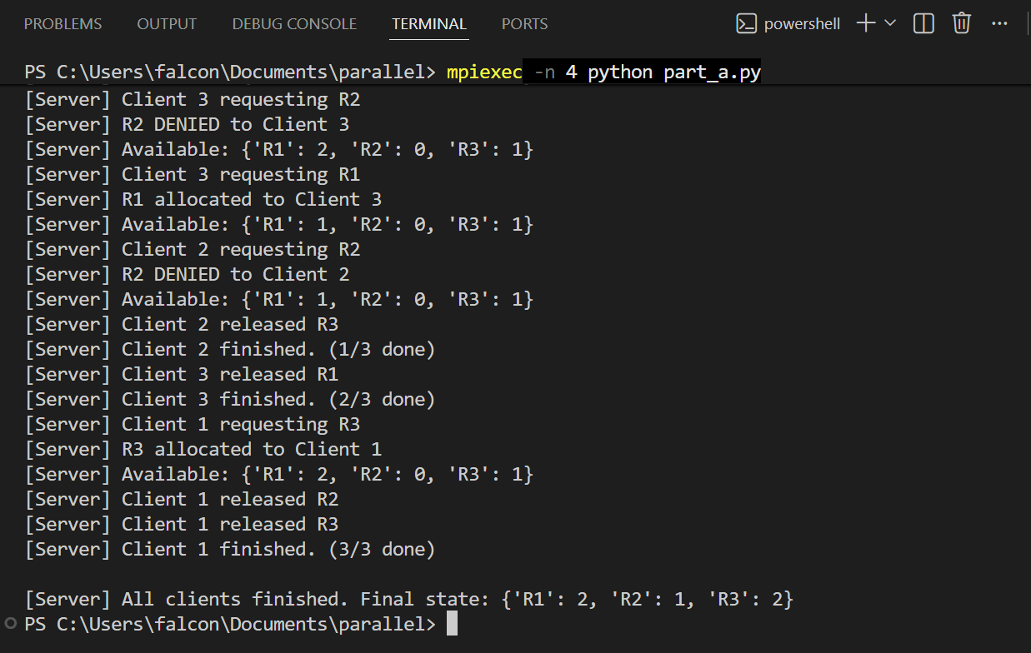

3. Part B — Deadlock Simulation (4 Marks)

3.1 Deadlock Scenario
R1 and R2 are each limited to 1 unit. Client 1 acquires R1 then waits for R2. Client 2 acquires R2 then waits for R1. Neither can proceed — circular wait.
DEADLOCK: C1 holds R1 waits R2 | C2 holds R2 waits R1 => Circular Wait

3.2 Coffman Conditions
Condition | Present? | Evidence
Mutual Exclusion | YES | R1, R2 have only 1 unit each.
Hold and Wait | YES | Client holds one resource while waiting for another.
No Preemption | YES | Server never forcibly reclaims resources.
Circular Wait | YES | C1->R2->C2->R1->C1 cycle.

3.3 Complete Source Code — part_b.py
from mpi4py import MPI
import time

comm = MPI.COMM_WORLD
rank = comm.Get_rank()
size = comm.Get_size()

TAG_REQUEST = 1
TAG_RESPONSE = 2
TAG_RELEASE = 3
TAG_DONE = 4

INITIAL_RESOURCES = {"R1": 1, "R2": 1, "R3": 2}
RESOURCE_NAMES = list(INITIAL_RESOURCES.keys())
DEADLOCK_TIMEOUT = 5

def resource_manager():
available = dict(INITIAL_RESOURCES)
allocated = {r: {} for r in RESOURCE_NAMES}
clients = size - 1
done_count = 0
print("\n[Server] Deadlock Simulation Mode")
print(f"[Server] Resources: {available}\n")
while done_count < clients:
status = MPI.Status()
deadline = time.time() + DEADLOCK_TIMEOUT
received = False
while time.time() < deadline:
if comm.Iprobe(source=MPI.ANY_SOURCE, tag=MPI.ANY_TAG, status=status):
received = True
break
time.sleep(0.1)
if not received:
print("\n[Server] *** POTENTIAL DEADLOCK DETECTED ***")
print(f"[Server] No message for {DEADLOCK_TIMEOUT} seconds.")
print("[Server] Allocation state:")
for r, holders in allocated.items():
if holders:
print(f" {r} held by: {list(holders.keys())}")
print("[Server] C1 holds R1 waiting R2 | C2 holds R2 waiting R1")
break
message = comm.recv(source=status.Get_source(), tag=status.Get_tag(), status=status)
src = status.Get_source()
tag = status.Get_tag()
if tag == TAG_REQUEST:
resource = message
print(f"[Server] Client {src} requesting {resource}")
if available.get(resource, 0) > 0:
available[resource] -= 1
allocated[resource][src] = allocated[resource].get(src, 0) + 1
print(f"[Server] {resource} allocated to Client {src}")
comm.send({"granted": True, "resource": resource}, dest=src, tag=TAG_RESPONSE)
else:
print(f"[Server] {resource} UNAVAILABLE - CLIENT WILL BLOCK")
comm.send({"granted": False, "resource": resource}, dest=src, tag=TAG_RESPONSE)
elif tag == TAG_RELEASE:
resource = message
allocated[resource][src] -= 1
available[resource] += 1
elif tag == TAG_DONE:
done_count += 1

def client_deadlock(hold_first, request_second):
cid = rank
print(f" [Client {cid}] Requesting {hold_first} first...")
comm.send(hold_first, dest=0, tag=TAG_REQUEST)
resp = comm.recv(source=0, tag=TAG_RESPONSE)
if resp["granted"]:
print(f" [Client {cid}] Acquired {hold_first}. Now wants {request_second}...")
time.sleep(0.5)
comm.send(request_second, dest=0, tag=TAG_REQUEST)
resp2 = comm.recv(source=0, tag=TAG_RESPONSE) # BLOCKS -> DEADLOCK
if resp2["granted"]:
time.sleep(0.3)
comm.send(hold_first, dest=0, tag=TAG_RELEASE)
comm.send(request_second, dest=0, tag=TAG_RELEASE)
else:
comm.send(hold_first, dest=0, tag=TAG_RELEASE)
comm.send(None, dest=0, tag=TAG_DONE)

# DEADLOCK: C1 holds R1 wants R2 | C2 holds R2 wants R1
if rank == 0:
resource_manager()
elif rank == 1:
client_deadlock("R1", "R2")
elif rank == 2:
client_deadlock("R2", "R1")

3.4 Run Command

mpiexec -n 3 python part_b.py

3.5 Expected Output

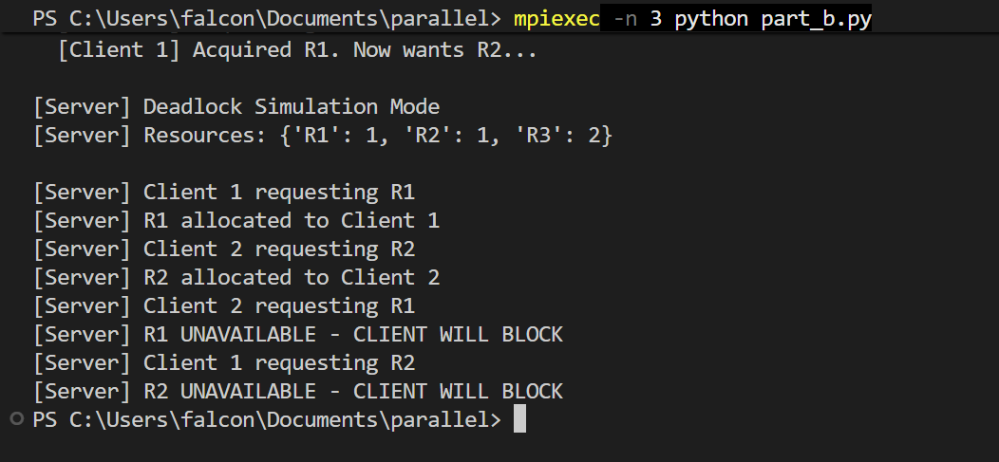

4. Part C — Deadlock Prevention: Resource Ordering

4.1 Strategy
Resources have a strict global numeric order: R1 < R2 < R3. A process may only request a resource with a HIGHER order number than any resource it currently holds. This makes circular wait mathematically impossible.
Rule: order(requested) > order(all held resources) — violation = immediate DENY

4.2 Why This Prevents Deadlock
For a cycle to exist, we would need order(Ra) < order(Rb) AND order(Rb) < order(Ra) simultaneously — a contradiction. Therefore no cycle, no circular wait, no deadlock.

4.3 Complete Source Code — part_c.py
from mpi4py import MPI
import time
import random
comm = MPI.COMM_WORLD
rank = comm.Get_rank()
size = comm.Get_size()
TAG_REQUEST = 1
TAG_RESPONSE = 2
TAG_RELEASE = 3
TAG_DONE = 4
INITIAL_RESOURCES = {"R1": 1, "R2": 1, "R3": 2}
RESOURCE_ORDER = {"R1": 1, "R2": 2, "R3": 3} # Strict global ordering
RESOURCE_NAMES = list(INITIAL_RESOURCES.keys())
def resource_manager():
available = dict(INITIAL_RESOURCES)
allocated = {r: {} for r in RESOURCE_NAMES}
clients = size - 1
done_count = 0
print("\n[Server] Resource Ordering Prevention Mode")
print(f"[Server] Order: R1 < R2 < R3")
print(f"[Server] Resources: {available}\n")
while done_count < clients:
status = MPI.Status()
message = comm.recv(source=MPI.ANY_SOURCE, tag=MPI.ANY_TAG, status=status)
src = status.Get_source()
tag = status.Get_tag()
if tag == TAG_REQUEST:
resource = message["resource"]
held = message.get("held", [])
# Ordering check - PREVENTS DEADLOCK
violation = any(
RESOURCE_ORDER[h] >= RESOURCE_ORDER[resource]
for h in held
)
if violation:
print(f"[Server] ORDERING VIOLATION: Client {src} holds {held}, wants {resource} - DENIED")
comm.send({"granted": False, "reason": "ordering_violation"}, dest=src, tag=TAG_RESPONSE)
continue
print(f"[Server] Client {src} requesting {resource} (holds: {held})")
if available.get(resource, 0) > 0:
available[resource] -= 1
allocated[resource][src] = allocated[resource].get(src, 0) + 1
print(f"[Server] {resource} allocated to Client {src}")
comm.send({"granted": True, "resource": resource}, dest=src, tag=TAG_RESPONSE)
else:
print(f"[Server] {resource} unavailable for Client {src}")
comm.send({"granted": False, "reason": "unavailable"}, dest=src, tag=TAG_RESPONSE)
print(f"[Server] Available: {available}")
elif tag == TAG_RELEASE:
resource = message
if allocated[resource].get(src, 0) > 0:
allocated[resource][src] -= 1
available[resource] += 1
print(f"[Server] Client {src} released {resource}")
elif tag == TAG_DONE:
done_count += 1
print(f"[Server] Client {src} finished. ({done_count}/{clients} done)")
print("\n[Server] All done. No deadlock occurred!")
print(f"[Server] Final resources: {available}")
def client_process():
cid = rank
num_res = random.randint(1, len(RESOURCE_NAMES))
# ALWAYS sort by resource order before requesting
to_request = sorted(
random.sample(RESOURCE_NAMES, k=num_res),
key=lambda r: RESOURCE_ORDER[r]
)
print(f" [Client {cid}] Will request (ordered): {to_request}")
held = []
for res in to_request:
print(f" [Client {cid}] Requesting {res} (holds: {held})")
comm.send({"resource": res, "held": list(held)}, dest=0, tag=TAG_REQUEST)
resp = comm.recv(source=0, tag=TAG_RESPONSE)
if resp["granted"]:
held.append(res)
print(f" [Client {cid}] Acquired {res}. Working...")
time.sleep(random.uniform(0.2, 0.5))
else:
print(f" [Client {cid}] {res} not granted ({resp.get("reason")})")
for res in held:
print(f" [Client {cid}] Releasing {res}")
comm.send(res, dest=0, tag=TAG_RELEASE)
comm.send(None, dest=0, tag=TAG_DONE)
print(f" [Client {cid}] Done.")
if rank == 0:
resource_manager()
else:
client_process()

4.4 Run Command
mpiexec -n 4 python part_c.py

4.5 Expected Output

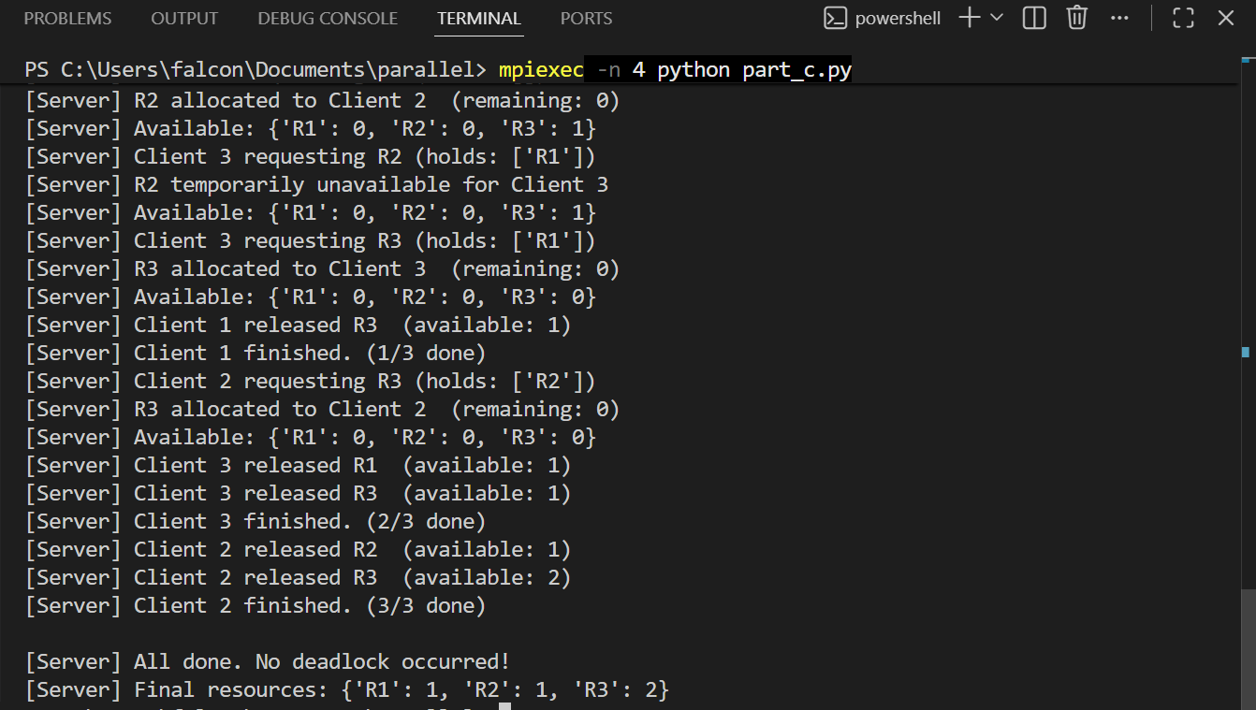

5. Part D — Performance Analysis (4 Marks)

Q1. What is Deadlock?
A deadlock is a system state where two or more processes are permanently blocked, each waiting for a resource held by another process in the same set. No process can proceed, causing the system to freeze indefinitely.

Q2. Which Deadlock Condition Was Observed?
All four Coffman conditions were present. The primary observable condition was Circular Wait: C1 waits for R2 held by C2, while C2 waits for R1 held by C1. This forms the cycle C1 -> R2 -> C2 -> R1 -> C1.

Q3. How Did Prevention Eliminate Deadlock?
Resource Ordering breaks Circular Wait. Since every request must target a higher-order resource than currently held, all hold->wait edges in the allocation graph point in the same direction. A directed cycle is impossible, so deadlock cannot occur.

Q4. What If the Number of Clients Increased?
- Server bottleneck: Rank 0 handles all requests serially — queue grows as O(N).
- Resource starvation: Many clients compete for R2 (only 1 unit); most get denied.
- MPI buffer overflow: Too many unprocessed messages may exhaust MPI buffers.
- False deadlock alarms: Timeout detection becomes unreliable under heavy load.

Q5. Limitations of This Implementation

Limitation | Description
Centralised Server | Single Rank 0 is a bottleneck; no fault tolerance.
No Retry Logic | Denied clients do not retry; real systems need back-off.
Heuristic Detection | Timeout may miss fast deadlocks or give false alarms.
No Priority | All requests treated equally; no scheduling policy.
Static Resources | Resource pool is fixed; no dynamic provisioning.
No Persistence | All state lost if server crashes.

6. Conclusion
This lab successfully demonstrated distributed resource management using MPI. Part A built a working client-server allocation system. Part B reproduced a classic circular-wait deadlock. Part C eliminated deadlock entirely using Resource Ordering. All four Coffman conditions were identified and the prevention strategy was validated.

6.1 File Summary
File | Contents
part_a.py | Resource Allocation System (Part A — 8 Marks)
part_b.py | Deadlock Simulation (Part B — 4 Marks)
part_c.py | Deadlock Prevention — Resource Ordering (Part C — 4 Marks)

