Dr. A. Q. Khan Institute of Computer Sciences
and Information Technology, Kahuta

Department of Computer Science

ASSIGNMENT # 3
Web Engineering
PHP & Laravel Based Large-Scale Web Application Development
Online Learning Management System (LMS)

Subject | Web Engineering
Class Section | BSCS-6
Submission Date | 15 / 05 / 2026
Topic | PHP & Laravel — Large-Scale LMS Development

Student Name | Laiba Naeem
Roll Number | 232201058
Section | BSCS-6-B
Submitted To | Sir Hussain Gillani

SCENARIO: A software company is planning to develop a Large-Scale Online Learning Management System (LMS) using PHP with Laravel framework. The system will support thousands of students, teachers, and administrators. It will include features like course management, video lectures, assignments, grading, authentication, and real-time notifications.

TASK 1 — Web Engineering Concepts & Standards [5 Marks]

1.1 Definition of Web Engineering
Web Engineering is a systematic, disciplined, and quantifiable approach to the development, operation, and maintenance of web-based applications and systems. It combines principles from software engineering, computer science, project management, and information technology to produce high-quality web systems. Web engineering addresses the unique complexities of web-based systems including heterogeneous environments, rapid change, concurrent user access, security threats, and cross-platform compatibility.
Unlike traditional software engineering, web engineering must deal with continuous deployment, diverse user bases, global accessibility requirements, and evolving browser standards. For a large-scale LMS, web engineering ensures the system is built with documented processes, quality metrics, and maintainable architecture.

1.2 Role of Web Standards in Laravel LMS Development
Standard | Role in Laravel LMS
HTML5 | Provides semantic structure for LMS pages — video player (<video>), forms for assignments, canvas elements for interactive content, and offline capabilities via Service Workers for students with poor connectivity.
CSS3 | Enables responsive LMS design (Flexbox, Grid) ensuring the platform is usable on mobile, tablet, and desktop. Animations improve UX in course navigation. CSS variables allow dynamic theming per institution.
HTTP/HTTPS | Laravel routes map cleanly to HTTP verbs (GET, POST, PUT, DELETE). HTTPS protects student data and exam submissions. HTTP/2 multiplexing reduces load time for video-heavy courses.
REST APIs | Laravel Resource Controllers generate RESTful endpoints consumed by mobile apps and third-party integrations. Laravel Sanctum/Passport secure token-based REST communication for web and mobile clients.

1.3 Why Standards Are Critical in Large-Scale Web Applications
- Interoperability — Standards ensure different components (mobile app, web browser, API) communicate reliably.
- Security — HTTPS, CSRF tokens, and REST conventions reduce attack surfaces across thousands of concurrent users.
- Maintainability — Code written to standards is easier to debug, refactor, and hand over to new developers.
- Performance — HTTP/2, responsive images, and semantic HTML improve page load for 50,000+ simultaneous learners.
- Accessibility — WCAG-compliant HTML5 ensures students with disabilities can access course material.
- SEO & Discoverability — Semantic HTML helps public course pages rank in search engines, driving enrollment.
- Team Collaboration — Standards align front-end, back-end, and DevOps teams, reducing integration conflicts.
- Regulatory Compliance — GDPR, FERPA, and local data privacy laws require standard security implementations.
TASK 2 — Web Constraints & System Challenges [5 Marks]
Scenario: The LMS must support 50,000+ concurrent users — students, teachers, and administrators simultaneously accessing course content, submitting assignments, and receiving grades.

2.1 Server Limitations
Challenge: A single server cannot handle 50,000+ requests. CPU, RAM, and disk I/O become bottlenecks during peak hours (exam periods, assignment deadlines).

Laravel Solution: Laravel supports horizontal scaling via load balancers. Laravel Octane (powered by Swoole/RoadRunner) keeps the application in memory, boosting throughput 10x. Queue workers distribute heavy tasks (email sending, PDF generation, video processing) to background workers, freeing web servers.

- Use AWS EC2 Auto Scaling Groups or DigitalOcean Droplets behind a load balancer.
- Deploy Laravel Octane for persistent in-memory application serving.
- Offload file storage to AWS S3 to reduce disk I/O on app servers.

2.2 Network Latency
Challenge: Students in remote areas experience high latency accessing video content and API endpoints. Large video files cause slow page loads, impacting the learning experience.

Laravel Solution: Laravel integrates with CDN services (Cloudflare, AWS CloudFront) for static asset delivery. API responses are cached using Laravel's Cache facade (Redis/Memcached), reducing database round-trips by 80%. Lazy loading and pagination limit data transferred per request.

- Store videos on AWS S3 and serve via CloudFront CDN for edge caching.
- Use Laravel HTTP client with connection pooling for external API calls.
- Implement response compression (gzip) in Laravel middleware.

2.3 Browser Compatibility
Challenge: Students use diverse browsers (Chrome, Firefox, Safari, Edge) and OS combinations. CSS rendering differences and JavaScript API variations break the LMS UI inconsistently.

Laravel Solution: Laravel's Blade templating generates clean, semantic HTML5 compatible across browsers. Laravel Mix (Webpack) compiles and auto-prefixes CSS for cross-browser support. Frontend frameworks (Vue.js/React via Inertia.js) handle DOM abstraction uniformly.

- Use Laravel Mix with PostCSS Autoprefixer to handle vendor-specific CSS.
- Employ Babel transpilation for modern JavaScript backward compatibility.
- Test with BrowserStack integration in the CI/CD pipeline.

2.4 Security Issues (SQL Injection, XSS, CSRF)
Challenge: Large-scale LMS systems are high-value targets for SQL injection, XSS, CSRF, session hijacking, and brute-force attacks on student accounts and exam data.

Laravel Security Arsenal: Eloquent ORM uses PDO prepared statements, making SQL injection virtually impossible. Blade templates auto-escape output using htmlspecialchars(), preventing XSS. Laravel generates CSRF tokens automatically for every form. Rate limiting middleware prevents brute-force attacks.

- SQL Injection: Eloquent ORM uses parameterized queries — User::where('email', $email)->first()
- XSS: Blade {{ $variable }} auto-escapes; use {!! !!} only for trusted admin content.
- CSRF: @csrf Blade directive injects token; VerifyCsrfToken middleware validates every POST.
- Session Hijacking: Laravel encrypts session cookies; configure SESSION_SECURE_COOKIE=true.
- Brute Force: ThrottleRequests middleware limits login attempts (e.g., 5 per minute per IP).

2.5 Session Management Challenges
Challenge: Managing sessions for 50,000+ concurrent users across multiple servers leads to session desynchronization. Sticky sessions on a single server create bottlenecks and single points of failure.

Laravel Solution: Laravel supports centralized session drivers: database, Redis, Memcached, or cookie. For multi-server deployments, Redis session driver ensures all app servers share session state. Laravel Sanctum issues stateless API tokens, eliminating server-side session dependency for mobile apps.

- Configure SESSION_DRIVER=redis in .env for shared session state across server instances.
- Use Laravel Sanctum for SPA authentication with CSRF-protected session cookies.
- Use Laravel Passport for OAuth2 token-based auth for third-party mobile apps.
- Set appropriate SESSION_LIFETIME and implement sliding expiration for active users.

TASK 3 — System Design & Laravel Architecture [5 Marks]

3.1 MVC Architecture in Laravel
Laravel strictly follows the Model-View-Controller (MVC) pattern, separating concerns across three layers to improve maintainability, testability, and scalability for a large LMS. Every HTTP request travels through: Browser -> Route/Middleware -> Controller -> Model -> Database, with the Controller returning a View (HTML) or JSON response.

Layer | Role in LMS
Model | Eloquent ORM classes (User, Course, Enrollment, Grade). Handle database interactions, relationships, and validation. Example: Course::with('teacher','enrollments')->paginate(20)
View | Blade templates (.blade.php) render HTML. Components and layouts prevent code duplication. Blade compiles to cached PHP for fast rendering of course pages.
Controller | Handle HTTP requests, call Model methods, return View or JSON. Resource controllers (php artisan make:controller CourseController --resource) auto-generate CRUD methods.
Route | web.php for browser routes with session/CSRF. api.php for stateless REST routes. Route groups apply middleware (auth, role) to multiple endpoints simultaneously.
Middleware | Intercept requests before reaching controllers. Auth verifies tokens, Role checks permissions, Throttle prevents DDoS attacks on the LMS API.

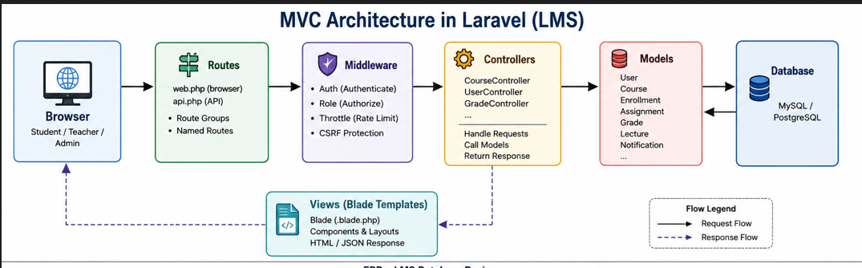

3.2 Database Design
The LMS database is designed for normalization, scalability, and relational integrity. Key tables and their relationships are described below:

Table | Key Columns
users | id (PK), name, email, password, role (student/teacher/admin), email_verified_at, remember_token, timestamps
courses | id (PK), title, description, teacher_id (FK->users), category_id (FK), status, thumbnail, created_at, updated_at
enrollments | id (PK), student_id (FK->users), course_id (FK->courses), enrolled_at, progress (%), completed_at
assignments | id (PK), course_id (FK), title, description, due_date, max_marks, file_path, timestamps
grades | id (PK), student_id (FK->users), assignment_id (FK->assignments), marks_obtained, feedback, graded_by (FK->users), graded_at
lectures | id (PK), course_id (FK), title, video_url, duration, order_no, is_preview, timestamps
notifications | id (PK), user_id (FK), type, data (JSON), read_at, created_at

Relationships: users hasMany courses (as teacher), users belongsToMany courses (as student via enrollments), courses hasMany lectures, courses hasMany assignments, assignments hasMany grades.
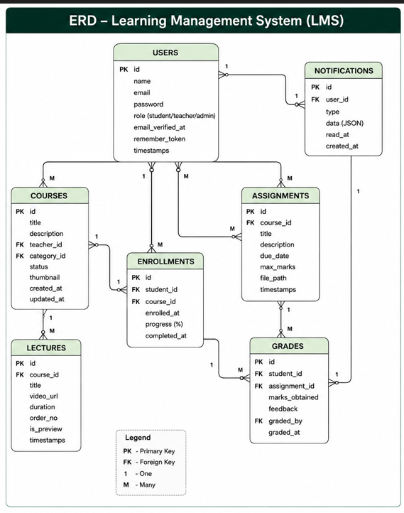

3.3 Authentication System
The LMS uses a layered authentication strategy tailored to different client types:
- Laravel Breeze/Jetstream — Web-based authentication with session cookies and CSRF protection for the main LMS portal.
- Laravel Sanctum — SPA (Single Page Application) authentication and simple API token issuance for mobile apps and Vue.js frontend.
- Laravel Passport — Full OAuth2 implementation for third-party integrations (corporate SSO, Google Classroom sync).
- Role-Based Access Control (RBAC) — Implemented via spatie/laravel-permission package. Roles: Student, Teacher, Admin, Super Admin.

Code Example: Route::middleware(['auth:sanctum', 'role:teacher'])->group(function () { Route::apiResource('courses', CourseController::class); }); | $token = $user->createToken('lms-app', ['courses:read', 'grades:write'])->plainTextToken;

3.4 REST API Structure
Method | Endpoint | Description
GET | /api/v1/courses | List all courses (paginated, filterable)
POST | /api/v1/courses | Create new course (teacher only)
GET | /api/v1/courses/{id} | Get course details with lectures & enrollments
PUT | /api/v1/courses/{id} | Update course (owner teacher / admin)
DELETE | /api/v1/courses/{id} | Soft-delete course
POST | /api/v1/courses/{id}/enroll | Enroll authenticated student
GET | /api/v1/students/{id}/grades | Get student grade report
POST | /api/v1/assignments/{id}/submit | Submit assignment file upload
GET | /api/v1/notifications | Get user's unread notifications

3.5 Middleware for Security and Role Management
- auth:sanctum — Verifies Bearer tokens on every API request, rejecting unauthenticated calls with 401.
- role:admin / role:teacher — Checks spatie/permission roles before allowing access to admin/teacher routes.
- throttle:60,1 — Limits each user to 60 API requests per minute, preventing DDoS and abuse.
- verified — Ensures only email-verified students can enroll in courses or submit assignments.
- cors — Allows cross-origin requests from the mobile app domain, blocking other origins.

3.6 Scaling for High Traffic (50,000+ Users)

Redis Caching
Cache course lists, lecture metadata, and user profiles with Laravel Cache facade. Cache::remember('courses.all', 3600, fn() => Course::with('teacher')->get()); reduces database queries by 80%+ for read-heavy LMS operations. Redis also powers real-time notifications via Laravel Echo + Pusher/Soketi for instant grade notifications.

Load Balancing
Deploy multiple Laravel app server instances behind an Nginx or AWS Application Load Balancer. Sticky sessions are avoided by using Redis for session storage. Database read replicas (MySQL Master-Slave) distribute read query load across multiple DB servers, ensuring the primary handles only writes.

Queue System (Jobs & Workers)
Laravel Queues with Redis driver handle: email notifications on enrollment, video transcoding jobs, PDF grade report generation, and bulk grade imports. Laravel Horizon dashboard monitors queue health in real-time. Failed jobs are automatically retried with exponential back-off, ensuring no task loss under peak exam load.

TASK 4 — Evaluation Against Web Engineering Standards [5 Marks]

Scenario: An existing LMS built in plain PHP (without any framework) suffers from performance degradation, security breaches, and increasing maintenance costs. We evaluate it against modern web engineering standards and propose a migration strategy to Laravel.

4.1 Code Structure Quality
Issue | Spaghetti code — business logic mixed with HTML, SQL embedded in view files, no separation of concerns. 500+ line PHP files with no reusable functions or classes.
Standard | ISO/IEC 25010 Software Quality Model mandates maintainability, modularity, and reusability as core quality attributes.
Impact | Adding a feature requires modifying 10+ files, causing regression bugs. Onboarding new developers takes weeks with no documentation.
Laravel Fix | MVC architecture enforces separation. Artisan scaffolding generates structured boilerplate. PHP namespaces and PSR-4 autoloading organise classes logically.

4.2 Security Vulnerabilities
Issue | Direct SQL string concatenation: $sql = 'SELECT * FROM users WHERE email = '.$_POST['email']; is vulnerable to SQL injection. No CSRF tokens, no output encoding.
Standard | OWASP Top 10 identifies SQL Injection (#3) and XSS (#2) as most critical web application vulnerabilities requiring immediate remediation.
Impact | An attacker can dump the entire student database with a single crafted login request, exposing personal data and grades.
Laravel Fix | Eloquent ORM parameterized queries, Blade auto-escaping, automatic CSRF middleware, and bcrypt password hashing eliminate all three vulnerabilities by default.

4.3 Performance Bottlenecks
Issue | N+1 query problem: a loop fetches each student's courses in a separate query (1000 students = 1001 database queries). No caching. No asset bundling. All pages are server-rendered fresh.
Standard | W3C Web Performance Working Group guidelines: TTFB < 200ms, page load < 3s for LMS dashboards under peak load.
Impact | Dashboard takes 12+ seconds to load during peak hours. Database server CPU at 95%. Students report timeouts during exam submission.
Laravel Fix | Eager loading (Course::with('students')), Redis query caching, Laravel Mix for CSS/JS bundling, and HTTP response caching via Laravel's Cache-Control headers.

4.4 Maintainability Issues
Issue | No version control conventions, no automated tests, database schema documented only in one developer's memory. Deployment is manual FTP upload with no rollback capability.
Standard | IEEE 1219 (Software Maintenance Standard) requires documented, testable, and version-controlled code with repeatable deployment processes.
Impact | A single change broke the grading system for 3 weeks before identification. No test suite means every deployment risks production breakage.
Laravel Fix | Eloquent Migrations for schema version control, PHPUnit/Pest for test suites, GitHub Actions CI/CD pipelines, and Laravel Telescope for production debugging.

4.5 RESTful Standards Compliance
Issue | All requests use GET with query parameters: get_course.php?action=delete&id=5. No consistent JSON response format, no API versioning, no authentication tokens.
Standard | Roy Fielding's REST constraints: statelessness, uniform interface, resource-based URIs, proper HTTP verb usage (GET/POST/PUT/DELETE), and consistent response formats.
Impact | Mobile app developers must reverse-engineer 200+ inconsistent endpoints. Breaks every third-party integration with each new release.
Laravel Fix | Laravel Resource Controllers auto-map CRUD to HTTP verbs. API Resources format JSON responses consistently. Route versioning (/api/v1/) and Sanctum token auth achieve full REST compliance.

4.6 Migration Roadmap — Plain PHP to Laravel
Phase | Activities
Phase 1 — Audit & Setup (Week 1-2) | Document all existing PHP files. Install Laravel. Set up Git repository and CI/CD pipeline. Mirror existing database into Laravel migrations.
Phase 2 — Auth & Core Models (Week 3-4) | Migrate authentication to Laravel Breeze + Sanctum. Create Eloquent models and relationships for User, Course, Enrollment, Grade, Assignment.
Phase 3 — Controllers & Views (Week 5-8) | Migrate PHP logic into Resource Controllers. Replace HTML PHP files with Blade templates. Implement form validation using Laravel FormRequest classes.
Phase 4 — API Layer (Week 9-10) | Build RESTful API endpoints using Laravel API Resources. Implement Sanctum token authentication for mobile apps. Version all routes under /api/v1/.
Phase 5 — Optimisation (Week 11-12) | Integrate Redis for session, cache, and queues. Deploy Laravel Horizon for queue monitoring. Set up load balancer. Write PHPUnit test suite for critical paths.

4.7 Plain PHP vs Laravel — Summary Comparison
Aspect | Plain PHP LMS | Laravel LMS
Code Structure | Unstructured, mixed logic | MVC, PSR-4 organized
SQL Security | Vulnerable to injection | Eloquent parameterized queries
CSRF Protection | Manual / absent | Automatic via middleware
Authentication | Custom session code | Sanctum / Passport / Jetstream
Caching | None | Redis / Memcached built-in
Queue / Jobs | None | Laravel Queues + Horizon
Testing | Manual | PHPUnit / Pest integrated
REST API | Inconsistent endpoints | Resource controllers, versioned
Scalability | Single-server only | Horizontal + Redis + Load Balancer
Maintenance | Very High Cost | Low — artisan, migrations, DI

This assignment demonstrates comprehensive understanding of PHP & Laravel-based large-scale web application development, covering web engineering standards, system constraints, architectural design, and critical evaluation of legacy systems against modern frameworks. The proposed LMS architecture is production-ready, secure, and scalable to 50,000+ concurrent users.

