

Theory Report of
Student Record Management System

Submitted By

Nayyab Gul(232201085)
Class

BsCs VI-B
Submitted To

Sir Hussain Shah Gillani
Subject

Web Engineering

1. Problem Description
A small educational institute wants to replace manual record-keeping with a simple digital system. This assignment involves developing a basic Student Record Management System (SRMS) using PHP and MySQL.
The main goals of the system are:
- Reduce paperwork and manual errors
- Improve data organization and accessibility
- Help administrative staff manage student records easily
- Provide a simple, readable interface for CRUD operations

Technologies Used
Technology | Purpose
PHP | Server-side scripting for CRUD logic
MySQL | Relational database for storing student records
HTML/CSS | Frontend forms and table display
XAMPP/Apache | Local web server environment

Task 1: Database Setup
Create the database and table using the following SQL commands in phpMyAdmin or MySQL terminal.

File: database.sql
CREATE DATABASE IF NOT EXISTS student_db;
USE student_db;

CREATE TABLE IF NOT EXISTS students (
id INT AUTO_INCREMENT PRIMARY KEY,
name VARCHAR(100) NOT NULL,
email VARCHAR(100) NOT NULL UNIQUE,
department VARCHAR(100) NOT NULL,
created_at TIMESTAMP DEFAULT CURRENT_TIMESTAMP
);

File: config.php
This file creates the database connection used across all PHP files:
<?php
// Database Configuration
$host = "localhost";
$user = "root";
$password = "";
$database = "student_db";

// Create connection
$conn = mysqli_connect($host, $user, $password, $database);

// Check connection
if (!$conn) {
die("Connection failed: " . mysqli_connect_error());
}
?>

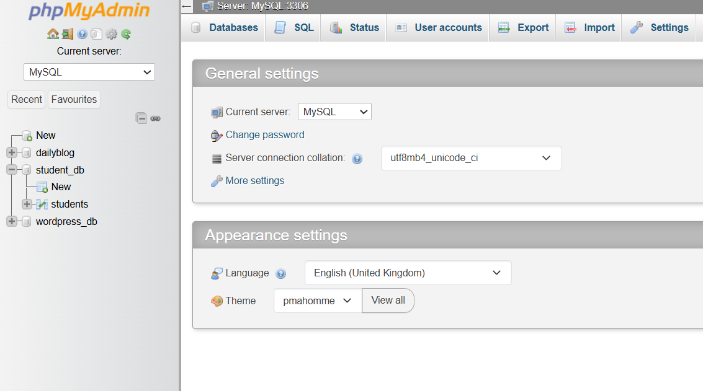

Task 2: Create — Insert Student Data
File: add_student.php — An HTML form collects student data and PHP inserts it into the database.

Insert Logic (from add_student.php):
if ($_SERVER['REQUEST_METHOD'] == 'POST') {
$name = trim(mysqli_real_escape_string($conn, $_POST['name']));
$email = trim(mysqli_real_escape_string($conn, $_POST['email']));
$dept = trim(mysqli_real_escape_string($conn, $_POST['department']));

$sql = "INSERT INTO students (name, email, department)
VALUES ('$name', '$email', '$dept')";
if (mysqli_query($conn, $sql)) {
$success = "Student added successfully!";
}
}

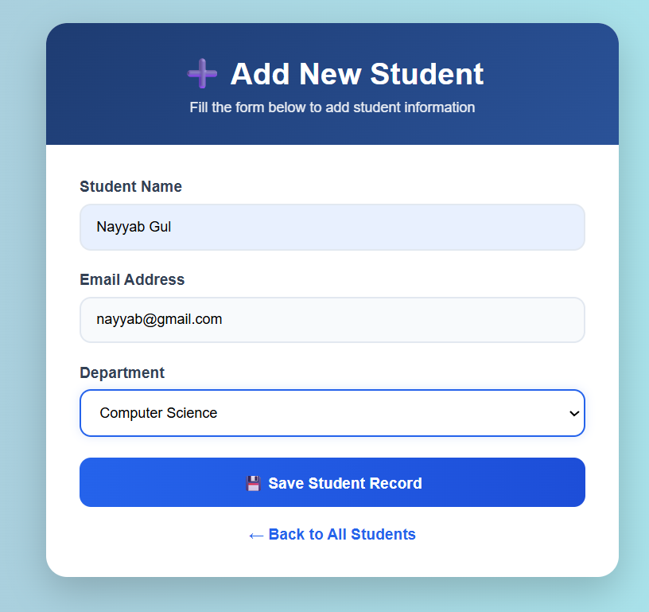

Task 3: Read — Display Student Records
File: index.php — Retrieves all students from the database and displays them in a formatted HTML table with Edit and Delete action buttons.

Read Logic (from index.php):
$result = mysqli_query($conn, "SELECT * FROM students ORDER BY id DESC");
while ($row = mysqli_fetch_assoc($result)) {
echo '<tr>';
echo '<td>' . $row['name'] . '</td>';
echo '<td>' . $row['email'] . '</td>';
echo '<td>' . $row['department'] . '</td>';
echo '</tr>';
}
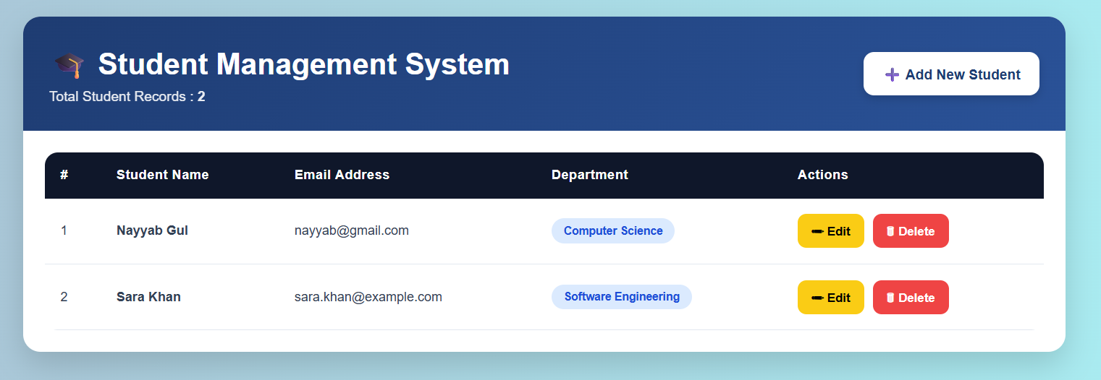

Task 4: Update — Edit Student Record
File: edit_student.php — Fetches a student record by ID, pre-fills the form with existing data, and on submission runs an UPDATE query.

Update Logic (from edit_student.php):
$sql = "UPDATE students SET
name='$name', email='$email', department='$department'
WHERE id=$id";
if (mysqli_query($conn, $sql)) {
$success = "Record updated successfully!";
}

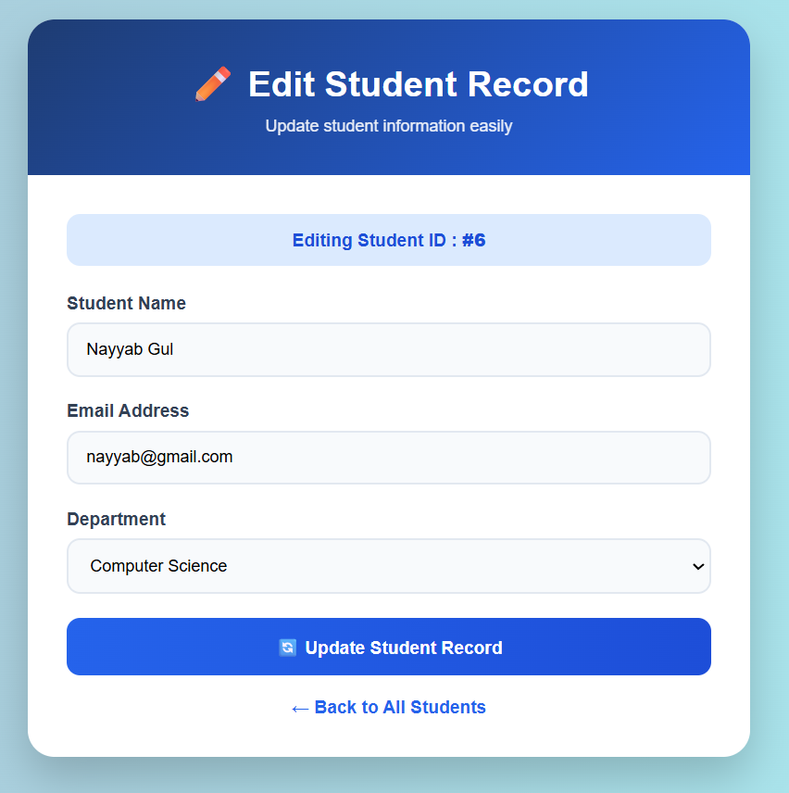

Task 5: Delete — Remove Student Record
File: index.php — A Delete button passes the student ID via URL parameter. A JavaScript confirm dialog prevents accidental deletion. The PHP then executes a DELETE query.

Delete Logic (from index.php):
if (isset($_GET['delete'])) {
$id = intval($_GET['delete']);
$sql = "DELETE FROM students WHERE id = $id";
if (mysqli_query($conn, $sql)) {
echo "<script>alert('Deleted!'); window.location='index.php';</script>";
}
}
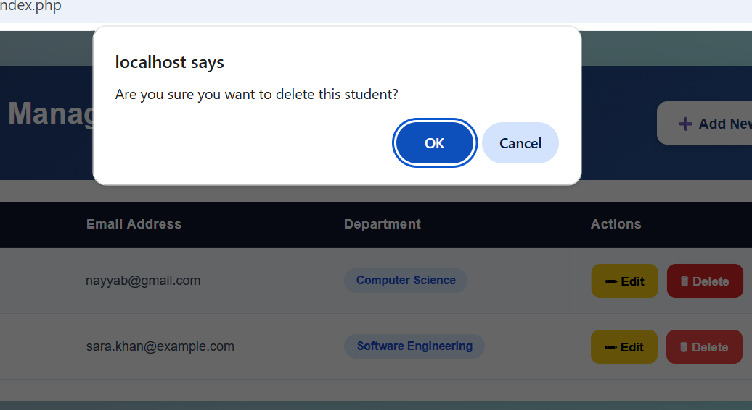

Task 6: Interface Improvements
The following basic interface improvements were made to ensure the output is clear and readable:
- Clear page headings and section labels on all pages
- Color-coded action buttons: Green = Add, Orange = Edit, Red = Delete
- Hover effects on table rows for readability
- Confirmation dialog before deleting a record
- Success and error messages displayed after each operation
- Dropdown department selector instead of free-text input
- Input validation: empty field check + email format check
Project File Structure
File Name | Description
database.sql | SQL script to create database and table
config.php | Database connection file
index.php | Main page — Read (display) + Delete
add_student.php | Add new student form — Create (Insert)
edit_student.php | Edit student form — Update

Step-by-Step Setup Guide
Follow these steps to run the project on your local machine:
1. Install XAMPP from https://www.apachefriends.org and start Apache + MySQL.
2. Open phpMyAdmin at http://localhost/phpmyadmin
3. Click 'New' to create a database, OR open the SQL tab and paste database.sql contents, then click Go.
4. Copy the php_project folder into: C:\xampp\htdocs\student_project
5. Open your browser and go to: http://localhost/student_project/index.php
6. You should see the Student Record Management System main page.
7. Use the 'Add New Student' button to insert records.
8. Use 'Edit' and 'Delete' buttons on each row.

