**Use Case Diagram** 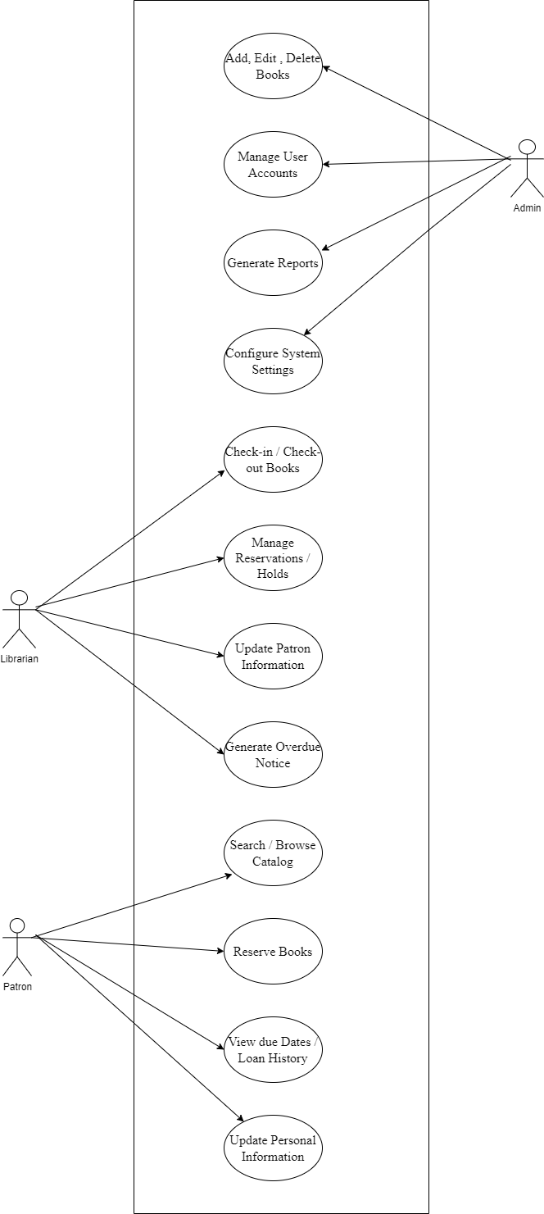

**Class Diagram**

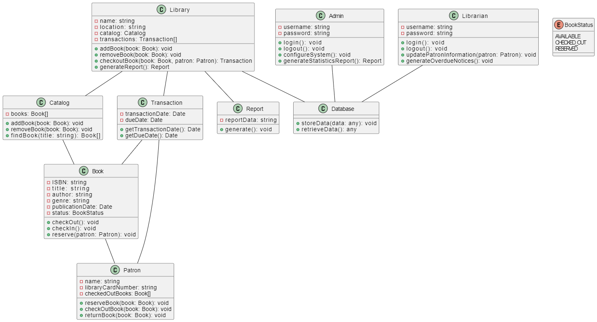

* Library manages the catalog, transactions, and generates reports on library activities.
* Catalog contains a list of books and provides methods to manage the catalog.
* Book represents individual books with properties like ISBN, title, author, and status (available, checked out, reserved).
* Patron represents library patrons and their interactions with books.
* Transaction tracks book transactions and due dates.
* Report generates reports based on library data.
* An enum named BookStatus is used to define the possible statuses of a book.
* The Admin class represents administrators with methods for login, logout, configuring the system, and generating statistics reports.
* The Database class represents the database used to store and retrieve data.
* The Librarian class represents librarians with methods for login, logout, updating patron information, and generating overdue notices.