

**Project Title**

**Sign Language Recognition**

**Prepared by**

**Nayyar Shoaib Malik**

**Submitted to**

**Dr. Akhtar Jamil**

**Course: Digital Image Processing**

**Introduction**

In this sign language recognition project, we create a sign detector, which detects numbers from 0 to 5 that can very easily be extended to cover a vast multitude of other signs and hand gestures.

This can be very helpful for the deaf and dumb people in communicating with others as knowing sign language is not something that is common to all, moreover, this can be extended to creating automatic editors, where the person can easily write by just their hand gestures.

Computer vision techniques and machine learning algorithms are utilized to achieve this goal.

**Data Collection and Preprocessing:**

The dataset used for training and testing consists of handwritten digit images. The images are collected from various sources and stored in separate directories based on their corresponding labels (0 to 5). OpenCV library is employed for image processing tasks such as reading, resizing, and converting the images to grayscale. Additionally, the images are preprocessed using thresholding techniques to enhance contrast and simplify digit shapes, which aids in better feature extraction.

A script is provided to collect the data by capturing images from a webcam. The script creates a directory structure for storing the images in the "data" folder. There are separate folders for training and testing, and within each folder, subfolders are created for each digit label (0 to 5). The script allows capturing images by pressing the corresponding key for each digit, and the captured images are saved in the respective folder.

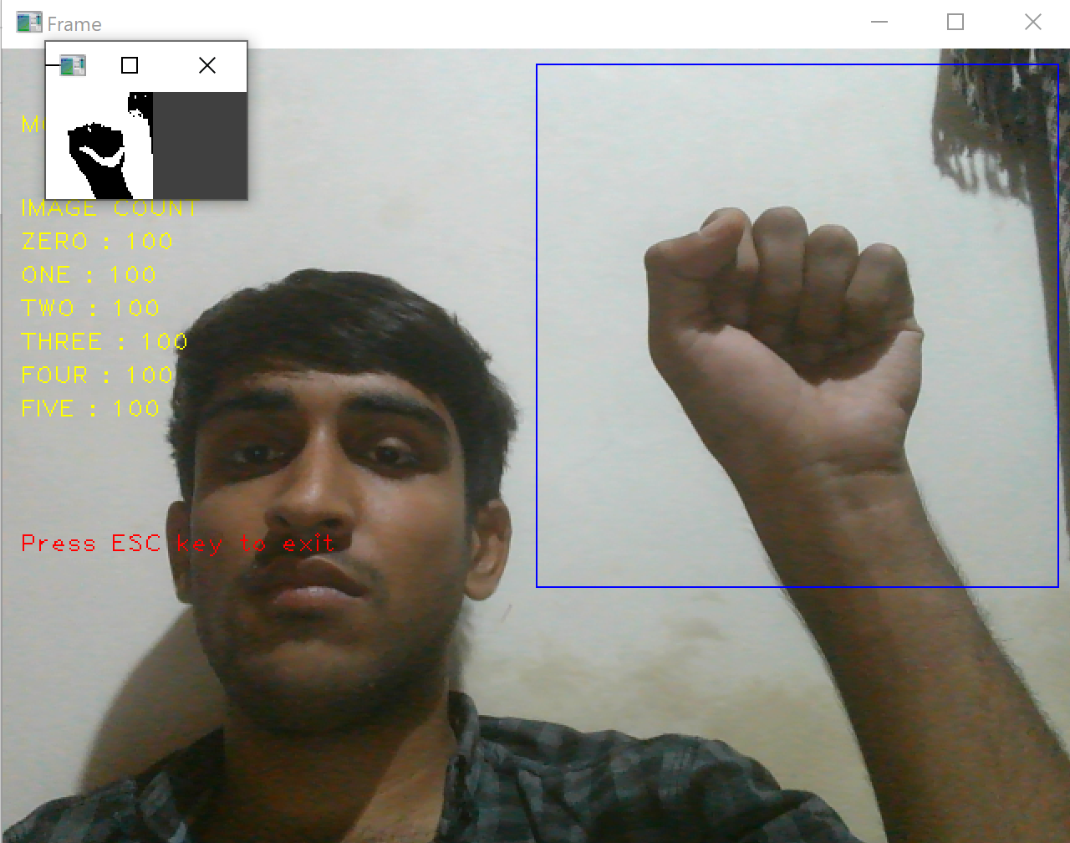

**Feature Extraction and Model Training:**

The digit images are processed using the Histogram of Oriented Gradients (HOG) method to compute gradient information, which provides essential details about the edges and contours of the digits. Additionally, local binary patterns (LBP) are employed to capture texture information. These extracted features are then used to train a machine learning model.

The chosen model for this task is a Convolutional Neural Network (CNN). The CNN architecture consists of convolutional and pooling layers for feature extraction, followed by fully connected layers for classification. The model is trained using the extracted features from the digit images. The training process involves optimizing the model's parameters to achieve the highest possible accuracy.

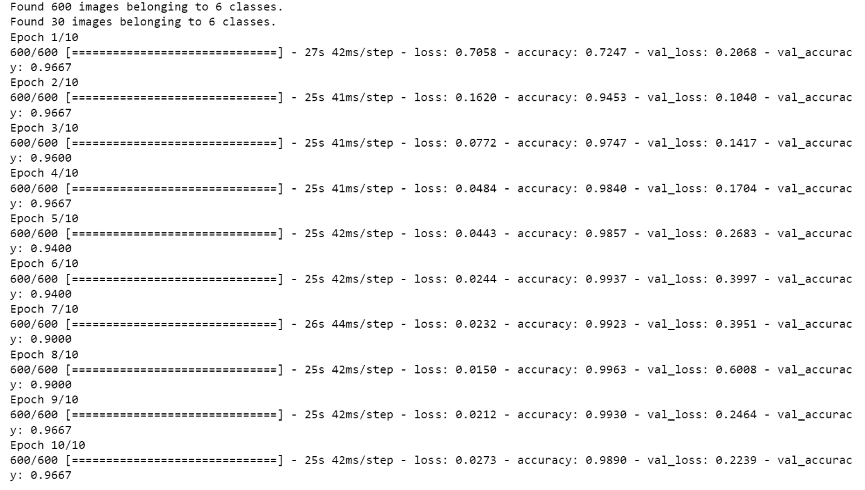

**Model Evaluation and Performance Metrics:**

The trained model is evaluated using a separate set of test images that were not used during the training phase. The accuracy, precision, recall, and F1-score are calculated to assess the performance of the model.

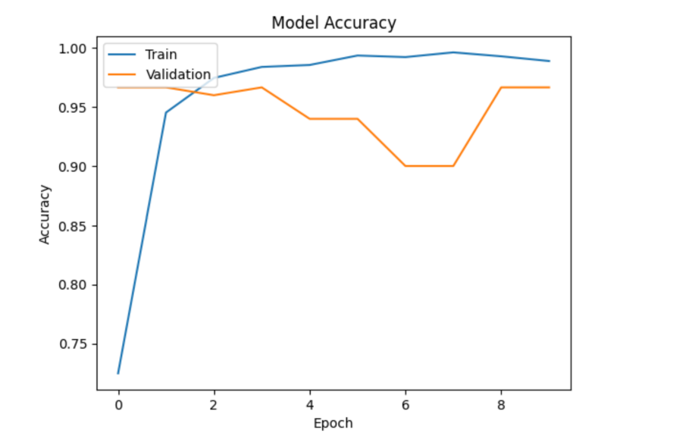

**Results and Conclusion:**

Based on the evaluation metrics and analysis, the developed model demonstrates a high level of accuracy in predicting handwritten digits.

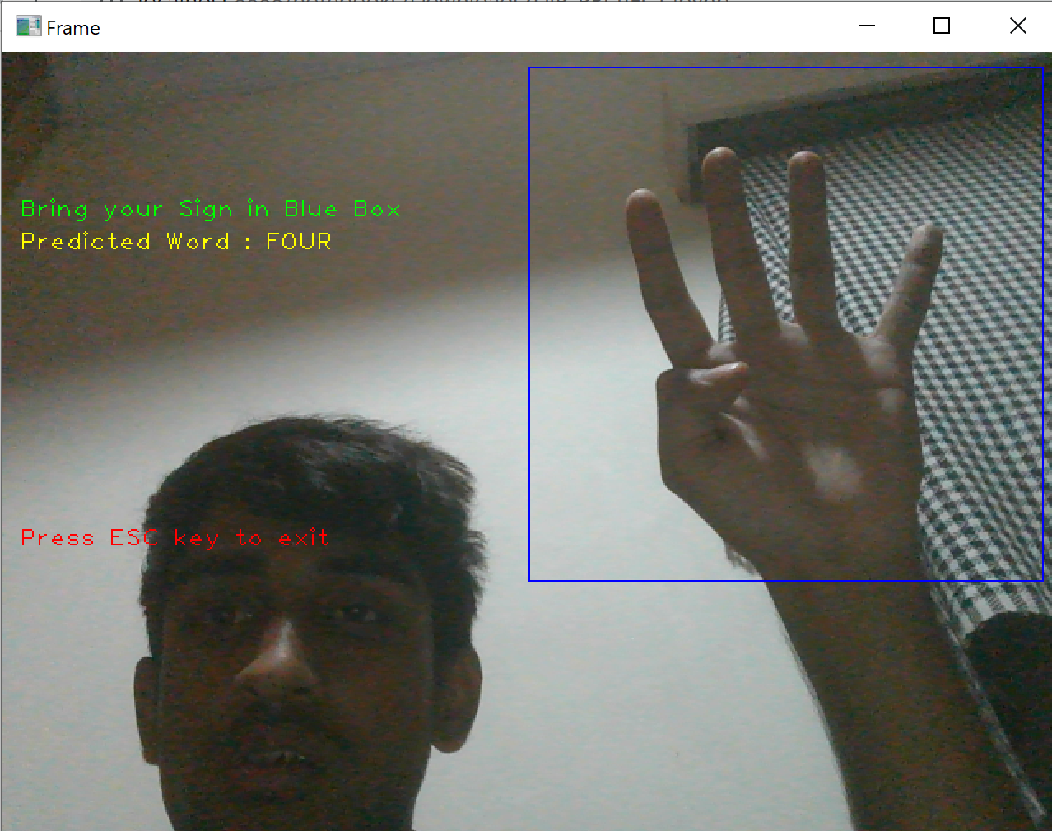

**Future Enhancements:**

While the current model performs well in predicting handwritten digits, there are several areas where improvements can be made. Possible future enhancements include exploring advanced deep learning architectures, such as convolutional neural networks (CNNs), to further improve accuracy. Additionally, expanding the dataset to include more diverse samples and investigating data augmentation techniques can enhance the model's ability to generalize to new instances.