Betülnaz HAYRAN-28354853660

Cansu GÜREL-16157401836

BIM209 Principles of Software Design and Development

Homework-2

Project name: Find Pharmacies with APHA

**The first part of our project:**

Firstly, we picked a project which was an application showing nearby pharmacies and their information. Then to visualize our project, we write a vision statement of our project. We list a requirement list from our vision statement. After that, we write at least 3 use cases and provide an alternate path for one of them. Then, we draw a use case diagram of the system to provide the simplified and graphical representation of what the system must do.We determine the clear value, start and stop conditions, and external initiator of the use cases. Then, we match steps of use case with the requirements list's items to see the relationship between them and to be sure that that our use case is related to the requirement list. After, we perform domain analysis to find our classes and methods name for our UML Diagram. Finally, we made preliminary UML design

**1. Imagine a software development scenario or select one of the suggested projects below.**

Pharmacy on Duty -> Application showing nearby pharmacies and their information.

**2. Write a statement of work (vision statement) having at least 200 words.**

Pharmacists says that their customers are having a hard time while they are trying to find close pharmacies, especially the customers who are old and heavily ill. And even if customers do find a pharmacy close to them, they are complaining about the lack of information about the pharmacies. Pharmacist says that if customers could find more information about pharmacies easier, they wouldn’t have to spend too much time to find the information and would reach to their emergent medicine more quickly. So as American Public Health Association, we thought an application to solve this issue and make both customers and pharmacist happy. We thought that this application should run on smartphones to make it more user-friendly and easier to access. We decided that its name should be “Find Pharmacies with APHA" and in the application opening screen it must write our name and our opening year. We want this application to show the top 5 pharmacies that are closest to users by using their location. It will also list the information about the pharmacies. We are thinking this information should be about name, address, telephone number, working hours of pharmacies and the distance to them. Lastly, we want the application to say, “Stay home, stay healthy!” as a closing slogan to take people attention to Covid-19.

**3. Write the requirements list.**

1. “Find Pharmacies with APHA” application will work on smartphones.

2. In the opening screen it must write APHA’s name and their opening year.

3. Application should detect the top 5 pharmacies that are closest to users by using their location.

4. Application will list information about 5 pharmacies like name, address, telephone number, working hours and distance.

5. When application closes, it should say “Stay home, stay healthy!”.

**4. Draw a use case diagram of the system.**

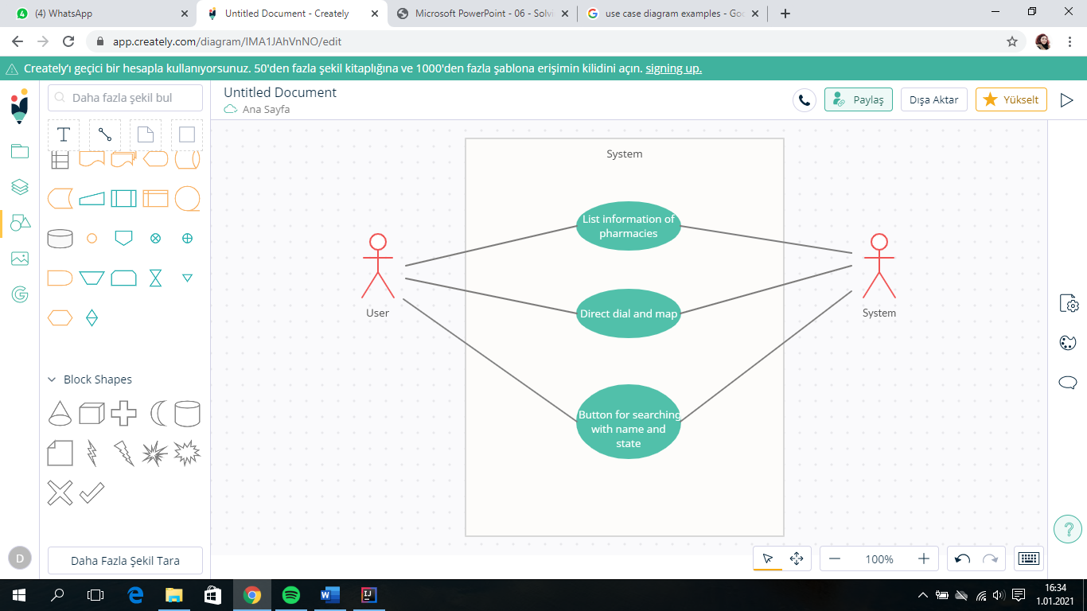

**5. Write at least 3 use cases and provide an alternate path for one of them.**

*Use case 1*

1. User opens the application

2. Application shows the APHA’s name and its opening year (1872).

3. Application detects user’s location coordinates automatically.

4. Applications calculates all pharmacies distances from users and pharmacies location coordinates. Then application detects the top 5 closest pharmacies.

5. Application lists 5 pharmacies with their name, address, telephone number, working hours.

6. When user clicks exit button, program says “Stay home, stay healthy!” and closes.

*Use case 2*

1. User clicks call or map button.

2. Application copies telephone number and directs to user’s dial or copies address of pharmacy and directs to user’s map application.

3. User goes back to application or exits.

*Use case 3*

1. User will click to “Search with name” button.

2. User will write the name of the pharmacy they want to find.

3. Application will check whether there is a matched pharmacy or not with searched name .

4. If there is/are pharmacies with the name that user search for, application will list the matched pharmacies with their information. Application will say “No match” if there is no pharmacy with the name that user searched for.

Alternate path

1.1. User will click to “Search with state” button.

2.1. User will write the name of the state they want to look up.

3.1. Application will check whether there is/are pharmacies in that state or whether there is a matched state or not.

4.1. If there is/are pharmacies in the state that user write, application will list the pharmacies that’s in that state. If there is not a state with that name or there is no pharmacy in that state, application will say “ No Match”.

**6. Depict (i) clear value, (ii) start and stop conditions, and (iii) external initiator of the use cases.**

*Use Case 1*

(i) Clear Value: User should reach nearby pharmacies and their information easily and quickly.

(ii) Start Condition: User opens the application.

Stop Condition: User closes the application. ( User clicks exit button. )

(iii) External Initiator: User of application.

*Use Case 2*

(i) Clear Value: To gain time, application should direct automatically after clicking.

(ii) Start Condition: Clicking buttons.

Stop Condition: Go back to application or exits.

(iii) External Initiator: User of application.

*Use Case 3*

(i) Clear Value: To help users who needs to find a specific pharmacy by making a search button.

(ii) Start Condition: User clicks “Search with name” or “Search with state” button.

Stop Condition: Application lists matching pharmacies or will say “no match”.

(iii) External Initiator: User of application.

**7. Match steps of use case with the requirements list's items.**

*Use case 1 Requirement list*

**1.** User opens the application. -> **(N/A)**

**2.** Application shows the APHA’s name and its opening year (1872). -> **2.** In the opening screen it must write APHA’s name and their opening year.

**3.** Application detects user’s location coordinates automatically. -> **3.** Application should detect the top 5 pharmacies that are closest to users by using their location.

**4.** Applications calculates all pharmacies distances from users and pharmacies location coordinates. Then application detects the top 5 closest pharmacies. ->**3.** Application should detect the top 5 pharmacies that are closest to users by using their location.

**5.** Application lists 5 pharmacies with their name, address, telephone number, working hours. ->**4.** Application will list information about 5 pharmacies like name, address, telephone number, working hours and distance.

**6.** When user clicks exit button, program says “Stay home, stay healthy!” and closes. -> **5.** When application closes, it should say “Stay home, stay healthy!”.

**8. Perform domain analysis (verb and noun analysis).**

*USE CASE 1*

*NOUN ->* User, application, APHA, opening year, location coordinates, pharmacy, distance, name, address, telephone number, working hours, information.

*VERB ->* Open, show, detect, calculate, list, click, say, close.

*USE CASE 2*

*NOUN->* Map button, call button, telephone number, user’s dial, location, user’s map application, application, user.

*VERB->* Click, copy, direct, go back, exit.

*USE CASE 3*

*NOUN->* “Search with name” button, “Search with state” button, pharmacy, state, application, user, match, search.

*VERB->* Click, find, write, check, say, show, want, search with name, search with state.

**9. Make a preliminary UML design and give details about your objects, define relationships between the objects, and apply principles.**

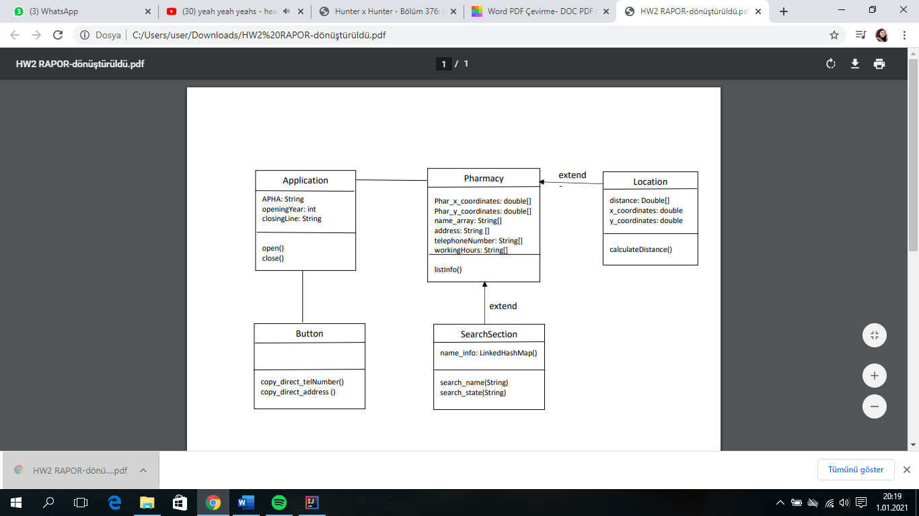

**The second part of our project:**

In this part of our project, we did the actual implementation our project software and prepare a release.

Pharmacy Class: Firstly, we declared two double type arrays and four String type arrays for Pharmacies information like x and y coordinates, name, address, telephone number, working hours. Then, we created a method called “listInfo()”. This method invokes the “calculateDistance()” method from Location class and then sorts the list which we created in Location class to make it listed from close to far in terms of distance between user and pharmacy. Finally, the method prints the top 3 closest pharmacies to the user with their information.

Location Class: First of all, we declared a double type array for distance and two double type for x and y coordinates of the user and assigned it to random numbers by using math random (because we don’t have a system that detects the location of user). Then, we created a ArrayList called list and a LinkedHashMap called information. After that, we created a method called “calculateDistance()”. In method’s for loop we calculated the distance between user and pharmacy by using d=√((x2-x1)²+(y2-y1)²) formula. At the end, we used the LinkedHashMap named 'Information' to link distance and its pharmacy's information.

SearchSection Class: In this class, we created two method that are called search_name() and search_state().In 'search_name' method, we have a map whose keys keep names and values keep pharmacies' information. We search the name and if it exists it will print the name with information by map. In 'search_state' method we use address array which we created it in 'Pharmacy' class in order to find pharmacies that presents in the searched state. If it exists we print information of pharmacies via arrays that are situated in 'Pharmacy' class .

Button Class: In this class, we created two method that are called copy_direct_telNumber() and copy_direct_address(). (In this class we were thinking that the user will click to telephone number icon or map icon. After clicking to telephone number icon, it will copy the telephone number and will direct to dial and paste to dial. Or after clicking to map icon, it will copy the address and will direct to map application and will paste the address to there. Unfortunately, the homework said “The software should not expect any input from the console during running the jar file. If you need to give input, you can give it statically.”.) This class prints the process of what is happening.

Application Class: This class is our main class that has a main method. This class has two string and one integer type which are APHA -the acronym stands for American Public Health Association- and APHA’s opening year and the closing line. This class has two another method too. These are open() and close() methods. In open() method it writes the opening line and in close() method it writes the closing line. In our main method, firstly it invokes the open() method then listInfo() method from Pharmacy and then search_name() and search_state() methods from SearchSection class with their parameters, then copy_direct_telNumber() and copy_direct_address() methods from Button class. Lastly, the class invokes the close() method.