**December 2017**



**Machine Learning Immersion Day**

*Hands-on with MXNet and Jupyter*

Table of Contents

Overview 3

Launching a Jupyter Notebook Server using Amazon SageMaker 4

Accessing the Jupyter Notebook Instance 6

Launching Jupyter Notebooks 6

Terminating the Notebook Instance 10

Conclusion 10

# Overview

Apache MXNet is a lean, flexible, and ultra-scalable deep learning framework that supports state of the art in deep learning models, including convolutional neural networks (CNNs) and long short-term memory networks (LSTMs). The framework has its roots in academia and came about through the collaboration and contributions of researchers at several top universities. It has been designed to excel at computer vision, speech, language processing and understanding, generative models, concurrent neural networks, and recurrent neural networks.

Amazon SageMaker is a fully-managed service that enables developers and data scientists to quickly and easily build, train, and deploy machine learning models at any scale. Amazon SageMaker removes all the barriers that typically slow down developers who want to use machine learning.

This lab is designed to demonstrate how to run the Amazon Deep Learning AMI using Amazon SageMaker, and will introduce the audience to:

* Launching Jupyter Notebook instance using Amazon SageMaker
* Stepping through and modifying Jupyter Notebooks
* Hands-on experience with:
  + Multi-Layer Perceptron
  + Convolutional Neural Networks
  + Long Short Term Memory artificial neural networks.

# Launching a Jupyter Notebook Server using Amazon SageMaker

1. Sign into the AWS Management Console <https://console.aws.amazon.com/>.
2. In the upper-right corner of the AWS Management Console, confirm you are in the desired AWS region (e.g., N. Virginia).
3. Click on **Amazon SageMaker** from the list of all services. This will bring you to the Amazon SageMaker console homepage.  
   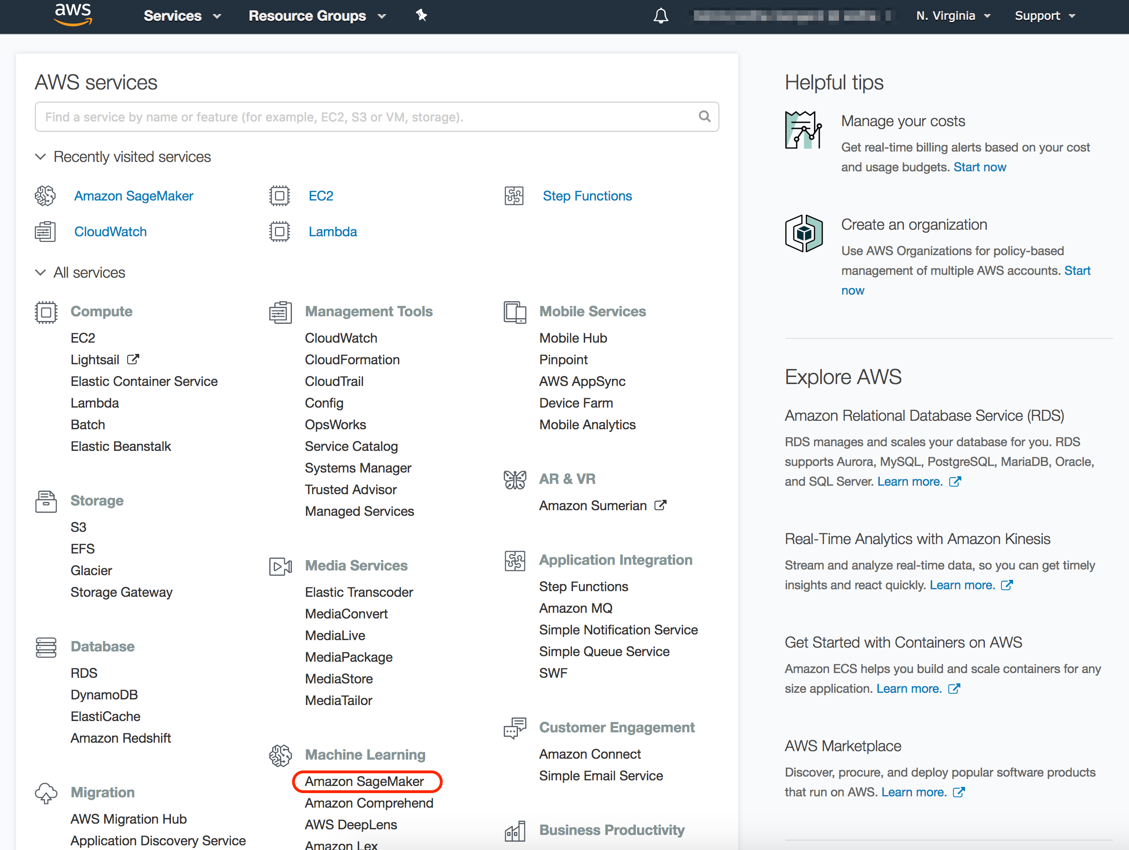
4. To create a new Jupyter notebook instance, go to **Notebook instances**, and click the **Create notebook instance** button at the top of the browser window.  
   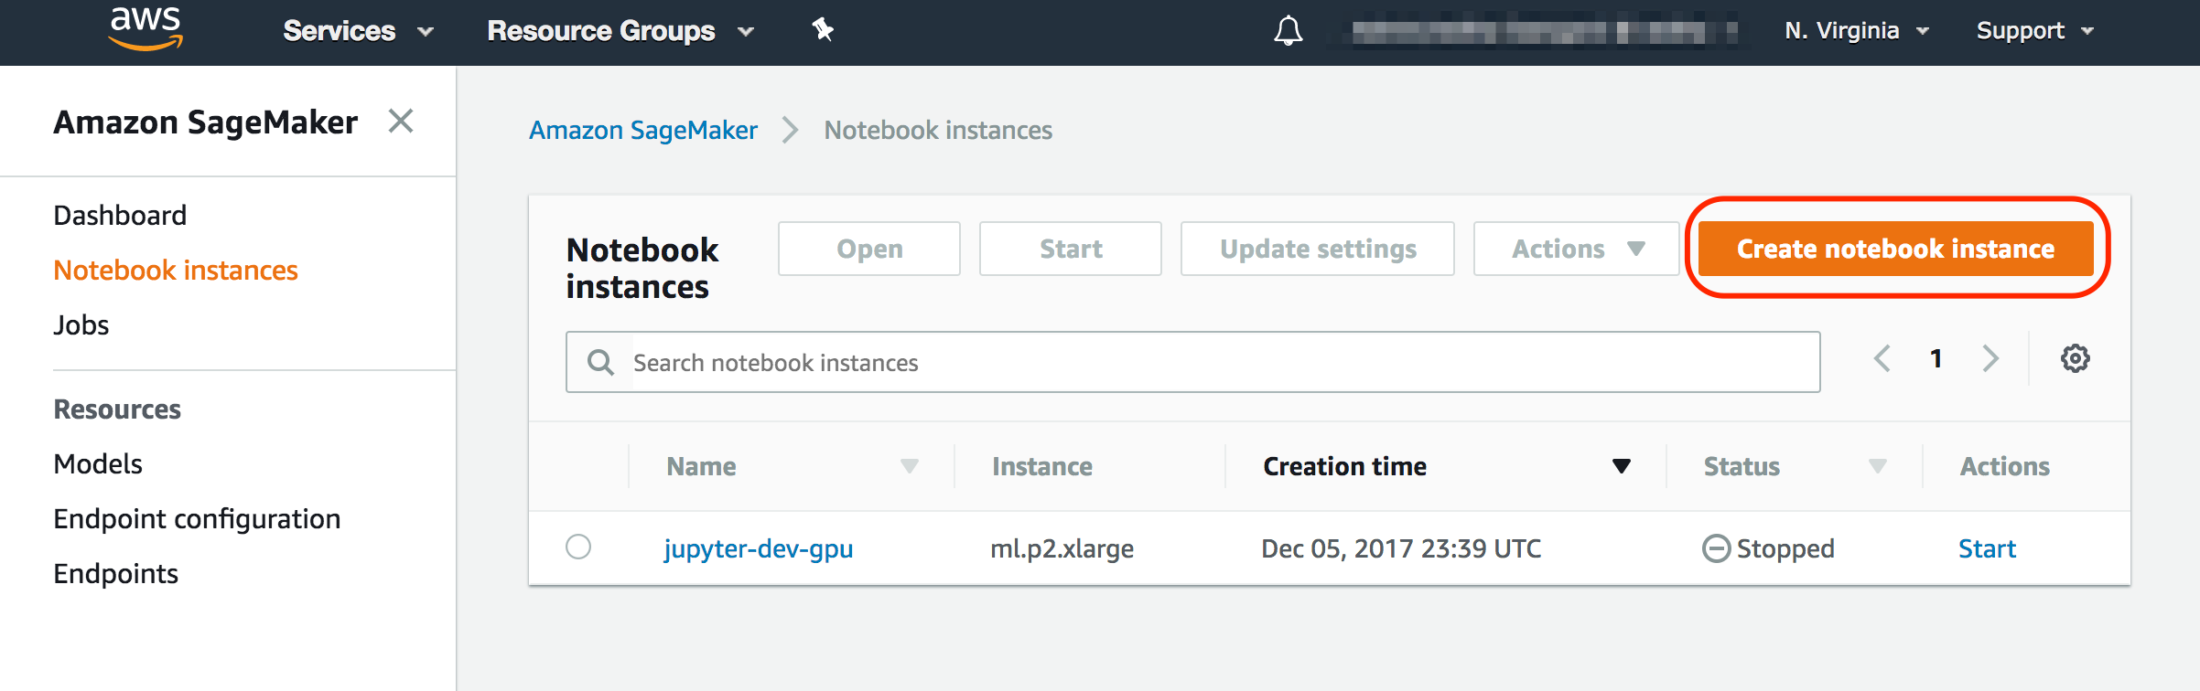
5. Type *[First Name]-[Last Name]-Lab-Server* into the **Notebook instance name** text box, *ml.p2.xlarge* into**the Notebook instance type***.*
6. In the resulting modal popup, choose **Create a new role**, and select *None* under the **S3 Buckets you specify – optional.** Click and **Create role.  
   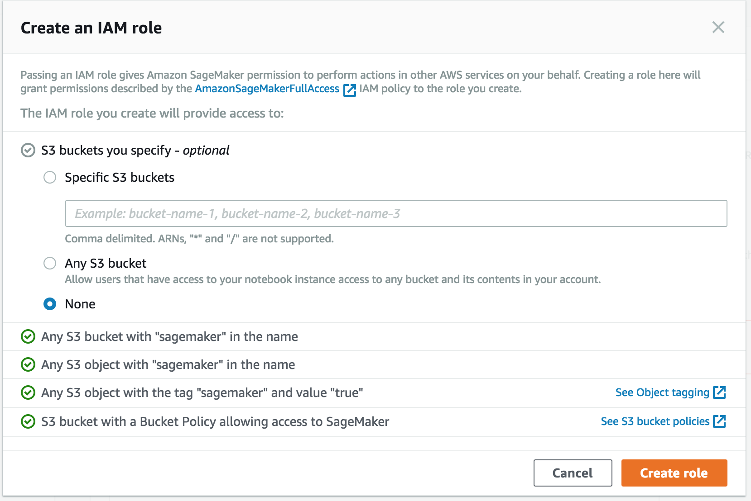**
7. You will be taken back to the **Create Notebook instance** page, click **Create notebook instance.** This will launch a p2.xlarge instance running the Amazon Deep Learning AMI.

# Accessing the Jupyter Notebook Instance

1. Make sure that the server status is **InService**. This will take a few minutes.

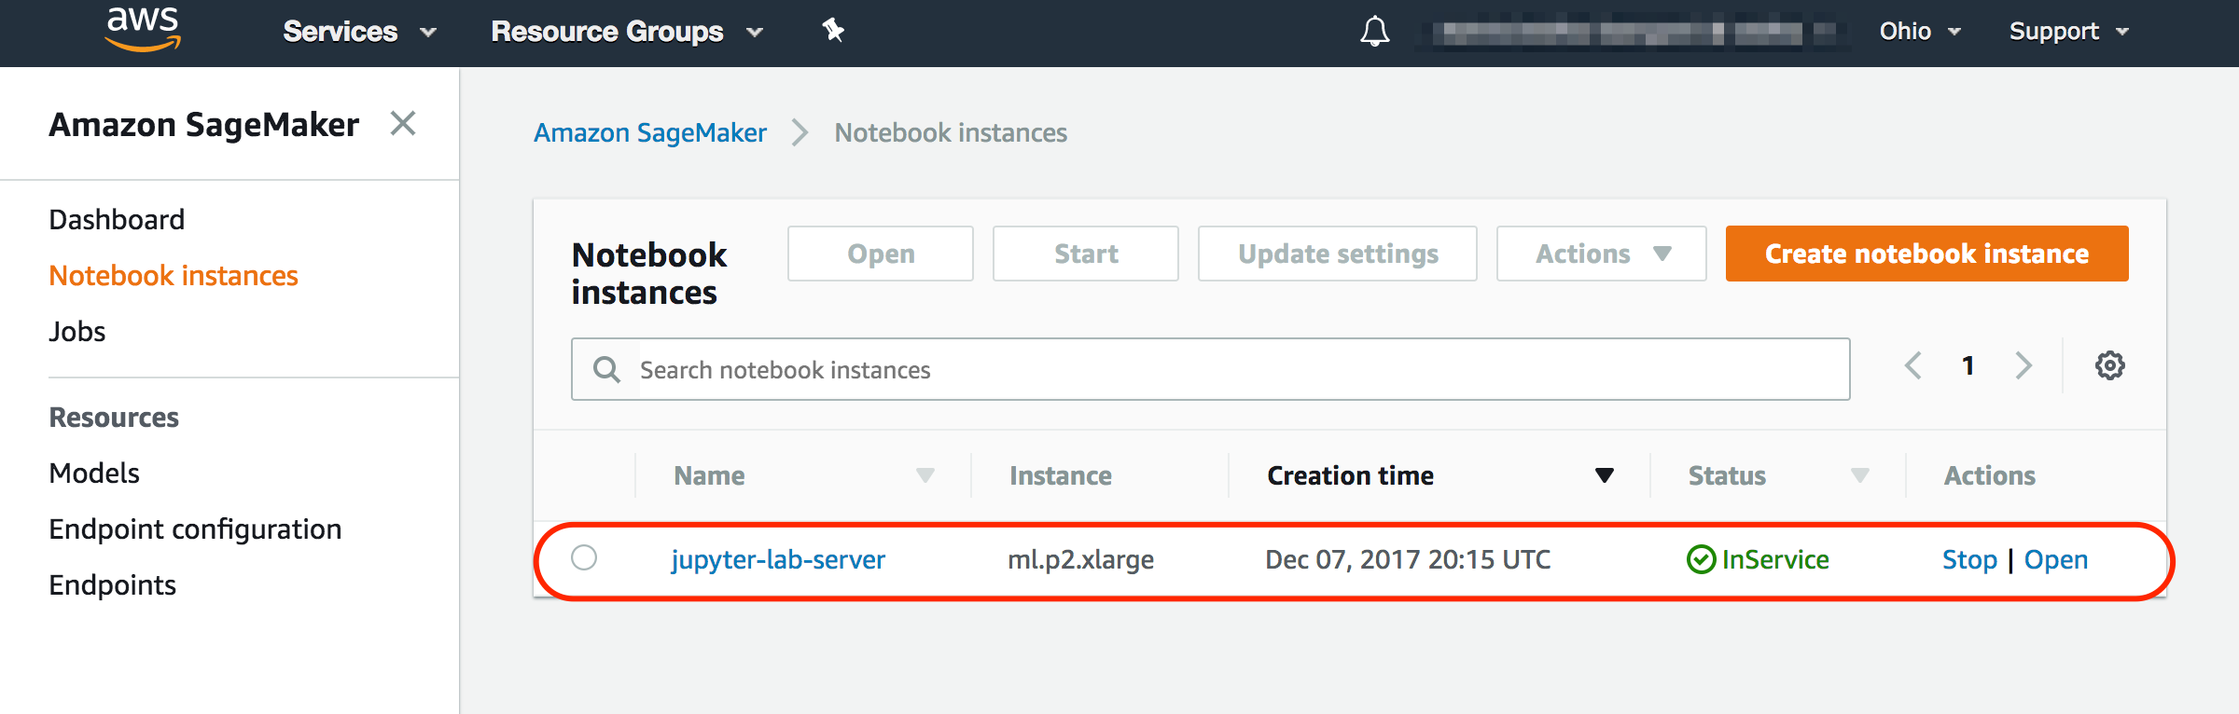

1. Click **Open**. You now have access to the Jupyter Notebok.

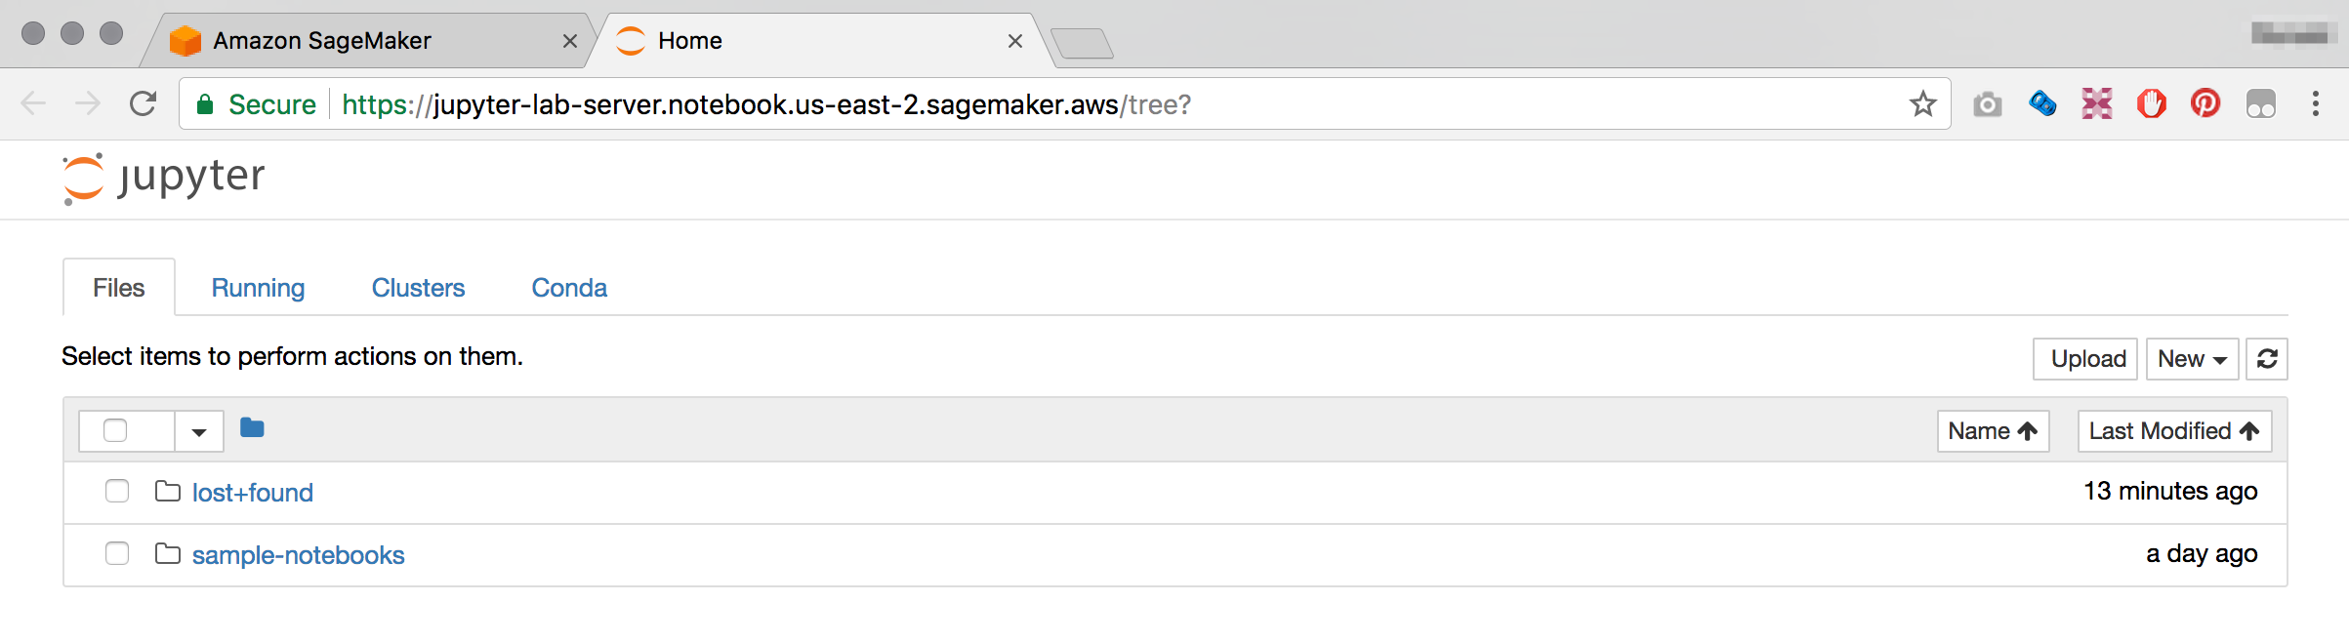

# 

# Launching Jupyter Notebooks

1. We are going to log on to the server by launching a terminal console. Click **New** and select **Terminal.** This will open up the terminal on a new browser tab.

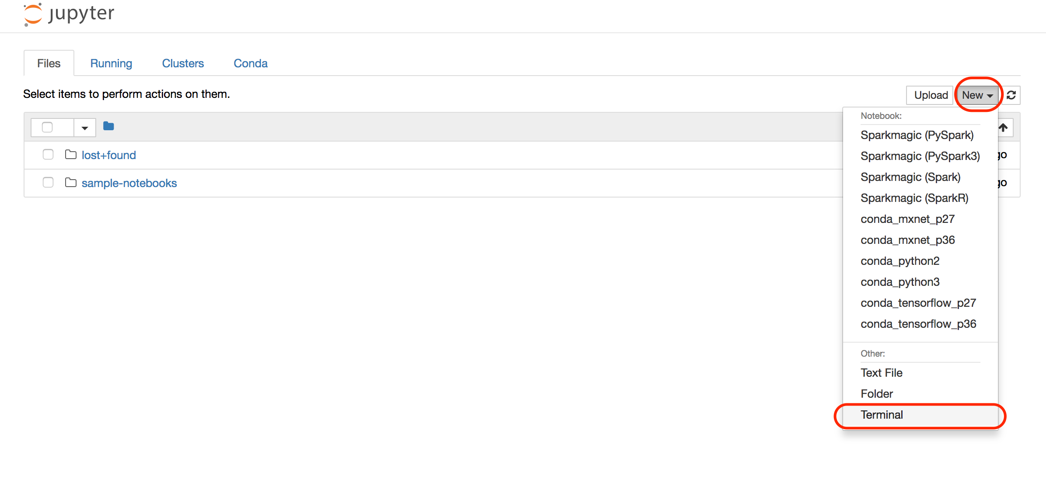

1. To download all the lab files and supporting file execute the following command

cd sample-notebooks/

wget https://s3.amazonaws.com/sa-imd/sa_ml_lab.tar.gz

1. Extract the files by typing

tar xf sa_ml_lab.tar.gz

1. Go back to the previous browser tab, and click on **sample-notebooks** and **ml-labs**, you should now see the following 3 note books:

* Sentiment_MLP_MXNet.ipynb
* Sentiment_CNN_MXNet.ipynb
* time-series-lstm.ipynb

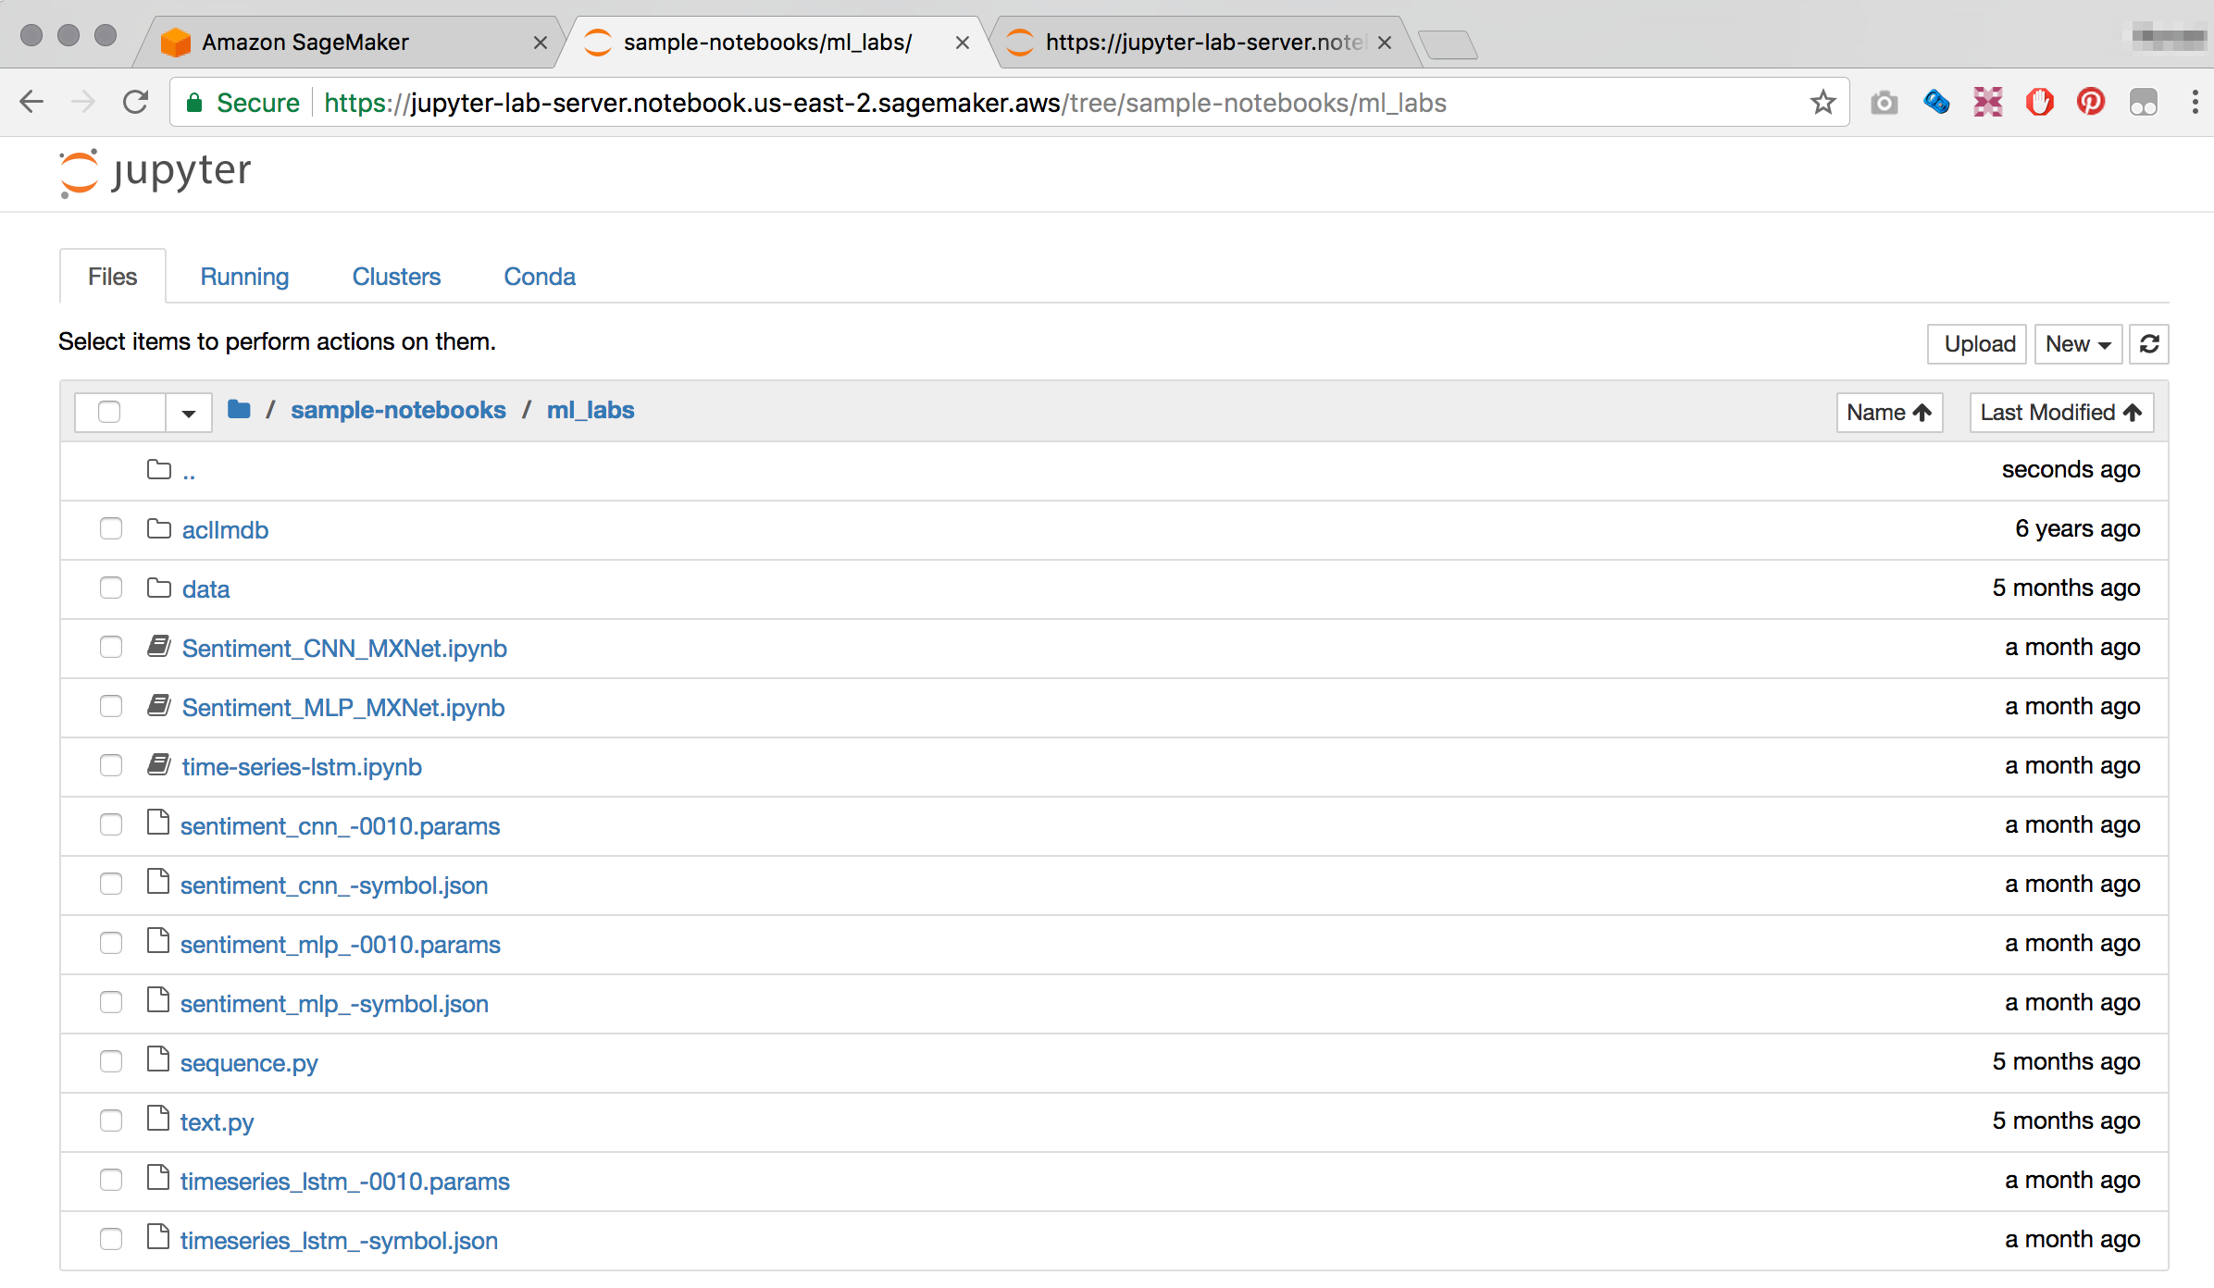

1. Click each of the notebooks to start the lab.
2. Change kernel to *“Environment (conda_mxnet_p27)”.*



1. Instructions continue on the Jupyter interface.

# Terminating the Notebook Instance

1. Open the Amazon SageMaker console <https://console.aws.amazon.com/sagemaker/> and click on **Notebook instances**
2. Find the notebook instance listed as *[First Name]-[Last Name]-Lab-Server* and click on the server name
3. Click **Delete** to terminate the Notebook Instance.

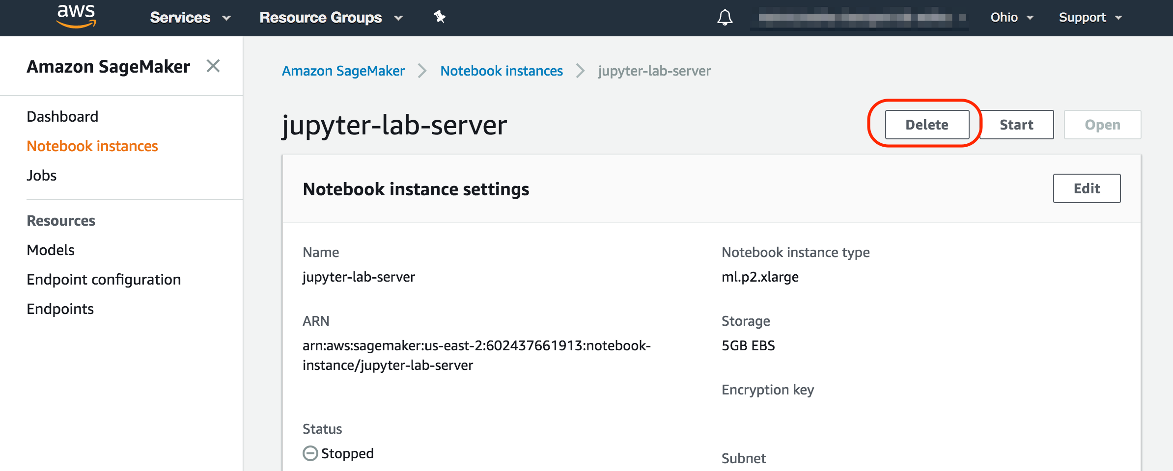

# Conclusion

In this lab you have learned the basic operations using Amazon SageMaker to launch the Amazon Deep Learning AMI on a P2.XLarge instance, run Jupyter Notebooks and step through some of these notebooks.