# **Stacking Quantum Error Mitigation Techniques using the Mitiq Python Toolkit**

Abir Hossain, Naziba Tasnim

## **Introduction**

In this report, we demonstrate an experimental investigation of combining multiple Quantum Error Mitigation (QEM) techniques using the Mitiq Python toolkit and explore their effectiveness. We aim to evaluate different combinations of QEM algorithms to attain the lowest possible error rate. We propose a Design of Experiments to find out the best possible result.

## **Methodology**

This report charts several experiments of combining error mitigation techniques through the Mitiq Python toolkit and aims to find the combinations with the lowest possible error rate for different types of circuits. For these experiments in particular, we simulate a set of QEM “stacks” (combinations) on randomized benchmarking and GHZ circuits under different noise models. This analysis aims to understand how each combination performs across a wide variety of quantum circuits.

### **Circuits**

The experiments were done on three sets of circuits: randomized benchmarking circuits, GHZ circuits, and W State circuits.

Randomized benchmarking (RB) of a quantum circuit quantifies average error rates through the execution of long sets of random gates through a single parameter [1]. The number of states differing from the ground state are counted, which acts as an estimate of gate error rates and an indicator of the overall performance of a quantum computer. It allows for the flexibility of applying various QEM combinations by adding Clifford gates to the circuit.

A generalized Greenberger-Horne-Zeilinger (GHZ) state in a quantum circuit includes at least three qubits, with a linear increase in depth with the number of qubits added. The GHZ state for a system of n-qubits is given as,

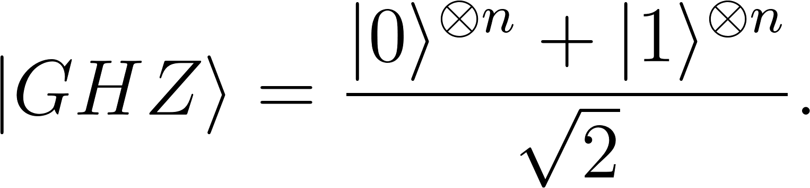

The W-state circuit is a type of general multipartite entangled circuit. It is useful for distributing quantum information processing as it is robust against loss and central to quantum memories, multiparty quantum network protocols and universal quantum cloning machines [2]. As a generalization, for n qubits of which exactly one is in an excited state  and all others remain in a ground state  with equal probability, a superposition of all possible states would be:

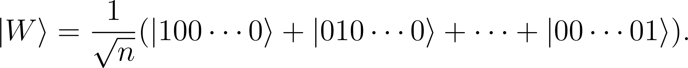

The benchmark circuits used in the experiments are generated from the **mitiq.benchmarks** module using the **generate_rb_circuit**, **generate_ghz_circuit**,and **generate_w_circuit** functions.

### **Noise Model**

Here, we utilize a noise model in the execute function. The noise model is a combination of depolarizing noise, bit-flip noise, and phase-flip noise. A combination of different noise models is taken to test the robustness of QEM techniques.

The noise models used in the experiments are generated from the **cirq** library using the **cirq.depolarize**, **cirq.bit_flip**, and **cirq.phase_flip** functions.

### **QEM Techniques**

The defined executor function with the noise model combinations is implemented for each of the techniques mentioned below, in order to run multiple circuits and store the results which are returned as bitstrings.

Readout error mitigation (REM) utilizes inverted transition/confusion matrices which are then applied to the noisy measurement results. The particular technique applied here involves the generation of a confusion matrix for a specific circuit, and the application of the calculated pseudoinverse of this matrix to the readout results.

In Digital Dynamical Decoupling (DDD), a series of gates are applied to single-qubit idle windows within a quantum circuit, in order to mitigate decoherence and reduce the effects of noise within open quantum systems [3].

Probabilistic error cancellation (PEC) expresses ideal gates as linear combinations of noisy gates known as quasi-probability representations [4]. In other words, additional qubits that store information about errors are introduced into the quantum circuit, which are then used to probabilistically cancel out errors.

Zero-noise extrapolation (ZNE) extrapolates a noiseless expectation value of an observable by scaling the noise at different noise levels. Methods used to scale the noise include unitary folding [5], identity scaling, local and global folding.

The QEM techniques used in the experiments are implemented using the techniques and functionalities provided by the **mitiq** library.

### **Design of Experiments**

**Table 1.** Design of Experiments with different combinations of QEM techniques, benchmark circuits, and noise models.

| **Experiment** | **QEM Stack** | **Benchmark** | **Noise Model** |
| --- | --- | --- | --- |
| E1 | DDD | RB [5, 10, 20] | DP=0.005, BF=0.05, PF=0.05 |
| E2 | ZNE | RB [5, 10, 20] | DP=0.005, BF=0.05, PF=0.05 |
| E3 | REM | RB [5, 10, 20] | DP=0.005, BF=0.05, PF=0.05 |
| E4 | REM + ZNE (Local) | RB [5, 10, 20] | DP=0.005, BF=0.05, PF=0.05 |
| E5 | REM + ZNE (Global) | RB [5, 10, 20] | DP=0.005, BF=0.05, PF=0.05 |
| E6 | REM + DDD | RB [5, 10, 20] | DP=0.005, BF=0.05, PF=0.05 |

In Table 1, we have created a DoE with a combination of parameters of the QEM stack and Benchmark circuits.

## **Evaluation & Results**

The best result is produced by E6 or the QEM stack of REM and ZNE with global folding. It has an absolute error percentage of 0.01 or 1%. Table 2 summarizes all the experiment results. It shows that on RB circuits REM and ZNE perform better than DDD. The table also shows relative error mitigation (REM) metric [6], which is calculated using the following formula:

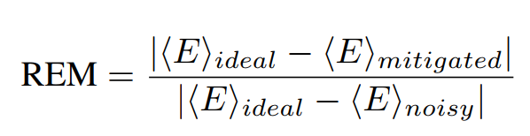

**Table 2.** Design of Experiments with different combinations of QEM techniques, benchmark circuits, and noise models.

| **Experiment** | **Ideal Value** | **Max. Mitigated Value** | **Min. Error** | **Min. REM** |
| --- | --- | --- | --- | --- |
| E1 | 2 | 1.24 | 0.37 | 0.97 |
| E2 | 2 | 1.93 | 0.03 | 0.07 |
| E3 | 2 | 1.52 | 0.24 | 0.6 |
| E4 | 2 | 2.07 | 0.03 | 0.06 |
| E5 | 2 | 1.97 | 0.01 | 0.03 |
| E6 | 2 | 1.55 | 0.22 | 0.58 |

Surface plot of the parameters of the experiments and their results are shown in Figure 1 and 2. The plots are generated using the results data.

**Figure 1.** (E1 - E6) Surface plots of the experiments where X-axis shows the benchmark circuit parameters, Y-axis shows the parameters of the QEM, and Z-axis shows the error.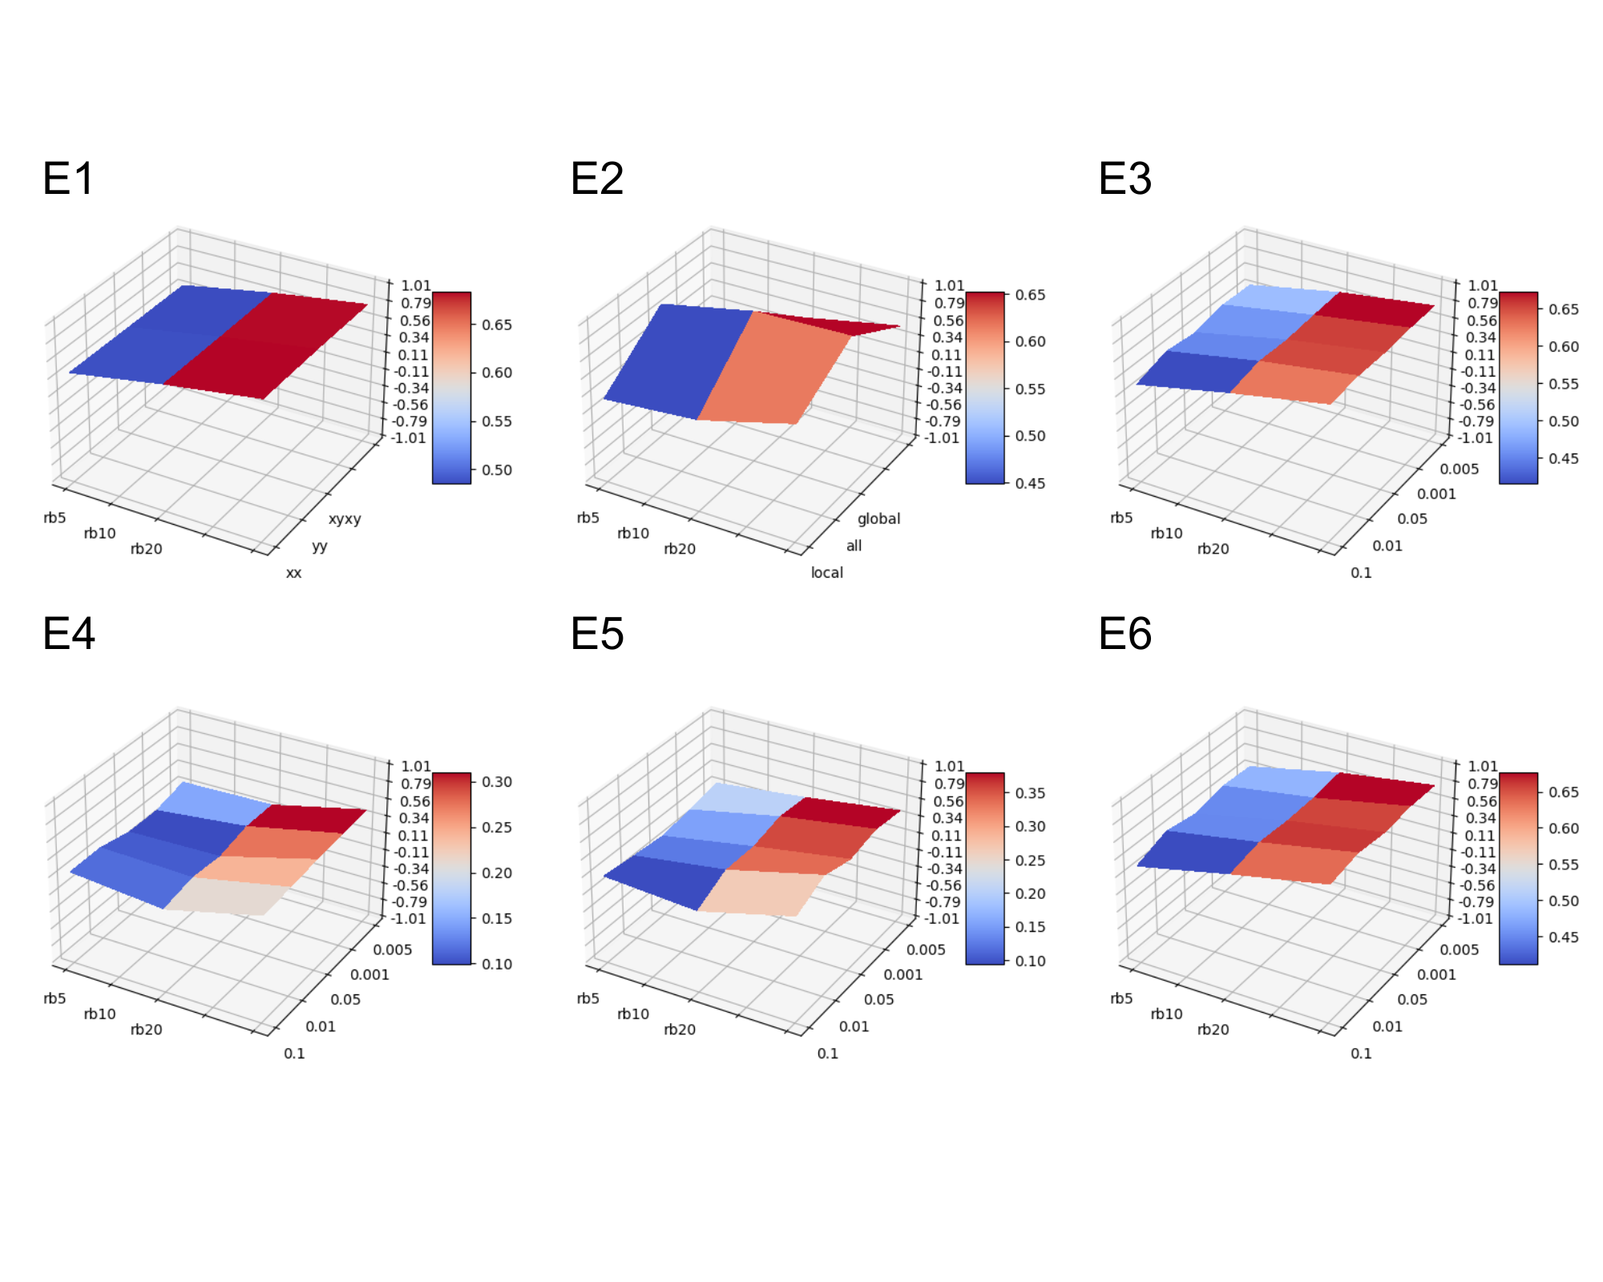

**Figure 2.** (E1 - E6) Surface plots (with gradients) of the experiments where X-axis shows the benchmark circuit parameters, Y-axis shows the parameters of the QEM, and Z-axis shows the error.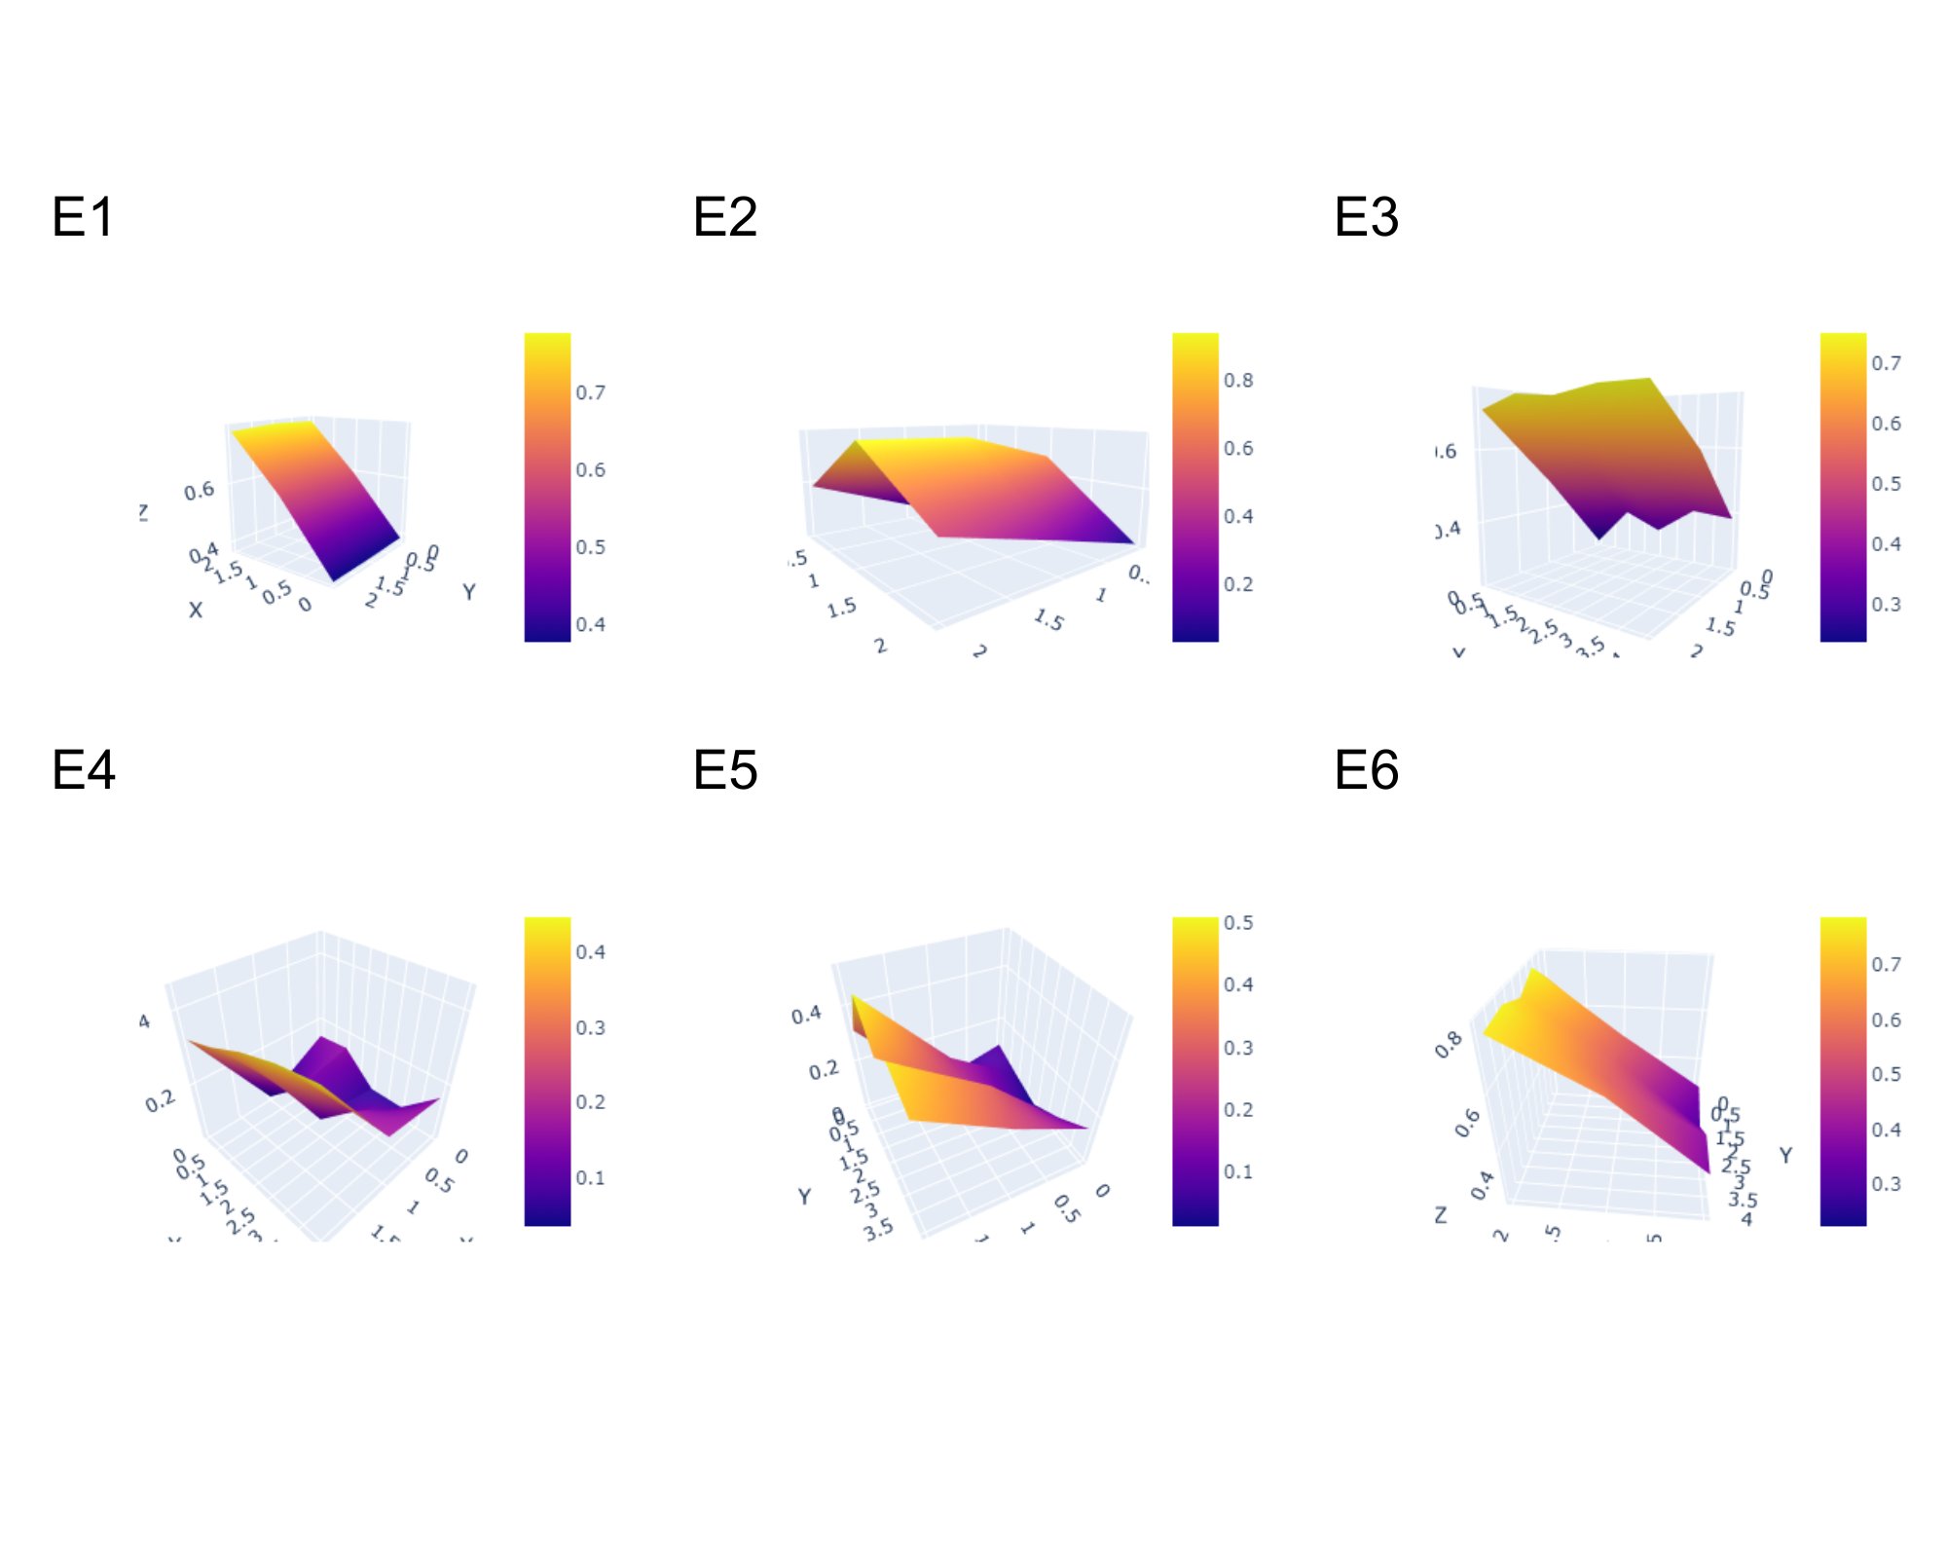

## **Conclusions & Future Work**

In this project, we explore the stacking QEM techniques to enhance the accuracy of quantum computations. By leveraging the Mitiq library, we investigated different combinations of QEM techniques with stacking and composing and assess their effectiveness in random benchmark circuits. The findings from this project will contribute to the advancement of QEM and pave the way for the realization of more robust quantum computers.

The experiments, in this project, can be extended to include several different circuits, noise models, and other QEM techniques. We chose not to incorporate relatively time-consuming and resource-intensive techniques such as PEC in our experiments. Covering all these aspects will make for better experimental work and provide more comprehensive results, and in subsequent work we aspire to explore this in depth.

## **Data & Code**

The code and the results of this experiment can be found the following colab notebook: [QRISE_UF_Challange_2024.ipynb](https://colab.research.google.com/drive/1rXkaTcxU7X3ucwiRmLeKki7I4CIgmxeV?usp=sharing)

## **References**

[1] Magesan, E., Gambetta, J., & Emerson, J. (2011). Scalable and robust randomized benchmarking of quantum processes. *Physical Review Letters*, *106*(18). <https://doi.org/10.1103/physrevlett.106.180504>

[2] Cruz, D., Fournier, R., Gremion, F., Jeannerot, A., Komagata, K., Tosic, T., Thiesbrummel, J., Chan, C.L., Macris, N., Dupertuis, M.-A. and Javerzac-Galy, C. (2019), Efficient Quantum Algorithms for GHZ and W States, and Implementation on the IBM Quantum Computer. Adv. Quantum Technol., 2: 1900015. https://doi.org/10.1002/qute.201900015

[3] Viola, L., Knill, E., & Lloyd, S. (1999). Dynamical decoupling of open quantum systems. *Physical Review Letters*, *82*(12), 2417–2421. <https://doi.org/10.1103/physrevlett.82.2417>

[4] Pashayan, H., Wallman, J. J., & Bartlett, S. D. (2015). Estimating outcome probabilities of quantum circuits using quasiprobabilities. *Physical Review Letters (Print)*, *115*(7). <https://doi.org/10.1103/physrevlett.115.070501>

[5] Liu, Y., & Benjamin, S. C. (2017). Efficient variational quantum simulator incorporating active error minimization. *Physical Review. X*, *7*(2). <https://doi.org/10.1103/physrevx.7.021050>

[6] A. A. Saki, A. Katabarwa, S. Resch, & G. Umbrarescu. (2023). Hypothesis Testing for Error Mitigation: How to Evaluate Error Mitigation. <https://doi.org/10.48550/arXiv.2301.02690>