Міністерство освіти і науки України

НАЦІОНАЛЬНИЙ УНІВЕРСИТЕТ «ЛЬВІВСЬКА ПОЛІТЕХНІКА»

Інститут комп'ютерних технологій, автоматики та метрології

Кафедра ЕОМ



**Звіт**

**До лабораторної роботи №9**

# З дисципліни: «Кросплатформні засоби програмування»

На тему «ОСНОВИ ОБ’ЄКТНО-ОРІЄНТОВАНОГО ПРОГРАМУВАННЯ У PYTHON»

# Варіант №17

Виконав: ст. гр. КІ-305

Легкобит Н.В

Прийняв:

Олексів М.В

Львів – 2023

**Мета:** оволодіти навиками реалізації парадигм об’єктно-орієнтованого програмування використовуючи засоби мови Python

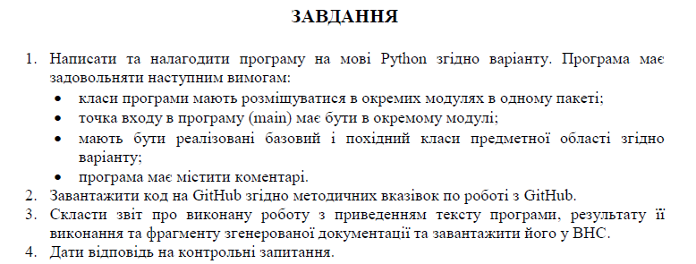



**Виконання:**

**Лістинг програми:**

class Button:  
 def __init__(self, action):  
 self.action = action  
  
 @property  
 def get_action(self):  
 return self.action  
  
 @property  
 def set_action(self, action):  
 self.action = action  
  
 def __str__(self):  
 return f'Button{{ action=\'{self.action}\'}}'

class HardDisk:  
 def __init__(self, capacity, producer):  
 self.capacity = capacity  
 self.producer = producer  
  
 @property  
 def get_capacity(self):  
 return self.capacity  
  
 @property  
 def get_producer(self):  
 return self.producer  
  
 @property  
 def set_capacity(self, capacity):  
 self.capacity = capacity  
  
 @property  
 def set_producer(self, producer):  
 self.producer = producer  
  
 def __str__(self):  
 return "HardDisk{ " + "capacity = " + str(self.capacity) + " mb." + ", producer = '" + self.producer + '\'' + '}'

from Screen import Screen  
from HardDisk import HardDisk  
from VideocassetteRecorder import VideocassetteRecorder  
  
def main():  
 screen_instance = Screen(7.8, "720x1980")  
 hard_disk_instance = HardDisk(1000, "Harman")  
  
 vcr_instance = VideocassetteRecorder(screen_instance, hard_disk_instance, "VHS")  
  
 vcr_instance.add_video("My birthday video")  
 vcr_instance.add_video("First time in France")  
 vcr_instance.add_video("Lviv")  
 vcr_instance.add_video("Party")  
 vcr_instance.add_video("Karate competition")  
  
 vcr_instance.turn_on_next_video()  
 vcr_instance.turn_on_next_video()  
 vcr_instance.turn_on_next_video()  
  
 vcr_instance.turn_on_prev_video()  
 vcr_instance.turn_on_prev_video()  
 vcr_instance.turn_on_prev_video()  
 vcr_instance.turn_on_prev_video()  
  
 print(vcr_instance)  
  
if __name__ == "__main__":  
 main()

class Screen:  
 def __init__(self, diagonal, expansion):  
 self.diagonal = diagonal  
 self.expansion = expansion  
  
 @property  
 def get_diagonal(self):  
 return self.diagonal  
  
 @property  
 def get_expansion(self):  
 return self.expansion  
  
 @property  
 def set_diagonal(self, diagonal):  
 self.diagonal = diagonal  
  
 @property  
 def set_expansion(self, expansion):  
 self.expansion = expansion  
  
 def __str__(self):  
 return f'Screen{{ diagonal = {self.diagonal}, expansion = \'{self.expansion}\'}}'

from VideoPlayer import VideoPlayer  
  
class VideocassetteRecorder(VideoPlayer):  
 def __init__(self, screen, hard_disk, cassette_type):  
 super().__init__(screen, hard_disk)  
 self.cassette_type = cassette_type  
  
 def insert_cassette(self):  
 print(f"Inserting {self.cassette_type} cassette into the videocassette recorder")  
  
 def eject_cassette(self):  
 print(f"Ejecting {self.cassette_type} cassette from the videocassette recorder")  
  
 def record_video_to_cassette(self, video):  
 print(f"Recording video to {self.cassette_type} cassette: {video}")

from Button import Button  
import logging  
  
class VideoPlayer:  
 def __init__(self, screen, hard_disk):  
 self.next_video = Button("next video")  
 self.prev_video = Button("prev video")  
 self.pause = Button("pause")  
 self.logger = logging.getLogger("logs.txt")  
 self.screen = screen  
 self.hard_disk = hard_disk  
 self.videos = []  
 self.cur_video = 0  
  
 self.logger.info("VideoPlayer constructor called")  
  
 def add_video(self, video):  
 self.videos.append(video)  
 print(f"{video} was added to video player")  
 self.logger.info("VideoPlayer add_video method was called")  
  
 def turn_on_next_video(self):  
 self.logger.info("turn_on_next_video VideoPlayer method was called")  
 if self.cur_video == len(self.videos) - 1:  
 print(f"You push button {self.next_video.get_action}")  
 print(f"Now showing {self.videos[self.cur_video]}")  
 self.cur_video = 0  
 elif 0 <= self.cur_video < len(self.videos) - 1:  
 print(f"You push button {self.next_video.get_action}")  
 print(f"Now showing {self.videos[self.cur_video]}")  
 self.cur_video += 1  
  
 def turn_on_prev_video(self):  
 self.logger.info("turn_on_prev_video VideoPlayer method was called")  
 if self.cur_video == 0:  
 print(f"You push button {self.prev_video.get_action}")  
 print(f"Now showing {self.videos[self.cur_video]}")  
 self.cur_video = len(self.videos) - 1  
 elif 0 < self.cur_video <= len(self.videos) - 1:  
 print(f"You push button {self.prev_video.get_action}")  
 print(f"Now showing {self.videos[self.cur_video]}")  
 self.cur_video -= 1  
  
 def __str__(self):  
 return f'VideoPlayer{{ screen={self.screen}, hard_disk={self.hard_disk}, videos={self.videos}, cur_video={self.cur_video}}}'

**Результати:**

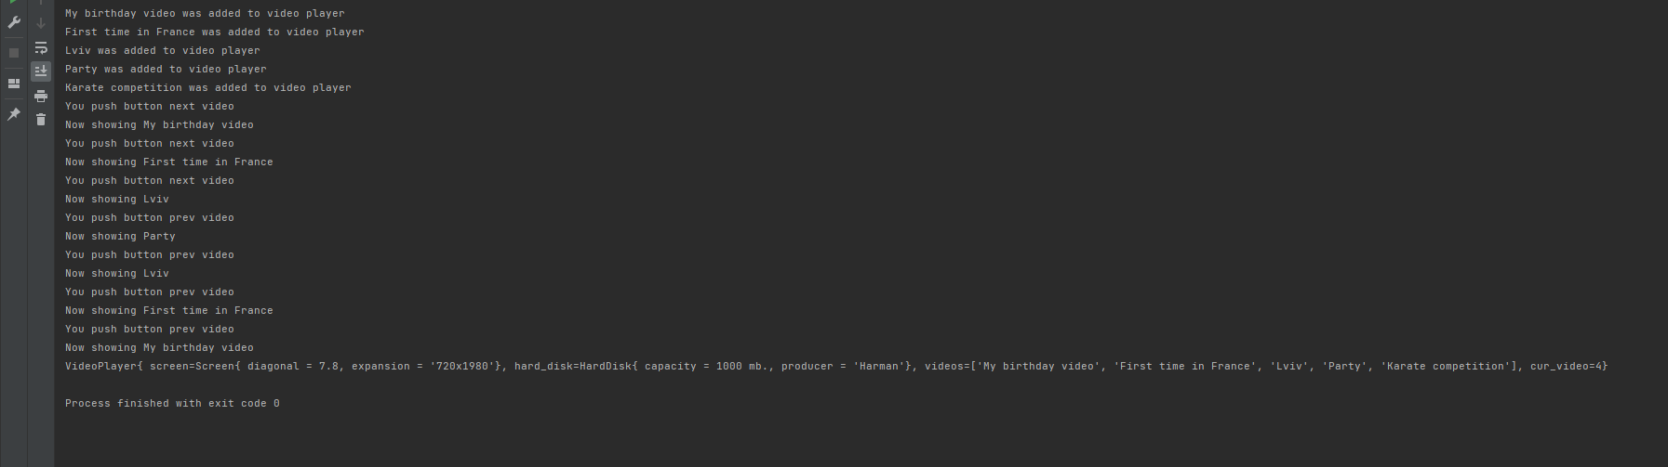

**Висновок:** ознайомився з основами ООП на мові програмування Python.