**МІНІСТЕРСТВО ОСВІТИ ТА НАУКИ УКРАЇНИ**

**НАЦІОНАЛЬНИЙ ТЕХНІЧНИЙ УНІВЕРСИТЕТ УКРАЇНИ «КПІ»**

**Кафедра інформаційних систем та технологій**

Лабораторна робота №2

з дисципліни «Розробка програмного забезпечення на платформі .Net»

на тему:

«Модульне тестування. Ознайомлення з засобами та практиками

модульного тестування»

|  |  |  |
| --- | --- | --- |
| Викладачк:  Бардін В. |  | Виконав:                                               Студент групи ІС-11  Петраков Назар |

Київ – 2023

**Мета лабораторної роботи** – навчитися створювати модульні тести для

вихідного коду розроблювального програмного забезпечення.

**Завдання:**

1. Додати до проекту власної узагальненої колекції (застосувати

виконану лабораторну роботу No1) проект модульних тестів,

використовуючи певний фреймворк (Nunit, Xunit, тощо).

2. Розробити модульні тести для функціоналу колекції.

3. Дослідити ступінь покриття модульними тестами вихідного коду

колекції, використовуючи, наприклад, засіб AxoCover.

Програмний код:

AddingTests.cs

namespace MyCollection.Tests

{

public class AddingTests

{

[Fact]

public void AddItem_NullKey_ArgumentNullException()

{

MyDictionary<object, object> myDictionary = new MyDictionary<object, object>();

var action = () => myDictionary.Add(null!, 2);

Assert.Throws<ArgumentNullException>(action);

}

[Fact]

public void AddItem_KeyAlreadyExist_ArgumentException()

{

MyDictionary<object, object> myDictionary = new MyDictionary<object, object>();

var action = () =>

{

myDictionary.Add(4, "four");

myDictionary.Add(4, "five");

};

Assert.Throws<ArgumentException>(action);

}

[Theory]

[MemberData(nameof(TestDataGenerator.GetNumbersFromDataGenerator), MemberType = typeof(TestDataGenerator))]

public void AddItems_ValidData_CollectionWithItems(KeyValuePair<object, object> kvp1, KeyValuePair<object, object> kvp2)

{

MyDictionary<object, object> myDictionary = new MyDictionary<object, object>();

myDictionary.Add(kvp1);

myDictionary.Add(kvp2);

Assert.Equal(kvp1.Value, myDictionary[kvp1.Key]);

Assert.True(myDictionary.ContainsKey(kvp2.Key));

}

}

}

ContainsTests.cs

namespace MyCollection.Tests

{

public class ContainsTests

{

[Fact]

public void ContainsKeyValue_ExistingPair_ReturnsTrue()

{

var myDictionary = new MyDictionary<int, string>();

myDictionary.Add(1, "One");

bool result = myDictionary.Contains(new KeyValuePair<int, string>(1, "One"));

Assert.True(result);

}

[Fact]

public void ContainsKeyValue_NotExistPair_ReturnsFalse()

{

var myDictionary = new MyDictionary<int, string>();

bool result = myDictionary.Contains(new KeyValuePair<int, string>(1, "One"));

Assert.False(result);

}

[Fact]

public void Contains_NullKey_ThrowsArgumentNullException()

{

var myDictionary = new MyDictionary<object, string>();

Action action = () => myDictionary.Contains(new KeyValuePair<object, string>(null!, "One"));

Assert.Throws<ArgumentNullException>(action);

}

[Fact]

public void ContainsKey_ExistingKey_ReturnsTrue()

{

var myDictionary = new MyDictionary<int, string>();

myDictionary.Add(1, "One");

bool result = myDictionary.ContainsKey(1);

Assert.True(result);

}

[Fact]

public void ContainsKey_NonExistentKey_ReturnsFalse()

{

var myDictionary = new MyDictionary<int, string>();

bool result = myDictionary.ContainsKey(1);

Assert.False(result);

}

[Fact]

public void ContainsKey_NullKey_ThrowsArgumentNullException()

{

var myDictionary = new MyDictionary<object, string>();

Action action = () => myDictionary.ContainsKey(null!);

Assert.Throws<ArgumentNullException>(action);

}

}

}

CopyToTests.cs

namespace MyCollection.Tests

{

public class CopyToTests

{

[Fact]

public void CopyTo_CopiesElementsToDestinationArray()

{

var myDictionary = new MyDictionary<int, string>

{

{ 1, "One" },

{ 2, "Two" },

{ 3, "Three" }

};

var array = new KeyValuePair<int, string>[3];

myDictionary.CopyTo(array, 0);

Assert.Equal(new KeyValuePair<int, string>(1, "One"), array[0]);

Assert.Equal(new KeyValuePair<int, string>(2, "Two"), array[1]);

Assert.Equal(new KeyValuePair<int, string>(3, "Three"), array[2]);

}

[Fact]

public void CopyTo_NullArray_ArgumentNullException()

{

var myDictionary = new MyDictionary<int, string>();

var array = (KeyValuePair<int, string>[])null!;

Action action = () => myDictionary.CopyTo(array, 0);

Assert.Throws<ArgumentNullException>(action);

}

[Fact]

public void CopyTo_NegativeArrayIndex_ArgumentOutOfRangeException()

{

var myDictionary = new MyDictionary<int, string>();

var array = new KeyValuePair<int, string>[3];

Action action = () => myDictionary.CopyTo(array, -1);

Assert.Throws<ArgumentOutOfRangeException>(action);

}

[Fact]

public void CopyTo_ArrayIndexOutOfRange_ArgumentOutOfRangeException()

{

var myDictionary = new MyDictionary<int, string>();

var array = new KeyValuePair<int, string>[3];

Action action = () => myDictionary.CopyTo(array, 5);

Assert.Throws<ArgumentOutOfRangeException>(action);

}

[Fact]

public void CopyTo_ArrayTooSmall_ArgumentException()

{

var myDictionary = new MyDictionary<int, string>

{

{ 1, "One" },

{ 2, "Two" }

};

var array = new KeyValuePair<int, string>[1];

Action action = () => myDictionary.CopyTo(array, 0);

Assert.Throws<ArgumentException>(action);

}

}

}

CreationTests.cs

namespace MyCollection.Tests

{

public class CreationTests

{

[Fact]

public void CreateMyDictionary_WithoutParams_EmptyDictionary()

{

MyDictionary<object, object> myDictionary;

myDictionary = new MyDictionary<object, object>();

Assert.Empty(myDictionary);

}

[Fact]

public void CreateMyDictionary_CapacityLessThanZero_ArgumentOutOfRangeException()

{

MyDictionary<object, object> myDictionary;

var action = () => { myDictionary = new MyDictionary<object, object>(-5); };

Assert.Throws<ArgumentOutOfRangeException>(action);

}

[Fact]

public void CreateMyDictionary_ZeroCapacity_EmptyDictionary()

{

MyDictionary<object, object> myDictionary;

myDictionary = new MyDictionary<object, object>(0);

Assert.Empty(myDictionary);

}

[Fact]

public void CreateMyDictionary_InitialCapacity_ShouldBeResized()

{

int initialCapacity = 10;

var myDictionary = new MyDictionary<int, string>(initialCapacity);

for (int i = 0; i < initialCapacity + 1; i++)

{

myDictionary.Add(i, $"Value{i}");

}

Assert.True(myDictionary.Count > initialCapacity);

}

}

}

EventsTests.cs

namespace MyCollection.Tests

{

public class EventsTests

{

[Fact]

public void AddedPairEvent()

{

bool isEventTriggered = false;

var myDictionary = new MyDictionary<int, string>

{

{ 1, "One" },

};

myDictionary.AddedPair += (sender, args) =>

isEventTriggered = true;

myDictionary.Add(2, "Two");

Assert.True(isEventTriggered);

}

[Fact]

public void RemovedPairEvent()

{

bool isEventTriggered = false;

var myDictionary = new MyDictionary<int, string>

{

{ 1, "One" },

};

myDictionary.RemovedPair += (sender, args) =>

isEventTriggered = true;

myDictionary.Remove(1);

Assert.True(isEventTriggered);

}

[Fact]

public void ChangedValueEvent()

{

bool isEventTriggered = false;

var myDictionary = new MyDictionary<int, string>

{

{ 1, "One" },

};

myDictionary.ChangedValue += (sender, args) =>

isEventTriggered = true;

myDictionary[1] = "!ONE!";

Assert.True(isEventTriggered);

}

[Fact]

public void ClearedEvent()

{

bool isEventTriggered = false;

var myDictionary = new MyDictionary<int, string>

{

{ 1, "One" },

};

myDictionary.Cleared += (sender, args) =>

isEventTriggered = true;

myDictionary.Clear();

Assert.True(isEventTriggered);

}

}

}

IndexerTests.cs

namespace MyCollection.Tests

{

public class IndexerTest

{

[Fact]

public void GetValueIndexer_ValueByKey1_One()

{

var myDictionary = new Dictionary<int, string>

{

{ 1, "One" }

};

var a = myDictionary[1];

Assert.Equal("One", a);

}

[Fact]

public void GetValueIndexer_ValueByKey2_KeyNotFoundException()

{

var myDictionary = new MyDictionary<int, string>

{

{ 1, "One" }

};

var action = () => myDictionary[2];

Assert.Throws<KeyNotFoundException>(action);

}

[Fact]

public void SetValueIndexer_ValueTwoByKey2_NewItem()

{

var myDictionary = new MyDictionary<int, string>

{

{ 1, "One" }

};

myDictionary[1] = "ONE";

Assert.Equal("ONE", myDictionary[1]);

}

[Fact]

public void SetValueIndexer_NullKey_ArgumentNullException()

{

var myDictionary = new MyDictionary<object, object>

{

{ 1, "One" }

};

var action = () => myDictionary[null!] = "ONE";

Assert.Throws<ArgumentNullException>(action);

}

[Fact]

public void SetValueIndexer_NotExistKey2_KeyNotFoundException()

{

var myDictionary = new MyDictionary<object, object>

{

{ 1, "One" }

};

var action = () => myDictionary[2] = "ONE";

Assert.Throws<KeyNotFoundException>(action);

}

}

}

MyEnumeratorTests.cs

namespace MyCollection.Tests

{

public class MyEnumeratorTests

{

[Fact]

public void MyEnumerator_Current_ValidIndex_ReturnsKeyValuePair()

{

var myDictionary = new MyDictionary<int, string>();

myDictionary.Add(1, "One");

var enumerator = myDictionary.GetEnumerator();

enumerator.MoveNext();

var currentKeyValuePair = enumerator.Current;

Assert.Equal(new KeyValuePair<int, string>(1, "One"), currentKeyValuePair);

}

[Fact]

public void MyEnumerator_Current_InvalidIndex_InvalidOperationException()

{

var myDictionary = new MyDictionary<int, string>();

var enumerator = myDictionary.GetEnumerator();

Func<object?> testCode = () => enumerator.Current;

Assert.Throws<InvalidOperationException>(testCode);

}

[Fact]

public void MyEnumerator_Reset_ResetsEnumeratorState()

{

// Arrange

var myDictionary = new MyDictionary<int, string>();

myDictionary.Add(1, "One");

myDictionary.Add(2, "Two");

myDictionary.Add(3, "Three");

var enumerator = myDictionary.GetEnumerator();

//Act

while (enumerator.MoveNext())

{

}

enumerator.Reset();

// Assert

Assert.True(enumerator.MoveNext());

Assert.Equal(new KeyValuePair<int, string>(1, "One"), enumerator.Current);

}

}

}

PropTests.cs

namespace MyCollection.Tests

{

public class PropTests

{

[Fact]

public void IsReadOnlyProp_ShouldReturnFalse()

{

var myDictionary = new MyDictionary<int, string>();

bool isReadOnly = myDictionary.IsReadOnly;

Assert.False(isReadOnly);

}

[Fact]

public void CountProp_ShouldBe3()

{

var myDictionary = new MyDictionary<int, string>()

{

{1, "one" },

{2, "two"},

{3, "three" }

};

var count = myDictionary.Count;

Assert.Equal(3, count);

}

[Fact]

public void KeysProp()

{

var myDictionary = new MyDictionary<int, string>()

{

{1, "one" },

{2, "two"},

{3, "three" }

};

var keys = myDictionary.Keys;

Assert.Collection(keys, key =>

{

Assert.Equal(1, key);

}, key =>

{

Assert.Equal(2, key);

}, key =>

{

Assert.Equal(3, key);

});

}

[Fact]

public void ValuesProp()

{

var myDictionary = new MyDictionary<int, string>()

{

{1, "one" },

{2, "two"},

{3, "three" }

};

var values = myDictionary.Values;

Assert.Collection(values, value =>

{

Assert.Equal("one", value);

}, value =>

{

Assert.Equal("two", value);

}, value =>

{

Assert.Equal("three", value);

});

}

}

}

RemovingTests.cs

namespace MyCollection.Tests

{

public class RemovingTests

{

[Fact]

public void RemoveItem_NullKey_ArgumentNullException()

{

var myDictionary = new MyDictionary<object, object>();

Action action = () => myDictionary.Remove(null!);

Assert.Throws<ArgumentNullException>(action);

}

[Fact]

public void RemoveItem_NotExistKey_KeyNotFoundException()

{

var myDictionary = new MyDictionary<int, string>();

Action action = () => myDictionary.Remove(1);

Assert.Throws<KeyNotFoundException>(action);

}

[Fact]

public void RemoveItem_ExistingKey_RemovesKey()

{

var myDictionary = new MyDictionary<int, string>()

{

{1, "one" },

{2, "two" },

{3, "three"}

};

bool result = myDictionary.Remove(2);

Assert.True(result);

Assert.False(myDictionary.ContainsKey(2));

}

[Fact]

public void RemoveKeyValue_NotExistPair_ReturnsFalse()

{

var myDictionary = new MyDictionary<int, string>();

bool result = myDictionary.Remove(new KeyValuePair<int, string>(1, "One"));

Assert.False(result);

}

[Fact]

public void RemoveKeyValue_NullKey_ArgumentNullException()

{

var myDictionary = new MyDictionary<object, string>();

Action action = () => myDictionary.Remove(new KeyValuePair<object, string>(null!, "One"));

Assert.Throws<ArgumentNullException>(action);

}

[Fact]

public void RemoveKeyValue_ExistingPair_RemovesPairAndReturnsTrue()

{

var myDictionary = new MyDictionary<int, string>()

{

{ 1, "One"},

{ 2, "Two"}

};

bool result = myDictionary.Remove(new KeyValuePair<int, string>(1, "One"));

Assert.True(result);

Assert.False(myDictionary.ContainsKey(1));

}

[Fact]

public void Clear_CountShouldBe0()

{

var myDictionary = new MyDictionary<int, string>()

{

{ 1, "One"},

{ 2, "Two"}

};

myDictionary.Clear();

Assert.Empty(myDictionary);

}

}

}

TestDataGenerator.cs

namespace MyCollection.Tests

{

internal class TestDataGenerator

{

public static IEnumerable<object[]> GetNumbersFromDataGenerator()

{

yield return new object[] {

new KeyValuePair<object, object>(1, "one" ),

new KeyValuePair<object, object>(-1, "minus one" ),

};

yield return new object[] {

new KeyValuePair<object, object>("one", 1 ),

new KeyValuePair<object, object>("ONE", 1 ),

};

yield return new object[] {

new KeyValuePair<object, object>(1.1, 1 ),

new KeyValuePair<object, object>(1.2, 1 ),

};

}

}

}

TryGetValueTests.cs

namespace MyCollection.Tests

{

public class TryGetValueTests

{

[Fact]

public void TryGetValue_KeyExists_ReturnsTrueAndValue()

{

var myDictionary = new MyDictionary<int, string>();

myDictionary.Add(1, "One");

bool result = myDictionary.TryGetValue(1, out var value);

Assert.True(result);

Assert.Equal("One", value);

}

[Fact]

public void TryGetValue_KeyDoesNotExist_ReturnsFalseAndDefault()

{

var myDictionary = new MyDictionary<int, string>();

bool result = myDictionary.TryGetValue(2, out var value);

Assert.False(result);

Assert.Null(value);

}

[Fact]

public void TryGetValue_NullKey_ThrowsArgumentNullException()

{

var myDictionary = new MyDictionary<object, string>();

Action action = () => myDictionary.TryGetValue(null!, out var value);

Assert.Throws<ArgumentNullException>(action);

}

}

}

Результати виконання:

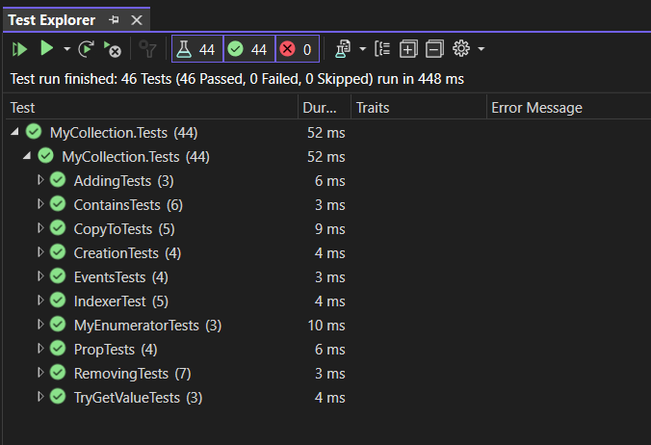

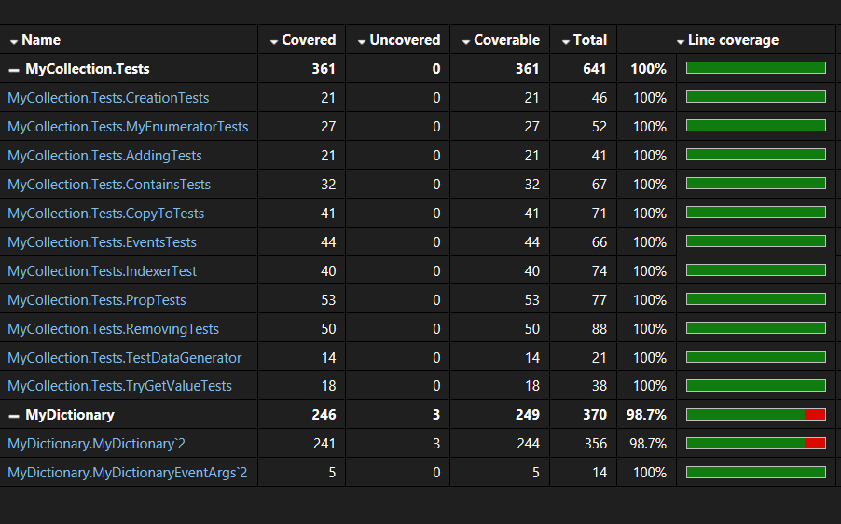

**Висновки:** в процесі виконання другої лабораторної роботи я навчився створювати модульні тести для вихідного коду розроблювального програмного забезпечення.