Stock Price Prediction: Technical vs. Fundamentals

Summary
I created, trained, and tested Keras regression and classification NNs to determine how well past technical and fundamentals data can predict the direction of a stock’s price change over the future 12 months.
Technical data, meaning past prices and volumes, failed to predict prices. Although the model’s accuracy was largely over 60%, the same model trained on all 1’s or 0’s produced identical results to the model trained on real data. Accuracy means the percentage of the model’s predictions that correctly determined the direction of the price change over the next 12 months: positive or negative.
Fundamentals data was marginally able to predict future prices. A model trained on real fundamentals data was only about 1-3% more accurate than the same model trained on all 1’s or 0’s. For this fundamentals model, as for the technical one above, just guessing that the price will always go up was roughly as accurate as the output of models trained on real market data.

Report on Design
The design was to use NN classification to predict price changes from past technical data and to use NN regression to predict price changes from past fundamentals data.

Fundamentals Data Approach
For fundamental metrics, the same format of training data and labels remained. See Figure 1 below.
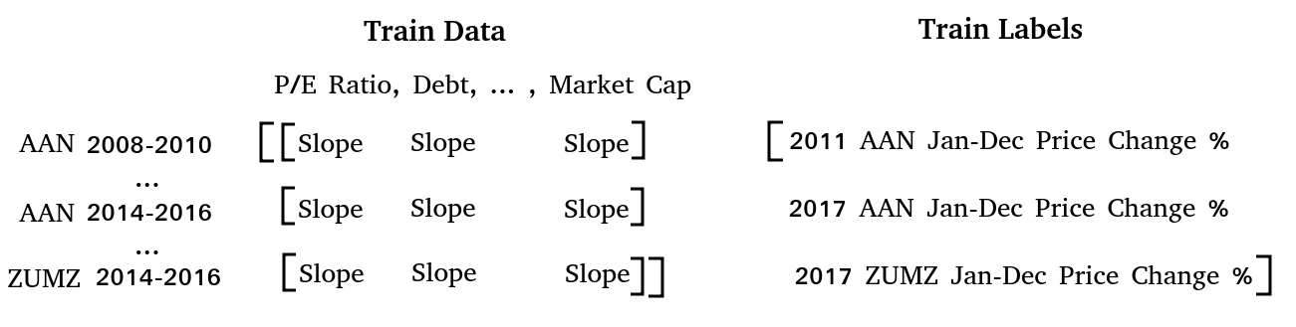
Figure 1. Format of training data and labels for fundamentals.

Two of the fundamental metrics, Total Assets and Shareholders' Equity, were dropped due to them missing too many values in Morningstar’s datasets [10].
The advantages of the above approach were that NN regression is a good model for the task of predicting a continuous output. Using metric slopes over three years is also a good approach to gauge the momentum of a stock.
The main disadvantage was not having data for a longer period. I only had Morningstar data from 2008 to 2017, which has been one of the longest running bull markets in the past century. The result was that the NN was over-fit to rising stock prices.

Below is a comparison of different model parameters’ effect on prediction accuracy. Each model setup was tested three times to get three accuracy readings. The best-performing setup was 1 hidden layer with five nodes
- 2 hidden layers of 52 nodes, Trainable parameters: 8,321 → 71%, 68%, 72% accuracy
- 1 hidden layer of 52 nodes, Total parameters: 2,809 → 69%, 65%, 70% accuracy
- 1 hidden layer of 5 nodes, Total parameters: 271 → 75%, 71%, 69% accuracy
- 1 hidden layer of 1 node, Total parameters: 55 → 75%, 63%, 70% accuracy
Below is a comparison of model accuracy when trained on actual data versus when trained on data of all 1’s or 0’s.
- Using actual fundamentals data → 71%, 68%, 72% accuracy
- Using all 0’s as training data → 69%, 70%, 69% accuracy

The model trained on real market data averaged 70.33% accuracy, while the bogus-trained model’s average accuracy is 69.33%.

Technical Data Approach
For technical data I took the same approach as in the design: using one or four-week price averages over three to nine years to predict if the price will rise or fall over the following year. Figure 2 below shows the format of training data and labels.
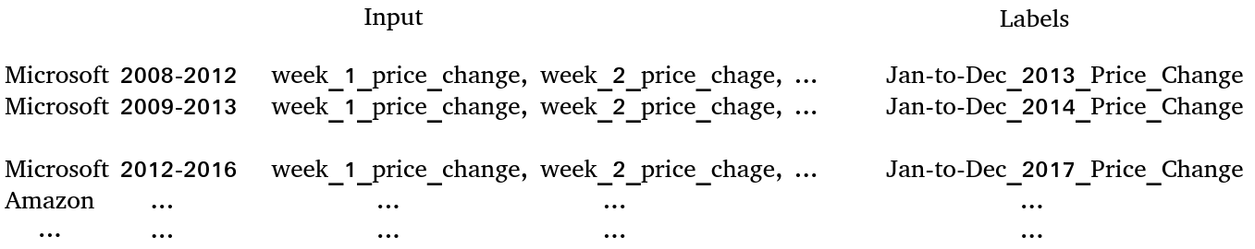
Figure 2. Format of technical training data and labels.

One advantage is that there is a lot of data for past prices and volumes. The data is clean, unlike the fundamentals data. No values are missing and everything that is supposed to be numeric is numeric.
One down side is overfitting to rising prices. The past 20 years only had a few down years. About 3/4th of the time the market was rising. This means that a model that hard-codes predicting an increase in price over the next year will be right on average about 3/4th of the time. This means the benchmark is not a coin toss of 50%, but the accuracy of a model trained on random and nonsense data. This nonsense-trained model was about 72% accurate. The accuracy of a model trained on actual past prices and volumes was also about 72% accurate.

Below is an overview of technical data inputs and output of the model.
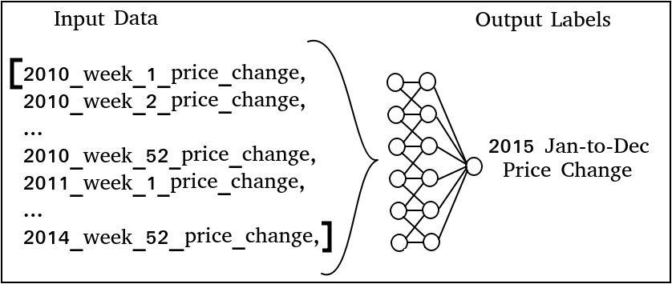
Below is an overview of fundamentals data inputs and output of the model.
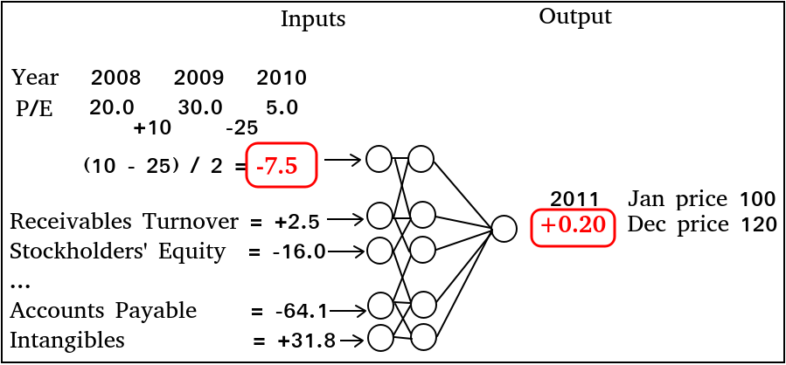
This is the list of fundamentals metrics I used.
Gross Margin % | Return on Assets % | Short-Term Debt
Operating Margin % | Financial Leverage (Average) | Total Current Liabilities
Payout Ratio % | Return on Equity % | Long-Term Debt
Shares Mil | Return on Invested Capital % | Total Liabilities
Book Value Per Share | Interest Coverage | Stockholders' Equity
Earnings Per Share | Operating Cash Flow Growth % YOY | Total Liabilities & Equity
Dividends | Free Cash Flow Growth % YOY | Current Ratio
Operating Cash Flow | Cap Ex as a % of Sales | Quick Ratio
Cap Spending | Free Cash Flow/Sales % | Financial Leverage
Free Cash Flow Per Share | Free Cash Flow/Net Income | Debt/Equity
Working Capital | Cash & Short-Term Investments | Days Sales Outstanding
Revenue | Inventory | Days Inventory
Operating Margin | Accounts Receivable | Payables Period
Net Int Inc & Other | Total Current Assets | Cash Conversion Cycle
EBT Margin | Net PP&E | Receivables Turnover
Tax Rate % | Intangibles | Inventory Turnover
Net Margin % | Total Assets | Fixed Assets Turnover
Asset Turnover (Average) | Accounts Payable | Asset Turnover
Below is a list of variables that had no or very little effect on classification model’s prediction accuracy. Varying these values kept the model’s accuracy almost the same.
- Number of days’ prices averaged together into a single data point
  - 1 and 4-week averaging windows both resulted in 67% accuracy
- Number of dense, hidden layers
  - 1 and 2 hidden dense layers with 16 nodes each resulted in 67% accuracy
- Number of nodes in a hidden layer
  - 4 and 16 nodes → 67% accuracy
  - 64 nodes → 65% accuracy (likely overfitting)
- Portion of training data used for validation
  - 5% and 30% data used for validation → 67% accuracy
- Whether past prices or past trading volumes were used as inputs to the model
  - Both resulted in an accuracy of 67%
- Number of inputs to the Embedding layer (called “Vocabulary size” in the original movie review example):
  - Number of input values: 1000 → 67.7% accuracy
  - Number of input values: 200 → 67.5% accuracy
  - Number of input values: 50 → 67.6% accuracy
  - Number of input values: 10 → 67.6% accuracy
  - Number of input values: 1 → 67.6% accuracy
Below is a list of variables that did have some effect on the classification model’s prediction accuracy.
- Prediction period: number of years used to predict the following year’s price change
  - 3 year prediction window → 54% accuracy
  - 5-year prediction window → 67% accuracy
  - 7-year prediction window → 72% accuracy (this window was best)
Unfortunately using bogus training data of all 0’s or all 1’s with a 7-year prediction window also resulted in 72% accuracy
  - 9-year prediction window → 59% accuracy
- Batch size: number of samples evaluated before updating weights
  - 1024 → 67% accuracy
  - 512 → 67% accuracy (I ended up using this batch size)
  - 256 → 66% accuracy
  - 128 → 60% accuracy
  - 64 → 56% accuracy
  - 32 → 58% accuracy
  - 16 → 55% accuracy
For the large, 3000-sample, training data set batch sizes of smaller than 256 cause overly-frequent weight updates and likely resulted in overfitting to training data.
- Number of samples in training data
  - 1000 → 63% accuracy
  - 2000 → 66% accuracy
  - 3000 → 67% accuracy (looks like smaller training sets caused under-fitting)
The tests above were a good exercise to see which variables affect accuracy the most. Special attention should be given to the number of training samples, batch size, and the prediction period.

Tools Used
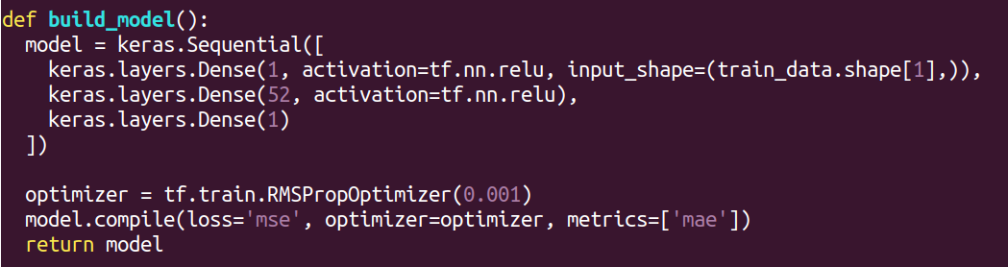
Figure 3. Creation of the regression model.

For both fundamentals and technical data I used Tensorflow Keras’ Sequential model [11]. Figure 3 below shows how the regression model is built.

Figure 4 below shows how the classification model is built.
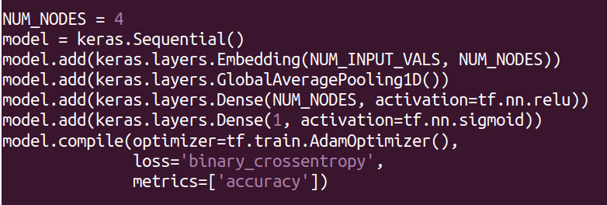
Figure 4. Creation of the classification model.

Unlike the regression model’ RMSprop optimization, the classification NN in Figure 4 uses the Adam optimizer. An optimizer defines how NN weights are adjusted to reduce loss.
RMSprop, Root Mean Squared, optimizer divides the learning rate by an exponentially decaying average of squared gradients [12]. RMSprop is robust and can deal with stochastic objectives well, making it useful for mini-batch learning [13]. Adam optimizer combines the advantages of the Adaptive Gradient Algorithm and Root Mean Square Propagation. Instead of only adapting learning rate on average first moment as in RMSprop, Adam also uses the second moments of the gradients [14]. I left the default optimizer choices that came with the examples.

Advantages of the Keras Sequential regression model include speed and ease of use. The above regression model in Figure 3 built, trained, and tested on 436 examples with 500 epochs all under 20 seconds. The input, output, and hidden layers are straightforward, as are the activation functions and choice of loss and metrics. Keras is minimalistic and fast to learn, unlike larger deep learning frameworks such as PyTorch, TensorFlow, and Microsoft’s Cognitive Toolkit [15]. Keras’ advantages include:
- Fast prototyping
- Fully-configurable modules
- Intuitive interface
- Support for training on multiple GPUs
- Ability to run on Spark
Being a minimalist framework, Keras does not offer as many functionalities as TensorFlow and provides less control over the network than lower-level deep learning frameworks.

Contrast between approaches
My two approaches were predicting the direction of next year’s price change from technical and fundamentals data. The question was: which approach had the best accuracy in predicting the direction of the following year’s price change? The fundamentals model was about 1-3% more accurate than the technical model.
Each approach was compared to its own baseline, the same model trained on nonsense data of all 0’s and 1’s. Both models were trained on real market data, then the prediction accuracy was compared to the nonsense-trained baseline.
The fundamentals regression NN was about 1% more accurate than the baseline. The average accuracy with a fundamentals model trained on real market data was 70.33%. The average baseline prediction, using all 0’s data for training, was 69.33%. Overall I am not confident in the ability of fundamentals data to give an edge in predicting next year’s price change. The difference in accuracy was too small and sometimes non-existent between using actual training data and using a set of all 1’s or 0’s.
The technical classification NN performed almost exactly the same as the baseline. That is, accuracy was the same whether the model was trained on actual past prices and volumes or on a set of all 1’s or 0’s. This shows that there is no pattern in past stock price and volume data. Always predicting that stock prices will rise yields the same accuracy as the model trained on real market data.
Both the regression and classification NN approaches accomplished their goal: to answer whether past stock prices, volumes, and fundamentals metrics hold patterns that allow a greater than 0% accuracy prediction of the stock price change over the following 12-months. For technical data, the answer is “no, there is no pattern.” For fundamentals data, the answer is “maybe about 1% accuracy, but more testing is needed.”

What did not work well
Using fundamentals metrics to predicting stock prices was only about 1% more accurate than a hard-coded “the price will rise” prediction. I expected that percentage to be higher.
One of the biggest problems was lack of fundamentals data. My fundamentals training data was from 2008 to 2017. Outside of the 2008 recession and a couple of fairly flat years, every year in the past decade had a positive price change. This means that if the NN output a constant prediction of “the price will go up,” then it will be correct most of the time. This is exactly what I saw when training on nonsense data of all 1’s or 0’s. Figure 5’s left side shows predictions from a model trained on actual market data. Figure 5’s right side shows predictions from a model trained on nonsense data of all 0’s.
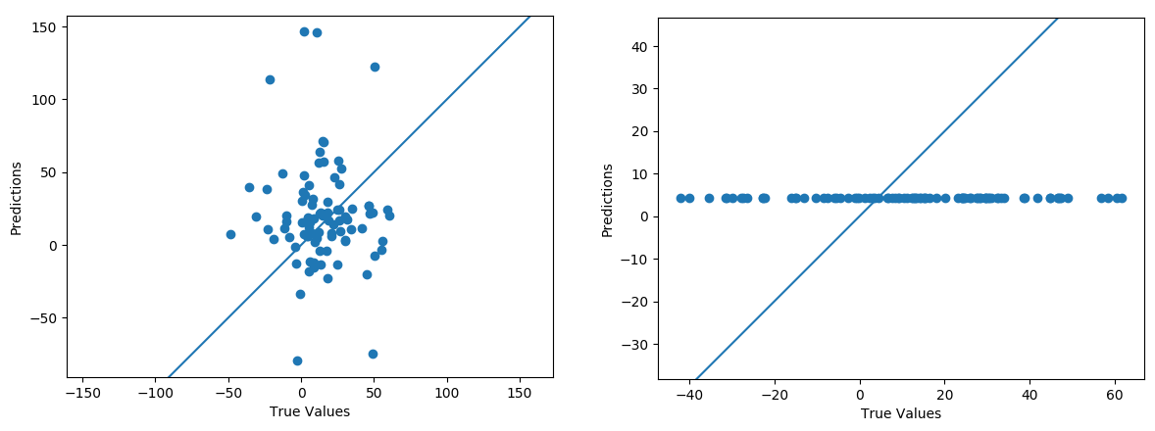
Figure 5. Comparison of models trained on real and fake data.

We see on the right that the nonsense-trained model always predicts that the price will rise. The real-data trained model predictions on the left show very little correlation with true values.
The best way around the problem of lop-sided training sets is more training data that spans multiple bull and bear markets. Unfortunately Morningstar’s free fundamentals data is limited to the past decade. Another problem was poor quality of fundamentals data. Many values were missing, causing me to discard many rows and CSV files. For example, before cleaning fundamentals data there were 4314 samples. After cleaning there were only 436 samples. Cleaning means removing samples with missing or corrupted data.
For technical data I used a NN classification model, which may not have been the best choice considering that I was looking for patterns in pricing data. Normalizing past prices and feeding them into a classification NN still worked, but it may have been better to use a recurrent NN, which recognizes sequences of inputs [8]. A recurrent NN uses Long Short-Term Memory (LSTM) nodes that use current and past inputs to determine outputs, which aids in learning patterns [9].

What did work well
I am pleasantly surprised how easy the Keras deep learning framework is to use. There is plenty of documentation, it is fairly stable, and it is fast. The time to build, train, and test a model on 3000 past price training sets took under 20 seconds. I manipulated many parameters to see the effect on the model’s accuracy. These parameters included:
- Number of days averaged into a single price data point
- Number of years used to predict next 12-months’ price change
- Number of training sets
- Number of inputs to the Embedding layer for the classification NN
- Number of hidden layers and number of nodes per hidden layer
- Number of training epochs
- Batch size
- Portion of training data to be used for validation
It would be very tedious to test all the above variables if the model were slow.

The project was a great learning experience. I learned how to match problem and data types to a machine learning algorithm. I also developed an intuitive feel for tuning a neural network. From the above bullet list of variables, for example, the following had the biggest impact on the model’s accuracy:
- Number of years used to predict next 12-months’ price change
- Number of training sets
- Batch size.

It is vital to have a good benchmark to compare you model against. If I did not test the model by training it with bogus data, the model accuracy of over 60% would be completely misleading. The intuitive benchmark for guessing stock price direction, up or down, is 50%, a coin toss. In my case, however, the training data used was largely from a bull market, which required a shift of this 50% benchmark closer to 70%. The 70% being roughly the accuracy of a model that always predicts a rising price.

References
[1] https://www.tensorflow.org/tutorials/keras/basic_regression
[2] https://www.tensorflow.org/tutorials/keras/basic_text_classification
[3] Dr. Braude, Eric, 2018, Nov. "Uncertainty and Bayes(2).pptx". Retrieved from https://learn.bu.edu/webapps/blackboard/content/
[4] Marsland, Stephen. Machine Learning: An Algorithmic Approach. New York, CRC Press, 2015, pp. 179-183.
[5] Dr. Braude, Eric, 2018, Nov. "Learning Rules.pptx". Retrieved from https://learn.bu.edu/webapps/blackboard/content/
[6] Dr. Braude, Eric, 2018, Nov. "Fuzzy Rules.pptx". Retrieved from https://learn.bu.edu/webapps/blackboard/content/
[7] https://www.kaggle.com/borismarjanovic/price-volume-data-for-all-us-stocks-etfs
[8] https://www.tensorflow.org/tutorials/sequences/recurrent
[9] https://colah.github.io/posts/2015-08-Understanding-LSTMs/
[10] https://www.morningstar.com/
[11] https://keras.io/models/sequential/
[12] http://ruder.io/optimizing-gradient-descent/
[13] https://climin.readthedocs.io/en/latest/rmsprop.html
[14] https://machinelearningmastery.com/adam-optimization-algorithm-for-deep-learning/
[15] https://www.netguru.co/blog/deep-learning-frameworks-comparison

