Tutorial

## Visit empty Home Page

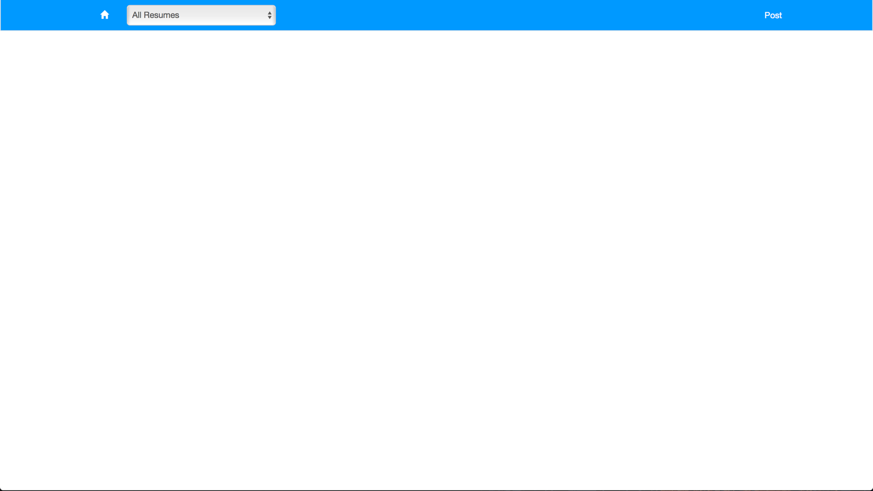

## Click on Post in the top right corner, choose category, select your file, click submit

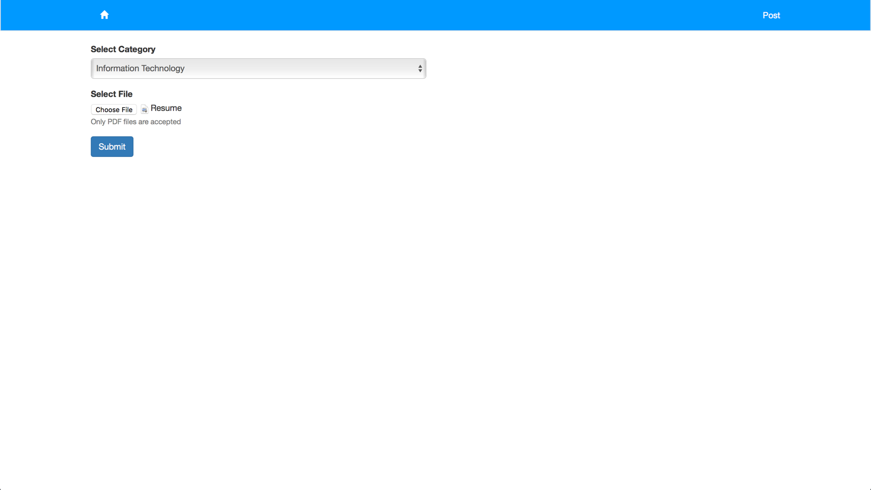

## File is saved, and we are taken to the resume page

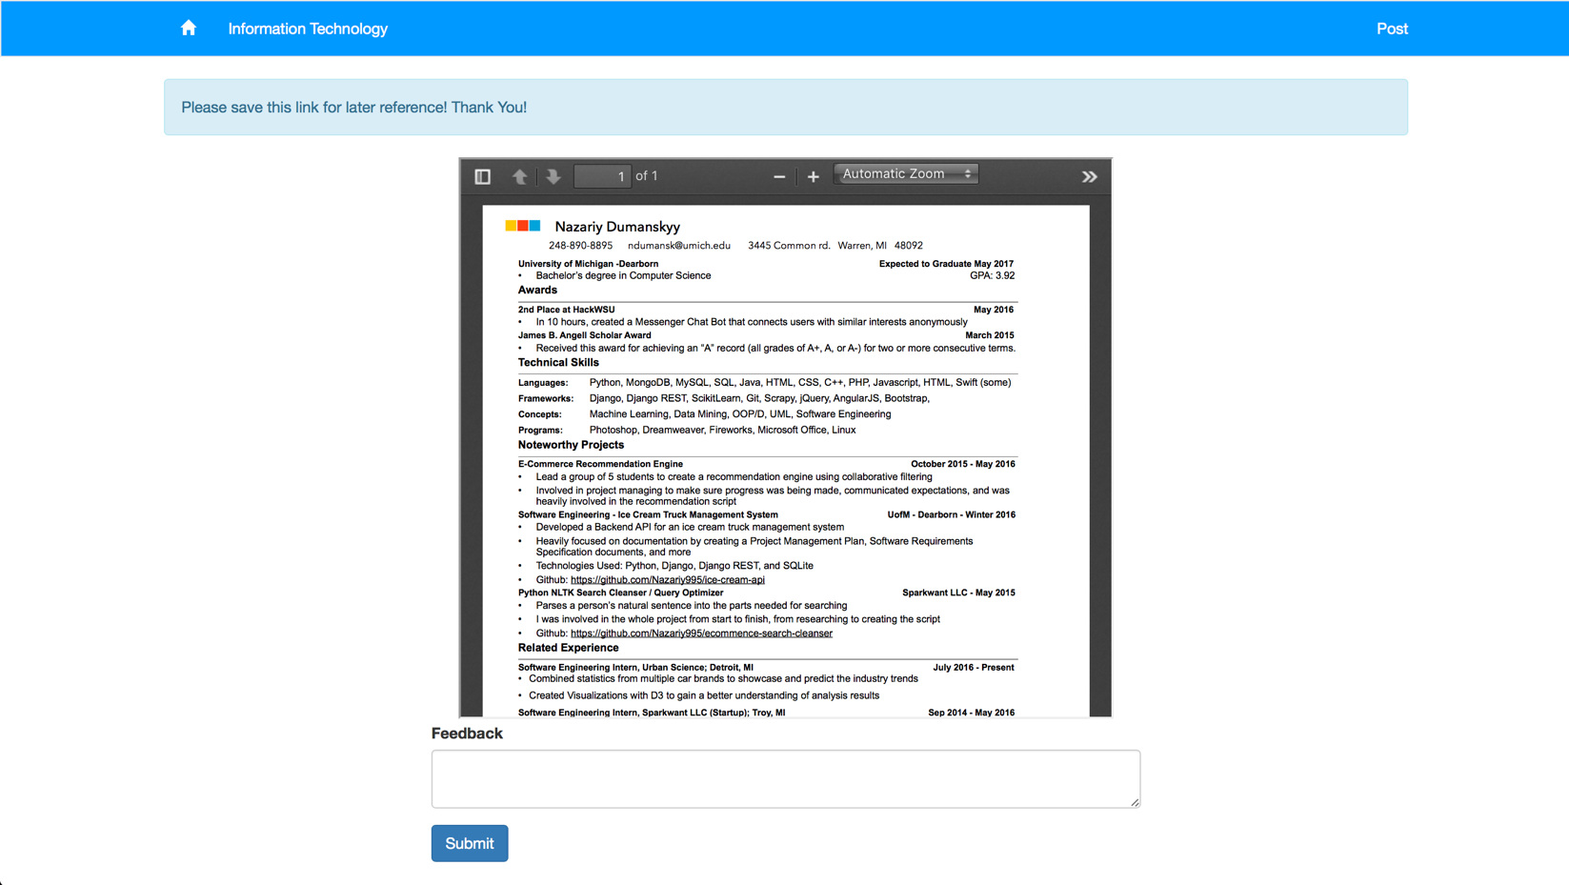

## Go back to the home page and we see that the resume appears there

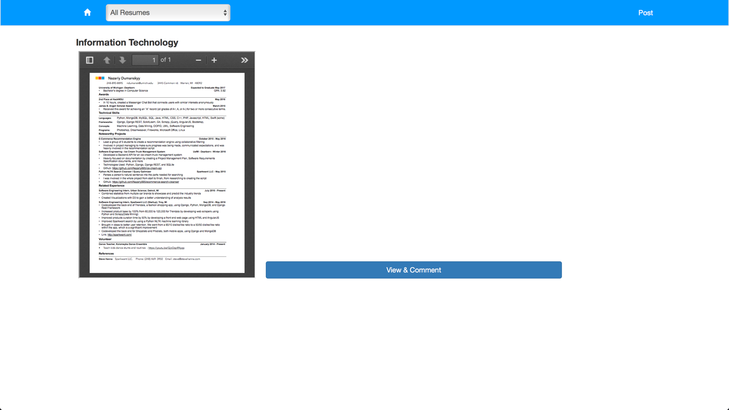

## Click View and Comment to be taken back to the resume page. Here we submit some feedback

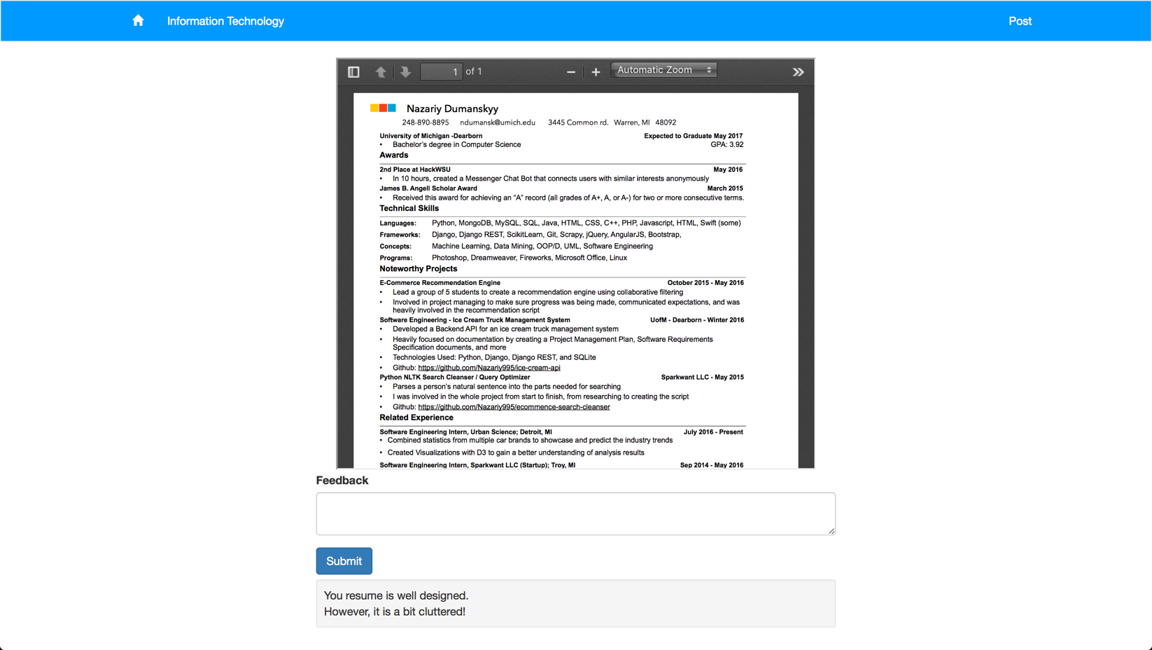

## Alert we get if we type nothing into the feedback text area and click submit

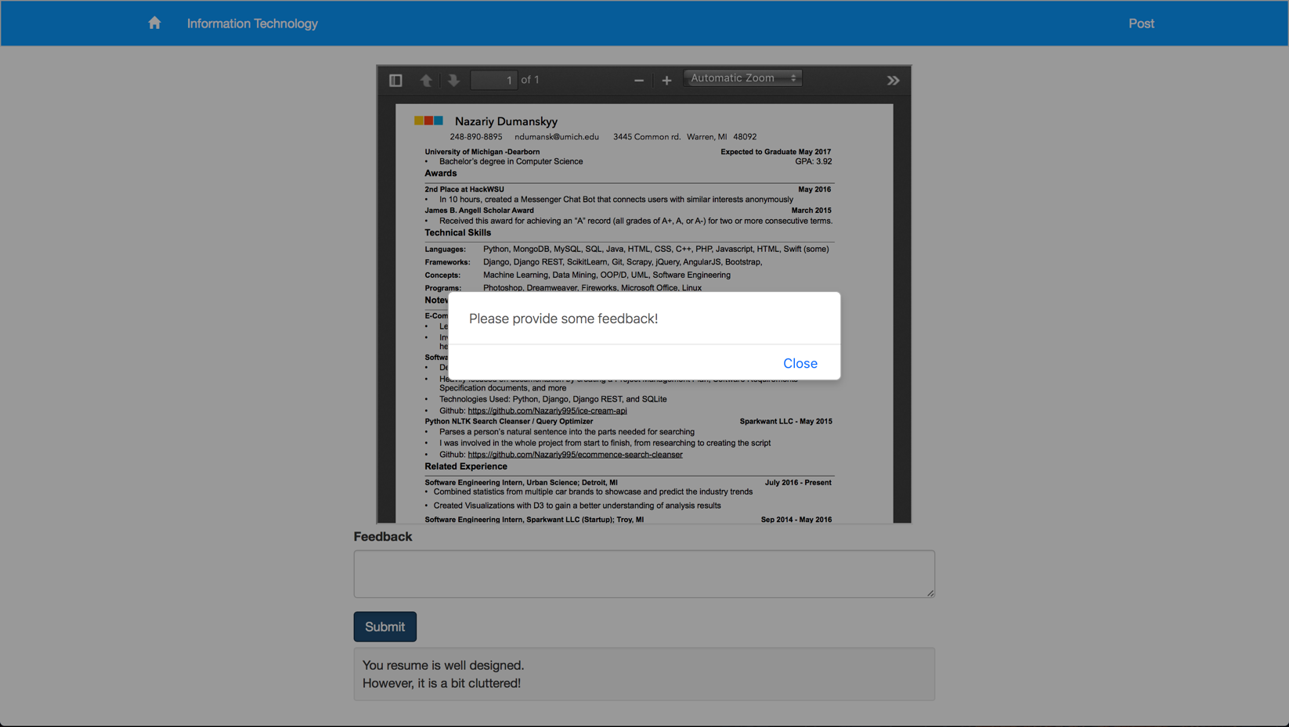

## We added some more resumes and now we have the three resumes under different categories. We don’t see the third one because it is below the viewing area

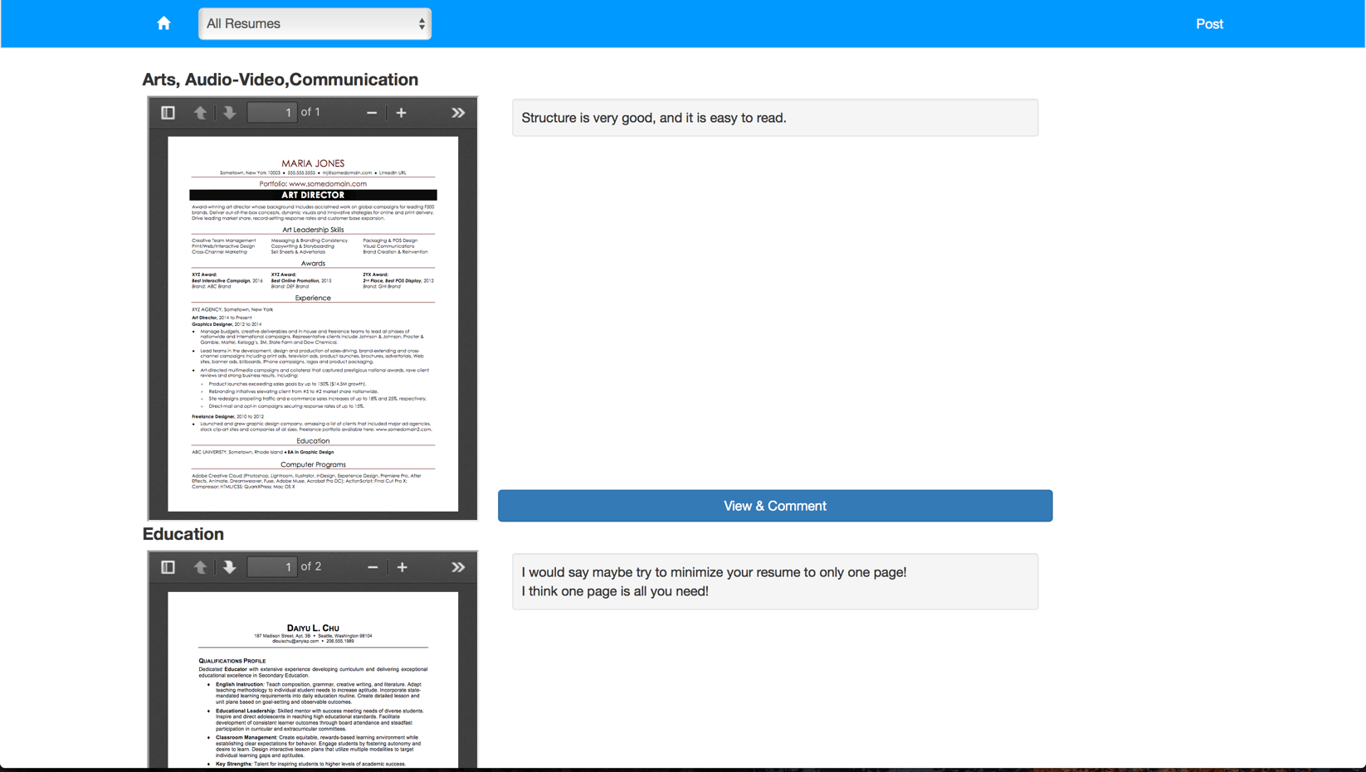

## If we use the category filter in the top left corner, we can see how only the resumes under the selected category show

