ElavaIT – Vulnerability Assessment and Penetration Testing Report
Date: May 17, 2026
Target: 192.168.230.128
By- Nazeef Shaikh

1. Scope of Assessment
Category | Details
Project Name | ElavaIT
Platform | VMware
Target Type | Linux Virtual Machine
Target IP | 192.168.230.128
Testing Type | Black Box Penetration Testing
Assessment Methodology | Manual + Tool-Assisted Testing
Objective | Identify exposed services and vulnerable web application modules

2. Attack Chain Overview
- Network connectivity verification using Ping
- Service enumeration using Nmap
- Directory enumeration using Gobuster
- Identification of vulnerable web applications
- SQL Injection testing in DVWA
- Reflected XSS testing
- Command Injection testing
- Documentation of findings and recommendations

3. Vulnerability Summary:
Vulnerability Name | Severity
Multiple Exposed Services | High
Directory Enumeration Exposure | Medium
SQL Injection Vulnerability | High
Reflected Cross Site Scripting (XSS) | Medium
Command Injection Vulnerability | Critical

4. Description:
During the assessment, multiple exposed services and intentionally vulnerable web applications were identified on the target machine. Enumeration revealed accessible directories, administrative interfaces, and vulnerable DVWA modules. Web application testing demonstrated SQL Injection, Cross Site Scripting (XSS), and Command Injection vulnerabilities within the lab environment.

5. Step 1: Network Connectivity Verification
Objective: Verify communication with the target machine.
Command Used: ping 192.168.230.128
Findings: The target replied successfully to ICMP packets, confirming network connectivity between Kali Linux and the target VM.
Screenshot:
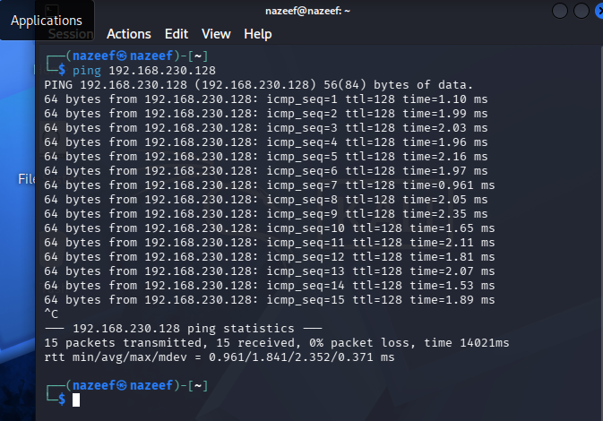

6. Step 2: Service Enumeration
Objective: Identify open ports and running services on the target machine.
Tool Used: Nmap
Command Used: nmap -sV 192.168.230.128
Findings:
The scan identified several open services including FTP, Apache HTTP server, SMB, MySQL, and WebDAV.
Multiple potentially vulnerable services were exposed to the network.
Screenshots:
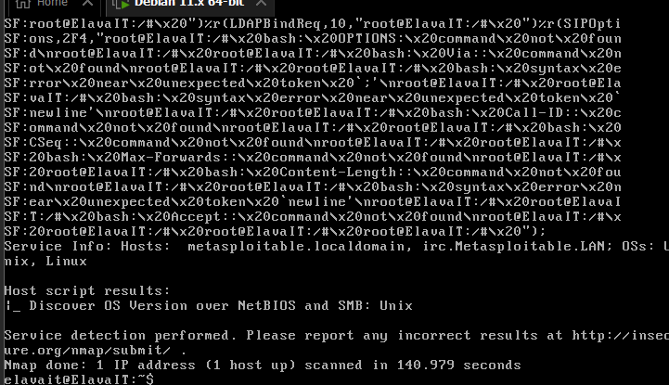

7. Step 3: Website Reconnaissance
Objective: Identify vulnerable web applications hosted on the target machine.
Findings:
The target hosted multiple intentionally vulnerable applications including:
- DVWA
- phpMyAdmin
- TWiki
- WebDAV
Screenshots:
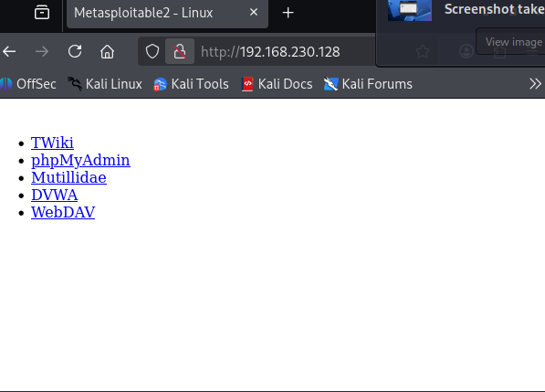

8. Step 4: Directory Enumeration
Objective: Discover hidden directories and files on the web server.
Tool Used: Gobuster
Command Used: gobuster dir -u http://192.168.230.128 -w /usr/share/wordlists/dirb/common.txt
Findings:
The scan identified several accessible directories including:
- /phpMyAdmin
- /twiki
- /dav
- /cgi-bin
- /phpinfo.php
Screenshots:
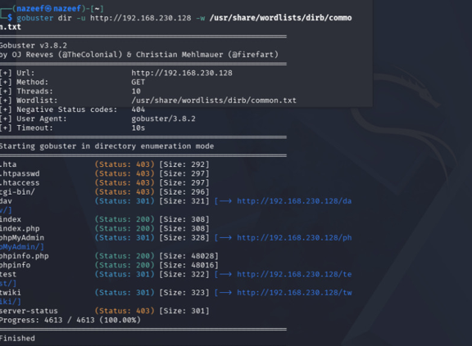

9. Step 5: SQL Injection Testing
Objective: Observe how the application processes database-driven input.
Application Tested: DVWA
Security Level: Low
Findings:
The application accepts user-controlled input and returns database-driven results. Improper input handling may expose the application to SQL Injection vulnerabilities.
Risk Level: High
Screenshots:
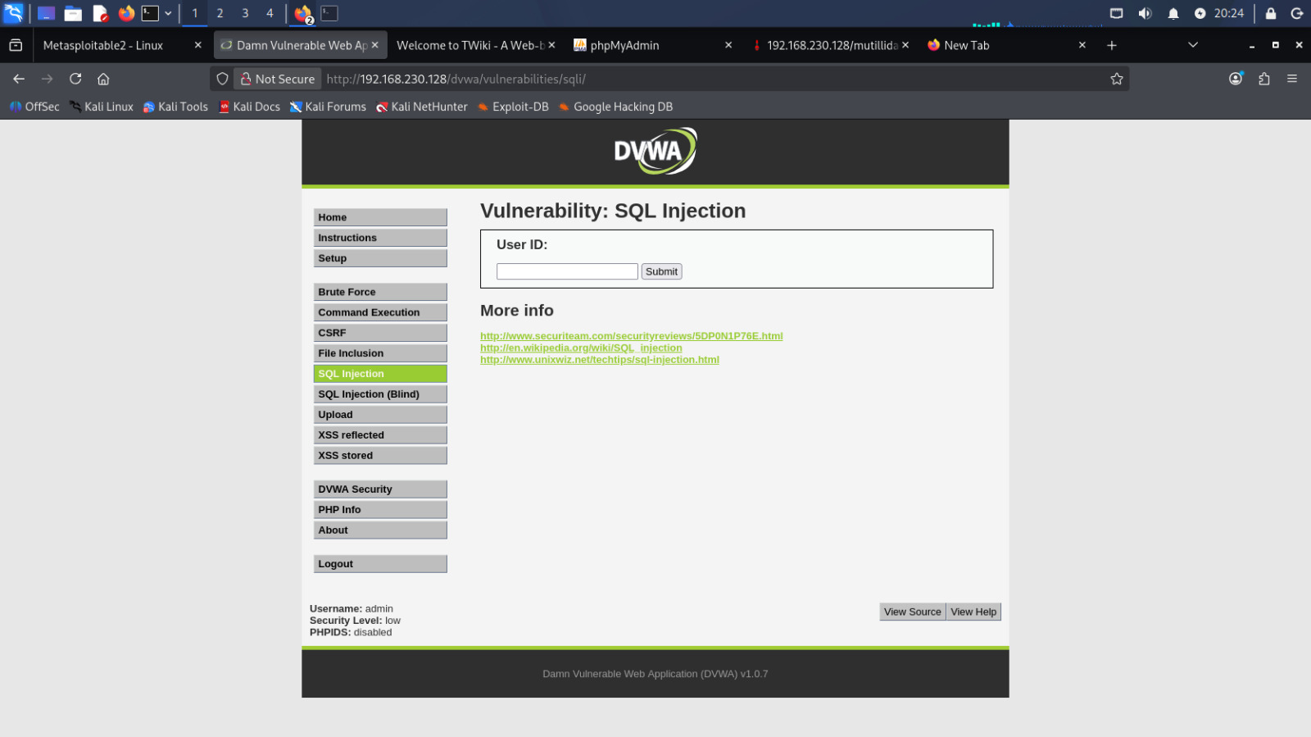

10. Step 6: Reflected XSS Testing
Objective: Observe how user input is reflected into webpage responses.
Application Tested: DVWA
Security Level: Low
Findings:
User-supplied input was reflected back into the webpage response without sufficient sanitization.
Risk Level: Medium
Screenshots:
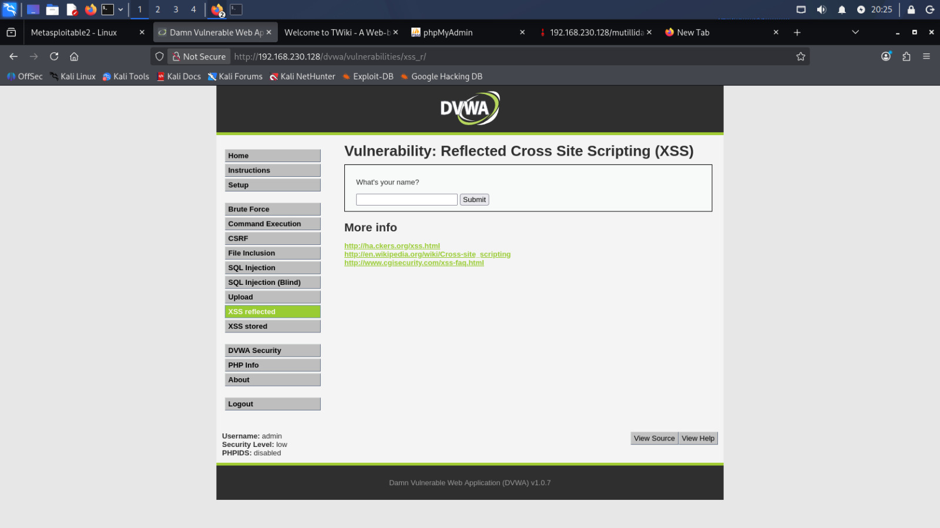

11. Step 7: Command Injection Testing
Objective: Observe how backend commands process user-controlled input.
Application Tested: DVWA
Security Level: Low
Findings:
The application executed backend system/network commands and displayed the output to the webpage.
Risk Level: Critical
Screenshots:
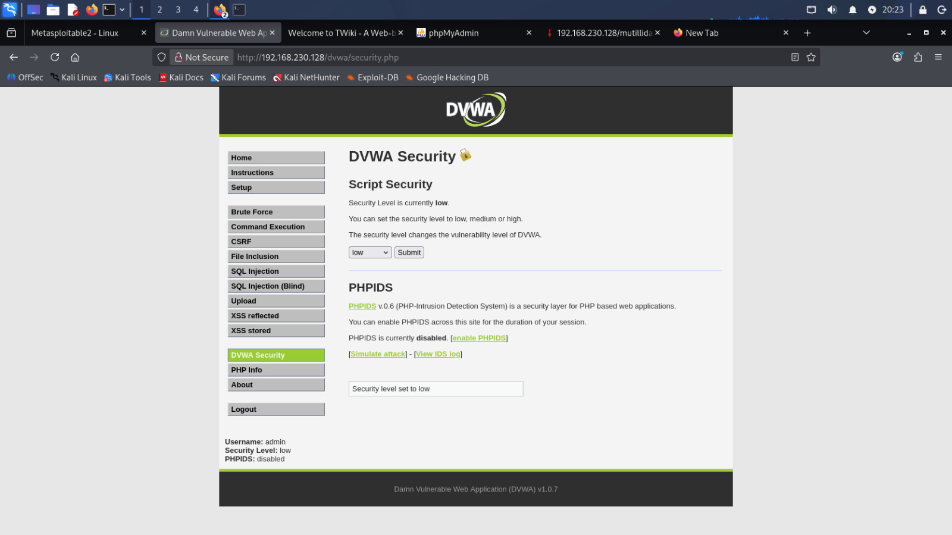

12. Impact
- Multiple exposed services identified
- Sensitive directories discovered
- SQL Injection vulnerability observed
- Reflected XSS vulnerability observed
- Command Injection behavior identified
- Potential risk of unauthorized access and backend command execution

13. Remediations & Recommendations
1. Implement proper input validation.
2. Use parameterized SQL queries.
3. Apply output encoding and sanitization.
- Restrict unnecessary services and exposed directories.
- Keep applications and services updated.
- Apply the principle of least privilege.
- Conduct regular vulnerability assessments and penetration testing.

14. Conclusion
The VAPT assessment successfully identified multiple intentionally vulnerable services and web application weaknesses within the ElavaIT VM environment. Enumeration, directory discovery, and web application testing were performed successfully using Kali Linux against the target machine. The assessment demonstrated common web application vulnerabilities including SQL Injection, Cross Site Scripting (XSS), and Command Injection.

