REPORT SPECIFICATION
Sales Performance and Pipeline
General Reporting and Data Model Specification
Purpose
Define the report scope, source structures, relationships, business logic and reporting requirements for a reusable sales performance solution.
Document Title | Sales Performance and Pipeline Report Specification
Solution Type | General business intelligence report
Author | Nazeer Joseph
Version | 1.0
Date | 25 July 2026
Status | Draft / Portfolio Specification

Contents
1. Document Control 3
2. Report Purpose and Scope 4
3. Reporting Requirements 4
3.1 Core Measures 4
3.2 Required Analysis Dimensions 4
4. Source Data Overview 5
4.1 Source File Groups 5
5. Data Model and Relationships 5
5.1 Relationship Matrix 6
6. Source Table Specifications 7
6.1 customer 7
6.2 subsidiary 7
6.3 item_category 7
6.4 item_pattern 8
6.5 item 8
6.6 transaction_header 8
6.7 transaction_line 9
6.8 deleted_records 9
6.9 sales_budget 10
6.10 fx_avg_rate 10
6.11 user_rls 10
7. Core Business Logic 11
7.1 Transaction Classification 11
7.2 Currency Conversion 11
7.3 Budget Matching 11
7.4 Incremental and Historical Processing 11
8. Power BI Semantic Model 11
8.1 Recommended Tables 11
9. Report Page Specifications 13
9.1 Overview Page 13
9.2 Pipeline Detail Page 13
10. Filters and Interactions 13
11. Data Quality, Refresh and Audit Requirements 13
11.1 Required Controls 13
12. Assumptions and Future Enhancements 13

1. Document Control
Document Owner | Nazeer Joseph
Primary Purpose | Define report requirements and data model expectations.
Intended Audience | Data engineers, BI developers, analysts and report stakeholders.
Scope | Sales actuals, open pipeline, budget comparison, currency conversion and report security readiness.
Out of Scope | Operational write-back, forecasting algorithms, source-system administration and production deployment procedures.

2. Report Purpose and Scope
The report provides a consolidated view of completed sales, open sales orders, open opportunities and sales budget. It is designed to help users understand current performance, future pipeline and expected landing against target.
- Track fully billed invoice sales as actual sales.
- Track open sales orders and open opportunities as future pipeline.
- Calculate estimated sales landing from actuals and open pipeline.
- Compare actual and estimated performance with monthly sales budget.
- Analyse results by fiscal period, customer, business unit and item attributes.
- Provide transaction-level pipeline detail for investigation and follow-up.
Fiscal calendar: The reporting year starts in February and ends in January. Fiscal month 1 is February and fiscal month 12 is January.

3. Reporting Requirements

3.1 Core Measures
Measure | Definition | Primary Use
Actual Sales | Value of Invoice transactions with status Fully Billed. | Overview KPIs, monthly trends and budget comparison.
Open Sales Orders | Value of Sales Order transactions with an open status. | Pipeline monitoring and delivery-month analysis.
Open Opportunities | Value of Opportunity transactions with an open status. | Opportunity pipeline and estimated landing.
Total Open Pipeline | Open Sales Orders + Open Opportunities. | Pipeline KPI and composition analysis.
Estimated Sales Landing | Actual Sales + Total Open Pipeline. | Expected result if current pipeline lands.
Sales Budget | Monthly budget converted to the reporting currency. | Target comparison.
Landing vs Budget | Estimated Sales Landing - Sales Budget. | Absolute variance.
Landing Achievement % | Estimated Sales Landing / Sales Budget. | Performance ratio.

3.2 Required Analysis Dimensions
Dimension | Examples
Time | Fiscal year, fiscal month, transaction date and expected delivery month.
Customer | Customer name and customer tier.
Business Unit | Business-unit code, legal name, country, currency and commercial group.
Item | Item name, code, type, project code, category, sub-category and pattern.
Transaction | Type, status, number and sales-record classification.
Budget | Budget version and month.

4. Source Data Overview
The source is a set of delimited extracts representing master data, transactions, budgets, exchange rates, deletion controls and optional security mappings. The specification does not depend on a specific vendor or organisation.
Input Format | Delimited text or CSV files.
Expected Delivery | Batch extracts placed in a controlled ingestion folder.
Primary Transaction Grain | Header and line tables.
Budget Grain | Budget version, month, customer label and business-unit code.
Exchange-Rate Grain | Currency pair by month after unpivoting.
Reporting Currency | USD in the current design; configurable if required.
Historical Tracking | Customer and item attributes may be preserved using SCD Type 2.

4.1 Source File Groups
Group | Tables | Purpose
Dimensions | customer, subsidiary, item, item_category, item_pattern | Descriptive attributes used to filter and group transactions.
Transactions | transaction_header, transaction_line | Header and line detail for actual sales and open pipeline.
Budget and Rates | sales_budget, fx_avg_rate | Targets and currency conversion.
Control and Security | deleted_records, user_rls | Hard-delete handling and optional access rules.

5. Data Model and Relationships
The model separates descriptive master data from transaction facts and supporting control tables. Confirmed source relationships use source identifiers. Budget, exchange-rate and security links are logical relationships applied during ETL or semantic-model construction. Refer to file Netsuite Project Schema PDF.
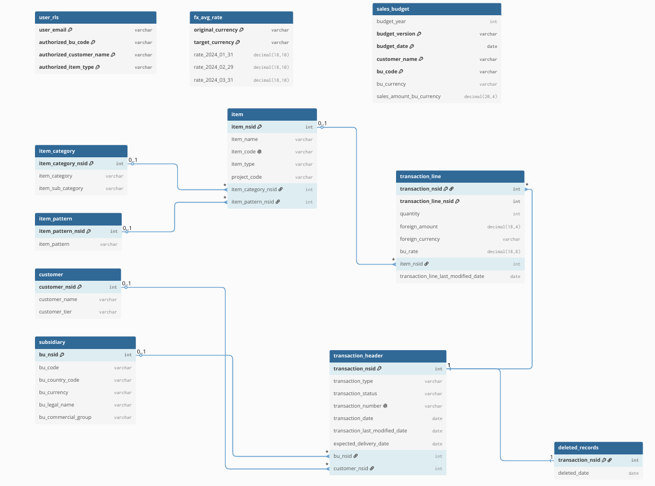

5.1 Relationship Matrix
Parent / Source | Child / Target | Join Key | Cardinality | Notes
customer | transaction_header | customer_nsid | 1 : many | Confirmed foreign-key relationship.
subsidiary | transaction_header | bu_nsid | 1 : many | Confirmed foreign-key relationship.
transaction_header | transaction_line | transaction_nsid | 1 : many | Header-to-line relationship.
item | transaction_line | item_nsid | 1 : many | Item-to-transaction-line relationship.
item_category | item | item_category_nsid | 1 : many | Category-to-item relationship.
item_pattern | item | item_pattern_nsid | 1 : many | Pattern-to-item relationship.
transaction_header | deleted_records | transaction_nsid | 1 : 0..1 | Deletion-control relationship.
sales_budget | sales reporting | budget_date + customer_name + bu_code | Logical | Monthly logical join; not enforced as a source foreign key.
fx_avg_rate | transactions and budget | currency + effective month | Logical | Effective-dated currency conversion lookup.
user_rls | report dimensions | user + authorised attributes | Logical | Optional future row-level security mapping.
Important: The subsidiary business-unit code is not guaranteed to be unique in the source. Transaction relationships therefore use bu_nsid. Budget uses bu_code as a logical reporting key at monthly aggregate grain.

6. Source Table Specifications
The following structures define the source-facing model. Nullability indicates the reporting expectation, while actual enforcement may occur in staging validation rather than in the raw source table.

6.1 customer
Purpose: Customer master used to classify and filter sales activity. | Grain: One row per customer.
Field | Type | Nullable | Description
customer_nsid | Integer | No | Primary key. Source customer identifier.
customer_name | Text | Yes | Customer display name.
customer_tier | Text | Yes | Customer classification such as Bronze, Silver or Gold.

6.2 subsidiary
Purpose: Business-unit master containing operating, legal and currency attributes. | Grain: One row per subsidiary or business unit.
Field | Type | Nullable | Description
bu_nsid | Integer | No | Primary key. Source business-unit identifier.
bu_code | Text | Yes | Business-unit code. Not guaranteed to be unique in the source.
bu_country_code | Text | Yes | Country code associated with the business unit.
bu_currency | Text | Yes | Functional currency of the business unit.
bu_legal_name | Text | Yes | Legal entity name.
bu_commercial_group | Text | Yes | Commercial grouping used for reporting.

6.3 item_category
Purpose: Reference table for item category and sub-category classifications. | Grain: One row per item category identifier.
Field | Type | Nullable | Description
item_category_nsid | Integer | No | Primary key.
item_category | Text | Yes | High-level item category.
item_sub_category | Text | Yes | Lower-level item sub-category.

6.4 item_pattern
Purpose: Reference table for the item-pattern attribute. | Grain: One row per item pattern identifier.
Field | Type | Nullable | Description
item_pattern_nsid | Integer | No | Primary key.
item_pattern | Text | Yes | Pattern or product grouping description.

6.5 item
Purpose: Item master containing product, project and classification attributes. | Grain: One row per item.
Field | Type | Nullable | Description
item_nsid | Integer | No | Primary key.
item_name | Text | Yes | Item display name.
item_code | Text | No | Unique item code.
item_type | Text | Yes | Item type used for reporting.
project_code | Text | Yes | Optional associated project code.
item_category_nsid | Integer | Yes | Foreign key to item_category.
item_pattern_nsid | Integer | Yes | Foreign key to item_pattern.

6.6 transaction_header
Purpose: Transaction-level header containing type, status, dates, customer and business unit. | Grain: One row per transaction.
Field | Type | Nullable | Description
transaction_nsid | Integer | No | Primary key.
transaction_type | Text | No | Invoice, Sales Order or Opportunity.
transaction_status | Text | No | Current transaction status.
transaction_number | Text | No | Unique business transaction number.
transaction_date | Date | No | Original transaction date.
transaction_last_modified_date | Date/Time | No | Last header modification timestamp.
expected_delivery_date | Date | Yes | Expected date for open orders and opportunities.
bu_nsid | Integer | No | Foreign key to subsidiary.
customer_nsid | Integer | No | Foreign key to customer.

6.7 transaction_line
Purpose: Line-level quantities, values, currencies, rates and items for each transaction. | Grain: One row per transaction and transaction-line identifier.
Field | Type | Nullable | Description
transaction_nsid | Integer | No | Composite primary key and foreign key to transaction_header.
transaction_line_nsid | Integer | No | Composite primary key.
quantity | Integer | Yes | Transaction-line quantity.
foreign_amount | Decimal(18,4) | Yes | Amount in the original foreign currency.
foreign_currency | Text | Yes | Three-character source currency code.
bu_rate | Decimal(18,8) | Yes | Rate used to convert the source amount into business-unit currency.
item_nsid | Integer | No | Foreign key to item.
transaction_line_last_modified_date | Date/Time | No | Last line modification timestamp.

6.8 deleted_records
Purpose: Control table containing transaction identifiers deleted from the source. | Grain: One row per deleted transaction.
Field | Type | Nullable | Description
transaction_nsid | Integer | No | Primary key and link to transaction_header.
deleted_date | Date | No | Date the transaction was deleted.

6.9 sales_budget
Purpose: Monthly sales targets by budget version, customer label and business-unit code. | Grain: One row per budget version, month, customer name and business-unit code.
Field | Type | Nullable | Description
budget_year | Integer | No | Calendar year of the budget date.
budget_version | Text | No | Budget scenario or version.
budget_date | Date | No | Month-end budget period.
customer_name | Text | No | Customer label used for logical matching.
bu_code | Text | No | Business-unit code used for logical matching.
bu_currency | Text | No | Currency of the budget amount.
sales_amount_bu_currency | Decimal(20,4) | No | Budget amount in business-unit currency.

6.10 fx_avg_rate
Purpose: Average exchange rates used to convert business-unit values into the reporting currency. | Grain: Source format: one row per currency pair. Reporting format: one row per currency pair and rate date.
Field | Type | Nullable | Description
original_currency | Text | No | Currency being converted.
target_currency | Text | No | Reporting currency.
rate_<date> | Decimal(18,10) | No | One or more source date columns, unpivoted during ingestion.
rate_date | Date | Derived | Month-end rate date created by the ETL unpivot.
avg_rate | Decimal(18,10) | Derived | Average rate created by the ETL unpivot.

6.11 user_rls
Purpose: Optional security configuration for restricting data by user and reporting attributes. | Grain: One row per user and configured access combination.
Field | Type | Nullable | Description
user_email | Text | No | User identifier.
authorized_bu_code | Text | No | Authorised business-unit values.
authorized_customer_name | Text | No | Authorised customer values.
authorized_item_type | Text | No | Authorised item-type values.

7. Core Business Logic

7.1 Transaction Classification
Transaction Type | Status | Reporting Classification
Invoice | Fully Billed | ACTUAL
Sales Order | Under Discussion or Ongoing | OPEN SALES ORDER
Opportunity | Under Discussion or Ongoing | OPEN OPPORTUNITY
Other or closed combinations | Any other status | Excluded from active sales pipeline.

7.2 Currency Conversion
Step | Logic
1 | Convert foreign line amount into business-unit currency using: foreign_amount × bu_rate.
2 | Select the monthly average FX rate for the business-unit currency to the reporting currency.
3 | Use the latest rate on or before the reporting month. If unavailable, use the earliest later rate.
4 | When the source currency already equals the reporting currency, use a rate of 1.
5 | Calculate reporting amount as amount_bu_currency × avg_rate.

7.3 Budget Matching
Element | Rule
Period | Sales and budget are aligned to month-end.
Customer | Logical match on standardised customer_name.
Business Unit | Logical match on standardised bu_code.
Unmatched Records | A full outer join retains sales without budget and budget without sales.
Item Analysis | Budget has no item grain; item-level budget comparisons are not supported unless allocation logic is added.

7.4 Incremental and Historical Processing
Area | Pattern
Customer and Item | SCD Type 2 retains previous attribute versions and flags one current version.
Reference Tables | Hash-based MERGE inserts new keys and updates rows only when tracked values change.
Transactions | Watermark identifies changed headers, changed lines and deleted transactions.
Transaction Reload | Affected transactions are deleted and reinserted at header and line level to keep both tables synchronised.
Deleted Records | Transaction identifiers in deleted_records are removed from current-state warehouse tables.

8. Power BI Semantic Model
The recommended Power BI model imports reporting-ready views rather than exposing raw, staging or intermediate ETL tables.

8.1 Recommended Tables
Table | Role
sales_vs_budget_monthly | Monthly summary fact for overview KPIs, trends, budget and variance.
sales_pipeline | Transaction-line detail for pipeline analysis and drill-through.
Calendar | Shared date dimension with fiscal-year and fiscal-month attributes.
Dim Business Unit | Shared business-unit filter connected to both facts.
Dim Customer | Shared customer filter connected to both facts.
Relationship direction: Use one-to-many, single-direction relationships from dimensions to fact tables. Avoid fact-to-fact relationships.

9. Report Page Specifications

9.1 Overview Page
Section | Required Content
Filters | Fiscal Year, Fiscal Month, Business Unit and Customer.
KPI Cards | Actual Sales, Open Sales Orders, Open Opportunities, Estimated Landing, Sales Budget and Landing vs Budget.
Monthly Trend | Line chart comparing Estimated Sales Landing with Sales Budget by fiscal month.
Sales Composition | Donut chart showing Actual Sales, Open Sales Orders and Open Opportunities.
Business Unit Comparison | Clustered chart comparing Estimated Landing with Sales Budget.
Summary Matrix | Business Unit with actual, pipeline, landing, budget, variance and achievement percentage.

9.2 Pipeline Detail Page
Section | Required Content
Filters | Fiscal Year, Expected Delivery Month, Business Unit, Customer and Item Type.
KPI Cards | Total Open Pipeline, Open Sales Orders, Open Opportunities, Open Sales Order Count and Opportunity Count.
Delivery Profile | Stacked column chart of open orders and opportunities by expected delivery month.
Item Mix | Pipeline value by item type or item category.
Customer Analysis | Top customers by open pipeline value.
Detail Table | Transaction number, type, status, customer, business unit, item details, expected delivery date and amount.

10. Filters and Interactions
- Slicers should filter all relevant visuals on the active page.
- Shared dimensions should be used for customer and business-unit slicers so both fact tables respond consistently.
- Month labels must sort by fiscal month number rather than alphabetically.
- Cross-highlighting should be enabled between charts where it improves investigation.
- The Pipeline Detail page should support drill-through from customer or business-unit selections where practical.
- Item filters belong primarily on the Pipeline Detail page because budget is not available at item grain.

11. Data Quality, Refresh and Audit Requirements

11.1 Required Controls
Control | Requirement
Pipeline Audit | Each run receives one unique pipeline_run_id with start time, end time, status and error message.
Table Audit | Each source load records source file, source row count, loaded row count and status.
Key Validation | Primary and composite keys are checked for nulls and duplicates.
Relationship Validation | Orphan transactions, lines, items, customers and subsidiaries are counted before warehouse load.
Business Rules | Allowed statuses, required fields, valid currencies, positive rates and valid dates are checked.
Quality Gate | Critical failures stop SCD and warehouse procedures.
Watermark | Transaction watermark advances only after successful header and line reload.
Report Refresh | Power BI refresh begins only after the ETL run completes successfully.

12. Assumptions and Future Enhancements
- The initial reporting currency is USD, but the model can be parameterised for another reporting currency.
- Budget customer_name may initially contain an aggregate label such as AllCustomers; customer-level budget analysis depends on source availability.
- FX source date columns are unpivoted into rate_date and avg_rate during ingestion.
- The initial report uses current-state transactions; monthly snapshot facts can be added later if point-in-time pipeline reporting is required.
- The user security table currently contains list-style values and should be normalised into bridge tables before production row-level security is enabled.
- Business-unit code uniqueness should be resolved or governed if it will be used as a durable enterprise key.
- Additional pages may be added for customer performance, budget variance investigation and data-quality monitoring.
Document ownership: This specification was authored by Nazeer Joseph. All organisation-specific names, contacts, logos and approval references have been intentionally excluded.

