**HYPOTHESIS TESTING EXCERCISE**

1. An F&B manager wants to determine whether there is any significant difference in the diameter of the cutlet between two units. A randomly selected sample of cutlets was collected from both units and measured? Analyze the data and draw inferences at 5% significance level. Please state the assumptions and tests that you carried out to check validity of the assumptions.

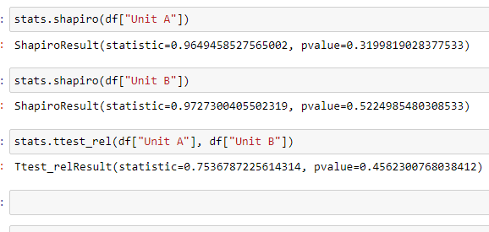

ANS: P=0.45

The p > α

The p value is greater than significance value so the **null hypothesis is True (H0).**

There is no significant difference in the diameter of the cutlet between two units.

1. A hospital wants to determine whether there is any difference in the average Turn around Time (TAT) of reports of the laboratories on their preferred list. They collected a random sample and recorded TAT for reports of 4 laboratories. TAT is defined as sample collected to report dispatch.

Analyze the data and determine whether there is any difference in average TAT among the different laboratories at 5% significance level.

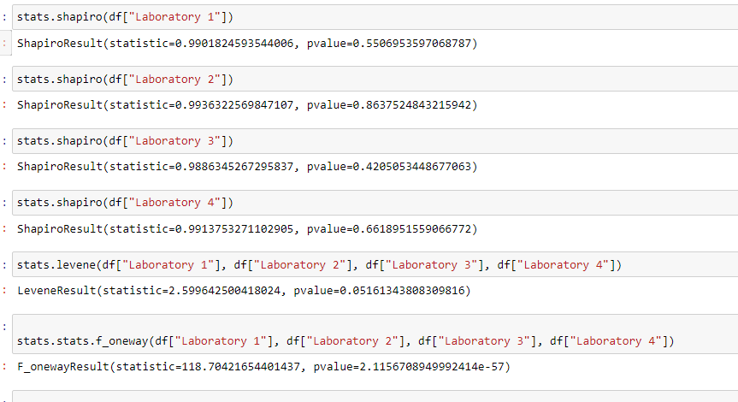

Ans: P has smaller values

There is a difference in average of TAT among the laboratories, **Alternate hypothesis is true (H1).**

1. Sales of products in four different regions are tabulated for males and females. Find if male-female buyer rations are similar across regions.

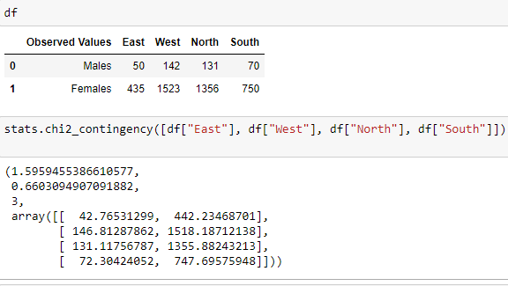

ANS: p = 0.66030 p > α

**Null hypothesis True (H0)**, the buyer ratio is similar across region.

1. TeleCall uses 4 centers around the globe to process customer order forms. They audit a certain % of the customer order forms. Any error in order form renders it defective and has to be reworked before processing. The manager wants to check whether the defective % varies by center. Please analyze the data at *5%* significance level and help the manager draw appropriate inferences

ANS: 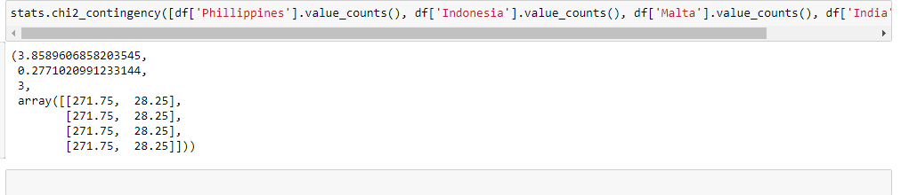P= 0.27, the p is greater than significance value; the defect % is not vary by center the **Null hypothesis True (H0).**