Software Requirements Specifications
ZBox – Zbang Boxes

Version: 1.0.4
Author: Yaniv Yechezkel
Last Update: 24/01/2011
Table of Contents
Table of Contents 2
Revision History 3
1. Introduction 4
1.1 Purpose 4
1.2 Document Conventions 4
1.3 Intended Audience and Reading Suggestions 4
1.4 Project Scope 5
1.5 References 5
2. Overall Description 6
2.1 Product Perspective 6
2.2 Product Features 7
2.3 User Classes and Characteristics 8
2.4 Operating Environment 9
2.5 Design and Implementation Constraints 16
2.6 User Documentation 16
2.7 Assumptions and Dependencies 16
3. System Features 17
3.1 Storage Services 17
3.2 Collaboration Service 20
3.3 Notification Services 23
3.4 Account Services 24
4. External Interface Requirements 26
4.1 User Interfaces 26
4.2 Hardware Interfaces 26
4.3 Software Interfaces 26
4.4 Communications Interfaces 26
5. Other Nonfunctional Requirements 27
5.1 Performance Requirements 27
5.2 Safety Requirements 27
5.3 Security Requirements 27
5.4 Software Quality Attributes 28
6. Other Requirements 29
Appendix A: Glossary 30
Appendix B: Analysis Models 31
Appendix C: Issues List 32

Revision History
Name | Date | Reason For Changes | Version
Yaniv Yechezkel | 27/12/2010 | Basic Skeleton  Template customization | 1.0.0
Yaniv Yechezkel | 28/12/2010 | 1.1 Purpose  1.2 Document Conventions  1.3 Intended Audience and Reading Suggestions  1.4 Project Scope  1.5 References  2.2 Product Features  2.3 User Classes and Characteristics | 1.0.1
Yaniv Yechezkel | 04/01/2011 | - Product Perspective  2.2 Product Features  2.3 User Classes and Characteristics  2.4 Operating Environment  2.5 Design and Implementation Constraints | 1.0.2
Yaniv Yechezkel | 08/01/2011 | - System Features  5.3 Security Requirements | 1.0.3
Yaniv Yechezkel | 09/01/2011 | 3.0 System Features | 1.0.4

Introduction

Purpose
This document serves as an SRS (Software Requirements Specifications) for the ZBox service.

The ZBox service is part of Zbang company collaboration solutions, and its main purpose is to provide users with the ability to share content over the web by providing users with a web interface to virtual boxes to store and share content.

This document’s scope is the ZBox service and NOT the Zbang application.

In the context of this document the Zbang application is another client for the ZBox service.

Document Conventions
Along this document the terms Product, Software, System, Solution and Service are used interchangeably and are all refer to ZBox service.

Intended Audience and Reading Suggestions
This document is organized into the following sections:
- Introduction
- Overall Description
- System Features
- External Interface Requirements
- Other Nonfunctional Requirements
- Other Requirements
- Glossary
- Analysis Models
- Issues List

This document is intended for different types of readers:

- Project Managers / Product Owners
Can use this document as a guideline for the project, do a project break-down to tasks, prioritize features, and do estimations.
- Architects
Can use this document in order to communicate ideas, and agree with other members in the project on the project scope, requirements, and general architecture.
- Developers
Can use this document as a blueprint for modeling the different components.
- Testers
Can uses this document in order to define and run unit and load tests based on different models and requirements described.
- Graphical & UX Designers
Can uses this document in order to emphasize variant aspects related to User Experience, layout and design of the Web Application User Interface, or refer to design materials that do so.

This document is suggested to be read in a sequence, beginning with the overview sections and proceeding through the sections that are most pertinent to each reader type.

Project Scope
The scope of the project is ZBox service design, implementation and eventually deployment and serving as in a SAAS fashion.

TODO: Relate the software to corporate goals or business strategies

ZBox service will let users collaborate and share content over the web in a simple way, by using a Web User Interface over the internet.

ZBox service will fall in the gap between similar services like DropBox and Box.Net. In comparison to those services ZBox will NOT be a pure storage service like DropBox, and will be much simpler then Box.Net which aims mostly for enterprise users.

References
In order to prevent redundancy and promote reuse, this document will not cover subjects like company vision, and PDS (Product Design Specifications) which are already covered in the following documents:

- For a PDS refer to zBox requierments_inc_web.docx
- For UI general ideas and sketches refer to Zbox web design flow.pptx
- For a preliminary UI Layout refer to Capture.JPG

Overall Description

Product Perspective
This service is a follow on the Zbang smart client application which operates as a standalone application with a local repository, and provides users with sharing and collaborations features.

The ZBox service will be available as SAAS for the public. The ZBox service will interact with Zbang smart client application and with other external systems in order to provide users with storage, collaboration, and notification services capabilities.

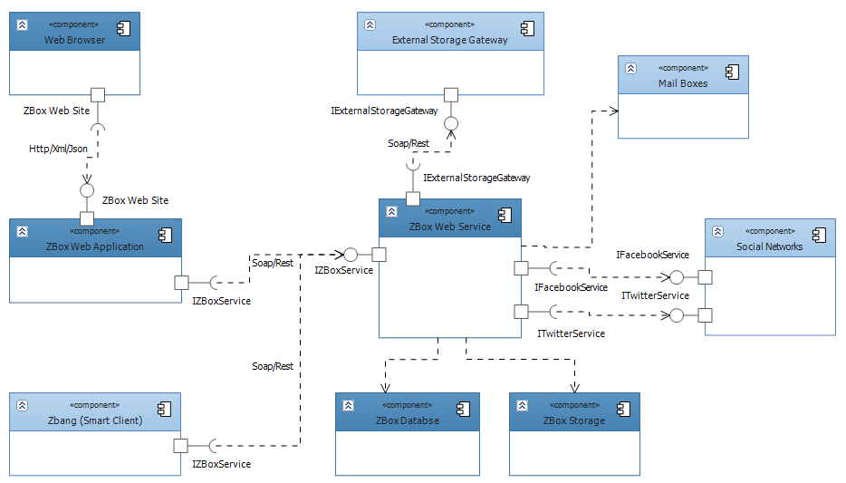
Diagram 1 - Major Components depicts service major components and the interaction/integration between the ZBox service, Zbang, and external systems.

Diagram 1 - Major Components

Product Features

The ZBox service will offer users the following features:

- Storage
Boxes creation and content management.
- Collaboration
Box sharing (files, music, video…).
- Notification
Notifications to user’s Mailbox, Facebook & Twitter.
Diagram 2 - Major Features provides a visualization of the features illustrated as high level use cases.

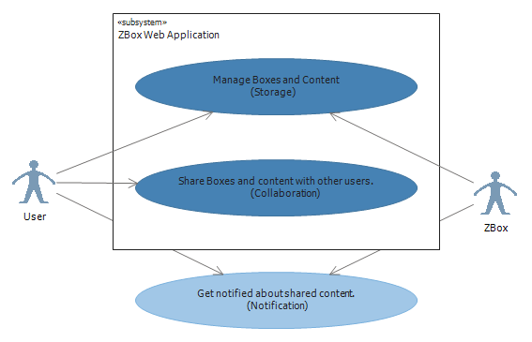

Diagram 2 - Major Features

User Classes and Characteristics
The system recognizes 2 classes of users: Guest and Registered User.

There is an additional reference to a Registered User with a Zbang Client.

Available Features / Allowed Tasks | Guest | Registered  User | Registered User  with Zbang Client
Register | x
Box URI | x | X
Search in box | x | X
Search across boxes | x | X
View multi-box display | x | X
View content (Component View) | x | X
Add a comment | x | X
Download | x | X
Login |  | X
Manage boxes |  | X
Contacts |  | X
Profile settings |  | X
Notification settings |  | X
View Quota |  | X
Privileges |  | X
Upload / Remove |  | X
Tags |  | X
Share box |  | X
New box |  | X
Change ZBox Skin |  | X
Box privacy |  | X
Send a file |  | X

TODO:
Refine the terms - Box URI, Privileges, Box privacy, Send a file

TODO:
Complete the third column

Operating Environment
The ZBox software will be provided as SAAS for public users and will operate on the Internet.
The software will be available both as a Web Application (UI) and as a Web Service (SI).

The selection of the hosting strategy will have a great impact on the entire application lifecycle.

Therefore, this section main goal is to provide as much information in order to take the most appropriate selection for the hosting and operating environment.

This section will deal with several aspects including:

- Hosting strategies.
- The drivers and barriers for cloud computing.
- Cloud services vendors.

Hosting Strategies
There are several options to consider when it comes to hosting strategy:
- In-house dedicated server(s).
Full responsibility and control over hardware, software, licensing and networking.
- Hosted dedicated server(s).
Partial responsibility and control over hardware, software, licensing and networking.
Some components are not always dedicated like firewall and load balancers.
- Cloud computing
Either as IAAS (Infrastructure as a Service) or PAAS (Platform as a Service).

The drivers and barriers for cloud computing
- Security
Storage, Transport/Message, Authentication and Authorization control, SSO with other cloud offerings and on-premise systems.
- Total Cost of Ownership (TCO)
Pricing model should be compared with an alternative of dedicated server(s), in order to evaluate the ROI (Return On Investment) options.
- Control
Technological control in the form of – Storage, Security, Deployment, Monitoring, Management,
and Integration with external systems.
- Culture
Company culture plays a significant role in technology adoption. Some companies adopt technologies only where they reach total maturity and are well adopted in the industry or community while others are more agile and embrace new technologies and tools if they have a business value.
- Competition
Reducing IT costs can get a company to be more competitive with the pricing model it offers to her clients.
- Time to Market
The time required to a product to be available in the market depends on the entire software lifecycle including packaging and deployment which sometimes rely heavily on hardware, licensing and other IT issues.
- Reliability
This encompasses the entire spectrum of quality attributes like Availability, Stability, Scalability, Performance, and Maintainability.
- Service Level Agreement (SLA)
An SLA not only covers the availability of a service, but also other objectives like customer expectations, performance measurements, reporting, quality standards, and relationship management.
A successful business driver for cloud services is an SLA addressing the quality of service required by the customer.

Cloud services vendors

- Amazon Web Services (AWS)
Amazon is considered a pioneer in this realm.
Amazon’s cloud services offerings consist of several services divided into the following categorized:
Category | Service | Description
Compute | EC2 | Amazon Elastic Compute Cloud is a web service that provides resizable compute capacity in the cloud.  It is designed to make web-scale computing easier for developers.
Compute | Elastic MapReduce | Amazon Elastic MapReduce is a web service that enables businesses, researchers, data analysts, and developers to easily and cost-effectively process vast amounts of data. It utilizes a hosted Hadoop framework running on the web-scale infrastructure of Amazon EC2 and Amazon S3.
Compute | Auto Scaling | Auto Scaling allows you to scale Amazon EC2 capacity automatically up or down according to pre-defined conditions.  Auto Scaling is particularly well suited for applications that experience hourly, daily, or weekly variability in usage.  Auto Scaling is part of Amazon CloudWatch Monitoring services.
Messaging | SQS | Amazon Simple Queue Service offers a reliable, highly scalable, hosted queue for storing messages as they travel between computers.  By using Amazon SQS, developers can simply move data between distributed components of their applications that perform different tasks, without losing messages or requiring each component to be always available.
Messaging | SNS | Amazon Simple Notification Service is a web service that makes it easy to set up, operate, and send notifications from the cloud.  It provides developers with a highly scalable, flexible, and cost-effective capability to publish messages from an application and immediately deliver them to subscribers or other applications.  It is designed to make web-scale computing easier for developers.
Storage | S3 | Amazon Simple Storage Service provides a simple web services interface that can be used to store and retrieve any amount of data, at any time, from anywhere on the web.
Storage | EBS | Amazon Elastic Block Store provides block level storage volumes for use with Amazon EC2 instances. Amazon EBS volumes are off-instance storage that persists independently from the life of an instance. Amazon Elastic Block Store provides highly available, highly reliable storage volumes that can be attached to a running Amazon EC2 instance and exposed as a device within the instance. Amazon EBS is particularly suited for applications that require a database, file system, or access to raw block level storage.
Networking | Elastic Load Balancing | Elastic Load Balancing automatically distributes incoming application traffic across multiple Amazon EC2 instances. It enables you to achieve even greater fault tolerance in your applications, seamlessly providing the amount of load balancing capacity needed in response to incoming application traffic.
Database | SimpleDB | Amazon SimpleDB is a highly available, scalable, and flexible non-relational data store that offloads the work of database administration. Developers simply store and query data items via web services requests, and Amazon SimpleDB does the rest.
Database | RDS | Amazon Relational Database Service is a web service that makes it easy to set up, operate, and scale a relational database in the cloud.  It provides cost-efficient and resizable capacity while managing time-consuming database administration tasks, freeing you up to focus on your applications and business.  Amazon RDS gives you access to the full capabilities of a familiar MySQL database.

Amazon cloud services falls into the type of IAAS (Infrastructure as a Service).
Amazon Web Services (AWS) provides the developer a sophisticated abstraction and automation layer on top of virtualizations software to run pre defined or custom instances of images which are bundles of OS, DB, Web Server, Development tools etc.
Compared to Google App Engine & MS Azure it gives the developer the ultimate freedom to run and mange instances of any operating system, database, and web server on various types of computing infrastructure (CPU, Memory, and IO).
With control comes the cost and responsibility of managing those environment and take control over the IT work alongside with handling the business software.
You can find full technical and pricing information on the AWS site at http://aws.amazon.com/
- Google App Engine
Google App Engine is a platform for building and hosting web applications. App Engine offers fast development and deployment, simple administration, with no need to worry about hardware, patches or backups, and effortless scalability
This approach allocates Google App as a true PAAS (Platform as a Service).
Google App Engine programming model is based on SDK’s that simulate a local development web server and consist of deployment, versioning and administration tools.
There two available SDK’s – for both Java and Python.
It is, by design, far more restrictive and imposes a lot of limitations for the developer in order to maintain application’s scalability and prevent resources abuse.
The application runs in a sandbox, the sandbox isolates your application in its own secure, reliable environment that is independent of the hardware, operating system and physical location of the web server.
Examples of the limitations of the secure sandbox environment include:
- Support only Java and Python environments, as mentioned above.
- Transport can be over HTTP(s) only.
- An application cannot write to the file system.
- Application code only runs in response to a web request, a queued task, or a scheduled task.
- Each request must return response data within 30 seconds in any case.
For complete reference go to http://code.google.com/appengine/
- Microsoft Windows Azure
Windows Azure is Microsoft’s platform for building and hosting web applications.
Windows Azure is also a type of PAAS, and is more similar to Google App Engine in its concept.
Windows Azure is less restrictive to the developer than App Engine.
There are SDK’s and Tools for Visual Studio 2008 and 2010 for building, running and deploying Azure applications.
Windows Azure Platform consists of three main elements: Windows Azure – the operating system,
SQL Azure, and the App Fabric (formally .NET Services).
Category | Service | Description
Windows Azure | Compute | The compute service offers scalable hosting of services on 64-bit Windows Server 2008 platform with Hyper-V support.  The platform is virtualized and designed to scale dynamically based on demand.  The platform runs Internet Information Server (IIS) version 7 enabled for ASP.NET Web applications.  Currently, the underlying Windows operating  system and other infrastructure components like IIS are not available directly to developers.
Windows Azure | Storage | There are three types of storage supported in Windows Azure: tables, blobs, and queues.  These storage types support REST-based direct access through REST APIs.
Windows Azure | Management | The management service supports automated infrastructure and service management capabilities to Windows Azure cloud services.  The fabric controller abstracts the underlying  virtualized platform infrastructure from the compute and storage services.
SQL Azure | Relational Data Storage | The relational data storage engine is the backbone of the SQL Azure and is based on the core SQL Server code base.  This component exposes the traditional SQL Server capabilities like the tables, indexes, views, stored procedures, and triggers.
SQL Azure | Data Sync | The Data Sync capabilities provide the synchronization and aggregation of data to and from SQL Azure to enterprise, workstations, partners and consumers devices using the Microsoft Sync Framework.
SQL Azure | Management | The management component provides automatic provisioning, metering, billing, load-balancing, failover and security capabilities to SQL Azure. Depending on the SLA, each database is replicated to one primary and two secondary servers. In case of a failover, the switching between the primary  and the secondary server is automatic without interruptions.
SQL Azure | Data Access | The Data Access component defines different methods of accessing SQL Azure programmatically. Currently, SQL Azure supports Tabular Data Stream (TDS), which includes ADO.NET, Entity Framework,  ADO.NET Data Services, ODBC, JDBC, and LINQ clients. Developers can access SQL Azure either directly from on-premise applications or through cloud services deployed in Windows Azure.
App Fabric | Access Control | The access control component provides rules-driven, claims based access control for distributed applications.
App Fabric | Service Bus | The service bus is a generic .NET Internet service bus. It is analogous to the Enterprise Service Bus (ESB) popularly seen in large enterprises.  Unlike the ESB, the AppFabric Service Bus is designed for Internet scale and messaging with cross-enterprise and cross-cloud scenarios in mind.  The service bus provides key messaging patterns like publish/subscribe, point to-point, and queues for message exchanges across distributed applications in the cloud as well as on-premise.
For a complete reference go to http://www.microsoft.com/windowsazure/
Summary
The 3 offerings are not directly comparable. There's a set of applications you could write for any of them, but you'll be writing a different thing in each case.

App Engine provides a restricted runtime environment - no writing to files, no sockets, and so forth - and a non-relational DBMS. But in return, you get a runtime environment that scales indefinitely, and a reasonable degree of assurance that your app will scale as big as you want it to.

Azure, on the other hand, provides a slightly less constrained environment, which lets you write a wider array of apps, but requires you to write more - since you're implementing more of the stack yourself - and provides a much looser assurance of scalability.

Finally, AWS provides the ultimate do-it-yourself solution. They provide the hardware, and the storage, and not much else. You build your stack from the ground up, maintain it, upgrade it, and so forth. Your app scales if and only if you write it to scale, which is no small challenge. But, you get complete control over your hardware.

Design and Implementation Constraints
Development Tools & Languages

The ZBang codebase is currently based on Microsoft .NET Framework 3.5.
The ZBang (Smart Client Application) is a WPF Application, written in C# using SQL CE/Light.

Hardware

The system will require access to local and remote storage.

User Documentation
TODO:
<List the user documentation components (such as user manuals, on-line help, and tutorials) that will be delivered along with the software. Identify any known user documentation delivery formats or standards.>

Assumptions and Dependencies
TODO:
<List any assumed factors (as opposed to known facts) that could affect the requirements stated in the SRS. These could include third-party or commercial components that you plan to use, issues around the development or operating environment, or constraints. The project could be affected if these assumptions are incorrect, are not shared, or change. Also identify any dependencies the project has on external factors, such as software components that you intend to reuse from another project, unless they are already documented elsewhere (for example, in the vision and scope document or the project plan).>

System Features
This section contains the functional requirements for the product by system features, the major services provided by the product.

Storage Services
3.1.1 Description and Priority
Storage Services will let users create and manage their own boxes.
Users can then upload and manage content in those boxes.
Priority: high.
3.1.2 Stimulus/Response Sequences
Diagrams below demonstrate boxes, and content use cases.
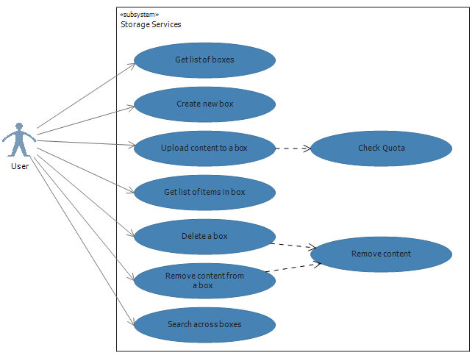

Diagram 3 – Boxes use cases

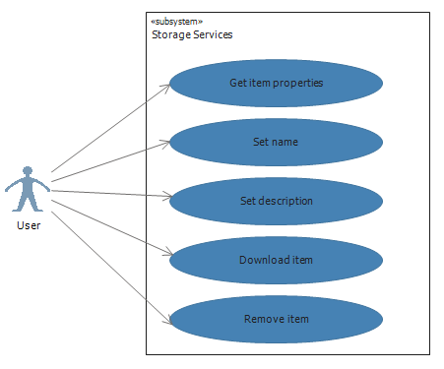

Diagram 4 – Content Item use cases.
3.1.3 Functional Requirements

REQ-01: Get list of boxes.
Get a list of all boxes related to a specific user.
REQ-02: Create a new box.
User is not limited to any number of boxes.
User must supply a unique name, else will get an error of duplicate name.
User can optionally add a description and an image.
REQ-03: Upload content to a box.
Browse for a file on the user’s file system, select a file and upload it to a selected box.
The system should verify that file meets those criteria and that that by loading it, user will not exceed his quota.
User should get an error for any of those criteria if compromised.
When an item is uploaded it will retain with its original name or with an enumeration postfix in case an item with the same name already exists in the same box.
REQ-04: Get list of items in a box.
Get a list of all items in a selected box.
List should include item name, description, thumbnail, size, type.
REQ-05: Delete a box.
Remove all items related to the box, and deleting the selected box.
This action is permanently.
REQ-06: Get content item properties.
Get all properties for a selected item in a selected box.
Properties will include: Name, Description, Size, Type, Creation time.
REQ-07: Set item’s name.
User can change the item’s original name as long as it is unique, and in the correct length.

REQ-08: Download an item.
Get a link to download the item.
REQ-09: Remove an item.
Remove a selected item.
This action is permanently.
REQ-10: Get boxes quota.
Get user’s storage size and capacity.
REQ-11: Search in box.
Search items by name in a selected box.
REQ-12: Search across boxes.
Search items by name across all boxes.

Collaboration Service
3.2.1 Description and Priority
Collaboration services include all features related to interaction, and content sharing between users.
Priority: low.
3.2.2 Stimulus/Response Sequences
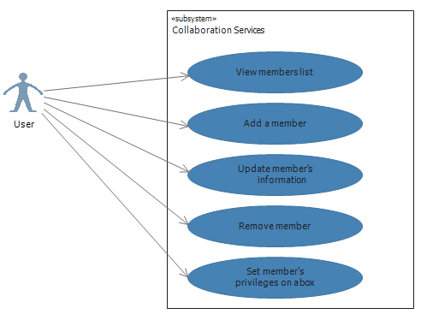

Diagram 5 – Members use cases.
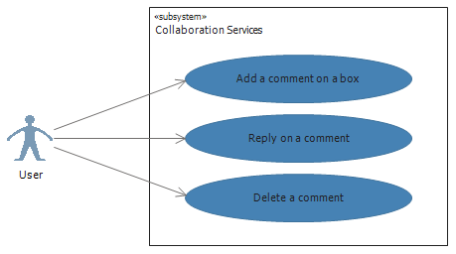

Diagram 6 – Conversation use cases.

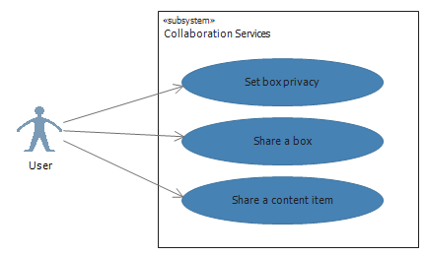

Diagram 7- Sharing use cases.

3.2.3 Functional Requirements
REQ-13: View members list.
View all box members.
Box members are people got invitation for a specific box by owner.

REQ-14: Add a member.
Add a new member manually.
Member’s information should contain the member’s email and optionally a display name.
A user can select from a predefined list of permissions which includes:
Viewer or Editor.
When adding a member a user can enter its info manually, or select it from list of already defined members.
A member actually becomes a member just after registration to the service and accepting the invitation. Until then its status is pending.

REQ-15: Update member.
Update member information.
REQ-16: Remove member.
Remove a member from user’s members list.
REQ-17: Add comment.
A comment can be added on an item, where an item can be a box, a content item, a comment (that would be a reply on a thread).
TODO: Specify behavior and terminology.
REQ-18: Delete a comment.
Delete a comment, and potentially all of its child comments.
REQ-19: Set box privacy.
By default all boxes are public.
A box owner can set the box private (by making it password protected), or read only.
REQ-20: Set members privileges.
A box owner can set a member to be viewer, editor, or owner on a box.
The default is viewer.
 | Owner | Manager | Write | Read
Share Box | X | X
Add File | X | X | X
Remove File | X | X | X
Delete Box | X
Change Privacy | X
Unsubscribe people from share box | X
Unsubscribe to box (myself) |  | X | X | X
Change Friend Privilege | X

REQ-21: Share a box.
A box owner or member can share a box.
A user that has got an invitation to share a box will receive the box URI.

Notification Services
3.3.1 Description and Priority
Notification services enable user to be notified on certain pre-defined events in the service.
Priority: low.
3.3.2 Stimulus/Response Sequences

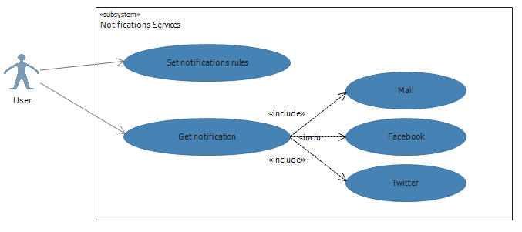

Diagram 8 – Notification services use case

3.3.3 Functional Requirements

REQ-22: Set notifications rules.
An owner can set notifications services on or off.
An owner can select on which events the box will trigger notifications to all subscribers / members.
A member can select from the available options the owner has defined on his box.
REQ-23: Get notification.
A user can be notified via mail, facebook or twitter on certain events.

Account Services
3.4.1 Description and Priority
Features described in this section relate to ZBox accounts and related profiles in general and not to specific services.
Priority: Medium.
3.4.2 Stimulus/Response Sequences
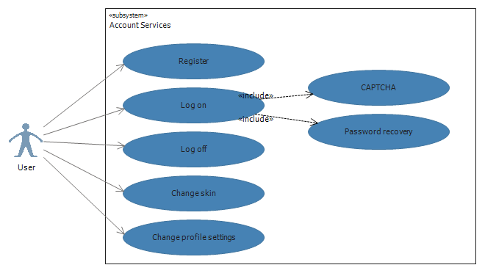

Diagram 9 – Account services use case

3.4.3 Functional Requirements

REQ-24: Register to service.
A user can register to the service for FREE by providing a unique username and password.
Flow will contain mail verification & CAPTCHA.
Registration fields: mail, password.
Optional fields: Display name & photo.
TODO: Explain the registration process of a Zbang user.
REQ-25: Log on.
A registered user can log on to service.
The log on process should contain CAPTCHA, lock, and password recovery
mechanisms.

REQ-26: Log off.
A logged on user can log off.
REQ-27: Change skin.
A user can select a skin from an available skins list.
REQ-28: Change profile settings.
A user can change profile settings.
Change password, display name, photo, unregister…

External Interface Requirements

User Interfaces
<Describe the logical characteristics of each interface between the software product and the users. This may include sample screen images, any GUI standards or product family style guides that are to be followed, screen layout constraints, standard buttons and functions (e.g., help) that will appear on every screen, keyboard shortcuts, error message display standards, and so on. Define the software components for which a user interface is needed. Details of the user interface design should be documented in a separate user interface specification.>

Hardware Interfaces
<Describe the logical and physical characteristics of each interface between the software product and the hardware components of the system. This may include the supported device types, the nature of the data and control interactions between the software and the hardware, and communication protocols to be used.>

Software Interfaces
<Describe the connections between this product and other specific software components (name and version), including databases, operating systems, tools, libraries, and integrated commercial components. Identify the data items or messages coming into the system and going out and describe the purpose of each. Describe the services needed and the nature of communications. Refer to documents that describe detailed application programming interface protocols. Identify data that will be shared across software components. If the data sharing mechanism must be implemented in a specific way (for example, use of a global data area in a multitasking operating system), specify this as an implementation constraint.>

Communications Interfaces
<Describe the requirements associated with any communications functions required by this product, including e-mail, web browser, network server communications protocols, electronic forms, and so on. Define any pertinent message formatting. Identify any communication standards that will be used, such as FTP or HTTP. Specify any communication security or encryption issues, data transfer rates, and synchronization mechanisms.>

Other Nonfunctional Requirements

Performance Requirements
<If there are performance requirements for the product under various circumstances, state them here and explain their rationale, to help the developers understand the intent and make suitable design choices. Specify the timing relationships for real time systems. Make such requirements as specific as possible. You may need to state performance requirements for individual functional requirements or features.>

Safety Requirements
<Specify those requirements that are concerned with possible loss, damage, or harm that could result from the use of the product. Define any safeguards or actions that must be taken, as well as actions that must be prevented. Refer to any external policies or regulations that state safety issues that affect the product’s design or use. Define any safety certifications that must be satisfied.>

Security Requirements
This section defines service security model and mechanisms.

5.3.1 Authentication
The service will provide an authentication.
Authentication will be based on simple credentials – username and password.
Username should be a unique mail.
Password will be saved hashed with a related salt field.
* Work with other token providers like facebook, live and others.
Explore and check for estimation.

5.3.2 Log on process
Log on process will prompt user to enter his username, password, and text from a CAPTHA (only
after several failures).
The service will provide a password recovery mechanism for users who forgot their passwords.
TODO: Provide an activity diagram, and a sequence diagram.
5.3.3 Authorization
The system will distinguish between registered user and a guest.
Refer to section 2.3 User Classes and Characteristics for a complete matrix of roles & features.

5.3.4 Permissions / Privileges
the system will provide a permission/privileges mechanisms for allowing users to manage their
boxes in terms of public, read only and password protected boxes.
A box owner can manage passwords for password protected box.
A box owner can set permissions for members in terms of viewer, editor and owner.

5.3.5 Confidentiality

5.3.6 Encryption

Software Quality Attributes
<Specify any additional quality characteristics for the product that will be important to either the customers or the developers. Some to consider are: adaptability, availability, correctness, flexibility, interoperability, maintainability, portability, reliability, reusability, robustness, testability, and usability. Write these to be specific, quantitative, and verifiable when possible. At the least, clarify the relative preferences for various attributes, such as ease of use over ease of learning.>

Other Requirements
<Define any other requirements not covered elsewhere in the SRS. This might include database requirements, internationalization requirements, legal requirements, reuse objectives for the project, and so on. Add any new sections that are pertinent to the project.>
Appendix A: Glossary
This section includes all the terms necessary to properly interpret the SRS, including acronyms and abbreviations.

SAAS - Software as a Service.
IAAS - Infrastructure as a Service.
PAAS - Platform as a Service.

Appendix B: Analysis Models
<Optionally, include any pertinent analysis models, such as data flow diagrams, class diagrams, state-transition diagrams, or entity-relationship diagrams.>
Appendix C: Issues List
- AVG Storage POC.
Get a little experience with the API, in order to be able to do a detailed design of the elements interacting with this component/service.
Get to be able to estimate efforts needed in order to build the module based on the design.
NOT for v 1.0.
The v 1.0 will only work with Local storage.
- Notifications to Mailbox in v 1.0 should be done in the simplest way of one mail with internal link, and no reply address.
- Options for relating ZBox boxes to mailboxes:
  - Create a unique mail account per user’s box
On box creation, creating a related mail account.
  - Use Mailing services and route mails by an identifier
A layer that handles mail to a defined account and route at to the relevant box.
- Notifications to Social Networks – Maintaining Accounts.
NOT for v 1.0.
- Contacts/Members -
Added manually?
Are they available from somewhere?

