Day-3 Hackathon

Marketeplace Bandage E-Commerce

API INTEGRATION & DATA MIGRATION

**API INTEGRATION:**

API integration is the process of connecting different software applications to communicate and work together. It involves using Application Programming Interfaces (APIs) to allow one system to access the functions and data of another system. This enables seamless data sharing and functionality between applications, enhancing efficiency and automation. For example, integrating a payment gateway API into your website allows customers to make secure payments directly on your site.

**DATA MIGRATION:**

Data migration is the process of moving data from one location to another, which can involve transferring it from an old system to a new one. This can include databases, applications, or storage systems. The goal is to ensure that the data remains intact and usable in the new location. It involves planning, transferring, testing, and validating the data to make sure everything works properly.

I practice data migration because it's very useful for my business goals. It helps keep data up-to-date, improves system performance, and supports the adoption of new technologies, making operations more efficient and reliable.

**API INTEGRATION & DATA MIGRATION:**

Data migration is the process of moving data from one location to another, which can involve transferring it from an old system to a new one. This can include databases, applications, or storage systems. The goal is to ensure that the data remains intact and usable in the new location. It involves planning, transferring, testing, and validating the data to make sure everything works properly.

I practice data migration because it's very useful for my business goals. It helps keep data up-to-date, improves system performance, and supports the adoption of new technologies, making operations more efficient and reliable.

I practice API integration because it's incredibly useful for achieving my business goals. It helps streamline operations, reduce manual work, and improve customer experience by enabling real-time data updates and smooth interactions across various platforms and services. I put my sanity project Id, and Token in **( importSanityData.mjs )** file.

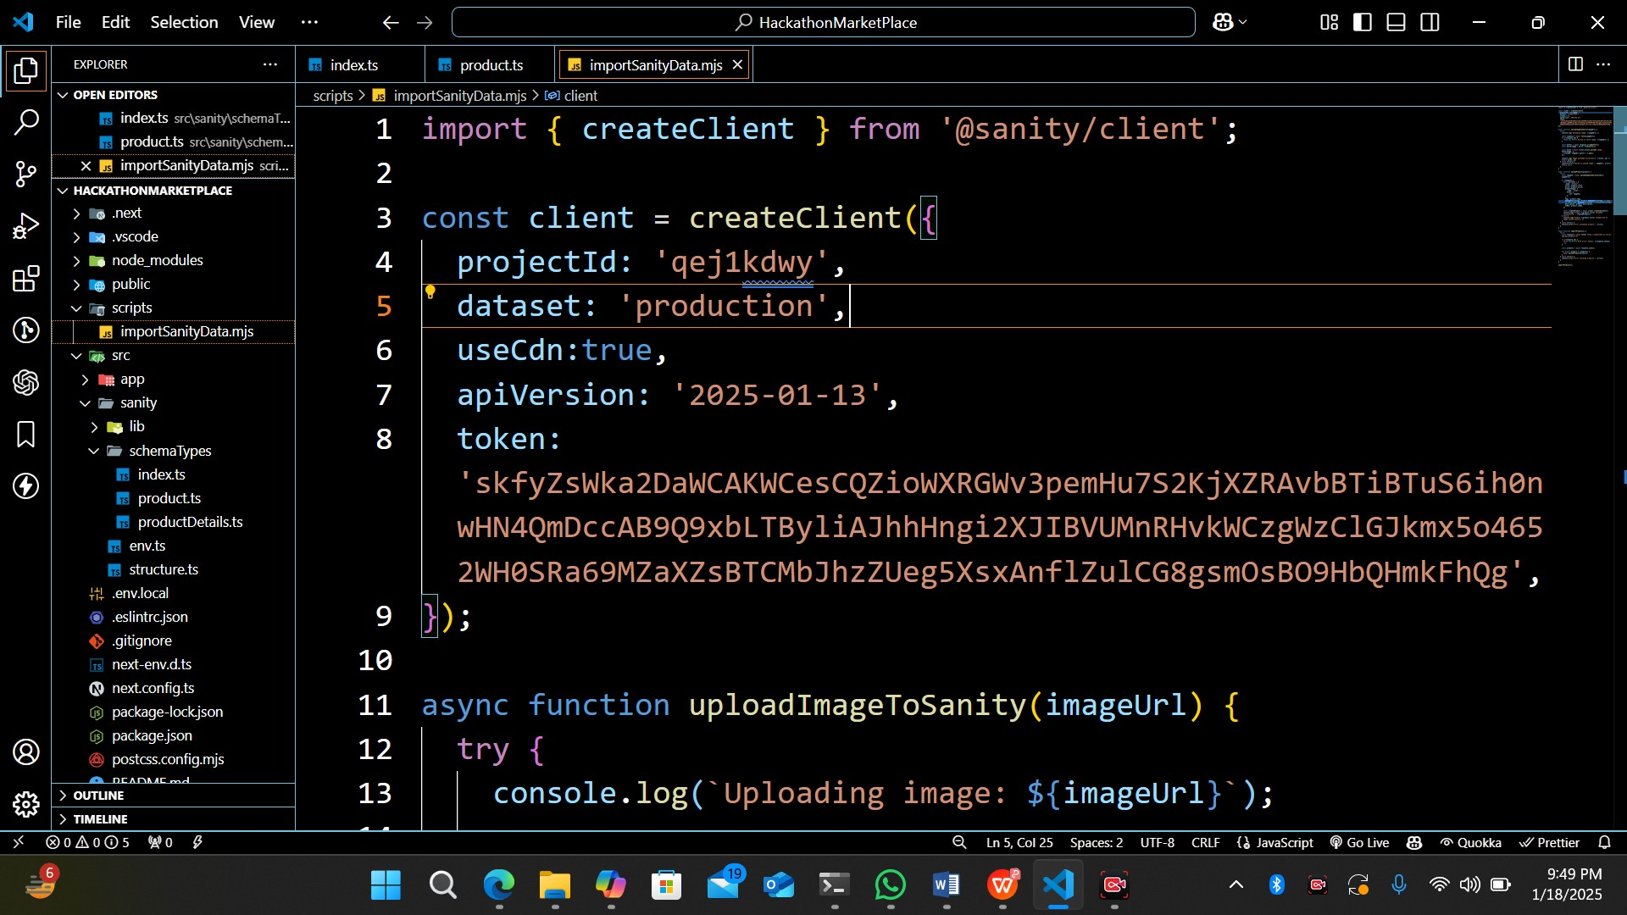

# **Running the Import Script:**

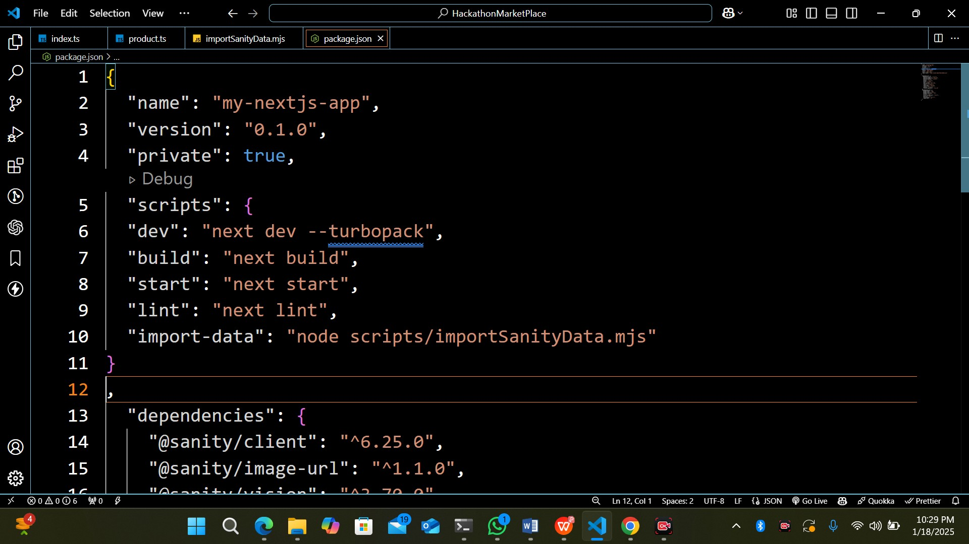

Then run the following commands import script using:

npm run scripts/importSanityData.mjs

This script fetch products from the FakeStoreAPI, upload any associated images to Sanity’s asset store, and then create new product documents in your Sanity dataset.

Sanity Studio Screen Shoot:

**Sanity Migration in Sanity Studio:**

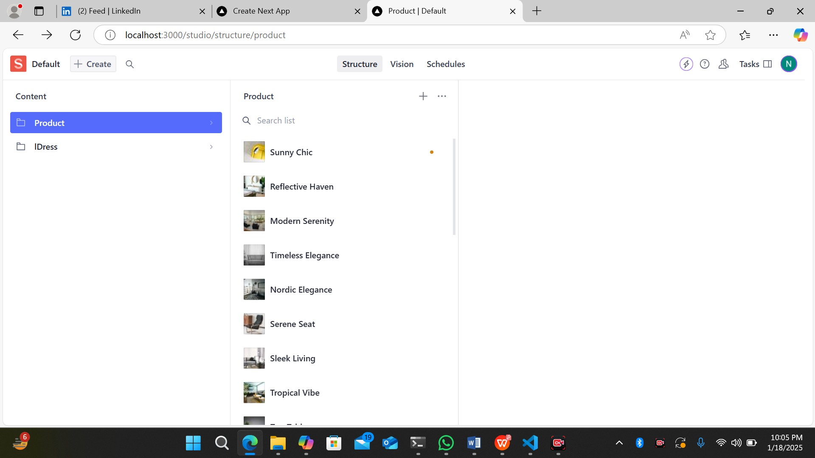

**Sanity Structure For Products Details:**

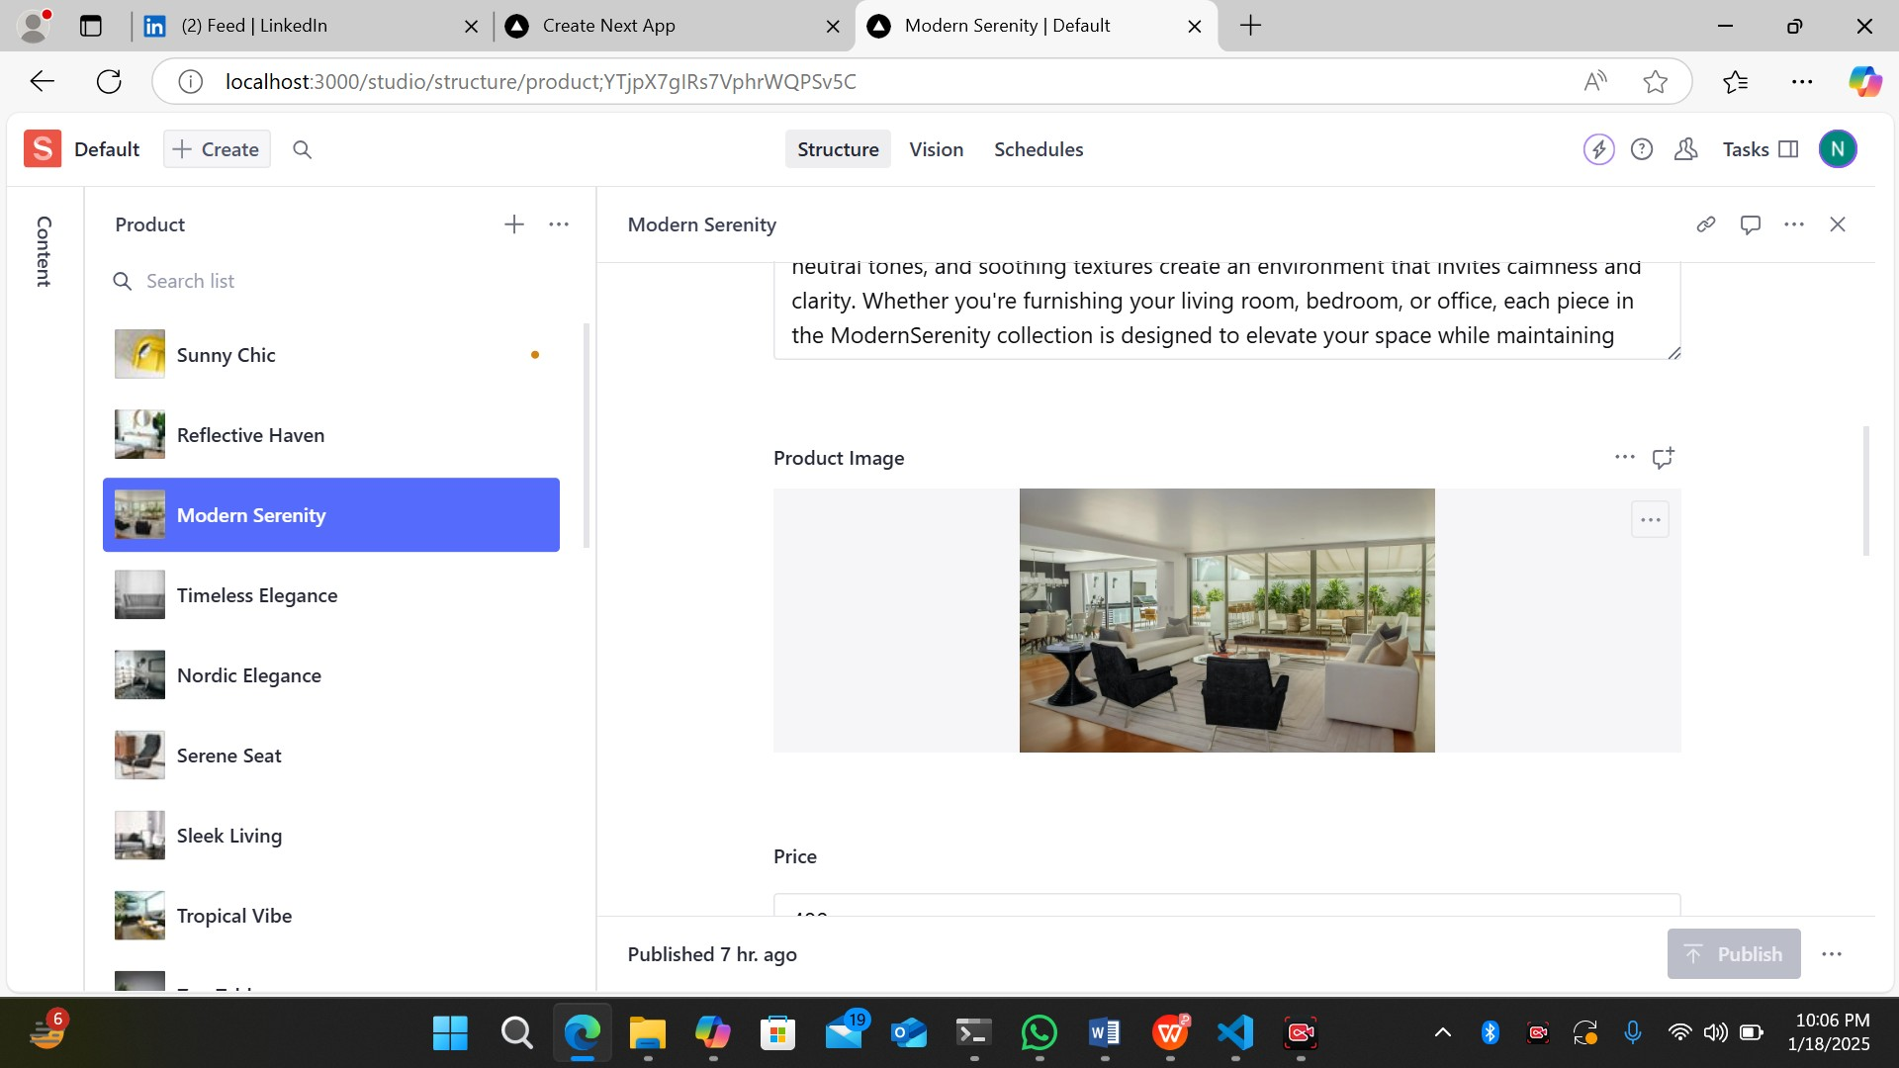

**Conclusion:**  
By this task , I’ve learned how to configure environment variables for Sanity integration, retrieve my Sanity Project ID and API token, create a custom product schema, and import data from an external API into my Sanity content .

# **Created My Own Sanity Data in website:**

First, I define the structure of my data with the Sanity schema. This lets me customize fields like text, numbers, images, and references. Once My schema is set up, I input data into Sanity's content studio.

In my Next.js project, I use the Sanity client to fetch and display this data. I created dynamic pages that show the updated content from Sanity, ensuring my website always has the latest information. This approach makes managing and updating content a breeze, saving time and effort.

Practicing this is very useful for my business goals because it allows for efficient content management and a smooth user experience.

**Product.ts (SCHEMA) :**

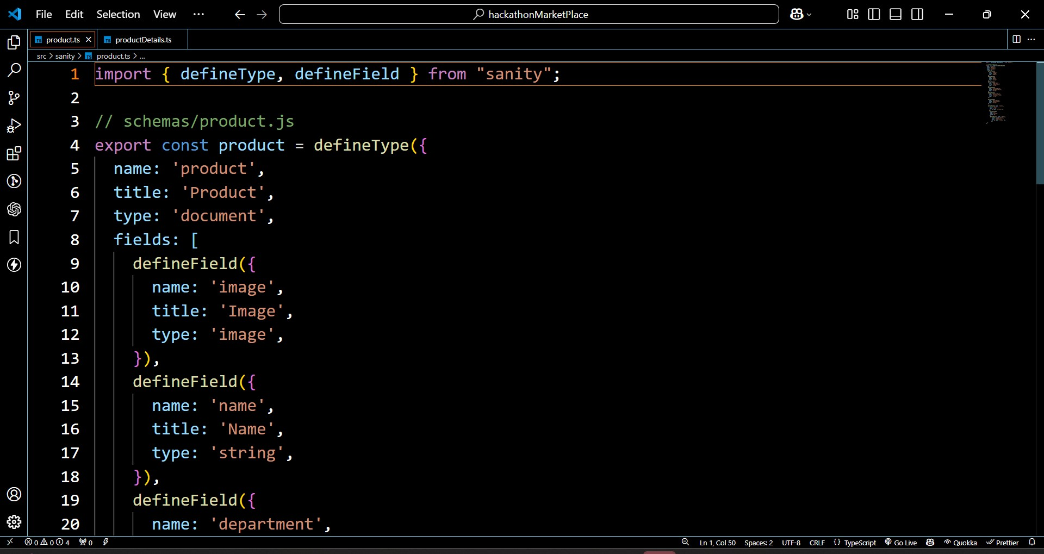

**ProductDetails.ts (SCHEMA) :**

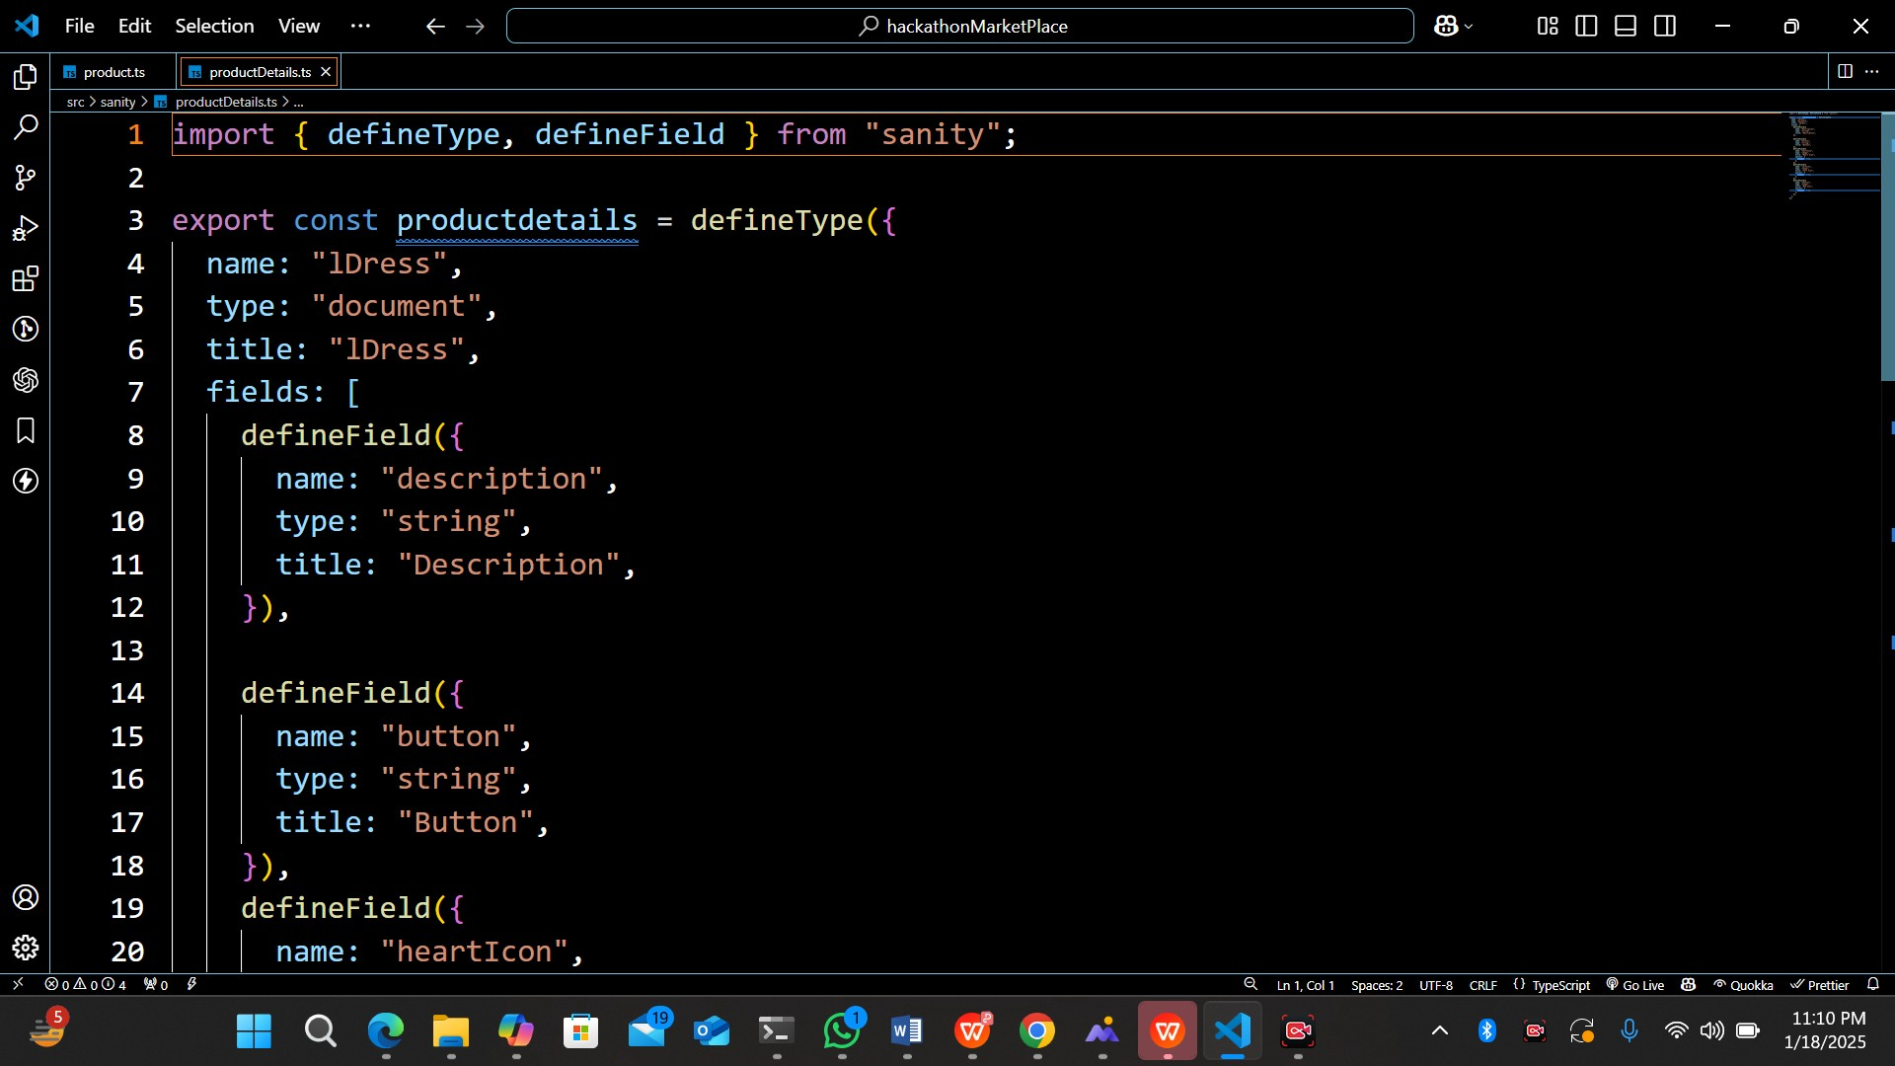

# **UI Products Cards Using Sanity Schema**



**Sanity Studio Display**

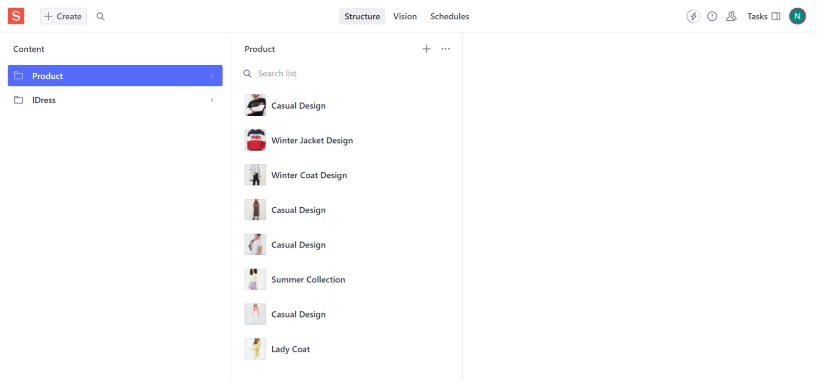

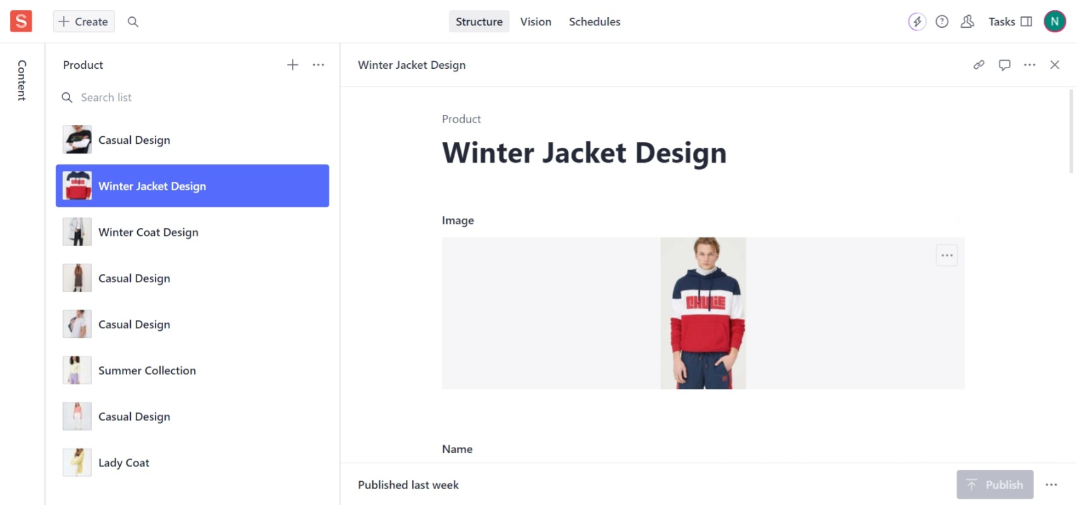



Conclusion:

By creating my own Sanity schemas and updating data in Next.js, I learned the importance of customizing data structures to fit specific needs. This experience showed me how to efficiently manage and display dynamic content. I also gained valuable skills in integrating back-end services with front-end frameworks, enhancing both my technical abilities and my project's functionality. This has been a significant step toward achieving my business goals by ensuring up-to-date and seamless content management.