GISMAA UNIVERSITY OF APPLIED SCIENCES
Department of computer and Data Sciencesrr
B103 Databases & Big Data
Domain: Healthcare System
By: Navjot Nazia Begam
[GH1035835]

CONTENTS:
1.Abstract 3
2.Introduction 3-4
3.Literature Review 4
4.Problem statement 5
5.Project Objectives 5
6.Database Design 5-10
.Entities
.Attributes
.Relationships
.ER Diagram
.Relational Schema
7.SQL Implementation 10-11
8. Database Normalization(1NF,2NF,3NF) 11-12
9. Challenges and Solutions 12
10.Conclusion 12-13
11.Links 13
12..Refrences 14

- ABSTRACT:
Healthcare organizations generate large volumes of patient , clinical, and administrative data every day. Managing this information efficiently requires a well- designed database system capable of maintaining data accuracy, consistency, and security. Relational Database Management Systems (RDBMS) provide a effective solution by organizing data into interconnected tables while enforcing relationships through primary and foreign key constraints.
This project presents the design and implementation of a relational Healthcare Management System using MySQL. The proposed database supports the management of patients, doctors , departments, appointments, medical records , laboratory tests , prescriptions, hospital rooms, and billing information. The database schema is developed using Entity-Relationship (ER) modelling and transformed into a relational model following database design principles.
The implementation demonstrates the creation of database objects using structured Query Language (SQL), including tables, constraints and sample queries for inserting , updating, retrieving and managing healthcare data. Furthermore, the database is normalized up to the Third Normal Form (3NF) to eliminate redundancy , improve consistency and enhance maintainability.
The project highlights the importance of relational database design in healthcare environments by illustrating how an integrated database can improve operational efficiency , support clinical decision- making and ensure reliable data management . The resulting system provides a scalable foundation that could be extended with additional features such as electronic health records, user authentication , and reporting functionalities.
- Introduction:
Modern healthcare institutions rely heavily on information systems to manage clinical services, administrative processes, and patient records. Hospitals generate significant amounts of structured information , including patient demographics, appointment schedules, medical histories, laboratory results, prescriptions and financial transactions. Without an efficient database management system, maintain the accuracy and accessibility of this information becomes increasingly difficult.
A Relational Database Management System (RDBMS) offers an effective solution for organizing healthcare data through structured tables linked by well-defined relationships. Such systems reduce data redundancy , Maintain data integrity Query Language (SQL) . Consequently, relational databases have become an essential component of modern Hospital Management Systems.
The primary objective of this project is to design and implement a relational database for a Healthcare Management a relational database for a Healthcare Management System using MYSQL. The database is designed to support essential hospital operations, including patient registration , appointment scheduling , medical record management, laboratory testing, billing, and room allocation. The project follows established database design methodologies , beginning with requirement analysis, followed by entity identification , relationship modelling, relational schema development , SQL implementation and normalization.
By applying normalization techniques and enforcing primary and foreign key constraints, the proposed database minimizes redundancy while maintaining consistency across related tables. The completed system demonstrates how relational database principles can be applied to solve real- world healthcare data management challenges and provides a scalable framework for future enhancements.
- Literature Review:
The healthcare sector has experienced significant digital transformation over the last two decades with database management systems becoming an essential component of hospital information systems. A relational database enables healthcare organizations to store , retrieve and manage large volumes of structured data while ensuring accuracy , consistency and security. These systems support day -to-day clinical and administrative activities , including patient registration , appointment scheduling , diagnosis recording , laboratory management, billing and reporting .
Relational Database Management systems (RDBMS) such as MySQL, Oracle database and Microsoft SQL Server, organize information into related tables connected through primary and foreign keys. According to Elmasri and Navathe (2016), the relational model improves data integrity by reducing redundancy and enforcing relationships between data entities. These features are particularly important in healthcare environments, where inaccurate or duplicated information may affect clinical decision- making and patient safety.
A fundamental stage in relational database development is conceptual modelling through Entity-Relationship(ER) diagrams. ER diagrams provide a graphical representation of system entities, their attributes, and the relationships between them. Coronel and Morris (2019) explain that ER modelling assists database designers in understanding business requirements before implementation , reducing design errors and simplifying future database maintenance.
Normalization is another important principle in database design. It is the process of organizing database tables to minimize redundancy and improve consistency. The First Normal Form(1NF) removes repeating groups by ensuring that each attribute contains only atomic values. The second Normal Form (2NF) eliminates partial dependencies, while the Third Normal Form (3NF) removes transitive dependencies. Applying these normalization techniques improves database performance , reduces storage requirements, and enhances data integrity.
Structured Query Language(SQL) serves as the standard language for interacting with relational databases. SQL enables developers to create databases, define tables, insert and modify records , retrieve information using queries and manage database security. Modern healthcare systems depend heavily on SQL because it allows rapid access to patient information while maintaining consistency through integrity constraints.
The increasing adoption of electronic health records (EHRs) has further emphasized the need for robust database systems. A well-designed healthcare database allows medical professionals to access complete patient histories, monitor treatments, coordinate care among departments, and generate analytical reports that support strategic decision -making . Consequently, relational databases remain one of the most reliable technologies for managing healthcare information efficiently.
4.PROBLEM STATEMENT:
Healthcare institutions manage extensive amounts of patient and operational data every day . Traditional paper -based record systems and poorly designed databses. Often result in data duplication , inconsistent records, delayed information retrieval, and difficulties in coordinating clinical services. These issues can reduce operational efficiency and negatively affect the quality of patient care.
Many healthcare facilities require an integrated database capable of managing patients, healthcare professionals, appointments, medical records, laboratory tests, billing transactions and room allocations within a single system. Without proper relational design and integrity constraints, maintaining accurate relationships between these entities becomes challenging.
This project addresses these challenges by designing and implementing a relational Healthcare Management System using MySQL. The proposed database emphasizes data integrity , reduced redundancy through normalization , efficient retrieval of information , scalability for future system expansion. The resulting solution demonstrates how relational database principles can support effective healthcare information management in a real-world environment.
5.PROJECT OBJECTIVES:
The primary objective of this project is to design and implement a relational database that efficiency manages healthcare information using MySQL.
The specific objectives are:
.To analyse the information requirements of a healthcare management system.
.To identify the major entities , attributes, and relationships involved in hospital operations.
.To develop an Entity-Relationship(ER) model representing the database structure.
.To convert the conceptual model into a relational database schema.
.To implement the database using SQL commands in MySQL.
.To establish primary keys, foreign keys, and integrity constraints that maintain data consistency.
.To normalize the database up to the Third Normal Form(3NF) to eliminate redundancy.
.To demonstrate database functionality through sample SQL queries.
6.DATABASE DESIGN:
6.1 SYSTEM OVERVIEW:
The Healthcare Management System is designed to centralize hospital operations by storing clinical and administrative information within a relational database. The proposed database supports patient registration, appointment scheduling, doctor and department management, medical records, laboratory tests, prescriptions, room allocations, and billing. Each entity is connected through primary and foreign key relationships , ensuring data integrity and minimizing redundancy.
The database follows the principles of relational database design, where each table represents a single entity and relationships between entities are maintained using foreign key constraints. This structure enables efficient querying , updating, and management of healthcare information while supporting scalability for future enhancements.
6.2 DATABASE ENTITIES:
The proposed database consists of the following entities:
1.Patient
The Patient table stores personal information about every registered patient.
Attributes
.PatientID (Primary Key)
.FirstName
.LastName
.Date of Birth
.Gender
.PhoneNumber
.Address
.BloodGroup
2.DOCTOR
The Doctor table stores information about medical practitioners working in the hospital.
Attributes
.DoctorID(Primary Key)
.FirstName
.LastName
.Specialization
.Email
.PhoneNumber
.DepertmentID(Foreign Key)
3.Department
Each doctor belongs to one hospital department.
Attributes
.DepartmentID(Primary Key)
.DepartmentName
.FloorNumber
4.Appointment
The Appointment table records scheduled consulations between patient and doctors.
Attributes
.AppointmentID (Primary Key)
.Patient ID(Foreign Key)
.DoctorID(Foreign Key)
.AppointmentDate
.AppointmentTime
.Status
5.Medical Record
This table stores diagnosis and treatment information.
Attributes:
.RecordID (Primary Key)
.PatientID(Foreign Key)
.MedicineName
.Dosage
.Duration
6.LaboratoryTest
Stores laboratory investigations performed for patients.
Attributes:
.TsetID (Primary Key)
.PatientID(Foreign Key)
.TestName
.TestDate
.Result
7.Room
Stores information about hospital rooms.
Attributes:
.RoomID(Primary Key)
.RoomType
.Capacity
.Availability
8.Billing
Maintains payment details for healthcare services.
Attributes:
.BillId (Primary Key)
.PatientID (Foreign Key)
.TotalAmount
.PaymentStatus
.BillingDate
6.3RELATIONSHIPS:
The relationships between the entities ensure that the database maintains consistency and avoids duplicate data.
.One department can have many doctors.
.One doctor can attend many appointments.
.One patient can schedule multiple appointments.
.One patient can have multiple medical records.
.One medical record can contain multiple prescriptions.
.One patient can receive multiple bills.
.Patients may be assigned hospital rooms during treatment.
These relationships are implemented using foreign keys to preserve referential integrity.
6.4 ENTITY-RELATIONSHIP DIAGRAM:
The ER diagram illustrates how the entities are connected within the Healthcare Management System. 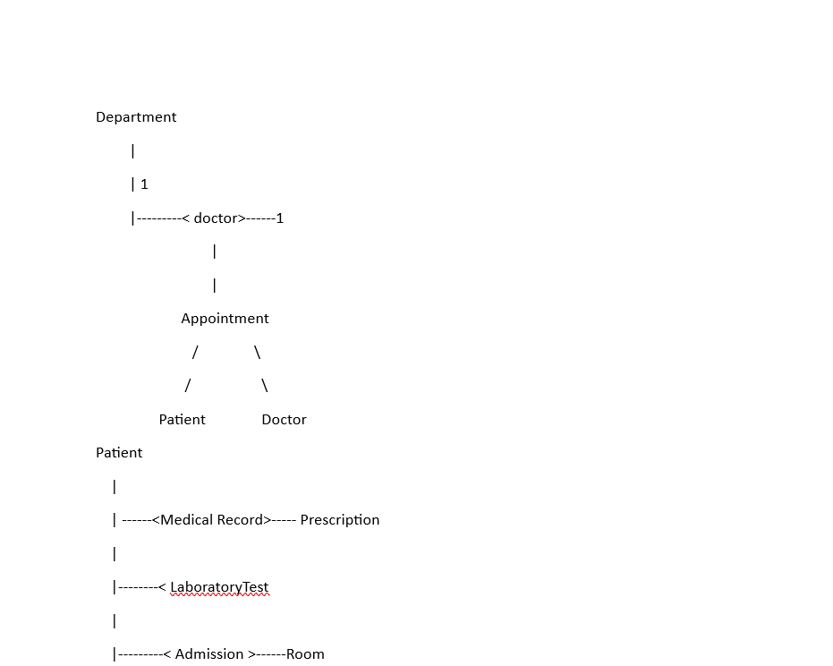

6.5 RELATIONAL SCHEME:The relational schema summaries the database tables and their relationships.
.Department(DepartmentID, DepartmentNmae, FloorNumber)
.Doctor (DoctorID, FirstName,LastName,Specialization, Email, PhoneNumber,DepartmentID)
.Patient (PatientID, FirstName, LastName, DateOfBirth,Gender ,PhoneNumber,Address, BloodGroup)
.Appointment(AppointmentID, PatientID,DoctorID, AppointmentDate,AppointmentTime,Status)
.MedicalRecord(RecordID, PatientID, DoctorID,Diagnosis,Treatment,VisitDate)
.Prescription(PrescriptionID,RecordID,MedicineName,Dosage,Duration)
.LaboratoryTest(TestID,PatientID,TestName,TestDate,Result)
.Room(RoomID,RoomType,Capacity,Availability)
.Billing(BillD,PatientID,TotalAmount,PaymentMethod,PaymentStatus,BillingDate)
7.SQL Implementation:The Healthcare Management System was implemented using MySQL, a widely used Relational Database Management System(RDBMS).SQL was used to create the database , define tables, establish relationships using primary and foreign keys, insert sample data and retrieve information through queries. The implementation demonstrates how a relational database can efficiency manage healthcare information while maintaining data integrity.
Figure 2 Creating database
Figure3 Formation of table
Figure 4 Forming table
Figure 5 Forming tables
8. Database Normalization:Normalization is an important step in relational database design because it reduces data redundancy and improves data consistency. The Healthcare Management System database was normalised to the Third Normal Form(3NF) to ensure that each table stores only relevant information and that relationships between tables are maintained correctly.
First Normal Form(1NF)The First Normal Form requires that each table contains atomic values and that every record is uniquely identified by a primary key. In this database ,each table contains individual values rather than multiple values within a single field.For example, each patient has one record in the Patient table and each appointment is stored as a separate record in the Appointment table.
Second Normal Form(2NF)The Second Normal Form eliminates partial dependencies by ensuring that all non- key attributes depend entirely on the primary key. Since each table in the proposed database uses a single -column primary key, attributes such as patient name, doctor specialization, and appointment status depend only on their respective primary keys.
Third Normal Form(3NF)The Third Normal Form removes transitive dependencies by ensuring that non- key attributes do not depend on other non-key attributes. For example, department information is stored separately in the Department table and referenced by the Doctor table using a foreign key. This approach reduces duplication and improves data integrity.
Overall, normalization enhances the efficiency of the database by reducing redundancy, simplifying maintenance, and ensuring consistency across all healthcare records.
9.Challenges and solutions:During the development of the Healthcare Management System, several challenges were encountered.
The first challenge involved establishing relationships between tables using foreign keys. Errors occurred when records were inserted into child tables before corresponding parent records had been created. This issue was resolved by creating tables in the correct order and inserting parent records before dependent records.
A second challenge involved avoiding duplicate information . Intially, some patient and doctor details were repeated across multiple tables. This problem was solved by applying normalization techniques and separating information into dedicated tables linked through foreign keys.
Another challenge involved writing SQL JOIN queries to retrieve information from multiple tables. Testing each query individually and validating the returned data ensured accurate retrieval of related information.
10.Conclusion:This project successfully demonstrates the design and impolementation of a relational Healthcare Management System using MySQL. The proposed database integrates patient management , doctor information , appointments , medical records, laboratory tests , hospital rooms, and billing into a single relational structure.
The application of primary keys, foreign keys, and normalization improves data integrity while reducing redundancy . SQL implementation demonstrates the practical use of relational database concept through database creation, table definition, data insertion, and information retrieval.
The completed Healthcare Management system provides a reliable and scalable solution for managing healthcare information . Future improvements could include user authentication , electronic health record integration , appointment reminders, and cloud-based deployment to enhance accessibility and security.
11.Links:GIThub repository link: https://github.com/Nazia3014/Healthcare-Management-System-Database.git

One drive: https://onedrive.live.com/my?viewid=39562570-a1ef-4768-9b0f-63aaeb380fe7&mkt=de-DE&lc=1031&id=%2Fpersonal%2FEE475EFEB604FA08%2FDocuments%2FDatabase_report

12.REFRENCES:
Connolly, T., & Begg, C. (2015). Database Systems: A Practical Approach to Design, Implementation and Management (6th ed.). Pearson.
Coronel, C., & Morris, S. (2019). Database Systems: Design, Implementation, & Management (13th ed.). Cengage.
Elmasri, R., & Navathe, S. B. (2016). Fundamentals of Database Systems (7th ed.). Pearson.
Oracle. (2024). MySQL 8.0 Reference Manual. https://dev.mysql.com/doc/
Silberschatz, A., Korth, H. F., & Sudarshan, S. (2020). Database System Concepts (7th ed.). McGraw-Hill.

