FINAL PROJECT DOCUMENTATION
E-Waste Collection & Recycling Management System
A Client–Server Desktop Application for E-Waste Logistics, Dynamic Dispatch, and Recycling Traceability
Course: Software Engineering
Submitted by: Anita Pervin, Nazia Hasan
Course: Design Pattern, BSSE, 16th Batch
Technology Stack: Java 17+, JavaFX 21, Spring Boot, SQLite, REST API, Maven
August 2026

Table of Contents
1. Executive Summary & Problem Domain 3
1.1 Overview 3
1.2 Problem Statement 3
1.3 Target Users 3
1.4 Core Value Proposition 3
2. System Architecture & Component Interactions 3
2.1 Layer Responsibilities 4
3. Design Pattern Realizations & Architectural Justifications 6
3.1 State Pattern — Pickup Lifecycle 6
3.2 Strategy Pattern — Prioritization and Dispatch 6
3.3 Observer Pattern — Cross-Actor Notification 7
3.4 Factory and Template Method Patterns 7
3.5 Builder Pattern — E-Waste Item Construction 8
3.6 Core Domain Model and Facade Coordination 9
3.7 Pattern Analysis & Trade-Off Matrix 9
4. Database Schema & Persistence Design 11
4.1 Relational Schema (DDL) 11
5. Non-Trivial Workflows & Business Logic 14
5.1 Workflow 1 — Multi-Step Pickup Scheduling & Dynamic Collector Dispatch 14
5.2 Workflow 2 — Facility Inspection, Template Processing & Reward Accrual 14
5.3 Pickup Lifecycle — UML State Diagram 15
5.4 Workflow 3 — Analytical Aggregations & Operational Reporting 16
6. Verification, Testing & Error Handling Strategy 18
6.1 Unit & Integration Test Suite Structure 18
6.2 Validation & Error Handling Architecture 18
7. User Interface Layout & Screen Mapping 18
8. Git Collaboration, Build & Execution Instructions 20
8.1 Collaborative Workflow & Branching Strategy 20
8.2 Maven Build & Run Commands 20

1. Executive Summary & Problem Domain

1.1 Overview
The E-Waste Collection & Recycling Management System is a client–server desktop application designed to address logistics bottlenecks, improper handling of toxic materials, and low customer engagement across electronic-waste supply chains. The system combines a JavaFX desktop client with a Spring Boot REST backend and a SQLite persistence layer to provide a complete, auditable pickup-to-recycling pipeline.

1.2 Problem Statement
Rapid technological turnover generates hazardous electronic waste that requires specialised sorting, safe transport, and verifiable recycling. Ad-hoc manual scheduling results in unoptimised collection routes, improper handling of hazardous components (e.g., lithium batteries and heavy-metal-bearing displays), and low citizen participation in formal recycling channels.

1.3 Target Users
- Customers / Citizens — register items, schedule collections, monitor status, and earn recycling rewards.
- Collection Personnel — view optimised task routes, track cargo weight constraints, and update pickup milestones.
- Administrators / Recycling Technicians — configure prioritisation metrics, assign collectors, perform facility inspections, and evaluate recycling yields.

1.4 Core Value Proposition
The system provides dynamic collector assignment, multi-tier cargo prioritisation, standardised inspection workflows, and persistent SQLite-backed auditing across the full pickup-to-processing lifecycle.

2. System Architecture & Component Interactions
The system implements a decoupled, four-tier architecture that separates client presentation, HTTP communication, domain logic, and persistence infrastructure. This separation enforces the Dependency Inversion Principle: the domain layer defines repository contracts that the infrastructure layer implements, so business rules remain free of persistence or transport concerns.
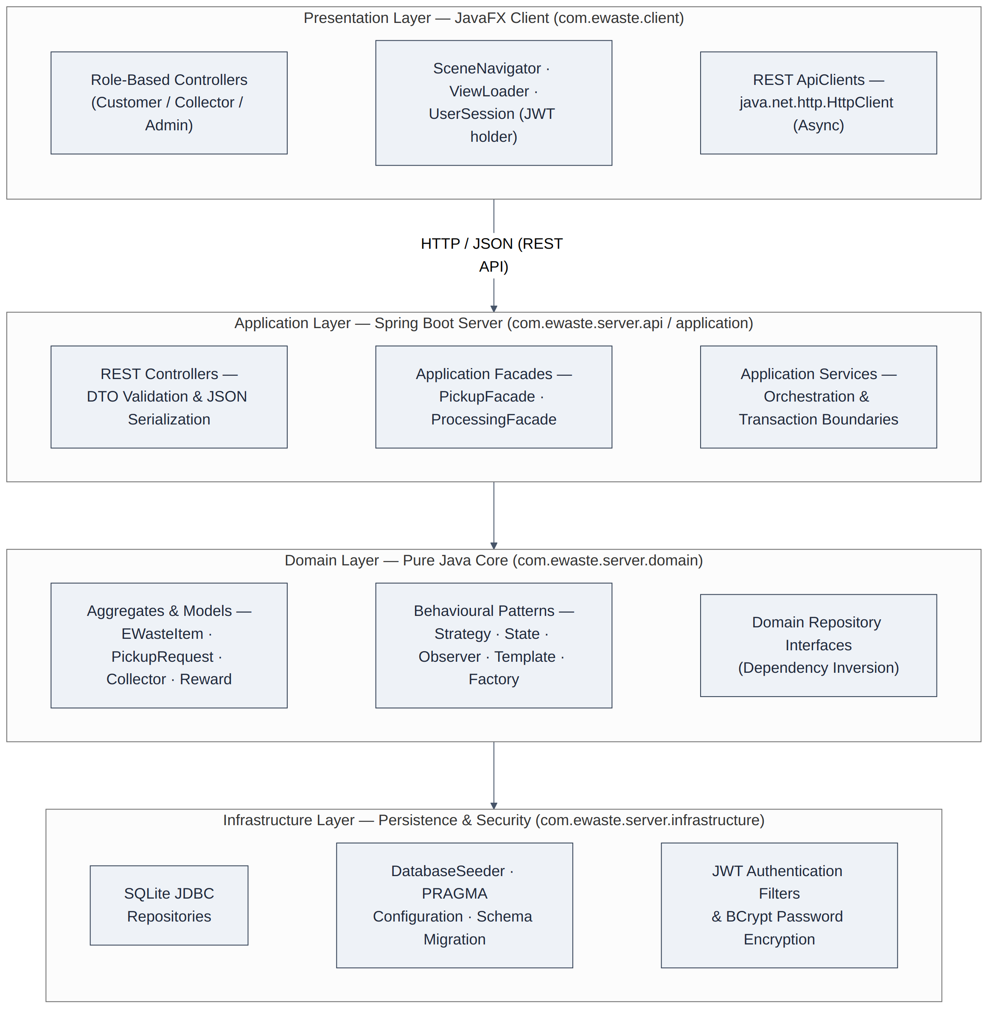
Figure 1. Layered system architecture and component responsibilities

2.1 Layer Responsibilities

2.1.1 JavaFX Client Layer (com.ewaste.client)
Manages UI state, captures user events, and invokes backend REST endpoints asynchronously off the JavaFX Application Thread, using role-specific controllers for the Customer, Collector, and Administrator experiences.

2.1.2 Server REST & Facade Layer (com.ewaste.server.api / application)
Provides token-based authentication, validates DTOs at the transport boundary, and orchestrates multi-step transactions through high-level application facades (PickupFacade, ProcessingFacade).

2.1.3 Domain Layer (com.ewaste.server.domain)
A pure Java layer holding business invariants, the six behavioural/creational pattern realisations described in Section 3, and repository interfaces with no dependency on UI frameworks or database drivers.

2.1.4 Infrastructure Layer (com.ewaste.server.infrastructure)
Executes raw SQL against SQLite, enforces referential integrity (PRAGMA foreign_keys = ON;), and verifies cryptographic tokens issued at authentication.

3. Design Pattern Realisations & Architectural Justifications
Six design patterns govern the system's most variable behaviour — pickup lifecycle transitions, prioritisation and dispatch logic, polymorphic item creation, complex object construction, cross-actor notification, and inspection workflows. Each is presented below as a focused UML class diagram followed by a trade-off analysis against the alternative considered and rejected. Section 3.7 cross-checks each pattern's implementation against the canonical definitions and structure catalogued on refactoring.guru, the reference used to name and validate the patterns in this project.

3.1 State Pattern — Pickup Lifecycle
The State pattern removes fragile if/else branching from the pickup lifecycle by encapsulating each lifecycle stage as an implementation of a common PickupState interface. PickupRequest acts as the Context: it holds a reference to the current state object and delegates all lifecycle operations to it.
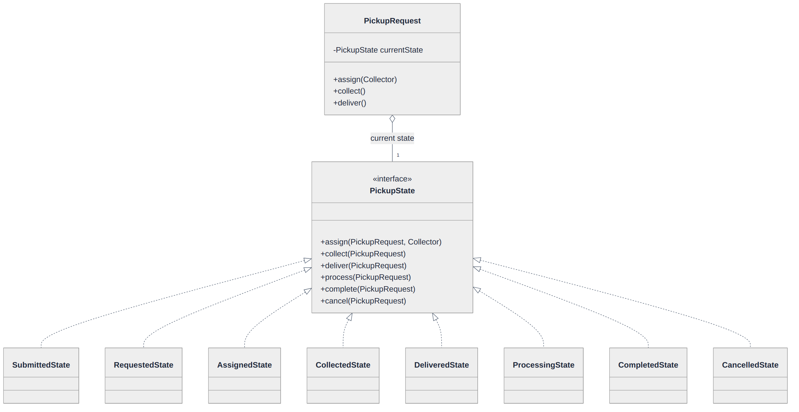
Figure 2. UML class diagram — State pattern applied to the pickup lifecycle

3.2 Strategy Pattern — Prioritisation and Dispatch
The Strategy pattern is applied twice: once to compute a composite priority score for a pickup request (PriorityStrategy), and once to select the collector who will service it (AssignmentStrategy). PickupFacade plays the Context role in both cases, delegating the algorithm to whichever concrete strategy is configured.
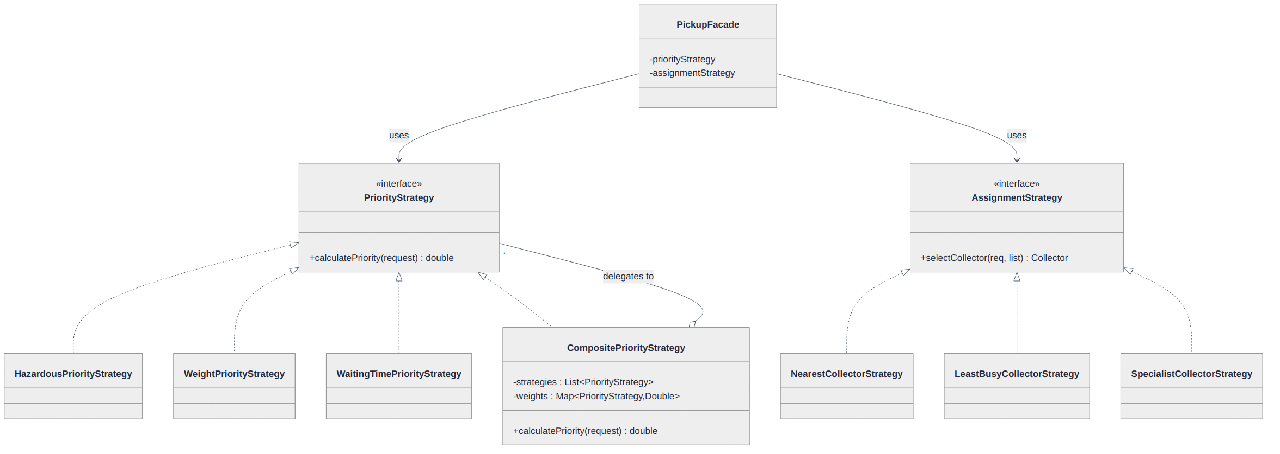
Figure 3. UML class diagram — Strategy pattern applied to priority scoring and collector assignment

3.3 Observer Pattern — Cross-Actor Notification
The Observer pattern decouples state-change notification from the transactional pipeline that triggers it. PickupEventPublisher plays the role refactoring.guru terms the Publisher; PickupEventListener is the Subscriber interface; the three notification observers are concrete subscribers.
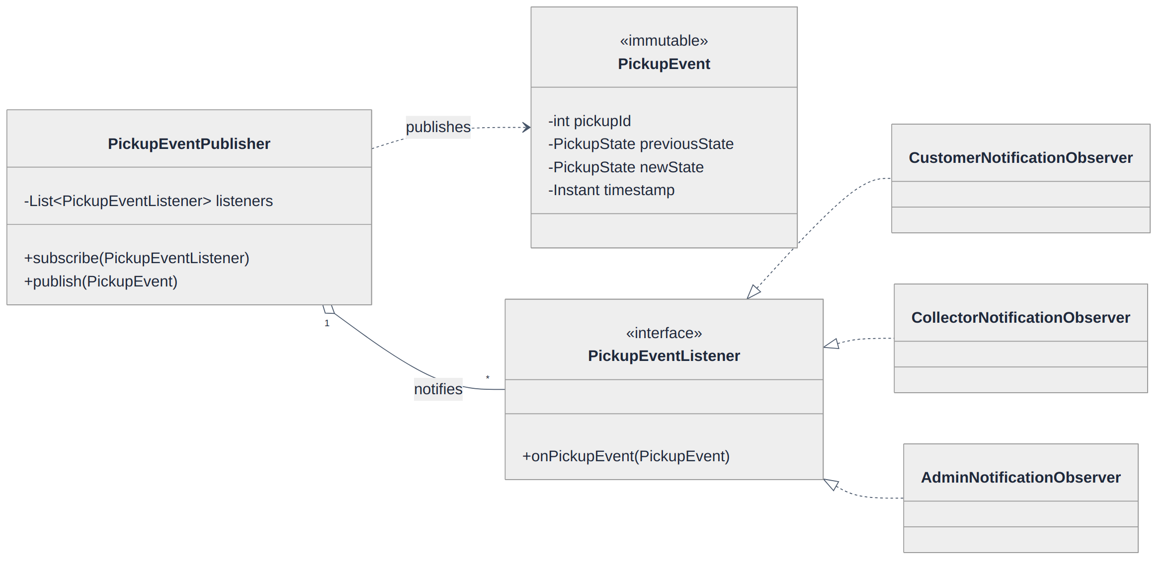
Figure 4. UML class diagram — Observer (Publisher/Subscriber) pattern applied to pickup event notification

3.4 Factory and Template Method Patterns
EWasteFactory centralises the instantiation of polymorphic e-waste item types behind a single creation method. As discussed in Section 3.7, this is more precisely a Simple Factory rather than the GoF Factory Method. The Template Method pattern standardises the invariant steps of facility inspection (AbstractProcessingTemplate) while allowing item-specific handling routines to vary in each concrete workflow.
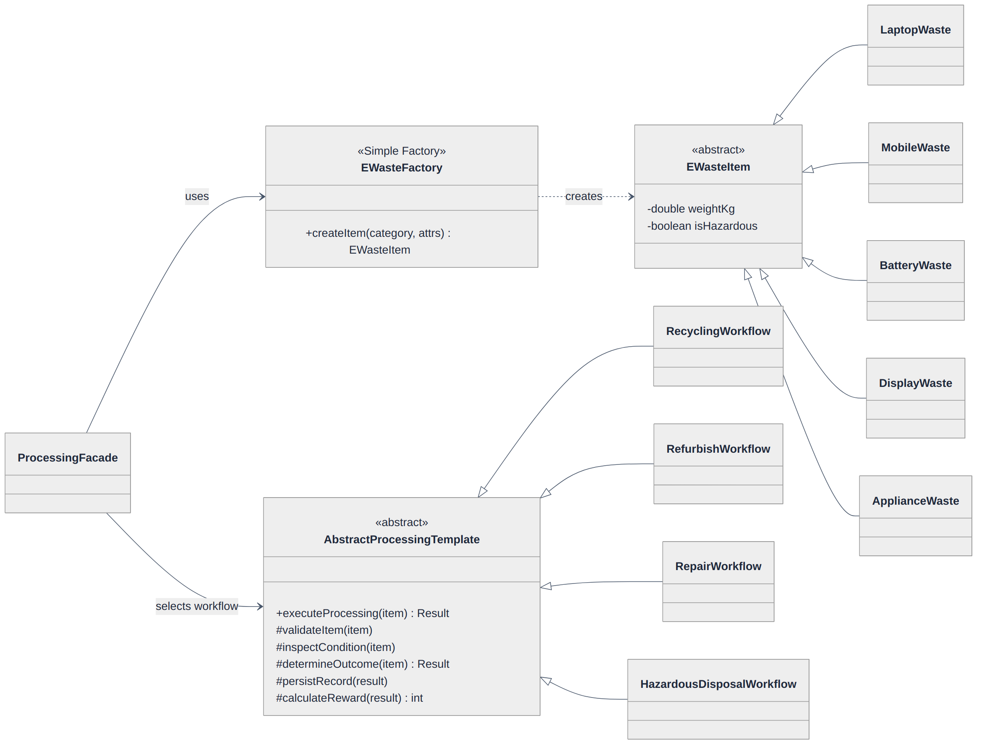
Figure 5. UML class diagram — Simple Factory pattern (EWasteItem hierarchy) and Template Method pattern (processing workflows)

3.5 Builder Pattern — E-Waste Item Construction
EWasteItem and its subtypes combine several mandatory attributes (model name, weight, category) with a variable set of optional attributes (hazard flags, waste condition, specific attributes) that differ by concrete waste type, which previously required long, error-prone constructors. AbstractEWasteItemBuilder exposes fluent setter methods for each attribute and a build() method that validates mandatory fields before returning a fully constructed EWasteItem, replacing telescoping constructors with a single readable construction chain. EWasteFactory now delegates to the concrete builder matching the requested category (LaptopWasteBuilder, BatteryWasteBuilder, DisplayWasteBuilder, etc.) rather than invoking constructors directly.
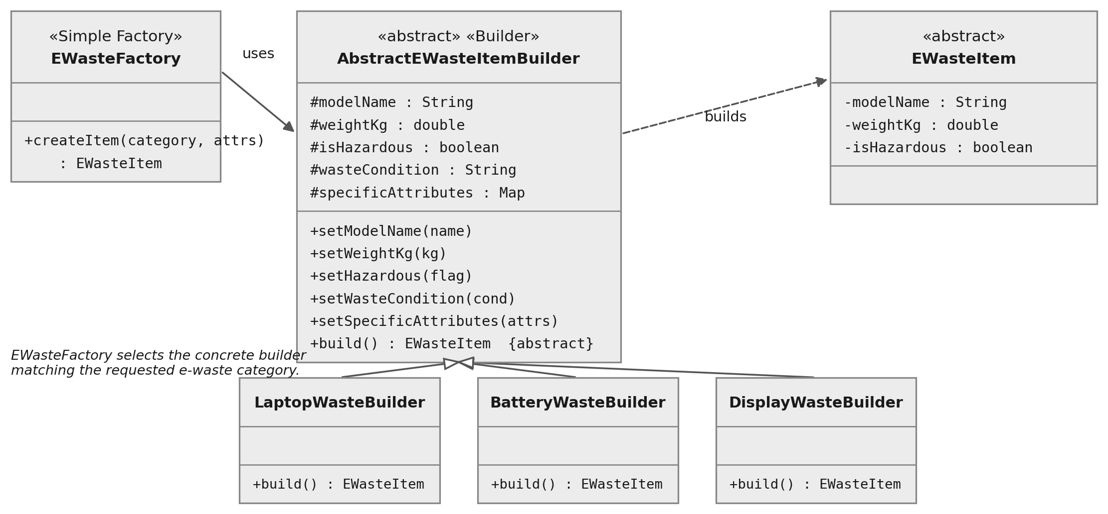
Figure 6. UML class diagram — Builder pattern applied to EWasteItem construction

3.6 Core Domain Model and Facade Coordination
The core aggregates (PickupRequest, PickupItem, EWasteItem, Collector, Reward, User) are coordinated by two application facades that keep REST controllers free of business logic.
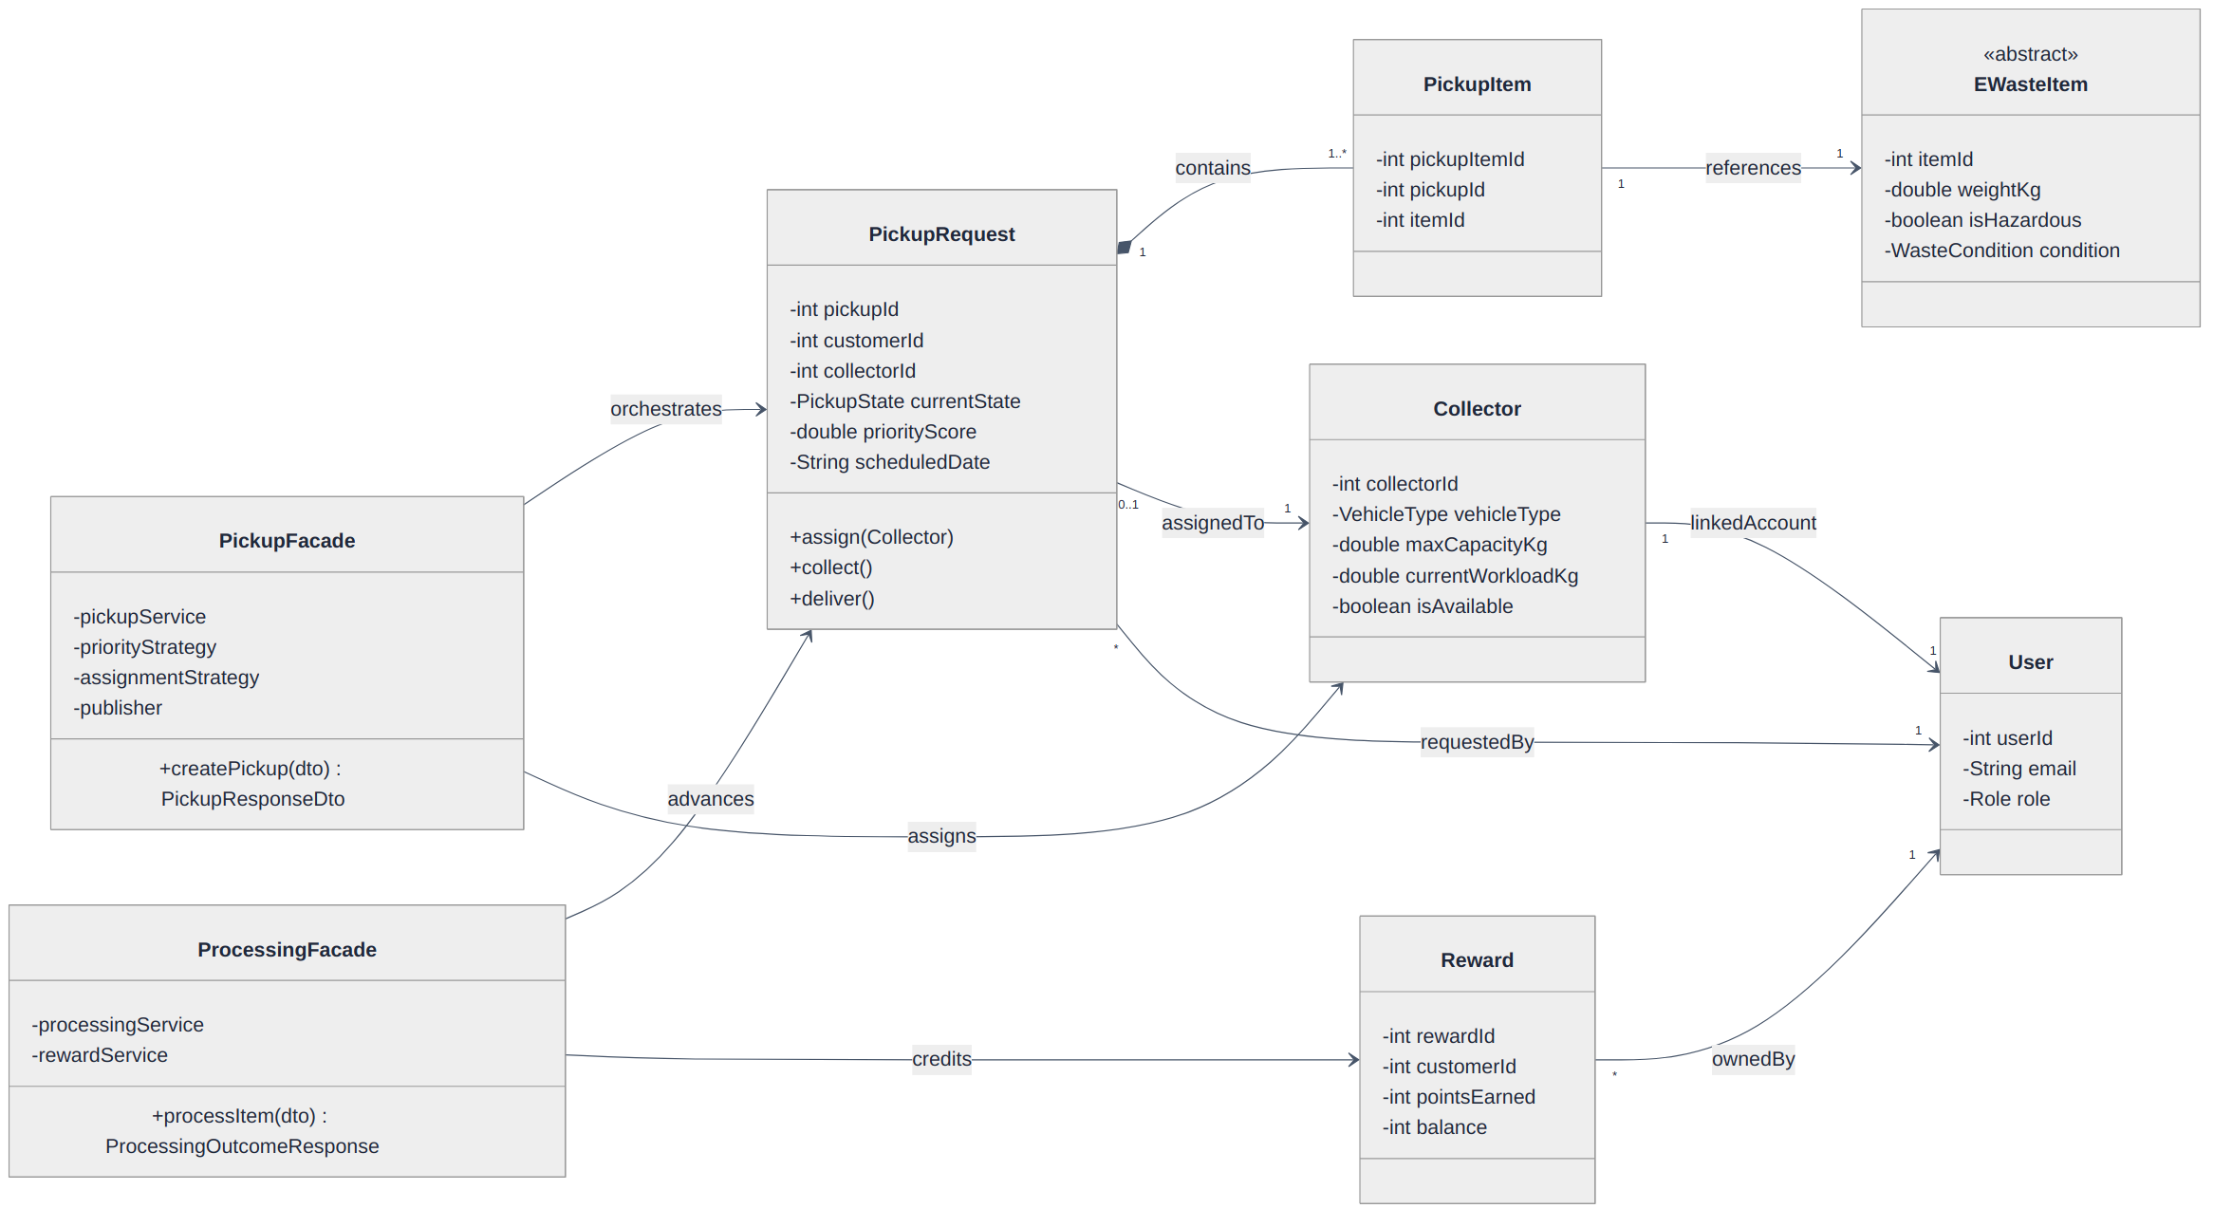
Figure 7. UML class diagram — core domain aggregates and facade coordination

3.7 Pattern Analysis & Trade-Off Matrix
Design Pattern | Problem Addressed | Selected Solution | Alternative Rejected | Extensibility Benefit
State | Complex pickup lifecycle (Requested → Assigned → Collected → Delivered → Processing → Completed / Cancelled) causing fragile conditional logic. | PickupState interface with concrete state classes (AssignedState, CollectedState, etc.) implementing transition methods. | Enums with switch statements — rejected for high cyclomatic complexity and Open/Closed Principle violations. | New intermediate states (e.g., PartiallyCollectedState) can be added without touching existing validation logic.
Strategy | Dynamic sorting of requests and collector assignment based on variable criteria (weight, hazard, queue time, proximity). | PriorityStrategy and AssignmentStrategy interfaces with interchangeable algorithms, combined via CompositePriorityStrategy. | Hardcoded scoring inside the service layer — rejected as new rules would force changes to monolithic methods. | New dispatch policies (e.g., EV-only routing) can be added as standalone classes.
Template Method | Redundant inspection pipelines with invariant steps but item-specific handling. | AbstractProcessingTemplate defining executeProcessing() with hook methods (validateItem, inspectCondition, determineOutcome, calculateReward). | Duplicated workflow classes — rejected due to logic drift and inconsistent auditing. | Standardises logging, reward creation, and persistence while permitting specialised handling of toxic substances.
Simple Factory | Direct instantiation of polymorphic EWasteItem models across multiple entry points. | EWasteFactory centralises creation of LaptopWaste, BatteryWaste, DisplayWaste, etc., behind one method. | Direct constructor calls — rejected as callers would need detailed knowledge of every concrete subtype. | New categories (e.g., SolarPanelWaste) require changes only to the factory.
Observer | Tightly coupled notification triggers across actors on pickup state change. | PickupEventPublisher broadcasts PickupEvent instances to registered listeners. | Direct in-line service calls — rejected as new channels (SMS, e-mail, audit log) would clutter transactional logic. | New observers (e.g., external audit integrations) subscribe with zero pipeline impact.
Builder | Complex EWasteItem construction with multiple mandatory and optional attributes (model name, weight, hazard flags, condition) causing cumbersome, error-prone constructors. | AbstractEWasteItemBuilder exposing fluent setters and a validating build() method, invoked internally by EWasteFactory. | Multi-argument constructors with parameter overloads — rejected for poor readability and error-prone positional arguments. | New optional attributes can be added as builder methods without breaking existing call sites.

4. Database Schema & Persistence Design
The SQLite database enforces strict relational integrity via PRAGMA foreign_keys = ON;. The revised Entity-Relationship Diagram below corrects a gap in the original schema, in which processing_records.center_id referenced a recycling_centers table that was never declared; that table is now included with its defining attributes.
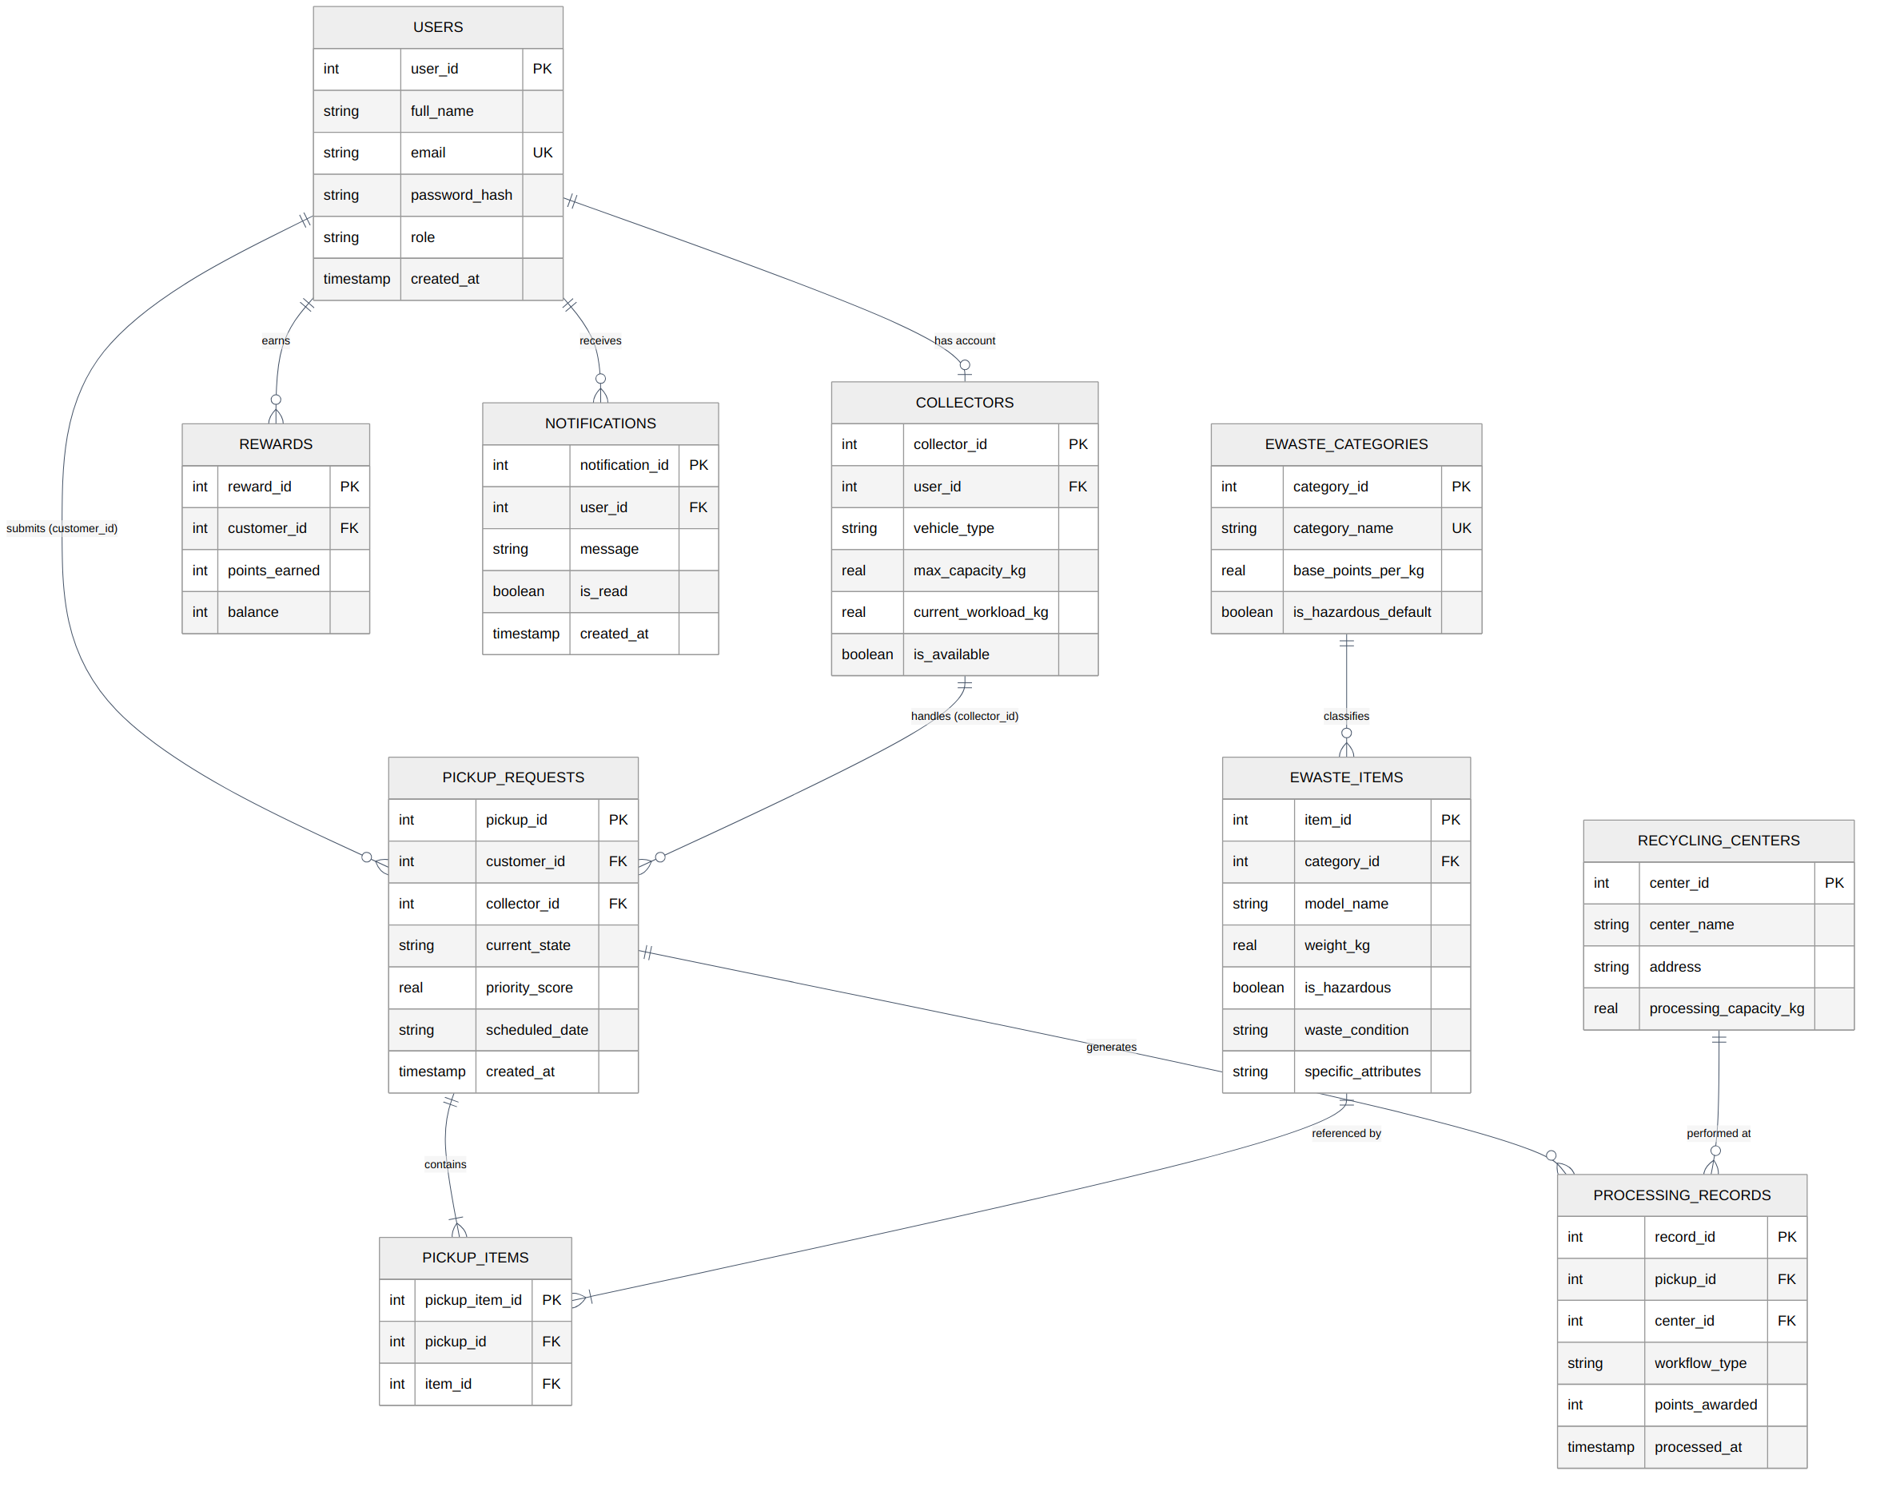
Figure 8. Entity-Relationship Diagram of the persistence schema (revised, with recycling_centers added)

4.1 Relational Schema (DDL)
CREATE TABLE IF NOT EXISTS users (
user_id INTEGER PRIMARY KEY AUTOINCREMENT,
full_name TEXT NOT NULL,
email TEXT UNIQUE NOT NULL,
password_hash TEXT NOT NULL,
role TEXT NOT NULL CHECK(role IN ('CUSTOMER', 'COLLECTOR', 'ADMIN')),
created_at TIMESTAMP DEFAULT CURRENT_TIMESTAMP
);
CREATE TABLE IF NOT EXISTS ewaste_categories (
category_id INTEGER PRIMARY KEY AUTOINCREMENT,
category_name TEXT UNIQUE NOT NULL,
base_points_per_kg REAL NOT NULL,
is_hazardous_default INTEGER NOT NULL DEFAULT 0
);
CREATE TABLE IF NOT EXISTS ewaste_items (
item_id INTEGER PRIMARY KEY AUTOINCREMENT,
category_id INTEGER NOT NULL,
model_name TEXT NOT NULL,
weight_kg REAL NOT NULL CHECK(weight_kg > 0),
is_hazardous INTEGER NOT NULL,
waste_condition TEXT NOT NULL,
specific_attributes TEXT,
FOREIGN KEY (category_id) REFERENCES ewaste_categories(category_id)
);
CREATE TABLE IF NOT EXISTS collectors (
collector_id INTEGER PRIMARY KEY AUTOINCREMENT,
user_id INTEGER NOT NULL UNIQUE,
vehicle_type TEXT NOT NULL,
max_capacity_kg REAL NOT NULL,
current_workload_kg REAL DEFAULT 0.0,
is_available INTEGER NOT NULL DEFAULT 1,
FOREIGN KEY (user_id) REFERENCES users(user_id)
);
CREATE TABLE IF NOT EXISTS pickup_requests (
pickup_id INTEGER PRIMARY KEY AUTOINCREMENT,
customer_id INTEGER NOT NULL,
collector_id INTEGER,
current_state TEXT NOT NULL,
priority_score REAL DEFAULT 0.0,
scheduled_date TEXT NOT NULL,
created_at TIMESTAMP DEFAULT CURRENT_TIMESTAMP,
FOREIGN KEY (customer_id) REFERENCES users(user_id),
FOREIGN KEY (collector_id) REFERENCES collectors(collector_id)
);
CREATE TABLE IF NOT EXISTS pickup_items (
pickup_item_id INTEGER PRIMARY KEY AUTOINCREMENT,
pickup_id INTEGER NOT NULL,
item_id INTEGER NOT NULL,
FOREIGN KEY (pickup_id) REFERENCES pickup_requests(pickup_id) ON DELETE CASCADE,
FOREIGN KEY (item_id) REFERENCES ewaste_items(item_id) ON DELETE CASCADE
);
-- Added in this revision: previously referenced but never declared.
CREATE TABLE IF NOT EXISTS recycling_centers (
center_id INTEGER PRIMARY KEY AUTOINCREMENT,
center_name TEXT NOT NULL,
address TEXT NOT NULL,
processing_capacity_kg REAL NOT NULL
);
CREATE TABLE IF NOT EXISTS processing_records (
record_id INTEGER PRIMARY KEY AUTOINCREMENT,
pickup_id INTEGER NOT NULL,
center_id INTEGER NOT NULL,
workflow_type TEXT NOT NULL,
points_awarded INTEGER NOT NULL,
processed_at TIMESTAMP DEFAULT CURRENT_TIMESTAMP,
FOREIGN KEY (pickup_id) REFERENCES pickup_requests(pickup_id),
FOREIGN KEY (center_id) REFERENCES recycling_centers(center_id)
);
CREATE TABLE IF NOT EXISTS rewards (
reward_id INTEGER PRIMARY KEY AUTOINCREMENT,
customer_id INTEGER NOT NULL,
points_earned INTEGER NOT NULL,
balance INTEGER NOT NULL,
FOREIGN KEY (customer_id) REFERENCES users(user_id)
);
CREATE TABLE IF NOT EXISTS notifications (
notification_id INTEGER PRIMARY KEY AUTOINCREMENT,
user_id INTEGER NOT NULL,
message TEXT NOT NULL,
is_read INTEGER NOT NULL DEFAULT 0,
created_at TIMESTAMP DEFAULT CURRENT_TIMESTAMP,
FOREIGN KEY (user_id) REFERENCES users(user_id)
);

5. Non-Trivial Workflows & Business Logic

5.1 Workflow 1 — Multi-Step Pickup Scheduling & Dynamic Collector Dispatch
- Submission: the customer selects waste items and conditions via SubmitEWasteController.
- Factory Item Instantiation: EWasteFactory instantiates typed items (BatteryWaste, DisplayWaste, etc.) and determines hazard flags.
- Priority Assessment: PickupFacade triggers CompositePriorityStrategy, scaling the score using hazard flags, weight, and queue age.
- Collector Allocation: AssignmentStrategy evaluates eligible collectors based on available vehicle capacity and hazard qualifications.
- State Initialisation: the request is persisted in RequestedState / AssignedState.
- Notification Event: PickupEventPublisher alerts both the customer and the assigned collector.
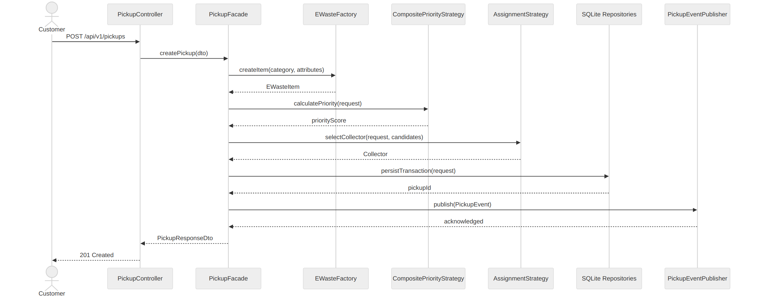
Figure 9. UML sequence diagram — pickup scheduling and dynamic collector dispatch

5.2 Workflow 2 — Facility Inspection, Template Processing & Reward Accrual
- Collector Delivery: the collector marks items as delivered (DeliveredState).
- Template Execution: an administrator triggers ProcessingFacade.processItem(), selecting the workflow (HazardousDisposalWorkflow, RecyclingWorkflow, RefurbishWorkflow, etc.).
- Template Steps: validateItem() checks item specifications and serial IDs; inspectCondition() verifies functional and physical degradation; determineProcessingOutcome() allocates recovery routes; persistRecord() writes yield logs to processing_records; calculateReward() computes recycling credits.
- Reward Credit & Completion: points are credited to the customer's ledger and the pickup transitions to CompletedState.
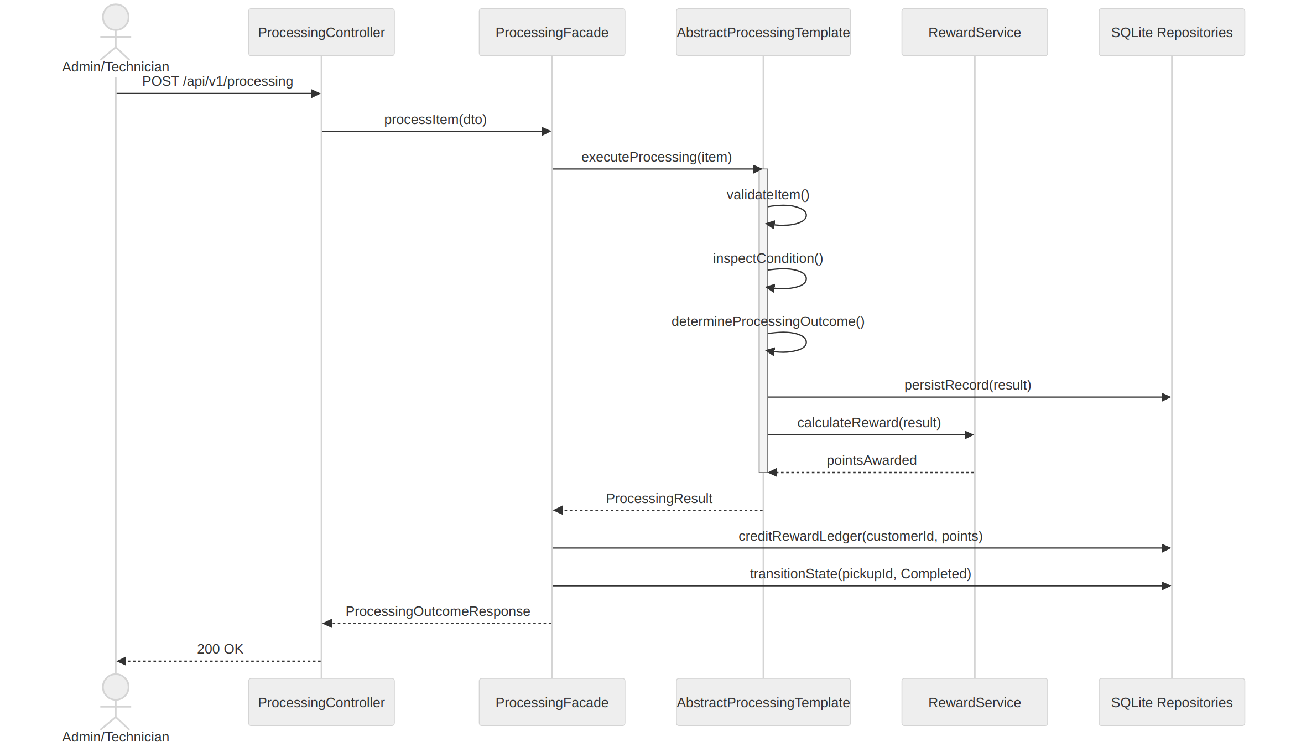
Figure 10. UML sequence diagram — facility inspection, template processing, and reward accrual

5.3 Pickup Lifecycle — UML State Diagram
The diagram below consolidates the full set of legal transitions enforced by the State pattern described in Section 3.1. Any transition attempted outside this graph raises an InvalidPickupStateException.
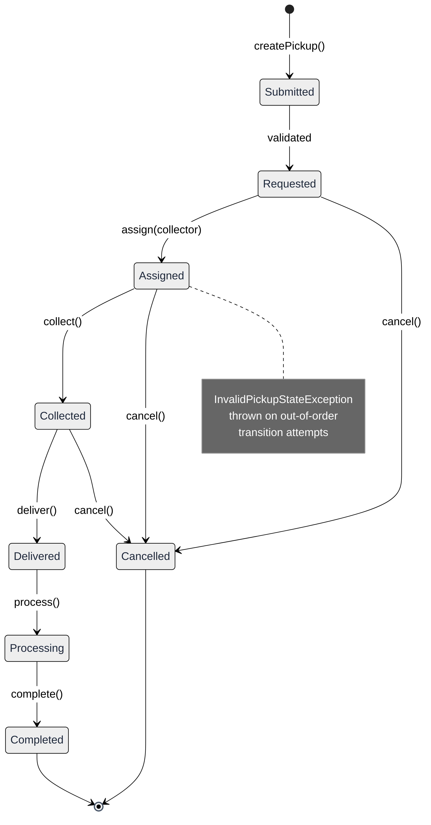
Figure 11. UML state diagram — pickup request lifecycle

5.4 Workflow 3 — Analytical Aggregations & Operational Reporting
The Administrator Dashboard exposes an Analytics & Reporting screen that surfaces system-wide operational metrics without requiring direct database access. The workflow is read-only and does not mutate pickup, collector, or reward state; it aggregates data already persisted by Workflows 1 and 2.
- Screen Load: the administrator opens AnalyticsController, which immediately requests the current operational summary through ReportApiClient rather than polling individual endpoints.
- Report Request: ReportApiClient issues GET /api/v1/reports/summary (optionally scoped by a date range) to ReportController on the server.
- Aggregation: ReportController delegates to ReportService, which runs a series of SQLite aggregation queries across pickup_requests, ewaste_items, processing_records, rewards, and collectors — computing total recycled weight, the hazardous-waste ratio, total points accrued, and per-collector capacity utilisation.
- Response Assembly: the four aggregate results are combined into a single ReportMetricsResponse DTO and returned as JSON, avoiding multiple round trips from the client.
- Chart Binding: AnalyticsController binds the response fields to JavaFX chart models — a PieChart for material/category breakdown and hazardous-waste ratio, and a BarChart for throughput and collector utilisation trends — rendering the completed dashboard to the administrator.
- Refresh Semantics: because the underlying queries are read-only aggregates, the screen can be safely re-queried on demand (e.g., via a manual refresh action) without side effects on the operational tables.
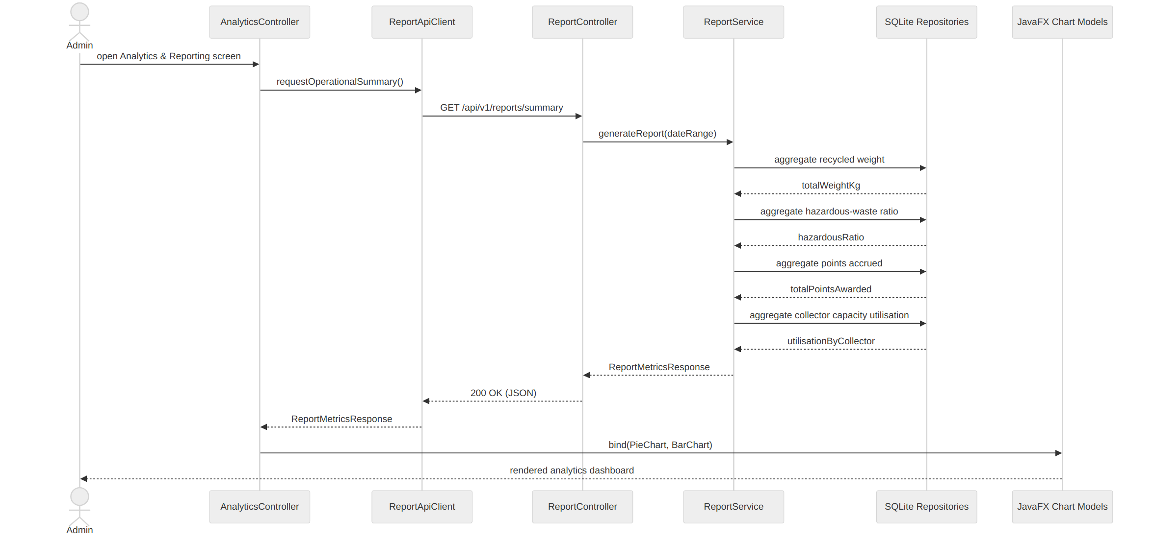
Figure 12. UML sequence diagram — analytical aggregation and operational reporting

6. Verification, Testing & Error Handling Strategy

6.1 Unit & Integration Test Suite Structure
src/test/java/com/ewaste/server/
├── application/facade/
│ └── PickupFacadeTest.java # facade workflow coordination
├── domain/
│ ├── factory/EWasteFactoryTest.java # model creation & hazard defaults
│ ├── builder/EWasteItemBuilderTest.java # fluent construction & validation
│ ├── state/PickupStateTransitionTest.java # valid/invalid transitions
│ ├── strategy/PriorityStrategyTest.java # composite priority calc.
│ ├── strategy/AssignmentStrategyTest.java # vehicle capacity selection
│ ├── template/ProcessingWorkflowTemplateTest.java # template steps
│ └── observer/NotificationObserverTest.java # event listener delivery
└── infrastructure/persistence/
└── SqliteRepositoryIntegrationTest.java # CRUD & constraint checks

6.2 Validation & Error Handling Architecture
- Validation Layer (PickupValidator, UserValidator) — enforces input constraints (positive weights, supported e-mail formats, past-date rejections) before domain processing.
- Domain Guarding — state methods throw InvalidPickupStateException when invalid operations occur (e.g., attempting to deliver an uncollected order).
- Global Exception Handling — GlobalExceptionHandler converts domain exceptions (ResourceNotFoundException, BusinessRuleException) into structured HTTP response payloads.
- UI Error Mapping — the JavaFX AlertHelper renders API error payloads to users through styled modal dialogs without freezing the interface.

7. User Interface Layout & Screen Mapping
The JavaFX application includes eleven FXML screens managed by SceneNavigator:
Screen Name | FXML Resource Path | Primary Role | UI Components & Functionality
Login View | auth/login.fxml | Public | Email/password fields, role-based redirection, error alerts.
Register View | auth/register.fxml | Public | Registration forms for customers and collectors with validation.
Customer Dashboard | customer/customer_dashboard.fxml | Customer | Summary cards for active pickups, point balances, and notifications.
Submit E-Waste | customer/submit_ewaste.fxml | Customer | Form with dynamic category dropdowns, weight inputs, and hazard flags.
Pickup History | customer/pickup_history.fxml | Customer | TableView showing past pickup statuses, assigned collectors, and timestamps.
Reward Ledger | customer/reward_view.fxml | Customer | Balance breakdown, historical point entries, and redemption stats.
Collector Dashboard | collector/collector_dashboard.fxml | Collector | Current capacity gauge, route overview, and active job counters.
Assigned Tasks | collector/assigned_tasks.fxml | Collector | Task action centre to update statuses (Assigned → Collected → Delivered).
Admin Dashboard | admin/admin_dashboard.fxml | Admin | High-level system statistics, health status, and quick-action toolbars.
Pickup Management | admin/pickup_management.fxml | Admin | Grid view for re-evaluating priorities and manual collector overrides.
Inspection & Processing | admin/inspection_processing.fxml | Admin / Tech | Workflow execution forms (Recycle, Refurbish, Dispose).
Analytics & Reporting | admin/analytics_view.fxml | Admin | Visual charts for throughput, material breakdown, and collector performance.

8. Git Collaboration, Build & Execution Instructions

8.1 Collaborative Workflow & Branching Strategy
Development follows a feature-branch workflow:
- main — production-ready, stable codebase.
- develop — integration branch for tested features.
- feature/<feature-name> — isolated branches for individual tasks (e.g., feature/state-pattern, feature/sqlite-persistence), merged into develop via pull requests.

8.2 Maven Build & Run Commands
# 1. Clone repository
git clone https://github.com/organization/e-waste-management-system.git
cd e-waste-management-system
# 2. Build the complete multi-module project
mvn clean install
# 3. Launch the Spring Boot server (executes DatabaseSeeder & SQLite setup)
cd server
mvn spring-boot:run
# 4. Launch the JavaFX client (in a separate terminal)
cd ../client
mvn javafx:run

