**DATE: 18-JAN-2025 NAZIA IMRAN**

**DAY 3 - API INTEGRATION**

**AND DATA MI GRATION** 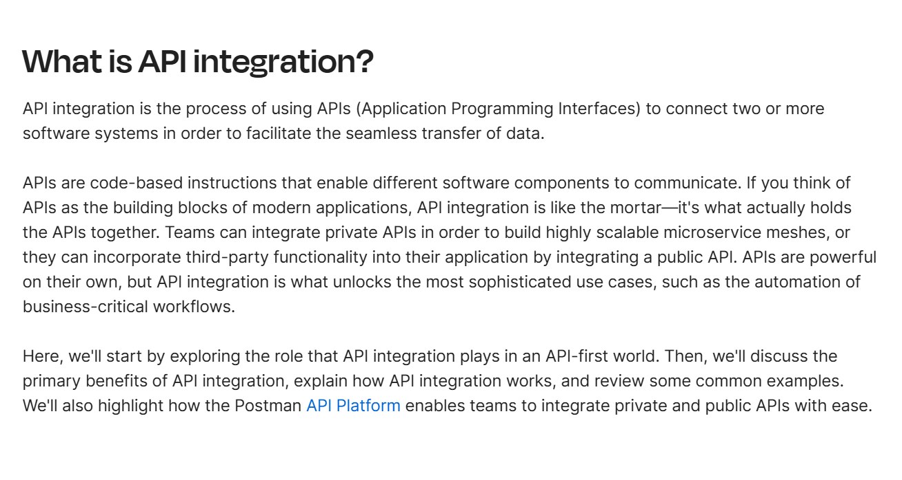

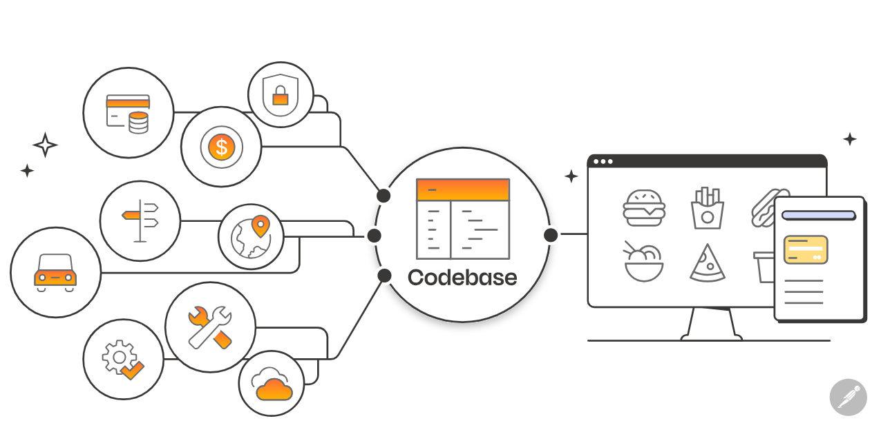

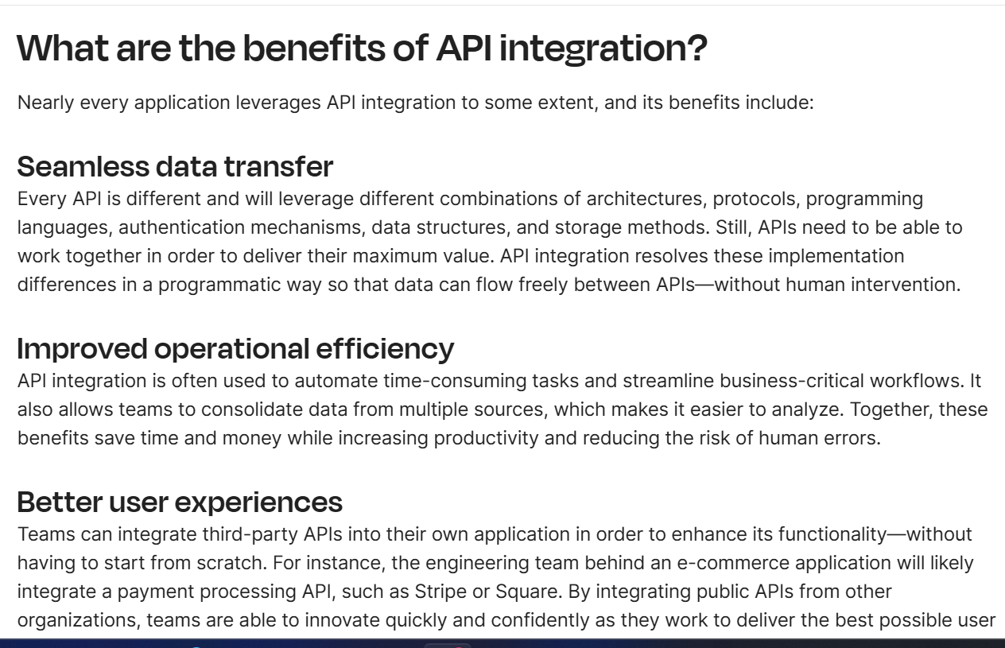

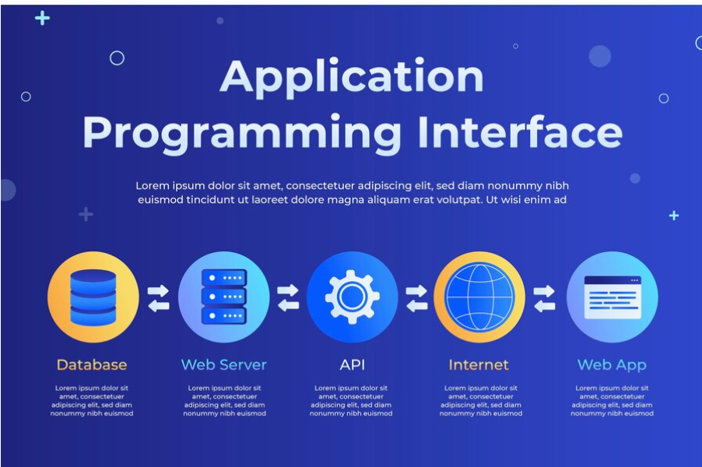

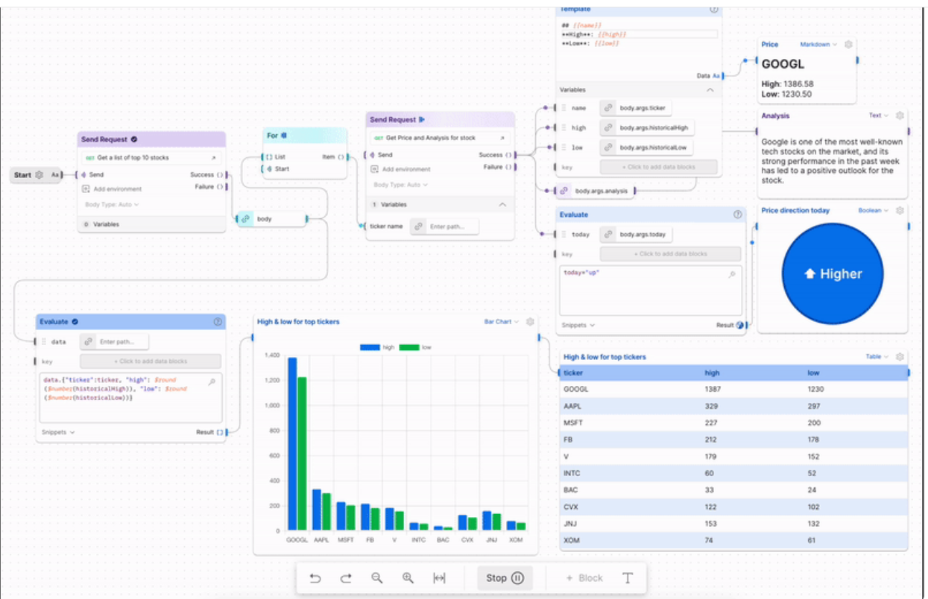**­­­**

**WORK FLOW OF API**

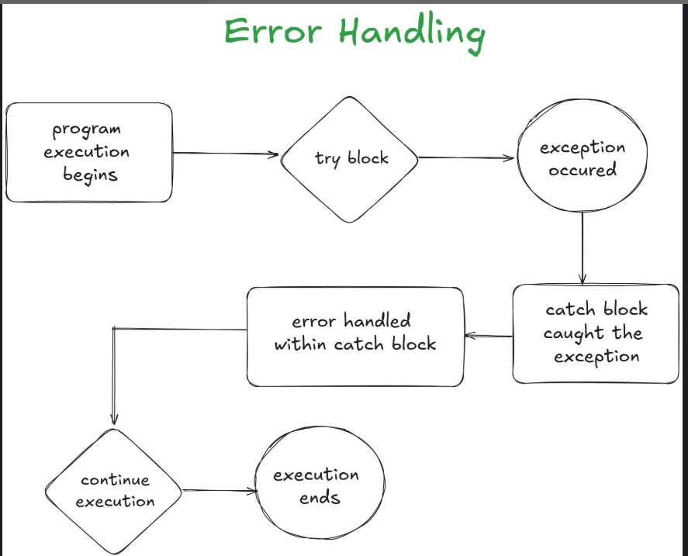

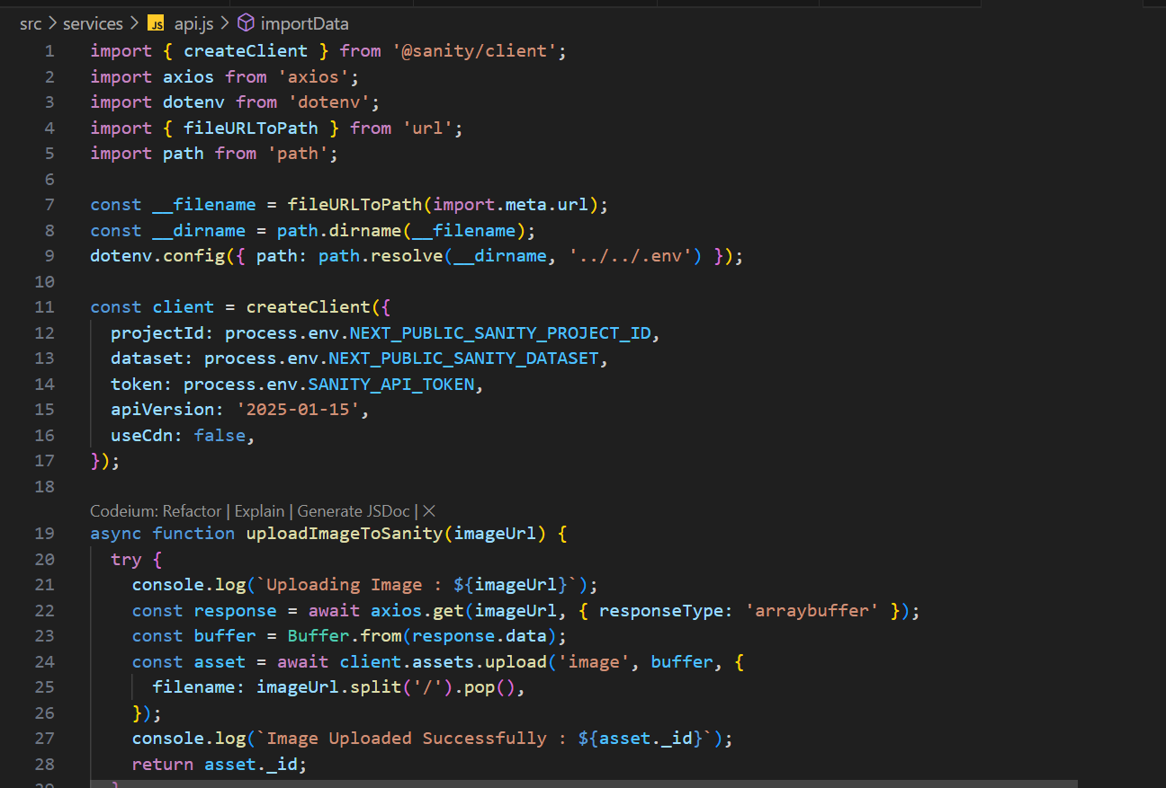

API FETCHING IN MY NEXT JS PROJECT

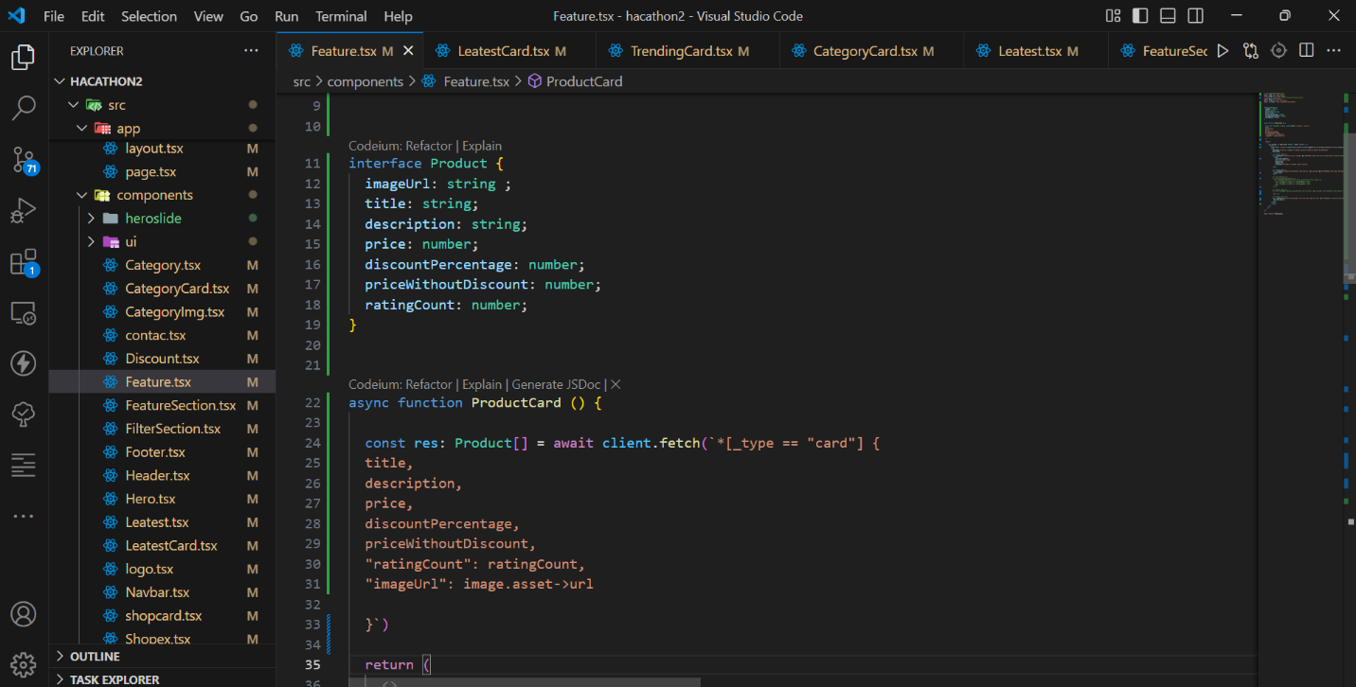

**GROW QUERY USE TO IMPORT DATA FROM SANITY**

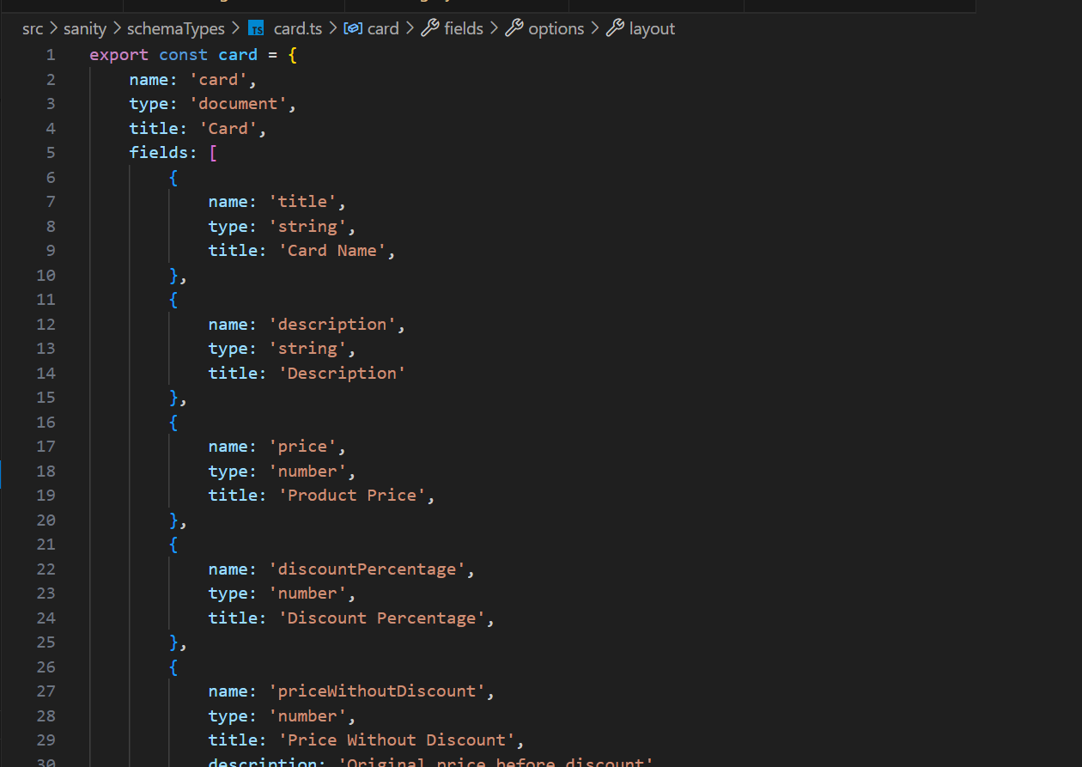

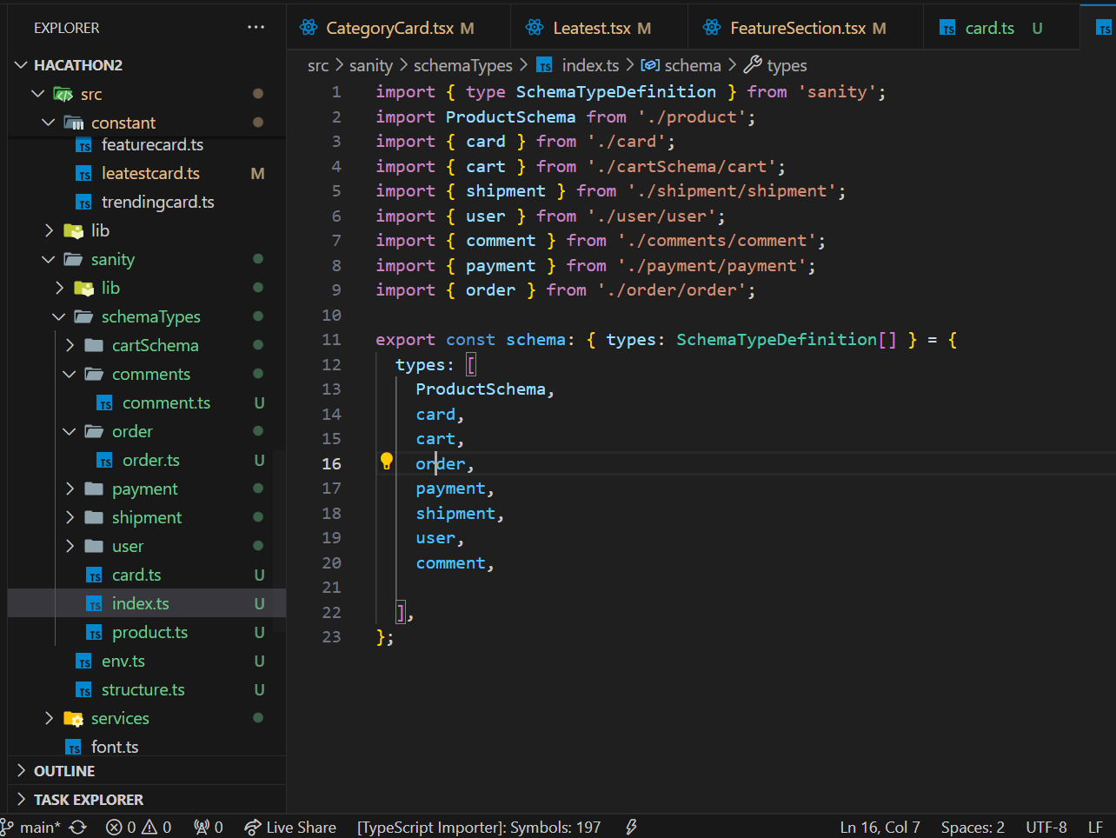**SCHEMA AND SCHEMA FLOW**

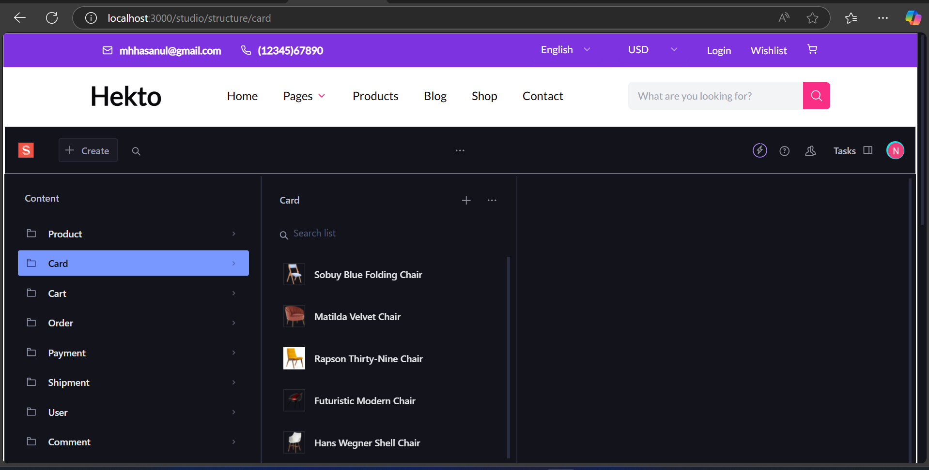

**SANITY CMS AFTER FETCHING DATA**

