Present by Nazia Siraj

GICIC 00443199

Friday 9am-12pm

Mentor Sir Humza Syed

Day-3: API Integration and Data Migration in Sanity

**MarketPlace-Builder Hackathon**

**Day-3: API Integration and Data Migration in Sanity**

**EXPLANATION OF MIGRATING DATA FROM API TO SANITY IN NEXTJS**

The focus for Day 3 of the hackathon was on API Integration and Data Migration. The task was to integrate external APIs into the marketplace project.

I implemented a solution that allows us to migrate and import data from an external API into Sanity CMS.

By the end of the day, the objective was to have a fully integrated marketplace with dynamic data fetched from APIs and correctly displayed on the frontend.

Below is a step-by-step explanation of how I achieved it:

# 2.Fetching Data From External API

# The first step in this process was to fetch data from the external API.In my Next.js application.where the frontend code was already present,i created a folder named “scripts” and within that .I created a file called “data-migration.mjs” where I wrote the code to fetch data from the API.Afterward,I tested it both in the application and through Postman API, and my data was successfully fetched.

scripts/data-migration.mjs

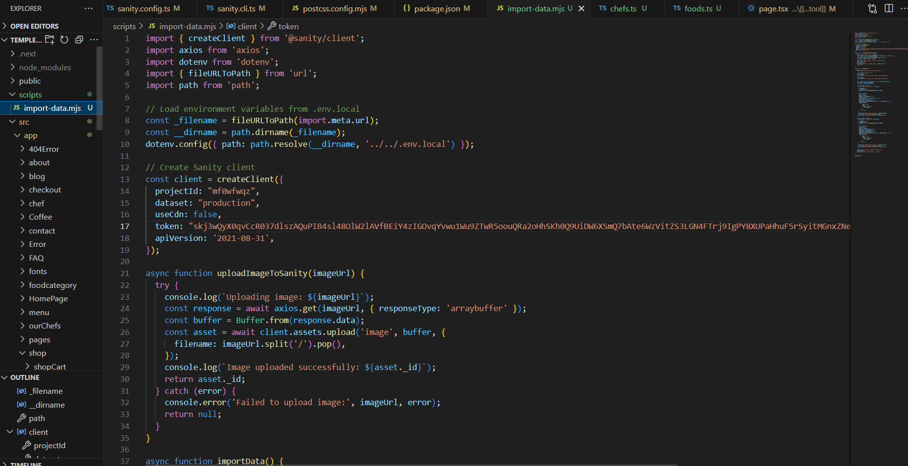

2.Comparing API data with Sanity Schema

After the data was fetched,the next task was to compare the data structure of the API with the Sanity schema.The Sanity schema will be used to handle the product data.The main purpose of this step was to ensure that the data coming from the API matches the Sanity schema.This Step ensures that the data from the API perfectly matches the Sanity schema .

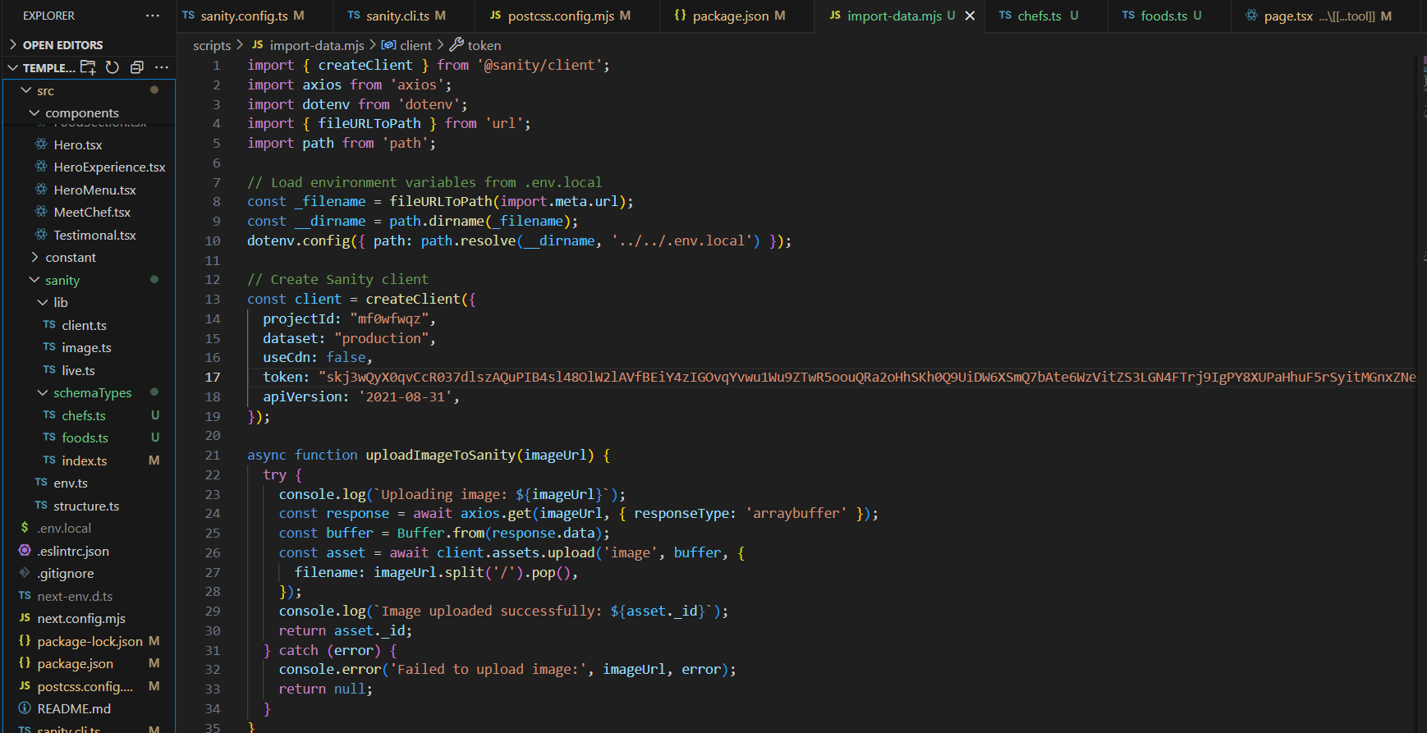

3. Data Migration Script

After coming the Schema the schema And the API data structure ,the next step was to write a migration script in existing file data-migration.mjs that wood automate the process of importing the fetch data into Sanity.A script was created that would:

1.Fetch data from API

2.Validate data with sanity schema

3.Use the sanity client to push data into sanity

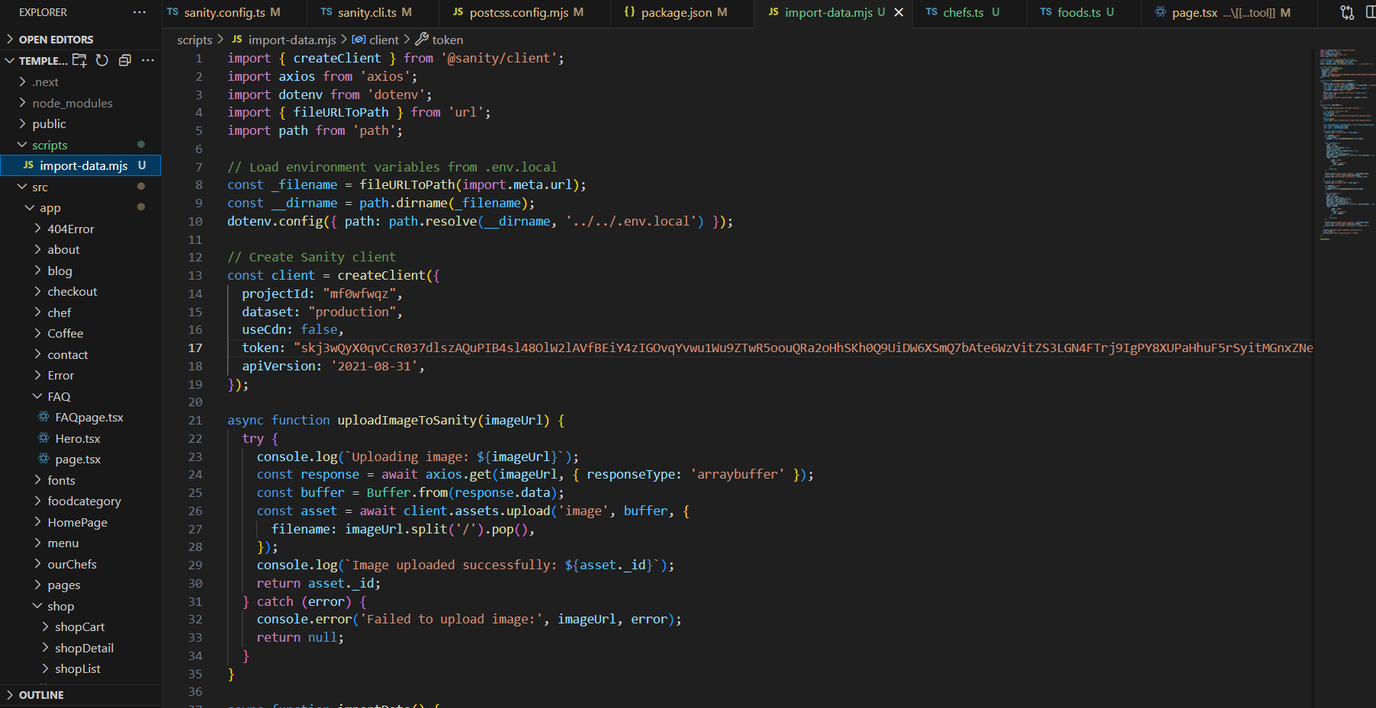

4.Setting Up The Environment

Once the script was written ,the next step was to configure Sanity .For the configuration, a token for the project needs to be generated from Sanity’s official website ,and by looking at the ID,DATA, and TOKEN,it needs to be written in the env.local file,and also provided in the data-migration.mjs file.

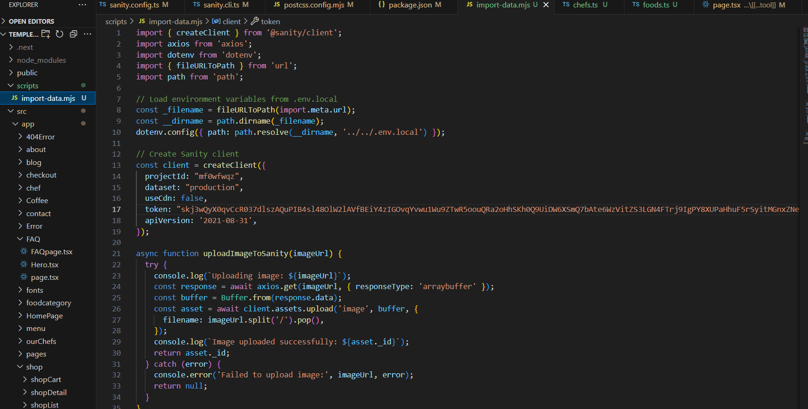

5.modifying Package.json

To the migration script,the necessary npm package was edit to the package.json file under the scripts section.This made it easier to run the script through the command line.

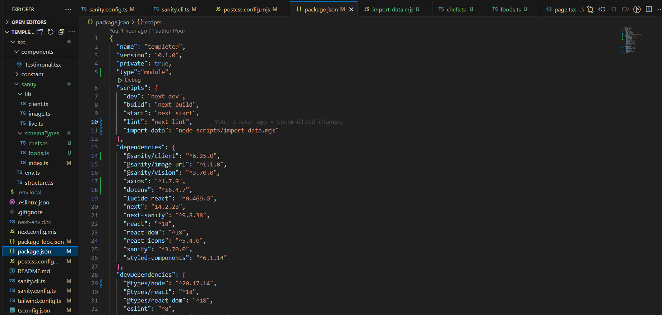

6. Importing Data into Sanity

With everything set up,I executed the migration script to send data into sanity by running the following command

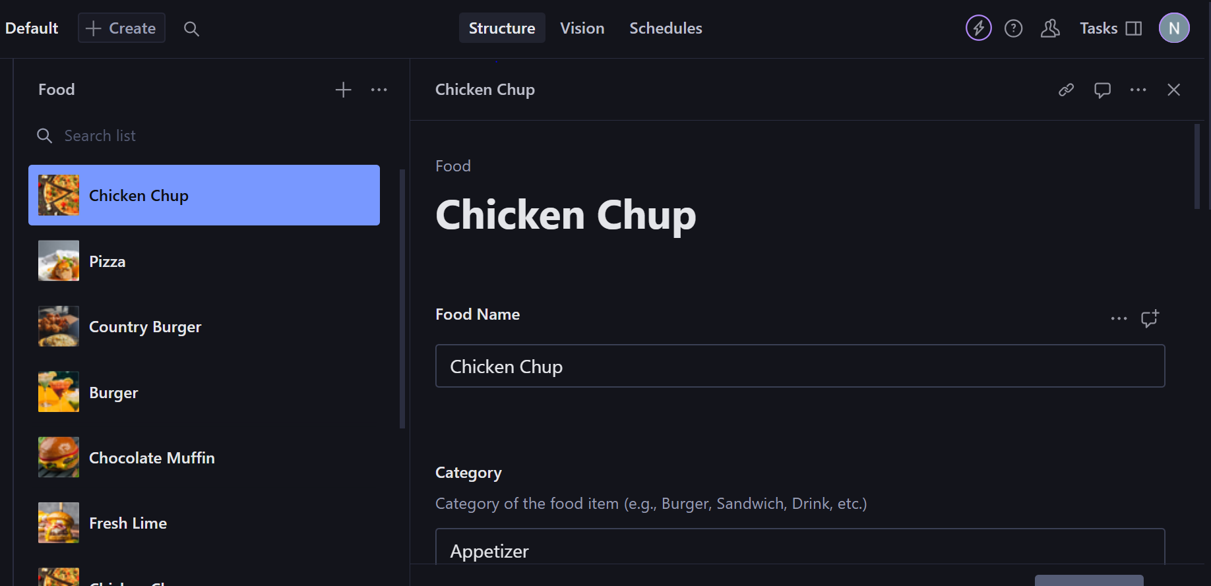

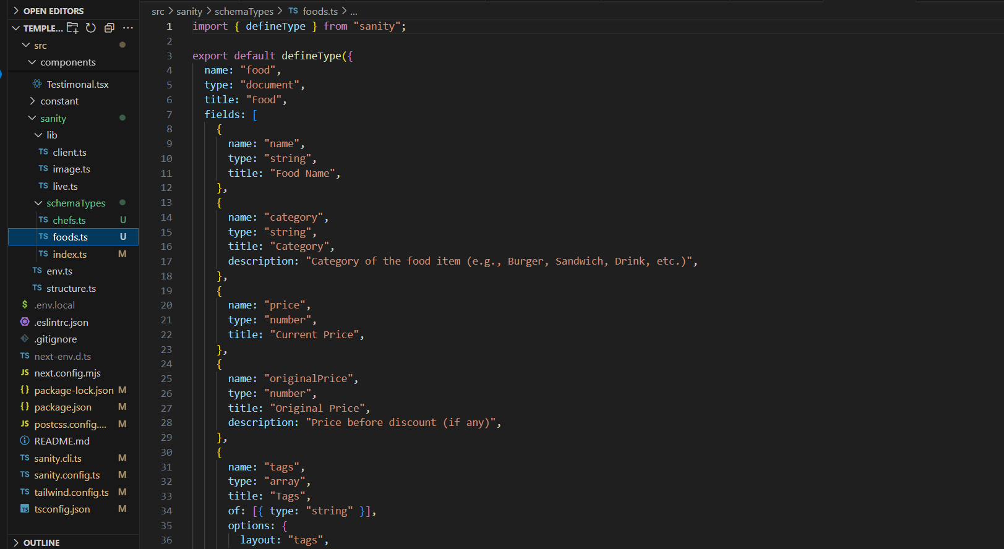

7. Displaying data in frontend

After fetching data from Sanity.i mapped it. And printed it in cards ,and successfully my data was displayed on the frontend .

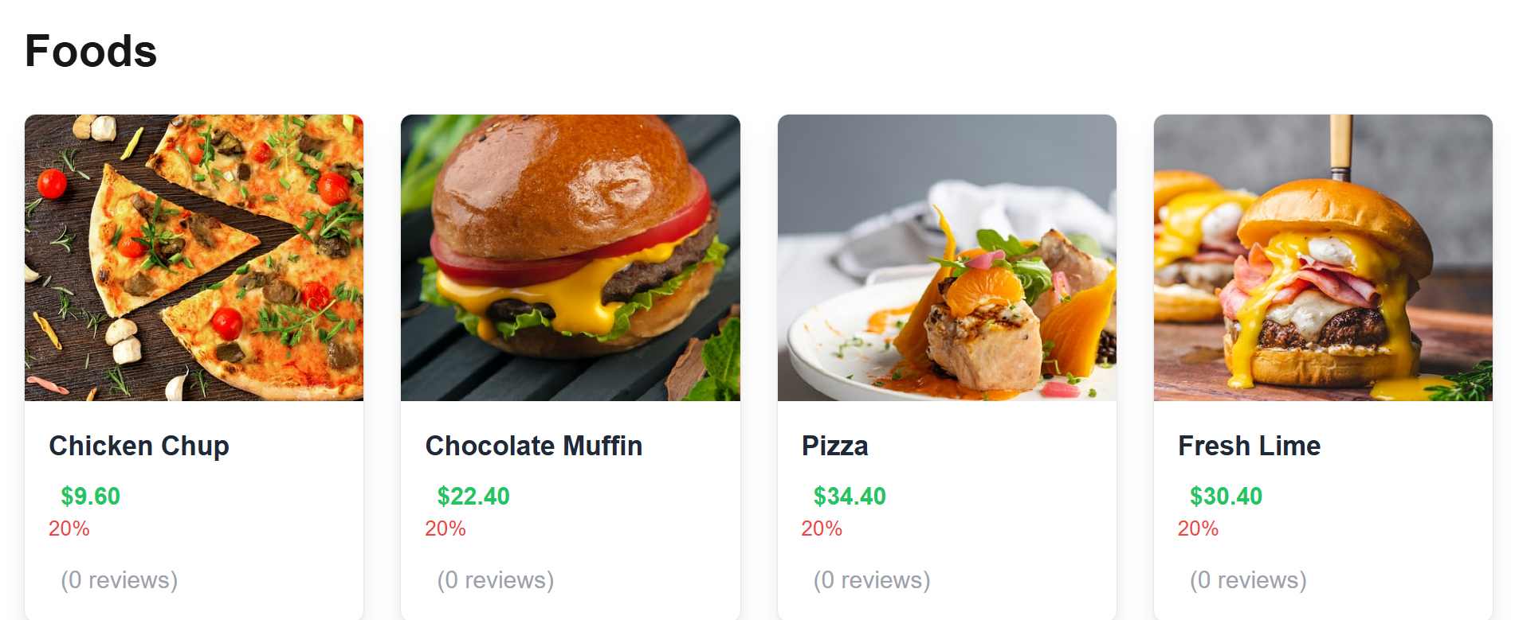

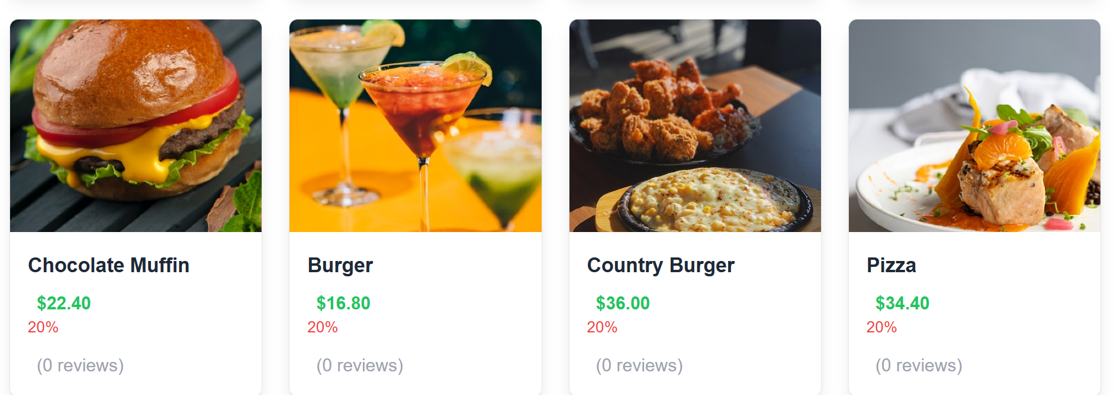

* Conclusion

This Process Successfully Automarted the Migration of data from external API to Sanity CMS.The Key steps included:

1.Fetching Data from External APIs

2.Comparing API data with Sanity schema

3.Data Migration Script

4.Setting Up The Environment

5.Modifying Package.json Importing Data into Sanity

7.Displaying data in frontend

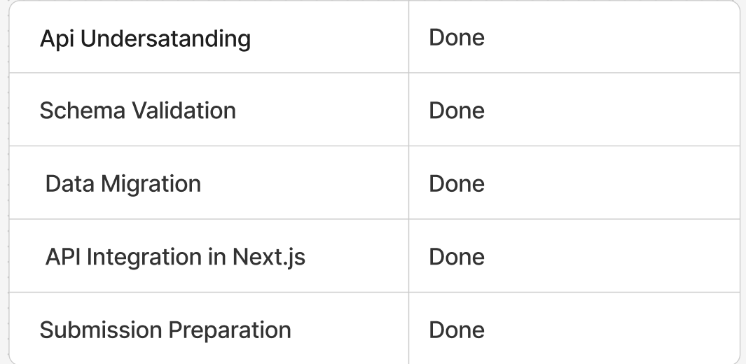

Presented By: Nazia Siraj