Heaven’s Light is Our Guide



DEPARTMENT OF ELECTRONICS & TELECOMMUNICATION ENGINEERING

Rajshahi University of Engineering & Technology, Bangladesh

Numerical Analysis of Dual Core SPR PCF with Extra Sensing Approach
[*Do Not Use Symbols, Special Characters, or Math in Title, use title case]
[Times New Roman, Bold, Font-16]

Author/Authors
[Times New Roman, Bold, Font-14 ]
Nazifa Tasneem Torsa
[Times New Roman, Font-14 ]
1504054
[Times New Roman, Font-14 ]

Supervised by
[Times New Roman, Bold, Font-14 ]
Jannatul Robaiat Mou
[Times New Roman, Font-14 ]
Assistant Professor
[Times New Roman, Font-14 ]

CONTENTS

Abstract

Introduction …………………………………………………...……........ [1-7]

Review of Photonic Crystal Fiber ………………………….……….........[8-17]

Review of SPR Sensor……………………………………….………….[18-21]

Modeling Method & Equation………………………………………..…[22-31]

Numerical Evolution of Parameters………………………………….….[32-26]

Measurement & Optimization of Sensitivity……………………..……..[37-40]

Conclusion & Future Works………………………………………………..[41]

ABSTRCT

A simple dual core photonic crystal fiber based on surface plasmon resonance sensor is designed for numerical evaluation and sensing approach. An active plasmonic gold layer and analyte layer is placed outside of the cladding region which can provide simpler and straight forward fabrication process. The birefringent behavior of the proposed design enhances the sensitivity. Numerical investigation of guiding material and sensing performance are governed by Finite Element Method (FEM). This model is built on 2D space dimension on the basis of Maxwell’s equation. It is conducted by electromagnetic wave equation on frequency domain analysis. PML layer is added to confine light by limiting structure of the model. Scattering boundary condition and perfect electric conduct has been placed in model in order to analyze more accurately. Mode analysis operation has been held to evaluate data for a precise number. The model guiding parameters is analyzed numerically by calculating losses of electric fields with the variation of resonant wavelength. The optical losses of birefringent model are depended on required parameters that is useful for creating model. A little change on any parameter yields a large computational difference of electrical field loss. As example, gold thin film of any SPR model can be numerically evaluated which gives much resonant value at a certain value, center diameter, width of analyte channel can be examined at a certain range of wavelength that gives resonant value. The interaction of evanescent field with thin film metal layer is the main working principle. This field might be created by placing air-holes on the two corners of the core diameter region. Propagation of light in the core produces evanescent field that penetrates through the cladding region. The real part core guided effective refractive index is equal to the surface plasmon guided effective refractive index. The core-cladding evanescent field excites the free electrons that generate surface plasmon wave. By using wavelength interrogation model and amplitude interrogation model, wavelength sensitivity, amplitude sensitivity, wavelength resolution, amplitude resolution can be measured. Graphene plays satisfactory role to optimize the loss spectra which is beneficial to high sensitivity. It also reduces the oxidation problem of silver and aluminum. Further study will be conducted on the basis of different applications.

LIST OF FIGURES
[Times New Roman, Bold, Font-16]

Figure 2.1: Drawing the cross section of (a) SMF, (b) solid core PCF, and (c) hollow-core PCF
Figure 2.2: Index-guiding PCF
Figure 2.4: Hybrid PCF
Figure 2.5: Drawings of various structures: (a) birefringent PCF; (b) ultra-small core PCF;(c) hollow core PCF; (d) hollow core Bragg fiber. The white regions represent silica, the black regions are hollow, and the colored regions are other materials (glasses or polymers)
Figure 2.6: Photonic crystal fiber fabrication: (a) creation of individual capillaries,(b) formation of the preform, (c) drawing of intermediate preform, (d) drawing of the final fiber
Figure 2.7: different structure of fabricated PCF
Figure 3.1: Growth of Food Analysis
Figure 4.1: (a) Geometry and (b) mesh of the cross-section of a dual-core PCF. Blue and grey regions represent, respectively, the air-holes and the other material. (c) Fundamental component of the magnetic field at 520 nm evaluated with the FEM-based full-vector modal solver
Figure 4.2: Proposed SPR-PCF sensor
Figure 4.7: (a) Y-polarization dispersion relation (b) X-polarization dispersion relation
Figure 4.8: Field profile of proposed sensor
Figure 5.1: Dependency of loss spectra with respect to thickness of gold thin film
Figure 5.2: Wavelength versus loss spectra with the variation of center diameter
Figure 5.3: Wavelength versus loss with the variation of analyte layer thickness
Figure 6.1: Analysis of losses for analyte variation
Figure 6.2: Analysis of amplitude sensitivity for analyte variation
Figure 6.3: Analysis of losses with graphene layer for analyte variation

LIST OF TABLES

Table-1.1: Important Milestone of PCFs Evolution
Table 2.1 performance comparison of conventional optical fiber and PCF based SPR sensors

INTRODUCTION

- Elevation of Photonic Crystal Fibers

Recently, due to the advancement of technology and for an extra degree of freedom photonic crystal fiber has drawn the attention of the researchers. Photonic crystal fiber (PCF) or holey fibers (HFs) or microstructure optical fibers (MOFs) contains a microscopic array of air channels that run through the entire fiber and formulates a lower index cladding on a silica background [1]. Being extremely sensitive, small size, label-free, capable of multi-analyte detection and online distributed sensing, the optical fiber surface plasmon resonance (SPR) sensor has gathered continuous research interests in medical diagnostics, food safety control, environmental control, and drug detection [2]. Generally the commercial prism coupled geometry is used for the SPR sensors. Prism is used to pass the light to the metal surface interface, whereas transverse magnetic (TM) or p-polarized light is induced in the metal or dielectric interface. The incident light is absorbed by the free electrons of the metal surface as a result, surface plasmon wave (SPW) is generated. The prism based SPR sensor is bulky and its limit the remote sensing applications. To overcome those problems, photonic crystal fiber based SPR sensor is introduced [3]. Optical fibers in discussion that guide signals in the form of light are typically made of from two glasses. It is a cylindrical in shape waveguide consisting of a higher refractive index solid glass core which runs down middle of the fiber. The other solid glass with a lower refractive index surrounds the core and makes the homogeneous cladding [4]. The core and cladding glasses are made of from the common material silica (SiO2). Generally, either germanium or fluorine is doped with the silica to increase or decrease the refractive index of the silica glass respectively [5]. An index difference between the core and the cladding helps trapping the light inside the core and guiding along length of the fiber by the mechanism of total internal reflection (TIR) [6]. This type of optical fiber is called conventional optical fiber. Although the present state of the art of such fibers represent a widespread usage in both sensor and non-sensor applications, there are something that these fibers simply cannot do. The limiting factor of such ordinary fibers is the properties of the glass from which it is formed [7]. As properties of the silica glass are not flexible, ordinary optical fibers cannot suit certain emerging applications. This difficulty of conventional fibers has led to another potential breakthrough in fiber-optics technology, the invention of the photonic crystal fiber (PCF)[8].

- The PCF Technology
The PCF is a single material optical fiber consisting of a silica-air microstructure. It contains microscopic air-holes in a silica background running down length of the fiber that form the silica-air microstructure as well as the lower refractive index cladding [9]. Air-hole can be arranged in the cladding in a periodic (hexagonal arrangement being the common) or an aperiodic array which is the important feature of this type of fibers. The core may either be a solid (made of silica) or a hollow (made of air). Based on the difference between the inherent mechanism and traditional transmission of electromagnetic wave, PCF, as a promising transmission media, can be classified into two forms: index-guiding PCF and photonic bandgap fibers (PBG)-PCF. The index-guiding PCF is also called total internal reflection (TIR)-PCF. It delivers light by modified total internal reflection similar to conventional fibers, considering that the effective cladding index is lower than that of the core. In contrast, in PBG-PCF, the light is confined to a low-index solid core, indicating that only a specific wavelength of light can pass. In the fiber, the existence of the PBG in the cladding makes it possible to confine light in the core with low transmission loss for a finite spectral window [10] .

PCFs consist of a core and cladding similar to a conventional optical fiber, but the cladding region in PCFs have a periodic air-holes which managing the light propagation [11]. Light propagating through the PCFs follows the modified TIR or photonic bandgap (PBG) effects [12]. By modifying air holes geometries and altering the number of rings light propagation can be controlled. Unique capabilities of PCFs have opened a window to overcome the conventional prism and optical fiber based SPR sensors problems. PCF SPR sensors are also compact and can be incorporated in microscales. Having the advantage of flexibility in design, PCFs geometry can be optimized for achieving the optimum evanescent field. For instance, the core-guided leaky-mode propagation can be controlled by using different types of PCF structures such as hexagonal, square, octagonal, decagonal, hybrid, and their guiding properties can be improved by changing its geometry [13]. The propagation of light in single mode fiber can be obtained by optimizing core and cladding diameters and positions. Single mode PCFs show narrow-band resonance peak results in enhancing the sensitivity [14].

- Evolution of PCF Research Field
The invention of PCF technology was introduced by Russel et al. [15] in 1991 and was held by Knight et al. in 1996. They have demonstrated practical realization of a holey fiber with periodic air-holes arranged in a hexagonal lattice [16]. Although their original aim was to discover light guiding based on the PBG principle, they discovered that the new holey fiber resemblance the conventional fibers in that it is guiding light based on a modified TIR mechanism .They soon after observed that the new fiber is robust and efficient in terms of light guiding. Significant differences between the conventional fibers and the PCFs were also observed in terms of design space and optical properties.
The field of index guiding PCFs thus continues to progress but due to limitations of realizing large air-holes for fiber core at the required dimension which is crucial for PBG guidance, hollow core fibers were not achieved then. Finally, following a progress in numerical computation i.e., formulation of full vectorial numerical methods, the PBG was demonstrated in 1998 [17] . Table-I shows major breakthroughs in PCF research since the discovery in 1996 [15].

Table-1.1:Important Milestone of PCFs Evolution

Year | Milestone
1995 | 2D bandgaps can exist in silica/air PCF for n_{ax}<1
1996 | First solid-core PCF
1997 | Endlessly single mode concept
1998 | Ultra-large mode area
1999 | Dispersion-shifted ultra-small core, Hollow core photonic band gap PCF
2000 | Multi-core PCF, Polarization-maintaining, Rare-earth doped PCF laser, Supercontinuum generation
2001 | Carbon-dioxide laser processing of PCF, Four-wave mixing, Polymer PCF, Soliton self-frequency shift
2002 | Laser-tweezer guidance of particles in HC-PCF, Long-period gratings, PCF made from Schott SF6 glass for SC generation, Stimulated Raman scattering in hydrogen
2003 | Photonic bandgaps, Rocking filters in PM PCF, Cancellation of the soliton self-frequency shift, Tellurite glass PCF
2004 | Four-wave mixing, Twin-photon generation in PCF
2005 | EIT in acetylene, High energy transmission in HC-PCF, Low-loss transitions between different PCFs, Photonic band gaps at 1% index contrast

PCFs are designed and fabricated for special-purpose applications that do not require large volumes of fibers. Therefore, these specialty fibers are currently produced in smaller quantities compared with traditional optical fibers, which are mass produced for signal transmission.

- Motivation

Optical fibers and integrated optical waveguides are today finding wide use in areas covering telecommunications, sensor technology, spectroscopy, and medicine [18]. It has opened a new horizon of massive potential and promise. The wider design space, flexible, superior, and extraordinary optical properties are considered the key to numerous scientific and technological applications in both linear and nonlinear regimes [8,9] .It is forecasted that the future of optics lies inside PCFs and the way of exploring its potentials in mastering the light. For examples, PCFs provide new ways of guiding and manipulating light, so that the sensor performance has been improved considerably in terms of accuracy and precision, the spectral regions of middle- and far-infrared (mid-IR to far-IR), from 2 to 10μm, are currently of growing interest because the development of a new generation of laser sources where PCF technology has the interesting solution, PCF technology gives better performance on THz guidance than triangular lattice bandgap fibers, LPGs written in large mode area PCFs have been exploited for high-power and sensitive biochemical applications, PCF based probes can be used for obtaining OCT images of an in vitro biological sample, Recent PCF developments have been enabling novel and interesting ways to properly generate, transform and deliver light, and, consequently, to improve PCF-based laser and amplifier performance. PCFs either hollow core or solid core indeed can serve as optical components for all these emerging sectors [19]. As refractive index is a fundamental material property, its accurate measuring is crucial in many applications. In food or beverage industries, the monitoring of refractive index is part of the quality control, and the development of simple and compact refractometers is key. Optical fiber refractive index sensors are attractive, owing to their small size, flexibility in their design, immunity to electromagnetic interference, network compatibility, and the aptitude for remote and in situ measurements [20]. These crucial tasks are remaining as great technological challenges. Some of these issues will be discussed in the following sections in brief and in details in the subsequent chapters. Considering the limitless promise of this growing field and the above technological issues, it has been decided to take part in the ongoing efforts to designing PCF structure for various technological applications.

- Aims and Objectives
The overall objective of the book is to focus ways to design and refine the optical properties of PCFs. Followings were the major objectives of this work.
o To design and numerical evaluation of PCFs for thickness of gold film, width of analyte layer, center diameter.
o To design and calculate sensitivity for different refractive indexes for optical sensor applications.
o To design and optimization of sensitivity using graphene-gold layer.

- Organization of This Book
The PCF is being considered a potential candidate for numerous elevating optical applications, it is still a new technology not only too many growing research areas but also to many peoples. Chapter 1 covers general introduction of the thesis and Chapter 2 covers introductory concepts of PCFs in brief.
Chapter 3 presents basic concept of SPR sensor.
Chapter 4 presents a brief discussion about the numerical computational methods for
PCF mode solutions, detail of the finite element method, computational equations used for calculating the light guiding properties of PCFs, proposed SPR model, and dispersion relation of the sensor.
Chapter 5 presents numerical evaluation of gold thin film layer, center diameter, and width of analyte channel.
Chapter 6 presents measurement of sensitivity for different refractive indexes of analytes, and optimization of the sensitivity using graphene-gold layer.
Finally, Chapter 7 includes conclusion and scopes for further study.

- Summary
The elevation of the field of PCF, factors influencing widespread applicability of these fibers, thesis motivation, goals and organization of the thesis have been presented in brief.

REFERENCES

[1] J. Knight, “Winter College on Fibre Optics, Fibre Lasers and Sensors Photonic crystal fibres,” no. February, 2007, [Online]. Available: http://indico.ictp.it/event/a06183/session/16/contribution/11/material/0/0.pdf.
[2] B. Lee, S. Roh, and J. Park, “Current status of micro- and nano-structured optical fiber sensors,” Opt. Fiber Technol., vol. 15, no. 3, pp. 209–221, 2009, doi: 10.1016/j.yofte.2009.02.006.
[3] A. A. Rifat, G. A. Mahdiraji, Y. G. Shee, M. J. Shawon, and F. R. M. Adikan, “A Novel Photonic Crystal Fiber Biosensor Using Surface Plasmon Resonance,” Procedia Eng., vol. 140, pp. 1–7, 2016, doi: 10.1016/j.proeng.2015.08.1107.
[4] G. P. Agrawal, “Nonlinear Fiber Optics BT - Nonlinear Science at the Dawn of the 21st Century,” 2000, pp. 195–211.
[5] G. P. Agrawal, Fiber-optic Communication Systems. Wiley-Interscience, 2002.
[6] G. P. Agrawal, Lightwave Technology: Components and Devices, no. v. 1. Wiley, 2004.
[7] R. A. Correa and J. Knight, “Specialty fibers: novel process eases production of hollow-core fiber,” Laser Focus World, vol. 44, pp. 67–71, 2008.
[8] J. Broeng, D. Mogilevstev, S. E. Barkou, and A. Bjarklev, “Photonic crystal fibers: A new class of optical waveguides,” Opt. fiber Technol., vol. 5, no. 3, pp. 305–330, 1999.
[9] P. Russell, “Applied physics: Photonic crystal fibers,” Science (80-. )., vol. 299, no. 5605, pp. 358–362, 2003, doi: 10.1126/science.1079280.
[10] T. Zhang, Y. Zheng, C. Wang, Z. Mu, and Y. Liu, “A Review of Photonic Crystal Fiber Sensor Applications for Different Physical Quantities,” vol. 4928, no. October, 2017, doi: 10.1080/05704928.2017.1376681.
[11] R. Ahmed, R. A. Aoni, and D. P. Fabrizio, “Design of ultra-flattened zero dispersion shifted photonic crystal fibers with lower confinement loss for telecommunication applications,” Opt. InfoBase Conf. Pap., vol. 4, no. 1, pp. 30–32, 2013, doi: 10.1364/sumsession.2013.tu6.
[12] A. V. Gulawani, S. Revathi, and S. R. Inabathini, “Characteristics analysis of highly birefringent with short-length splitter of Novel Dual Core Photonic Crystal Fiber (PCF),” Proc. 2nd IEEE Int. Conf. Eng. Technol. ICETECH 2016, no. March, pp. 940–945, 2016, doi: 10.1109/ICETECH.2016.7569386.
[13] R. Ahmmed, R. Ahmed, and S. M. A. Razzak, “Design of large negative dispersion and modal analysis for hexagonal, square, FCC and BCC photonic crystal fibers,” 2013 Int. Conf. Informatics, Electron. Vision, ICIEV 2013, 2013, doi: 10.1109/ICIEV.2013.6572577.
[14] J. Homola, S. S. Yee, and G. Gauglitz, “Surface plasmon resonance sensors: review,” Sensors Actuators, B Chem., vol. 54, no. 1, pp. 3–15, 1999, doi: 10.1016/S0925-4005(98)00321-9.
[15] P. Russell, “Photonic Crystal Fibers: A Historical Account,” Ieee Leos Newsl., no. October, pp. 11–15, 2007.
[16] J. C. Knight, T. A. Birks, P. S. J. Russell, and D. M. Atkin, “All-silica single-mode optical fiber with photonic crystal cladding: errata,” Opt. Lett., vol. 22, no. 7, p. 484, 1997, doi: 10.1364/ol.22.000484.
[17] J. Broeng, S. E. Barkou, A. Bjarklev, J. C. Knight, T. A. Birks, and P. S. J. Russell, “Highly increased photonic band gaps in silica/air structures,” Opt. Commun., vol. 156, no. 4–6, pp. 240–244, 1998, doi: 10.1016/S0030-4018(98)00470-2.
[18] A. Bjarklev, Optical fiber amplifiers: design and system applications. Artech House Boston-London, 1993.
[19] S. Arismar Cerqueira, “Recent progress and novel applications of photonic crystal fibers,” Reports Prog. Phys., vol. 73, no. 2, 2010, doi: 10.1088/0034-4885/73/2/024401.
[20] A. M. R. Pinto and M. Lopez-Amo, “Photonic crystal fibers for sensing applications,” J. Sensors, vol. 2012, 2012, doi: 10.1155/2012/598178.
[21] T. A. Birks, D. M. Atkin, G. Wylangowski, P. J. S. Russell, and P. J. Roberts, “2D photonic band gap structures in fibre form,” in Photonic Band Gap Materials, Springer, 1996, pp. 437–444.

REVIEW OF PHOTONIC CRYSTAL FIBERS

2.1 PCF Construction

A special class of components incorporating photonic crystals are optical fibers or waveguides with a two-dimensional (2D) periodic variation in the plane perpendicular to the fiber axis and an invariant structure along it which is referred as photonic crystal fibers PCF [1]. Photonic crystal fibers present a wavelength-scale periodic microstructure array of air channels running along their length. Their core and two-dimensional photonic crystal are based on varied geometries and materials, enabling light guidance due to different propagation mechanisms in an extremely large wavelength range, extending to the terahertz regions. As a result, these fibers have revolutionized the optical fiber technology by means of creating new degrees of freedom in the fiber design, fabrication and applicability [2]. The conventional single-mode fibers (SMFs) geometry entails a doped core surrounded by a pure silica cladding (Figure 2.1(a)), ensuring that the core refractive index is higher than the cladding. Photonic crystal fiber’s geometry is characterized by a microstructured air hole cladding running along the entire length of the fiber, which surrounds the core that can be solid or hollow. As so, PCFs can be divided in two families based on their geometry: solid core and hollow-core PCFs. Solid core PCFs, as can be deducted from the name, present a solid core surrounded by a periodic array of microscopic air holes, running along its entire length (Figure 2.1(b)).Hollow-core photonic crystal fibers (HC-PCFs) present an air hole as core, surrounded by a microstructured air-hole cladding (Figure 2.1 (c)). During the modeling as well as the manufacturing process there are different physical parameters to be controlled depending on the kind of fiber to the produced: in an SMF the only parameter to take into account is the diameter of the core, while in a PCF there are three physical parameters to be controlled: the core diameter ρ (which for solid core PCF is defined as the diameter of the ring formed by the innermost air holes), the diameter of the air holes of the cladding-d-and the pitch Λ (distance between the center of two consecutive air holes). These three physical parameters in combination with the choice of the refractive index of the material and the type of lattice make the fabrication of PCFs very flexible and open up the possibility to manage its properties, leading to a freedom of design not possible with common fibers. Different geometry and different materials will imply different structural design such as to enable different guidance mechanisms through the PCFs: modified total internal reflection (TIR) and/or photonic bandgap guidance (FBG) [3].

There are four different guidance mechanisms depending on the PCFs geometry and core/cladding materials [2]:
(i) index-guiding PCF—guides in a solid core through modified TIR
(ii) PBG-guiding PCF—guides through PBG effect in a hollow-core
(iii) all-solid PBG PCF—guidance through PBG anti-resonant effect in a solid core
(iv) hybrid PCF—guidance through simultaneous propagation of FBG and modified TIR.

Figure 2.1: Drawing the cross section of (a)SMF, (b) solid core PCF, and (c) hollow-core PCF [3].

2.2 Advantages of PCF over Conventional Fiber

PCFs are consist of a core and cladding similar to a conventional optical fiber, but the cladding region in PCFs have a periodic air-holes which managing the light propagation [4] where conventional fiber does not include periodic pattern of air-holes. Light propagating through the PCFs follows the modified TIR or photonic bandgap (PBG) effects [4,5]. By modifying air holes geometries and altering the number of rings light propagation can be controlled on PCF fibers. Unique capabilities of PCFs have opened a window to overcome the conventional prism and optical fiber based SPR sensors problems. PCF SPR sensors are also compact and can be incorporated in microscales. Having the advantage of flexibility in design, PCFs geometry can be optimized for achieving the optimum evanescent field. For instance, the core-guided leaky-mode propagation can be controlled by using different types of PCF structures such as hexagonal, square, octagonal, decagonal, hybrid, and their guiding properties can be improved by changing its geometry [6,7]. By optimizing the core-cladding diameter and position, the propagation of light in single mode can be obtained. Single mode PCFs show narrow-band resonance peak results in enhancing the sensitivity [8]. Sensing range and sensitivity can be enhanced by optimizing the structural parameters of the device. Table Ⅱ shows performance comparison of conventional optical fiber and PCF based SPR sensors [9].

Table 2.1 performance comparison of conventional optical fiber and PCF based SPR sensors

Characteristics | Wavelength (nm) | RI Range | Sensitivity (nm/RIU) | Resolution
Fiber optic SPR sensor for the IR region ITO | 1000-1200 | 1.2-1.21 | 1310 | _
Tapered fiber optic based SPR sensor in visible range | 450-670 | 1.3328-1.3623 | 2000 | _
Wagon wheel fiber based SPR sensor | 550-730 | 1.33-1.36 | 1535 | 6.5$×$10⁻⁵
Fiber optic based SPR sensor coated with ITO-Au bio-layers | 500-650 | 1.30-1.35 | 1929 | _
Metal/graphene/MoS₂ coated fiber optic based SPR sensor | 550-800 | 1.330-1.332 | 6200 | _
Fiber optic based SPR sensor using ZnO thin film | 450-700 | 1.30-1.37 | 3161 | _
Tapered fiber optic based SPR sensor | 450-800 | 1.333-1.342 | 8545 | _
Indium Nitride (InN) coated fiber optic based SPR sensor | 400-1600 | 1.30-1.40 | 4493 | _
Experimentally demonstrated Graphene based fiber optic based SPR biosensor | 500-670 | 1.3326-1.3497 | 414 | _
Gold wire based PCF SPR sensor | 1600-2000 | 1.30-1.79 | 3233 | 3.09$×$10⁻⁵
D-shaped PCF based SPR sensor | 1005-1550 | 1.43-1.46 | 9000 | 1.30$×$10⁻⁵
External PCF SPR sensing approach | 550-820 | 1.33-1.37 | 4000 | _
Highly birefringence microstructured fiber based SPR sensor | 540-660 | 1.33-1.34 | 3100 | _

2.3 Light Guiding Mechanism of PCF

Light in PCFs can be guided either by TIR or/and PBG effect, depending on the core and cladding photonic crystal materials. Their core can be formed by pure silica; doped silica; high nonlinearity glasses, for instance tellurite, bismuth and lead silicate; air; liquids; gases, for example hydrogen, xenon, acetylene and methane; and quantum dots. Taking into consideration the propagation mechanism behind light guidance in PCFs, there are basically four types: index guiding PCF, hollow-core PCF, all-solid PBGF, hybrid PCF. Index-guiding PCF represents the simplest type of PCF, since its light guidance is based on modified TIR. As shown in figure 2.2(a), it has a solid core embedded in a two-dimensional photonic crystal with a micrometer-spaced array of air holes, traditionally arranged in a hexagonal pattern. This solid core is basically formed by introducing a defect (omission of a single air hole) in the photonic crystal. This idea is illustrated in figure 2.2, which shows the schematic of this type of PCF and its refractive index profile.
- Schematic (b) Refractive index profile

Figure 2.2: Index-guiding PCF [2].
Hollow fibers based on the standard technology use external reflection and are thus inherently weak and highly multimode, allowing only relatively short lengths. On the other hand, hollow-core PCFs provide quasi-single mode operation by guiding light in a hollow core surrounded by a microstructured cladding formed by a periodic arrangement of air holes in silica. They are considered quasi-single mode because in spite of most hollow-core PCFs supporting a number of optical modes at any given wavelength within the band gap, including both air-guided and surface modes, the fundamental mode can be selectively excited by careful designing of the launch optics.
The most spectacular properties of PBGFs are found in fibers with hollow cores, PBG guidance can also be observed when the core is solid. In this case, the fiber PBG is formed by an arrangement of high-index solid inclusions. PBGs are often associated with large refractive index contrasts, but all-solid PBGFs with an index contrast of only 1% have been demonstrated, in which the pure silica core is surrounded by an array of germanium-doped silica rods.
The hybrid PCF is composed of air holes and germanium doped silica rods disposed around an un-doped silica core, as shown in figure 2.4. The air holes are arranged in an hexagonal pattern as in the index-guiding PCFs, whereas the high-index rods replace a single row of air holes along one of the PCF axes, forming a one-dimensional PBG in this direction. Compared with the traditional PCFs, one more design parameter must be included, the rod diameter D [2].
Figure 2.4: Hybrid PCF [2].

2.4 Different Classes of PCF

PCFs can further be classified into a number of other types depending on the dimensions of the fiber parameters, structures, and specific guiding properties. IG-PCFs are implied as birefringent PCF, ultra-small core PCF, HNA fiber are implied as hollow core fiber. PBG-PCFs are classified as air-guiding (AG)/ HC fibers, LIC fibers, or Bragg fibers. Figure 2.5 shows examples of all these microstructure fibers types.
PCFs can again be of another type namely polarization maintaining (PM) fibers having either a stress applying part or an asymmetric cladding structure to maintain a linear state of polarization. Again, likewise conventional fibers, PCFs are also classified as single mode or multi-mode fibers depending on the number of modes supported by a particular PCF (IG or PBG).
(a) birefringent PCF (b) ultra-small core PCF
(c) hollow core PCF (d) hollow core Bragg fiber

Figure 2.5: Drawings of various structures: (a) birefringent PCF; (b) ultra-small core PCF;
(c) hollow core PCF; (d) hollow core Bragg fiber. The white regions represent silica, the black
regions are hollow, and the colored regions are other materials (glasses or polymers) [10].

2.5 PCF Fabrication

Fabrication is a key factor in the designing and developing of new fibers. The PCF technology not only provides a great controllability of the fiber design, but also allows fibers to be made from just a single material, eliminating needs for two thermally, chemically and optically compatible glasses to form their core and cladding, as otherwise required within conventional fibers. A wide range of materials has been used to fabricate PCFs, including chalcogenide, lead silicate, bismuth silicate and tellurite glasses, and even polymers [2]. The use of different materials opens up a new degree of freedom for the fiber design.

Figure 2.6: Photonic crystal fiber fabrication: (a) creation of individual capillaries,
(b) formation of the preform, (c) drawing of intermediate preform, (d) drawing of the
final fiber [11].

The stack-and-draw procedure has been clarified as the most used in PCF fabrication [2]. This technique provides high versatility, allowing complex lattices to be assembled from individual stackable units of the correct size and shape. Solid, empty or doped glass regions can be easily incorporated. It involves no chemical process and its summary is illustrated in figure 2.6. The fabricated structure of different PCFs is illustrated in figure 2.7.

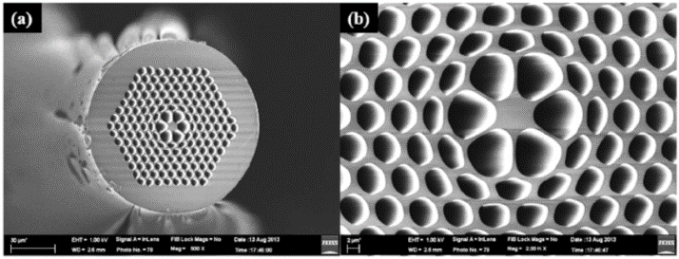
Figure 2.7: different structure of fabricated PCF[12].
2.6 Application of PCF

The PCF core, cladding and hybrid modes make them very attractive for sensor applications, since all these modes can be excited and measured in a controlled fashion. For example, while all modes are sensitive to the temperature and strain perturbations, only some of the cladding modes are sensitive to the surrounding media changes. Therefore, in addition to the unusual properties inherent to the PCF microstructure, post-processing techniques—such as tapering and injection of gas, liquids and metal film are also applied to further enhance the sensor performance. For this reason, PCF-based solutions have been spread out to many sensor classes: temperature sensors, strain sensors, pressure, electric field sensors, bend sensors, biosensors, fluorescence sensors and gas sensors.

2.7 Modal Properties of PCF

2.7.1 Chromatic Dispersion

The dispersion in optics is a phenomenon which causes separation of a wave into its spectral components. Separations of spectral components occur due to a dependence of the wave's speed on its wavelength. It is sometimes called the chromatic dispersion to emphasize its wavelength-dependent nature. There are in general two sources of fiber dispersion: the material dispersion, which comes from a frequency-dependent response of a material to waves; and the waveguide dispersion, which occurs when the speed of a wave in a waveguide depends on its operating frequency.

2.7.2 Confinement Loss

The confinement loss is a phenomenon whereby part of the guided light penetrates to the cladding region and thereby causes signal degradation. Similar to the conventional fibers, IG-PCFs guide light based on the TIR mechanism and supports three kinds of modes namely- the guided mode, the radiation mode, and the leaky modes. Among these modes, confinement loss is treated as the loss of leaky modes. In PCF, the core and the cladding effective refractive indexes are the same except that there are a finite number of air-holes in the cladding. As a result, guided modes in PCFs are intrinsically leaky. There will be no confinement losses in PCFs if and only if there is infinite number of air-holes in the cladding. Theoretically, confinement losses in PCFs arise from the finite size of the cladding. A fiber with infinite cladding can be free from confinement losses. This loss depends on the size of the core, air-hole dimension, pitch, and number of rings in the cladding.

2.8 Summary

Some basic concepts of PCFs including construction, light guiding mechanisms, types, fabrication technique, and an overview of optical fiber properties namely, dispersion, confinement loss have been presented.

REFERENCES

[1] T. A. Birks, D. M. Atkin, G. Wylangowski, P. J. S. Russell, and P. J. Roberts, “2D photonic band gap structures in fibre form,” in Photonic Band Gap Materials, Springer, 1996, pp. 437–444.
[2] S. Arismar Cerqueira, “Recent progress and novel applications of photonic crystal fibers,” Reports Prog. Phys., vol. 73, no. 2, 2010, doi: 10.1088/0034-4885/73/2/024401.
[3] A. M. R. Pinto and M. Lopez-Amo, “Photonic crystal fibers for sensing applications,” J. Sensors, vol. 2012, 2012, doi: 10.1155/2012/598178.
[4] Z. Lee and M. Devarajan, : “v _ J !/ I,” vol. 6, pp. 1–3, 2011.
[5] T. A. Birks, J. C. Knight, and P. S. J. Russell, “Endlessly single-mode photonic crystal fiber,” Opt. Lett., vol. 22, no. 13, p. 961, 1997, doi: 10.1364/ol.22.000961.
[6] R. Ahmed, R. A. Aoni, and D. P. Fabrizio, “Design of ultra-flattened zero dispersion shifted photonic crystal fibers with lower confinement loss for telecommunication applications,” Opt. InfoBase Conf. Pap., vol. 4, no. 1, pp. 30–32, 2013, doi: 10.1364/sumsession.2013.tu6.
[7] R. Ahmmed, R. Ahmed, and S. M. A. Razzak, “Design of large negative dispersion and modal analysis for hexagonal, square, FCC and BCC photonic crystal fibers,” 2013 Int. Conf. Informatics, Electron. Vision, ICIEV 2013, 2013, doi: 10.1109/ICIEV.2013.6572577.
[8] J. Homola, S. S. Yee, and G. Gauglitz, “Surface plasmon resonance sensors: review,” Sensors Actuators, B Chem., vol. 54, no. 1, pp. 3–15, 1999, doi: 10.1016/S0925-4005(98)00321-9.
[9] A. A. Rifat et al., “Photonic crystal fiber based plasmonic sensors,” Sensors Actuators, B Chem., vol. 243, pp. 311–325, 2017, doi: 10.1016/j.snb.2016.11.113.
[10] P. Russell, “Photonic Crystal Fibers: A Historical Account,” Ieee Leos Newsl., no. October, pp. 11–15, 2007.
[11] S. Février, “Photonic crystal fibers,” Adv. Fiber Opt., no. May, pp. 87–126, 2011, doi: 10.1201/b16404-4.
[12] G. A. Mahdiraji et al., “Challenges and solutions in fabrication of silica-based photonic crystal fibers: An experimental study,” Fiber Integr. Opt., vol. 33, no. 1–2, pp. 85–104, 2014, doi: 10.1080/01468030.2013.879680.

REVIEW OF SPR SENSOR

- Introduction
Surface plasmon resonance (SPR) has drawn enormous attention and found extensive applications in chemical sensors and biosensors. The notion of SPR sensor research began more than 80 years ago from the first observed phenomena by Wood, until the initially introduced principle for gas sensing and bio-sensing by Liedberg et al.. This milestone is quite progressive among other sensing platform developments, particularly in its prominent features such as its sensitivity, real-time detection, and label-free assay. The fundamental principle of SPR sensor construction lays on the resonance of a strong electromagnetic field oscillation at the interface of nanometal film and a dielectric medium with p-polarized incident light resulting in a dark band profile in the light reflectivity at a specific wavelength and incident angle. To date, the past three decades have witnessed remarkable improvements and several implementations of the SPR sensor technology including in the area of chemical sensing, foodborne marker screening, environmental monitoring and medical diagnostics. Light technology has been through a long evolution since more than a century ago marked by the invention of incandescent light and a halogen lamp. Laser subsequently emanated and profoundly explored into a more complex integration such as in the development of helium-neon laser as the first gas laser at Bell Labs and the semiconductor laser diode at General Electric using GaAs material. Later on, the light emitting diode (LED) technology proposed by Oleg Vladimirovich Losev in 1927 was introduced as modern lighting and gained tremendous attention despite its drawbacks from monochromatic color and low emission flux, and the unfavorable impacts of silicon-based materials yielding only the red or green color spectra due to the limited band gap energy properties. However, revolutionary research on the building-up of blue LED based on III-V compound semiconductor by Nakamura successfully exploited the ability of LED devices to emit all primary colors (red, green and blue/RGB). Henceforth, the organic light-emitting diode (OLED) appeared as a promising technology with the ease of process and surpasses the other light technologies, such as laser, in regards to room temperature processes and the possibility for fabrication on large and flexible substrates, enabling the integration of red, green, and blue colors into a single device to obtain visible range spectrum [1].

- Configuration of SPR sensor
A metal-dielectric interface supports plasma oscillations. These charge density oscillations along the metal-dielectric interface are known as surface plasma oscillations. The quantum of these oscillations is referred to as surface plasmon (also a surface plasmon wave or a surface plasmon mode). These surface plasmons are accompanied by a longitudinal (TM or p-polarized) electric field, which decays exponentially in metal as well as dielectric (Fig. 1). Due to this exponential decay of field intensity, the field has its maximum at metal-dielectric interface itself. Both of these crucial properties of surface plasmons being TM-polarized and exponential decay of electric field are found by solving the Maxwell’s equation for metal-dielectric kind of refractive index distribution. By the solution of Maxwell’s equation, one can also show that the surface plasmon wave propagation constant (K_{SP}) is continuous through the metal-dielectric interface and is given by:
$K_{SP }= \frac{ ω}{c} {(\frac{ε_{m} ε_{s}}{ε_{m}+ε_{s}})}^{1/2}$

where $ε_{m}$ and $ε_{s}$ represent the dielectric constants of metal layer and the dielectric medium; $ω$ represents the frequency of incident light, and $c$ is the velocity of light. The above equation implies that the properties of surface plasmon wave vector depend on both media, i.e., metal and dielectric. [2]

- Application of SPR
3.3.1 Food analysis

The presence of herbicides or pesticides in crops, vegetables and fruit as well as remnants of veterinary drugs in meat, milk and fish are issues for farmers, food industry, legislators and consumers. Monitoring residual levels is an analytical issue.
A nutraceutical is a food or beverage with a vitamin, herb or nutrient added to enhance its nutritional value. Analysis of fortified food to ensure that correct levels have been added is of primary interest for both the food industry and the end-consumer.

Figure 3.1: Growth of Food Analysis [3].

3.3.2 Mechanism of light-coupling

Enhancing light-coupling mechanisms from the fiber core to the immediate surroundings of the cladding. This arises by increasing the operating wavelength, inducing a higher penetration depth of the electromagnetic field (evanescent wave) in the surrounding medium.

3.3.3 Advancement of bio-receptors

Amplifying the SPR response with smart labeling techniques using gold, silica, and/or magnetic nanoparticles. Nanoparticles improve the sensitivity not only because of an increased binding mass but also an increased perturbation of the evanescent electromagnetic field. Hence, with their different sizes and shapes, they can be functionalized with different bio-receptors (antibodies, aptamers, etc.) to realize “sandwich-like” bioassays. There is a strong confinement (that arises from the excitation of LSPRs) of the electromagnetic field, which is favorable for its interaction with analytes [4].

3.3.4 Advancement of nanoparticle

Improving the SPR response by nano-patterning the gold sheath, yielding similar effects as those obtained from NPs. It must be pointed out here that the patterning or distribution of nanoparticles need not be periodic, or regular in any way, as most fiber optic probes measure the average perturbation of the light over macroscopic distances along the fiber.

- Summary
This chapter includes introduction, configuration and applications like food analysis, mechanism of light coupling, advancement of bio-receptors and advancement nanoparticles of SPR sensor.

REFERENCES

[1] B. A. Prabowo, A. Purwidyantri, and K. C. Liu, “Surface plasmon resonance optical sensor: A review on light source technology,” Biosensors, vol. 8, no. 3, 2018, doi: 10.3390/bios8030080.
[2] Phan Trung Thanh, A. Akiyama, and T. Saji, “Evaluation of Corrosion Resistance of Anodized Aluminum By Polarization Resistance Method.,” Boshoku gijutsu, vol. 30, no. 5, pp. 265–269, 1981, doi: 10.3323/jcorr1974.30.5_265.
[3] R. Karlsson, “SPR for molecular interaction analysis: A review of emerging application areas,” J. Mol. Recognit., vol. 17, no. 3, pp. 151–161, 2004, doi: 10.1002/jmr.660.
[4] C. Caucheteur, T. Guo, and J. Albert, “Review of plasmonic fiber optic biochemical sensors: improving the limit of detection,” Anal. Bioanal. Chem., vol. 407, no. 14, pp. 3883–3897, 2015, doi: 10.1007/s00216-014-8411-6.

MODELING METHOD & EQUATIONS

4.1 Modeling of PCFs

A close interconnection between theory and practical experimental works is pivotal for every prospering research field. Theoretical study is very important to learn various aspects of the problems for proper understanding of the research field. It is equally important in advancing new fibers based devices. Numerical modeling plays an acute role for theoretical studies of PCFs because of the complex nature of the electromagnetic waves.

4.2 Computational Method of Electromagnetics

Wave equations in fiber-optics are based on Maxwell’s equations. Various computational methods individually or in combination used to solve wave equations including the plane wave expansion method (PWEM) [1] suitable for periodic structures, bi-orthonormal basis method [2] suitable for accurate dispersion calculations, multipole method (MPM) [3] suitable for predicting leakage losses of PCFs, Fourier decomposition method [4], beam propagation method (BPM) [5], localized function method [6], boundary element method [7], finite element method (FEM) [8] and finite difference method (FDM) in time domain [9] or in frequency domain [10]. The index contrast between the silica and air in PCFs is generally high and therefore, the scalar wave analysis methods are not accurate to predict their propagation properties, a full-vector approach is required [11]. Among the full vector methods, the FDM is simple, accurate, and is suitable for arbitrary structured waveguides as the PCF [11]. In this thesis the comsol multiphysics software based on the FEM in frequency domain is used for PCFs modal computations.

4.3 Finite Element Method

The finite-element method is a popular technique in computational electromagnetics. Two different approaches are commonly used when applying the finite-element method to solve vector field problems. In both techniques, the domain of interest is divided into subdomains or elements. The difference in the two approaches is in the manner in which the field is approximated within the elements. In the nodal element approach, each component of the field is represented by an expansion of scalar basis functions, whereas, in the edge-element approach, the vector field is approximated by an expansion of vector basis functions. The latter technique offers some significant advantages over the former. For one, it does not suffer from spurious or non-physical solutions for many types of problems, as does the nodal clement approach. In addition, boundary conditions are generally easier to impose along conductor edges and material interfaces when the edge elements are used [12].

4.4 FEM modeling PCF

The FEM allows the PCF cross-section in the transverse x – y plane to be divided into a patchwork of triangular elements, which can be of different sizes, shapes, and refractive indices. In this way any kind of geometry, including the PCF air-holes, as well as the medium characteristics, can be accurately described. In particular, the FEM is suited for studying fibers with non-periodic air-hole arrangements. Moreover, it provides a full-vector analysis which is necessary to model PCFs with large air-holes and high index variations, and to accurately predict their properties (4.1). The formulation of the FEM is based on the curl–curl equation. For a medium described by the complex tensors of the relative dielectric permittivity ${\overset{̿}{ϵ}}_{r}$ and the magnetic permeability ${\overset{̿}{μ}}_{r}$ it reads
$\overset{̿}{∇}$ × (${{\overset{̿}{ε}}_{r} ̅}^{1}\overline{∇}$ ×$\overline{h}$) – $k_{0}^{2}$ ${\overset{̿}{μ}}_{r}$ $\overline{h}$= 0 ………….. (4.1)
where $\overline{h}$ is the magnetic field, and k₀ = 2π/λ is the wave number in the vacuum, λ being the wavelength. The magnetic field of the modal solution is expressed as $\overline{h}$ = $\overline{H}$ e^{−γz}, where $\overline{H}$ is the field distribution on the transverse plane and
$γ= α+jk_{0}n_{eff}$………………….……. (4.2)
is the complex propagation constant, with α the attenuation constant and n_{eff} the effective index.
By applying the variational finite element procedure, Eq. (1) yields the algebraic problem (2)
([A] − ${(\frac{γ}{k_{0}})}^{2}$ [B]){H} = 0 …………….….. (4.3)
where the eigenvector {H} is the discretized magnetic field-vector distribution of the mode. The matrices [A] and [B] are sparse and symmetric, thus allowing an efficient resolution of Eq. (3) by means of high-performance algebraic solvers. In order to enclose the computational domain without affecting the numerical solution, anisotropic Perfectly Matched Layers (PML) are placed before the outer boundary (3,4). This formulation is able to deal with anisotropic material both in terms of dielectric permittivity and magnetic permeability, allowing anisotropic PML to be directly implemented.

The FEM has allowed the successful investigation of PCF dispersion, amplification and nonlinear properties. Moreover, the complex FEM formulation has been very useful, for instance, to evaluate the PCF leakage or confinement losses, due to the finite number of air-hole rings in the cladding lattice (4.3).
As an example, a PCF cross-section and the corresponding mesh used for the simulations are reported in Fig. 4.1a and b, respectively. Notice that, by properly changing the dimension of the triangular elements which constitute the mesh, it is possible to accurately describe all the regions with different geometric and dielectric properties in the fiber transverse section. In particular, as shown in Fig. 4.1b, the silica region, where the guided-mode field is mainly confined, are described with a lot of triangles of reduced dimensions. The magnetic field fundamental component of the guided mode, computed at 520 nm, is reported in Fig. 4.1c

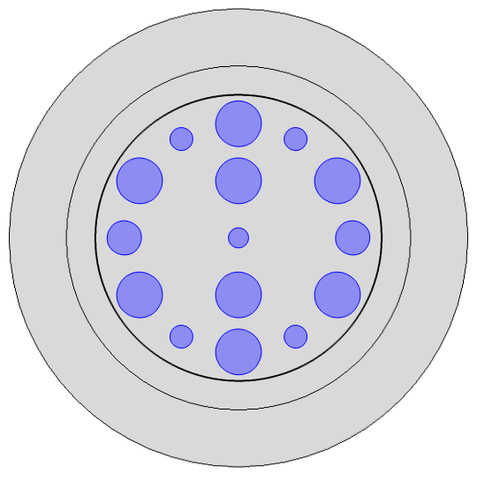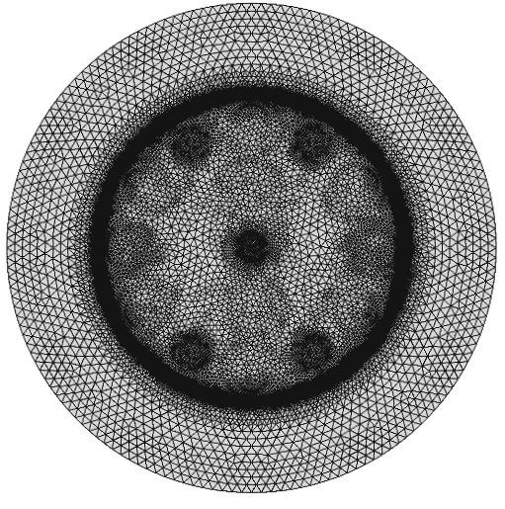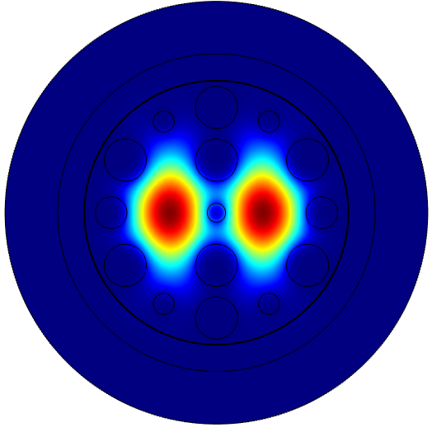
(a) (b) (c)
Figure 4.1: (a) Geometry and (b) mesh of the cross-section of a dual-core
PCF. Blue and grey regions represent, respectively, the air-holes
and the other material. (c) Fundamental component of the magnetic field at 520
nm evaluated with the FEM-based full-vector modal solver.

4.5 Computational of PCF Modal Properties
4.5.1 Chromatic Dispersion
Starting from the knowledge of the effective refractive index n_{eff} versus the wavelength, the dispersion parameter
D(λ) = − $\frac{λ}{c}$ $\frac{d^{2}n_{eff}}{{dλ}^{2}}$ …………….(4.4)
can be derived using simple finite difference formulae. The chromatic dispersion of silica is taken into account through the Sellmeier equation [13], so the refractive index of the structure is changed, according to the working wavelength, before using the FEM solver to get the modal field and n_{eff,} as in Eq. (2).

4.5.2 Confinement losses
In a PCF with an infinite number of air-holes in the photonic crystal cladding, the propagation is theoretically lossless. However, in the fabricated fibers the number of air-holes is finite, so the guided modes are leaky. The confinement loss L_{C} of the mode is deduced from the attenuation constant α in Eq. (4.2) as
L_{C} = 20α log10 e = 8.686α (dB/m) ……(4.5)

4.6 Proposed SPR-PCF Model
The schematic diagram of dual core SPR-PCF Model is depicted on figure 4.2. It is carried out using most commonly used commercially available finite element method (FEM) based software comsol multiphysics 4.2. Physics controlled mesh sequence with extremely fine element size is used to get maximum accuracy in simulation. The circular air-holes based annular cladding and analyte channel is proposed in a silica (SiO₂) substrate. Different diameters of air holes d1, d2, d3 and d4 are used to shape the cladding which has significant effect in confinement loss and light propagation through fiber. As the holes reduce the refractive index of silica, the phase matching condition between the fundamental mode and plasmonic mode can be guaranteed. Gold (Au) is used as plasmonic as it has bio-compatibility and can be applied as chemical vapor deposition method. This metal is mostly used because it has no oxidation problem as silver (Ag) and aluminum (Al). The perfectly matched layer (PML) is the outmost layer and radiation observer. The pitch, p= 2μm, center diameter, d2= 0.35 μm , d3= 0.6 μm, d4= 0.4 μm, d1=0.8 μm, gold thickness, tg= 30 nm, Analyte thickness, ta= 1 μm and PML layer= 2 μm was taken to optimize this model to study. Here d3 diameter is used intentionally to create evanescent field with metal layer. The refractive index of fuced silica was varied using Sellmeier equation [14]:

${ n}^{2}= 1+ \frac{B_{1} λ^{2}}{λ^{2}-C_{1}}+\frac{B_{2} λ^{2}}{λ^{2}-C_{2}}+ \frac{B_{3} λ^{2}}{λ^{2}-C_{3}}$………..(4.5)

where n and λ(nm) is the index of refraction and wavelength respectively, B(i = 1,2,3) and
C (i= 1,2,3) are Sellmeier coefficients. The values of the coefficients are defined as follows B1 =
0.696166300, B2 = 0.407942600, B3 = 0.897479400, C1 = 4.67914826 × 10⁻³μm²,
C2 =1.35120631 × 10⁻² μm² and C3 = 97.9340025 μm²
The dielectric constant of gold can be obtained from Drude-Lorentz model [15]:

$ε_{Au}= ε_{∞}- \frac{ω_{D}^{2}}{ω\left(ω+jγ_{D}\right)}- \frac{∆εΩ_{L}^{2}}{(ω^{2}-Ω_{L}^{2})+jΓω}$…………(4.6)

where, $ε_{Au}$ is the permittivity of gold, $ε_{∞}$ is the permittivity at a high frequency with the value of 5.9673, $ω$ is the angular frequency, which is given by $ω=2πc/λ$, c is the velocity of light in vacuum, $ω_{D}$ is the plasma frequency and $γ_{D}$ is damping frequency. Here, $ω_{D}/2π$ = 2113.6 THz, $γ_{D}/2π$ = 15.92 THz, the weighting factor $∆ε=1.09$. The spectral width and oscillator strength are given by $Γ_{L}/2π$ = 104.86THz, $Ω_{L}/2π=$ 650.07 THz respectively.

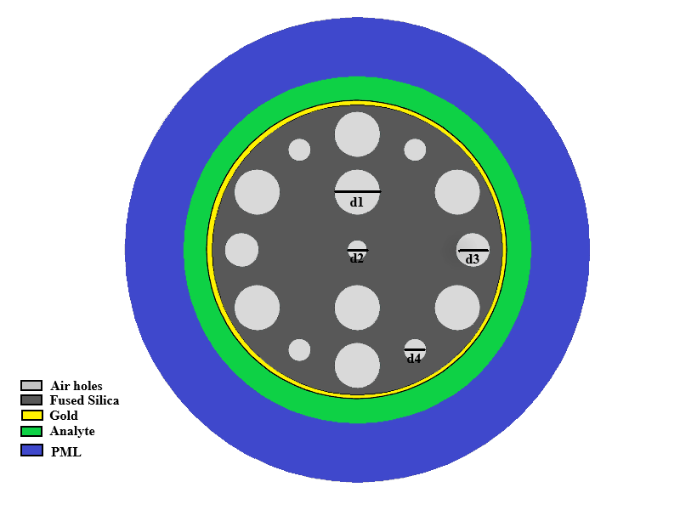
Figure 4.2: Proposed SPR-PCF sensor.

4.7 Dispersion Relation of Model

The principle of this model is based on interaction of evanescent field with metal layer thickness. Propagation of light in core region produce evanescent field that penetrates through cladding region. The real part of fundamental mode guided effective refractive index and plasmonic mode guided effective refractive index are same at the resonant wavelength. The generation of surface plasmon wave is occurred due to free electrons which is produced from the excitation of the core-cladding evanescent field. A sharp peak can be observed from resonant wavelength which can be used for detecting unknown analyte, bio-layer thickness etc. by measuring wavelength shift and amplitude variations. As the reason of birefringence, there are two core modes generations where y-mode generation gives better performance than x-mode generation. This is depicted on figure 4.7(a,b).

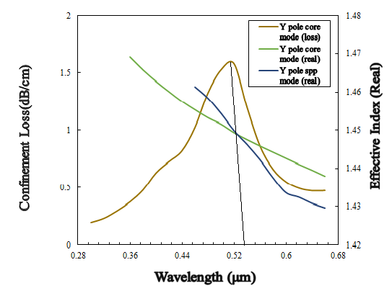
Figure 4.7: (a) Y-polarization dispersion relation.
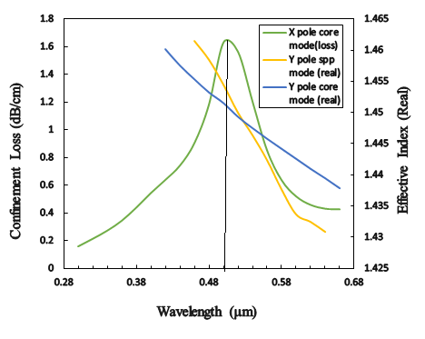

(b) X-polarization dispersion relation.

This operation was performed with RI = 1.38 where 540 nm is the resonant wavelength of y-component electric field and 500 nm is the resonant wavelength of x-component electric field. Fig. 4.7(a) shows the phase matching at 540 nm where the effective index of core-guided fundamental mode and spp mode coincide for same analyte. When both modes are strongly coupled, largest energy is transferred from core guided fundamental mode to spp mode. The phase matching coupling phenomenon is verified by coincidence of resonant peak and intersection between dispersion relations of core-guided mode and spp mode. In Fig. 4.8, it is clearly visible that light propagation is much stronger of y-component rather than x-component.

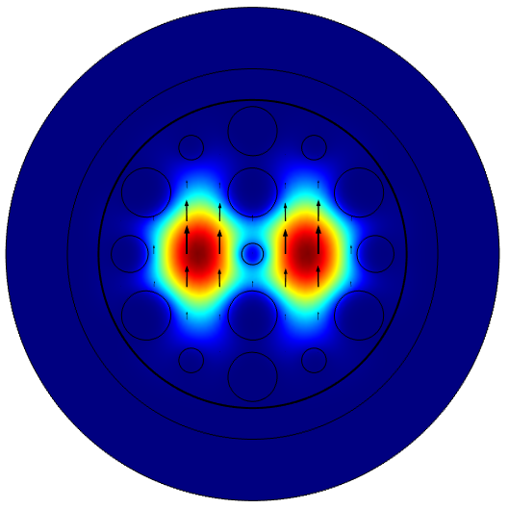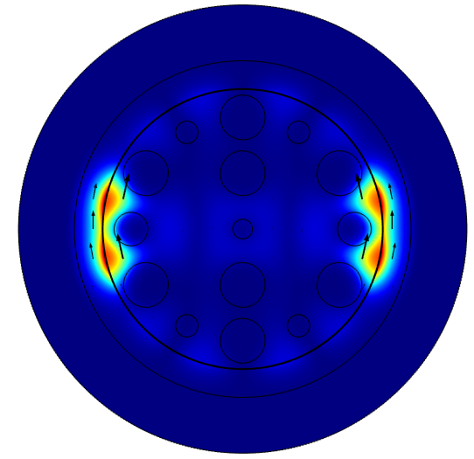

- Fundamental and plasmonic mode for Y-polarization at 540 nm wavelength

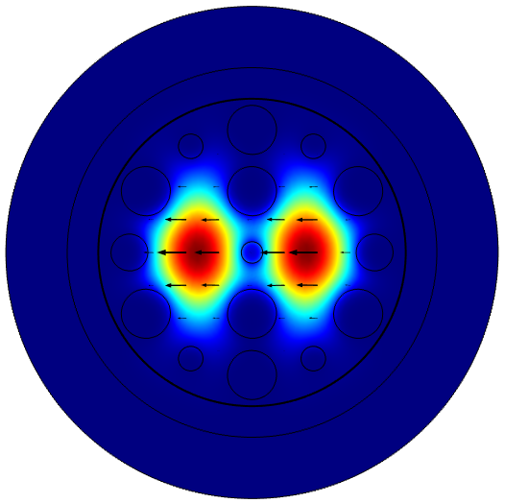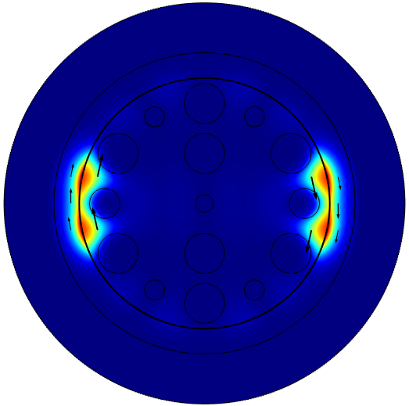
(b) Fundamental and plasmonic mode for X-polarization at 500 nm wavelength

Figure 4.8: Field profile of proposed sensor.

4.8 Summary

This chapter includes modeling of PCF structure, types, Finite Element Method, FEM modeling of PCF, proposed SPR-PCF sensor and dispersion relation of proposed sensor.

REFERENCES

[1] Z. Zhang and S. Satpathy, “Electromagnetic wave propagation in periodic structures: Bloch wave solution of Maxwells equations,” Phys. Rev. Lett., vol. 65, no. 21, pp. 2650–2653, 1990, doi: 10.1103/PhysRevLett.65.2650.
[2] A. Ferrando, J. J. Miret, E. Silvestre, P. Andrés, and M. V. Andrés, “Vector Description of a Realistic Photonic Crystal Fiber,” Opt. Photonics News, vol. 9, no. 12, p. 33, 1998, doi: 10.1364/opn.9.12.000033.
[3] N. M. Litchinitser et al., “Resonances in microstructured optical waveguides,” Opt. Express, vol. 11, no. 10, p. 1243, 2003, doi: 10.1364/oe.11.001243.
[4] L. Poladian, N. Issa, and T. Monro, “Fourier decomposition algorithm for leaky modes of fibres with arbitrary geometry,” Opt. Express, vol. 10, no. 10, p. 449, 2002, doi: 10.1364/oe.10.000449.
[5] F. Fogli, L. Saccomandi, P. Bassi, G. Bellanca, and S. Trillo, “Full vectorial BPM modeling of Index-Guiding Photonic Crystal Fibers and Couplers,” Opt. Express, vol. 10, no. 1, p. 54, 2002, doi: 10.1364/oe.10.000054.
[6] D. Mogilevtsev, T. A. Birks, and P. S. J. Russell, “Localized function method for modeling defect modes in 2-D photonic crystals,” J. Light. Technol., vol. 17, no. 11, p. 2078, 1999.
[7] N. Guan, S. Habu, K. Takenaga, K. Himeno, and A. Wada, “Boundary element method for analysis of holey optical fibers,” J. Light. Technol., vol. 21, no. 8, p. 1787, 2003.
[8] K. Saitoh and M. Koshiba, “Full-vectorial imaginary-distance beam propagation method based on a finite element scheme: Application to photonic crystal fibers,” IEEE J. Quantum Electron., vol. 38, no. 7, pp. 927–933, 2002, doi: 10.1109/JQE.2002.1017609.
[9] M. Qiu, “Analysis of guided modes in photonic crystal fibers using the finite-difference time-domain method,” Microw. Opt. Technol. Lett., vol. 30, no. 5, pp. 327–330, 2001, doi: 10.1002/mop.1304.
[10] C. Yu and H. Chang, “Compact finite-difference frequency-domain method for the analysis of two-dimensional photonic crystals,” Opt. Express, vol. 12, no. 7, p. 1397, 2004, doi: 10.1364/opex.12.001397.
[11] J. Broeng, D. Mogilevstev, S. E. Barkou, and A. Bjarklev, “Photonic crystal fibers: A new class of optical waveguides,” Opt. fiber Technol., vol. 5, no. 3, pp. 305–330, 1999.
[12] G. S. Warren and W. R. Scott, “Numerical dispersion in the finite‐element method using triangular edge elements,” Microw. Opt. Technol. Lett., vol. 9, no. 6, pp. 315–319, 1995, doi: 10.1002/mop.4650090606.
[13] S. Zhang, J. Li, S. Li, Q. Liu, J. Wu, and Y. Guo, “Surface plasmon resonance sensor based on D-shaped photonic crystal fiber with two micro-openings,” J. Phys. D. Appl. Phys., vol. 51, no. 30, 2018, doi: 10.1088/1361-6463/aace72.
[14] M. F. H. Arif, K. Ahmed, S. Asaduzzaman, and M. A. K. Azad, “Design and optimization of photonic crystal fiber for liquid sensing applications,” Photonic Sensors, vol. 6, no. 3, pp. 279–288, 2016, doi: 10.1007/s13320-016-0323-y.
[15] A. V. Gulawani, S. Revathi, and S. R. Inabathini, “Characteristics analysis of highly birefringent with short-length splitter of Novel Dual Core Photonic Crystal Fiber (PCF),” Proc. 2nd IEEE Int. Conf. Eng. Technol. ICETECH 2016, no. March, pp. 940–945, 2016, doi: 10.1109/ICETECH.2016.7569386.

NUMERICAL EVALUATION OF PARAMETERS

5.1 Introduction

As the performance of SPR-PCF sensors are remarkably dependent on the structure of the sensor, a little structure change may lead to remarkable performance variation. Therefore, it is crucial to investigate the influence of structures on performances of the PCF-SPR sensors and further numerical calculation is necessary step to design high-sensitivity PCF-SPR sensors. Here, the study is mainly focused on y-component electric field which was discussed in previous chapter. In order to study resonant peak, calculation of confinement loss or optical loss or loss spectra is needed. The equation of confinement loss is described as [1]:

Confinement loss ${,α}_{c}=8.686×\left(\frac{2π}{λ}\right)Im(n_{eff})×{10}^{4}$………….. (5.1)

5.2 Evaluation of Gold Layer Thickness Variation

The geometric parameters influence the optical parameters of sensor and gold thin film is one of the significant parameters. Fig. 5.1. shows the dependency of confinement loss on variation of gold thin film for different resonant wavelength. The refractive index of analyte is 1.39. The diameter of center air-hole is 0.35μm. The analyte width is 1μm. The loss spectra increases initially after that it decreases with the gold layer thickness. The range of analysis is tg =28-40 nm where all operating wavelength has resonant peak on 32nm.

Figure 5.1: Dependency of loss spectra with respect to thickness of gold thin film.

5.3 Evaluation of Center Diameter Variation

This evaluation is operated by variating center diameter with the difference of 0.05μm, from 0.35μm to 0.50μm. The refractive index is 1.37, gold layer thickness, tg = 30nm and width of analyte layer, ta = 1μm. Fig. 5.2 presents the optical losses of different diameters in the range of 0.40 to 0.60μm wavelength. It is observed that highest resonant peak has been analyzed at 0.40μm center diameter on 0.50μm wavelength.

Figure 5.2: Wavelength versus loss spectra with the variation of center diameter.

5.4 Evaluation of Analyte Layer Thickness Variation

This evaluation is operated by variating width of analyte layer with the difference of 0.05μm, from 0.95μm to 1.10μm. The refractive index is 1.37, gold layer thickness, tg = 30nm and center diameter, d2 = 1μm. Fig. 5.2 presents the optical losses of different diameters in the range of 0.40 to 0.58μm wavelength. It is observed that highest resonant peak has been analyzed at 1.10μm center diameter on 0.50μm wavelength.

Figure 5.3: Wavelength versus loss with the variation of analyte layer thickness.

5.5 Summary

In this chapter numerical evaluation of proposed sensor is applied for thin gold film, center diameter and width of analyte channel.

REFERENCES

[1] X. Yan, B. Li, T. Cheng, and S. Li, “Analysis of high sensitivity photonic crystal fiber sensor based on surface plasmon resonance of refractive indexes of liquids,” Sensors (Switzerland), vol. 18, no. 9, 2018, doi: 10.3390/s18092922.

MEASUREMENT & OPTIMIZATION OF SENSITIVITY

6.1 Introduction

Wavelength interrogation method is useful to determine the sensitivity parameter of any SPR based PCF sensor. The sensitivity of PCF based SPR sensors depends on the evanescent fields. Stronger evanescent fields results in higher transmission loss in fiber which increases the interaction with the metal surface and subsequently improves the sensor sensitivity. This parameter includes wavelength or spectral sensitivity, amplitude sensitivity, spectral resolution and amplitude resolution.

6.2 Measurement of SPR Sensor’s Sensitivity

SPR is particularly sensitive to the surrounding dielectrics. In this thesis, the loss characteristics of the sensor are investigated for analyte refractive index from 1.36 to1.41 and the result is presented in Fig. 6.1. The resonance strength increases with increasing refractive indexes and resonant peak-shifts. By detecting the changes in the resonance peak positions (${Δλ}_{peak}$) and variations of the analyte refractive indexes ($Δn_{a}$), the wavelength sensitivity can be calculated as follows [1]:
S($λ$) = $\frac{{Δλ}_{peak}}{Δn_{a}}$(nm/RIU)………..(6.1)

There $Δn_{a}$ is assumed to be 0.01. The resonant peak are found at 520, 540, 560 nm wavelength for the analyte of RI 1.39, 1.40 and 1.41 respectively. The sensitivity of 2000, 2000 and 2000 nm/RIU respectively are achieved when analyte varies from 1.39-1.40 and 1.40-1.41.
The wavelength resolution is assumed to be $Δλ_{min}$ = 0.1nm
The refractive index resolution of proposed is defined as [2]:

$R= {Δn_{a}Δλ_{min}}/{Δλ_{peak}}$………………..(6.2)

Sensing resolution is obtained as $5×{10}^{-5}$ between 1.36 to 1.41 refractive indexes.

Figure 6.1: Analysis of losses for analyte variation.

Figure 6.2: Analysis of amplitude sensitivity for analyte variation.

Fig.6.2 is illustrated as amplitude sensitivity for analyte variation. Amplitude sensitivity is calculated by using ():

$S_{A}\left(λ\right)[{RIU}^{-1}]=-\frac{1}{α\left(λ,n_{a}\right)}\frac{∂α\left(λ,n_{a}\right)}{∂n_{a}}$……….(6.3)

From Fig6.2, the amplitude sensitivity increases gradually with the increase of analyte RI. The proposed sensor shows the maximum amplitude sensitivity of 282 (1/RIU) on detecting to 1.41.

6.3 Optimization of SPR Sensor’s Sensitivity

Figure 6.3: Analysis of losses with graphene layer for analyte variation.

To optimize the energy losses of SPR sensor, Graphene plays vital role attaching with gold metal layer. Graphene reduces oxidation problem in silver and aluminum layer. Fig.6.3 shows the resonant wavelengths due to inject graphene layer on proposed model. This evaluation is observed using 20 nm of graphene layer outside of the gold layer.

6.4 Summary

This chapter includes measurement of sensitivity for certain refractive indexes, and optimization of the sensor sensitivity using graphene-gold layer.

REFERENCES

[1] J. N. Dash and R. Jha, “SPR biosensor based on polymer PCF coated with conducting metal oxide,” IEEE Photonics Technol. Lett., vol. 26, no. 6, pp. 595–598, 2014, doi: 10.1109/LPT.2014.2301153.
[2] J. N. Dash and R. Jha, “Graphene-based birefringent photonic crystal fiber sensor using surface plasmon resonance,” IEEE Photonics Technol. Lett., vol. 26, no. 11, pp. 1092–1095, 2014, doi: 10.1109/LPT.2014.2315233.

CONCLUSION & FUTURE WORK

7.1 Conclusion

- In this report, evolution of PCF research field has been discussed.
- Numerical analysis has been performed on proposed sensor.
- Measurement of sensitivity for different analytes has been performed and optimized using extra graphene layer.

7.2 Future Work

Further study for improving sensitivity of proposed sensor is inspired for future.

