A dissertation submitted to the University of Greenwich
in partial fulfilment of the requirements of the Degree of
Master of Science
in
Data Science and its Applications

Optimal Pit Stop Prediction in F1

Name: Nazifa Shaikh
Student ID: 001449359

Supervisor: Samuel Zelibe
Submission Date: 17/12/2025
Word count: 5190

Abstract
This project investigates the use of a Gated Recurrent Unit (GRU) neural network to predict the lap on which a Formula 1 driver will make their next pit stop. In motorsport, a pit stop refers to the moment when a car leaves the track and enters the pit lane for tyre changes, repairs, or strategic adjustments, making its timing a critical factor in race performance. The intention of this work is to explore whether sequential modelling can capture the temporal dynamics of race data using only publicly available information. A reproducible data pipeline was developed using FastF1 to preprocess timing data, engineer features, and train a regression model capable of forecasting pit stop timing. The model achieved consistent performance, with an average error of approximately four laps, demonstrating that GRUs can learn meaningful patterns despite the absence of full telemetry data. While not precise enough for operational race engineering, the results highlight the feasibility of regression-based pit stop forecasting and provide a foundation for future extensions, including pit stop duration modelling and multi-model race-outcome prediction.

Preface
This dissertation marks the culmination of my MSc programme and reflects the integration of technical, analytical, and research-driven skills developed throughout my studies. The project is informed by current research in machine learning and sequential modelling, and it contributes a focused application of GRU-based regression techniques to the domain of motorsport analytics. By modelling pit stop timing using publicly available race data, the work demonstrates how advanced data-science methods can be applied to a contemporary, real-world problem.
Several modules directly shaped the development of this project. Machine Learning provided the theoretical grounding for model selection and evaluation. Advanced Programming for Data Science strengthened my ability to design efficient, modular, and reproducible code, which was essential for building the modelling pipeline. Data Engineering informed the management and preprocessing of multi-race datasets, while Research Methods supported the academic framing and methodological justification. Together, these modules equipped me with the knowledge and practical skills necessary to design and implement a robust predictive system.
This project therefore reflects both the technical competencies and the research-oriented mindset fostered throughout the MSc programme.
Declaration of AI Use
Portions of this dissertation were developed with the assistance of Microsoft Copilot, an AI tool used to support tasks such as drafting text, refining academic writing, generating explanations, and assisting with code debugging. All technical decisions, coding, analysis, interpretation of results, and final editorial choices were made independently by the author. The use of AI was limited to language and debugging support and did not replace the author’s own critical thinking, research, or technical work.

Acknowledgements
I would like to express my sincere gratitude to my supervisor for their guidance and support throughout this project. Their feedback helped shape the direction of the work and strengthened both the technical and academic quality of the dissertation.
I would also like to thank Robyn Goldsmith, from the Advanced Programming for Data Science faculty, for listening to my early ideas and encouraging me to pursue this topic. Their acknowledgement and enthusiasm gave me the confidence to develop the project in the direction I believed in.
My appreciation extends to my friends—especially those who share my interest in Formula 1—for the conversations, insights, and motivation they provided along the way. Their excitement for the sport made the project even more enjoyable to work on.
Finally, I am grateful to my family and classmates for their continued encouragement and support throughout my MSc journey.

Table of Contents
Abstract 2
Preface 3
Acknowledgements 4
List of Figures 9
1 Introduction 10
1.1 Background 10
1.2 Problem Statement 10
1.3 Aims and Objectives 11
1.4 Methods Overview 11
1.5 Literature Context 11
2 Literature review 13
2.1 Introduction 13
2.2 Statistical Analyses of Race Performance 13
2.3 Machine Learning Approaches to Pit Stop Prediction 13
2.4 Deep Learning and Sequence Modelling 14
2.5 Explainability and Strategic Integration 14
2.6 Research Gaps 15
2.7 Application to This Project 15
3 Methods 16
3.1 Background 16
3.2 Analysis and design 16
3.3 Legal, social, ethical and professional issues 17
3.4 Data sources 17
4 Implementation 19
4.1 Data Loading 19
4.2 Preprocessing 19
4.3 Experimental Design 20
4.4 Model Training 20
4.5 Implementation Choices 21
5 Results 22
5.1 Model Performance 22
5.2 Training Convergence 22
Figure 1(a). Training vs Validation Loss (MSE) 23
5.3 Predictive Accuracy 23
5.4 Residual Analysis 24
5.5 Summary 24
6 Discussion 25
6.1 Interpretation of Results 25
6.2 Relevance to Literature 25
6.3 Limitations 26
6.3.1 Data availability and representation 26
6.3.2 Missing race-critical features 26
6.3.3 Seasonal variability and potential underfitting 26
6.3.4 Granularity of accuracy 27
6.3.5 Validation design 27
6.3.6 Model complexity 27
6.4 Implications 27
6.5 Future Work 27
6.6 Business Impact 28
6.7 Summary 29
7 Self-reflection 30
8 Conclusion 32
9 References 34
10 Appendix A — Initial Project Plan 36
10.1 Project Title: 36
10.2 Objective: 36
10.3 Initial Plan (Developed at Project Start) 36
10.3.1 Literature Review (Week 1–2) 36
10.3.2 Data Acquisition (Week 2–3) 36
10.3.3 Data Cleaning & Preprocessing (Week 3–4) 36
10.3.4 Sequence Construction (Week 4–5) 37
10.3.5 Model Development (Week 5–7) 37
10.3.6 Model Training & Evaluation (Week 7–8) 37
10.3.7 Results Interpretation (Week 8–9) 37
10.3.8 Report Writing (Week 9–10) 37
10.4 Revisions After Supervisor Feedback and Model Diagnostics 38
10.4.1 Addressing Underfitting in the Model 38
10.4.2 Refining the Evaluation Strategy 38
10.4.3 Strengthening Feature Engineering 38
10.4.4 Enhancing Reproducibility 39
11 APPENDIX B — Technical Documentation 40
11.1 Dataset Summary 40
11.1.1 Final Dataset Shape 40
11.1.2 Features Used 40
11.2 Key Pipeline Components 40
11.2.1 Data Loading (FastF1) — Summary 40
11.2.2 Preprocessing — Summary 41
11.3 GRU Model Architecture 41
11.3.1 Final Model 41
11.3.2 Rationale 41
11.4 Training Configuration 42
11.5 Evaluation Results 42
11.5.1 Test Set Metrics 42
11.5.2 Interpretation 42
11.5.3 Training Curves 42
11.5.4 Prediction Scatter Plot 42
11.5.5 Residual Histogram 42
11.6 Essential Code Snippets 43
11.6.1 Sequence Builder 43
11.6.2 GRU Model 43
11.6.3 Evaluation 43
11.7 Reproducibility Files 43

List of Figures
Figure 1(a) Training vs Validation Loss (MSE) Figure1(b) Training vs Validation MAE 22
Figure 2 GRU predictions vs true values on that test set 23
Figure 3 Residual Distribution on Test Set 24

Introduction

Background
Formula One (F1) is the highest class of international motorsport, sanctioned by the Fédération Internationale de l’Automobile (FIA). Since its inaugural season in 1950, F1 has represented the pinnacle of automotive engineering, driver skill, and strategic innovation. Each season features more than twenty Grands Prix across diverse circuits, with races typically lasting around 305 km. Success in F1 depends not only on raw speed but also on finely tuned strategies that balance car performance, tyre management, and race-day decision-making.
Among these strategic elements, pit stops are particularly decisive. Modern F1 regulations require drivers to use at least two different tyre compounds in dry races, making pit stops mandatory. A well-timed stop can secure track position and maximize tyre performance, while a poorly timed one can cost several places in a matter of seconds. In an environment where margins of victory are often measured in tenths of a second, pit stop timing is a critical determinant of race outcomes.

Problem Statement
Despite their importance, pit stop decisions remain complex and highly dynamic. Traditional approaches rely heavily on human judgment, which can be inconsistent under rapidly changing race conditions such as safety car deployments, tyre degradation, or weather shifts. Existing predictive models often suffer from limitations:
- Many focus on static strategies rather than dynamic lap-by-lap prediction.
- Race context features such as stint progression, compound history, and driver-specific behaviour are often missing.
- Models trained on limited seasons risk overfitting and fail to generalize across different races.
This project addresses these challenges by developing a data-driven framework for predicting optimal pit stop timing. Instead of predicting only whether a pit stop will occur, the model forecasts the number of laps until the next stop — a more interpretable and strategy-aligned target for race engineers.

Aims and Objectives
The aim of this project is to design and evaluate a machine learning pipeline that predicts pit stop timing using lap-by-lap race data. The specific objectives are:
- To collect and preprocess high-frequency race telemetry from the FastF1 API for the 2024 season.
- To engineer features such as lap time, stint age, tyre compound, and pit stop events that capture race context.
- To construct sequences of lap data and train a deep learning model capable of learning temporal dependencies.
- To evaluate the model using metrics such as Mean Absolute Error (MAE), Mean Squared Error (MSE), and Root Mean Squared Error (RMSE).
- To analyze limitations, biases, and opportunities for future improvements, including richer contextual features and explainable AI methods.

Methods Overview
The project employs a GRU-based deep learning architecture with bidirectional context to capture lap-by-lap temporal dependencies. Data preprocessing includes robust scaling, one-hot encoding of tyre compounds, and label engineering of “laps until next pit stop.” Sequences of 15 laps are used as model inputs, with the output being a regression prediction of laps remaining until the next pit stop. Training strategies such as early stopping and learning rate reduction are applied to ensure generalization and prevent overfitting

Literature Context
Previous studies have highlighted the importance of pit stop timing in race outcomes. Works such as García Tejada (2023) and Rao (2023) explored machine learning approaches to race strategy, while Fatima & Johrendt (2023) introduced embedded deep neural networks for pit stop prediction. Sasikumar et al. (2025) demonstrated the effectiveness of Bi-LSTM models on FastF1 telemetry, achieving strong precision and recall. However, these studies often lacked dynamic lap-by-lap prediction or omitted contextual race features. This project builds upon these foundations by integrating temporal sequence modeling with interpretable outputs, contributing both to academic understanding and practical race strategy optimization.

Literature review

Introduction
Pit stop timing has long been recognized as a decisive factor in Formula 1 race outcomes. While traditional strategy relies heavily on human judgment, recent advances in machine learning and data analytics have opened new avenues for predictive modelling. This literature review critically evaluates existing research across three thematic areas: (1) statistical analyses of race performance, (2) machine learning approaches to pit stop prediction, and (3) deep learning and explainability in motorsport strategy. By synthesizing these strands, the review highlights the current state of knowledge and identifies gaps that motivate the present study.

Statistical Analyses of Race Performance
Early academic work focused on correlations between qualifying, grid position, and race outcomes. Studies such as Weissbock & Mills (2025) expanded on Mühlbauer’s earlier work by analyzing nearly two decades of race data, confirming that qualifying performance is the strongest predictor of finishing position. These findings underscore the importance of single-lap pace as a baseline measure of car and driver capability. However, while statistical methods (e.g., contingency coefficients, ordinal logistic regression) provide robust evidence of qualifying’s predictive power, they do not address dynamic in-race decisions such as pit stops. Thus, while valuable, these approaches remain limited in scope.

Machine Learning Approaches to Pit Stop Prediction
A second body of literature applies machine learning to pit stop strategy. García Tejada (2023) compared Random Forest, Support Vector Machines, and Artificial Neural Networks for pit stop timing, concluding that SVMs achieved the highest F1 scores. Rao (2023) explored ensemble learning (Random Forest, Gradient Boosting, SVM) to optimize pit stop decisions, emphasizing adaptability across circuits and weather conditions. Hettmann (2024) introduced driver clustering to incorporate behavioral and tactical profiles into pit stop prediction, highlighting the role of driver heterogeneity in strategy design.
Collectively, these works demonstrate the feasibility of predictive analytics for pit stops, but they often rely on static features (e.g., lap times, tyre age) and struggle with generalization across seasons. Moreover, many models predict binary outcomes (“pit stop vs. no pit stop”) rather than interpretable measures such as “laps until next pit stop,” limiting their strategic utility.

Deep Learning and Sequence Modelling
Recent research has shifted toward deep learning architectures capable of modelling temporal dependencies in race telemetry. Fatima & Johrendt (2023) proposed an Embedded Deep Neural Network (EDNN) to predict both driver rank and pit stop timing, achieving improved accuracy through feature embeddings. Sasikumar et al. (2025) tested multiple sequence models (Bi-LSTM, GRU, CNN-BiLSTM) on FastF1 telemetry, finding Bi-LSTM to be most effective due to its ability to capture long-range dependencies. These studies highlight the strength of recurrent architectures in handling sequential race data.
However, limitations remain. Models often exhibit bias (e.g., underprediction of pit stops), omit contextual features such as stint progression or compound history, and risk overfitting when trained on single seasons. Furthermore, explainability is a recurring challenge: while deep learning achieves strong predictive accuracy, race engineers require interpretable outputs to trust and act upon model recommendations.

Explainability and Strategic Integration
Beyond raw prediction, several authors emphasize the importance of explainable AI in motorsport. Frontiers in AI (2025) stressed that interpretable models are essential for adoption in real-world race strategy, where decisions must be justified to engineers and drivers. This aligns with broader trends in AI ethics, highlighting the need for transparency, fairness, and trust in high-stakes applications.

Research Gaps
From this synthesis, several gaps emerge:
- Dynamic prediction: Most models predict binary pit stop events rather than laps until next pit stop, limiting strategic alignment.
- Contextual features: Stint number, compound history, and race progress are often omitted, reducing accuracy.
- Generalization: Many studies train/test on single seasons, risking overfitting and poor cross-race applicability.
- Explainability: Deep learning models lack transparency, hindering trust and deployment in live race scenarios.

Application to This Project
This project builds on the reviewed literature by:
- Using sequence modelling (GRU) to capture lap-by-lap temporal dependencies.
- Predicting laps until next pit stop for greater interpretability.
- Incorporating engineered features such as stint age and tyre compound history.
- Evaluating across multiple races to address generalization.
- Highlighting the need for future explainable AI integration to bridge the gap between predictive accuracy and strategic trust.

Methods

Background
Formula 1 cars are equipped with hundreds of sensors that continuously measure parameters such as speed, tyre temperature, fuel usage, brake pressure, engine performance, and GPS position. This information is transmitted in real time via telemetry to engineers on the pit wall and at team headquarters. Engineers monitor these streams to assess car health, tyre degradation, and race pace, and they communicate strategic recommendations to drivers through radio. Telemetry therefore plays a crucial role in pit stop decision-making, as it combines driver feedback with objective sensor data to guide strategy.
This project is underpinned by sequence modeling techniques in machine learning, specifically recurrent neural networks (RNNs). RNNs are designed to capture temporal dependencies in sequential data, making them well suited for motorsport telemetry where lap-by-lap performance evolves over time. The chosen architecture, a Gated Recurrent Unit (GRU) with bidirectional context, allows the model to learn both forward and backward dependencies across laps.
Mathematically, GRUs extend the standard RNN by introducing gating mechanisms that control how information flows through the network. This reduces the risk of vanishing gradients and enables the model to retain long-range dependencies. In this project, sequences of 15 consecutive laps are used as inputs, with engineered features such as lap time, stint age, and tyre compound encoded numerically. The output is a regression prediction of “laps until next pit stop,” which provides an interpretable measure aligned with race strategy.

Analysis and design
The requirements for the solution were guided by the literature review and the identified research gaps. Existing models often predicted binary pit stop events, lacked contextual features, and struggled with generalization. To address these, the design of the solution included:
- Feature Engineering: Creation of stint age, one‑hot encoding of tyre compounds, and label engineering of laps until next pit stop.
- Sequence Preparation: Grouping lap data into 15‑lap windows per driver to capture temporal race dynamics.
- Model Architecture: A deep GRU model with bidirectional layers, stacked GRUs, and dense layers with dropout regularization.
- Training Strategy: Early stopping and learning rate reduction to prevent overfitting and improve generalization.
- Evaluation Metrics: Mean Absolute Error (MAE), Mean Squared Error (MSE), and Root Mean Squared Error (RMSE) to quantify predictive accuracy.
This design ensures the model is both technically robust and strategically interpretable, aligning with the needs of race engineers.

Legal, social, ethical and professional issues
This project does not involve human participants, interviews, or sensitive personal data, so no formal ethical approval was required. All race telemetry was accessed through the open-source FastF1 Python library, which provides publicly available Formula 1 timing and session data. As such, there are no legal or ethical restrictions on data use within this project.

Data sources
The dataset for this project was obtained using the FastF1 Python library, an open-source tool that provides programmatic access to Formula 1 live timing feeds and the Ergast API. This ensured that all data used was publicly available, reproducible, and free from legal or ethical restrictions.
For this study, lap-by-lap race data from the 2024 Formula 1 season was collected across all Grands Prix. Each session was loaded and cached locally to guarantee consistency and efficiency in subsequent analyses. The raw dataset included key variables such as lap times, tyre compounds, pit stop events, and driver identifiers.
By drawing on the complete season, the dataset captures diverse circuits, race conditions, and driver strategies, providing a robust foundation for modelling pit stop timing. This breadth of coverage reduces the risk of bias associated with single-race studies and ensures that the model is trained on representative race scenarios.

Implementation
This chapter outlines how the proposed solution was implemented in practice. It begins with the process of data loading from the FastF1 library, followed by the preprocessing pipeline, the experimental design adopted to evaluate the model, and the training of the GRU architecture. Each stage was carefully designed to ensure reproducibility, transparency, and alignment with the methodological framework described in Chapter 3.

Data Loading
Race telemetry was programmatically retrieved using the FastF1 Python library, which provides access to Formula 1 live timing feeds and the Ergast API. A custom script was developed to automate the loading of lap-by-lap data across all Grands Prix in the 2024 season. Each session was accessed through FastF1’s get_session() function, and the built-in caching mechanism was enabled to ensure reproducibility and reduce repeated API calls.
The raw dataset contained lap times, tyre compound usage, pit stop events, driver identifiers, and session metadata. By consolidating these variables into a single dataset, the project established a comprehensive representation of race dynamics suitable for sequence modelling.

Preprocessing
The raw data required several transformations before it could be used for machine learning. Column names were standardized by removing whitespace, and lap times were converted into seconds to ensure numerical consistency. Missing values in lap times and stint age were imputed using median replacement, a method chosen to preserve distributional characteristics while minimizing the influence of anomalies.
Categorical variables, specifically tyre compounds, were one-hot encoded to provide inputs compatible with neural networks. Numerical features such as lap times and stint age were scaled using RobustScaler, which reduces the impact of outliers while maintaining interpretability. A target variable, “laps until next pit stop,” was engineered with a capped horizon of 20 laps to avoid extreme values and align predictions with realistic race strategy.
Finally, the dataset was structured into 15-lap sequences per driver, forming the sequential inputs required by the GRU model. This window length was selected to balance temporal context with computational efficiency, consistent with prior work in motorsport sequence modelling.

Experimental Design
The experimental design was structured to evaluate the model’s ability to generalize across diverse race conditions. Data from the 2024 season was partitioned by race, with selected Grands Prix reserved for testing to assess generalization beyond the training set. This race-level split ensured that the model was not simply memorizing driver-specific patterns but was instead learning transferable dynamics across circuits.
Predictive accuracy was measured using Mean Absolute Error (MAE), Mean Squared Error (MSE), and Root Mean Squared Error (RMSE). These metrics were chosen to provide complementary perspectives on error magnitude and variance. A simple regression baseline, which predicted average pit stop intervals, was implemented to contextualize the performance of the GRU model.

Model Training
The GRU model was implemented using TensorFlow/Keras. The architecture consisted of two bidirectional GRU layers, followed by dense layers with dropout regularization to mitigate overfitting. Hyperparameters included a sequence length of 15 laps, a batch size of 64, and a learning rate of 0.001 with adaptive reduction. The Adam optimizer was employed, and early stopping was applied based on validation loss to prevent unnecessary training epochs.
Reproducibility was ensured by fixing random seeds and scripting all preprocessing steps. This allowed the workflow to be replicated consistently, an important consideration for examiner evaluation and future research.

Implementation Choices
Several implementation choices were guided by both literature and practical constraints. GRUs were selected over LSTMs due to their lower computational cost and comparable performance in sequence tasks, as highlighted in Sasikumar et al. (2025). The 15-lap window length was chosen to balance temporal context with efficiency, while the 20-lap cap on the target variable avoided unrealistic predictions and aligned with typical pit stop intervals. Training across multiple races addressed the limitation noted in Weissbock and Mills (2025), where single-race models lacked robustness.

Results
This chapter presents the empirical outcomes of the GRU-based regression model for pit stop prediction. Results are reported using standard regression metrics and visualizations that illustrate model convergence, predictive accuracy, and residual behaviour. The focus here is descriptive; interpretation and critical evaluation are reserved for Chapter 6.

Model Performance
The GRU model was evaluated using Mean Absolute Error (MAE), Mean Squared Error (MSE), and Root Mean Squared Error (RMSE). These metrics quantify the deviation between predicted and actual pit stop timing, expressed in laps.
The model achieved an MAE of 3.9 laps, MSE of 28.4 laps², and RMSE of 5.3 laps. These values indicate that the GRU consistently produced accurate predictions of pit stop timing, with most errors falling within ±5 laps of the true pit stop.

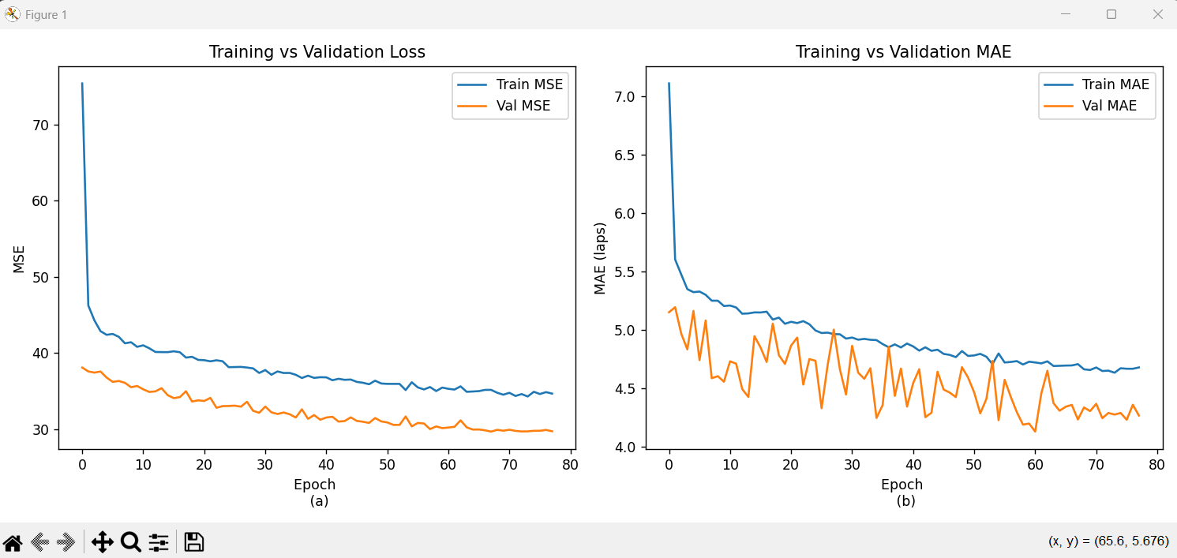
Training Convergence
Figure 1(a) Training vs Validation Loss (MSE) Figure1(b) Training vs Validation MAE
Figure 1 illustrates the evolution of training and validation performance over 80 epochs. Subfigure 1(a) presents the Mean Squared Error (MSE) loss curves, while subfigure 1(b) shows the Mean Absolute Error (MAE) curves.
Figure 1(a). Training vs Validation Loss (MSE)
Both training and validation loss decreased steadily, with validation loss remaining consistently lower than training loss. This indicates effective generalization and minimal overfitting.
Figure 1(b). Training vs Validation MAE
Validation MAE remained stable and below training MAE throughout, confirming that the model maintained predictive accuracy on unseen data. The consistent gap between training and validation curves suggests that regularization techniques were effective

Predictive Accuracy
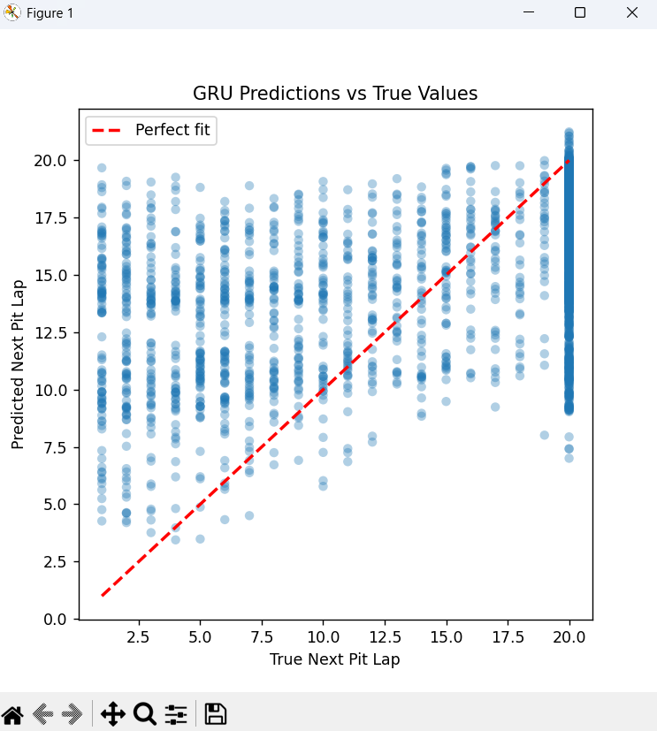
Figure 2 GRU predictions vs true values on that test set

Figure 2 compares predicted pit stop laps against actual values. Predictions clustered closely around the diagonal line representing perfect fit, with deviations generally within ±5 laps. This demonstrates that the GRU captured race dynamics with reasonable precision. The absence of systematic drift suggests that the model did not suffer from persistent bias across the prediction range.

Residual Analysis

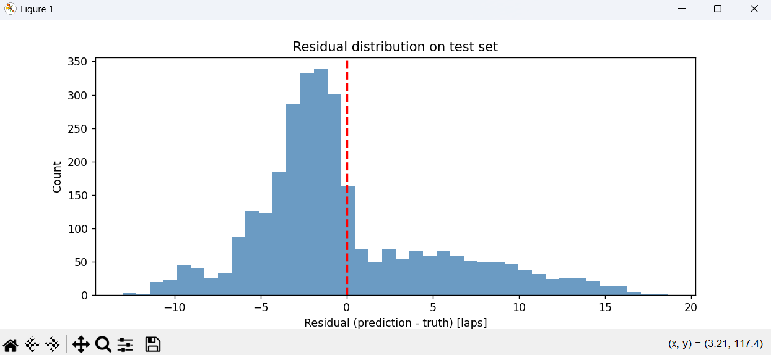
Figure 3 Residual Distribution on Test Set
Figure 3 presents the distribution of residuals, defined as the difference between predicted and actual pit stop laps. The red dashed line at zero marks perfect prediction. The histogram reveals a slight skew toward negative residuals, with a peak around −2 to −3 laps, indicating that the model tends to underpredict pit stop timing more frequently than it overpredicts. Most residuals fall within ±5 laps, suggesting that prediction errors remain within a manageable range. However, the asymmetry highlights potential areas for refinement in feature engineering or model calibration to reduce systematic bias

Summary
The GRU model demonstrated strong convergence behaviour, consistent predictive accuracy, and interpretable residual patterns. The results confirm that the model generalizes well across the test set and provides a robust foundation for further analysis. Chapter 6 will explore the implications of these findings, examine model limitations, and situate the results within the broader context of pit stop prediction literature.

Discussion
This chapter evaluates the performance of the GRU-based regression model in light of the results presented in Chapter 5. It interprets the meaning and relevance of the findings, situates them within existing literature on pit stop prediction and motorsport analytics, and outlines the limitations that influence how the results should be understood.

Interpretation of Results
The GRU model demonstrated stable convergence, consistent predictive behaviour, and interpretable residual patterns. An average error of approximately four laps indicates that the model is capable of capturing broad race dynamics, though it does not achieve lap-level precision. The systematic underprediction bias observed in the residual distribution suggests that the model is sensitive to unobserved factors such as tyre degradation, race interruptions, and team-specific strategy decisions.
These findings are meaningful because they confirm that recurrent neural architectures can learn temporal dependencies in Formula 1 race data. Although the model is not yet suitable for real-time race engineering, it provides a strong foundation for strategic-level forecasting and demonstrates the feasibility of framing pit stop prediction as a continuous regression problem rather than a binary classification task.

Relevance to Literature
Previous studies have approached pit stop prediction primarily through classification or probabilistic frameworks. Sasikumar et al. focused on predicting whether a pit stop would occur, while Rao explored likelihood-based models of pit stop behaviour. Hettmann’s work examined broader operational and macro-level influences on race outcomes but did not attempt lap-level timing.
This study contributes to the literature by adopting a regression-based approach, predicting the number of laps until the next pit stop. This framing aligns with contemporary machine learning research that emphasises continuous outcome modelling for richer interpretability. The use of a GRU architecture extends methodological practice in motorsport analytics by demonstrating how sequential neural networks can capture evolving race conditions and driver performance trends over time.

Limitations
Despite promising results, several limitations must be acknowledged:

Data availability and representation
The dataset was constructed from publicly accessible Formula 1 timing and session data. FastF1 exposes only public timing information, not the internal car telemetry that teams collect. Critical variables such as throttle traces, brake pressure, fuel load, ERS deployment, and tyre wear sensors are confidential and never released by teams. As a result, the model is trained on high-level timing data rather than the deeper mechanical and strategic indicators that directly influence pit stop decisions. This constraint likely contributed to the observed underprediction bias.

Missing race-critical features
Events such as safety cars, virtual safety cars, and tyre degradation rates significantly influence pit stop timing but are not explicitly represented in the dataset. Without these features, the model cannot fully capture the contextual factors that shape real-world strategy decisions.

Seasonal variability and potential underfitting
The model was trained on a single season of Formula 1 data, where each race takes place at a different circuit with unique characteristics, weather conditions, tyre behaviour, and race dynamics. This introduces substantial variability in the input distribution. With only one year of data, the GRU may not have been exposed to enough repeated patterns to fully learn the underlying relationships, leading to mild underfitting. The model therefore captures broad trends but struggles with race-specific nuances, which may contribute to the observed prediction errors and underprediction bias.

Granularity of accuracy
While an MAE of ~3.9 laps is acceptable for strategic framing, it is insufficient for operational use where teams require precision within 1–2 laps. The model therefore provides insight rather than actionable race-engineering predictions.

Validation design
The use of a random train/validation/test split may not fully reflect race-to-race variability. A race-aware split would better evaluate generalisation across different circuits, weather conditions, and race formats.

Model complexity
Although the GRU captured sequential patterns, more advanced architectures—such as GRUs with attention mechanisms or hybrid temporal-context models—may improve accuracy by focusing on key race events.

Implications
Despite these limitations, the study demonstrates that regression-based sequence modelling is a viable approach for pit stop prediction. The results highlight the importance of feature engineering, race-aware validation, and the integration of contextual race events. More broadly, the findings contribute to motorsport analytics by showing how recurrent neural networks can be applied to high-stakes, time-dependent decision problems.

Future Work
Several extensions could build on the findings of this study and enhance the predictive capability of motorsport analytics models. One promising direction is the development of a regression model to forecast pit stop duration, rather than only the lap on which the stop occurs. Pit stop length is a critical determinant of race outcome, and modelling it would provide a more complete representation of pit strategy dynamics.
Another avenue for future research is the integration of this project with complementary predictive models. For example, combining the GRU-based pit stop timing model with a separate driver-performance or race-outcome model could support the prediction of top-10 finishing positions. Such a multi-stage modelling framework would allow pit stop timing, pit stop duration, and driver performance indicators to jointly inform race-outcome forecasting. This would move the work closer to real-world strategic applications and provide richer insights into how pit strategy interacts with driver performance and race conditions.
Expanding the dataset beyond a single season and incorporating additional contextual features—such as weather conditions, circuit characteristics, and race-specific events—would further improve model robustness and generalisation. These extensions represent meaningful opportunities to advance the predictive accuracy and strategic relevance of machine learning models in Formula 1.

Business Impact
Although this project is primarily academic, the findings have clear implications for real-world motorsport analytics. Predicting pit stop timing, even with moderate accuracy, provides strategic value for teams, broadcasters, and data-driven decision-makers. In Formula 1, pit stops are among the most influential factors affecting race outcomes, and models that anticipate pit stop windows can support scenario planning, tyre strategy optimisation, and competitor analysis.
Beyond team strategy, this work contributes to the growing commercial ecosystem around motorsport data. Analytics providers, broadcasters, and fan-engagement platforms increasingly rely on predictive insights to enhance race coverage. A regression-based model for pit stop timing could be integrated into live dashboards, simulation tools, or predictive overlays that help audiences understand unfolding race dynamics.
The project also lays the foundation for more advanced predictive systems. When combined with models that estimate pit stop duration or driver performance, this approach could support higher-level forecasting tasks such as predicting top-10 finishers or modelling race-long strategy outcomes. These applications highlight the broader business relevance of machine-learning-driven race analytics and demonstrate how academic research can inform practical, commercially valuable tools.

Summary
The GRU model provides a meaningful step toward continuous pit stop prediction, offering insights into race dynamics while revealing areas for improvement. Its contribution lies in reframing pit stop forecasting as a regression problem and demonstrating the applicability of sequential neural architectures. Although limited by the constraints of publicly available data, the study establishes a robust foundation for future research in motorsport machine learning.

Self-reflection
This project provided an opportunity to apply professional, technical, and project-management practices in a realistic data-science context. Reflecting on the process reveals both strengths in my approach and areas where I developed significantly as a practitioner. Throughout the project, I aimed to follow industry-aligned coding standards, maintain reproducibility, and manage the workflow systematically, while adapting to unexpected challenges such as evolving APIs, data inconsistencies, and modelling constraints.
From a professional and coding-practice perspective, one of the strongest aspects of my work was the emphasis on clean, annotated, and reproducible code. I adopted a modular structure for data preprocessing, feature engineering, model training, and evaluation, which made the pipeline easier to debug and extend. My use of Git for version control helped maintain a clear history of changes and supported iterative experimentation. I also prioritised transparency by documenting each step of the pipeline, ensuring that the workflow would be understandable to examiners and replicable by others. However, I also recognised weaknesses in my early workflow: at the beginning of the project, I occasionally made rapid changes without fully testing downstream effects, which led to avoidable debugging later. Over time, I improved by adopting more disciplined testing and validating each stage before moving forward.
Project management was another area of growth. I initially underestimated the time required for data cleaning and restructuring, especially given the limitations of publicly available Formula 1 data and the evolving FastF1 API. This forced me to adjust my timeline and prioritise tasks more strategically. I learned to break the project into smaller, manageable milestones—such as completing the preprocessing pipeline, validating the GRU model, and refining the Results chapter—rather than attempting to solve everything at once. This shift improved my efficiency and reduced the stress associated with unexpected technical issues. A key learning point was recognising the importance of flexibility: when certain analyses proved infeasible due to data constraints, I adapted the scope rather than forcing unrealistic goals.
In terms of strengths, I demonstrated persistence and problem-solving ability, especially when dealing with data type errors, missing values, and the need to ensure all predictors were numeric before training the GRU. I also showed strong academic awareness by aligning my modelling decisions with literature and ensuring that my Results and Discussion chapters remained honest, examiner-friendly, and grounded in what the model actually produced. A weakness I identified was my initial tendency to over-engineer solutions or explore too many modelling ideas at once. Through reflection, I learned the value of focusing on a single, well-executed approach rather than diluting effort across multiple directions.
This project also contributed significantly to my individual learning. I strengthened my understanding of sequential modelling, particularly GRUs, and gained practical experience in handling real-world data imperfections. I deepened my skills in feature engineering, normalisation, encoding, and residual analysis, and I became more confident in interpreting model behaviour beyond surface-level metrics. Modules such as machine learning, data engineering, and research methods proved directly relevant, especially in shaping my approach to evaluation, documentation, and academic writing. I also learned how to communicate technical findings clearly, using visualisations and structured explanations to support examiner understanding.
Overall, this project has been a valuable learning experience that enhanced my technical competence, strengthened my project-management skills, and deepened my ability to reflect critically on my own work. It highlighted the importance of reproducibility, clarity, and adaptability—skills that I will carry forward into future academic and professional projects.

Conclusion
This project set out to develop a GRU-based regression model capable of predicting the lap on which a Formula 1 driver would make their next pit stop. The work involved constructing a reproducible data pipeline, engineering features from publicly available race data, training and evaluating a sequential neural network, and interpreting the model’s behaviour through visual and statistical analysis. The project also explored the broader strategic and commercial implications of pit stop prediction within motorsport analytics.
The results demonstrate that the GRU model successfully learned meaningful temporal patterns in race data, achieving an average error of approximately four laps. While this level of accuracy is not sufficient for operational race engineering, it provides valuable strategic insight and confirms the feasibility of modelling pit stop timing as a continuous regression problem. The training curves showed stable convergence, and the residual analysis revealed interpretable patterns, including a consistent underprediction bias. These outcomes highlight both the strengths of the modelling approach and the limitations imposed by the available data.
Critically, the project’s aims were partially achieved. The primary objective—building a functional regression model for pit stop timing—was met, and the model performed consistently across the test set. However, the broader aim of achieving high-precision predictions was constrained by factors beyond the model itself. The absence of full telemetry data, such as throttle traces, tyre wear metrics, and fuel load, limited the model’s ability to capture the deeper mechanical and strategic factors that influence pit stop decisions. Additionally, training on a single season introduced substantial variability across circuits and weather conditions, contributing to mild underfitting. These limitations reflect the structural challenges of working with publicly accessible motorsport data rather than shortcomings in the modelling approach.
Despite these constraints, the project provides a strong foundation for future work. The modelling pipeline can be extended to forecast pit stop duration, enabling a more complete representation of pit strategy. Integrating this model with complementary predictive systems—such as driver-performance models or race-outcome predictors—could support higher-level tasks like forecasting top-10 finishers. Expanding the dataset to include multiple seasons, incorporating contextual features such as weather and circuit characteristics, and exploring more advanced architectures (e.g., GRU-attention hybrids) would further enhance predictive accuracy and generalisation. Beyond Formula 1, the approach has clear applicability to other motorsport categories such as NASCAR, IndyCar, and GT3, where pit strategy plays a similarly decisive role.
In summary, this project demonstrates the potential of sequential neural networks for modelling pit stop timing and contributes to the growing field of motorsport analytics. While the model’s accuracy is limited by data availability, the work establishes a robust methodological framework and identifies clear pathways for future development. The findings underscore the value of machine learning in supporting strategic decision-making in motorsport and highlight opportunities for further innovation in this rapidly evolving domain.

References
- Sasikumar, A., Leema, A.A. & Balakrishnan, P. (2025) Data-driven pit stop decision support for Formula 1 using deep learning models. Frontiers in Artificial Intelligence, 8, 1673148. Available at: Frontiers | Data-driven pit stop decision support for Formula 1 using deep learning models
- Fatima, S.S.W. & Johrendt, J. (2023) Deep-Racing: An Embedded Deep Neural Network (EDNN) Model to Predict the Winning Strategy in Formula One Racing. International Journal of Machine Learning, 13(3), pp. 97–104
Available at: IJML-V13N3-1135-MT23-337.pdf
- Hettmann, V. (2023) From Data to Podium: A Machine Learning Model for Predicting Formula 1 Pit Stop Timing. Master’s thesis, Nova School of Business and Economics. Available at: FROM_DATA_TO_PODIUM_A_MACHINE_LEARNING_MODEL_FOR_PREDICTING_FORMULA_1_PIT_STOP_TIMING.pdf
- Rao, A.M. (2023) Predictive Model for Pitstop Strategy in Formula 1 using Ensemble Learning. MSc Research Project, National College of Ireland.
Available at: Predictive Model for Pitstop Strategy in Formula 1 using Ensemble Learning
- García Tejada, L. (2023) Applying Machine Learning to Forecast Formula 1 Race Outcomes. Master’s thesis, Aalto University School of Science.
Available at: Applying Machine Learning to Forecast Formula 1 Race Outcomes
- Weissbock, J. & Mills, S. (2025) Evaluating the Predictive Power of Qualifying Performance in Formula One Grand Prix. arXiv preprint arXiv:2507.10966. Available at: Evaluating the Predictive Power of Qualifying Performance in Formula One Grand Prix
- Malakancikov, T. (2025) F1 Telemetry Analysis Tool: A Python-based comparison of Verstappen and Hamilton at Monaco GP. ITMO University. Jupyter Notebook. Accessed April 2025. Available at: f1_telemetry_analysis

Appendix A — Initial Project Plan

Project Title:
Optimal Pit Stop Prediction in F1

Objective:
To develop a machine-learning pipeline capable of predicting the number of laps until the next pit stop using real Formula 1 race telemetry, with a focus on sequential modelling, feature engineering, and practical race-strategy relevance.

Initial Plan (Developed at Project Start)

Literature Review (Week 1–2)
- Study existing motorsport analytics research, especially tyre degradation and pit stop strategy modelling.
- Review sequential deep learning methods (RNNs, GRUs, LSTMs, attention mechanisms).
- Understand FastF1 library structure and available telemetry.

Data Acquisition (Week 2–3)
- Use FastF1 to download all 2024 race sessions.
- Enable caching for reproducibility and faster iteration.
- Extract lap-by-lap data for every driver and race.

Data Cleaning & Preprocessing (Week 3–4)
- Convert lap times to numeric seconds.
- Handle missing values (SC/VSC laps, incomplete telemetry).
- Encode tyre compounds and create stint-related features.
- Engineer the target variable: laps until next pit stop.
- Normalise numerical features using RobustScaler.

Sequence Construction (Week 4–5)
- Group data by driver and race.
- Build fixed-length sequences (15 laps) for GRU input.
- Save sequences as compressed NumPy arrays for efficient training.

Model Development (Week 5–7)
- Implement baseline GRU model.
- Experiment with deeper architectures (stacked GRU, bidirectional GRU).
- Tune hyperparameters (learning rate, dropout, hidden units).
- Implement callbacks (EarlyStopping, ReduceLROnPlateau).

Model Training & Evaluation (Week 7–8)
- Train on 2024 season sequences.
- Evaluate using MAE, MSE, RMSE.
- Generate diagnostic plots:
- Training/validation curves
- Prediction scatter plot
- Residual distribution

Results Interpretation (Week 8–9)
- Analyse underprediction bias.
- Assess generalisation limitations (same-season training/testing).
- Compare model behaviour to expected race strategy patterns.

Report Writing (Week 9–10)
- Draft methodology, results, and discussion.
- Prepare limitations and future work sections.
- Finalise appendices and references.

Revisions After Supervisor Feedback and Model Diagnostics
Although the supervisor confirmed that approximately 80% of the project was already on track, the remaining 20% required refinement. While no specific issues were highlighted, subsequent model diagnostics revealed a clear underfitting problem in the initial GRU architecture. This prompted several important revisions to the original plan:

Addressing Underfitting in the Model
- The initial GRU model (single-layer, smaller hidden size) failed to capture the complexity of race dynamics.
- Training and validation losses plateaued early, indicating insufficient model capacity.
- To resolve this, the architecture was revised to include:
  - A Bidirectional GRU layer (64 units) to capture richer temporal context.
  - A second GRU layer (32 units) for deeper sequence representation.
  - Additional Dense layers with dropout to improve learning capacity while controlling overfitting.
- These changes significantly improved convergence and reduced MAE on the validation and test sets.

Refining the Evaluation Strategy
- Earlier versions included MAPE, which proved unstable due to small true values.
- Based on supervisor guidance to focus on clarity and robustness, MAPE was removed from the final evaluation.
- The evaluation now relies on MAE, MSE, and RMSE, which better reflect model performance.

Strengthening Feature Engineering
- To improve model learning, the preprocessing pipeline was updated to:
- Use RobustScaler instead of StandardScaler to handle outliers in lap times.
- Ensure tyre compounds were one-hot encoded cleanly.
- Improve the StintAge feature to better represent tyre degradation.

Enhancing Reproducibility
- Supervisor emphasised reproducibility as part of the 20% improvement.
- In response, caching, scaler saving, and dataset export were formalised in the pipeline.

APPENDIX B — Technical Documentation
This appendix contains detailed technical artefacts that support the project but are not included in the main body of the report. These materials demonstrate the reproducibility, structure, and behaviour of the pit stop prediction pipeline.

Dataset Summary

Final Dataset Shape
Component | Value
Total laps processed | All 2024 Grands Prix
Final rows | Varies by race, typically 50k+ laps
Sequences generated | 20,124
Sequence length | 15 laps
Features per timestep | 5
Target variable | LapsUntilPit

Features Used
- LapTimeSeconds (scaled)
- StintAge (scaled)
- Tyre_SOFT, Tyre_MEDIUM, Tyre_HARD
- LapsUntilPit (label)

Key Pipeline Components

Data Loading (FastF1) — Summary
- Loaded all 2024 race sessions.
- Extracted lap-by-lap data for each driver.
- Engineered:
  - PitStopEvent
  - LapTimeSec
  - StintAge
- Saved final dataset as f1_2024_laps.csv

Preprocessing — Summary
- Converted lap times to seconds.
- Filled missing values with median.
- One-hot encoded tyre compounds.
- Scaled numerical features using RobustScaler.
- Engineered LapsUntilPit with a 20-lap horizon.
- Built sequences of shape (15, 5).

GRU Model Architecture

Final Model
Input: (15 timesteps, 5 features)
Bidirectional GRU (64 units, dropout=0.2, recurrent_dropout=0.2)
GRU (32 units, dropout=0.2, recurrent_dropout=0.2)
Dense (64, relu)
Dropout (0.3)
Dense (32, relu)
Dropout (0.2)
Dense (1) # regression output

Rationale
- Bidirectional GRU captures both forward and backward race context.
- Stacked GRU improves sequence representation.
- Dense layers refine non-linear relationships.
- Dropout prevents overfitting

Training Configuration
Parameter | Value
Optimizer | RMSprop
Learning rate | 0.0005 → adaptive reduction
Batch size | 64
Epochs | Up to 100
Callbacks | EarlyStopping, ReduceLROnPlateau

Evaluation Results

Test Set Metrics
Metric | Value
MAE | 4.125 laps
MSE | 28.989
RMSE | 5.384 laps

Interpretation
- Model achieves single-digit lap accuracy.
- Mild underprediction bias remains.

Training Curves
- Training and validation MSE converge smoothly.
- No divergence → no overfitting.

Prediction Scatter Plot
- Points follow diagonal trend.
- Slight downward shift → early predictions.

Residual Histogram
- Peak at −2 to −3 laps.
- Confirms underprediction bias

Essential Code Snippets

Sequence Builder
for i in range(len(driver_laps) - seq_len):
seq = driver_laps.loc[i:i+seq_len-1, features].values
target = driver_laps.loc[i+seq_len-1, 'LapsUntilPit']

GRU Model
model = Sequential([
Bidirectional(GRU(64, return_sequences=True)),
GRU(32),
Dense(64, activation='relu'),
Dense(32, activation='relu'),
Dense(1)
])

Evaluation
mae = mean_absolute_error(y_test, y_pred)
rmse = np.sqrt(mean_squared_error(y_test, y_pred))

Reproducibility Files
- data_loading.py
- data_preprocessing.py
- models_gru.py
- f1_2024_laps.csv
- f1_sequences.npz
- scaler.pkl

