REACT NATIVE

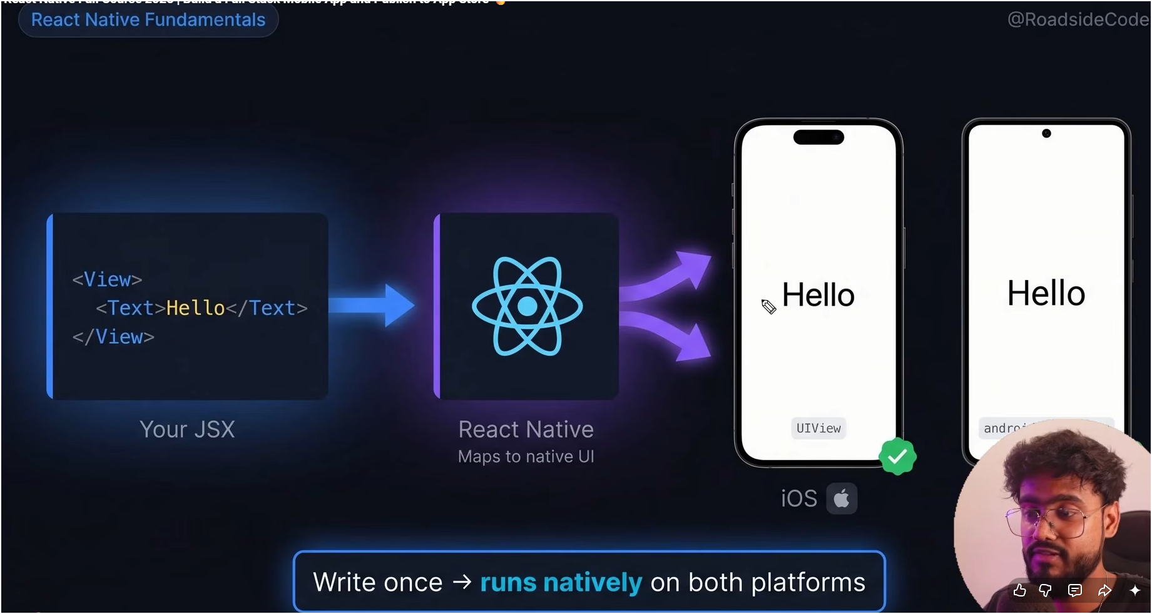

We just have to write code once, And React Native will map that code according to the device. i.e. Android / iOS

It is used by Facebook, Instagram, Shopify, Microsoft

React React Native Tags

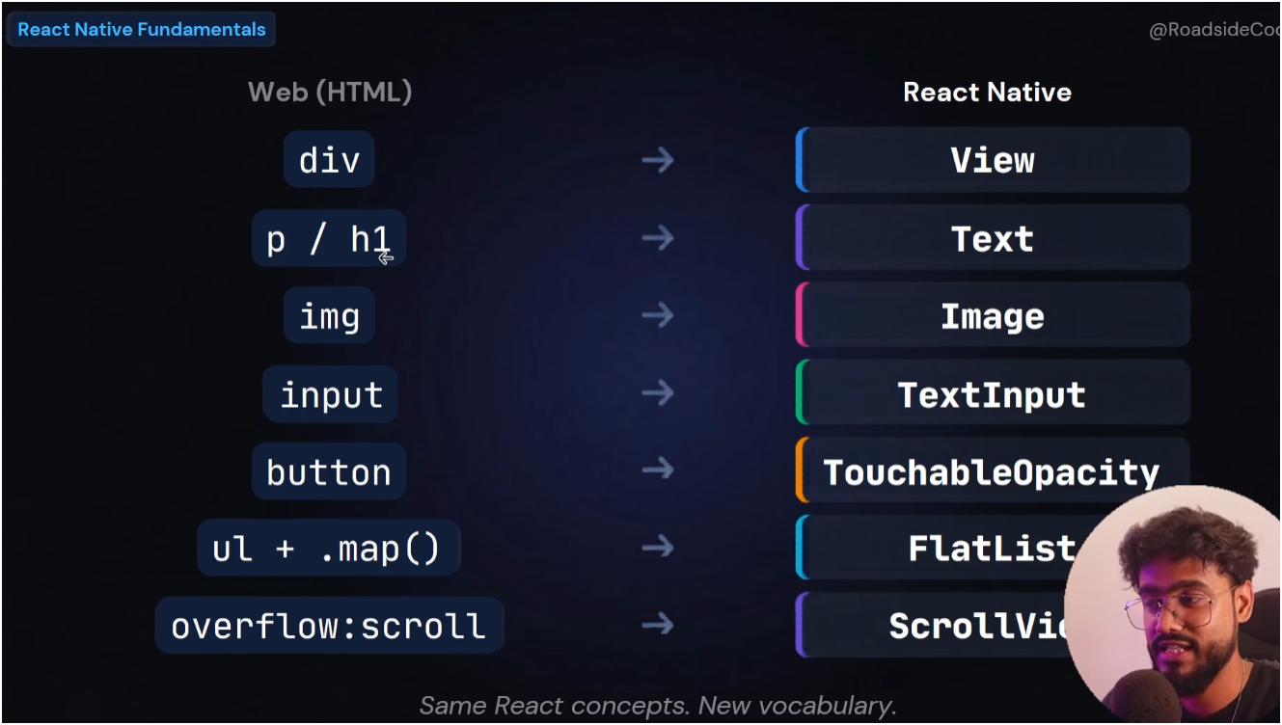

Number 1 rule)
We have to place <Text></Text>


SafeAreaView
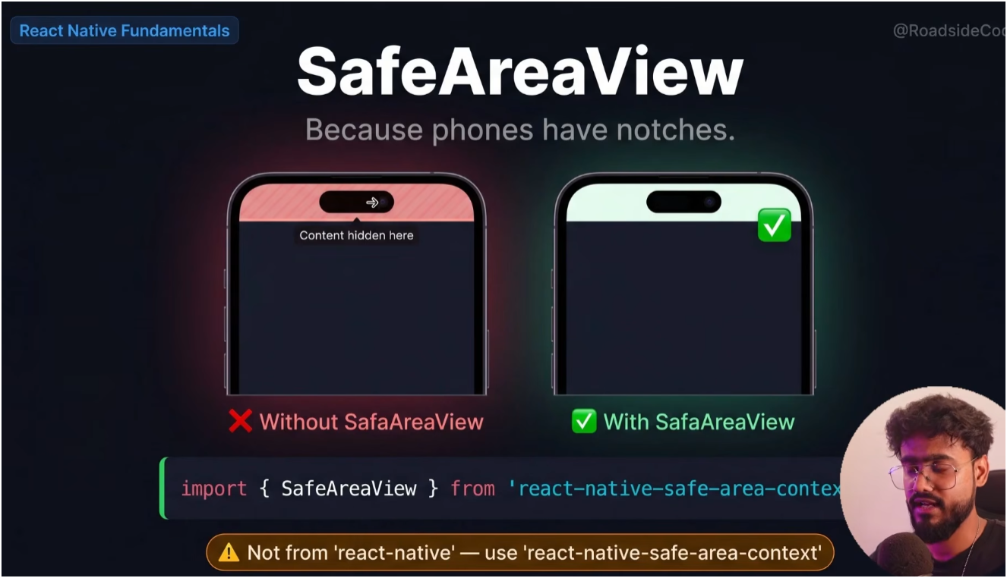
To set our content according to phone notches

