Practical-13: Prepare a Full-fledged case study for the Web screen.
Definition: Create a case study on any specific system for the Web screen with scrolling.
Solution:
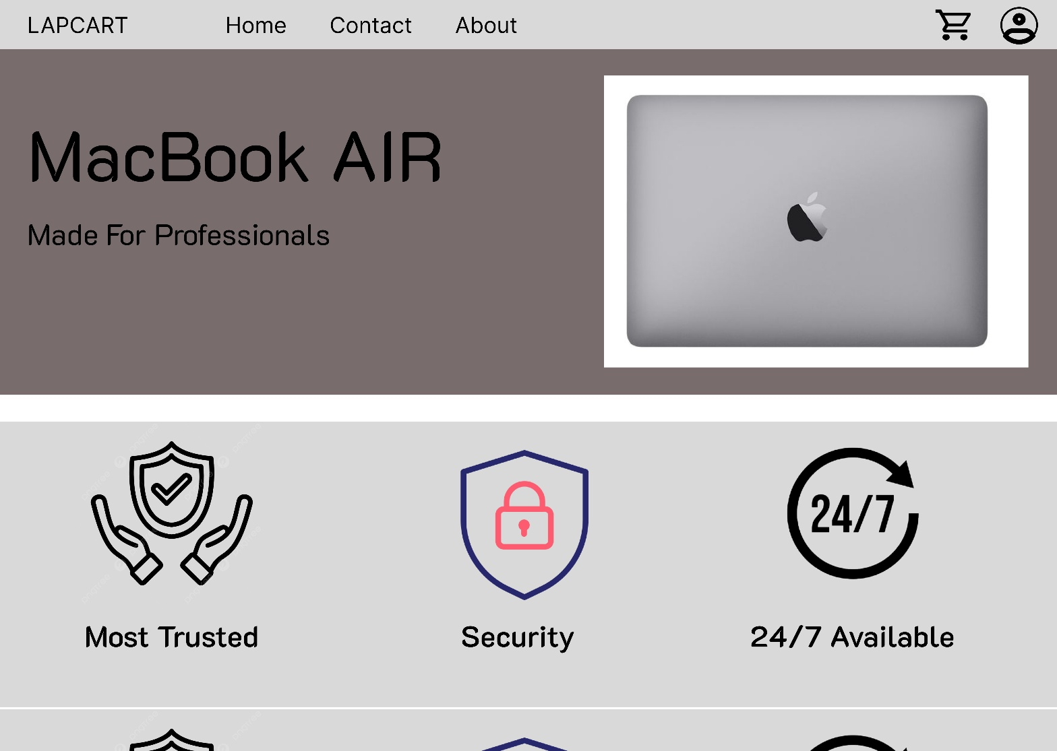

Working:
- First, open Figma. Add a new Figma design file.
- Rename a file as 210_Practical-13_WebScrolling.
- In this design, the following tools are used for a particular operation:
Tools Name | Use | Properties
Text-Boxes | Used to write text on it like LAPCART, Home, Contact, about. | Width: 139px,  Height: 36px  Color fill: #000000  Size:30
Icons | Use for Cart and Profile Icon. | Cart Icon:  Width: 48.33px,  Height: 41.67px  Color fill: #000000  Profile Icon:  Width: 65px,  Height: 62px  Color fill: #000000
image | Image of Macbook AIR | Width: 578px,  Height: 398px  Plugins: RemoveBG  Ctrl+G  Ctrl+alt+G  Clip Contant  Scroll: Horizontal
image | image for Most Trusted, Security, 24/7 Available. | Width: 280px,  Height: 280px  Plugins: removeBG  Ctrl+G  Ctrl+alt+G  Clip Contant  Scroll: Vertical
- Export your design as a JPEG file.

