Practical-10: Prepare a Full-fledged case study for the Mobile screen.
Definition: Create a case study on any specific system for mobile screens with scrolling.
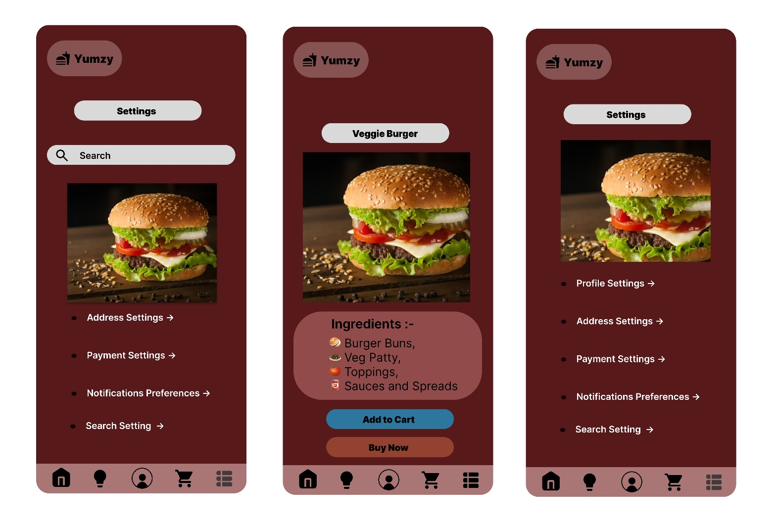
Solution:

Working:
- First, open Figma. Add a new Figma design file.
- Rename a file as 210_Practical-12_Scrolling.
- In this design, the following tools are used for a particular operation:
Tools Name | Use | Properties
Android Compact-1 | Used to design Vertical Scrolling screen of Online Food Store. | Width: 412px  Height: 917px  Corner radius: 0px  Color fill: #571A1A  Opacity: 100%,  Frame Selection Ctrl+Alt+G,  Clip Content,  Scrolling: Vertical
Android Compact-2 | Used to design Horizontal Scrolling screen of Online Food Store. | Width: 412px  Height: 917px  Corner radius: 0px  Color fill: #571A1A  Opacity: 100%,  Frame Selection Ctrl+Alt+G,  Clip Content,  Scrolling: Horizontal
Android Compact- 3 | Used to design both Scrolling screen of Online Food Store. | Width: 412px  Height: 917px  Corner radius: 0px  Color fill: #571A1A  Opacity: 100%,  Frame Selection Ctrl+Alt+G,  Clip Content,  Scrolling: Both
Text-Boxes | Used to write on it. | Width1:89px  Height1: 22px  Width2:60px  Heighh2: 22px  Width3:43px  Height3: 22px  Opacity: 100%  Corner Radius: 0  Typography:  Inter, Regular, 18, Auto, 0%  Fill: #8B9C2C 100%
Rectangles | Used to draw High Fidelity screen’s elements. | Width1: 147px  Heigth1: 70px  Width2: 147px  Heigth2: 40px  Width3: 369px  Heigth3: 39px  Width4: 147px  Heigth4: 39px  Width5: 149.4px  Heigth5: 135.52px  Opacity:100%  Corner Radius1: 56  Corner Radius2: 56  Corner Radius3: 56  Corner Radius4: 0  Color: #D9D9D9 100%
Polygon | Used to Go to next or previous. | Width: 15px  Heigth: 19.14px  Opacity: 100%  Corner Radius: 0  Count: 3  Color: #D9D9D9 100%
Ellipse | Used to show the navigation of pages. | Width: 10px  Heigth: 8px  Opacity: 100%  Corner Radius: 0  Count: 20  Ratio: 71%  Color: #D9D9D9
Icons | Used to show icons like Food, Search, Home, Help, Profile, Cart, Arrow & List.  Using Iconify Plugin. | Width: 34.17px  Height 37.58px  Corner radius: 0  Opacity: 100%  Color: #433A3A
Images | Used to take images of Food items from Unsplash Plugin. | Width: 149.4  Height: 133.69  Opacity: 100%  Corner Radius: 0px
- Export your design as a JPEG file.

