Practical-14: Design an Animated Navigation Bar.
Definition: Design a navigation bar with animation, ensuring each icon or element can be updated consistently across all screens.
Solution:
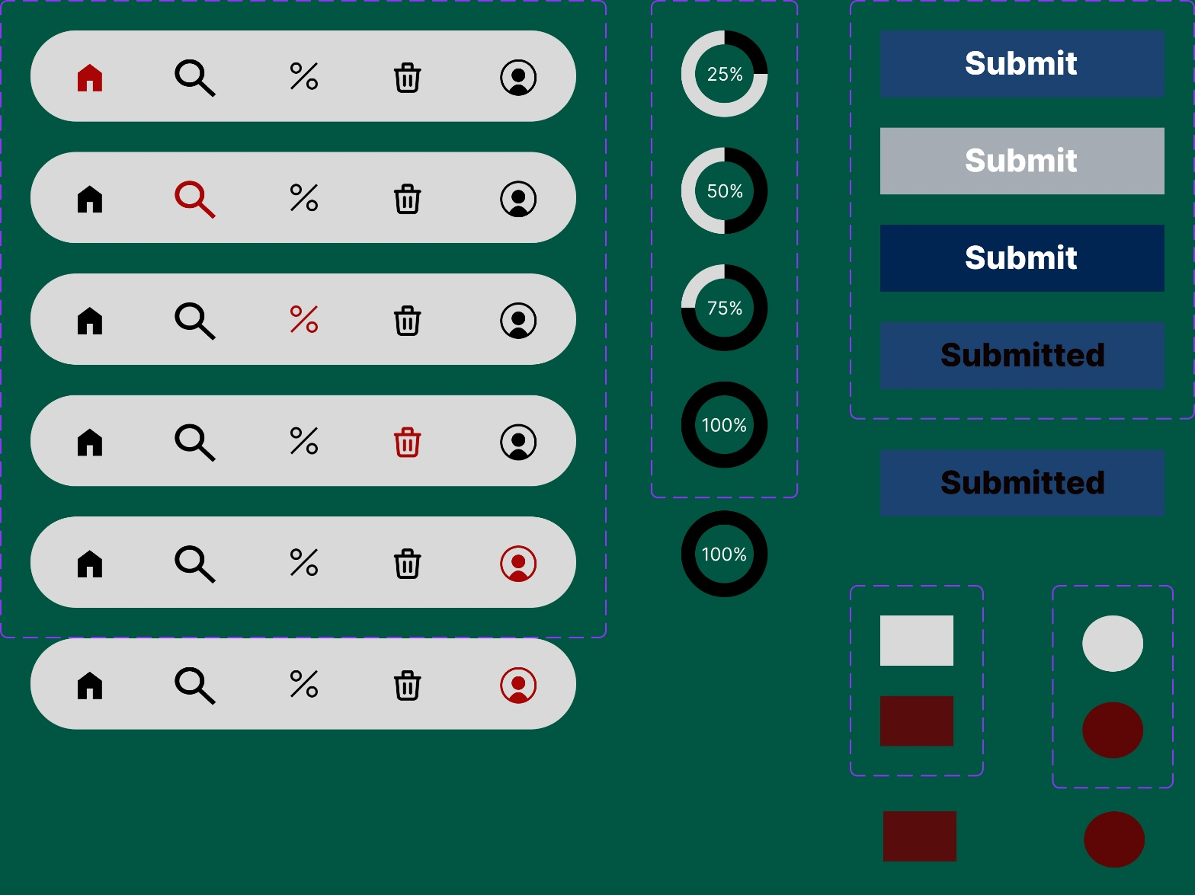
Working:
- First, open Figma. Add a new Figma design file.
- Rename a file as 210_Practical-14_NavigaionBar.
- In this design, the following tools are used for a particular operation:
Tools Name | Use | Properties
Android Medium-1 | The Android Medium-1 is used as a Frame for this design | Width: 589 px  Height: 786px  Color fill: # 005642,100%  Corner radius: 0PX  Blend mode: pass through
Rectangle | Used to create Navigation-Bar.  Uploaded icons using Iconify Plugin.  Applied prototype. | Width: 359px  Height: 60px  Corner radius: 50px  Color fill: # D9D9D9  Opacity: 100%  Trigger: On Click  Action: Change To  Navigation Bar: Home, Search, Delete, Profile & Percentage
Ellippse | Used to design Loading Buttons.  Applied prototype. | Width: 97px  Heigth: 328px  Opacity:100%  Corner Radius: 50  Color: # 8A38F5 100%  Effects: Inner Shadow: Blur-30, Color-3412F3, Spread-20  Trigger: After delay  Delay: 1ms  Action: Change To  Loading button: 25, 50, 75 & 100%  Animation: Smart animate  Curve: Linear  Dutration: 500ms
Rectangle | Used to design Submit Button.  Applied Prototype. | Width: 227px  Heigth: 276px  Opacity: 100%  Corner Radius: 5  Ratio: 71%  Color: # 8A38F5  Trigger: While hovering  Action: Change To  Submit Button: Hover  Animation: Smart animate  Curve: Linear  Duration: 200ms
Rectangle | Used to design Check Boxes.  Applied Prototype. | Width: 88px  Height: 126px  Opacity: 100%  Corner radius: 5  Color1: # D9D9D9  Color2: # 580C0C  Trigger: On Click  Action: Change to  Check Box: Female  Animation: Smart animate  Duration: 200ms
Ellipse | Used to design Radio Button.  Applied Prototype. | Width: 80px  Height: 134px  Opacity: 100%  Corner Radius: 5  Color1: # 8A38F5  Color2: # D9D9D9  Trigger: On click  Action: Change to  Radio button: Checked  Animation: Smart animate  Duration: 200ms
Rectangle | Text-Boxes in it. | Width1: 26px  Heigth1: 23px  Width2: 114.96  Height2: 21  Width3: 45  Height3: 19  Opacity: 100%  Corner Radius: 0
Icons | Used to show symbols of Home, Search, Perecntage, Trash & Profile. | Width: 18  Height: 18  Opacity: 100%  Corner Radius: 0
- Export your design as a JPEG file.

