Abstract

This project “Gym Management System” is solution fitness centers to manage the customers in an easier and more convenient way. The administrator, is able to view all the members of fitness centers as well as their details.

Documentation

Gym Website

Muhammad Nazim Ali (BB-28847)  
Mir Murtaza Hussain (BB-28838)

Acknowledgement

The project has been a lot of work, but we couldn’t have done it without the support and guidance from some very important people. We want to thank **Ahsan-ul-Haq** for all their help with this project; they provided us with resources as well as essential information that was needed to complete our task successfully.

Thank you also goes out to our parents and friends who were there every step of the way during this time period-without them, I’m not sure what would’ve happened!

We also want to thank all of the people who have been working alongside us on this project. It’s so great that you are willing to help out when we need it! Thank you for your hard work and dedication, which has made our success possible.

**Table of Contents**

**1 Introduction 3**

**1.1 Introduction to the Project 3**

**1.2 Objectives of the Project 3**

**2 System Analysis 3**

**3 Workflow 3**

**4 Web Development Life Cycle (Web Engineering) 4**

**4.1 Requirement & Research Analysis 4**

**4.2 Planning 4**

**4.3 Design 4**

**4.3.1 Home Page 5**

**4.3.2 About Us Page 6**

**4.3.3 Register Page 6**

**4.4 Content Creation 7**

**4.5 Development 7**

**4.5.1 Home Page 7**

**4.5.2 About Us Page 7**

**4.5.3 Register Page 7**

**4.6 Testing 8**

**4.7 Maintenance 8**

# Introduction

## Introduction to the Project

This project is designed to facilitate a gymming and fitness center to automate its operations of keeping records and store them in form of a large and user-friendly database further facilitating easy access to the personnel.

## Objectives of the Project

* Existing system was manual.
* Time consuming as data entry which include calculations took lot of time.
* Searching was very complex as there could be 100’s of entry every year.
* The proposed system is expected to be faster than the existing system.

# System Analysis

System Analysis is conducted with the following objectives in mind:

1. Identify the customer’s need.
2. Evaluate the system concept for feasibility.
3. Perform economic and technical analysis.
4. Allocate functions to hardware, software people, database and other system elements.
5. Establish cost and schedule constraints.
6. Create a system definition that forms the foundation for all the subsequent engineering work.

# Workflow

I’ve used Web Development Life Cycle workflow to build this kind of website. I break down the process in 7 major phases:

1. Requirement & research.
2. Planning.
3. Designing.
4. Content creation.
5. Development.
6. Testing.
7. Maintenance.

# Web Development Life Cycle (Web Engineering)

The basic objective of software engineering is to: develop methods and procedures for software development that can scale up for large systems and that can be used to consistently produce high quality software at low cost and with a small cycle time. That is, the key objectives are consistency, low cost, high quality, small cycle time, and scalability.

## Requirement & Research Analysis

Requirement analysis is done in order to understand the problem the software system is to solve. The problem could be automating an existing manual process, developing a new automated system, or a combination of the two. The emphasis in requirements analysis is on identifying what is needed from the system, not how the system will achieve its goals. There are at least two parties involved in the software development a client and a developer. The developer has to develop the system to satisfy the client’s needs. The developer does not understand the client’s problem domain, and the client does not understand the issues involved in the software systems. This causes a communication gap, which has to be adequately bridged during requirements analysis.

At first, we will find out market competitors and review the services that they are provided in their Gym website. Our market competitors are Plant Fitness and Gold’s Gym.

## Planning

On this phase, we will plan the whole structure of the website.

## Design

On design phase, I’ll design the concept mockup of the website design of the UI/UX design. Where you can get an exact idea and feel of the website.

Look! You know that people usually scan the website rather than going through it so the layout of the website plays a big role on it. That’s why I’ve given your website a simple and sleek look as much as possible that will exact point out towards your business.

I’ve used Adobe XD to design the UI/UX of the website. So, your website, is based on 3 pages.

1. Home Page.
2. About Us Page.
3. Register Page.

### Home Page

I’ve given the homepage a simple look. I’ve designed a simple header, and after that I’ve divided the homepage into 3 sections,

* **Banner Image:** add an attractive and simple banner image with some text to attract the target audience.
* **Services:** where the customer will know about the services that you are offer.
* **Trainer:** where we will show our best trainers, and their basis into.

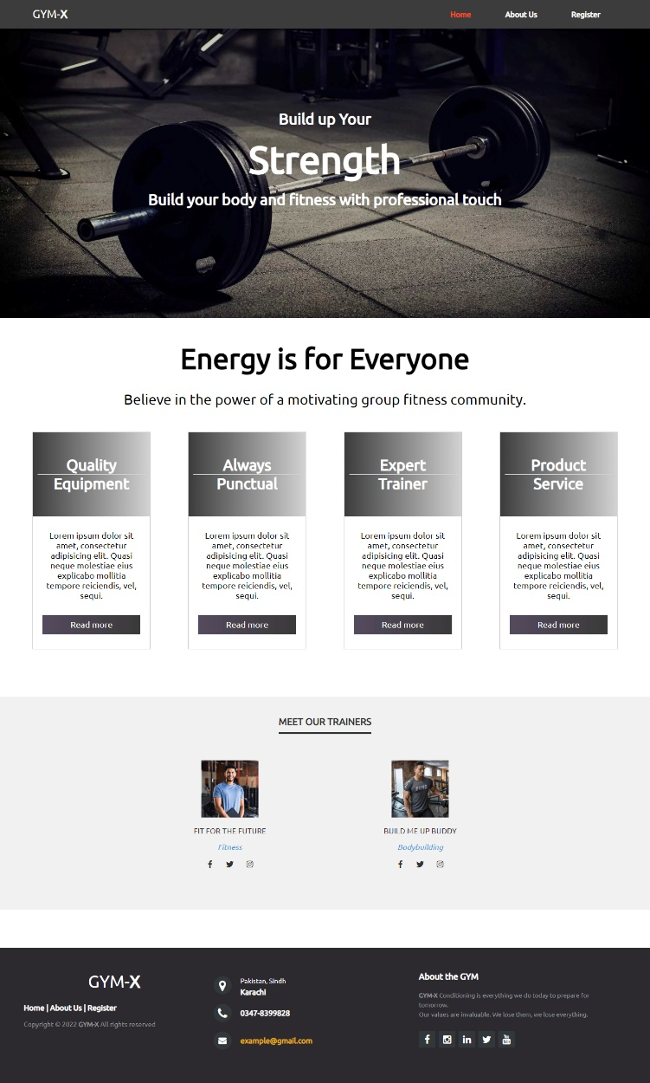

And after these sections, I’ve built a footer a footer on Black color. On the footer we have added the contact details.

### About Us Page

On the about page, we will use the same header and footer which we have used on the homepage. I’ve added some basic details for Who We Are on it.

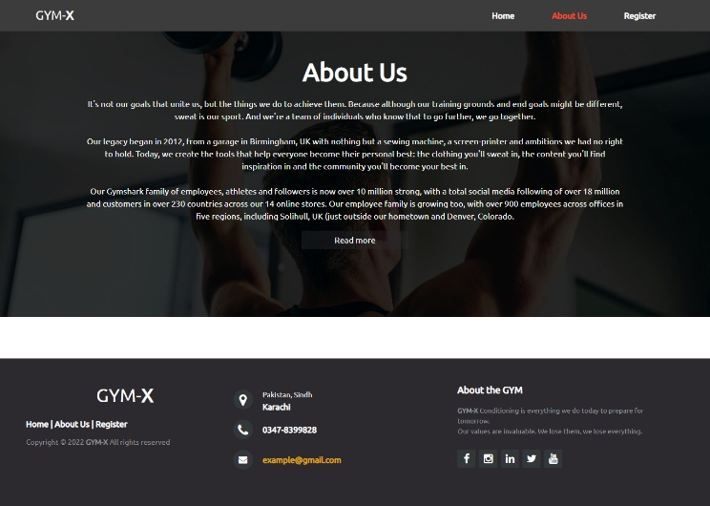

### Register Page

On the register page, we also keep use the same header and footer. And In addition of that I’ve add the basis content who to enroll in our pages and also design a simple and sleek register form the customer to become a part of the GYM-X.

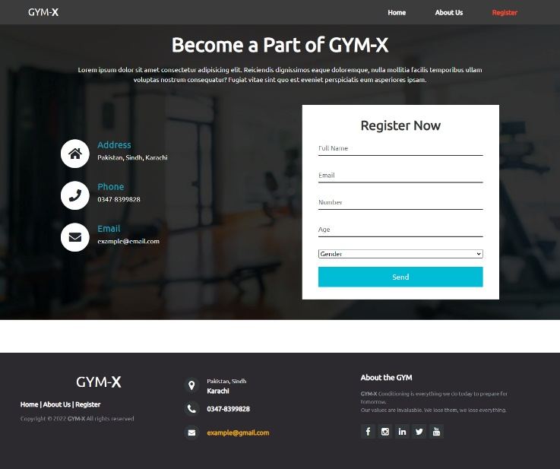

## Content Creation

On the content creations process, I’ve written the content according to the services you’ve provided. And also use some up-to-date keywords to increase the google ranking of your website.

## Development

In the development phase we’ve fully convert the UI/UX design into fully functional Website. For the front-end we’ve used the HTML, CSS and Bootstrap and JavaScript. And for the back-end we’ve used PHP.

### Home Page

On the homepage we added some hover effects on the Nav-bar. And after that we’ve added a banner image and give it a black transpiration effect. And on the next section we’ve created 4 boxes to display the services we’ve provided. And on the next section we’ve added 2 portfolio section for our Trainers.

We’ve developed the homepage using HTML, CSS, Bootstrap classes and JS.

### About Us Page

On the about page, we’ve used the same coding for the header and footer. And as per the UI/UX design, I’ve aligned all the about content on the center and also add the background images on it and also add the transpiration effects on it.

We’ve developed the about using HTML, CSS, and Bootstrap classes.

### Register Page

On the register page we’ve used the same header and footer code. And for the rest page sections we’ve added the content using the same CSS styling that we’ve used in the about page. And also create a Register form and to make the register from functional we’ve integrated it on our local database (XAMPP) using PHP. And also add the background image which gives the Register form an attractive look.

On the Register page, we’ve have used the HTML, CSS and Bootstrap classes for the front-end and for the back-end we’ve used the PHP.

## Testing

I tend to deploy the websites to the hosting you provide me. Then test the live version to its core using both automated and manual testing techniques.

## Maintenance

You might need to perform several tasks to keep the content on your website updated. I'll offer you 3 months free maintenance services, which includes changing content, images and colors.

Such as:

* **Remove or refresh old content:** Outdated information should be changed or removed from your website.
* **Add new content:** It's wise to add content regularly - particularly if you run a blog, offer news or like to post new stories on social media.
* **Change product and pricing information:** If your products or prices change, your website should reflect this.

I would love to work with my client on a long haul.