Introduction

Currently, I am working as a Junior It Analyst in Cloud IT Company, where I was assign to continue on my work on designing and developing a development for Exel Tuition Centre. In Exel Tuition Centre, a student can choose to enroll to several subjects. Upon the enrolment, the student will be given schedules which list the assigned tutor and classroom for each of the subjects, depending on their chosen
The next method for me was to convert the completed database design into an actual working database. Where it will be used for the staffs of Exel tuition Centre record the details of students, subject, schedules, tutor and classrooms.
The database will feature data entry forms for staff to key in information. Staff can then perform queries on the database, for example to produce schedule list for a student. Once the database development is completed, I was then required to carry out testing and evaluation to ensure the database is working correctly and fulfils all the requirement needs of Exel Tuition Centre. The following are several sample details of the information currently being stored by Exel Tuition Centre in their spreadsheet-based records. The tables are not yet normalized and may contained data redundancy.

Task 1

You are required to design a relational database containing at least five tables based on the given scenario. The design documentations that you need to provide are listed below:
a) Normalisation (UNF, 1NF, 2NF and 3NF)
Normalization =
Database standardization seems to be an information organization method throughout the database. Standardization is a strategic approach in rotting databases to remove duplication and unwelcome features such as entry, updating as well as termination abnormalities. This is a triple-step method which places information in numeric shape, clearing replicated information from databases of relationships.
Importance of Normalization =
Enforcing quality of information - When after updating the record still remains, it may result in inconsistent information, it is solved by normalization and guarantees consistency of information.
Isolation of Data – A well-designed database claims which one table or field modifications do not influence another table. This is accomplished by standardizing.
To guarantee the dependency of information – The information is kept throughout the right table and assures normalization.
Remove information duplication – Various storages with the identical document object were recognized as Data Redundancy. A normalization table has no information data integrity problem.

Procedures of Normalization
There are a lot of issues with incorrectly stored information. The rational as well as effective layout was just as important in a relational database. A badly constructed system might provide incorrect data, could be hard to be using, or could fail to function correctly. Some of these issues lead from two poor design characteristics termed duplicate information but also abnormalities. Redundant information is useless recurring information. Anomalies were any event which destabilizes the information's credibility owing to uneven or incompatible space. Typically, standardization was the process of organizing information in a database effectively. A normalization method has two main goals: remove unnecessary information and ensure of information repositories. Both of these are useful objectives as they decrease the quantity of room consumed by a database and guarantee that information is kept rationally.
The method of developing a relational database involves ensuring that a table just includes information directly linked to a main core, each information section contains just one information item, and that duplicate information is removed. A database creator's job would be to organize information in such a manner which removes unwanted duplication as well as offers a quick search route to all information needed. It procedure is known as normalization to identify as well as define tables, keys, columns, and relationships to produce an effective database.

UNF
An abnormal relationship was the relationship which includes characteristics which are repeated. An abnormal relationship may often include relationships nestled in many other relationships, along with all sorts of transitive repositories. Occasionally abnormal relationships were meant by 0NF, but there is no need to confuse an abnormal relationship with a denormal relationship. An unnormalized relationship would be any raw relationship, and it usually includes repetition values and other features not observed in denormalized relationships. The denormalization method is really intentional effort to put managed useless objects onto an already standardized type.

UNF
Learner Information
Learner_ID
Learner_Name
Learner_Home_Address
Learner_ContactNumber
Timetable_ID
Timetable Information
Timetable_ID
Date, Time
Module
Location
Module Information
Module
instructor
Date, Time
Instructor
Instructor_ID
Instructor_FirstName
Instructor_Home_Address
Instructor_ContactNumber
Figure 1 (UNF Table)
In figure 1, an unnormalized form was the relationship which includes characteristics which are repeated. It could frequently consist of relationships nestled in many other relationships, along with all sorts of transitive repositories. In case, in table of timetable information and module information have the characteristic of the modules.

1NF
First normal form (1NF) has become a relational database possession of a relationship. A relationship was the first standard form and simply when each quality's site produces only single values and each attribute's quality includes only one particular value from that area. In addition, in table there are no row/column intersections that contain a null value and multi-value.
1NF
Learner Information  Learner_ID  Learner_Name  Learner_Address  Learner_Contact Number  Learner_IC  Learner_Email  Learner_DateofBirth  Timetable_ID | Timetable Information  Timetable_ID  Timetable_Day_Date  Timetable_Time  Timetable_area | Module Information  Module  Instructor 1  Instructor 2  Instructor 3  Instructor 4  Date  Day  Time | Instructor  Instructor_ID  Instructor_Name  Instructor_Date  Instructor_Time  Instructor_HomeAddress  Instructor_ContactNumber
Figure 2 (1NF Table)
In figure 2, were the examples of the first normal form. Where every column of the table is unique with the separated tables was created for each set of related data. Every chart should be recognized with a single column where it was identified as primary key. Moreover, there are no row and column that could be duplicated. In case, the column of the table in learner information was exclusive with divided table was produced for each set of related data.

2NF – Discussion with example
The 2nd ordinary type was the 2nd step of a database's normalization. 2NF was based on first ordinary shape. Standardization was the information organization method at the database to fulfill 2 fundamental criteria: 1. there’s no information duplication. 2. Dependence on records was logical.

2NF
Learner Information  Learner_ID  Learner_Name  Learner_Address  Learner_Contact Number  Learner_IC  Learner_Email  Learner_DateofBirth  Timetable_ID | Timetable Information  Timetable_ID  Timetable_Day_Date  Timetable_Time  Timetable_area  Learner_ID | Module  Information  Module_ID  Module_Name  Instructor_ID  Timetable_ID | Instructor  Information  Instructor_ID  Instructor_Name  Instructor_Date  Instructor_Time  Instructor_ContactNumber | Labroom  Labroom_ID  Lab_Name
Figure 3 (2NF Table)
In figure 3, was the illustration of the 2NF. The 2NF was based on the 1NF where there is no data repetition at the column and the record was logically dependence. For example, regard as a Learner’s ContactNumber. Where Learner’s ContactNumber was depend at the LearnerID which was simply fraction of the primary key.

3NF – Discussion with example
A 3rd ordinary form (3NF) was the 3rd stage of a database's normalization, depending on first and second ordinary forms. 3NF suggests it was essential to eliminate any column links that were not dependent on the primary key in the quoted data

.
3NF
Learner Information  Learner_ID  Learner_Name  Learner_Address  Learner_Contact Number  Learner_IC  Learner_Email  Learner_DateofBirth | Timetable  Information  Timetable_ID  Timetable_Day_Date  Timetable_Time  Timetable_area  Module_Name | Module  Information  Module_ID  Module_Name  Timetable_ID  Instructor_ID | Instructor  Information  Instructor_ID  Instructor_Name  Instructor_ContactNumber | Labroom  Labroom_ID  Lab_Name | Learner Timetable  LearnerTimetable_ID  Learner_ID  Instructor_ID  Module_ID  Lab_ID  Timetable_ID
Figure 4 (3NF Table)
In figure 4, it was the example of the 3NF where it claims that it was possible to eliminate all section references in linked data which are not based on a main component. Moreover, the example of it also that in the table of Module information, the [Timetable_ID] decides [Instructor_ID], and [Instructor_ID] decides [Module_ID], and [Module_ID] decides [Module_Name]. Therefore, [Timetable_ID] decides [Module_Name] via [Module_ID] and they have transitive functional dependency.

- Entity Relationship Diagram (ERD)
ENTITIES
LEARNER | TIMETABLE | MODULE | INSTRUCTOR | LABROOM | Learner Timetable
Figure 5 (Entities Table)
Diagram of ERM
Learner Timetable
M
M
1
Learner
1
1
M
Module
M
1
M
1
M
Timetable
M
M

1
1
1
M
Labroom
1
M
Instructor
Figure 6 (ERD Table version 1)
It was often referred as an entity-relationship (ER) graph was a visual depiction in individuals as well as the interactions with one another, generally worn to computation resource organization in databases or computer technologies. An entity would be a set of data-an item or idea that stores information about.

Final Version of ERM:

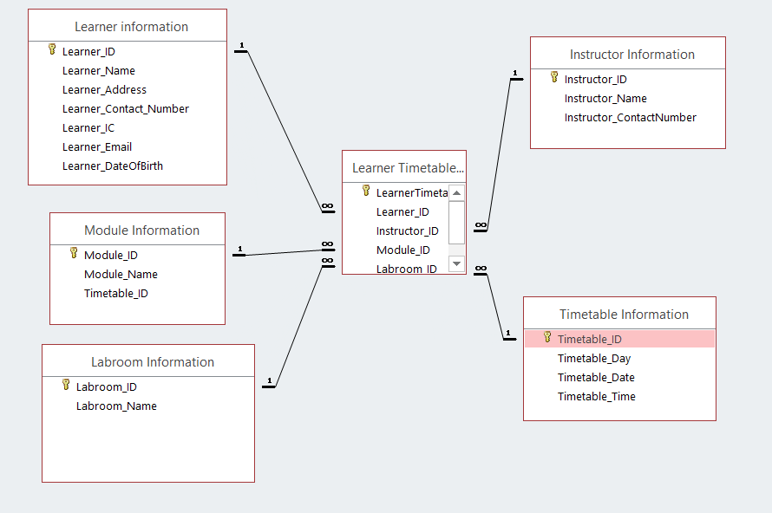
Figure 7 (ERM Final Version)

Task 2 - [LO2: P3]

Linked Tables with referential integrity, cascade update and Cascade delete
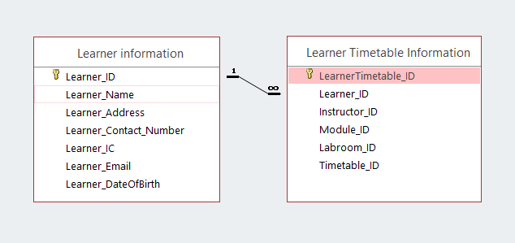
Figure 8.1 (Relationship)
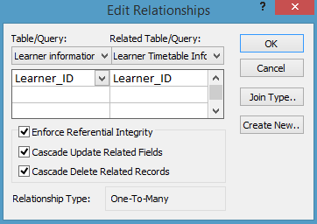
Figure 8.2 (Edit relationships)
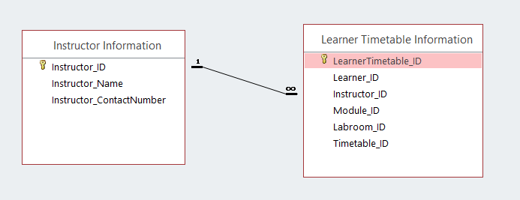
Figure 9.1 (Relationship)
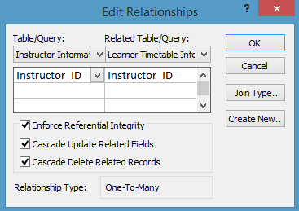
Figure 9.2 (Edit Relationship)

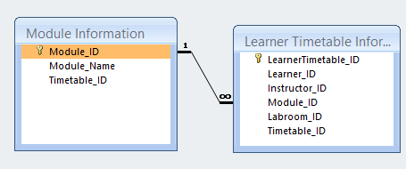
Figure 10.1 (Relationship)
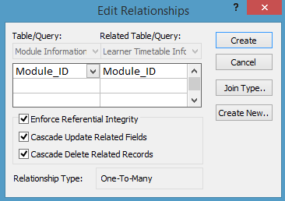
Figure 10.2 (Edit Relationship)
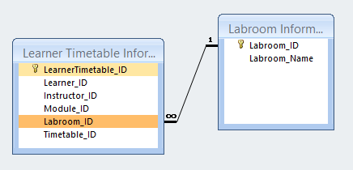
Figure 11.1 (Relationship)
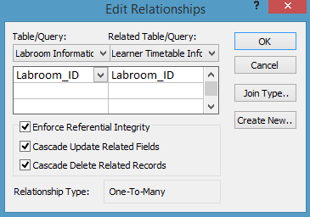
Figure 11.2 (Edit Relationship)
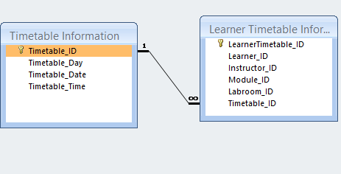
Figure 12.1 (Relationship)
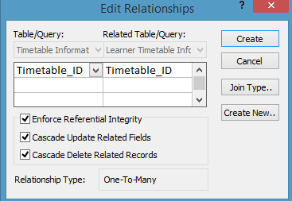
Figure 12.2 (Edit Relationship)

- Every table must be populated with appropriate data.
Learner Information
learner_ID | Learner_Name | Learner_address |  | Learner_Contact_Number | Learner_IC | Learner_Email | Learner_DateofBirth | Instructor_ID
S121 | Aliff | No 12, Spg 53-98, Kg Mata Mata |  | (673)7458211 | 51-302876 | aliff@gmail.com | 11-02-1997 | T111
S122 | Tirah | No. 1, Spg 73-41, Kg Sinarubai |  | (673)7211032 | 52-037889 | Tirah@gmail.com | 15-10-1997 | T112
S123 | Rahimah | No. 8, Spg 32-11, Anggerek Desa |  | (673)8222323 | 51-327872 | rahimah@gmail.com | 06-8-1998 | T120
S124 | Nimum | No. 22, Spg 21-129, Kg Madang |  | (673)7123458 | 51-321456 | Nimum@gmail.com | 20-1-1998 | T119
S125 | Rizan | No. 12, Spg 13-19, Kg Serasa |  | (673)8328171 | 51-123787 | Rizan@gmail.com | 11-02-1999 | T118
S126 | Zirah | No 10, Spg 09-25, Kg Sungai Hanching |  | (673)8221132 | 51-232561 | Zirah@gmail.com | 09-11-1998 | T114
S127 | Erah | No 97, Spg 100-9, Kg Lamunin |  | (673)7123847 | 51-197289 | Erah@gmail.com | 29-7-1999 | T113
S128 | Lina | No 24, Spg 32-23, Kg Saba |  | (673)7826952 | 51-324123 | Lina@gmail.com | 12-12-1999 | T115
S129 | Zury | No. 19, Spg 21-52, Kg pandai besi ‘A’ |  | (673)8251578 | 51-902131 | zury@gmail.com | 01-01-1998 | T117
S130 | Faizah | No. 21, Spg 25-21, Kg jerudong |  | (673)8152612 | 51-123781 | faizah@gmail.com | 02-02-1998 | T116

Timetable Information
Timetable_ID | Timetable_Day | Timetable_Date |  | Timetable_Time
C412 | Sunday | 4 Jun 17 |  | 8:00-19:00
C413 | Sunday | 4 Jun 17 |  | 8:00-19:00
C414 | Sunday | 4 Jun 17 |  | 8:00-19:00
C415 | Monday | 5 Jun 17 |  | 10:00-12:00
C416 | Monday | 5 Jun 17 |  | 10:00-12:00
C512 | Saturday | 3 Jun 17 |  | 17:00-19:00
C513 | Saturday | 3 Jun 17 |  | 17:00-19:00
C514 | Saturday | 3 Jun 17 |  | 17:00-19:00
C515 | Tuesday | 5 Jun 17 |  | 14:00-16:00
C516 | Tuesday | 5 Jun 17 |  | 14:00-16:00
Module Information
Module_ID | Module_Name | Timetable_ID
M100 | Science | C412
M101 | Science | C413
M102 | Science | C414
M103 | Geography | C415
M104 | Geography | C416
M105 | Mathematics | C512
M106 | Mathematics | C513
M107 | Mathematics | C514
M108 | History | C515
M109 | History | C516

Instructor Information
Instructor_ID | Instructor_Name |  | Instructor_ContactNumber
T111 | John Hamilton |  | (673)7241211
T112 | Beatrice Lee |  | (673)7423032
T113 | Sam Codd |  | (673)8432123
T114 | Mike Amjad |  | (673)7235658
T115 | Ana Clayton |  | (673)8012171
T116 | James Milner |  | (673)8068032
T117 | Brooklyn |  | (673)7325747
T118 | Jessi lyn |  | (673)7125452
T119 | Mason Myne |  | (673)8122478
T120 | Mikel Brown |  | (673)8921241
Labroom Information
Labroom_ID |  | Labroom_Name
L011 |  | Lab 1
L012 |  | Lab 2
L013 |  | Lab 3
L014 |  | Lab 4
L015 |  | Lab 5
L016 |  | Lab 6
L017 |  | Lab 7
L018 |  | Lab 8
L019 |  | Lab 9
L020 |  | Lab 10
Learner Timetable Information
LearnerTimetable_ID | Learner_ID | Instructor_ID |  | Module_ID | Labroom_ID | Timetable_ID
LT0111 | S121 | T111 |  | M100 | L011 | C412
LT0112 | S122 | T112 |  | M101 | L012 | C413
LT0113 | S123 | T113 |  | M102 | L013 | C414
LT0114 | S124 | T114 |  | M103 | L014 | C415
LT0115 | S125 | T115 |  | M104 | L015 | C416
LT0116 | S126 | T116 |  | M105 | L016 | C512
LT0117 | S127 | T117 |  | M106 | L017 | C513
LT0118 | S128 | T118 |  | M107 | L018 | C514
LT0119 | S129 | T119 |  | M108 | L019 | C515
LT0120 | S130 | T120 |  | M109 | L020 | C516

Table in database system (ACCESS)
Instructor Information
Datasheet View
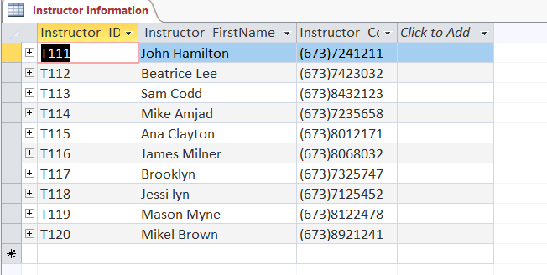
Figure 13.1 (Data-sheet View Instructor table)
Design View
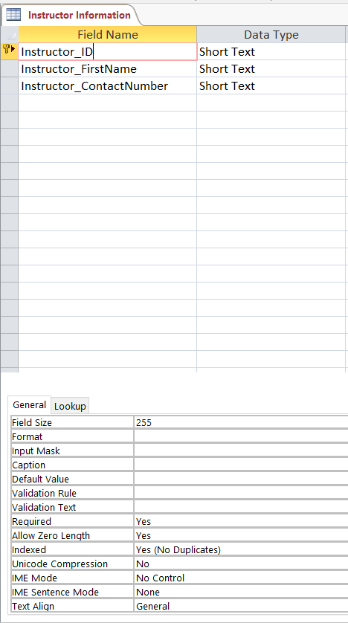
Figure 13.2 (Design View Instructor table)
Labroom Information

Datasheet View
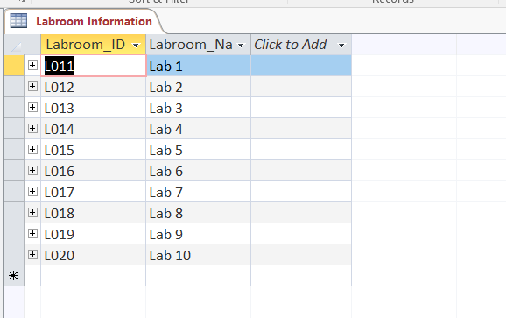
Figure 14.1 (Data-sheet View Labroom table)
Design View

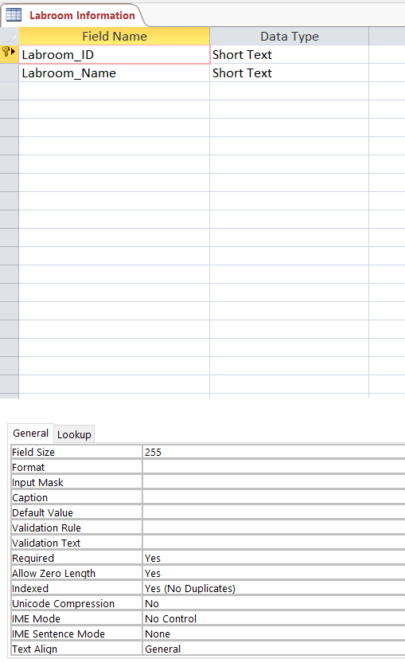
Figure 14.2 (Design View Labroom table)
Learner Information
Datasheet View

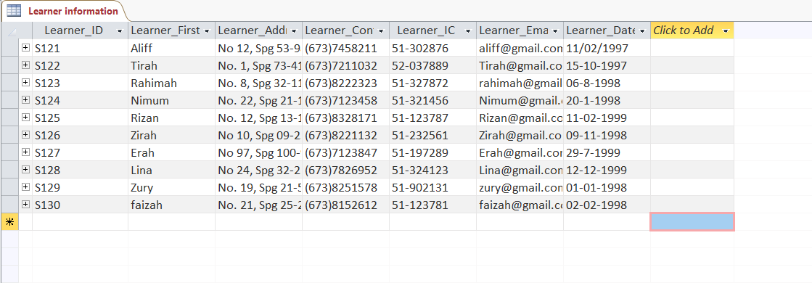
Figure 15.1 (Data-sheet View Learner table)
Design View

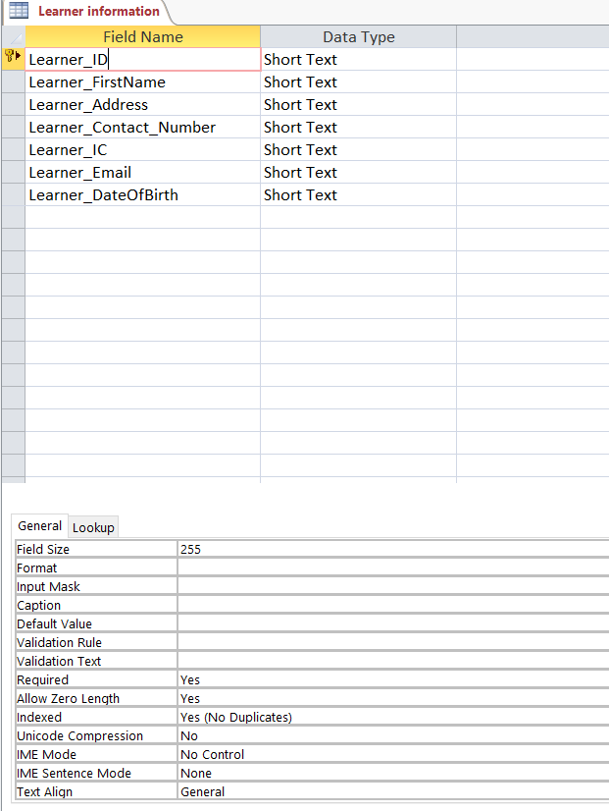
Figure 15.1 (Design View Learner table)
Learner Timetable Information

Datasheet View

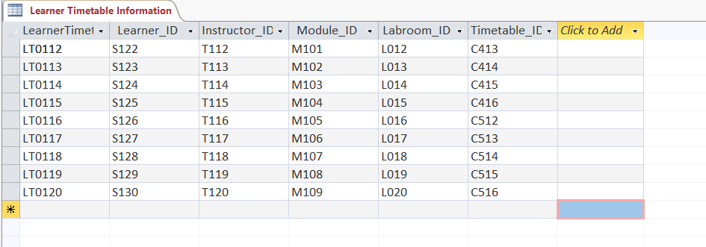
Figure 16.1 (Data-Sheet View Learner Timetable table)
Design View

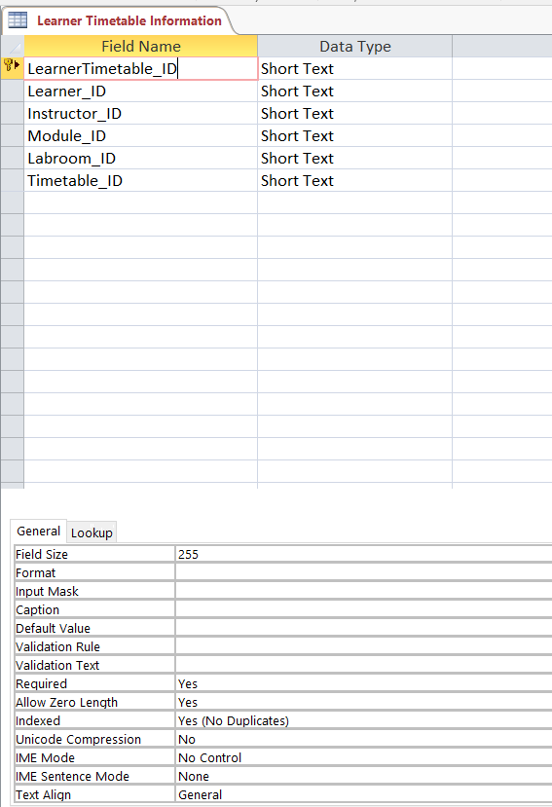
Figure 16.2 (Design View Learner Timetable table)
Module Information
Datasheet View

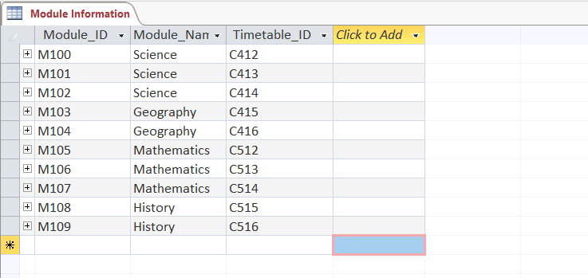
Figure 17.1 (Data-Sheet View Module table)

Design View

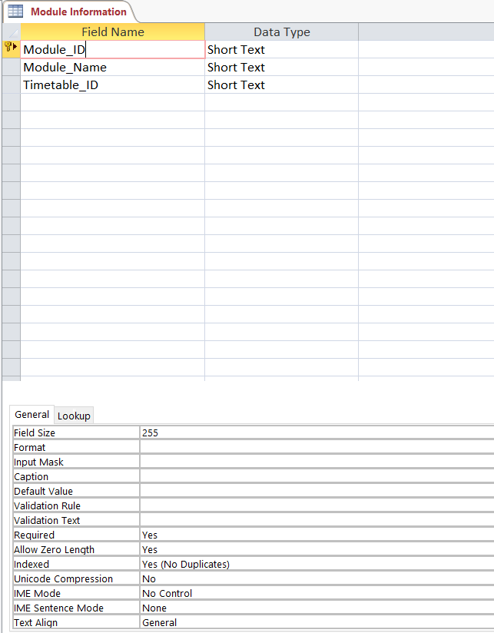
Figure 17.2 (Design View Module table)

Timetable Information
Datasheet View

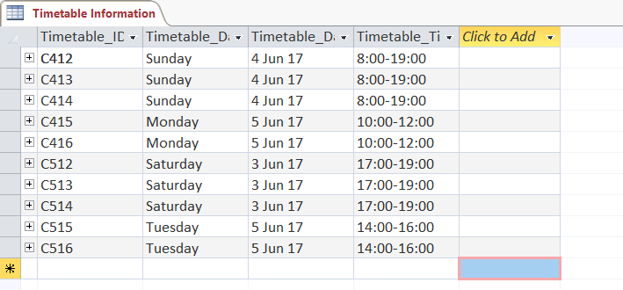
Figure 18.1 (Data-Sheet View Timetable table)

Design View

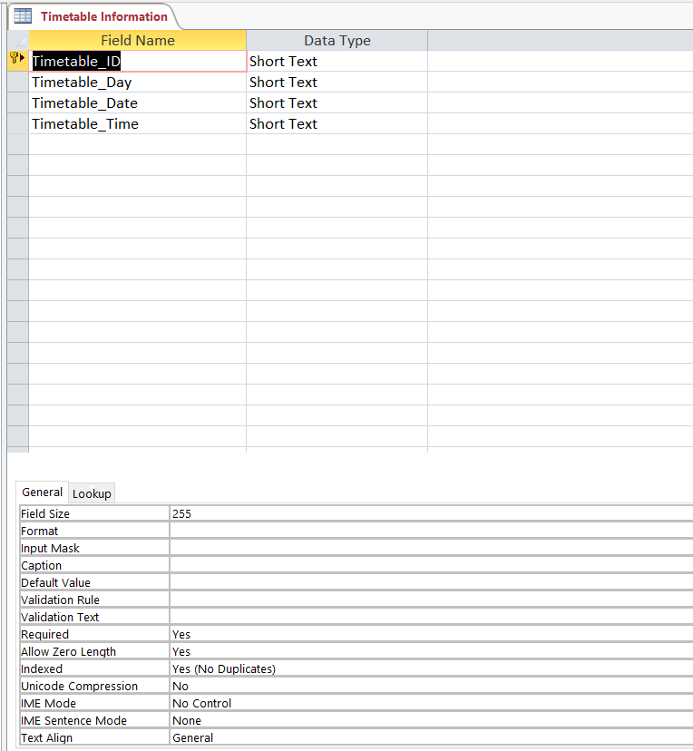
Figure 18.2 (Design View Timetable table)

Task 3 - [LO2: P4, P5 & P6]

You are required to create data entry forms with proper features to endure validity and integrity of data for the tables that were created in Task 2.
Instructor Information:
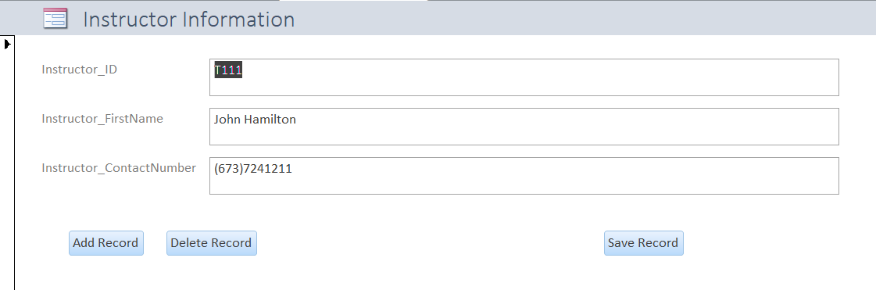
Figure 19.1 (Instructor Form View)
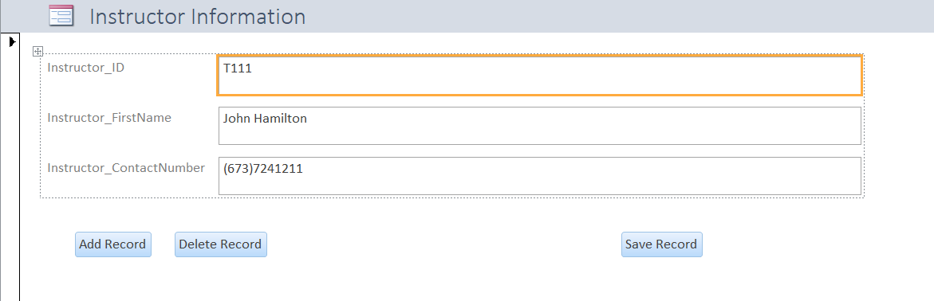
Figure 19.2 (Instructor Layout View)
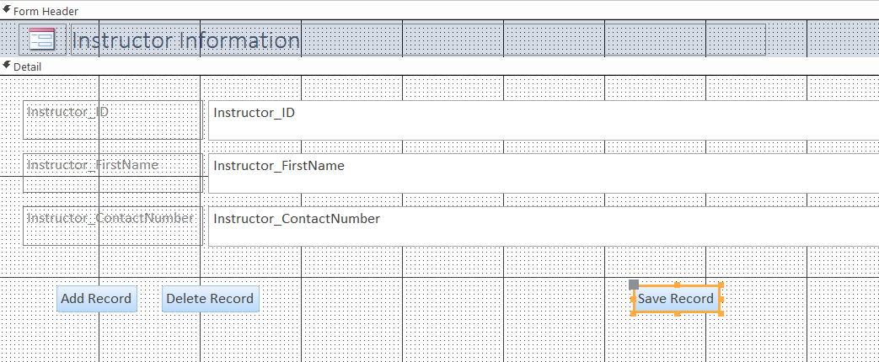
Figure 19.3 (Instructor Design View)
Labroom Information:
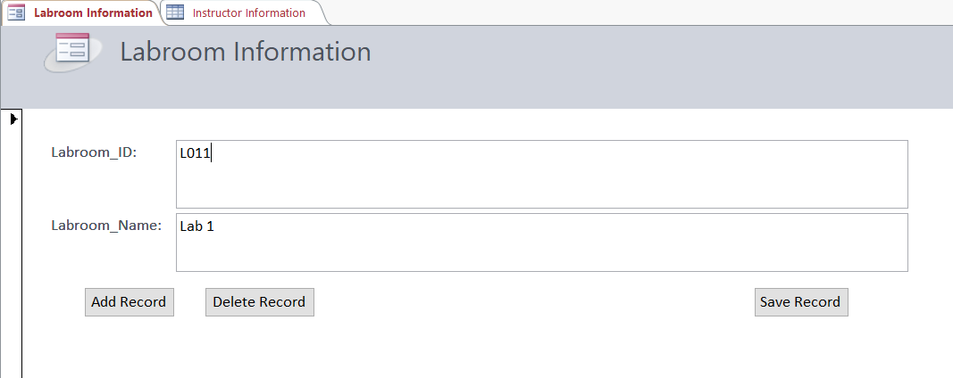
Figure 20.1 (Labroom Form View)
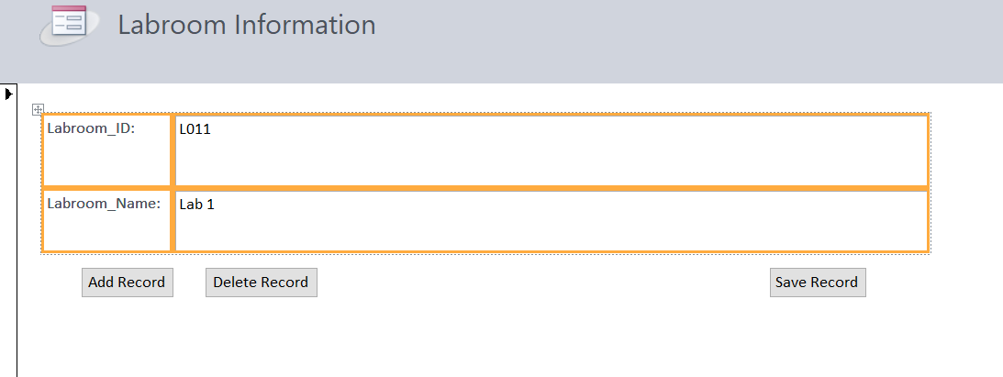
Figure 20.2 (Labroom Layout View)
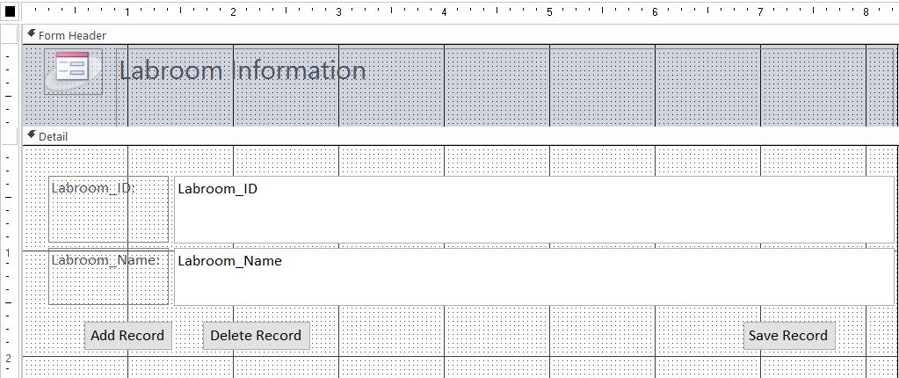
Figure 20.3 (Labroom Design View)

Learner Information:
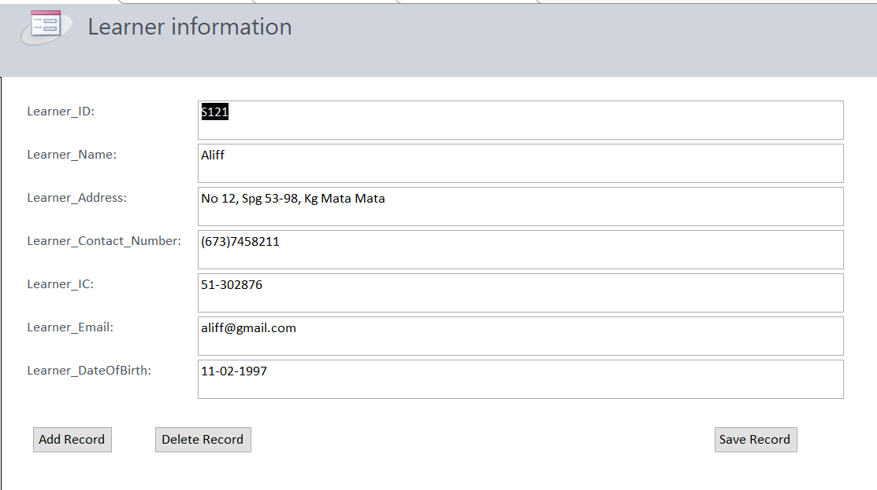
Figure 21.1 (Learner Form View)
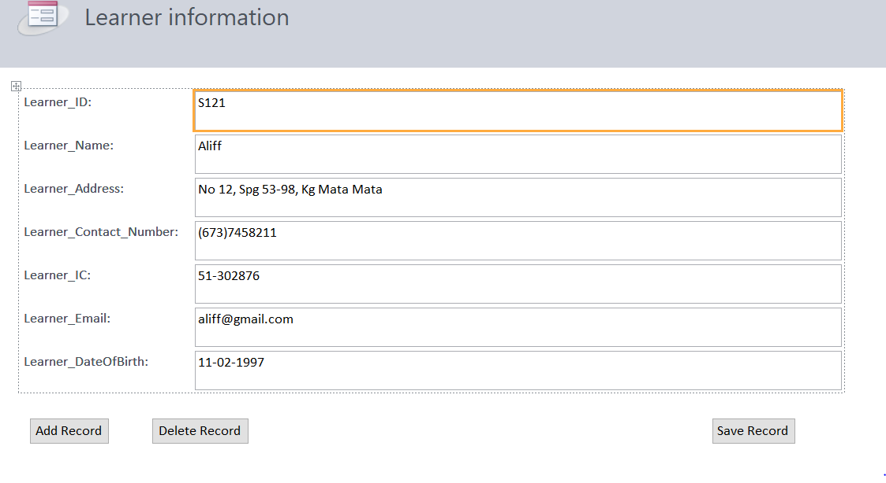
Figure 21.2 (Learner Layout View)
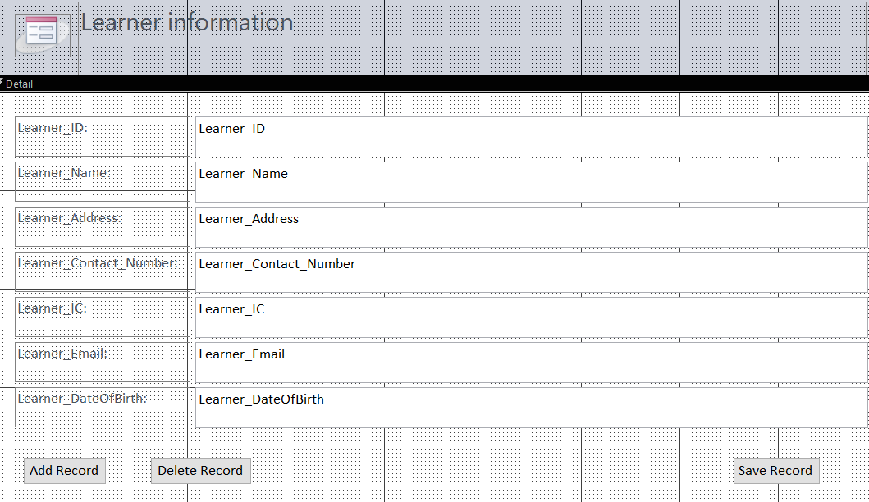
Figure 21.3 (Learner Design View)

Learner Timetable Information:
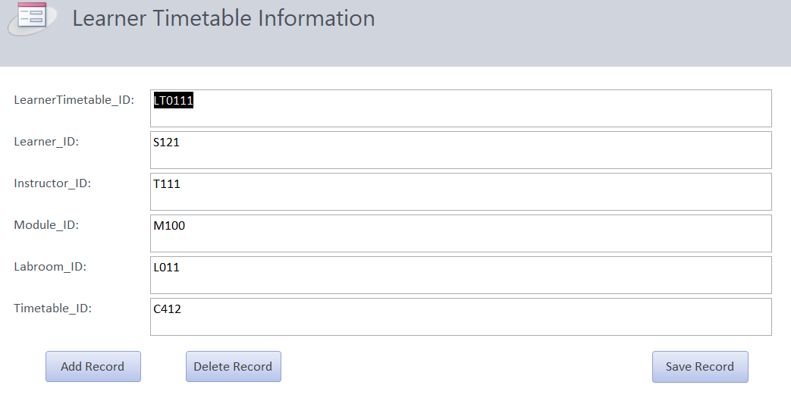
Figure 22.1 (Learner Timetable Form View)
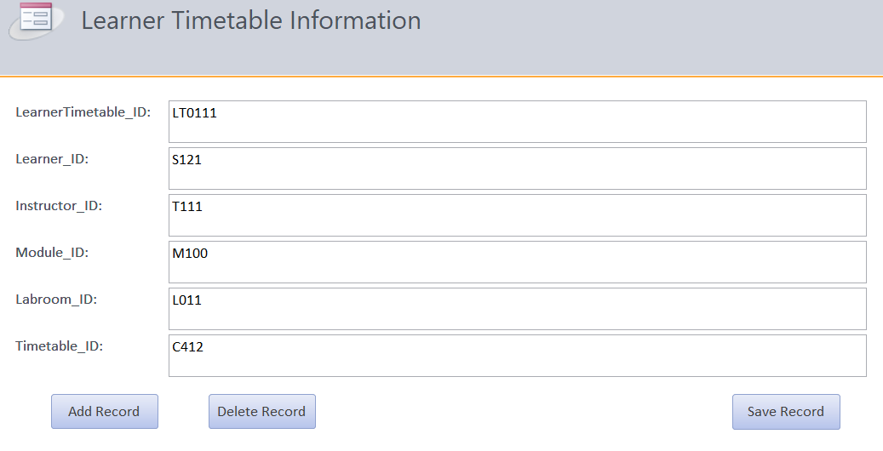
Figure 22.2 (Learner Timetable Layout View)

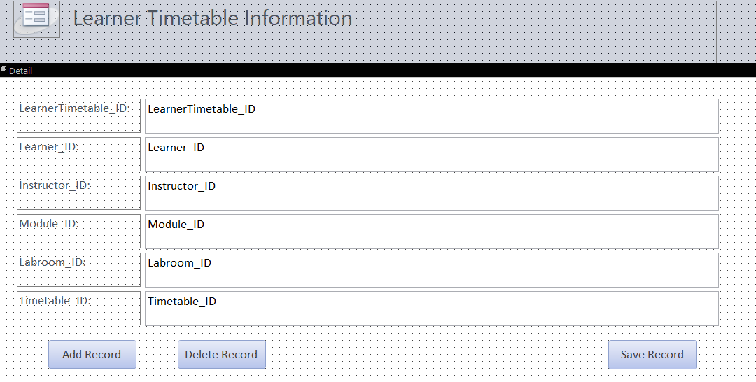
Figure 22.3 (Learner Timetable Design View)

Module Information:
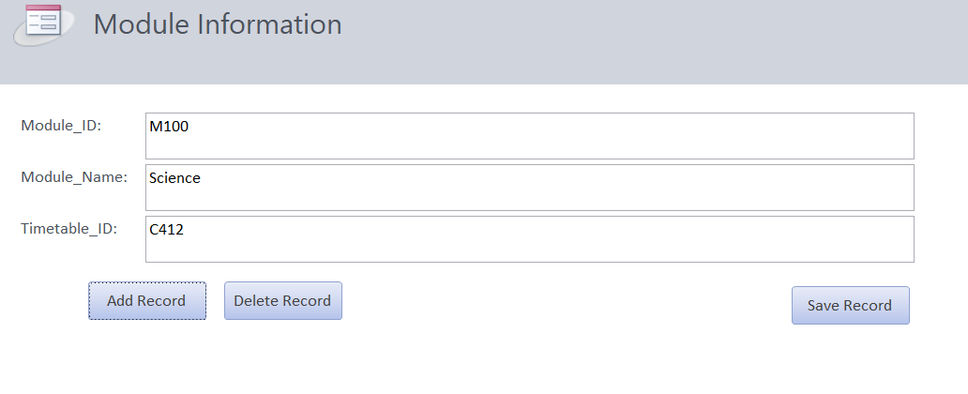
Figure 23.1 (Module Form View)
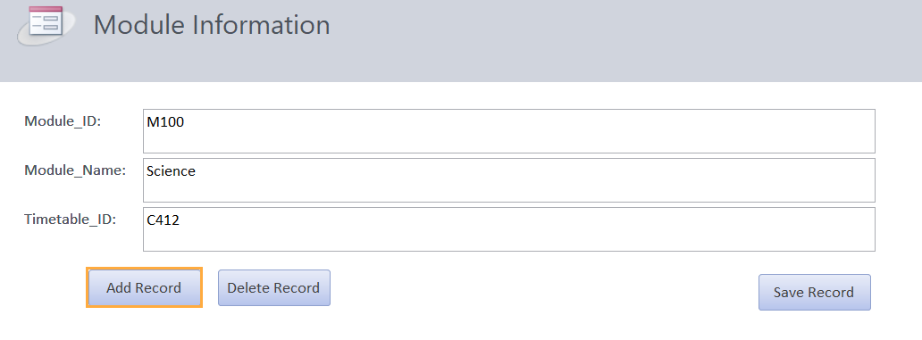
Figure 23.2 (Module Layout View)
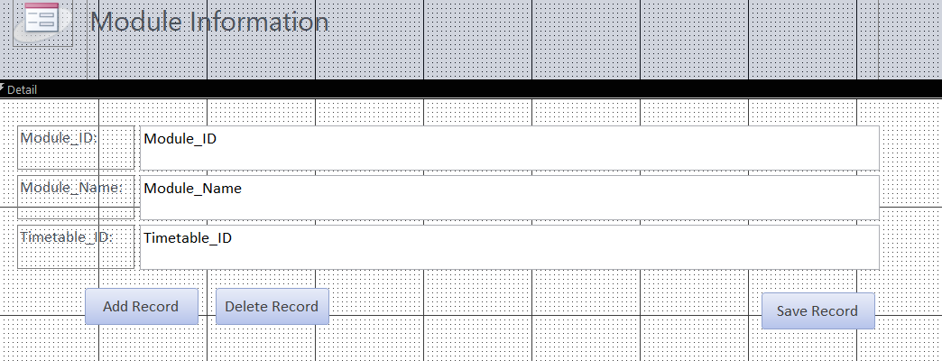

Figure 23.3 (Module Design View)
Timetable Information:

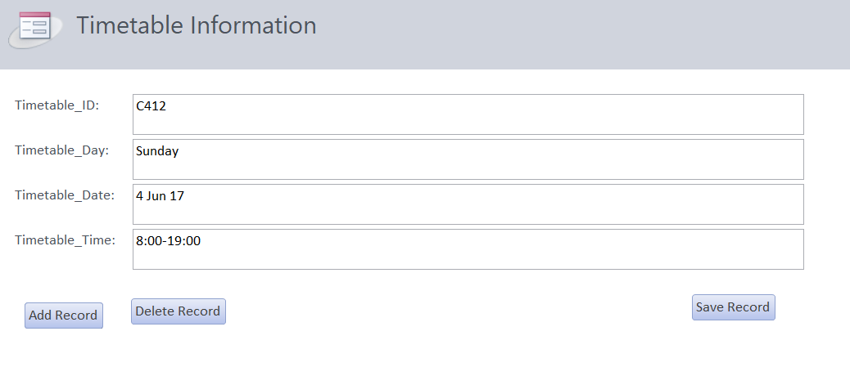
Figure 24.1 (Timetable Form View)

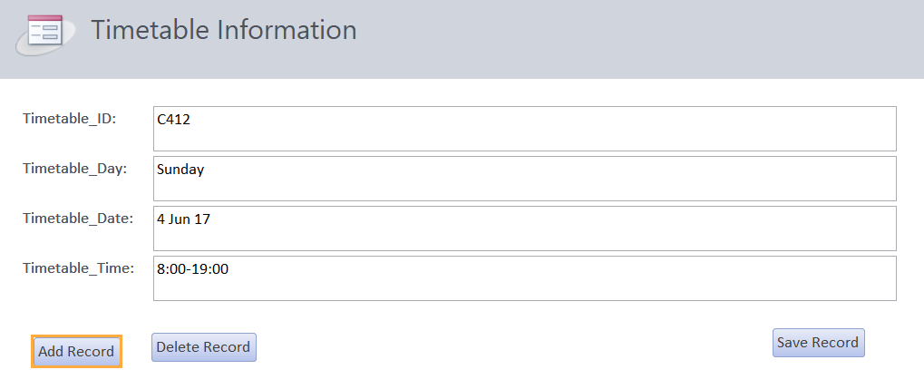
Figure 24.2 (Timetable Layout View)
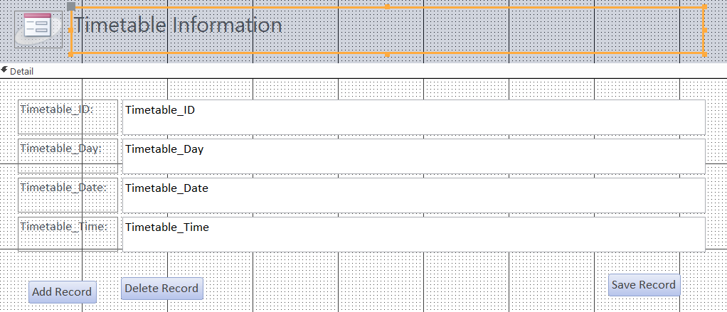
Figure 24.3 (Timetable Design View)

You are required to perform queries using a minimum of two tables and a minimum of two criteria. You need to run and test the queries to ensure that it produces the correct result.

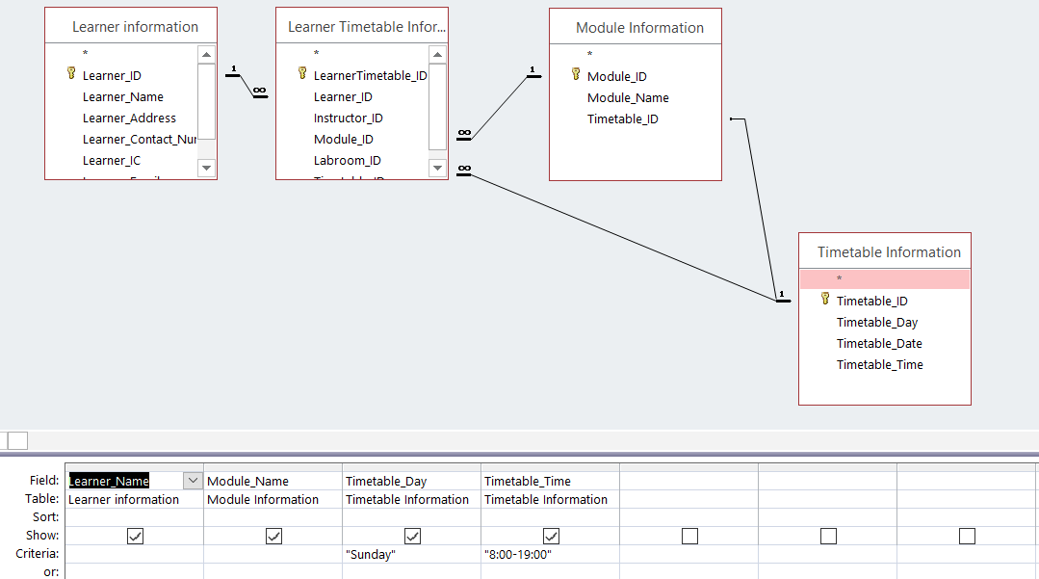
Figure 25.1 (Query 1)
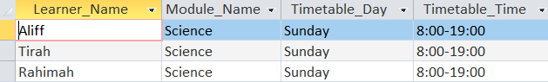
Figure 25.2 (Query 1)
In figure 18, is the query where it shows the learner was studying in 8:00 to 19:00 pm in Sunday with science module.
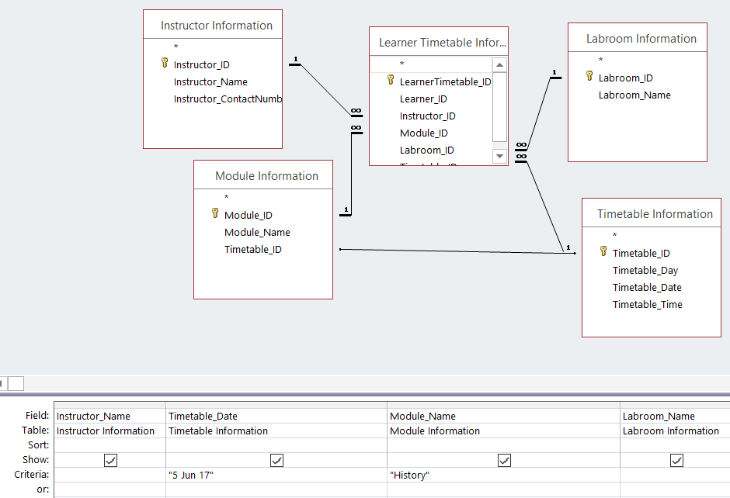
Figure 26.1 (Query 2)
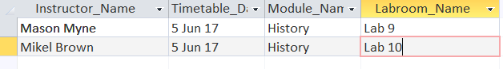
Figure 26.2 (Query 2)
In figure 19, is the query where it shows the different instructor teaching the student at the same date and module with different laboratory.

You are required to include at least one of the advanced features in a database design (For examples: creating styles for the data entry forms, add buttons in forms such as add, delete and update record buttons or using menus/ toolbars in the data entry forms).

Entry Form final:
Form View Main Menu:
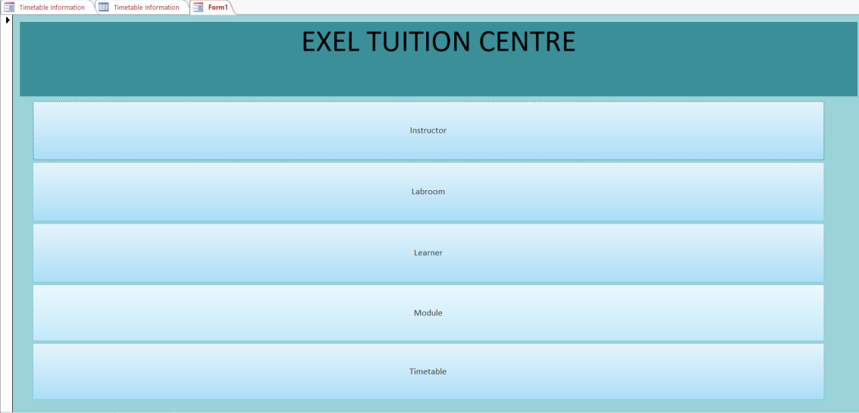
Figure 27.1 (Form View Main Menu)
Layout View Main Menu:
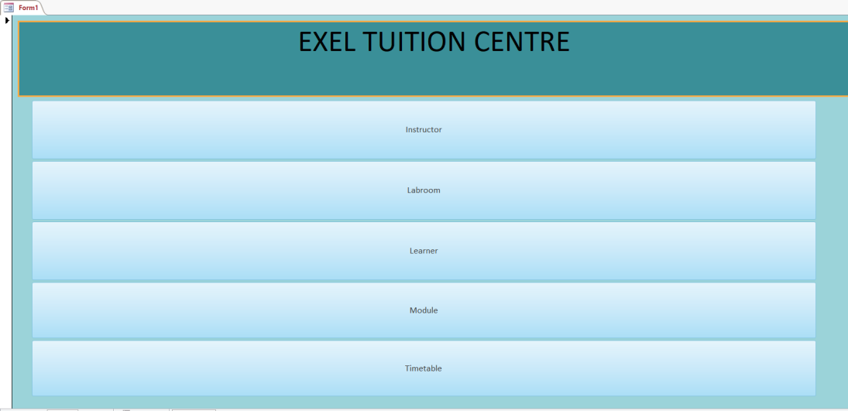
Figure 27.2 (Layout View Main Menu)
Design View Main Menu:
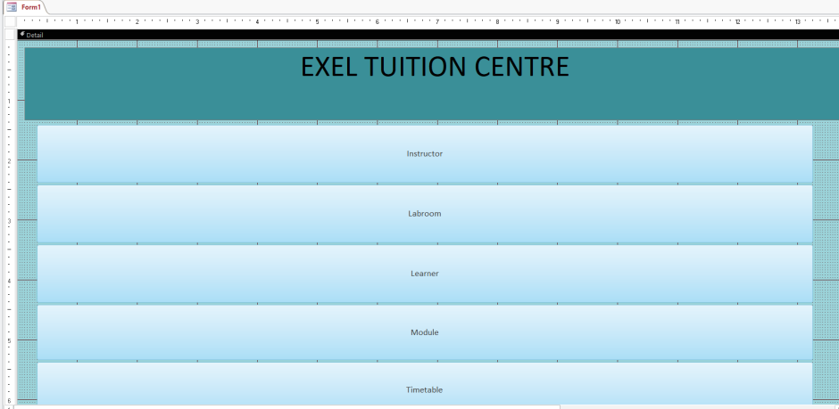
Figure 27.3 (Design View Main Menu)
Form View Instructor information:
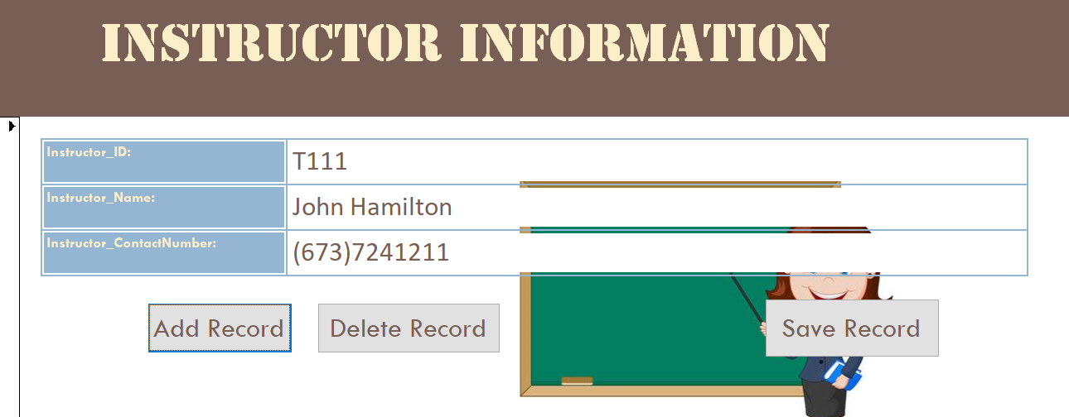
Figure 28.1 (Form View Instructor)
Layout View Instructor information:
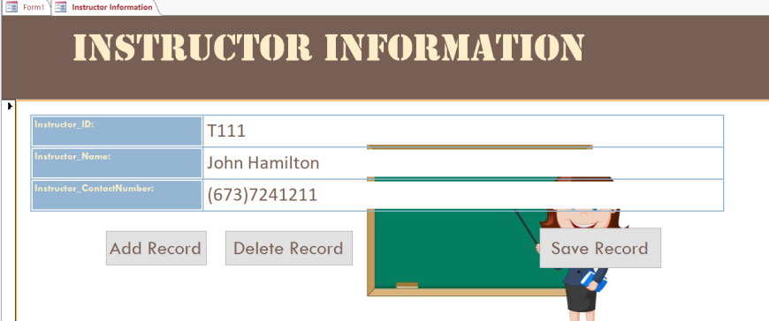
Figure 28.2 (Layout View Instructor)

Design View Instructor information:
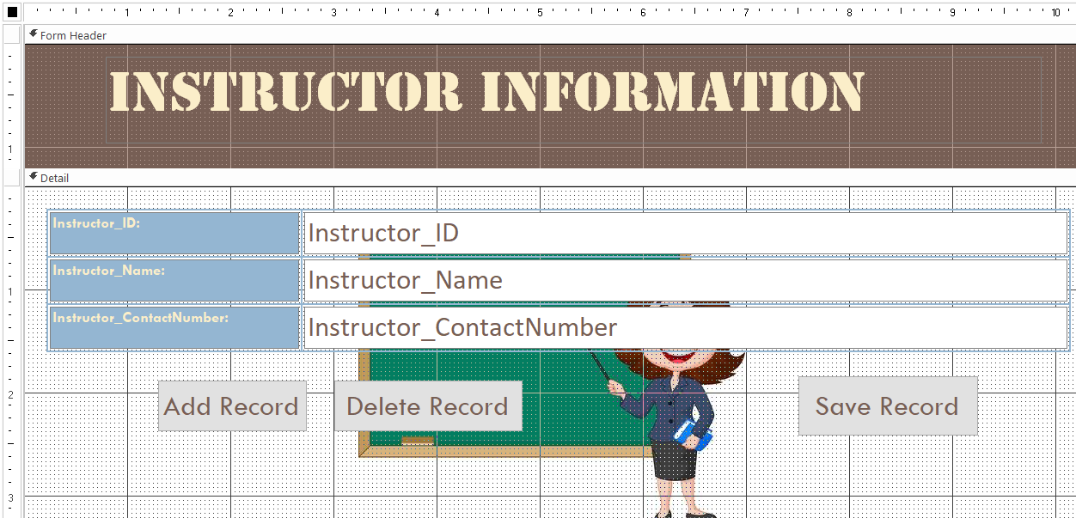
Figure 28.3 (Design View Instructor)
Form View labroom information:
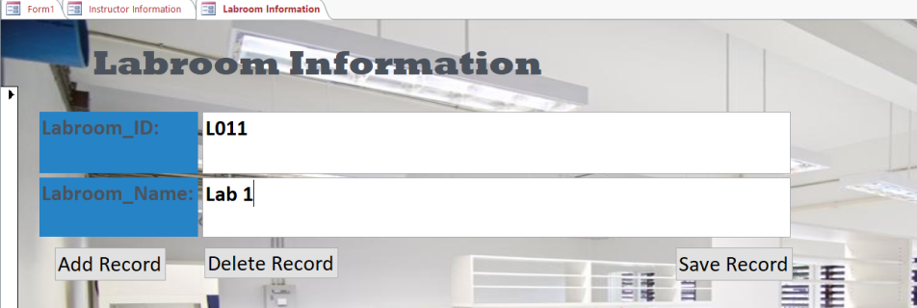
Figure 29.1 (Form View Labroom)
Layout View Labroom information
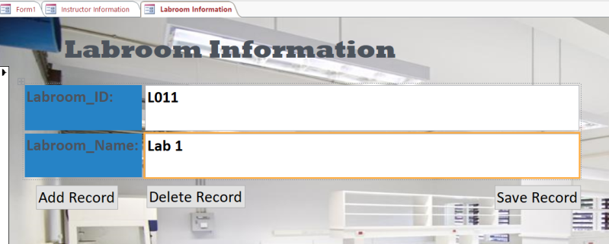
Figure 29.2 (Layout View Labroom)

Design View Labroom information
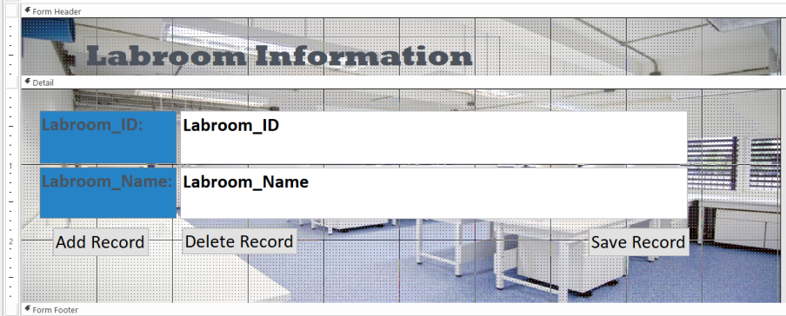
Figure 29.3 (Design View Labroom)
Form View Learner information
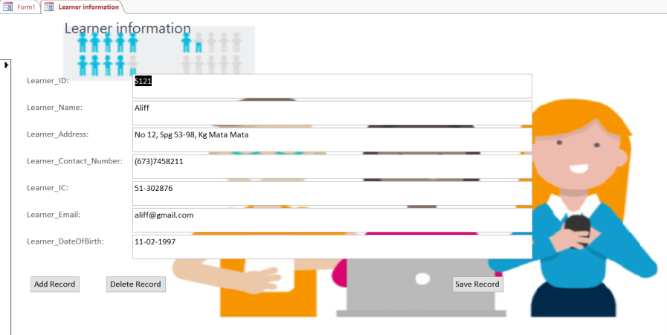
Figure 30.1 (Form View Learner)
Layout View Learner information
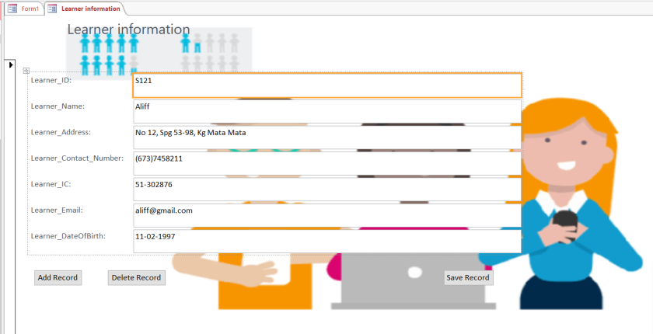
Figure 30.2 (Layout View Learner)
Design View Learner information
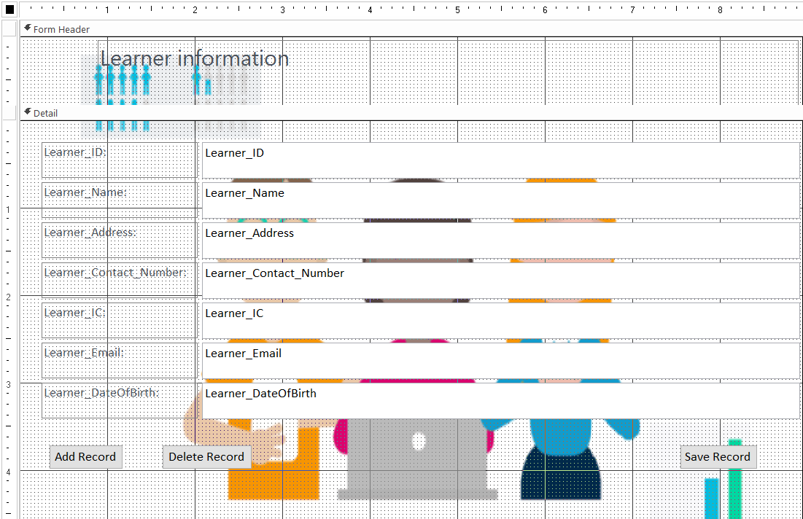
Figure 30.3 (Design View Learner)
Form View Module information
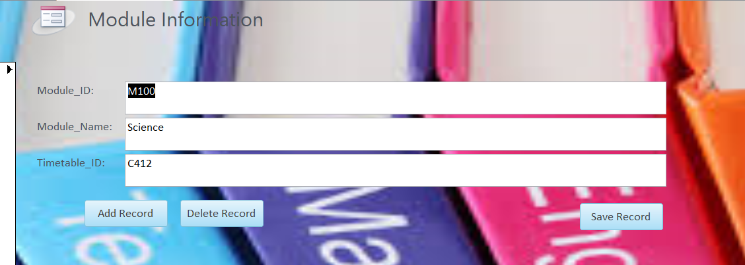
Figure 31.1 (Form View Module)
Layout View Module information
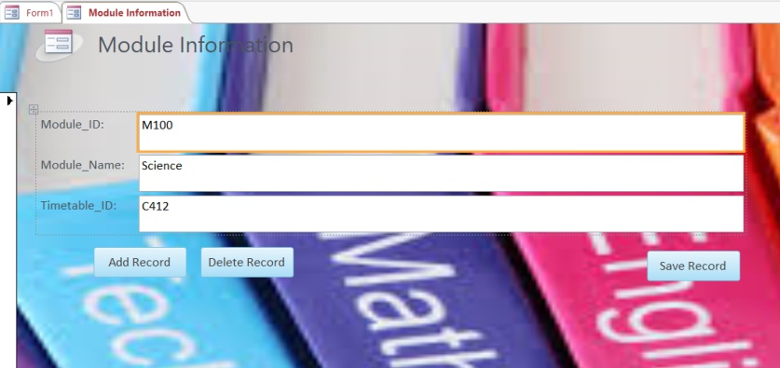
Figure 31.2 (Layout View Module)
Design View Module information
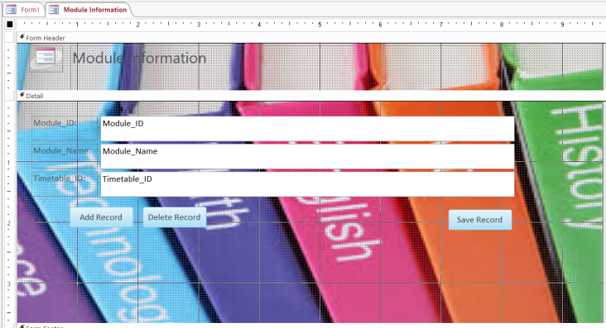
Figure 31.3 (Design View Module)
Form View Timetable information
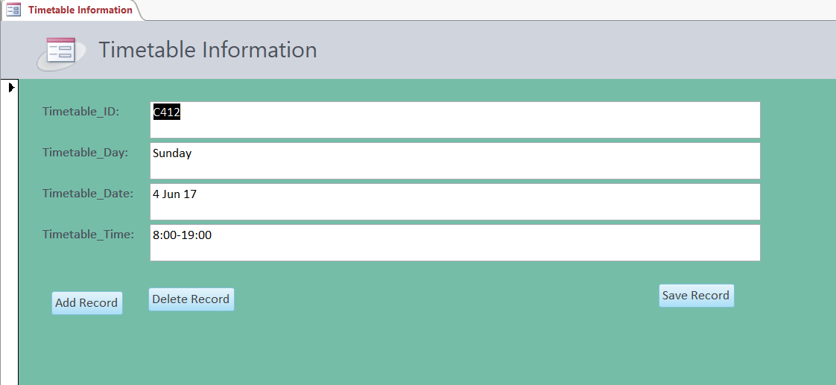
Figure 32.1 (Form View Timetable)
Layout View Timetable information
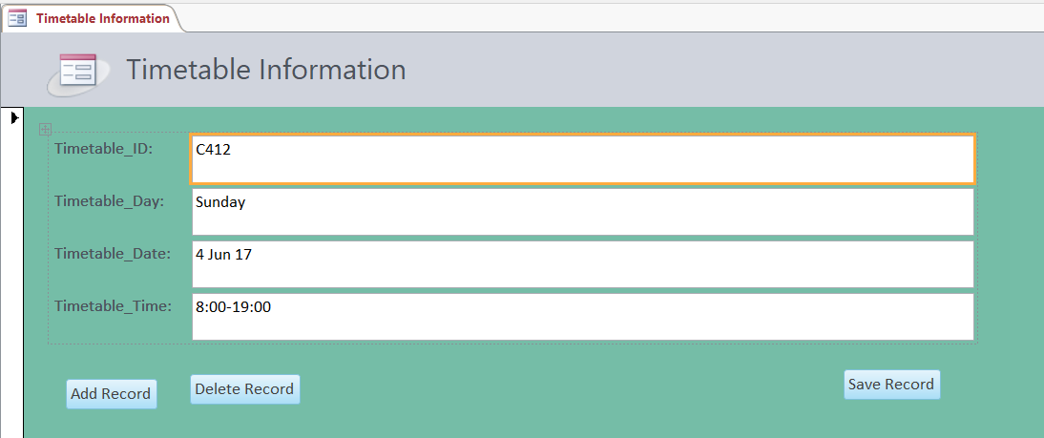
Figure 32.2 (Layout View Timetable)

Design View Timetable information
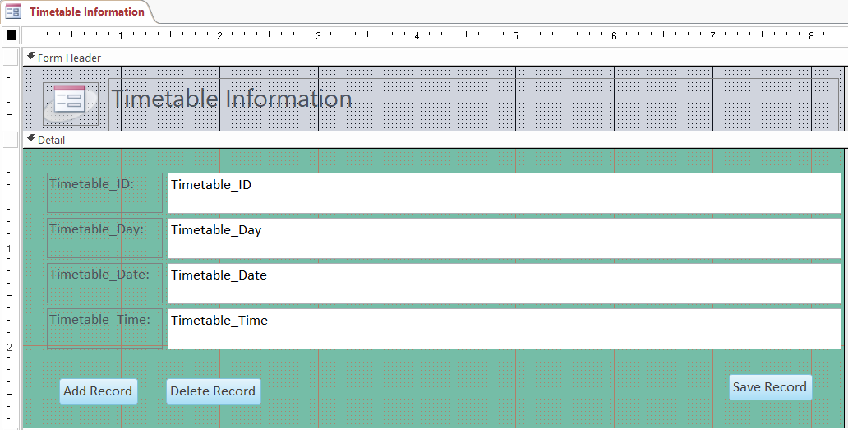
Figure 32.3 (Design View Timetable)

Add, Delete and Save Record
Instructor Information
Add Record:
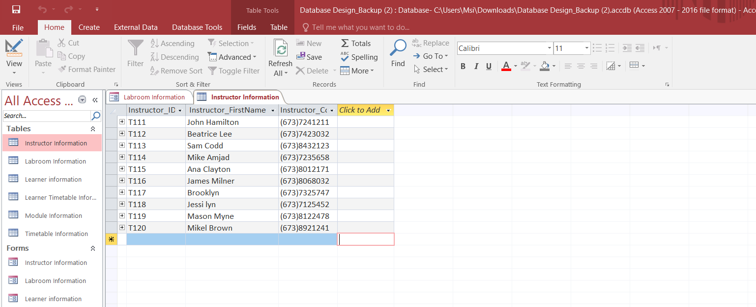
Figure 33.1 (Before Table)
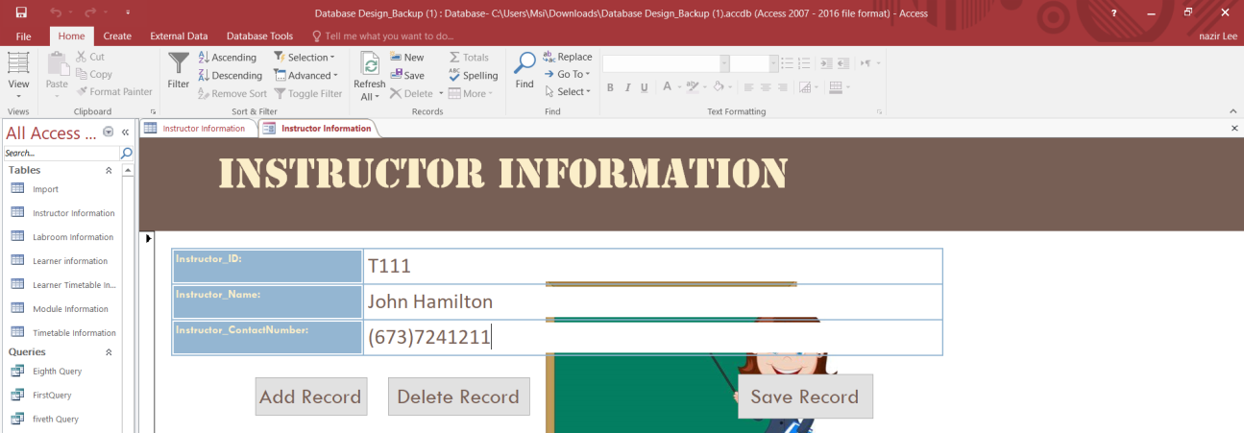
Figure 33.2 (Go to Form View)

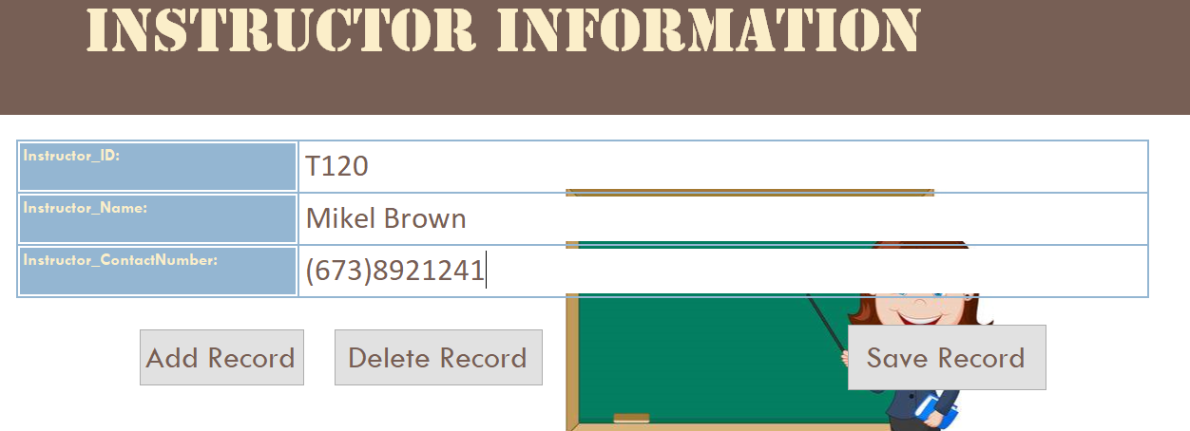
Figure 33.3 (Click Add Record)
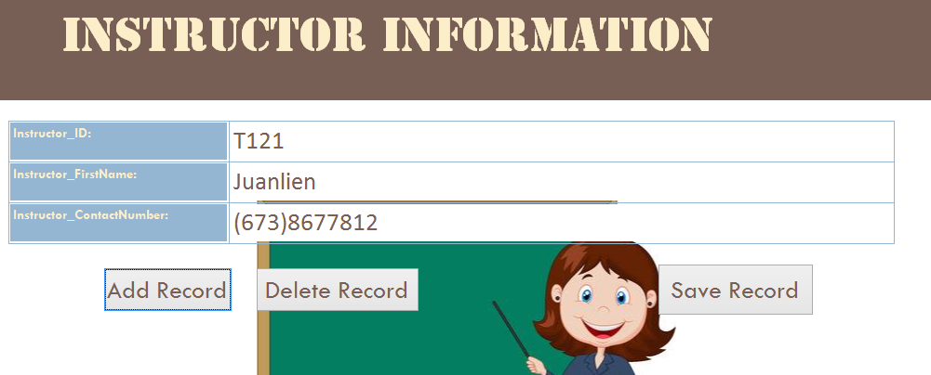
Figure 33.4 (Save Record)
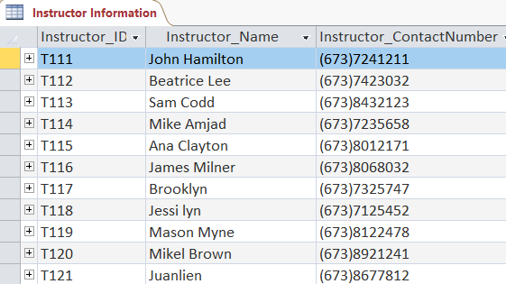
Figure 33.5 (After Table)
Delete Record:
Figure 34.1(Before Table)
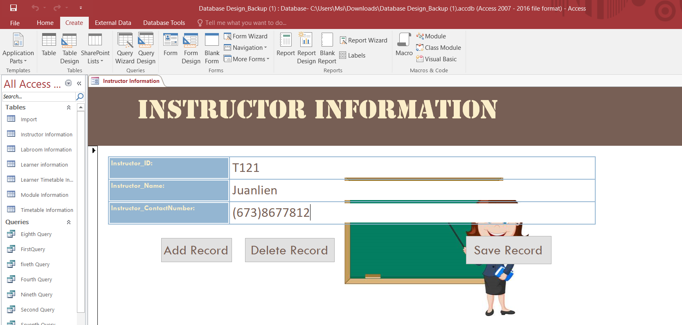
Figure 34.2 (Go to Form View)
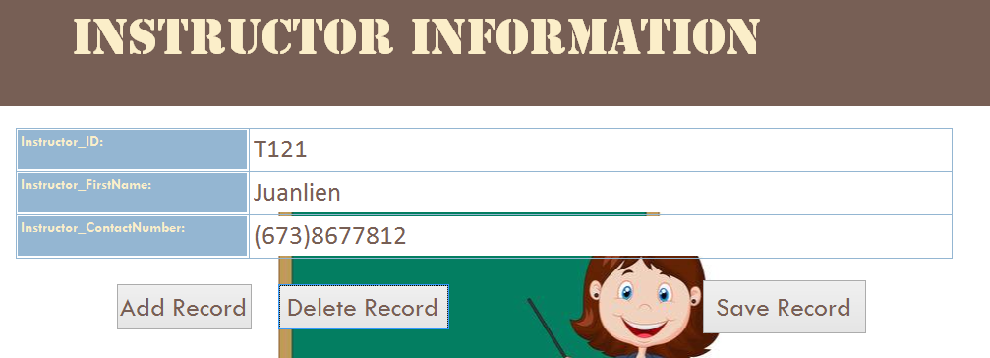
Figure 34.3 (Tap Delete Record)
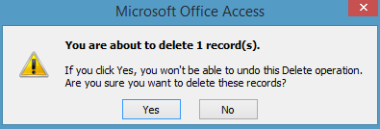
Figure 34.4 (Click Yes)
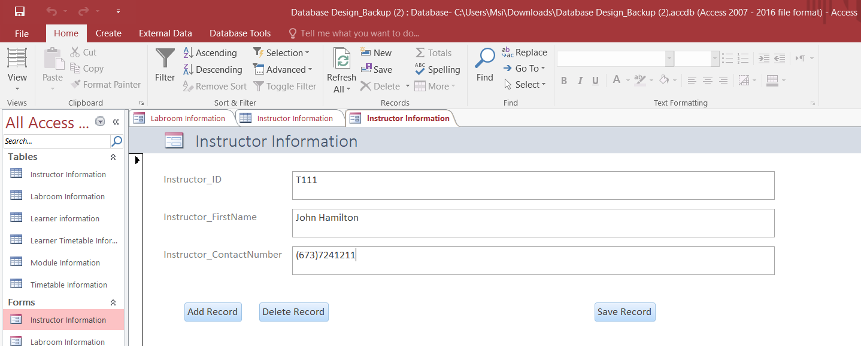
Figure 34.5 (Form View)
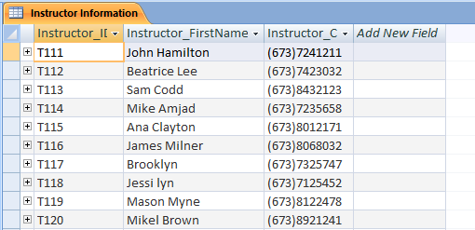
Figure 34.6 (After table)
Labroom Information
Add Record:
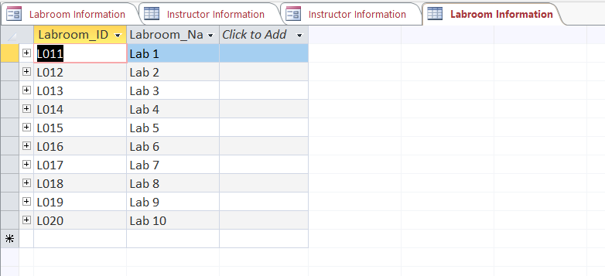
Figure 35.1 (Before table)
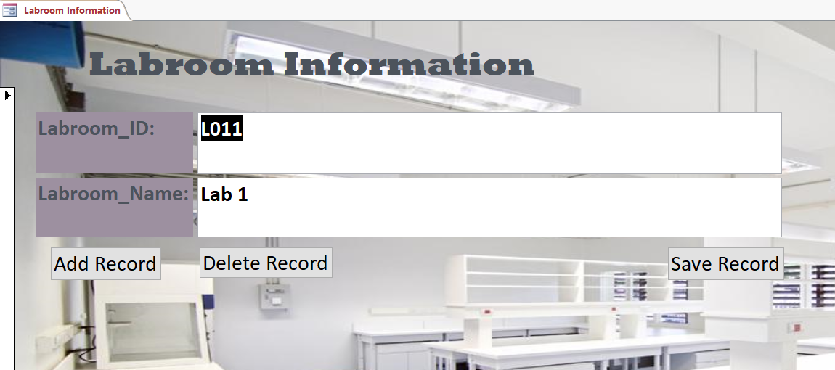
Figure 35.2 (Go to Form View)
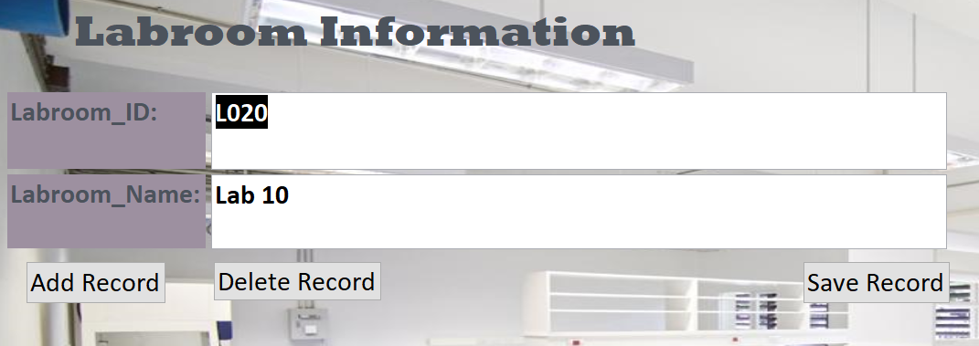
Figure 35.3 (Click Add Record)
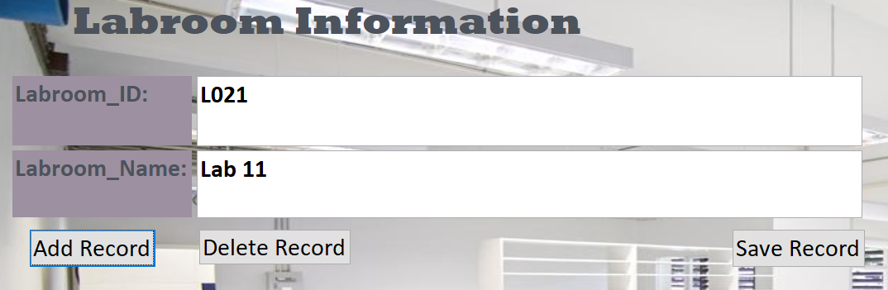
Figure 35.4 (Save Record)
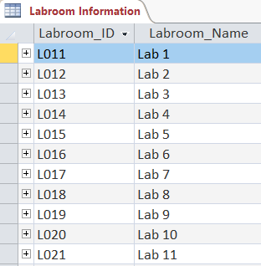
Figure 35.5 (After table)

Delete Record
Figure 36.1 (Before table)

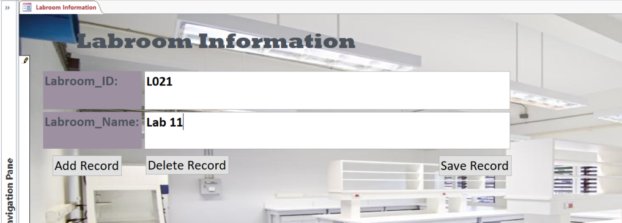
Figure 36.2 (Form View)
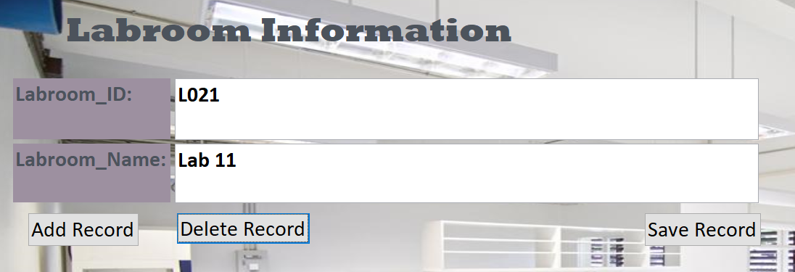
Figure 36.3 (Click Delete Record)
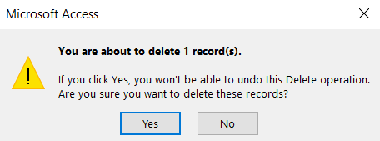
Figure 36.4 (Click Yes)
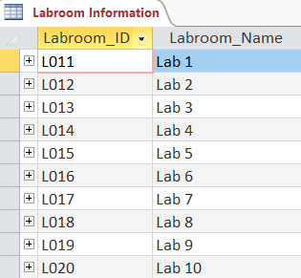
Figure 36.5 (After table)
Learner Information
Add Record:
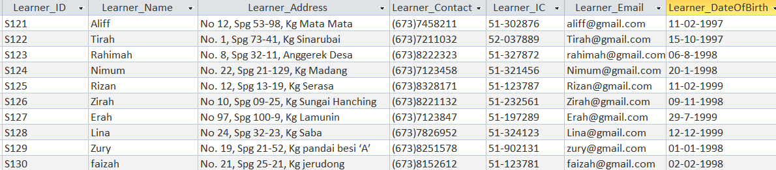
Figure 37.1 (Before table)
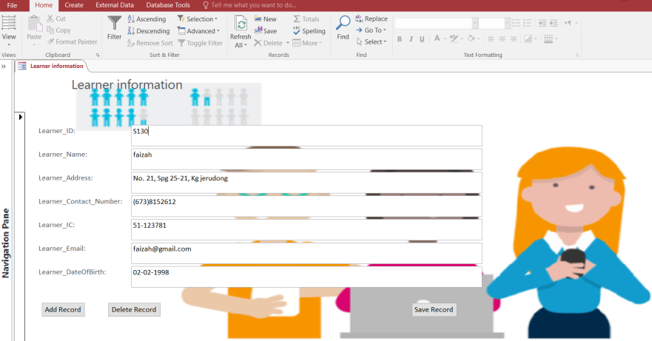
Figure 37.2 (Form View)
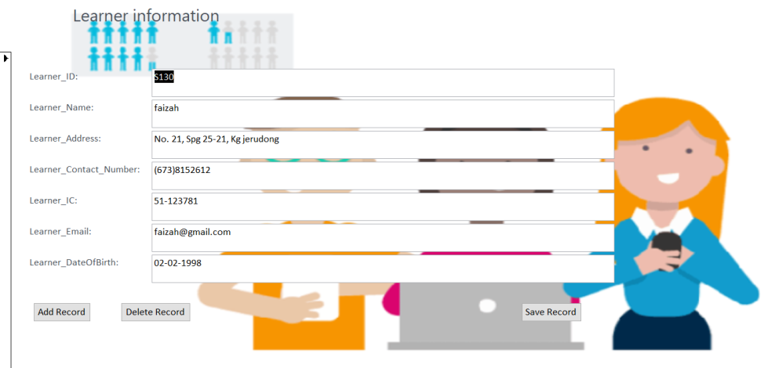
Figure 37.3 (Add Record)
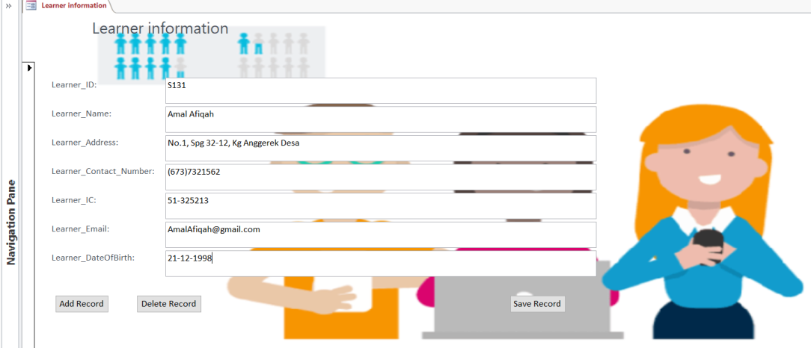
Figure 37.4 (Click Save Record)
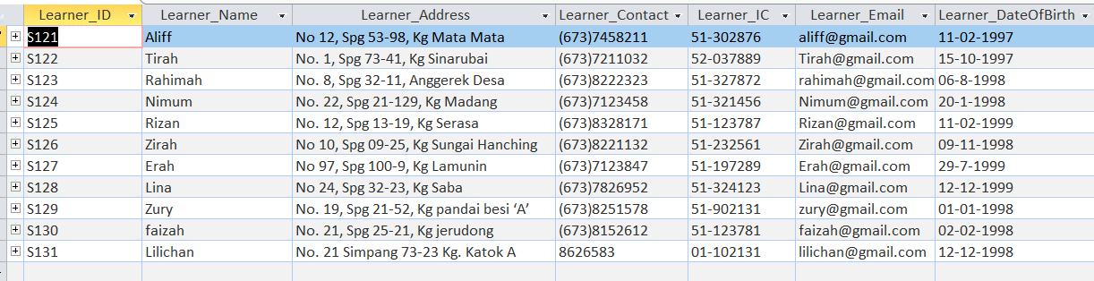
Figure 37.5 (After table)

Delete Record
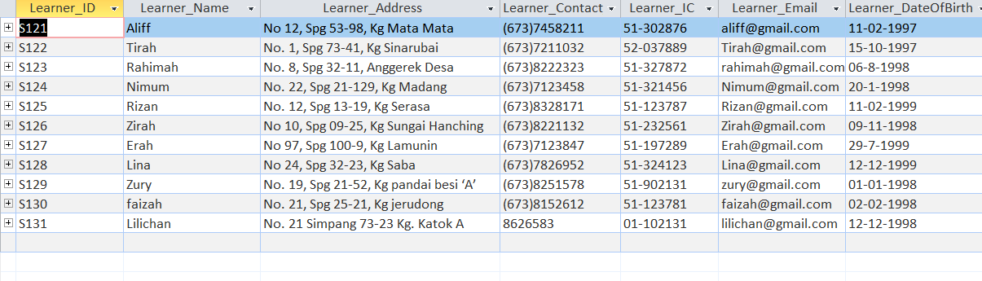
Figure 38.1 (Before table)
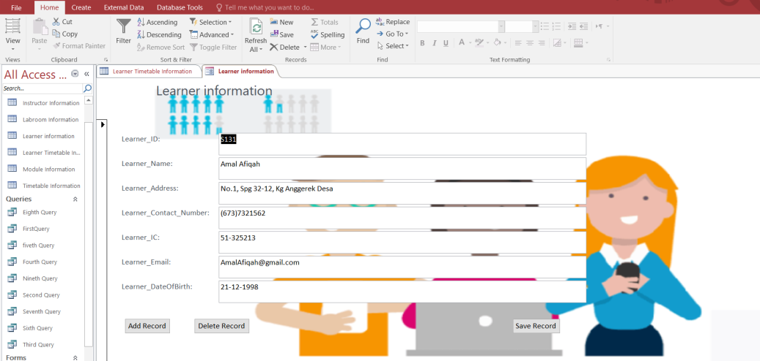
Figure 38.2 (Form View)
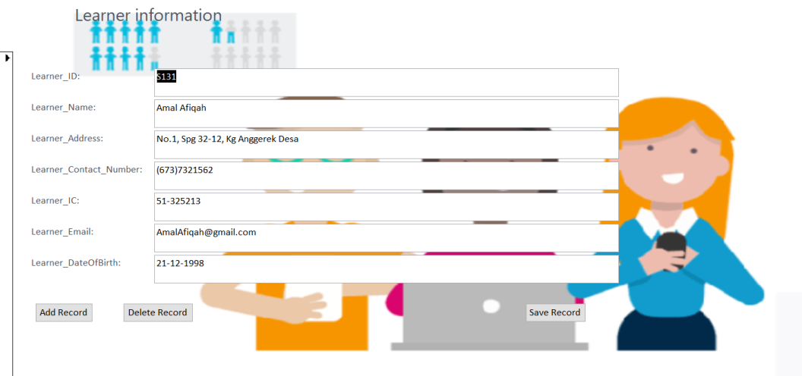
Figure 38.3 (Click Delete Record)
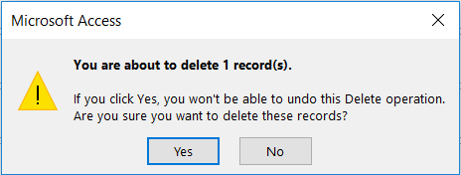
Figure 38.4 (Click Yes)
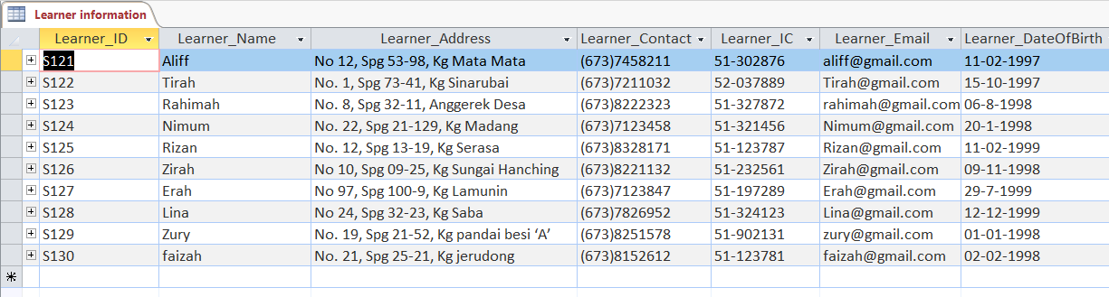
Figure 38.5 (After table)
Module Information:
Adding Record
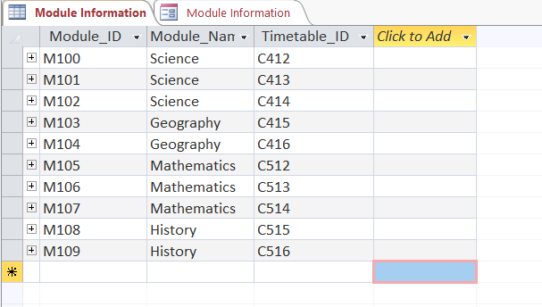
Figure 39.1 (Before table)
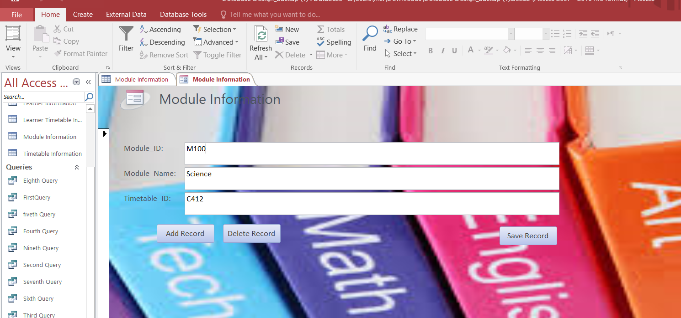
Figure 39.2 (Form View)
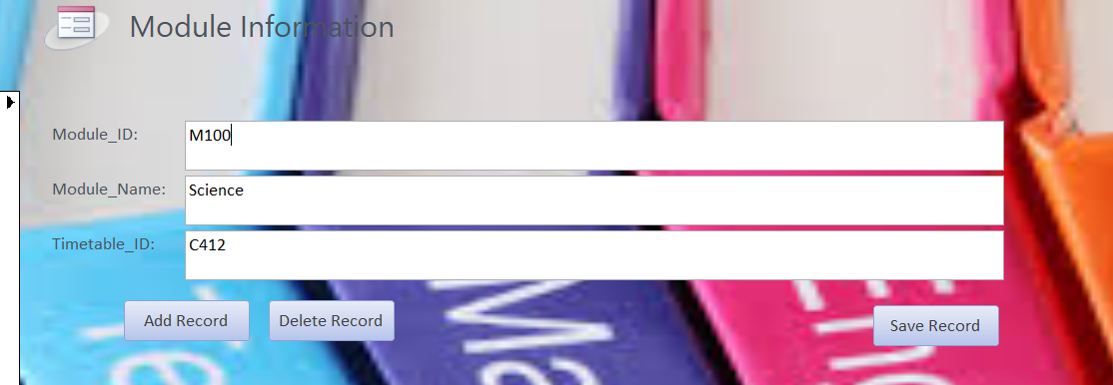
Figure 39.3 (Add Record) 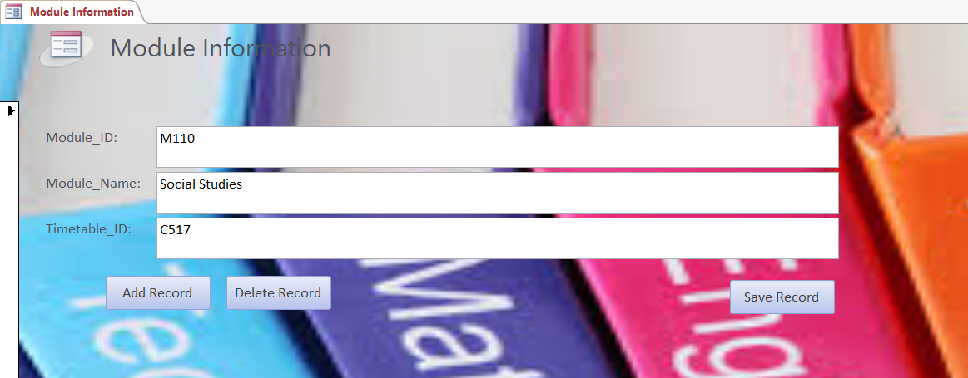
Figure 39.4 (Save Record)
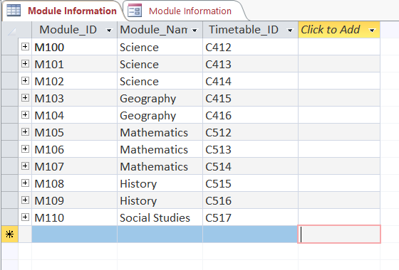
Figure 39.5 (After Table)
Delete Record
Figure 40.1 (Before Table)
Figure 40.2 (Form View)
Figure 40.3 (Click Delete Record)

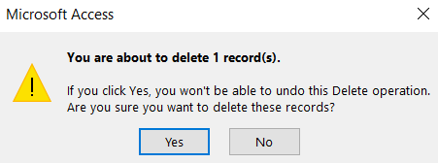
Figure 40.4 (Click Yes)
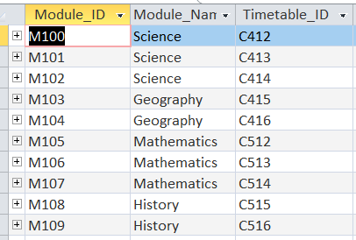
Figure 40.5 (After Table)
Timetable Information
Adding Records:
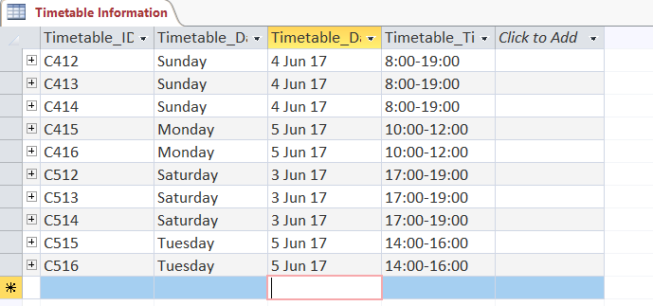
Figure 41.1 (Before Table)
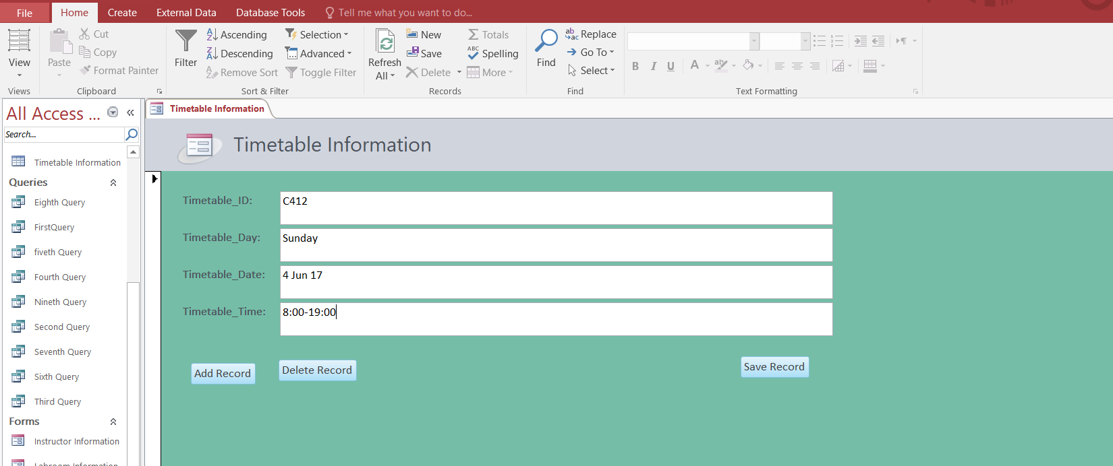
Figure 41.2 (Form View)
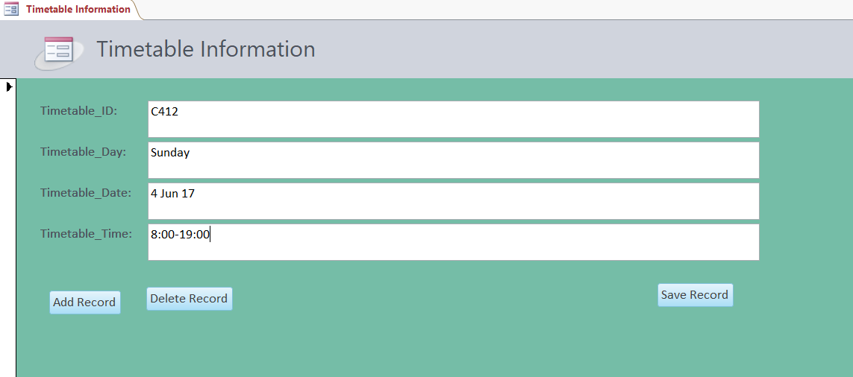
Figure 41.3 (Click Add Record)
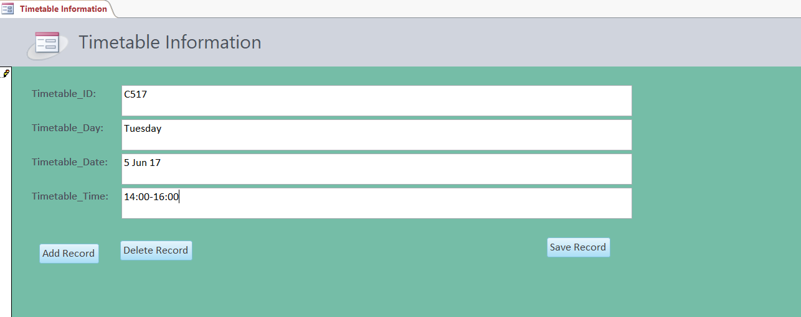
Figure 41.4 (Click Save Record)
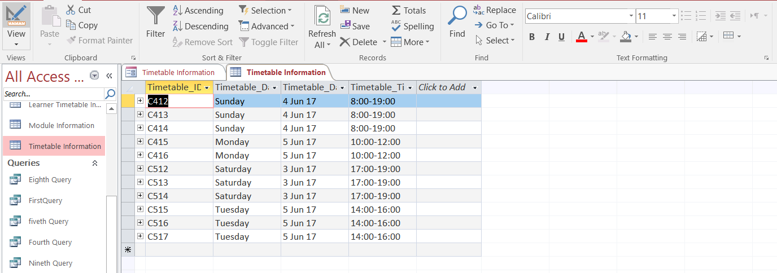
Figure 41.5 (After Table)
Deleting Records
Figure 42.1 (Before table)
Figure 42.2 (Form View)
Figure 42.3 (Click Delete Record)
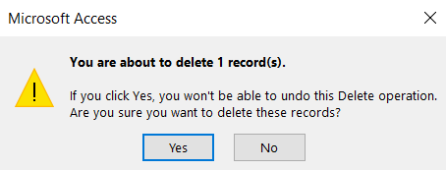
Figure 42.4 (Click Yes)
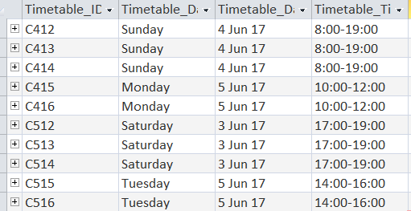
Figure 42.3 (After Table)

Task 4: P7 Testing

Import from excel

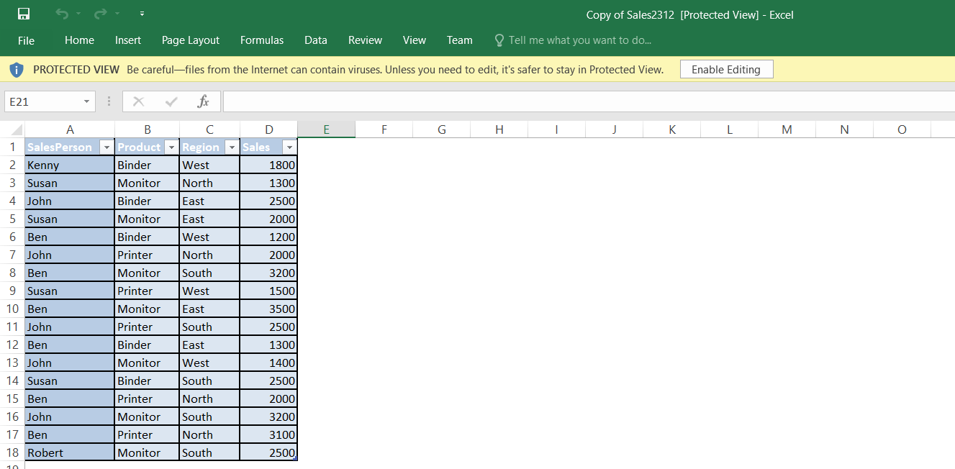
Figure 43 (Excel)
First, you have to go to excel then check the files you want to import and save it.
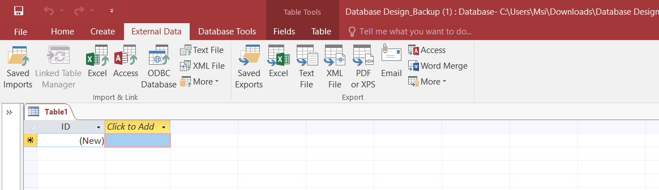
Figure 44 (Access)
Then, go to access and click external data. After that click excel above that I give box.
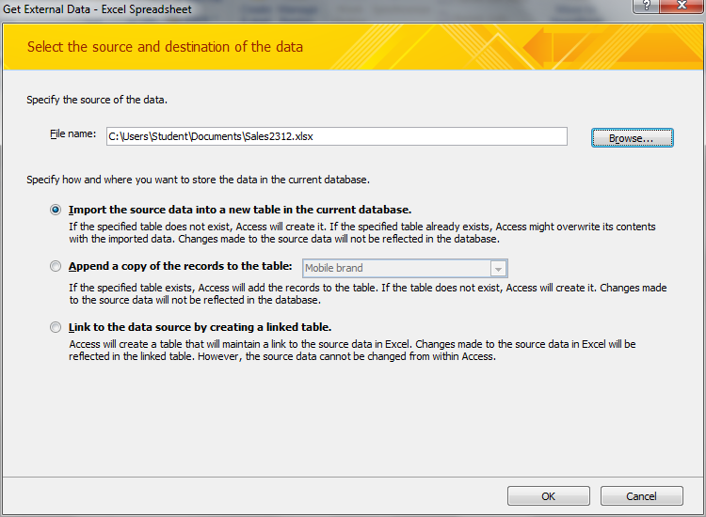
Figure 45 (Import Step 1)
After that, you have to browse the file or paste the name of the files that you saved. Next you have to pick “Import the source data into a new table in current database” and click “OK”
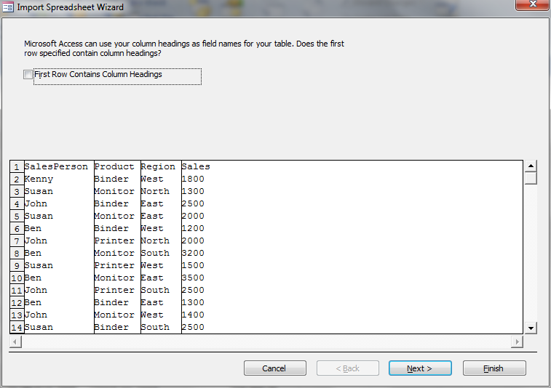
Figure 46 (Import Step 2)
In figure 35, you just need to tap “next”

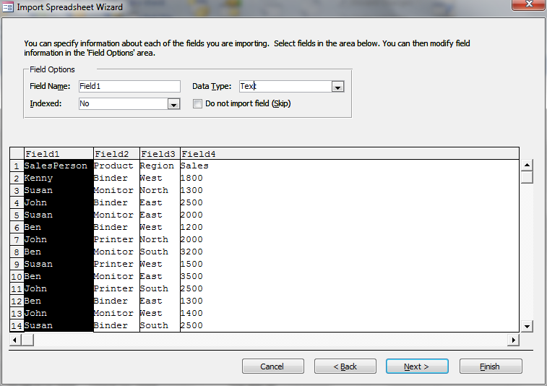
Figure 47 (Import Step 3)
In figure 36, you just need to tap “next”
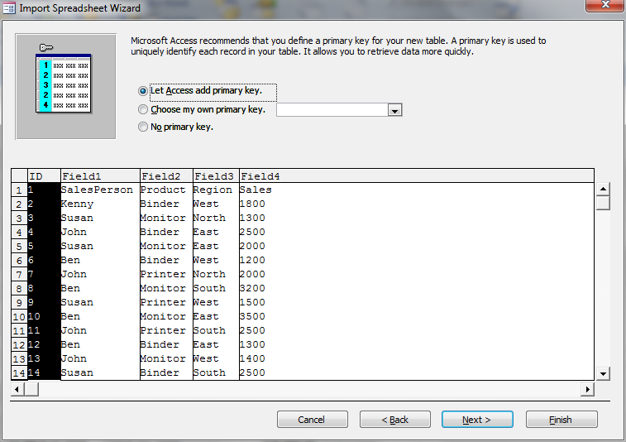
Figure 48 (Import Step 4)
In figure 37, you just need to tap “next”
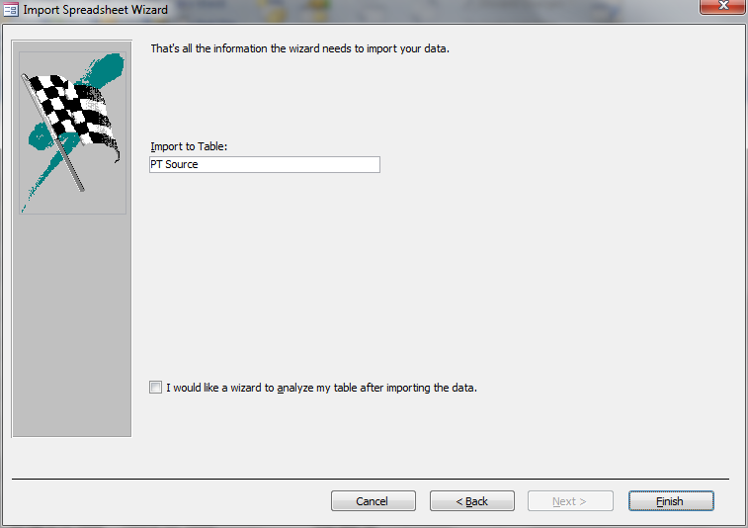
Figure 49 (Import Step 5)
In figure 38, you have to tap “Finish”
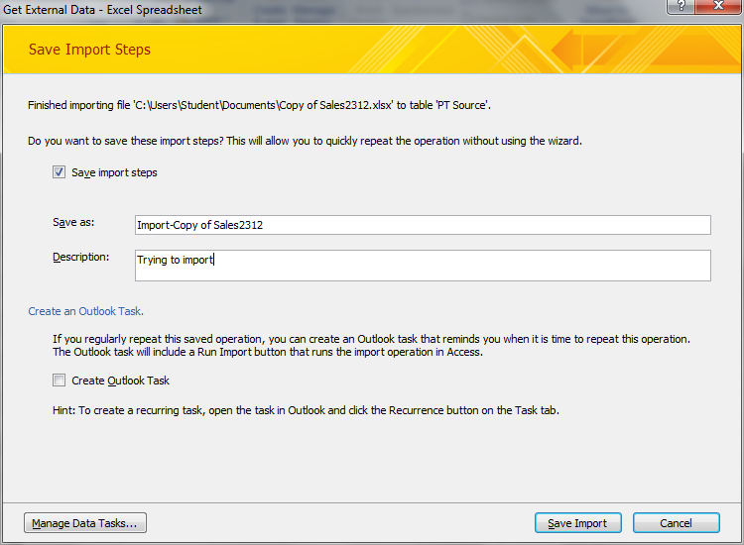
Figure 50 (Import Step 6)
In figure 39, you have to tick “save import steps” and then you may rename the folder and add the description.
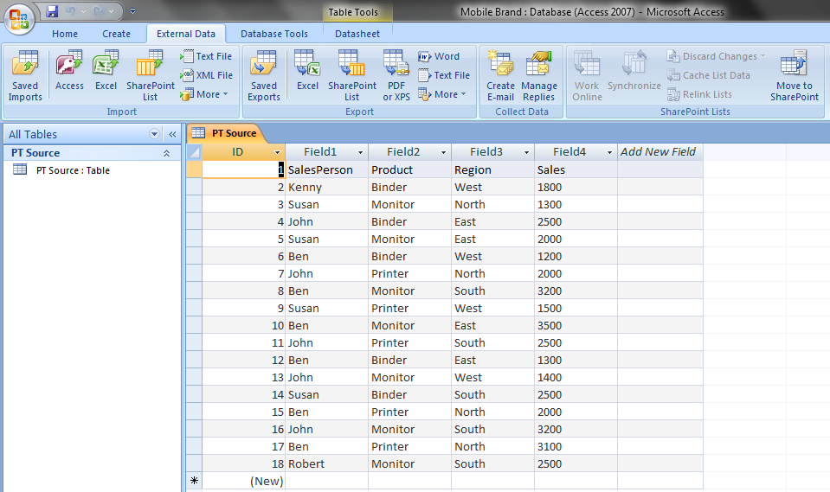
Figure 51 (Import Step 7)
In figure 40, you can see where the table already been import to the access.

Export:
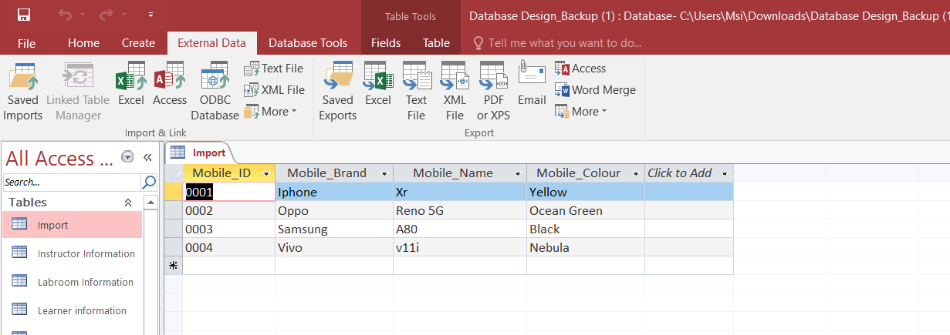
Figure 52 (Access)
In figure 41, is the table that I want to export. First you have to tap external data then click excel where it put the box above.
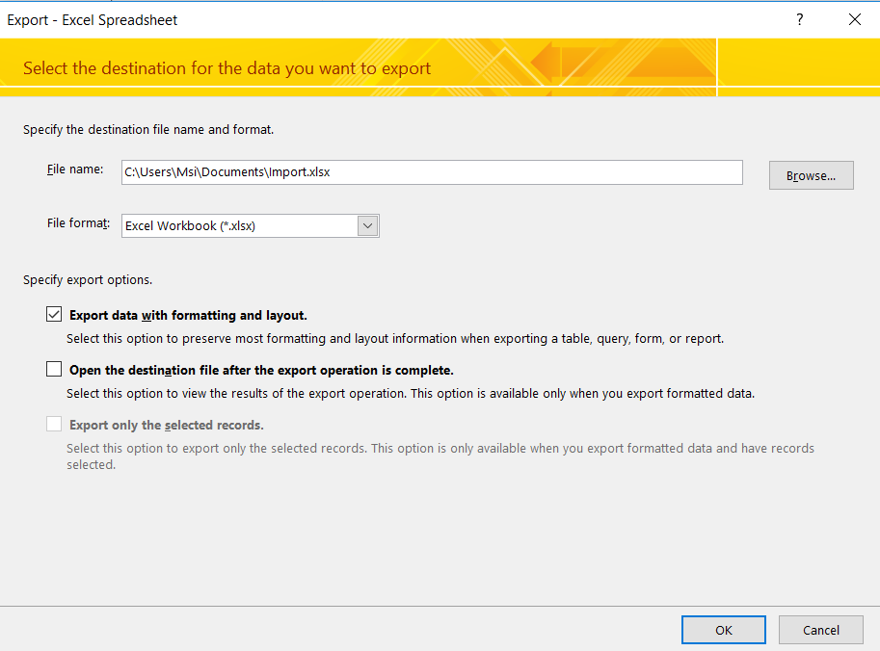
Figure 53 (Step 1 Export)
After that it will show the file name and the format file. You have to select “export data with formatting and layout” then click “OK”

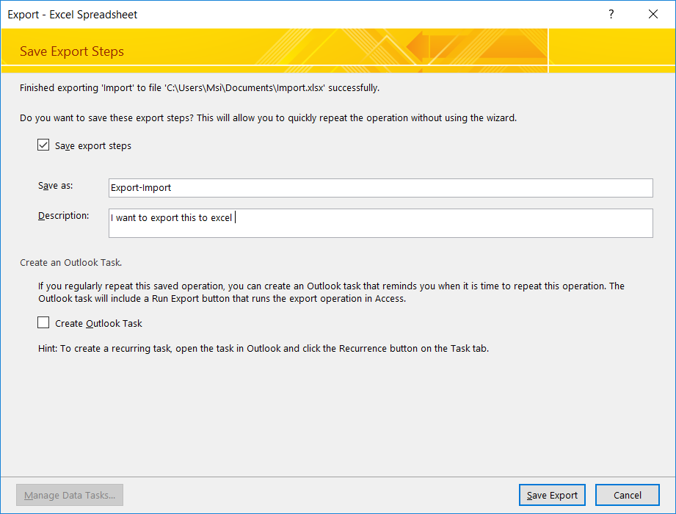
Figure 54 (Export Step 2)
In figure 43, is the table that I want to export. First you have to tap external data then click excel where it put the box above.

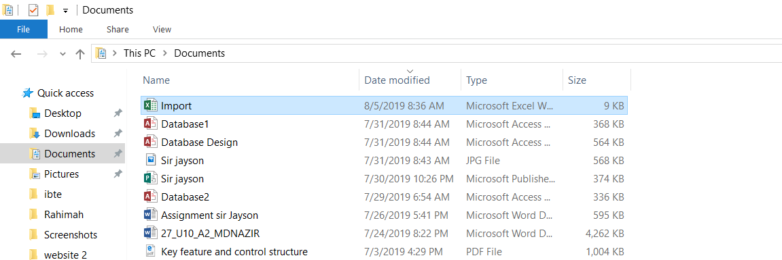
Figure 55 (Check the files)
After that you have to open document and search the name of the files. Then open it.

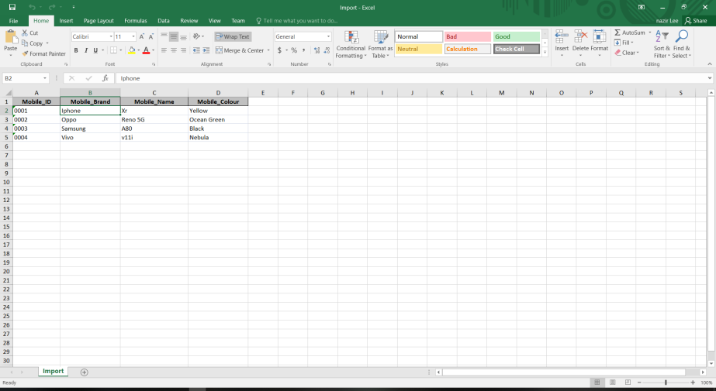
Figure 56 (Excel)
In figure 45, is the table that I already export to the excel.

Automated Function

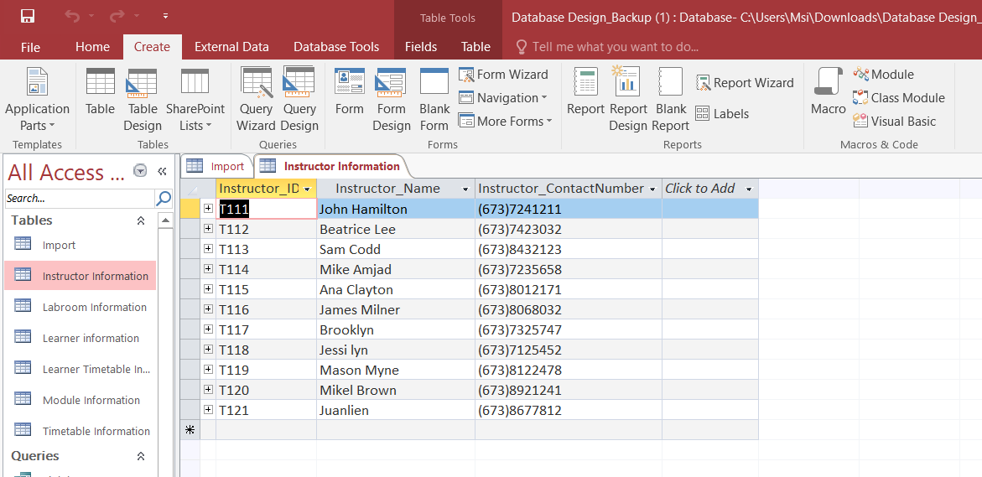
Figure 57 (Click report)
In figure 46, is the table that I want to automated function. First you have to tap “report”

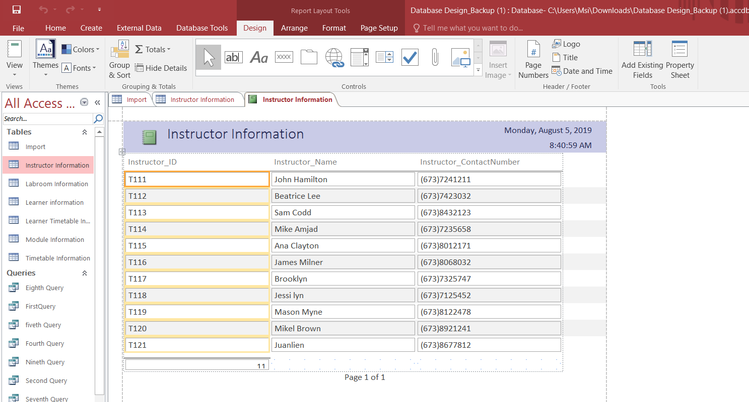
Figure 58 (Layout View)
After that it display the report. You have to change the view to design view.

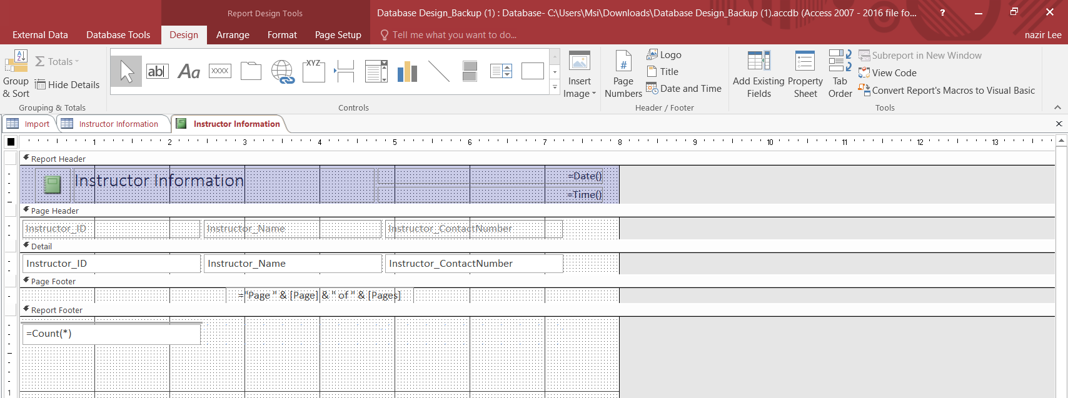
Figure 59 (Design View)
Then you have to tap property sheet.
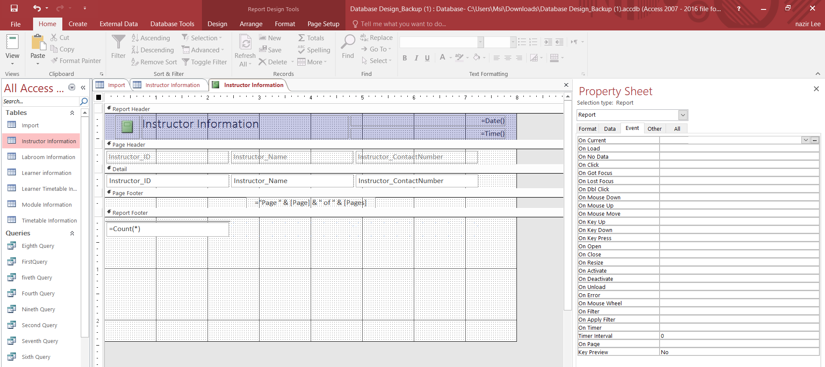
Figure 60 (Property Sheet)
After that, you should tap the event.
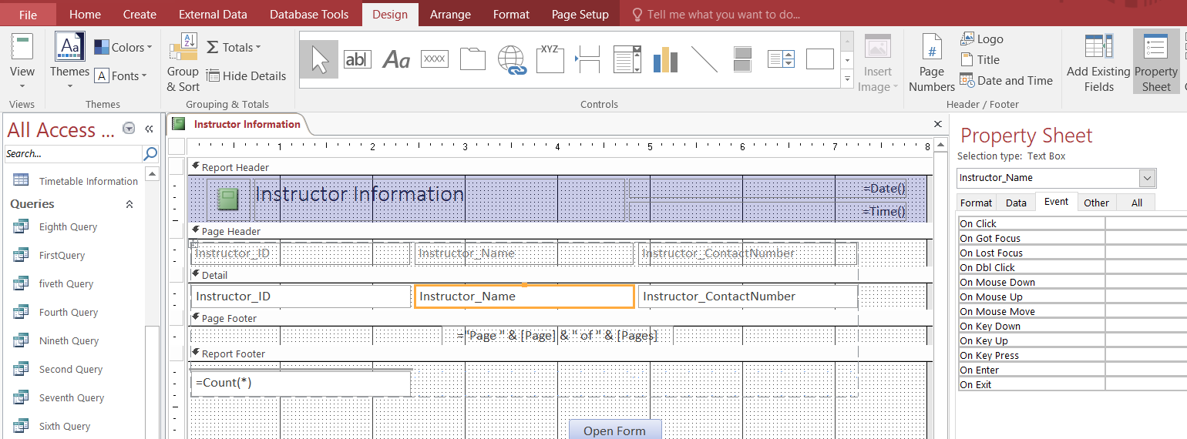
Figure 61 (Button)
After select the event, you have to tap the button where I put boxes there and put it below the report footer and named it.
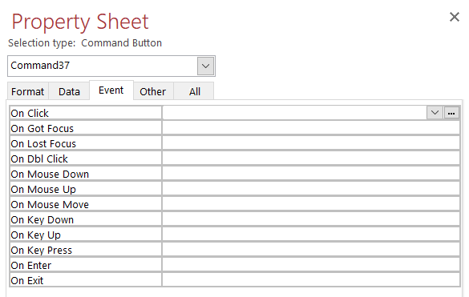
Figure 62 (Event)
After that, you have to click at the “…” on click in the right.

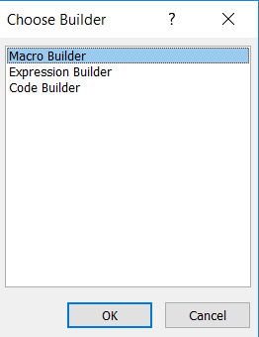
Figure 63 (Choose Builder)
After that, it will display choose builder and you have to click “macro builder” then click OK.
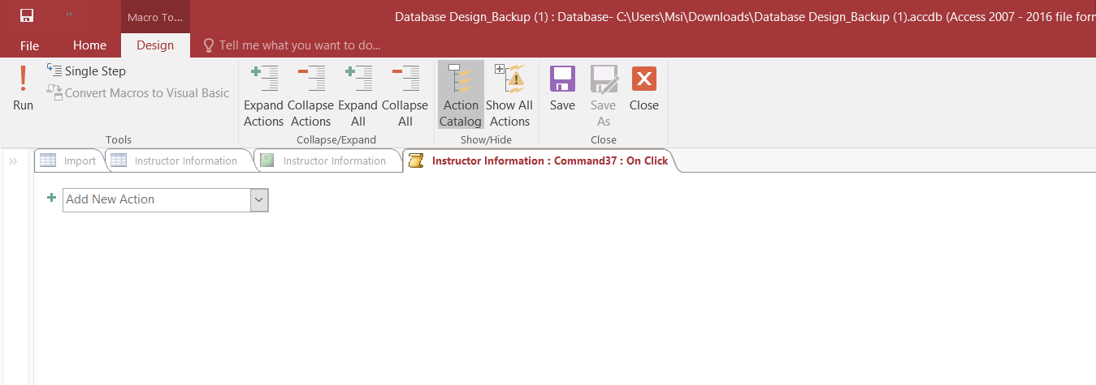
Figure 64 (Command 37: On Click)
After I click macro builder this page will show up. This page is where I can edit the function.

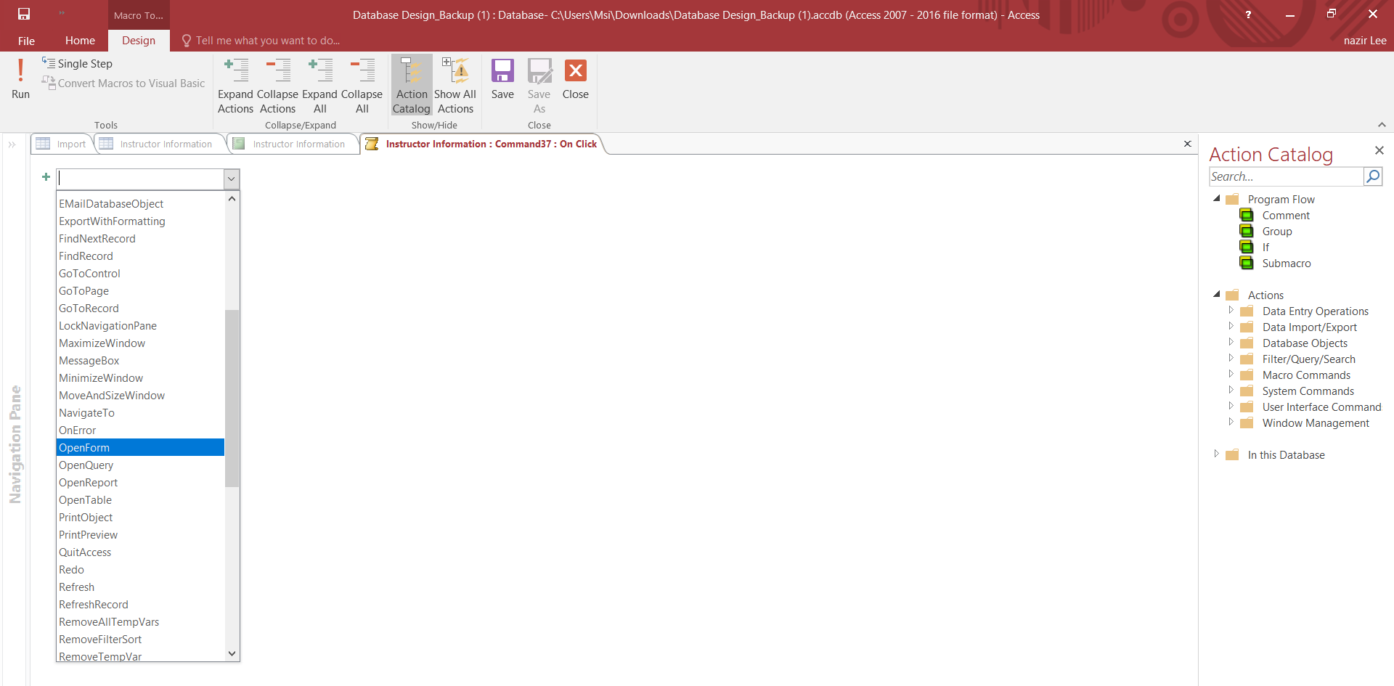
Figure 65 (add new action)
To edit the function first, you have to click “Add new action” then pick what you want to do with it. For example, in figure 54 where I make the open form as the function.
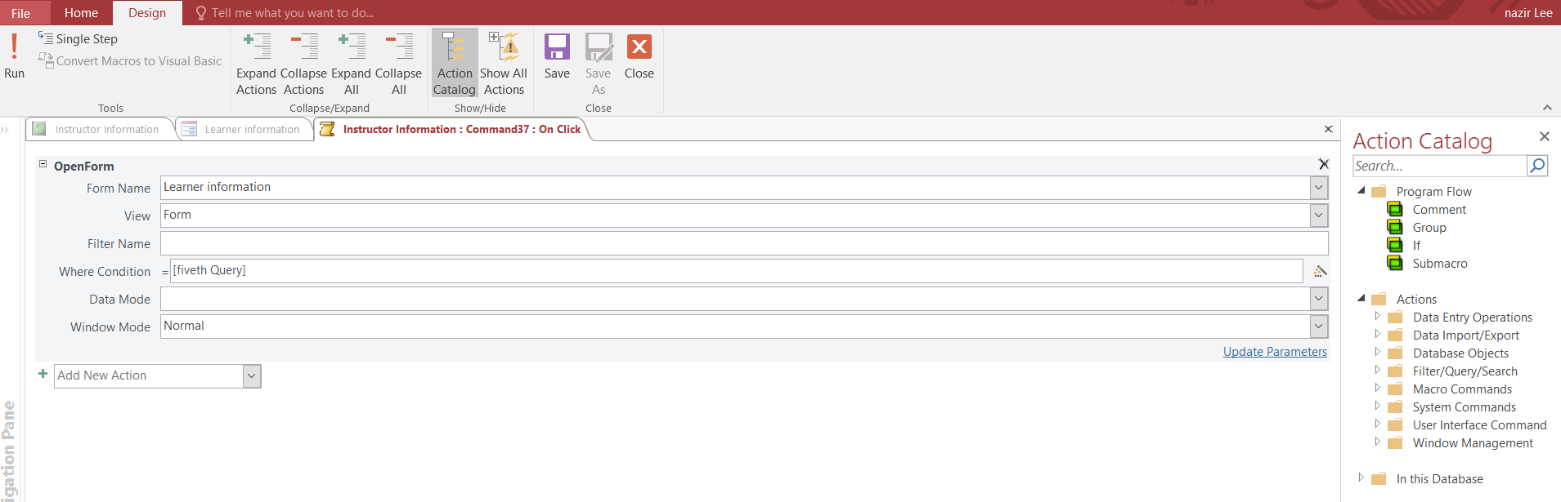
Figure 66 (Open Form)
After I click the open form, it will display the Form Name, view, first name, where condition =, data mode and window mode where it should be renaming or edit it. After that, click save and close.
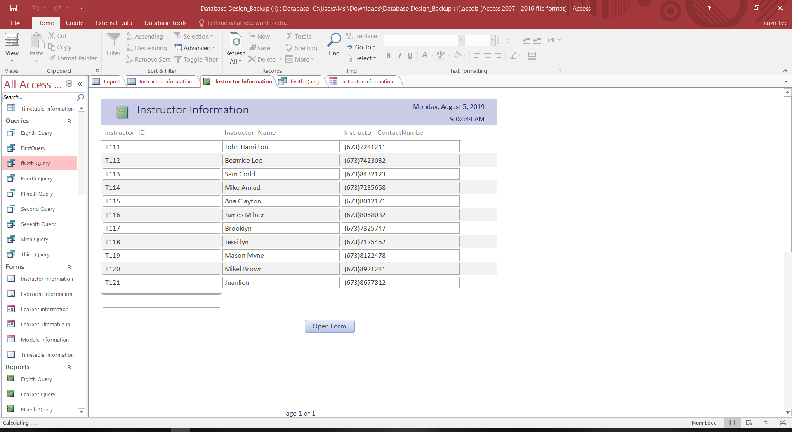
Figure 67 (Form View)
After that, it will go back the form view. If user want to check the function is working or not, they should click open form.
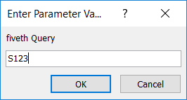
Figure 68 (Enter Parameter Value)
Then the figure 57 will pop up. In this there will be an Enter Parameter Value which means that we need to type in the ID of the learner, so that it will go to the specific learner form
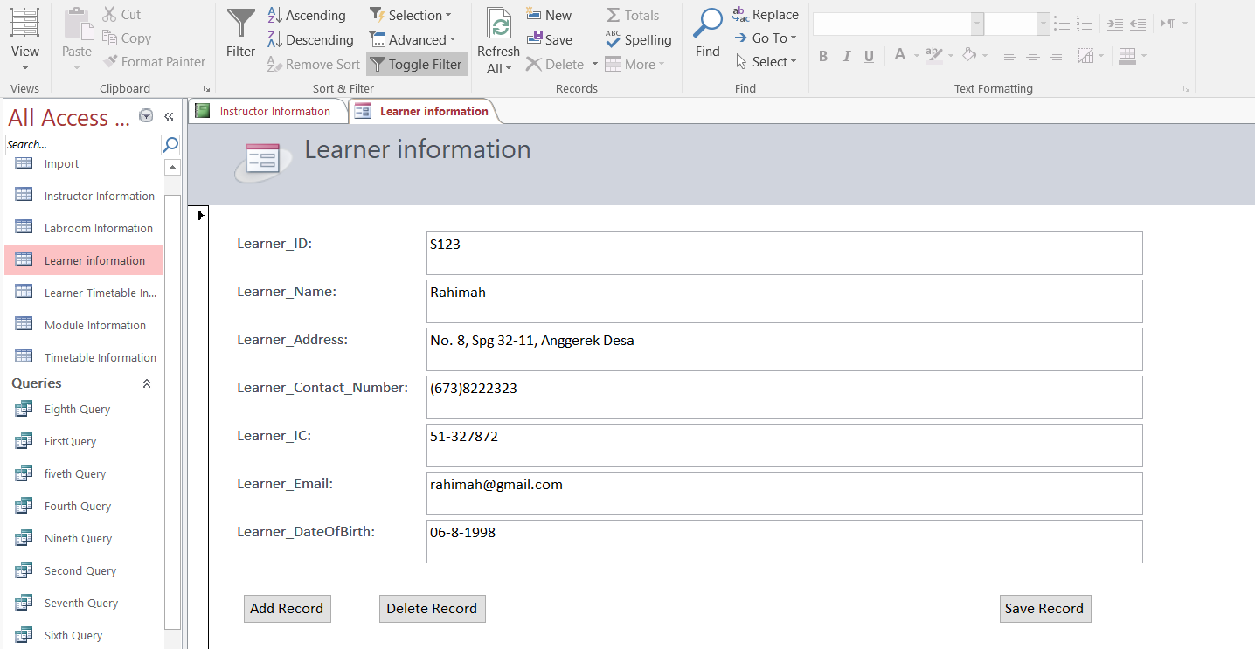
Figure 69 (Learner Information form view)
In this figure, is where it displays the learner information.

Task 5:

P7 Testing
- Adding New Student
Test No. | Date | Test Description | Outcome 1 (Expected) | Outcome 2 (Actual) | Pass/ Fail
1 | 1 August 2019 | To add Amal Afiqah in the list | Amal afiqah will be part of student table | The learner successfully added in learner table. | Pass
Screenshot of Evidence
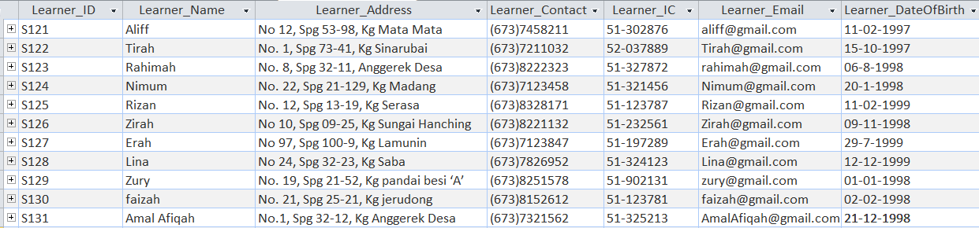
Figure 70 : Outcome of Test No. 1 (Pass)

- Creating a new Subject
Test No. | Date | Test Description | Outcome 1 (Expected) | Outcome 2 (Actual) | Pass/ Fail
2 | 1 August 2019 | To add Social Studies in the list | Social Studies will be part of Module table | The module successfully added in module table. | Pass
Screenshot of Evidence
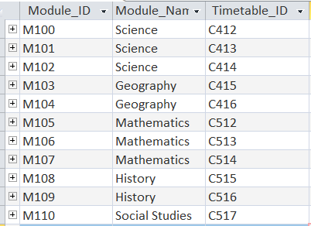
Figure 71 : Outcome of Test No. 2 (Pass)

- Selection of Tutors available schedule
Test No. | Date | Test Description | Outcome 1 (Expected) | Outcome 2 (Actual) | Pass/ Fail
3 | 1 August 2019 | To select the instructor available following with the schedule table. | Instructor will available in the schedule table | The instructor successfully available in schedule table. | Pass
Screenshot of Evidence
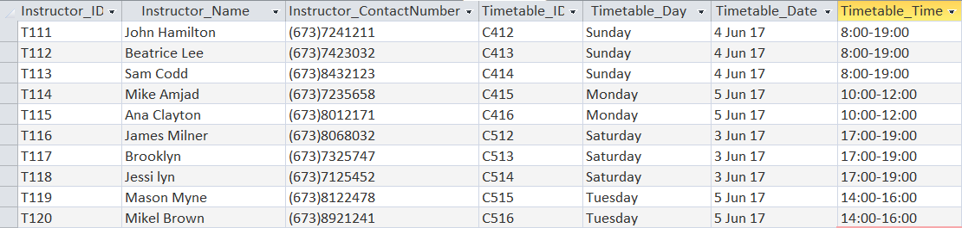
Figure 72 : Outcome of Test No. 3 (Pass)

- Selection of the available classrooms
Test No. | Date | Test Description | Outcome 1 (Expected) | Outcome 2 (Actual) | Pass/ Fail
4 | 1 August 2019 | To select the classroom available following with the schedule table and the Instructor. | Instructor and lab room will available in the schedule table | The instructor and lab room successfully available in schedule table. | Pass
Screenshot of Evidence
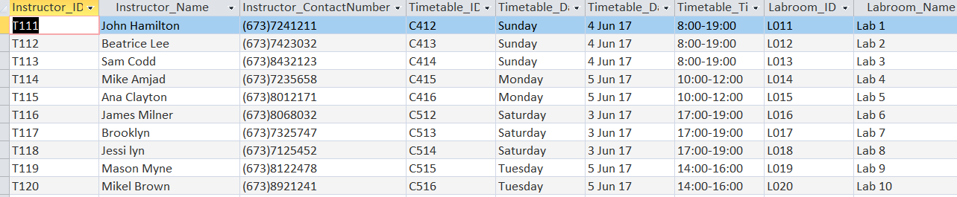
Figure 73 : Outcome of Test No. 4 (Pass)

- Print schedule for student
Test No. | Date | Test Description | Outcome 1 (Expected) | Outcome 2 (Actual) | Pass/ Fail
5 | 2 August 2019 | To print the schedule available for student. | Schedule time and day will be printed same as ID student and name | It is already printed with the student ID and name which show the Sunday timetable. | Pass
Screenshot of Evidence
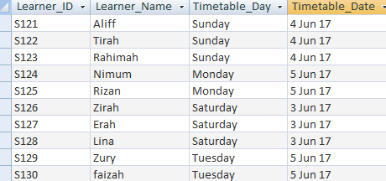
Figure 74.1: Outcome of Test No. 5 (Pass) – Datasheet View
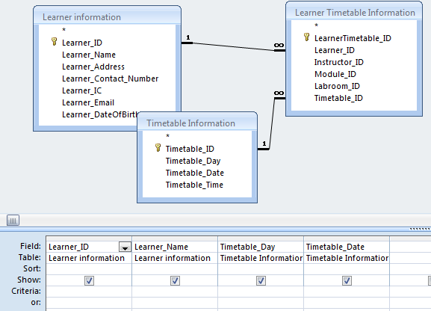
Figure 74.2: Outcome of Test No. 5 (Pass) – Design View
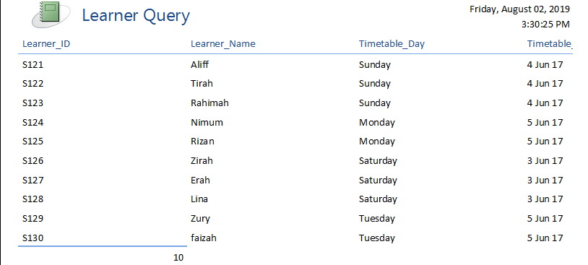
Figure 74.3: Outcome of Test No. 5 – Printing view for learner (Pass)

- Print schedule for tutor
Test No. | Date | Test Description | Outcome 1 (Expected) | Outcome 2 (Actual) | Pass/ Fail
6 | 2 August 2019 | To print the schedule available for Lecturer | Schedule time and day will be printed same as ID lecturer and name | It is already printed with the lecturer ID and contact number which show the Sunday timetable. | Pass
Screenshot of Evidence
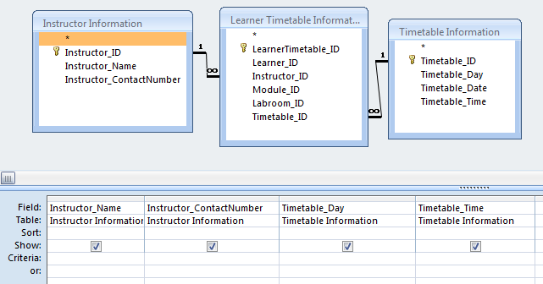
Figure 75.1: Outcome of Test No. 6 (Pass) – Datasheet View
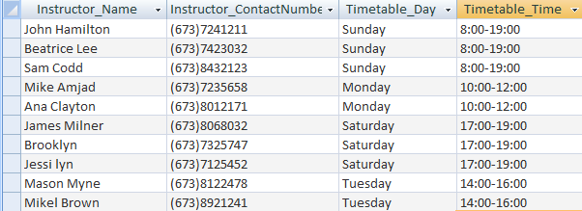
Figure 75.2: Outcome of Test No. 6 (Pass) – Design View
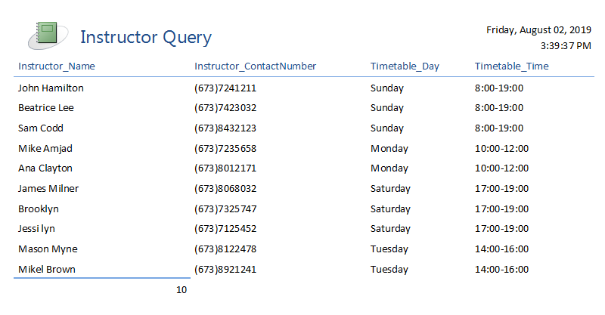
Figure 75.3: Outcome of Test No. 6 (Pass) – Design View

- Selection of students enrolled in a particular subject
Test No. | Date | Test Description | Outcome 1 (Expected) | Outcome 2 (Actual) | Pass/ Fail
7 | 1 August 2019 | To select the student available following with particular student. | Student will available in the particular subject table | The student successfully available in subject table. | Pass
Screenshot of Evidence
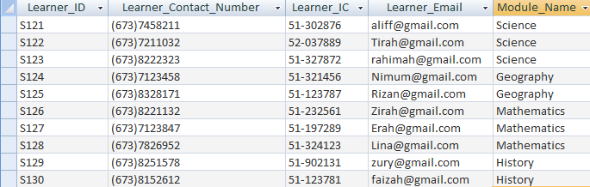
Figure 76.1: Outcome of Test No. 7 (Pass) – Form View
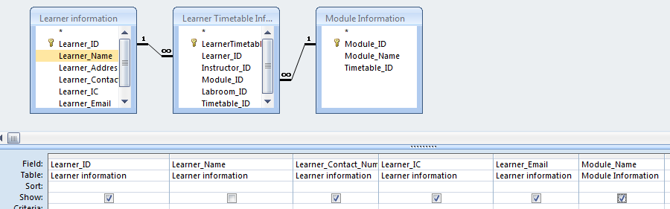
Figure 76.2 : Outcome of Test No. 7 (Pass) – Design View

D2. Evaluate a database against the specified user need.
The aim of this task was to build a database system which will be used to inventory Exel Tuition Center documents. The Exel Tuition Center database system has 6 individuals for each record. Those individuals are Student, Schedule, Subjects, Classroom, Tutor and Student Schedule. In the Student table, I have to put for the student information such as the Learner_ID, Learner_Name, Learner_Address, Learner_Contact_Number, Learner_IC, Learner_Email and Learner_DateofBirth. While the schedule table, is where I have put 4 attributes that were Timetable_ID, Timetable_Day, Timetable_Date and Timetable_time. In Module table, I have inserted the Module_ID, Module_Name and Timetable_ID. While Classroom table, I have typed the Labroom_ID and Labroom_name. In terms of Tutor table, the attributes that I have created are Instructor_ID, Instructor_Name and Instructor_ContactNumber. Lastly but not least the Student Schedule table, I have inserted LearnerTimetable_ID, Learner_ID, Instructor_ID, Module_ID, Labroom_ID, Timetable_ID. The other ID’s on Student Schedule table acts as the foreign key for the reference from the other table and it is used for the database relationships.
Strength of my database design
The strength in this Exel Tuition Centre database is where I have created the features for form that are adding, deleting and save button for the example at figure 30.1. In addition, I also add the menu form where it can go to the learner table, instructor table, labroom table, timetable table, learner schedule timetable and schedule timetable. At the queries, I had make 2 specific queries, 1st queries are the learner name, module name timetable_day and timetable_time with 2 criteria where it only displays when the day is Sunday and around 8 a.m to 19.00 pm. The 2nd queries are the instructor name, timetable date, module name and labroom name where it will only display when the criteria are at 5 Jun 17 and the module name is history. Moreover, I already performed the tests to ensure that the database was working correctly, for instance, I entered valid information into my forms and submitted the data to check that it was being correctly appended into my tables. I also checked that all my validation rules for my forms were working correctly by submitting incorrect data, error messages appeared to show that the validation rules had worked, and the data was not appended into my tables.

Weakness
However, the weaknesses in this Exel Tuition Centre database is that I only use the basic features for this database system and sometimes the feature is not working as the data are invalid or error. In this database system I don’t include multiple buttons onto my form that ran one of several commands such as add new record and undo records. Where I do not sure that the button will working properly simply by clicking them and seeing if the desire outcome was achieved, when appending data from the form in database. Moreover, the database system that I make was too simple where it doesn’t look too nice to see. In addition, for the report where it is used to show data from the database. Where in my report it doesn’t add the button widget for open form where it can display to the other table where it is useful to used. Report is very useful in this situation since it doesn’t require large amount of data from the database. Furthermore, the weakness of my database design is it doesn’t have the switchboard. Switchboard is also important in the database since it allow the user to navigate the forms easily.
Future Improvement
To improve this database, I have to learn on the advanced features of using these database systems that are such as using more automated function in the form design and import or export the Exel Tuition Centre database into Excel file. Moreover, I want to have multiple buttons into my form that ran one of several command like add new and undo records which is more convenient to used. It is useful to ensure that all of the buttons were working properly by clicking them and seeing if the desired outcome was achieved, when appending the data from the form into the database. In addition, I also want to create switchboard which it allows the user navigate easily with the form. Switchboard is consisting of buttons where user may click, these program can be utilized to open forms, reports, queries and many more. Furthermore, I also want to create more button widget into the report to make it easier to open form to the others tables. Reports was useful if the user only need to show a small selection of the database for any purpose, as they prevent the need to scroll through an entire table looking for the information required.

Conclusion

Presently, I remain working as a Junior It Analyst in Cloud IT company, where I had assigned my work on designing and developing a development for Exel Tuition Centre. In Exel Tuition Centre, a student can choose to enroll to several subjects. Upon the enrolment, the student will be given schedules which list the assigned tutor and classroom for each of the subjects, depending on their chosen.
The next method that I already type is to convert the completed database design into an actual working database. Where it will be used for the staffs of Exel tuition Centre record the details of students, subject, schedules, tutor and classrooms.
The database will feature data entry forms for staff to key in information. Staff could then perform queries on the database, for example to produce schedule list for a student. Once the database development was completed, I had then necessary to carry out testing and evaluation to ensure the database was working correctly and fulfils all the requirement needs of Exel Tuition Centre. The following were several sample details of the information currently being stored by Exel Tuition Centre in their spreadsheet-based records. The tables were not yet normalized and may contained data redundancy.

Reference

Oracle physical design unnormalized . 2019. Oracle physical design unnormalized . [ONLINE] Available at: http://www.remote-dba.net/tp_Oracle_physical_design_unnormalized.htm. [Accessed 09 August 2019].
Anon, (2019). [online] Available at: https://wikivisually.com/wiki/Unnormalized_form [Accessed 9 Aug. 2019].
En.wikipedia.org. (2019). Unnormalized form. [online] Available at: https://en.wikipedia.org/wiki/Unnormalized_form [Accessed 9 Aug. 2019].
Techopedia.com. (2019). What is First Normal Form (1NF)? - Definition from Techopedia. [online] Available at: https://www.techopedia.com/definition/25955/first-normal-form-1nf [Accessed 9 Aug. 2019].
Guru99.com. (2019). What is Normalization? 1NF, 2NF, 3NF & BCNF with Examples. [online] Available at: https://www.guru99.com/database-normalization.html [Accessed 9 Aug. 2019].
En.wikipedia.org. (2019). Second normal form. [online] Available at: https://en.wikipedia.org/wiki/Second_normal_form [Accessed 9 Aug. 2019].
Techopedia.com. (2019). What is Second Normal Form (2NF)? - Definition from Techopedia. [online] Available at: https://www.techopedia.com/definition/21980/second-normal-form-2nf [Accessed 9 Aug. 2019].
Support.microsoft.com. (2019). [online] Available at: https://support.microsoft.com/en-us/help/283878/description-of-the-database-normalization-basics [Accessed 9 Aug. 2019].
Webopedia.com. (2019). What is Entity Relationship Diagram? Webopedia Definition. [online] Available at: https://www.webopedia.com/TERM/E/entity_relationship_diagram.html [Accessed 9 Aug. 2019].

