AIRBNB
MARKET ANALYSIS
Data Cleaning • Data Modelling • DAX • Power BI Dashboard

PROJECT REPORT
Prepared from the supplied 27-page project document

Contents
1. Project Overview
2. Data Preparation and Cleaning
3. Final Data Quality Summary
4. Statistical Analysis and Pivot Tables
5. Power BI Data Model
6. DAX Measures
7. Dashboard Design and Analysis
8. Conclusion and Notes
Appendix A. Selected Evidence from the Original Report

1. Project Overview
This project analyses Airbnb listing information through a structured workflow covering data sampling, data cleaning, validation, statistical summaries, data modelling and interactive dashboard development in Power BI. The report documents the steps and decisions recorded in the supplied project file.

1.1 Project objectives
- Prepare a manageable working sample from the original dataset.
- Identify and handle duplicate records, missing values, formula errors and invalid numerical values.
- Retain unknown values as blanks where the true value cannot be reliably established.
- Prepare statistical summaries and Pivot Tables for analysis.
- Build a star-schema-style Power BI model with FactListings and supporting dimension tables.
- Create DAX measures and three dashboard pages covering market overview, pricing and property analysis, and availability and customer reviews.

1.2 Dataset preparation
Stage | Activity | Recorded result
1 | Random sampling | 10,000 records selected from 102,599 original records.
2 | Create Cleaned_Data | A separate working copy was created from Sample_Data.
3 | Remove duplicates | 5 exact duplicate rows removed; 9,995 records remained.
4 | Missing-value analysis | Missing values were identified across the dataset.
5 | Remove License | License column removed because all 9,995 values were blank.

2. Data Preparation and Cleaning
The cleaning approach prioritised data integrity. Values were replaced only when a consistent value or a suitable category was supported by the available records. Where the true value could not be established, blanks were retained rather than estimated.

2.1 Categorical columns
Column(s) | Issue identified | Action recorded
House Rules | 5,065 blank entries and #NAME? entries. | Replaced with “Not provided”.
Host Name | 42 missing cells and some #NAME? errors. | Replaced with “Unknown”.
Host Identity Verified | 24 blank entries and some #NAME? errors. | Replaced with “Unknown”.
Neighbourhood Group / Neighbourhood | 3 missing values in each column. | Replaced missing categorical values with “Unknown”.
Country / Country Code | 51 missing Country values and 10 missing Country Code values. | Filled with “United States” and “US”, based on consistency of the existing records.
Name | 19 missing listing names and 3 #NAME? records. | Replaced with “Unknown”.
Instant Bookable | 8 missing values. | Replaced with “Unknown”.
Cancellation Policy | 6 missing values. | Replaced with “Unknown”.

2.2 Review-related columns
The Number of Reviews column contained 18 missing values. These were checked against Last Review and Reviews per Month. Missing review counts were retained when the available fields did not support a reliable replacement.
Record condition | Action
Number of reviews = 0, Last Review blank, and Reviews per Month blank | Replace Reviews per Month with 0.
Number of reviews = 0, but Reviews per Month contains a value | Retain the existing value.
Reviews per Month blank, but Number of Reviews is greater than 0 | Retain the blank and investigate; do not assume a value.
Last Review blank but Reviews per Month has a value | Retain the existing monthly review value.

Reviews per Month originally contained 1,544 missing values. After cross-checking Number of Reviews and Last Review, missing monthly review values for records with zero reviews and no review date were replaced with zero. Existing monthly review activity was preserved. Thirteen missing values remained and were retained.

2.3 Numerical and date-related columns
Column | Issue / validation | Decision
Construction Year | 15 missing values; available years ranged from 2003 to 2022. | Retained the 15 blanks; no construction year was assumed.
Minimum Nights | 44 missing values; no zero or negative values. Values such as 182, 227 and 335 were observed. | Retained missing values and high values. Two values, 366 and 480, were flagged for investigation.
Review Rate Number | 32 missing values. | Retained blanks because no reliable replacement was available.
Price | 25 missing values; no zero or negative values detected. | Converted currency text to numeric values; retained missing prices as blanks.
Service Fee | 23 missing values; no zero or negative values detected. | Converted currency text to numeric values; retained missing fees as blanks.
Calculated Host Listings Count | 38 missing values. | Retained missing values because the actual counts could not be established.
Latitude / Longitude | One listing had both coordinates missing. | Retained both values as blank; no artificial coordinates were introduced.

2.4 Availability validation
Availability 365 was expected to contain values from 0 to 365. The column initially contained 53 missing values, 38 negative values (ranging from -10 to -1), and 261 values above 365. The 38 negative values and 261 values exceeding 365 were converted to blanks. All listing records were retained.
The two unusually high Minimum Nights values (366 and 480) were retained and flagged for investigation rather than automatically removed. The report records no zero or negative Minimum Nights values.

2.5 Data type and formula checks
- Price and Service Fee were converted from text-based currency values to numeric data types for calculations and visualisation.
- Missing Price and Service Fee values were preserved as blanks rather than replaced with zero.
- A final formula-error check was performed; no Excel formula errors remained.

3. Final Data Quality Summary
Data quality item | Recorded result
Initial sample | 10,000 records
Duplicate records removed | 5
Final cleaned records | 9,995
License column removed | 1 column; all 9,995 values were blank
Negative Availability 365 values corrected | 38
Availability 365 values above 365 corrected | 261
Formula errors remaining | 0
Final Availability 365 missing-value count | 352

The final missing-value review confirmed that categorical fields such as host name, verification status, neighbourhood, country, country code, instant booking, cancellation policy and house rules were addressed using supported replacement values. Missing numerical, review, date and coordinate values were retained where reliable source information was unavailable.

4. Statistical Analysis and Pivot Tables
The original report records that statistical measures were calculated and Pivot Tables were created to support the dashboard. The supplied report includes screenshots of the calculated measures and Pivot Tables, but does not provide a complete written list of all Pivot Table results in editable text.
- Statistical summaries were prepared from the cleaned dataset.
- Pivot Tables were used to summarise listing counts and averages across selected categories.
- The Pivot Table evidence is included in Appendix A.

5. Power BI Data Model
The Power BI model was refined around FactListings as the central fact table. Separate dimension tables were maintained for host, location, room type and cancellation policy. The Cleaned_Data table was retained as a reference.
Redundant relationships connected to the Cleaned_Data reference table were removed to maintain a clear star-schema structure and avoid unnecessary filtering paths. The original report also includes screenshots documenting relationship verification and model refinement.

6. DAX Measures
The following measures are reproduced from the supplied report. They are intended to support KPI cards and further analysis in the Airbnb dashboard.
Total Listings
Total Listings = DISTINCTCOUNT(FactListings[id])
Average Price
Average Price = AVERAGE(FactListings[price])
Average Service Fee
Average Service Fee = AVERAGE(FactListings[service fee])
Average Availability
Average Availability = AVERAGE(FactListings[availability 365])
Total Reviews
Total Reviews = SUM(FactListings[number of reviews])
Average Reviews
Average Reviews = AVERAGE(FactListings[number of reviews])
Average Minimum Nights
Average Minimum Nights = AVERAGE(FactListings[minimum nights])
Average Rating
Average Rating = AVERAGE(FactListings[review rate number])
Total Hosts
Total Hosts = DISTINCTCOUNT(FactListings[host id])
Average Reviews per Month
Average Reviews per Month = AVERAGE(FactListings[reviews per month])

7. Dashboard Design and Analysis
Three Power BI dashboard pages are documented in the supplied report. The following descriptions reflect the visuals and interactive controls recorded in that report.

7.1 Market Overview
- Four KPI cards: total listings, distinct hosts, average listing price and average availability.
- Doughnut chart: distribution of listings across room types.
- Horizontal bar chart: listing counts across neighbourhood groups.
- Column chart: listing distribution by cancellation policy.
- Interactive slicers: neighbourhood group and room type.
The Market Overview page provides a high-level view of listings, host participation, pricing, availability, room types, geographical distribution and cancellation policies.

7.2 Pricing and Property Analysis
- Four KPI cards: average price, median price, average service fee and average minimum nights.
- Clustered bar chart: average listing price by room type.
- Column chart: average listing price by neighbourhood group.
- Bar chart: average service fee by room type.
- Column chart: average minimum-night requirements by room type.
- Interactive slicers: neighbourhood group and room type.
This page compares pricing, service fees and minimum-night requirements across room types and geographical areas.

7.3 Availability and Customer Reviews
- Four KPI cards: total reviews, average reviews, average monthly reviews and average review rating.
- Horizontal bar chart: average listing availability by room type.
- Column chart: total guest reviews by room type.
- Bar chart: average review ratings by neighbourhood group.
- Interactive slicers: neighbourhood group and room type.
This page explores property availability, guest review activity and customer ratings across listing categories and neighbourhood groups.

8. Conclusion and Notes
The project documents an end-to-end Airbnb listing analysis workflow, from sampling and cleaning through modelling, DAX development and Power BI dashboard creation. The working dataset was reduced to 9,995 records after removing five exact duplicates. The License column was removed because it was entirely blank, invalid Availability 365 values were converted to blanks, and the final formula-error check reported zero remaining errors.
A key data-quality principle applied throughout the work was to avoid inventing values. Where a reliable replacement could not be determined, missing values were retained. The Power BI model used FactListings as its central fact table with separate dimensions for host, location, room type and cancellation policy. Ten DAX measures and three dashboard pages were documented.
Note: The source report describes the dashboard components but does not provide the final numerical KPI values or written findings such as which room type or neighbourhood group ranked highest. Those results should be added only after checking the underlying Power BI report or dataset.

Appendix A. Selected Evidence from the Original Report
The following page images preserve selected screenshots and supporting evidence from the original PDF. The main report above is editable Word text; these evidence pages are included as images for visual reference.

Cleaning evidence: duplicate and missing-value checks
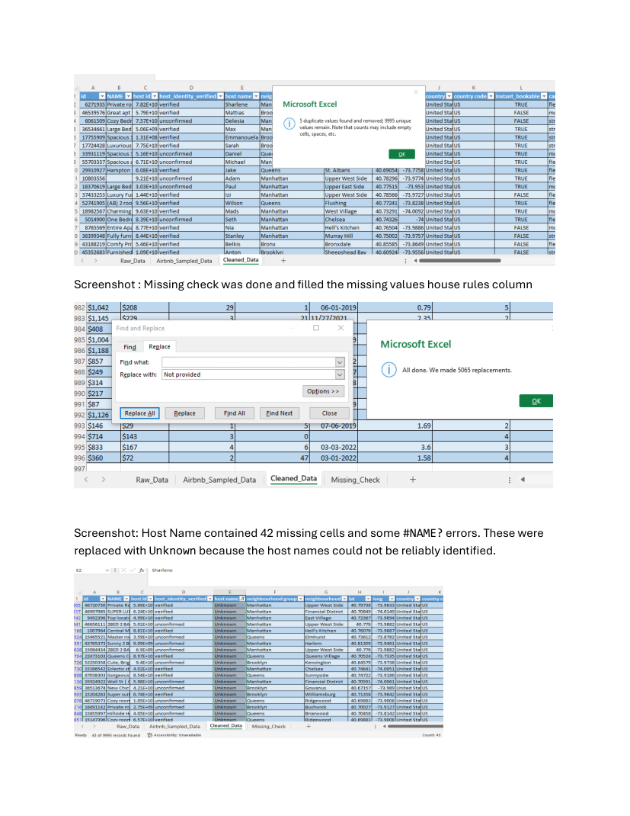

Cleaning evidence: host, neighbourhood and country fields
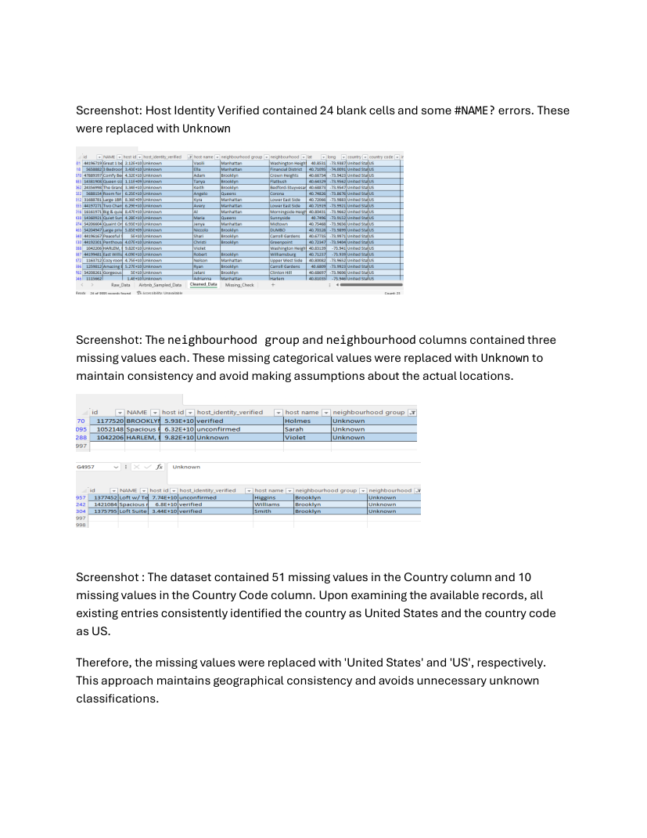

Missing-value inventory and review-count investigation
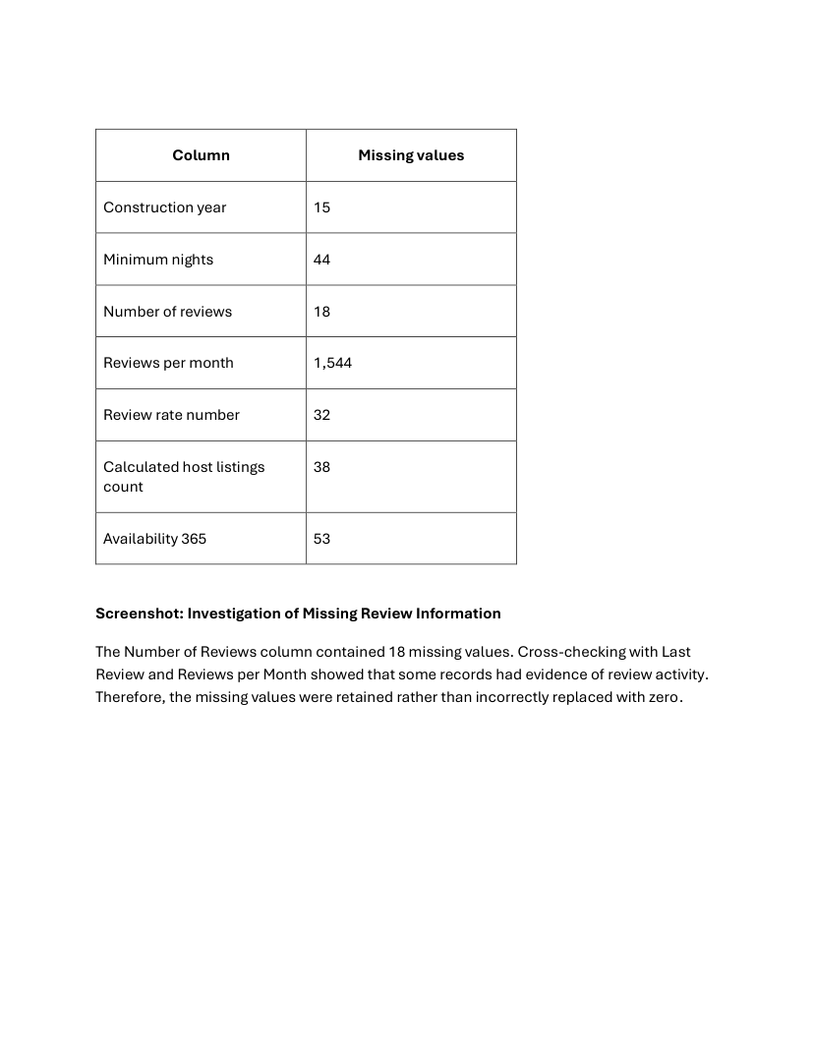

Review-per-month cleaning rules
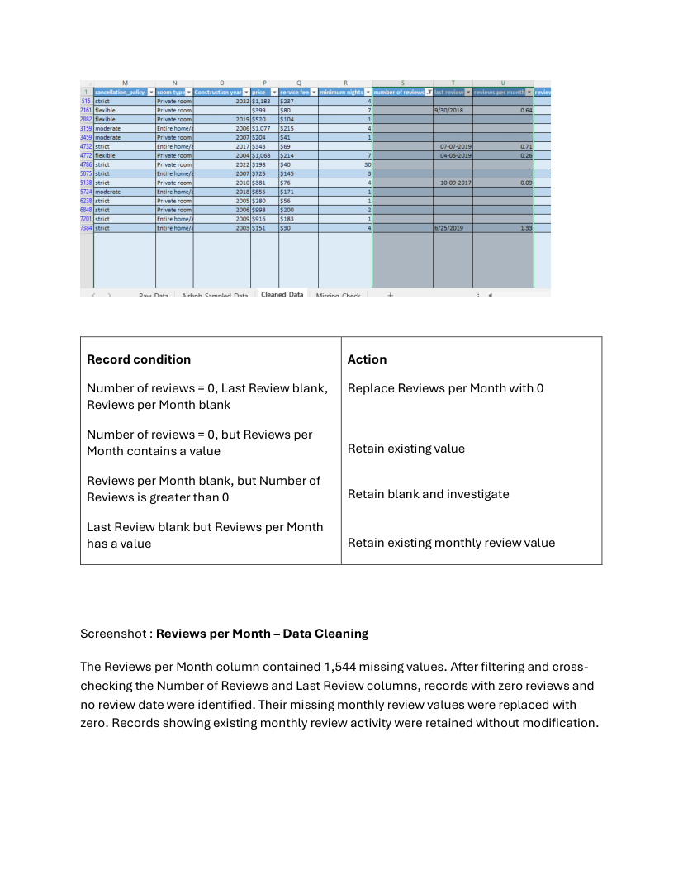

Review and construction-year cleaning
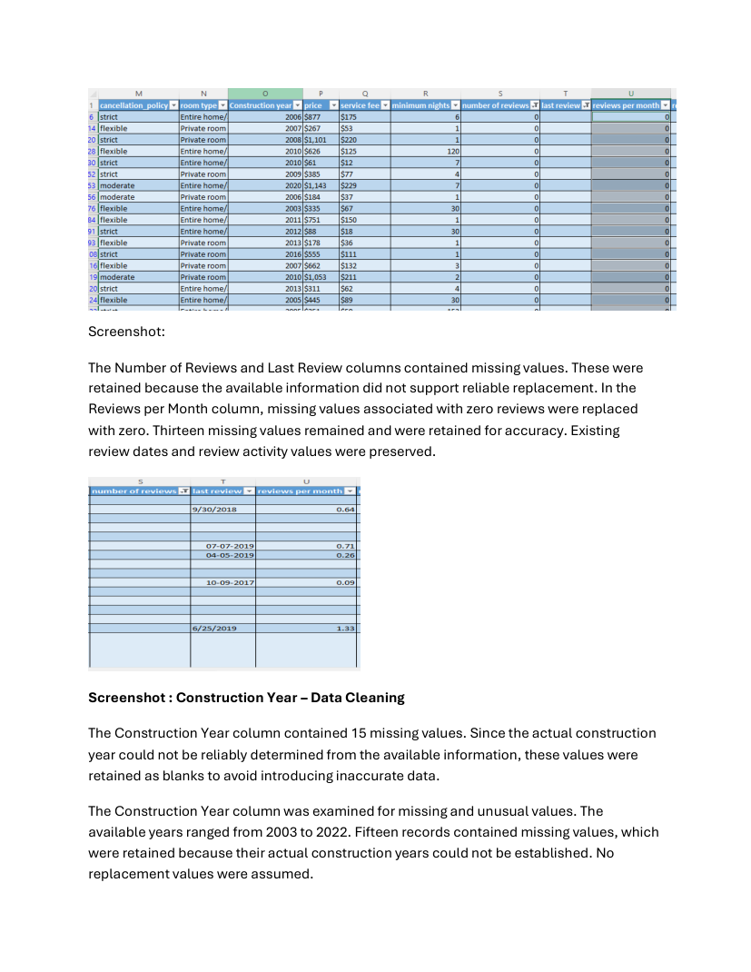

Construction-year and minimum-night validation
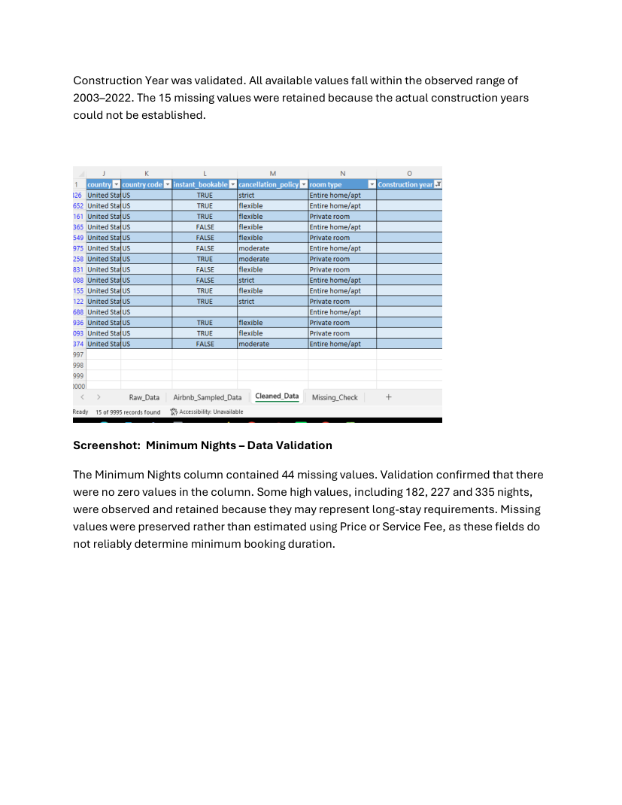

Price and service-fee conversion and validation
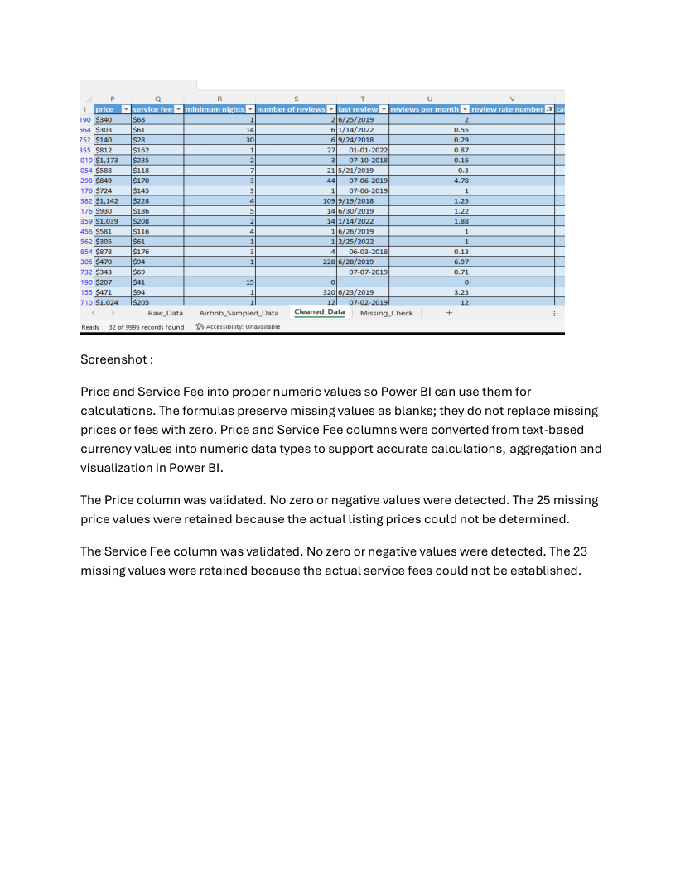

Coordinates, host listing counts and negative availability values
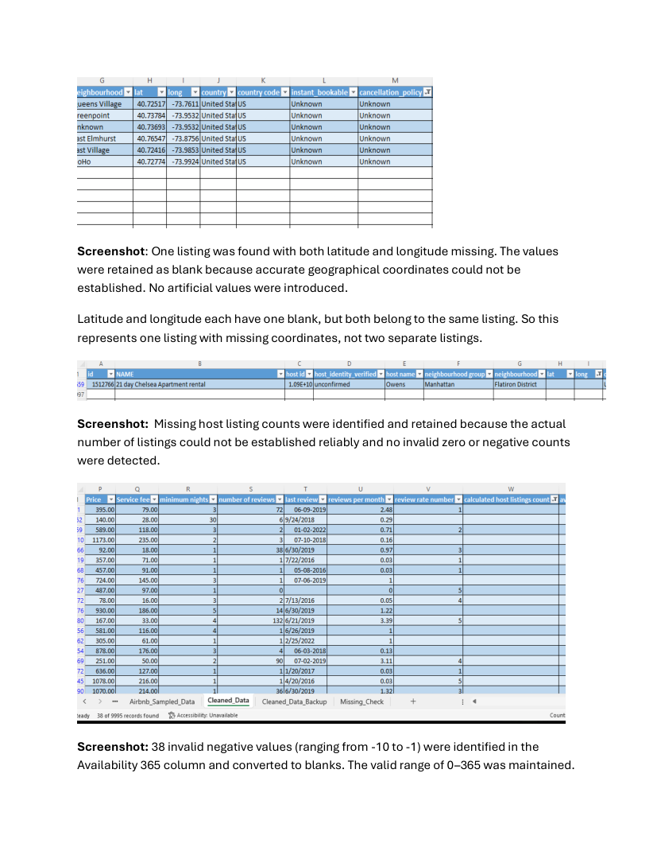

Availability values above 365 and unusual minimum stays
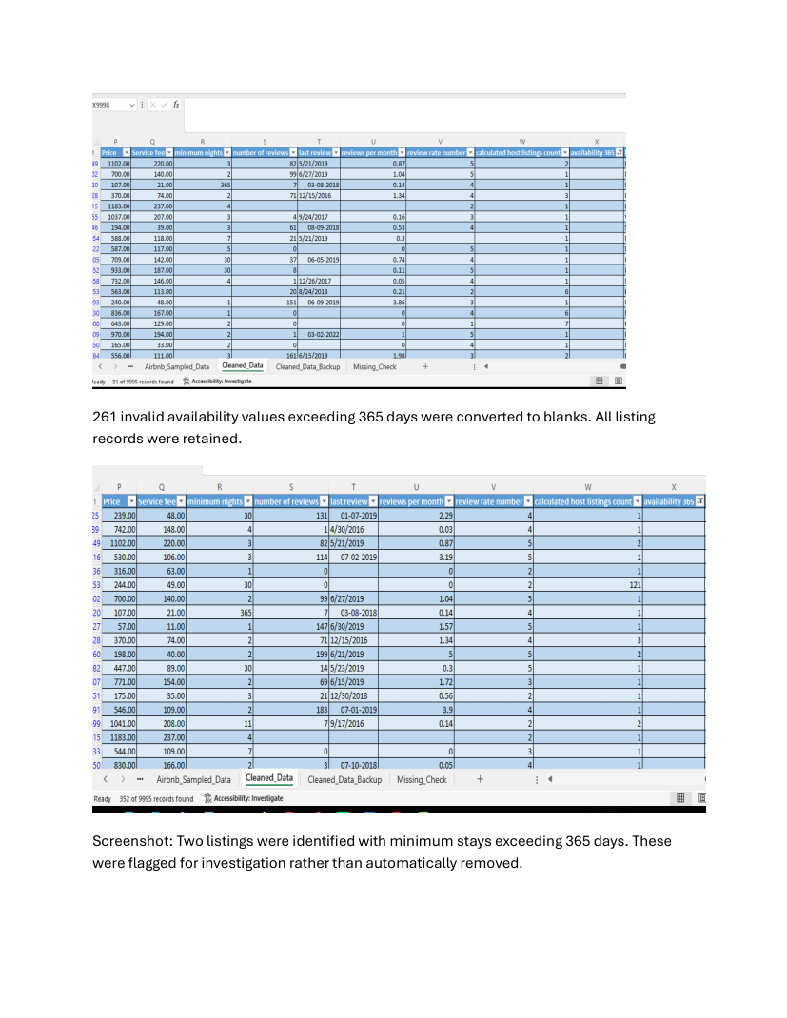

Final missing-value analysis
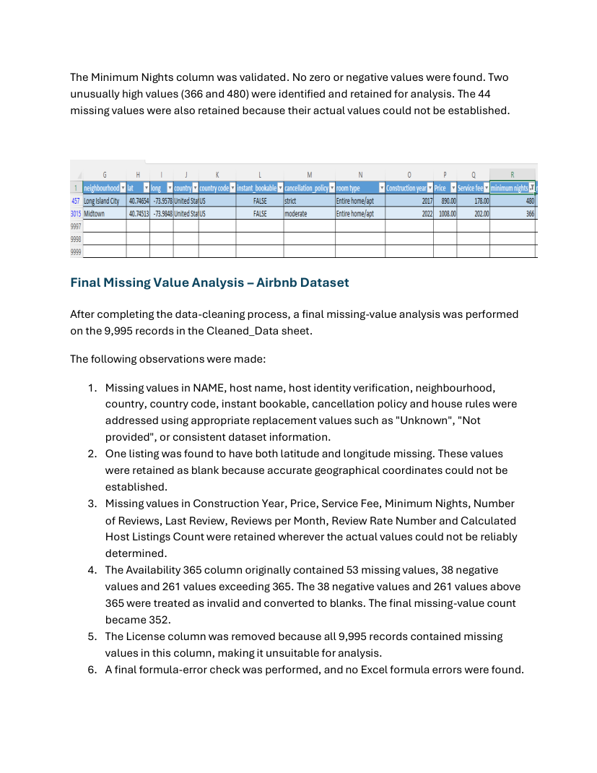

Pivot Table evidence
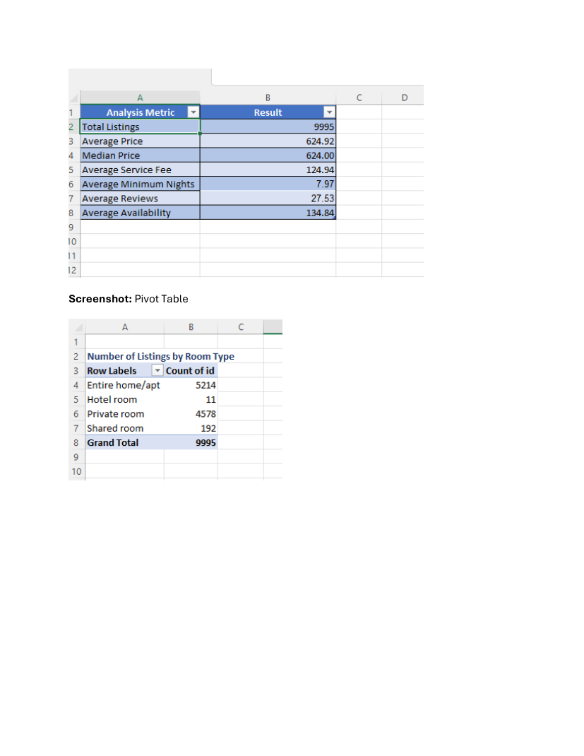

Power BI relationship verification
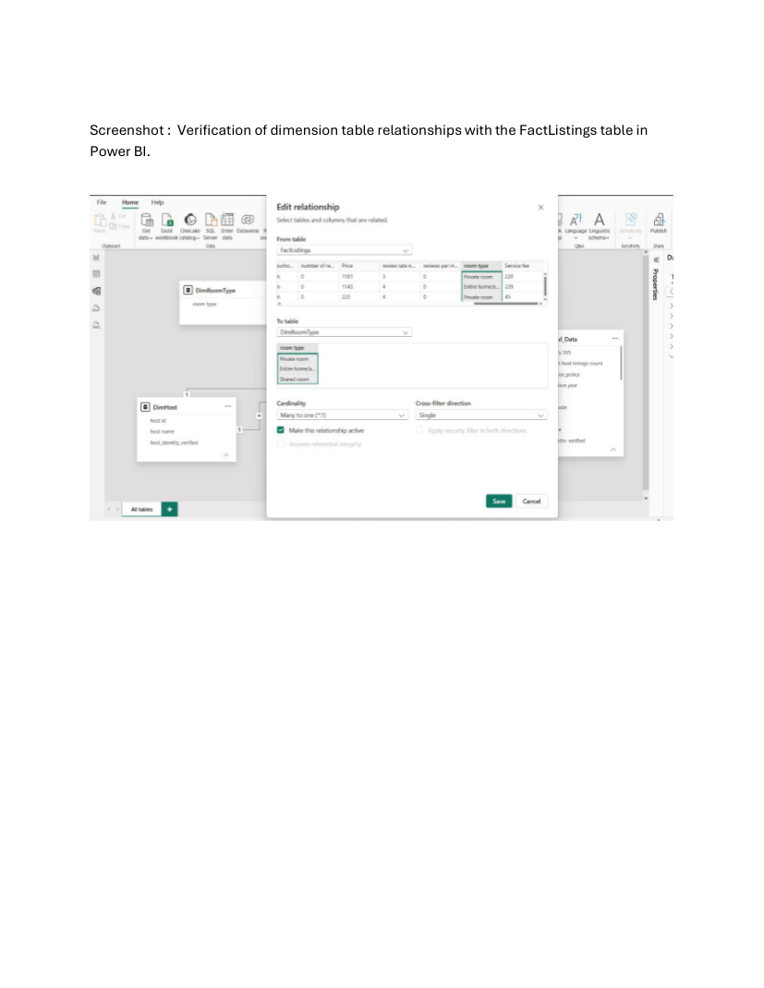

Refined Power BI data model
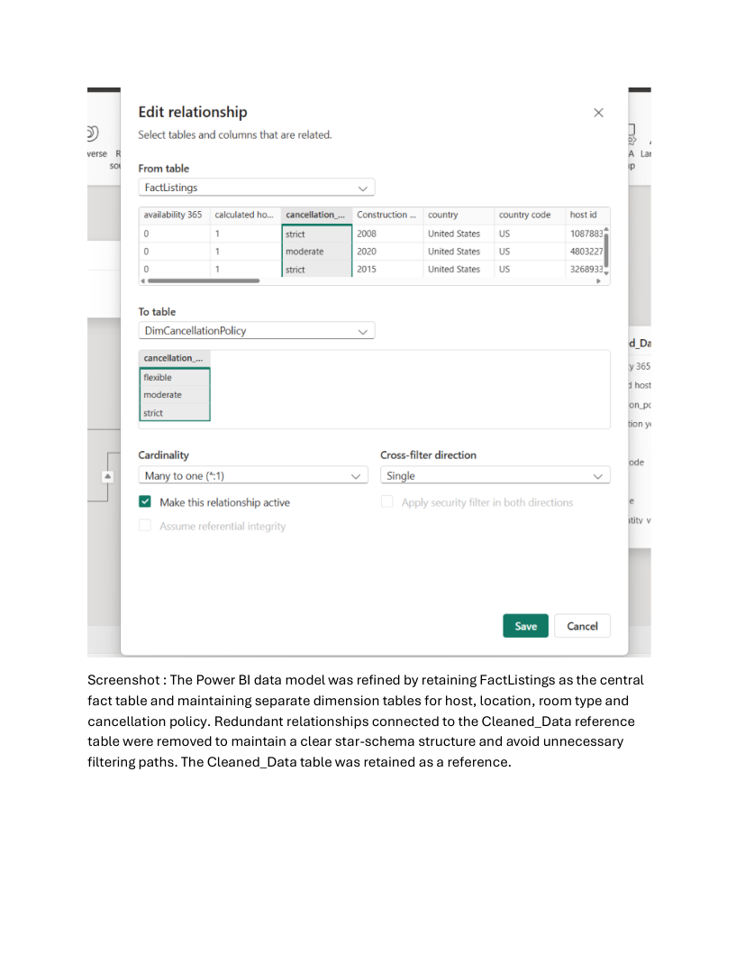

DAX measures and model screenshot
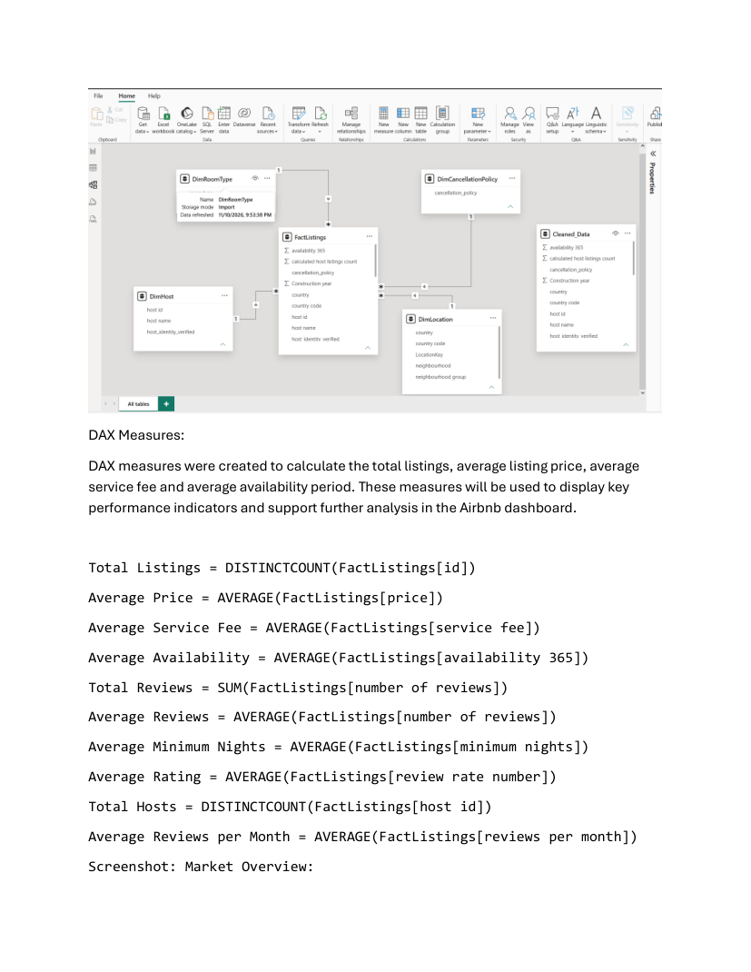

Market Overview dashboard
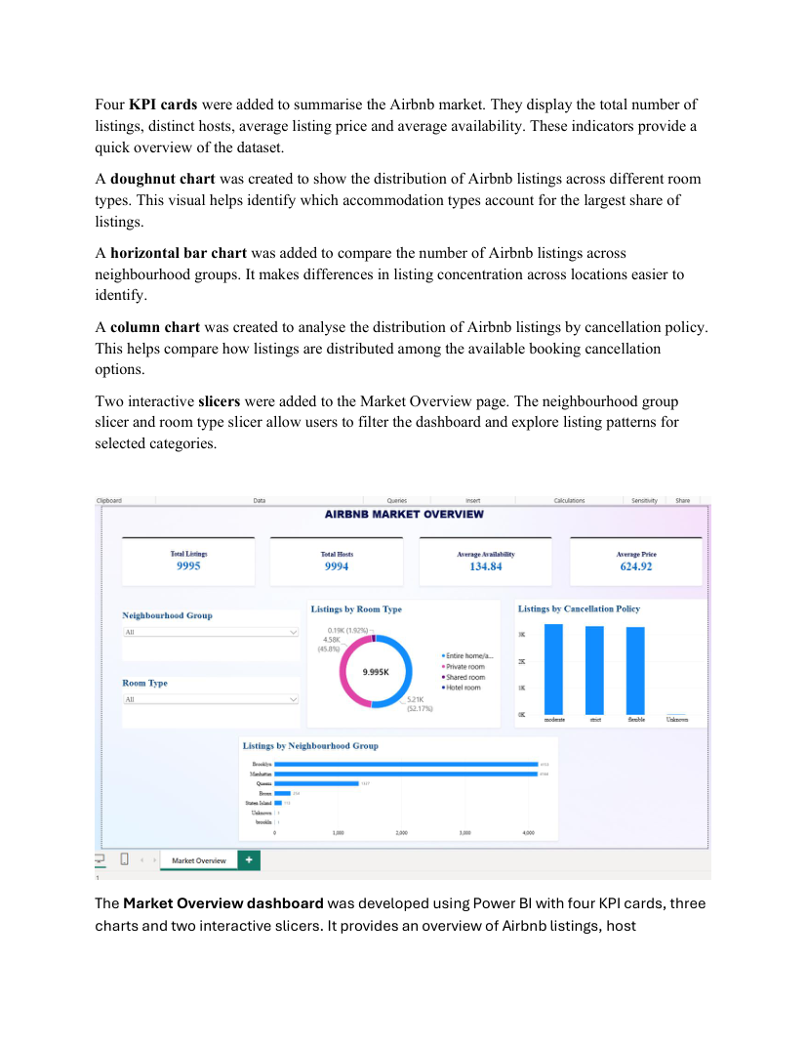

Pricing and Property Analysis dashboard
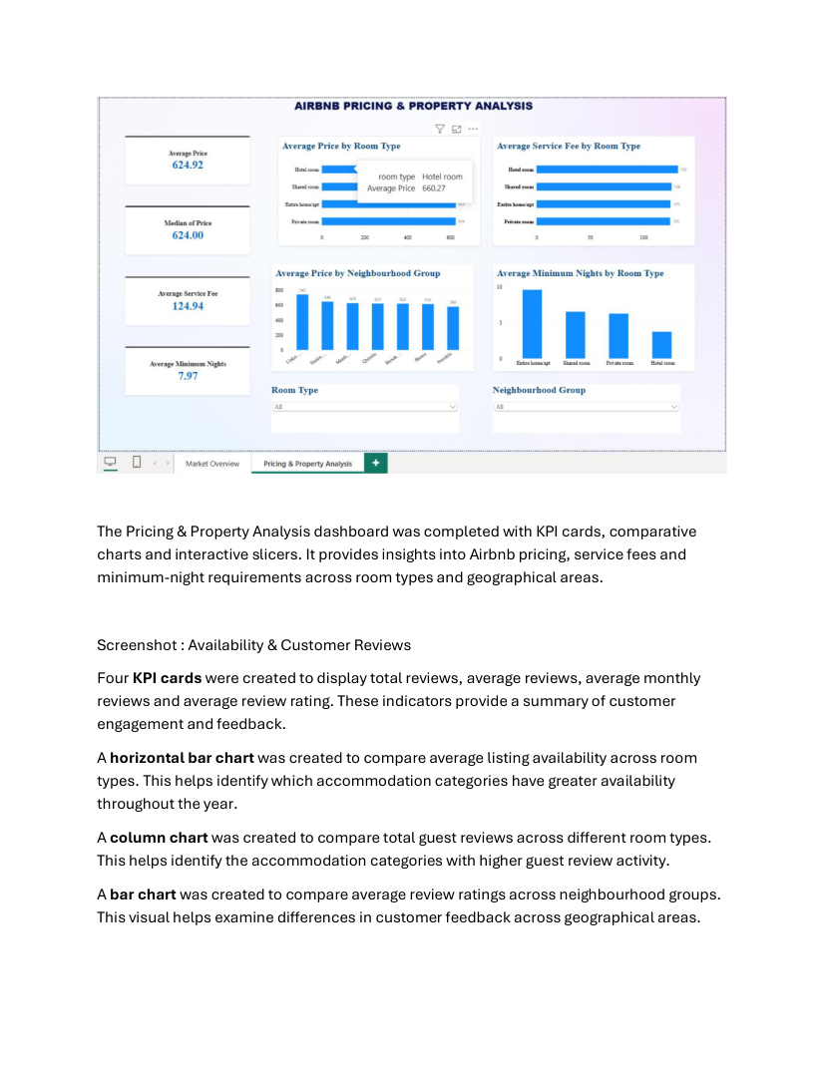

Availability and Customer Reviews dashboard


