DATA ANALYTICS MINI PROJECT

AIRBNB MARKET ANALYSIS
A practical project using Microsoft Excel and Power BI
DATA CLEANING • DATA MODELLING • DAX • DASHBOARDING

Project | Airbnb Market Analysis
Tools | Microsoft Excel and Microsoft Power BI

1. Project Overview and Objective
This project analyses Airbnb listing data using Excel for data cleaning, validation and preliminary analysis, and Power BI for data modelling, DAX calculations and interactive visualisation. The objective is to explore listing distribution, pricing, accommodation types, availability and guest-review patterns to support market-level understanding.

2. Data Sources
Dataset described in the project evidence: Airbnb Open Data, attributed to Ariana Zmoudeh on Kaggle.
Potential matching source URL: https://www.kaggle.com/datasets/arianazmoudeh/airbnbopendata
The project report records 102,599 original records and a 10,000-record working sample. The supplied project evidence does not independently confirm the exact download URL or dataset licence. Verify the source page and its licence before redistributing the raw or cleaned data.

3. Problem Statement
- How are Airbnb listings distributed across neighbourhood groups and room types?
- How do listing prices and service fees vary across room types and locations?
- How do minimum-night requirements and availability differ across listings?
- What patterns are visible in guest reviews and review ratings?
- How are listings distributed across cancellation policies and host characteristics?

4. Attribute (Column / Feature) Details
The cleaned dataset contains 25 columns. The following table describes key analytical fields; field names should be checked against the workbook before final submission.
Attribute | Data type | Description
id | Integer / identifier | Unique identifier for an Airbnb listing.
host id | Integer / identifier | Identifier for the listing host.
host name | Categorical | Name associated with the host.
neighbourhood group | Categorical | Higher-level geographic grouping.
neighbourhood | Categorical | Neighbourhood associated with the listing.
latitude / longitude | Decimal | Geographic coordinates of the listing.
room type | Categorical | Type of accommodation offered.
price | Numeric / currency | Listing price.
service fee | Numeric / currency | Service fee associated with the listing.
minimum nights | Whole number | Minimum required nights for a stay.
number of reviews | Whole number | Total number of reviews recorded.
reviews per month | Decimal | Average monthly review count.
review rate number | Numeric | Review rating value.
availability 365 | Whole number | Availability days in a 365-day period.
cancellation_policy | Categorical | Cancellation policy assigned to the listing.

5. Tools & Technologies
- Microsoft Excel: sampling, data cleaning, missing-value review, validation, summary analysis and Pivot Tables.
- Microsoft Power BI: data modelling, relationships, DAX measures, report pages, slicers and visualisations.

6. Data Pre-Processing (Excel)
The project report documents a 10,000-record sample taken from the stated 102,599-record source. Five exact duplicate rows were removed, leaving 9,995 records in the cleaned sample.
- Removed the License column because all values in the cleaned sample were blank.
- Standardised missing or error values in selected text fields using labels such as Unknown or Not provided.
- Converted Price and Service Fee values to numeric values; retained unresolved blanks.
- Retained missing values where the true value could not be established rather than inserting unsupported estimates.
- Checked Availability 365 against the 0–365 range; 38 negative and 261 above-365 values were converted to blanks.
- The report records zero remaining Excel formula errors after validation.

7. Data Modelling and DAX (Power BI)
The documented model uses FactListings as the central fact table with dimension tables for Host, Location, Room Type and Cancellation Policy. Cleaned_Data is retained as a reference table. The supplied model screenshot shows these tables and their relationship layout. Confirm relationship cardinality, filter direction and key uniqueness in Power BI Model view before submission.

DAX measures documented in the project
- Total Listings = DISTINCTCOUNT(FactListings[id])
- Average Price = AVERAGE(FactListings[price])
- Average Service Fee = AVERAGE(FactListings[service fee])
- Average Availability = AVERAGE(FactListings[availability 365])
- Total Reviews = SUM(FactListings[number of reviews])
- Average Reviews = AVERAGE(FactListings[number of reviews])
- Average Minimum Nights = AVERAGE(FactListings[minimum nights])
- Average Rating = AVERAGE(FactListings[review rate number])
- Total Hosts = DISTINCTCOUNT(FactListings[host id])
- Average Reviews per Month = AVERAGE(FactListings[reviews per month])

7.1 Data Model – Power BI Model View
Actual model screenshot supplied for this project. The diagram shows FactListings connected to DimHost, DimLocation, DimRoomType and DimCancellationPolicy. Cleaned_Data is visible separately as a reference table in the supplied screenshot.
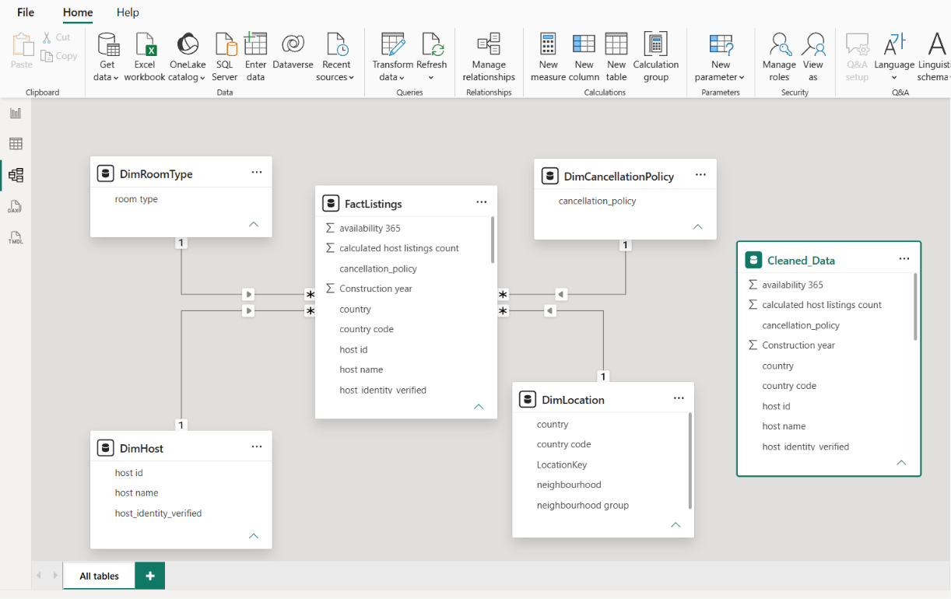
Figure 1. Airbnb Market Analysis – Power BI relationship model (screenshot provided).

8. Analysis and Visualizations (Power BI)
The project report describes three dashboard pages:
- Market Overview – high-level listing and market summary.
- Pricing & Property Analysis – pricing, service fee and property-type comparisons.
- Availability & Customer Reviews – availability, review volume and rating analysis.

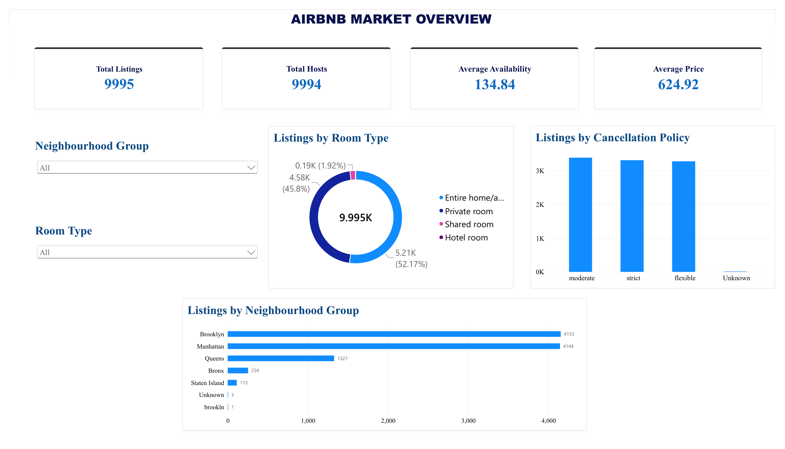
Figure 2. Airbnb Market Overview dashboard.
The overview page summarises 9,995 listings and 9,994 hosts. The displayed average availability is 134.84 days and the average price is 624.92. Charts compare listings by room type, cancellation policy and neighbourhood group.
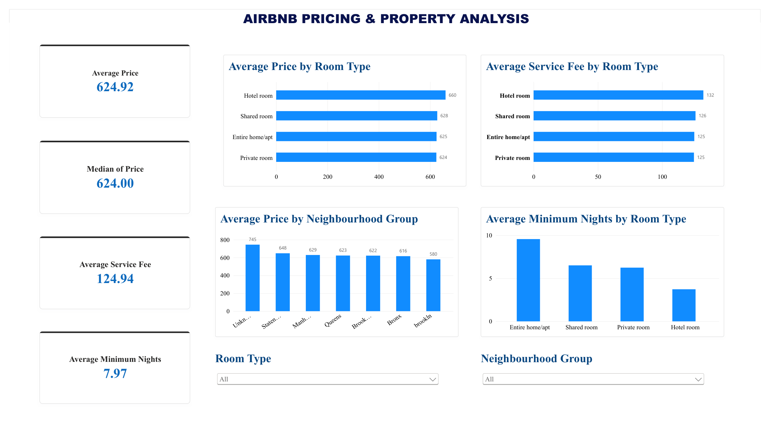
Figure 3. Airbnb Pricing & Property Analysis dashboard.
The pricing page displays an average price of 624.92, a median price of 624.00 and an average service fee of 124.94. Comparisons show average price and service fee by room type, average price by neighbourhood group and average minimum nights by room type.
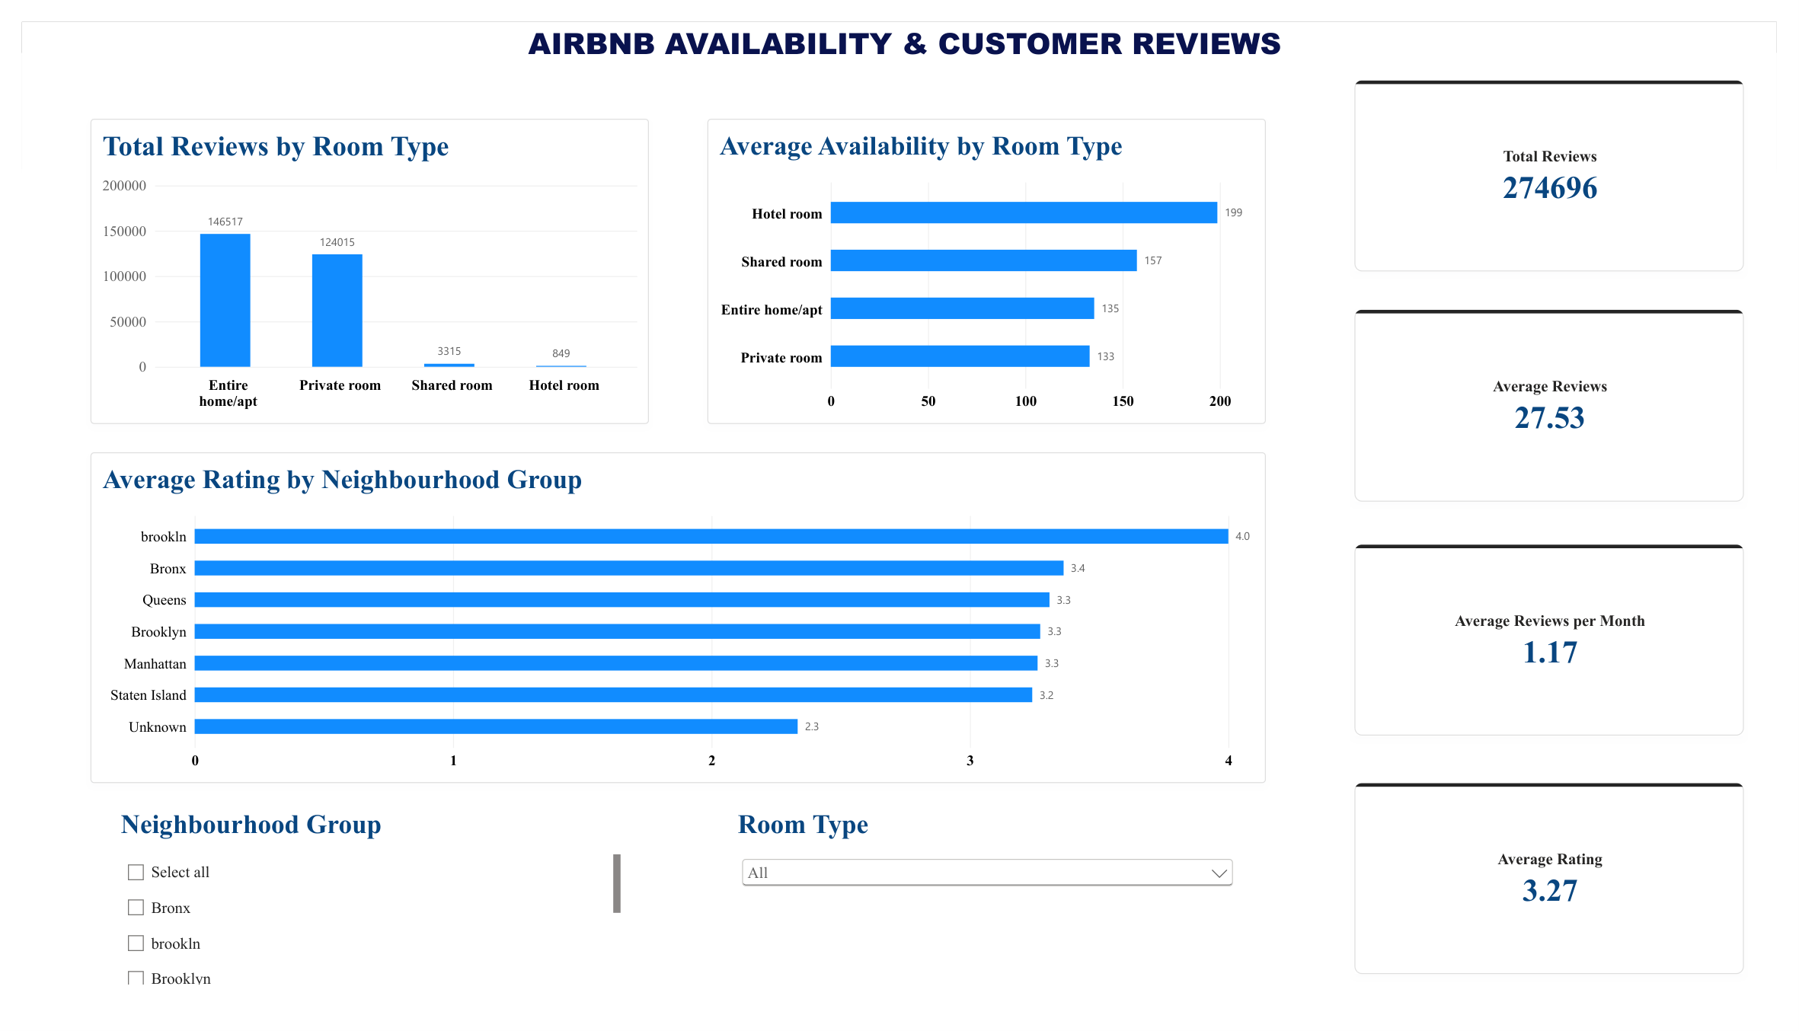
Figure 4. Airbnb Availability & Customer Reviews dashboard.
The review page displays 274,696 total reviews, 27.53 average reviews, 1.17 average reviews per month and a 3.27 average rating. Charts compare review totals and availability by room type and average rating by neighbourhood group.

9. Insights & Conclusions
The supplied project documentation identifies the analysis dimensions and dashboard pages, but it does not provide verified numerical rankings or a written list of final category-level findings. Therefore, the following are the supported insight areas rather than invented results:
- Descriptive: compare listing counts by neighbourhood group and room type; report the actual values shown in the dashboard.
- Diagnostic: investigate differences in price, service fee, availability and reviews across listing categories.
- Predictive: the current project is descriptive/exploratory; no forecasting model is documented.
- Prescriptive: use verified dashboard patterns to guide further market investigation; do not claim causal recommendations without supporting analysis.

10. Conclusions
The project demonstrates an end-to-end analytical workflow using Excel and Power BI: preparing a sample, cleaning and validating data, documenting data-quality decisions, creating summary analysis, modelling fact and dimension tables, defining DAX measures and presenting interactive dashboards. The final submission should include the cleaned workbook, editable PBIX file, dashboard export PDF, this project template document and the separate data-model PDF.

