AIRBNB MARKET ANALYSIS

Power BI Dashboard Observation
Dashboard pages, KPI observations and visual interpretation
DATA CLEANING • EXCEL • POWER BI • ANALYSIS

1. Objective
I used Power BI to model the cleaned Airbnb listing data, create DAX measures and build an interactive report. The report is organised into three pages so that the market overview, pricing patterns, availability and guest review information can be explored separately.

2. Data model and measures
The model is organised around FactListings with supporting dimensions for Host, Location, Room Type and Cancellation Policy. Cleaned_Data is retained separately as a reference table in the supplied Model View screenshot. The documented DAX measures cover listing counts, average price, service fee, availability, reviews, minimum nights, ratings, hosts and monthly reviews.
Model table | Role in the model
FactListings | Central listing-level fact table used for report calculations.
DimHost | Host-related descriptive attributes.
DimLocation | Country, neighbourhood and neighbourhood group attributes.
DimRoomType | Room type category.
DimCancellationPolicy | Cancellation policy category.
Cleaned_Data | Separate reference table visible in the supplied Model View screenshot.

3. Dashboard Page 1 – Airbnb Market Overview
The first page provides a high-level summary of the listing sample. It includes KPI cards for Total Listings, Total Hosts, Average Availability and Average Price. The visuals show listings by room type, cancellation policy and neighbourhood group. Neighbourhood Group and Room Type slicers allow the displayed results to be filtered.
KPI / visual | Observed result or purpose
Total Listings | 9,995
Total Hosts | 9,994
Average Availability | 134.84 days
Average Price | 624.92
Listings by Room Type | Entire home/apt and Private room form the largest groups.
Listings by Neighbourhood Group | Brooklyn and Manhattan have the largest listing counts in the chart.
Listings by Cancellation Policy | Compares listing counts across moderate, strict, flexible and Unknown policies.
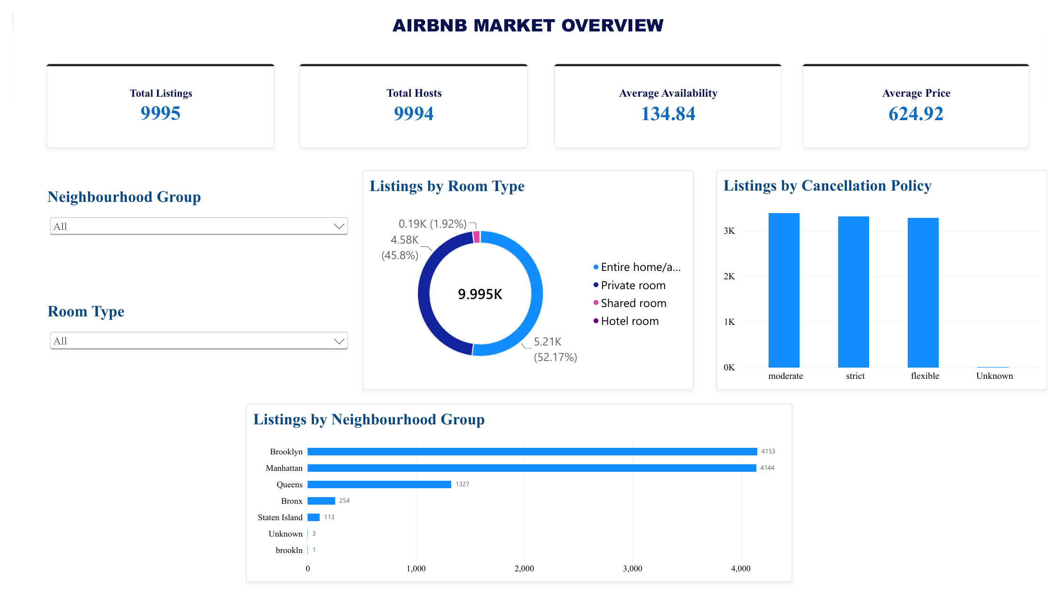
Figure 1. Airbnb Market Overview dashboard page.

4. Dashboard Page 2 – Airbnb Pricing & Property Analysis
The second page focuses on listing price and property characteristics. KPI cards display Average Price, Median Price, Average Service Fee and Average Minimum Nights. Bar and column charts compare average price by room type and neighbourhood group, average service fee by room type, and average minimum nights by room type. Room Type and Neighbourhood Group slicers support category-level comparisons.
KPI | Observed result
Average Price | 624.92
Median Price | 624.00
Average Service Fee | 124.94
Average Minimum Nights | 7.97 nights
In the displayed chart, Hotel room has the highest average price among the room types shown (approximately 660), while the other room types are grouped around 624–628. Hotel room also shows the highest average service fee in the visual. Entire home/apt has the highest average minimum-night requirement in the displayed comparison.
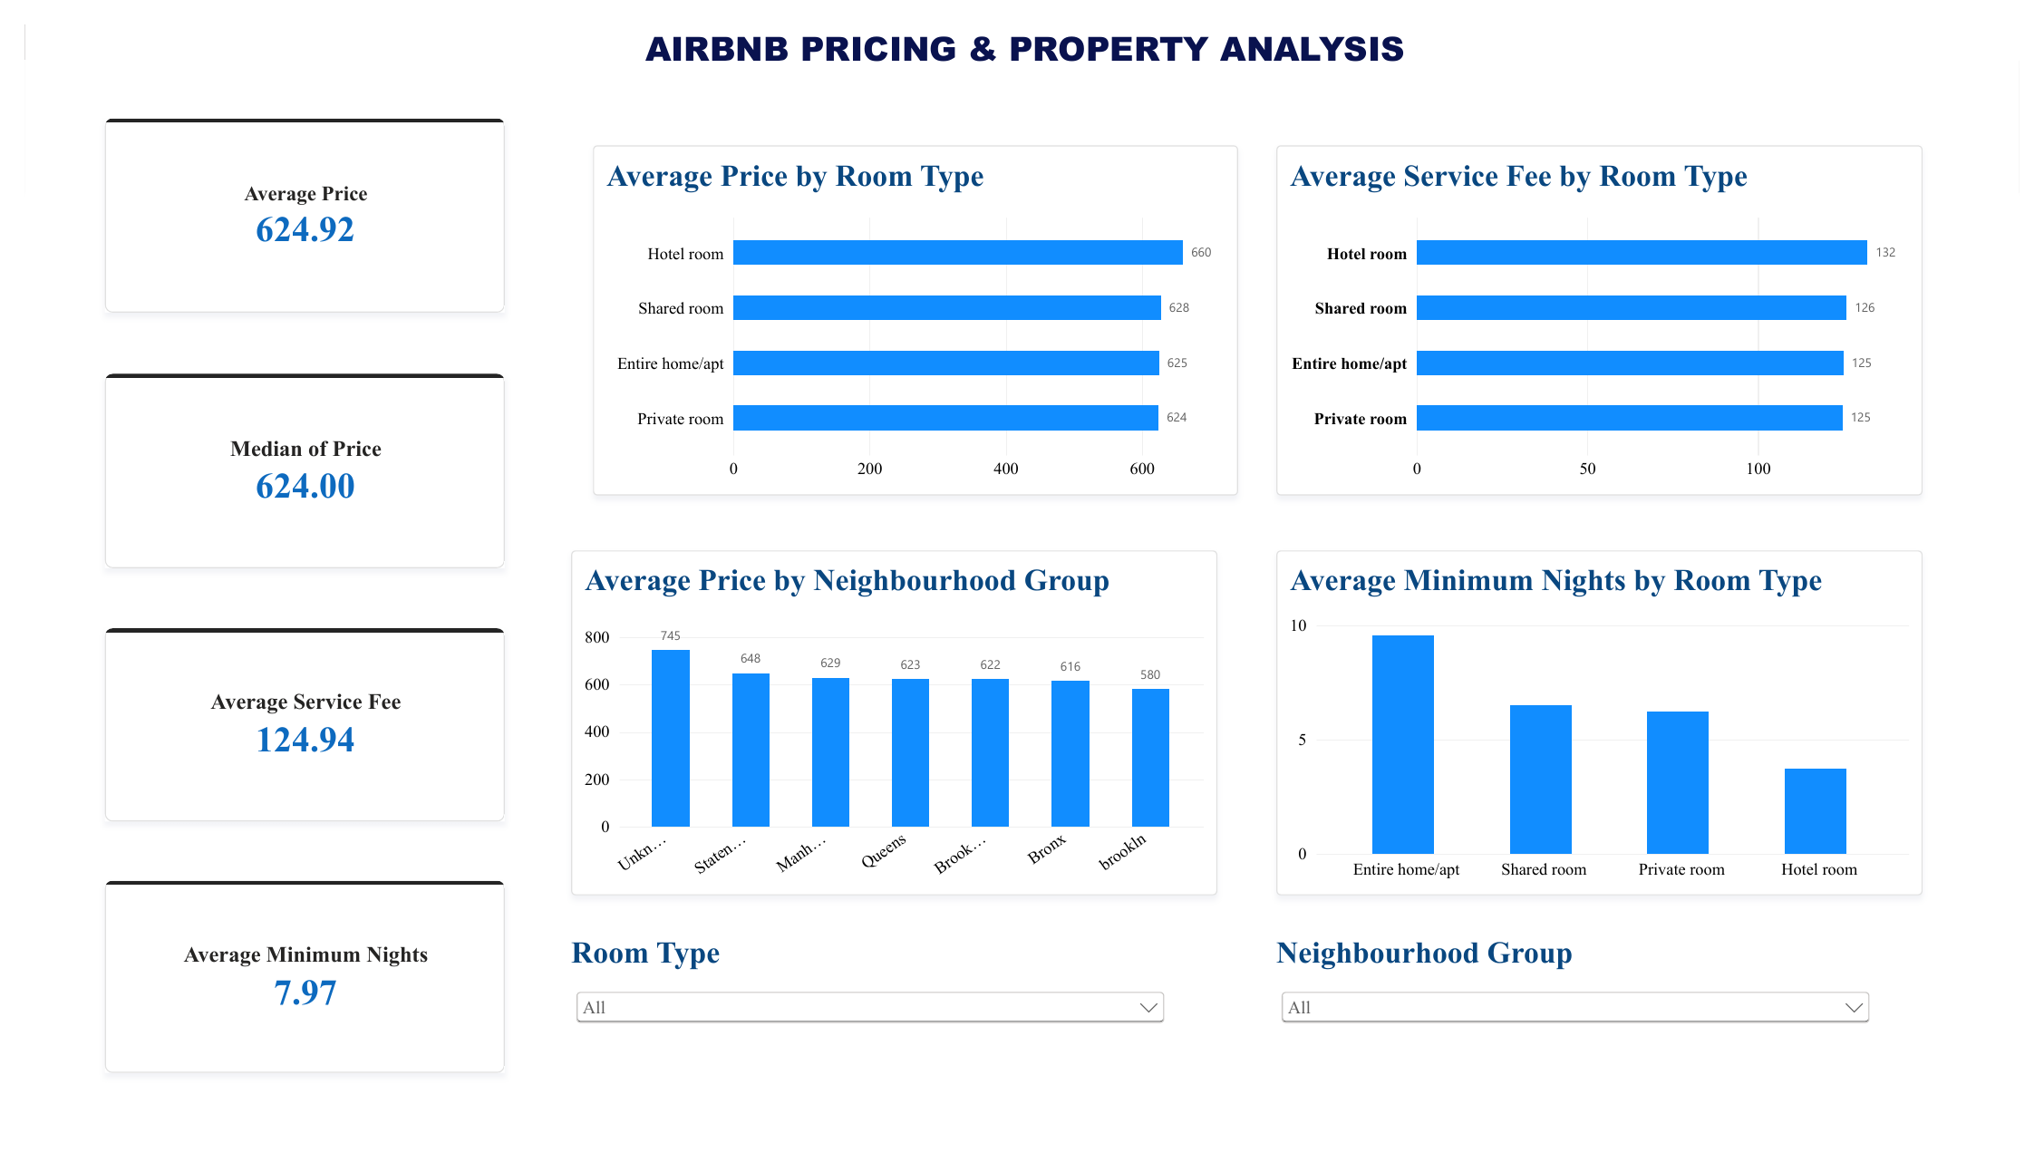
Figure 2. Airbnb Pricing & Property Analysis dashboard page.

5. Dashboard Page 3 – Airbnb Availability & Customer Reviews
The third page examines guest review activity, review ratings and listing availability. KPI cards show Total Reviews, Average Reviews, Average Reviews per Month and Average Rating. Charts compare total reviews by room type, average availability by room type and average rating by neighbourhood group. Neighbourhood Group and Room Type controls are provided for filtering.
KPI | Observed result
Total Reviews | 274,696
Average Reviews | 27.53
Average Reviews per Month | 1.17
Average Rating | 3.27
In the displayed report, Entire home/apt has the largest total review count, followed by Private room. Hotel room shows the highest average availability in the room-type comparison, while Private room has the lowest. The chart shows a 4.0 average rating for the one-record “brookln” category; this small category should not be compared directly with larger neighbourhood groups without checking its record count.
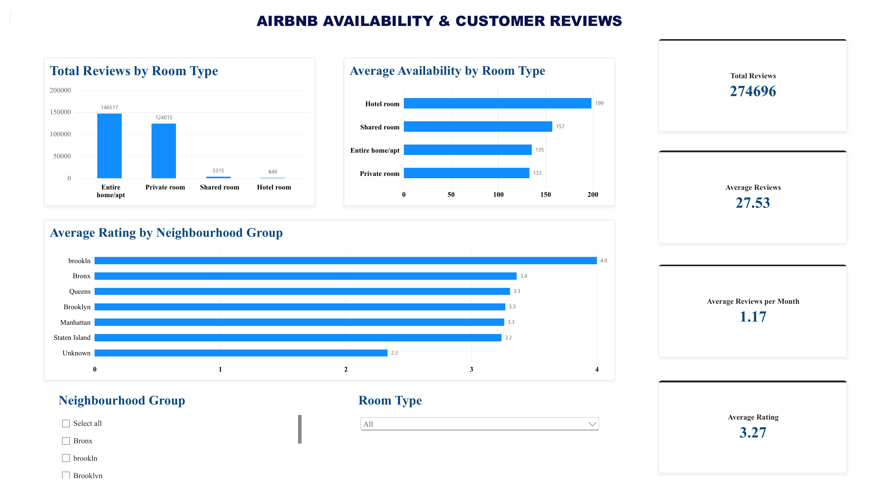
Figure 3. Airbnb Availability & Customer Reviews dashboard page.

6. Overall observations
- The report contains three pages covering market overview, pricing and property analysis, and availability and customer reviews.
- The listing sample is dominated by Entire home/apt and Private room categories.
- The displayed average listing price is 624.92 and the median price is 624.00.
- The displayed total review count is 274,696 and the average rating is 3.27.
- The report includes slicers for neighbourhood group and room type to support interactive comparisons.

7. Data interpretation notes and limitations
The displayed dashboard includes a separate “brookln” category with one listing. This category should be checked against the source data and corrected to Brooklyn only if the original record confirms that spelling error. The average rating for this one-record category is not representative of a larger neighbourhood group. The dashboard values describe the cleaned sample and should not automatically be generalised to the entire Airbnb market. The source report does not document a forecasting model; therefore, the current report is descriptive and comparative rather than predictive.

8. Conclusion
The Power BI report brings together listing, pricing, availability and review information in three dashboard pages. KPI cards provide summary measures, charts compare categories and slicers allow the user to explore the report by neighbourhood group and room type. The dashboard is supported by the cleaned Excel workbook and the documented FactListings and dimension-table model.

