Data Analytics (DA) | Module-End Assignment 1
Data Cleaning, Analysis & Visualization with Excel
E-Commerce Sales Dataset: Screenshots and Observations

1. Objective of the Assignment

My Understanding
The main objective of this assignment was to understand how raw e-commerce data can be cleaned, organized and analysed using Excel. I worked with customer, product, store and sales data. I performed data cleaning, used Excel formulas, combined information from different tables, created PivotTables and charts, and finally prepared a dashboard to understand the sales data better.

2. Data Entry & Table Setup
Screenshot 1: Source Workbook
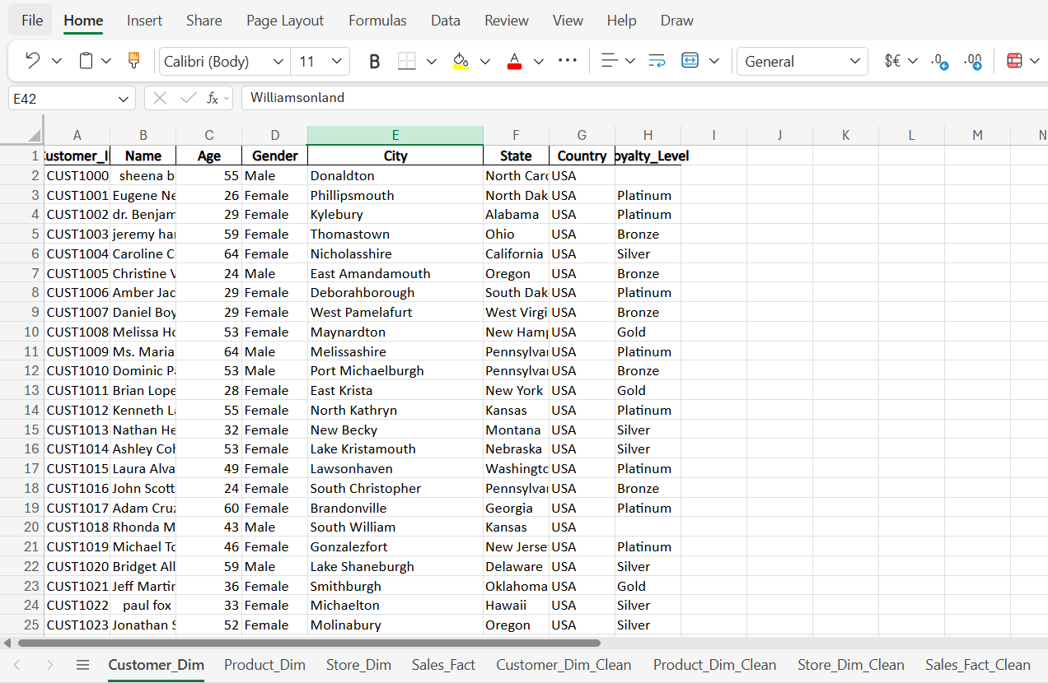
Observation: The original workbook contains four source tables: Customer, Product, Store and Sales. The original sheets have been preserved so that they remain available for comparison with the cleaned and analysed data.

Screenshot 2: Converting the Data into an Excel Table
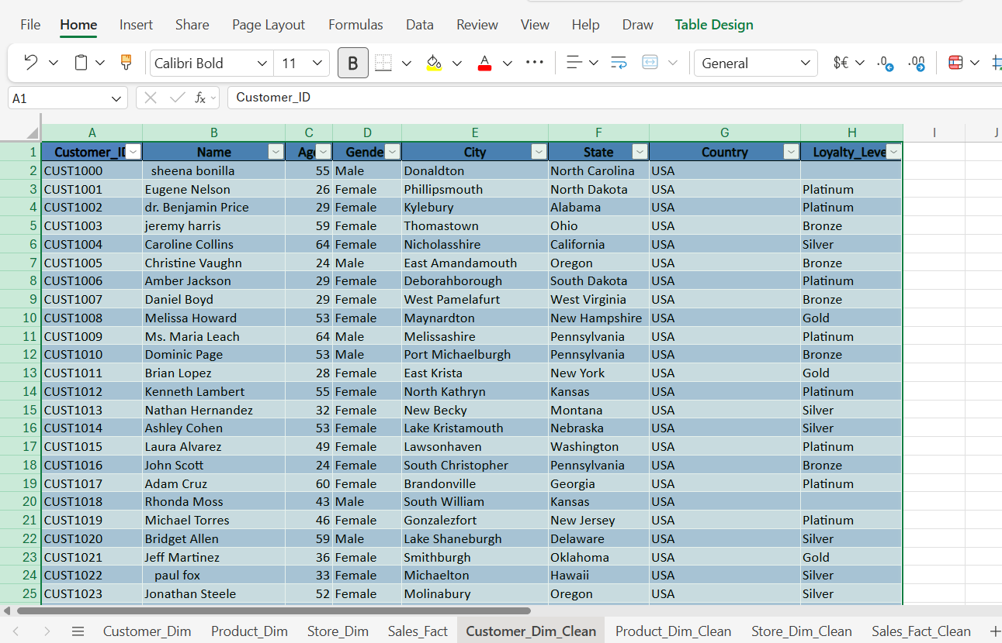
Observation: The dataset has been converted into an Excel Table. Table formatting and filter controls make the dataset easier to sort, filter and analyse.

3. Data Cleaning & Transformation

3.1 Duplicate Check
Screenshot 3: Remove Duplicates
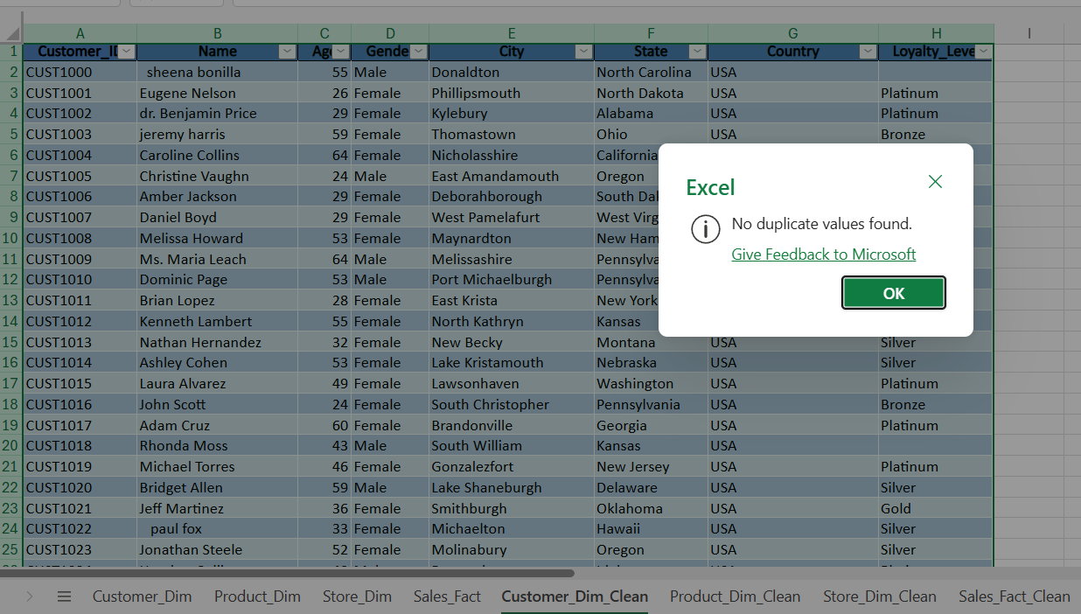
Observation: Duplicate checking was performed on the dataset using all columns. No exact duplicate records were identified, so no customer, product, store or sales records were removed.

3.2 Customer Table: Missing and Inconsistent Data
Screenshot 4: Missing Loyalty Level
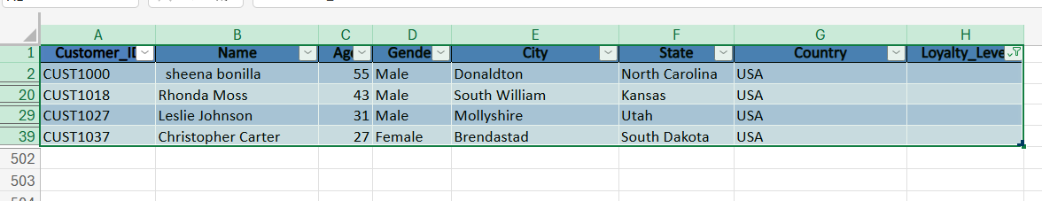
Observation 4A: Four Customer records were identified with missing Loyalty Level values. The missing values were listed using the column filter before deciding how to handle them.

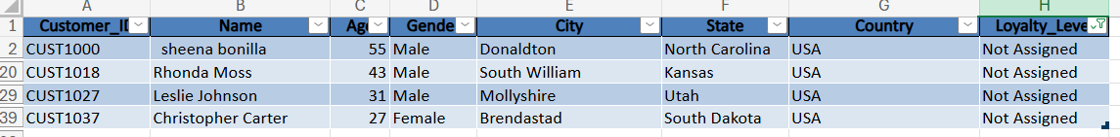
Observation 4B: Missing Loyalty Level values were replaced with “Not Assigned” rather than assigning an unsupported loyalty category. This preserves the original meaning of the missing information.

Screenshot 5: Correcting Names with TRIM and PROPER
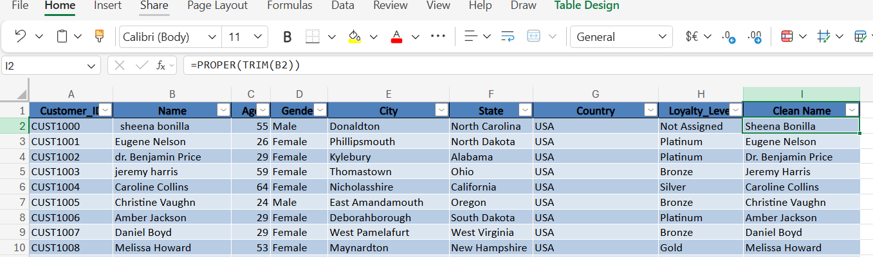
Observation: The TRIM and PROPER functions were used to correct unnecessary spaces and inconsistent capitalization in customer names. This provides a consistent format without manually editing each record.

Screenshot 6: Standardizing Country Labels (Find and Replace)
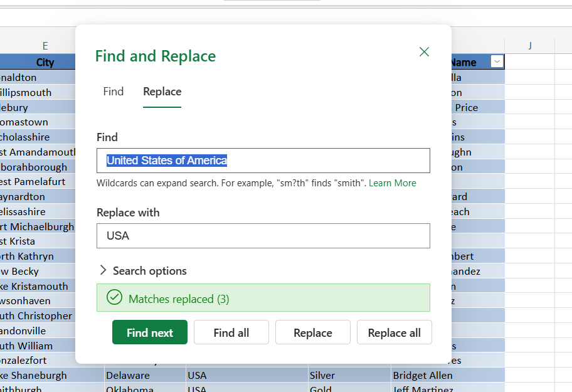
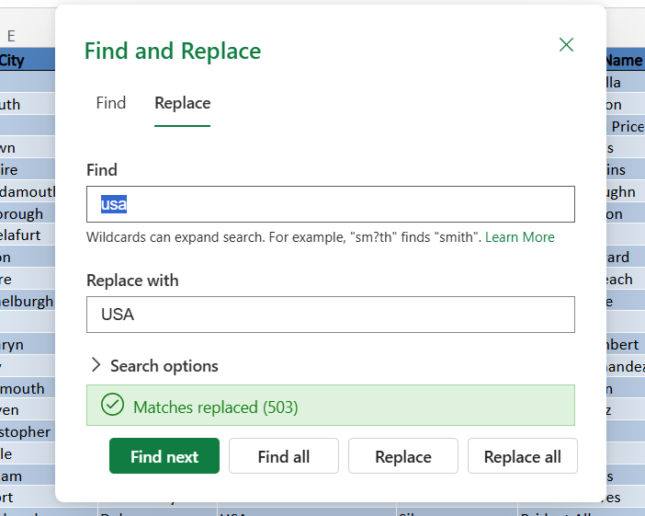
Observation: Inconsistent country labels (for example “United States of America” and “usa”) were standardized to “USA” so that the same country is represented consistently during filtering, summarization and visualization.

3.3 Product Table: Missing Numerical Data
Screenshot 7: Missing Cost Values
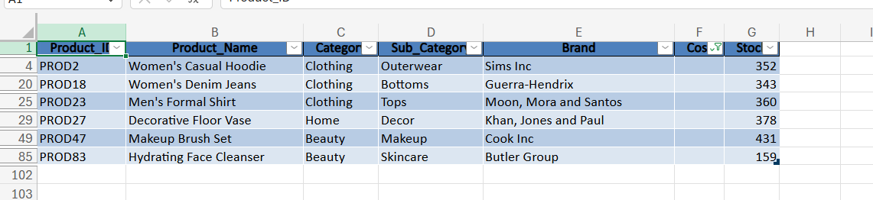
Observation 7A: Six missing Cost values were identified in the Product dataset using the column filter.

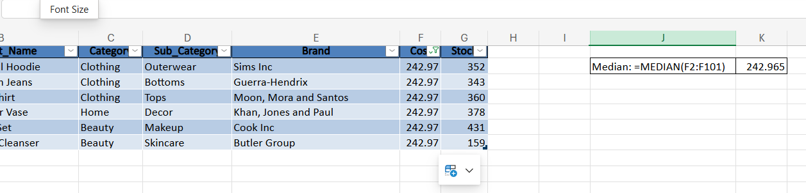
Observation 7B: The median Cost value of 242.965 was calculated using the MEDIAN function and used to replace the six missing Cost values. This provides a consistent statistical method for handling the missing numerical data.

Screenshot 8: Missing Stock Values
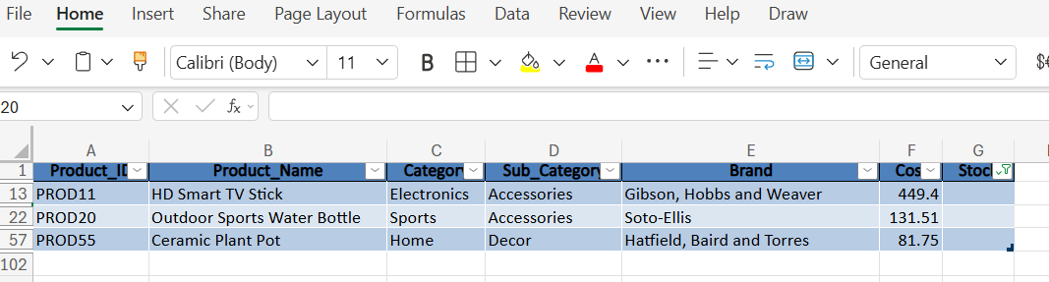
Observation 8A: The Stock column was filtered to identify missing values. Three Product records were found with blank Stock values. These records were isolated before applying a method to handle the missing numerical data.

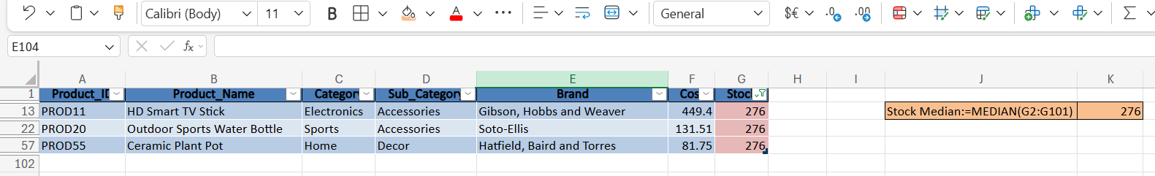
Observation 8B: The median Stock value was calculated as 276 using the MEDIAN function. The three missing Stock values were replaced with 276 to maintain a consistent statistical approach for handling missing numerical data.

3.4 Product ID Consistency
Screenshot 9: Product ID Format Check
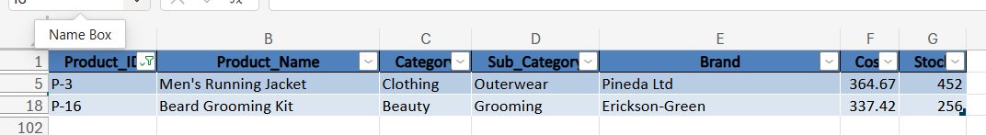
Observation 9A: Product ID formats were reviewed for consistency. Two IDs (P-3 and P-16) use the “P-number” pattern while all other records use the “PROD-number” pattern.

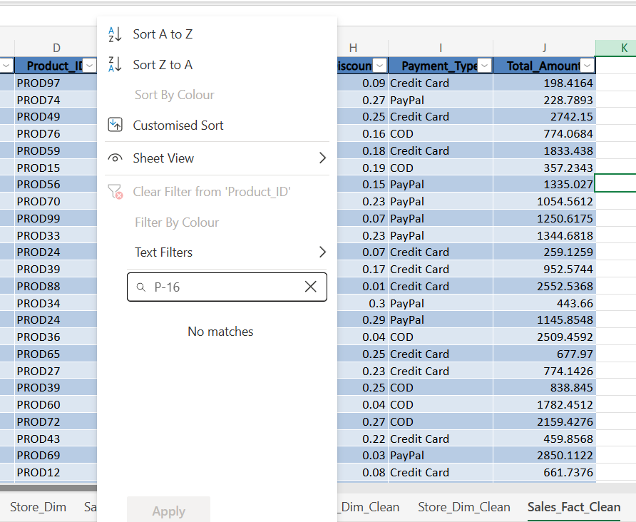
Observation 9B: Filtering the Sales table for “P-16” returns no matches, which shows that the Sales table does not use the “P-number” format.

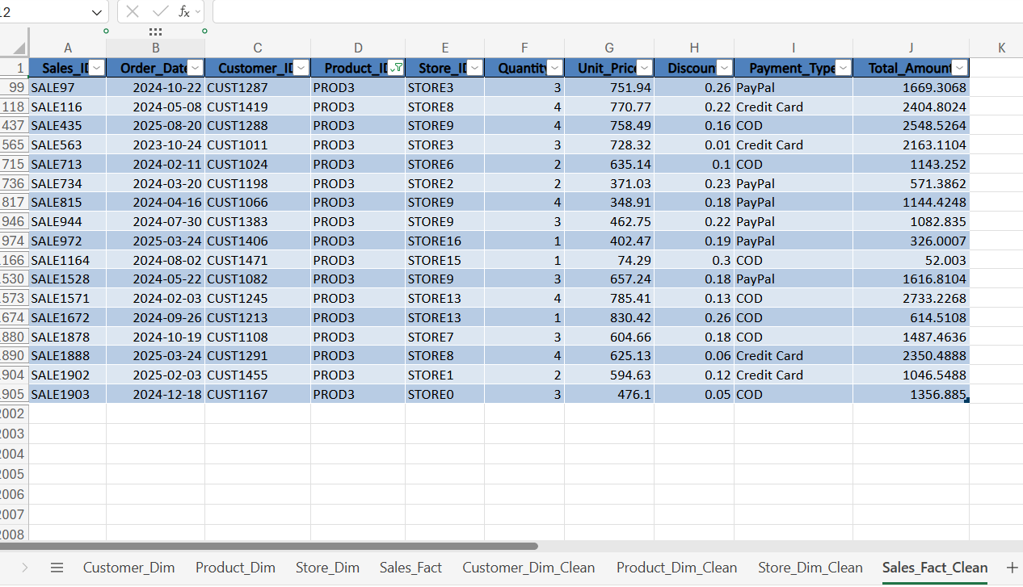
Observation 9C: The Sales table uses PROD3 rather than P-3 for the same product (Men’s Running Jacket), confirming the mismatch between the Product and Sales tables.

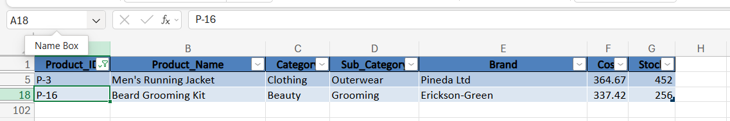
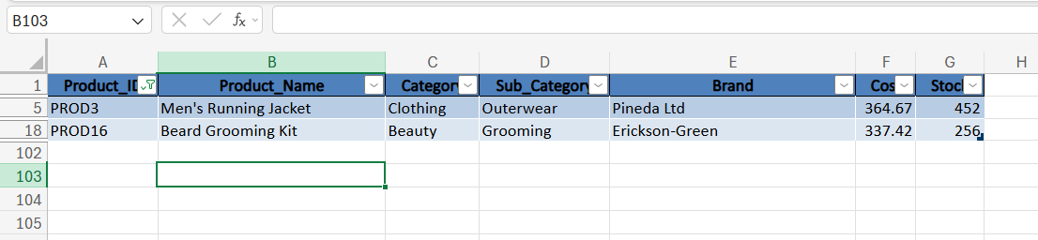
Observation 9D (before and after): Product ID consistency was checked between the Product and Sales tables. The Product table contained P-3 and P-16, while the Sales table used PROD3 and PROD16 for the corresponding transactions. Since Product ID is used to link the Product and Sales tables, the inconsistent IDs were standardized from P-3 to PROD3 and from P-16 to PROD16. The other product details were not changed.

3.5 Sales Table: Validation and Missing Values
Screenshot 10: Calculated Total Amount (Validation Column)
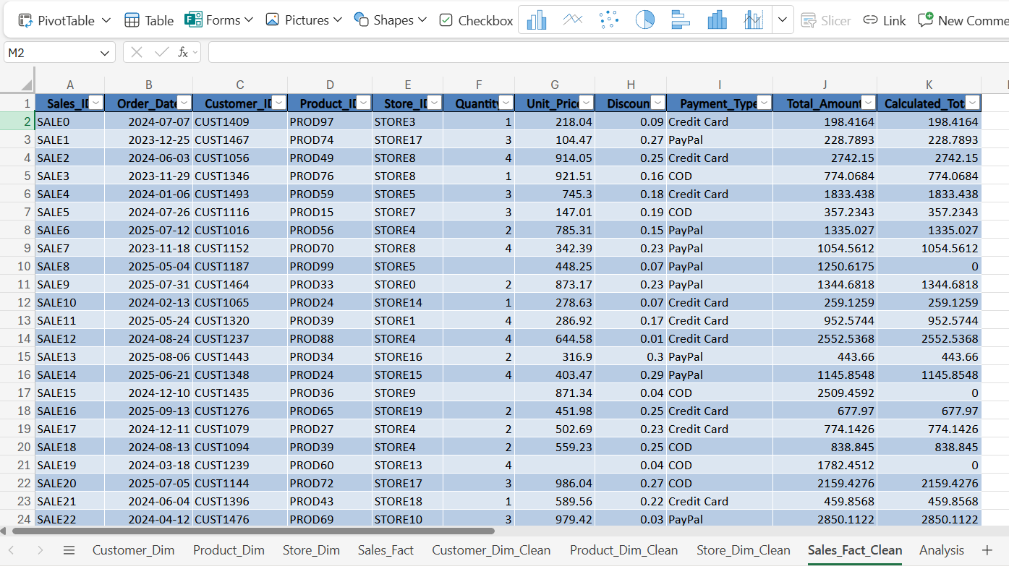
Observation: A calculated Total Amount (Quantity × Unit Price × (1 − Discount)) was generated in a helper column. This formula was used to validate the existing Total Amount values and to identify records requiring correction. Rows where a source value is blank show a calculated total of 0 or a mismatch.

Screenshot 11: Missing Values Identified in the Sales Table
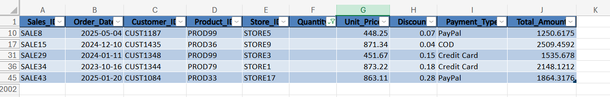
Observation 11A: Five Quantity values were missing (SALE8, SALE15, SALE29, SALE34, SALE43).

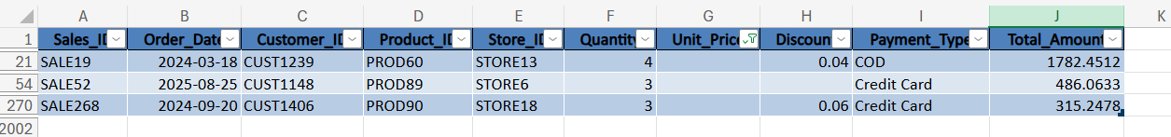
Observation 11B: Three Unit Price values were missing (SALE19, SALE52, SALE268).

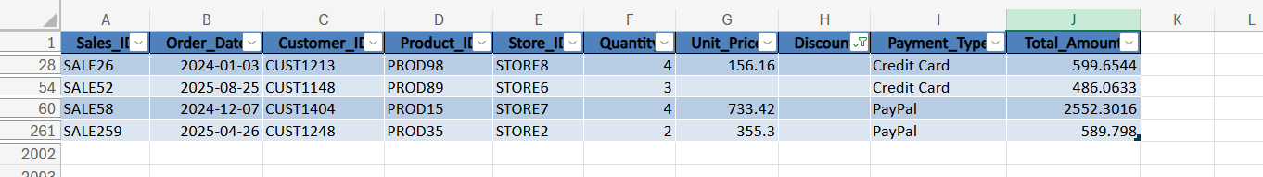
Observation 11C: Four Discount values were missing (SALE26, SALE52, SALE58, SALE259).

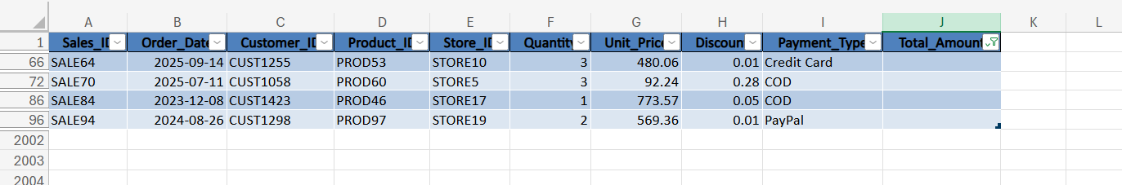
Observation 11D: Four Total Amount values were missing (SALE64, SALE70, SALE84, SALE94).

Screenshot 12: Reconstructing the Missing Values
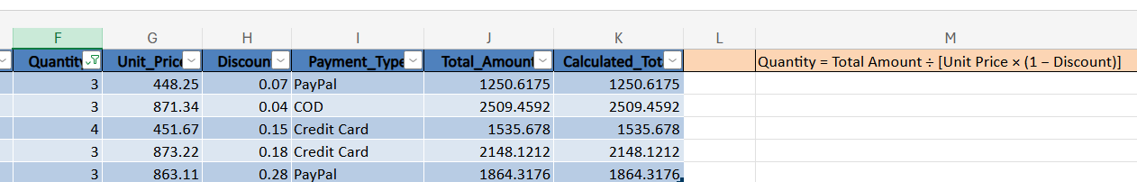
Observation 12A (Quantity): Since Unit Price, Discount and Total Amount were available for these five transactions, Quantity was reconstructed using Quantity = Total Amount ÷ [Unit Price × (1 − Discount)].

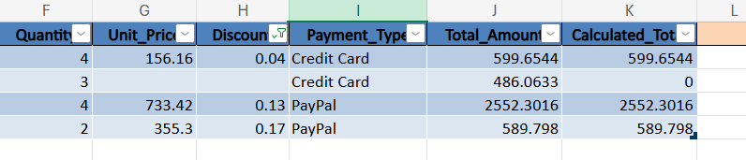
Observation 12B (Discount): Missing Discount values were identified and mathematically reconstructed where Quantity, Unit Price and Total Amount were available.

Observation 12C (SALE52): SALE52 contained missing values for both Unit Price and Discount. Since both variables could not be uniquely derived from the available information, the dataset median Discount of 0.14 was used as a documented imputation value. Unit Price was then calculated from the existing Total Amount and Quantity, resulting in approximately 188.40.

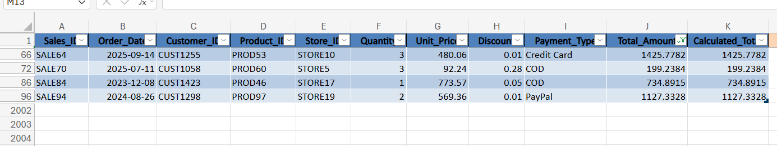
Observation 12D (Total Amount): Since Quantity, Unit Price and Discount were available, the four missing Total Amount values were reconstructed using Quantity × Unit Price × (1 − Discount).

4. Combining Tables with XLOOKUP
The cleaned Sales table was enriched with attributes from the Customer, Product and Store dimension tables on a new Analysis sheet. Each lookup uses the shared ID as the key and returns “Not Found” (or “Not Assigned” for loyalty) when no match exists.
Screenshot 13: XLOOKUP Across the Dimension Tables
13A. Customer Name
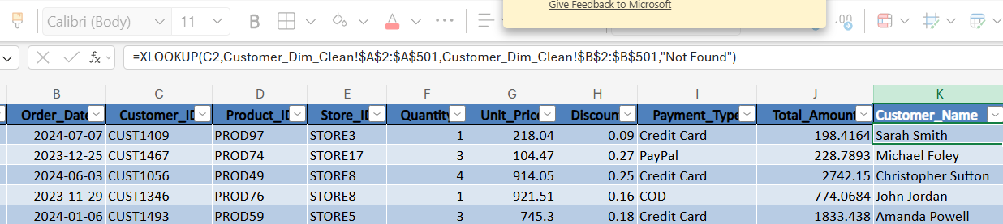
Observation: XLOOKUP was used to retrieve the Customer Name from the Customer dimension table using Customer ID as the matching field. This demonstrates how information from separate tables can be combined using a common key.

13B. Loyalty Level
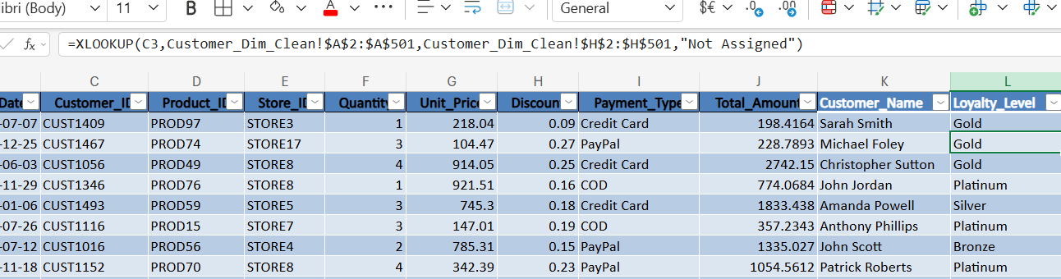
Observation: XLOOKUP was used to retrieve Loyalty Level from the Customer table using Customer ID as the common key. Missing loyalty information is displayed as “Not Assigned” where applicable.

13C. Product Name
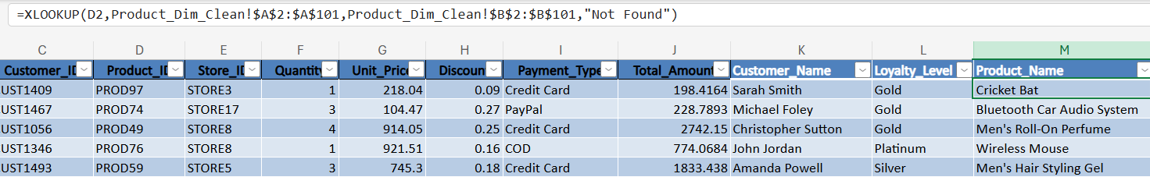
Observation: XLOOKUP was used to retrieve Product Name from the Product dimension table using Product ID as the common key between the Sales and Product tables.

13D. Product Category
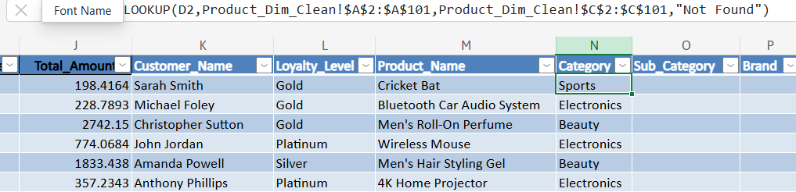
Observation: XLOOKUP was used to add Product Category to the Sales analysis using Product ID as the matching key.

13E. Sub-Category
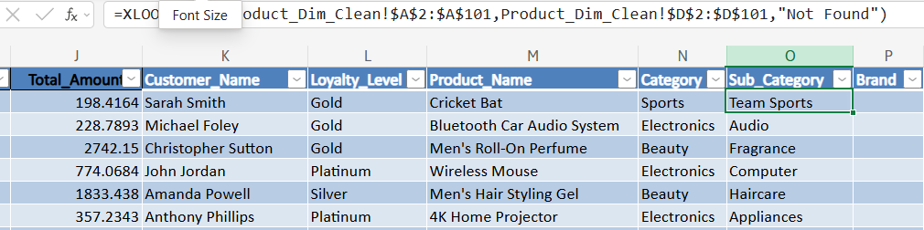
Observation: XLOOKUP was used to add Sub-Category from the Product table using Product ID as the matching key.

13F. Brand
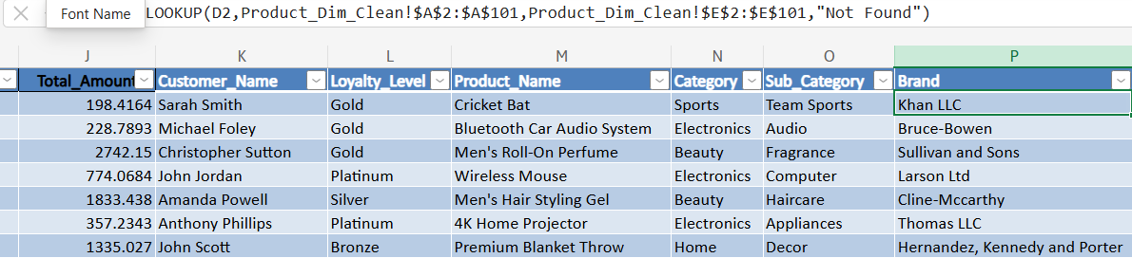
Observation: XLOOKUP was used to add Brand from the Product table using Product ID as the matching key.

13G. Store Name
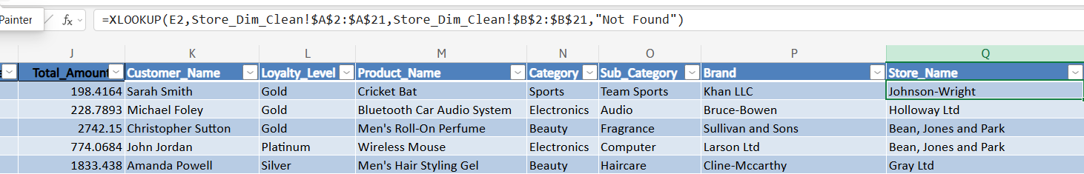
Observation: XLOOKUP was used to retrieve Store Name from the Store dimension table using Store ID as the matching key.

13H. Region
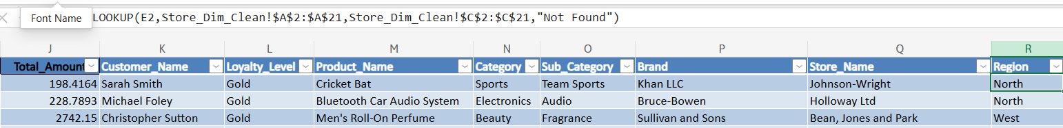
Observation: XLOOKUP was used to add the sales Region from the Store dimension table using Store ID as the matching key.

13I. Store City
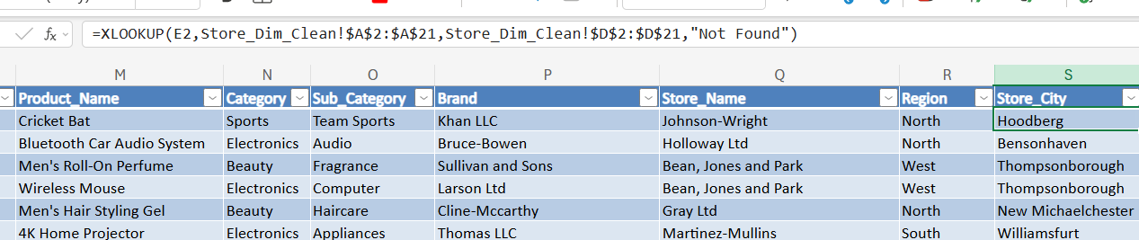
Observation: XLOOKUP was used to add the Store City from the Store dimension table using Store ID as the matching key.

13J. Store Type
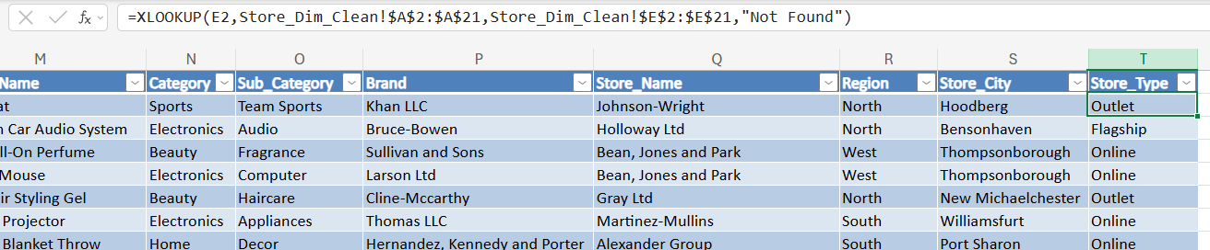
Observation: XLOOKUP was used to add Store Type (Flagship, Online or Outlet) to the Sales analysis using Store ID as the common key.

Summary: The Analysis table combines transaction-level Sales information with Customer, Product and Store attributes using XLOOKUP. It also adds a Sale_Category column (IF: “High” when Total Amount ≥ 1,000, otherwise “Normal”) and a Sales_Month column (TEXT). The resulting structured table of 2,000 rows provides a consolidated dataset for the statistical analysis, PivotTables and visualization that follow.

5. Excel Formulas & Functions
Screenshot 14: Formula Analysis
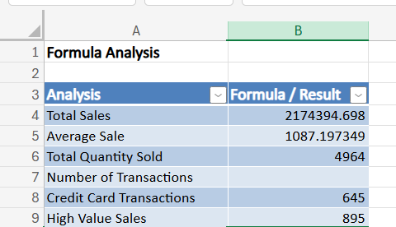
Observation: Various Excel formulas and functions were used to analyse the cleaned sales data: SUM (total sales and total quantity), AVERAGE (average sale), COUNTA (number of transactions), COUNTIF (credit card and high-value transactions), IF (sale classification) and TEXT (month name). The calculations helped summarize sales performance, identify transaction patterns, classify sales, and extract useful information for further analysis and visualization. The workbook shows 2,000 transactions, 645 credit card transactions and 895 high-value sales.

6. Descriptive Statistics
Screenshot 15: Descriptive Statistics for Total Amount
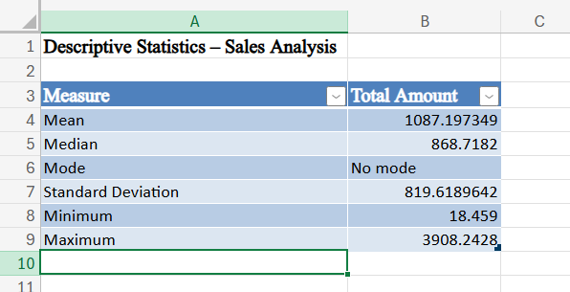
Observation: Descriptive statistics were calculated for Total Amount using mean (1,087.20), median (868.72), mode (no repeated value), sample standard deviation (819.62), minimum (18.46) and maximum (3,908.24). These measures provide an overview of the central tendency and variation of sales values. Because the mean is higher than the median, the distribution is right-skewed: a smaller number of large orders pull the average up.

7. Data Summarization with PivotTables
Screenshot 16: PivotTables
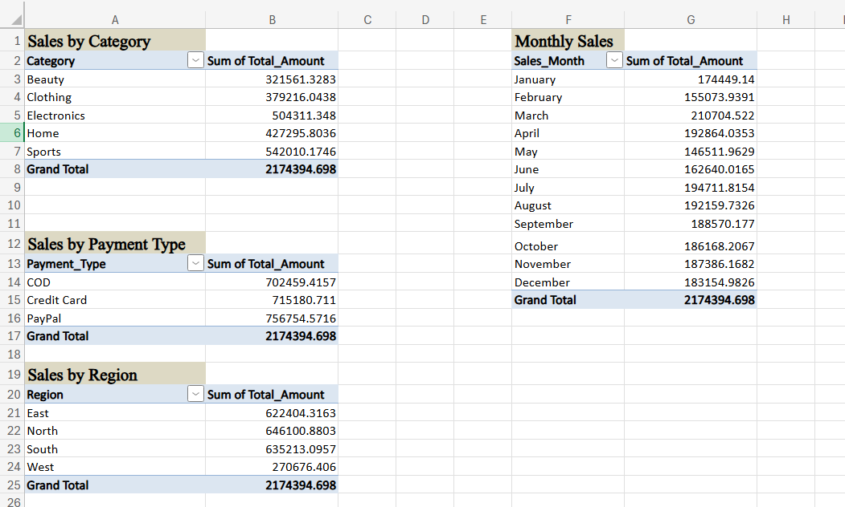
Observation: PivotTables were created to summarize and analyse the cleaned sales data from different perspectives, including Product Category, Payment Type, Region and Month. They provide a quick and organized view of sales performance and make it easier to identify patterns and compare different segments of the business. Every PivotTable reconciles to the same Grand Total of 2,174,394.70.

8. Data Visualization and Dashboard
Screenshot 17: E-Commerce Sales Analysis Dashboard
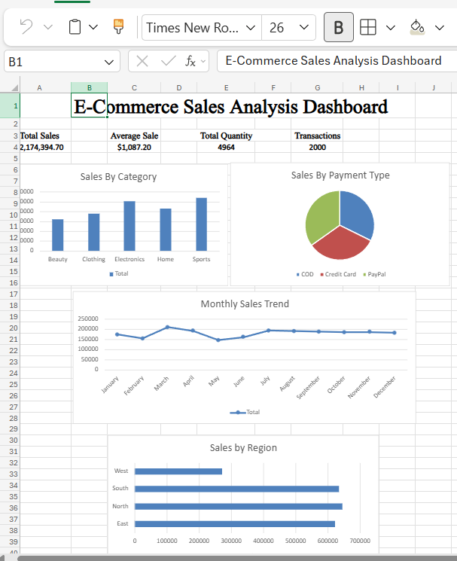
Observation: A sales dashboard was created using key performance indicators and four PivotChart-based visuals: a column chart (sales by category), a pie chart (sales by payment type), a line chart (monthly sales trend) and a bar chart (sales by region). The dashboard provides a consolidated view of sales performance by category, payment type, month and region, making the results easier to understand and interpret.

9. Summary: E-commerce Sales Analysis — Module End 1
Data Cleaning, Analysis & Visualization with Excel

Data Cleaning & Preparation
Four source tables (Customer, Product, Store and Sales) were reviewed and kept as raw tabs beside cleaned tabs. No exact duplicate rows were found. Names were standardized with TRIM and PROPER; country values were unified to USA; two product IDs (P-3, P-16) were corrected to the PRODn convention; missing loyalty values were labeled Not Assigned; missing product Cost (6) and Stock (3) were median-imputed; missing Quantity (5), Discount (4) and Total_Amount (4) were recalculated from the other transaction fields using Total = Quantity × Unit Price × (1 − Discount); and SALE52, which lacked both Unit Price and Discount, used the median Discount of 0.14. XLOOKUP then joined customer, product and store attributes onto 2,000 sales rows.

Key Findings
Total revenue: ₹2,174,394.70 across 2,000 orders; average order value ₹1,087.20; 4,964 units sold.
Sports was the highest-revenue category at ₹542,010.17 (24.9%), followed by Electronics at ₹504,311.35; Beauty was lowest.
North was the leading region at ₹646,100.88; West was lowest at ₹270,676.41 (12.4%), with only 2 of 20 stores yet the highest average sale (₹1,161.70).
PayPal generated the most revenue among payment types at ₹756,754.57 (34.8%); Credit Card and COD were close behind.
March was the peak month (₹210,704.52) and May the lowest (₹146,511.96).
Online stores contributed 42.0% of sales. The 895 high-value sales (₹1,000 or more) were 45% of orders but 75.5% of revenue. Revenue is right-skewed: mean ₹1,087.20 exceeds median ₹868.72 (standard deviation ₹819.62).

Visualization & Reporting
The workbook contains KPI cards, four PivotChart visuals (category column chart, payment-type pie chart, monthly line chart and regional bar chart), PivotTable summaries, a formula analysis sheet, descriptive statistics and an Analysis sheet built with XLOOKUP. Raw and clean tabs make every transformation auditable.

Conclusion
The cleaned dataset is suitable for exploratory e-commerce sales analysis and dashboard reporting. One open item: four Customer IDs (CUST1464, CUST1486, CUST1491, CUST1499) are stored as “C-xxxx”, so 22 sales (1.2% of revenue) show Not Found in customer lookups; category, region and payment totals are unaffected. Imputation assumptions are documented so the analysis can be reproduced and reviewed.

