POWER BI ASSIGNMENT 2

E-Commerce Sales Analysis
DAX calculations, data model and dashboard observation report

Document purpose | Evidence included
To document the work completed for the assignment and provide an observation record of the Power BI report. | Required calculated columns and measures; additional dashboard measures; four report-page screenshots; visual coverage review.

1. Assignment overview
The assignment uses e-commerce order, order-detail and sales-target data to calculate business metrics and build interactive visualizations for sales trends, profitability, target achievement and geographic performance.
The report contains four pages: Sales Overview, Product Analysis, Geographical Analysis and Sales Target Analysis.

2. Data model and tables
Table | Role / fields referenced in the report
Order Details | Transaction-level values: Amount, Profit, Quantity, Order ID, Category and Sub-Category.
List of Orders | Order/customer/geography details: Order ID, Order Date, CustomerName, City and State.
Sales target | Sales target values by category/segment (the exact target field used in the model is Sales Target).
Calendar | Date table used for time intelligence, including Calendar[Date].
MonthDim / Month | Month and month-sort attributes used for monthly reporting.
Category | Category dimension used for category analysis.

Data relationships were established before building visuals, as required by the assignment. The model also uses date/month support tables for time-based analysis.

3. Required calculated columns
Create these columns in the Order Details table using Modeling > New column. The expressions below reflect the assignment requirements and the field names visible in the model.
Calculated column | DAX expression | Purpose
Category Type | Category Type =  'Order Details'[Category] & " - " &  'Order Details'[Sub-Category] | Combines category and sub-category into one descriptive field.
Revenue per Order | Revenue per Order =  'Order Details'[Amount] *  'Order Details'[Quantity] | Calculates the requested row-level revenue value.
Sales Category | Sales Category =  VAR AverageAmount =  CALCULATE(  AVERAGE('Order Details'[Amount]),  ALL('Order Details')  )  RETURN  IF(  'Order Details'[Amount] >= AverageAmount,  "Above Average",  "Below Average"  ) | Labels each row according to whether its Amount is at least the overall average Amount.

Note: The assignment wording explicitly specifies Amount × Quantity for Revenue per Order. If Amount in the source is already the extended line total, multiplying by Quantity again would overstate revenue; retain the formula above only if it matches the assignment’s intended data definition.

4. Required calculated measures
Measure | DAX expression | Purpose
Order Count | Order Count =  COUNT('Order Details'[Order ID]) | Counts order-detail rows/order IDs in the Order Details table. If the intention is unique orders, use DISTINCTCOUNT instead.
Average Profit in Delhi | Average Profit in Delhi =  CALCULATE(  AVERAGE('Order Details'[Profit]),  'List of Orders'[City] = "Delhi"  ) | Calculates average profit for transactions related to Delhi through the model relationship.
YTD Sales | YTD Sales =  TOTALYTD(  [Total Sales],  'Calendar'[Date]  ) | Accumulates Total Sales from the beginning of the year through the current date context.

5. Additional measures used in the report
Measure | DAX expression | Use
Total Sales | Total Sales =  SUM('Order Details'[Amount]) | Sales KPI and sales charts.
Total Profit | Total Profit =  SUM('Order Details'[Profit]) | Profit KPI and profitability analysis.
Total Quantity | Total Quantity =  SUM('Order Details'[Quantity]) | Quantity KPI.
Total Orders | Total Orders =  DISTINCTCOUNT('List of Orders'[Order ID]) | Distinct order KPI.
Total Customers | Total Customers =  DISTINCTCOUNT('List of Orders'[CustomerName]) | Customer count, where used.
Average Order Value | Average Order Value =  DIVIDE([Total Sales], [Total Orders], 0) | Average sales per distinct order.
Profit Margin % | Profit Margin % =  DIVIDE([Total Profit], [Total Sales], 0) | Profitability KPI. Format as Percentage.
Sales Previous Year | Sales Previous Year =  CALCULATE(  [Total Sales],  SAMEPERIODLASTYEAR('Calendar'[Date])  ) | Prior-year sales comparison.
Sales Growth % | Sales Growth % =  DIVIDE(  [Total Sales] - [Sales Previous Year],  [Sales Previous Year],  0  ) | Year-over-year sales growth. Format as Percentage.
Sales Target Amount | Sales Target Amount =  SUM('Sales target'[Sales Target]) | Aggregated sales target. Confirm the target column name in the model.
Target Achievement % | Target Achievement % =  DIVIDE(  [Total Sales],  [Sales Target Amount],  0  ) | Actual sales divided by target. Format as Percentage.
Sales Variance | Sales Variance =  [Total Sales] - [Sales Target Amount] | Difference between actual sales and target.

Formatting: Select each percentage measure in the Data pane, open Measure tools (or Modeling), choose Format > Percentage, and set the required decimal places. Do not multiply the DAX result by 100 when using Percentage formatting.

6. Dashboard pages and visual observations
The following screenshots are included as evidence of the report pages created. The values shown are observations from the submitted screenshots and may change when report filters are changed.

Sales Overview
KPI cards show Total Sales 431.50K, Total Profit 23.96K, Total Orders 500, Total Quantity 6K, Profit Margin 5.55% and Target Achievement 98.99%. The page also includes Year and Category slicers, a monthly sales trend, profit by category, sales by category, category target comparison and State slicer.
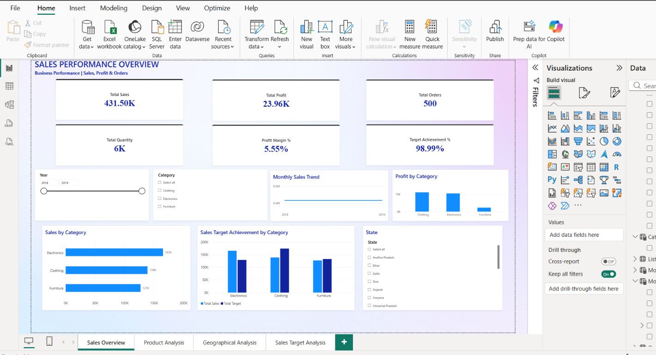

Product Analysis
Includes sales contribution by category (donut), profit by product category (column chart), top sub-categories by sales (bar chart), and a category summary table with sales, profit and quantity.
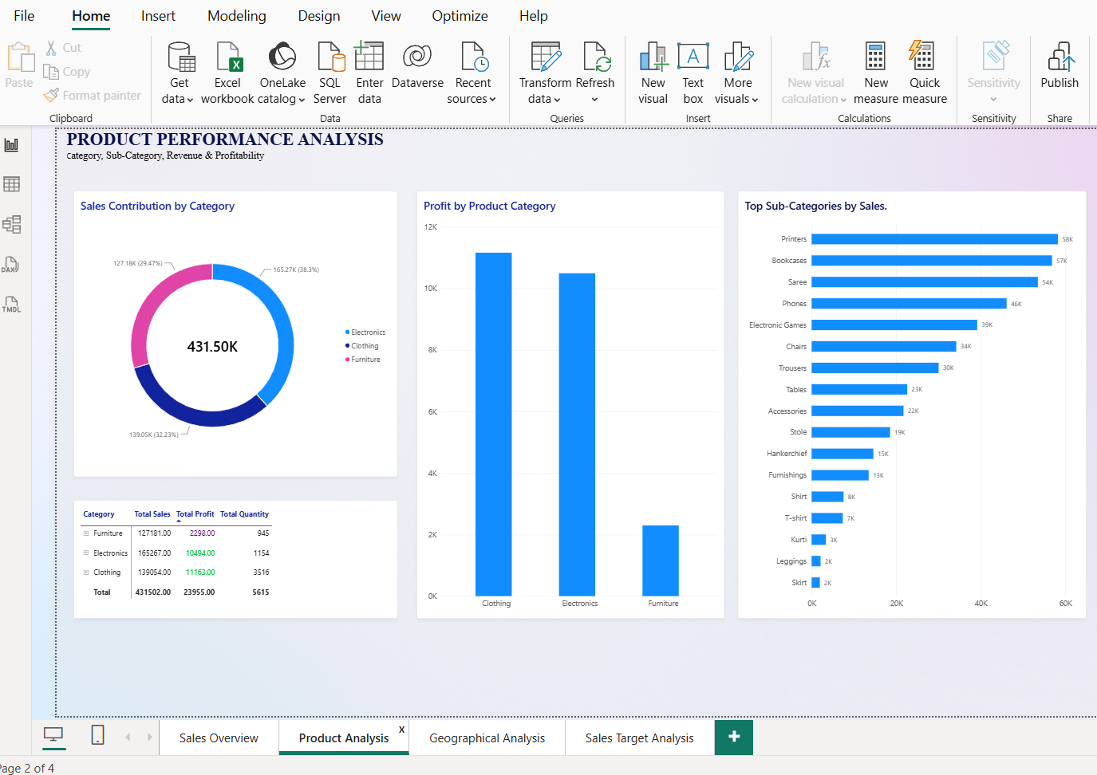

Geographical Analysis
Includes Top States by Revenue, Top Cities by Revenue and a map showing sales distribution across India.
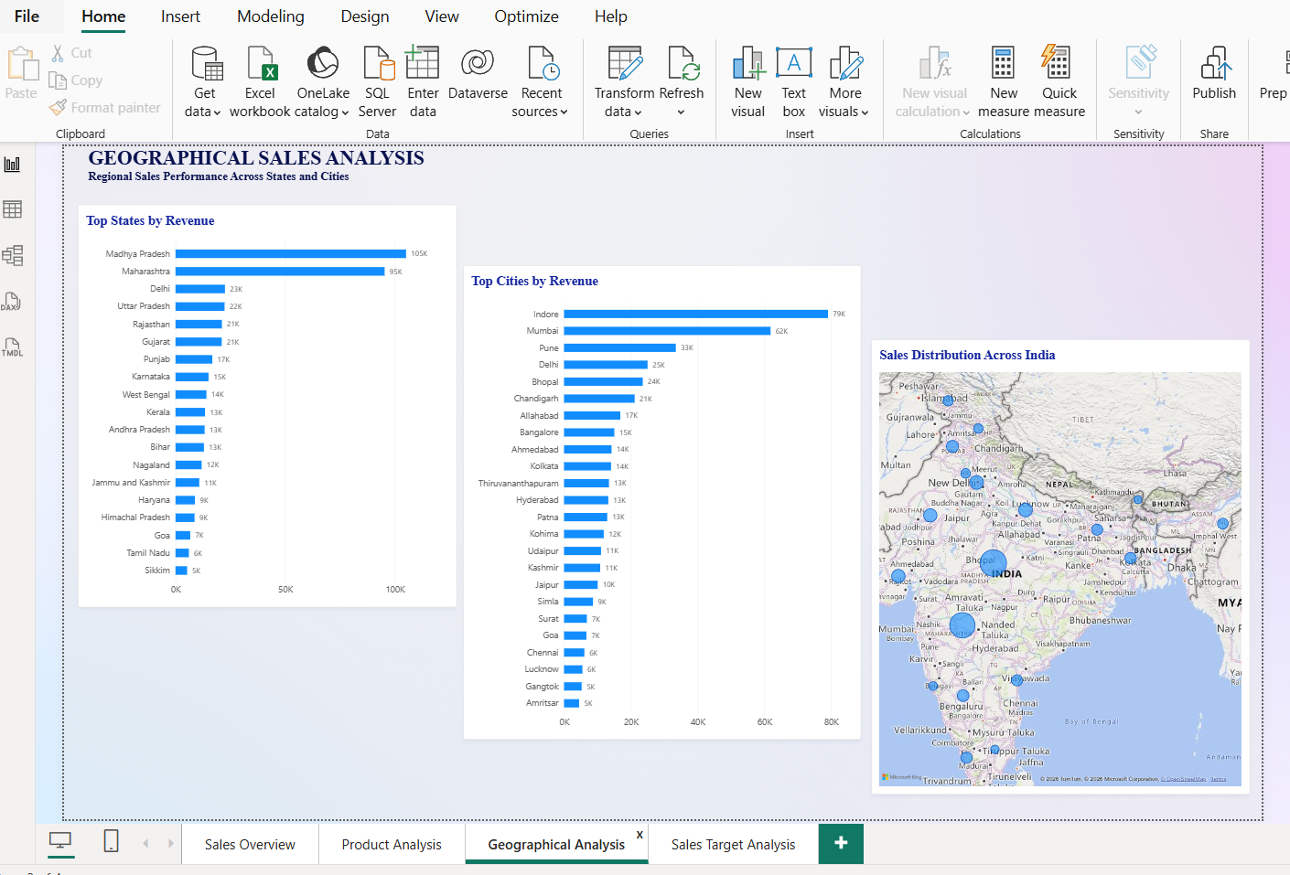

Sales Target Analysis
Includes Actual Sales vs Target, Overall Target Achievement, Sales vs Target Variance, category-wise target performance table, and actual sales vs target by category.
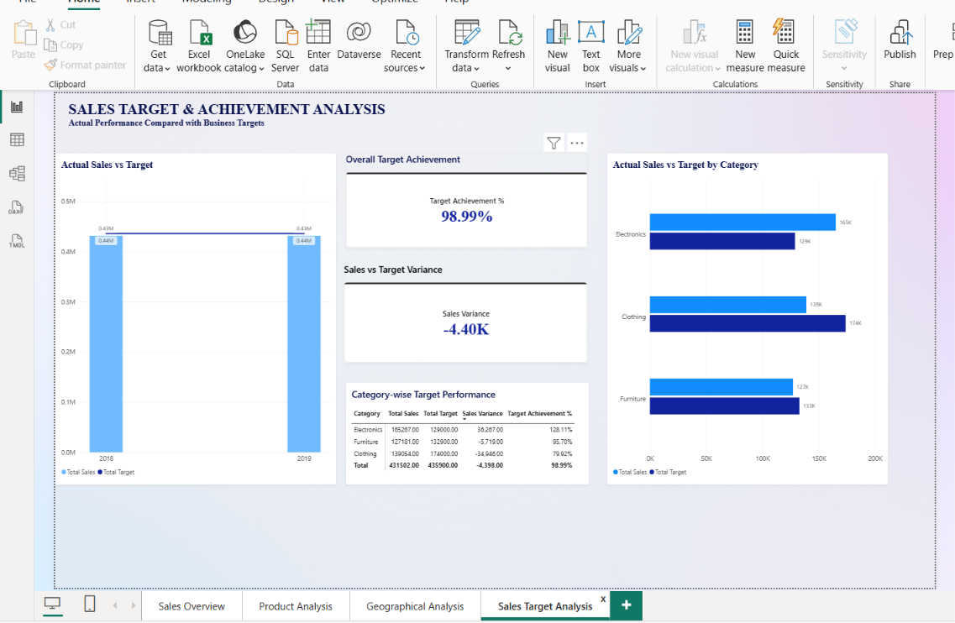

7. Assignment visualization checklist
This checklist compares the assignment brief with what can be identified in the supplied screenshots. “Visible” means the visual is evident in the screenshots; “Not evident” means it is not identifiable in the supplied evidence and should be checked in Power BI before final submission.
Assignment requirement | Evidence in supplied report | Observation
Sales Target Achievement by Category – clustered column chart | Sales Target Analysis page: actual sales vs target by category; Sales Overview also shows category target comparison. | Visible
Max Profit Margin by Sub-Category – donut chart | Product Analysis contains a donut for Sales Contribution by Category, not maximum profit margin by sub-category. | Not evident – verify/add the specified donut.
Monthly Sales Trend – line chart | Sales Overview page. | Visible
Profit vs Quantity by Sub-Category – scatter chart | Not identifiable in the supplied page screenshots. | Not evident – verify/add scatter chart.
Cards for Total Sales and Sales Target; multi-row card for minimum target by segment | KPI cards and target achievement cards are visible; minimum target by segment multi-row card is not identifiable. | Partially visible – verify/add minimum-target card.
Sales Performance Matrix by Category and Month | Category summary table is visible, but a category-by-month matrix is not identifiable. | Not evident – verify/add matrix.
Geographic Sales Analysis – map by city | Geographical Analysis map is visible with city-level sales distribution. | Visible
Sales Distribution by Sub-Category – treemap | Top sub-categories bar chart is visible; treemap is not identifiable. | Not evident – verify/add treemap.
Order Count Analysis by State – funnel chart | State sales bar chart is visible, but an order-count funnel is not identifiable. | Not evident – verify/add funnel chart.

8. Overall observation and completion statement
A four-page Power BI report has been created with a consistent visual theme, KPI cards, slicers, category and product charts, geographic analysis, and sales target analysis. The screenshots provide evidence that the report pages and several key calculations/visualizations have been built.
Before submitting, cross-check the “Not evident” items in Section 7 against the assignment brief. The screenshots alone do not confirm that every specifically requested visual is present. Also verify that all three required calculated columns and all three required measures exist in the model and that their formulas use the exact source column names.
Prepared as an observation and evidence document for Power BI Assignment 2 – DAX & Data Visualization.

