
ASSIGNMENT 3: ACADEMIC WRITING

Subject | : | Technology and Information System (SECP1513)
Session | : | 2024/2025 Semester 1
Task | : | ACADEMIC WRITING on INDUSTRIES TALK 2
Title | : | Project Management dan System Development
Duration | : | 10 Days (18 December 2025 until 29 December 2025 before 12.00 am)
Submission | : | This is a GROUP WORK
a. Upload a report (in .pdf format) via UTM E-learning
b. Upload a report (in .pdf format) via GitHub (A WEEK after a submission through UTM E-learning)

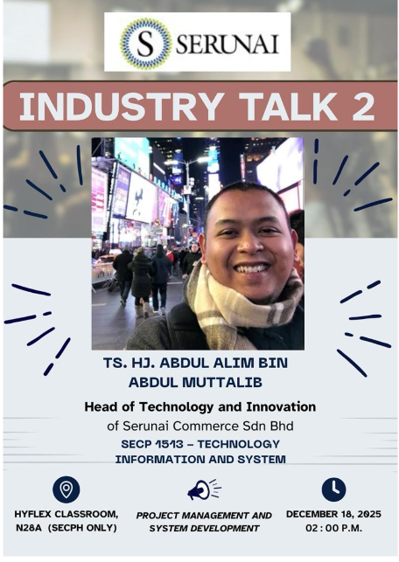
Poster for Industry Talk
Password: JiSS5UJW
Recording link: https://utm.webex.com/recordingservice/sites/utm/recording/2781d11fd97c49c4a1d20ba6ceec47cc/playback

Instruction:

- Students are required to prepare AN ACADEMIC WRITING.

- The length of the ACADEMIC WRITING SHOULD NOT EXCEED 3 PAGES:
- Page one: This is the cover of the REPORT; it should include a proper title and a representative picture. The cover page should also include the titles for the topics covered in the REPORT and names of group member.
- Pages two and three should include:
- Industry Talk on Project Management dan System Development. The content should consist of: description of the speaker experience, what is project management and system development. How the Project Management dan System Development has been used in your program such as (data engineering, computer network, bioinformatics, and computer graphics)?. Student should add the reference from academic paper. Format for cited (author name, year).
- The reflection [each student] from the industry talk. How you will successful in the computer science related in next four year?
- The list of references.
**Note: The content of your report is your own opinion and views. You may refer the rubric of report in the next page.

- The report will contribute 7% of the course assessment.

- Follow the format of report as follows:
  - Justify alignment for text description.
  - Include the page number in each page.
  - Design your report using your own creativity.

- You may refer to the following links as your reference for designing your academic writing:
- Academic Phrasebank | The University of Manchester
- How to write in an academic style | StudySkills@Sheffield | The University of Sheffield

- PLAGIARISM of the content is prohibited. If any of the content is known to be copied from other website/review/blogs, you will be given 0 mark.

- You can get photos/information from other resources, but you must include credits (in citation/link) to the original owners.

Rubric for Report (7%)

Criteria | Excellent  10-7 | Fair  6-4 | Poor  3-0 | WEIGHTAGE | MARKS
Informative and Attractive | - Provide accurate information (Content).  - All required information is presented in a logical order. | - Some information (Content) is inaccurate, but presented in a logical order.  - Very few required information is missing and presented in a logical order. | - Most Information (Content) are inaccurate, or not presented in a logical order, making it difficult to follow.  - Most required information is missing and not presented in a logical order, making it difficult to follow. | 10 | ____ X 10  10
Contents | Page one:  This is the cover of the REPORT; it should include a proper title and a representative picture. The cover page should also include the titles for the topics covered in the REPORT and names of group member.  Pages two and three should include:  The content should consist of: description of the speaker experience, basic skills required for computer science and skills required by industry.  The reflection [each student] from the talk. How you will successful in the computer science in next four year? |  |  | 30 | ____ X 30  10
Contents | - All contents included  - Very good presentation of content and well organized.  - Use many graphics, pictures. | - Included but not well covered  - Moderate presentation of content and well organized  - Use moderate graphics, pictures. | - Included but poorly covered  - Lack of content and not organized properly.  - Use inappropriate graphics or pictures.
Reflection | The reflection [each student] from the talk. How you will successful in the computer science in next four year? |  |  | 30 | ____ X 30  10
Reflection | - Excellent explanation. | - Fair explanation. | - Poor explanation. | 30 | ____ X 30  10
Report Features | - Include all required features, such as main report, graphics with captions and reporters.  - All features relate to the subject and are appropriate for the targeted audience.  - The layout is creative. | - Not all required features, such as main report, graphics with captions and reporters.  - All features are almost related to the subject and are appropriate for the targeted audience.  - The layout shows some degree of creativity but is not organized logically and/or is cluttered. | - Lack of features, such as main report, graphics with captions and reporters.  - All features are unrelated to the subject and are inappropriate for the targeted audience.  - The layout is messy, disorganized or cluttered. | 10 | ____ X 10  10
Organization and Structure | - Structure of text is interesting and organized very well, easy to understand. | - Structure of text is quite interesting and organized. | - Most parts of the structure of text are not really interesting and unorganized. | 10 | ____ X 10  10
Text | - All texts are easy to read and clear explanation.  - Use appropriate font size.  - Use not more than three different font styles. | - Most texts are easy to read and clear explanation.  - Use appropriate font size.  - Use more than three different font styles. | - Some texts are difficult to read unclear explanation.  - Use medium font size.  - Use more than four different font styles. | 5 | ____ X 5  10
Timeliness | - Due date on time submission. | - Due date one day late submission. | - Due date more than one day late submission. | 5 | ____ X 5  10
Total |  |  |  |  | / 100

