MSc THESIS PROPOSAL
Quality-Aware Self-Supervised Video Question Answering with Synthetic Supervision and Visual-Grounding Audits

Researcher: Nazmul Karim Tanvir
Supervisor: Md. Golam Rabiul Alam, PhD
Department: Computer Science and Engineering
Institution: BRAC University, Dhaka, Bangladesh
Status: Draft for supervisor review, October 2026

Reading guide. Every claim is tagged by status: [Implemented] (author-reported, local), [Proposed] (planned, not yet done) or [Illustrative] (made-up example for explanation, not a dataset annotation). No experimental results are reported. Real MSVD frames must be inserted from your local copy of the dataset (see Section 6.2); they could not be downloaded in the environment used to prepare this document.

Abstract
Video Question Answering (VideoQA) asks a model to answer a natural-language question about a video. Human-labelled QA data is expensive to collect, and automatically generated QA pairs can be unsupported by the video, ambiguous, repetitive, or answerable from the question wording alone. This proposal studies whether quality-filtering synthetic QA pairs, combined with self-supervised video representation learning, produces models that rely more on visual evidence. Candidate QA pairs will be generated from the captions of training videos and passed through four checks: evidence support and answerability, answer consistency, question-only shortcut risk, and duplicate/ambiguity detection. A VideoQA model (R3D-18 video encoder, DistilBERT question encoder, cross-attention fusion, answer classifier) will be trained with and without filtered synthetic data on MSVD-QA, with UCF101 used for contrastive pre-training of the video encoder. Visual dependence will be measured with counterfactual audits: correct video, question-only, masked video and shuffled video. The central hypothesis is that filtering can improve data quality and visual dependence; it is an empirical question, and no result is claimed here.
Keywords: video question answering, self-supervised learning, synthetic supervision, data quality, shortcut learning, visual grounding.

1. Introduction

1.1 The idea in plain language
Imagine a short clip in which a person lifts a glass and drinks water. A question such as “What is the person doing?” has the answer “drinking”, and that answer is visible in the clip. Now consider three other questions that a question generator might also produce for the same clip:
- “What colour are the person’s shoes?” The feet are not visible, so the video does not contain the evidence. The pair should be rejected.
- “What is the person drinking?” with the answer “juice”, when the clip shows clear water. The answer contradicts the video. The pair should be rejected.
- “What do people usually drink when they are thirsty?” with the answer “water”. A model can guess this without watching anything. The pair teaches a language habit, not video understanding.
If such pairs are used for training, the model is rewarded for wrong or irrelevant behaviour. This thesis asks whether automatically checking the quality of generated QA pairs helps, and how to tell whether a model really uses the video.

1.2 Context
VideoQA combines computer vision and language understanding, and may require recognising actions, objects and the order of events [5]. Generating QA pairs automatically from narrated or captioned videos is a promising way to reduce annotation cost [1], [2], but generated pairs are not guaranteed to be faithful to the visual content. Separately, strong accuracy does not guarantee that answers are grounded in relevant visual evidence [3]; a similar language-prior problem is well documented in image QA [11]. This thesis therefore treats data quality and visual grounding as linked problems: filter unreliable training examples, then test whether the model depends on the video.

2. Problem Statement and Research Gap
Synthetic QA can be produced at scale, but scale also multiplies noise. Existing work shows that synthetic QA can train useful models [1], [2], that accuracy alone can hide poor grounding [3], and that structured progression can help self-generated learning [4]. What remains to be tested in a single controlled protocol is whether individual quality checks change (i) accuracy and (ii) reliance on the video, and whether any gain survives when filtered and unfiltered training sets are matched in size. Three explanations must be separated: filtering helps because it removes wrong labels; filtering reduces language shortcuts; or the apparent gain is only a side-effect of data quantity or selection.
Novelty statement. This proposal does not claim that synthetic QA, filtering, or grounding audits are new individually. Any originality is limited to the controlled, filter-by-filter comparison with visual-dependence audits on MSVD-QA, and must be re-checked against the literature before submission.

3. Research Aim, Objectives and Questions
Aim. To evaluate whether quality-aware filtering of synthetic QA supervision, together with self-supervised video representation learning, improves VideoQA accuracy and visual dependence under controlled data-size conditions.
Objectives.
- Establish a verified MSVD-QA baseline with the existing R3D-18 + DistilBERT + cross-attention model.
- Build a reproducible pipeline that generates candidate QA pairs from training-split captions and records the evidence used.
- Implement four quality checks and report how many pairs each removes.
- Compare baseline, unfiltered synthetic, and filtered synthetic training, at matched data sizes.
- Audit visual dependence with full, question-only, masked and shuffled-video evaluation.
Research questions.
- RQ1: Does filtered synthetic QA outperform unfiltered synthetic QA when training-set size is matched?
- RQ2: Which check (evidence, consistency, shortcut risk, duplicate/ambiguity) has the largest effect on accuracy and visual dependence?
- RQ3: Do counterfactual audits show reduced reliance on question-only shortcuts after filtering?
- RQ4: Does contrastive pre-training of the video encoder on UCF101 change downstream MSVD-QA performance compared with an encoder without it?
An optional curriculum (ordering retained pairs from easy to hard, inspired by CurEvo [4]) is kept as a stretch goal and is not part of the core research questions.

4. Related Work

4.1 VideoQA and datasets
MSVD-QA was built by Xu et al. [5] on top of the Microsoft Research Video Description corpus of Chen and Dolan [6]. Its question-answer pairs were generated automatically from the human-written video descriptions and then processed further [5]. UCF101 [7] is an action-recognition dataset of 13,320 videos in 101 classes and is used here only for unlabeled representation learning.

4.2 Synthetic supervision
Yang et al. [1] generate QA pairs from transcribed narrations of a very large collection of instructional videos (HowToVQA69M) and show that such supervision can scale VideoQA training. Di and Xie [2] use language-model-based synthesis for long egocentric videos and address answering and temporal grounding jointly. Both works motivate synthetic data; this thesis differs in emphasis by studying which quality checks matter rather than scale or a new architecture.

4.3 Visual grounding and shortcuts
Xiao et al. [3] introduce NExT-GQA, which adds temporal-grounding annotations to a VideoQA benchmark, and show that high QA accuracy does not imply answers are supported by relevant visual segments. In image QA, Goyal et al. [11] showed that models can exploit language priors and built a dataset that balances them. These works motivate the counterfactual audits used here. The audits are simpler than temporal localisation and must not be presented as equivalent to it.

4.4 Self-evolution and curriculum
Zeng et al. [4] propose CurEvo, a curriculum-guided self-evolution framework that adapts task difficulty, evaluation criteria and data diversity to the model’s competence; it is reported on seven backbones and four VideoQA benchmarks. [4] is a recent arXiv preprint (April 2026) and, as far as could be verified, has no peer-reviewed venue listed. It is cited only as motivation for the optional curriculum.

4.5 Representation components
R3D-18 follows the residual 3D-convolution family studied by Tran et al. [8]. DistilBERT [9] is a smaller, faster distilled version of BERT. The contrastive objective follows the InfoNCE formulation introduced with contrastive predictive coding [10]. VideoMAE [12] is a masked-autoencoder alternative; it is mentioned only as a possible future encoder because it is heavier than R3D-18 and would change the baseline.

5. Proposed Methodology

5.1 Pipeline overview and status
Figure 1 shows the full workflow. Solid boxes are components the author reports as implemented; dashed boxes are proposed. Table 1 states the status of each component explicitly.
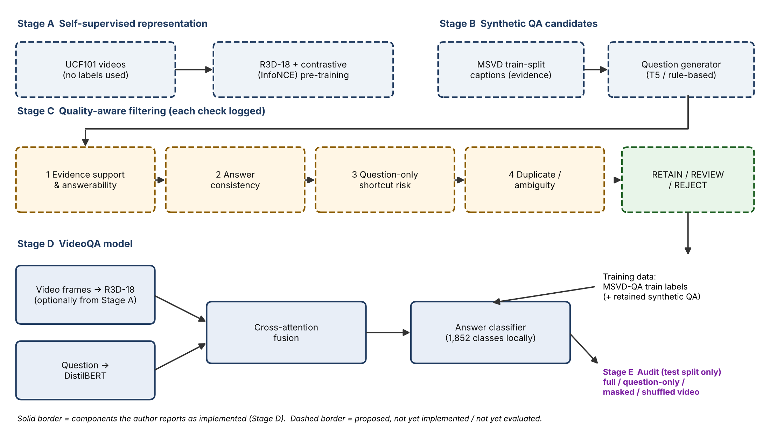
Figure 1. Proposed pipeline. Solid border: reported as implemented (Stage D). Dashed border: proposed. Stage A optionally initialises the video encoder; Stage C filters Stage B candidates; retained pairs are added to the MSVD-QA training labels; Stage E uses the test split only.
Component | Status | Evidence / note
UCF101 videos (13,320 found locally) | Implemented (local) | File count observed by the author; matches the 13,320 videos stated by the dataset page [7].
R3D-18 video encoder, DistilBERT, cross-attention, classifier (1,852 classes) | Implemented (local) | Reported by the author. Class count is a local observation, not a dataset statistic.
Preliminary validation accuracy ≈ 25% | Early observation | Early training only. Not a result and not evidence of improvement.
Contrastive pre-training on UCF101 | To confirm | Dataset is present; whether pre-training was run and evaluated must be confirmed.
Synthetic QA generation | Proposed | Generator choice to be fixed (Section 5.3).
Four quality checks and retention rule | Proposed | Thresholds to be set on a manually reviewed pilot sample.
Counterfactual audits | Proposed | Run on the test split with a fixed protocol.
Table 1. Status of components. Status is also given in words so that it does not rely on colour.

5.2 Models and objectives
A video encoder f maps sampled frames of video v to features z = f(v); a text encoder g maps the question q to h = g(q). A cross-attention module lets question tokens attend to video features, and a classifier estimates p(a | v, q) over K answer classes. The existing implementation uses R3D-18 [8] and DistilBERT [9].
Contrastive pre-training [Proposed]. For two augmented views z and z⁺ of the same clip, an InfoNCE-style loss [10] pulls positives together relative to other clips in the batch:
L_con = −(1/N) Σᵢ log [ exp(sim(zᵢ, zᵢ⁺)/τ) / Σⱼ exp(sim(zᵢ, zⱼ)/τ) ]
where sim is cosine similarity, τ a temperature and N the batch size. The benefit of this step must be shown by comparing against the same pretrained encoder without the extra step. Answer classification: cross-entropy over a fixed answer vocabulary,
L_QA = − Σᵢ log p(aᵢ | vᵢ, qᵢ)
Synthetic answers outside the vocabulary will be counted and reported, not silently dropped.

5.3 Synthetic QA generation [Proposed]
Evidence for each training video is its human-written captions. A pretrained text-to-text question-generation model (for example a T5-family model) or a rule-based generator will produce (question, answer) candidates from each caption, and the source caption is stored with every pair so that each pair is traceable. The exact generator will be fixed after a small pilot.
Issue for discussion with the supervisor. MSVD-QA itself was generated automatically from the same style of captions [5]. Candidates generated from MSVD training captions may therefore overlap heavily with existing MSVD-QA training pairs. Options: (a) accept this and focus on filtering effects; (b) use a different generator/question style and report overlap; (c) add extra captioned videos from another dataset, which adds cost. The choice affects how much new supervision the synthetic data really adds.

5.4 Quality-aware filtering [Proposed]
Check | Question it asks | Possible implementation
1. Evidence support and answerability | Is the answer supported by the evidence, and can the question be answered from it? | Text entailment (NLI) between caption and the statement “question + answer”; optionally a visual-support score from an image–text model on sampled frames, since captions alone are not visual proof.
2. Answer consistency | Does a second pass give the same answer? | A verifier model answers from the stored evidence, or a paraphrased question is answered; disagreement is flagged.
3. Question-only shortcut risk | Could the answer be guessed without the video? | Train a text-only model; record p_text(a | q). High values are flagged, and reported separately.
4. Duplicate and ambiguity | Is the pair repeated or underspecified? | Normalised-text or embedding similarity per video; rules/manual review for vague references such as “he” when several people appear.
Table 2. The four checks.
Let E be the evidence-support score, C = 1 if the answer is consistent, B = p_text(a | q), and D = 1 if the pair is neither duplicated nor ambiguous. The strict retention rule is
retain ⇔ E ≥ τ_E ∧ C = 1 ∧ B < τ_B ∧ D = 1
Pairs that fail only one soft check are sent to manual review rather than silently dropped. Thresholds τ_E and τ_B are chosen on a small, manually reviewed pilot sample and then fixed; they are never tuned on the benchmark test set. A high B does not prove a question is invalid, since some valid questions are naturally easy; for this reason shortcut-risk pairs are reported separately and the effect of the check is tested as an ablation. Agreement between generator and verifier is not independent proof if both share weaknesses, so a human-checked subset will be compared with the automatic decisions.

6. Quality-Aware Synthetic QA Filtering: Worked Examples
[Illustrative] The rows below are invented to explain the checks. They are not MSVD-QA annotations and no real clip is shown for them yet. Replace them with verified rows after inserting the real frames (Section 6.2). Decisions are written in words and symbols (✔ retain, ✘ reject, ? review) as well as colour.

6.1 Worked table
Scenario A is a clip of a person drinking water from a glass. Scenario B is a clip of a woman cutting vegetables. Both scenarios are hypothetical until real clips are chosen.
Candidate question | Candidate answer | Visual evidence | Quality decision | Reason
A1. What is the person doing? | drinking | Person lifts glass to mouth and drinks (Scenario A) | ✔ RETAIN | Check 1 pass: supported. Check 2 pass: matches the visible action. Check 3: moderate text-only score only. Check 4: unambiguous.
A2. What colour are the person’s shoes? | black | Feet not visible | ✘ REJECT | Check 1 fail: the video does not contain the evidence, so the answer cannot be verified (unanswerable).
A3. What is the person drinking? | juice | Clear liquid in a glass; caption says water | ✘ REJECT | Check 2 fail: the answer contradicts the visible content and the caption.
A4. What do people usually drink when they are thirsty? | water | Not clip-specific | ✘ REJECT | Check 3 fail: answerable from general knowledge without the video (high shortcut risk).
A5. What is the person doing? (second copy, same clip) | drinking | Same as A1 | ✘ REJECT | Check 4 fail: duplicate of A1; keep one copy.
A6. What is he doing? (two people in clip) | drinking | Two people visible, only one drinking | ? REVIEW | Check 4: ambiguous reference. A person may rewrite it, or it is dropped.
B1. What is the woman cutting? | vegetables | Woman cuts items on a board (Scenario B) | ✔ RETAIN | Supported and consistent with the caption “a woman is cutting vegetables”.
B2. What is the woman cutting? | onions | Items on board not clearly distinguishable | ? REVIEW | Check 1 uncertain: the caption says only “vegetables”, so the specific answer is not confirmed; needs a human look at the frames.
Table 3. Illustrative filtering decisions (not dataset annotations).

6.2 Where real MSVD frames go
Figures 2–4 are reserved for real frames. Each holds four evenly spaced frames from one MSVD clip. Until they are filled, the grey boxes are placeholders, not dataset images. For each figure, the verified MSVD-QA question–answer pairs for that clip (printed by the supplied script) go in the caption and in the table rows above.

Figure 2. [Placeholder: insert real MSVD frames — a person drinking.] Source: MSVD video ID ____, frames at ____ s. Verified MSVD-QA entries for this clip: Q: ____ A: ____. Visual evidence: ____. Filter outcome: ____.
Figure 3. [Placeholder: insert real MSVD frames — a person cutting vegetables / food.] Source: MSVD video ID ____, frames at ____ s. Verified MSVD-QA entries for this clip: Q: ____ A: ____. Visual evidence: ____. Filter outcome: ____.
Figure 4. [Placeholder: insert real MSVD frames — another clear action, ideally one where a QA pair should be rejected.] Source: MSVD video ID ____, frames at ____ s. Verified MSVD-QA entries for this clip: Q: ____ A: ____. Visual evidence: ____. Filter outcome: ____.
Files needed. To fill the figures, the author needs the local MSVD video files (the YouTubeClips folder or equivalent), the MSVD-QA annotation JSON, and the video-ID mapping file if the annotation uses numeric IDs. The script `extract_msvd_examples.py` extracts frames and prints the matching annotations. Only clips actually present in the author’s copy and only annotations printed from the author’s file should be used.

7. Dataset and Experimental Design

7.1 Datasets and roles
Dataset | What it contains (source) | Role in this thesis
UCF101 [7] | 13,320 videos in 101 action classes (dataset page). | Unlabeled videos for contrastive pre-training of the video encoder. Class labels are not used.
MSVD [6] | Short video clips with human-written descriptions. | Source of evidence captions for synthetic QA (training split only).
MSVD-QA [5] | About 1,970 clips and 50,505 QA pairs, five question types (what, who, how, when, where), roughly 61% / 13% / 26% of QA pairs for train / validation / test (as described in a secondary source; verify against the official release). | Principal downstream benchmark: training labels, validation for model selection, test split for final reporting.
Table 4. Datasets. Totals must be re-verified against the official release before reporting.
Local observations [not universal statistics]: about 13,320 UCF101 videos; 30,933 MSVD-QA training QA entries covering 1,161 unique training video IDs in the author’s training file; an answer classifier with 1,852 classes. The number of videos should be checked against the official split lists, and the reason for the class count documented (for example the answer-frequency cut-off used).
Correction to the annotation description. MSVD-QA answers are derived automatically from human captions [5]; they are not manually written QA pairs. The proposal therefore calls them benchmark QA labels and states that benchmark labels are used for training and evaluation. The system is not described as free of human supervision.

7.2 Splits and leakage control
- Use the official train / validation / test video split. Synthetic QA is generated only from training-split videos and captions.
- Test videos, their captions and their QA are excluded from generation, from filter-threshold selection and from model selection.
- Check for duplicate or near-duplicate videos across splits, and check overlap between synthetic candidates and existing MSVD-QA training pairs.
- UCF101 pre-training uses no MSVD-QA data.
- Use a fixed random seed list and report the number of runs.

7.3 Imbalance and shortcuts
Answer frequency will be tabulated per question type. Because the classifier has many classes and a few answers (such as common action or object words) are likely to dominate, majority-answer and question-only baselines will be reported next to the model. Per-question-type accuracy will be reported so that gains are not hidden in the frequent types. Rare-answer handling (class weights or grouping) is a design choice to be fixed before the main runs.

8. Evaluation Metrics and Counterfactual Grounding Audits

8.1 Counterfactual audit
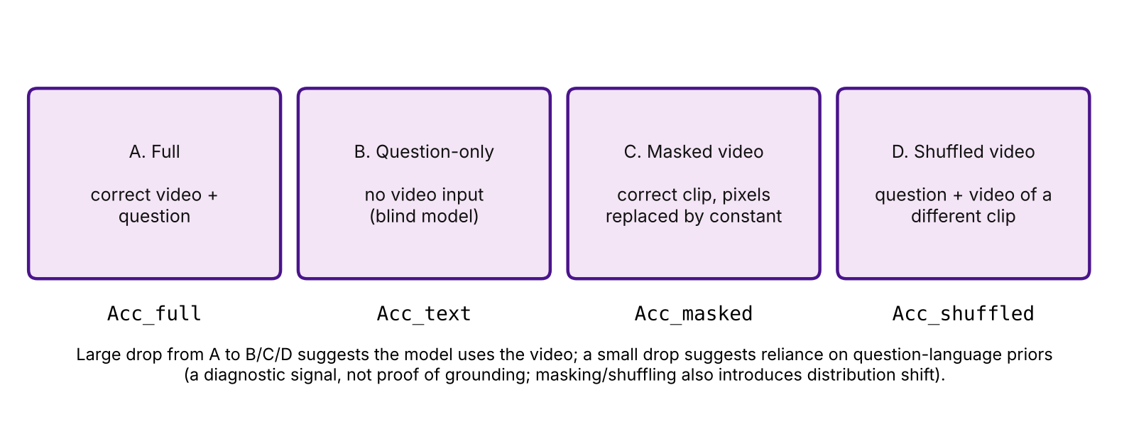
Figure 5. Four evaluation conditions applied to the same trained model (the question-only condition may use a separate text-only model; this is reported).
Metric | Definition | Reading
Acc_full | Accuracy with the correct video and question. | Standard benchmark accuracy.
Acc_text | Accuracy with the question only (no visual input). | How far language alone goes.
Acc_masked | Accuracy when the clip’s pixels are masked. | Does performance collapse without visual content?
Acc_shuffled | Accuracy when the question is paired with a different video. | Does a mismatched video hurt?
G_blind = Acc_full − Acc_text | Blind-accuracy gap. | Larger gap suggests more use of video.
Δ_mask, Δ_shuffle | Acc_full − Acc_masked; Acc_full − Acc_shuffled. | Large drops suggest dependence on the matching video.
Table 5. Metrics.
A large gap between the correct-video and video-ablated conditions suggests the model uses visual information. A small gap suggests the model leans on question wording or answer frequency. These tests are diagnostics, not proof: a model can be sensitive to masking simply because masked input is out-of-distribution, and these tests do not eliminate language bias or establish temporal grounding. Results will be read together with per-question-type accuracy, filter retention rates and qualitative error examples.

8.2 Experimental conditions and ablation template
Planned comparisons: (1) baseline on MSVD-QA labels only; (2) baseline + unfiltered synthetic QA; (3) baseline + filtered synthetic QA; (4) the same with each check removed in turn; (5) matched-size comparison of (2) and (3); (6) with versus without contrastive pre-training. Table 6 is a template only.
Condition | Acc_full | Acc_text | Acc_masked | Acc_shuffled | Retained / size
Baseline (MSVD-QA labels only) | To be measured | To be measured | To be measured | To be measured | —
+ unfiltered synthetic | To be measured | To be measured | To be measured | To be measured | To be measured
+ all four checks | To be measured | To be measured | To be measured | To be measured | To be measured
− evidence check | To be measured | To be measured | To be measured | To be measured | To be measured
− consistency check | To be measured | To be measured | To be measured | To be measured | To be measured
− shortcut-risk check | To be measured | To be measured | To be measured | To be measured | To be measured
− duplicate/ambiguity check | To be measured | To be measured | To be measured | To be measured | To be measured
Unfiltered, size matched to filtered | To be measured | To be measured | To be measured | To be measured | To be measured
With UCF101 contrastive pre-training | To be measured | To be measured | To be measured | To be measured | —
Table 6. Ablation template. All cells are intentionally empty; no results exist yet. The ≈25% early validation accuracy is a training-time observation and is not entered here.
Where feasible, repeated runs with different seeds and confidence intervals will be reported. Final claims will follow the observed results, including negative or mixed outcomes.

9. Expected Contributions
- A reproducible pipeline for generating and filtering synthetic VideoQA candidates from captions, with per-check logging.
- A filter-by-filter ablation under matched data sizes.
- A counterfactual audit protocol (full, question-only, masked, shuffled) applied to a baseline and to filtered-data models.
- A documented, honest account of what the checks can and cannot detect, including a human-checked subset.
These are expected contributions, contingent on the experiments; they are not findings.

10. Limitations and Ethical Considerations
- Captions can omit visual detail, so caption-based evidence is weaker than checking the video; a small manual video check is planned.
- Generator and verifier may share biases, so agreement is not independent proof.
- The shortcut-risk check may remove valid easy questions; masked and shuffled videos introduce distribution shift.
- MSVD-QA is small and its questions come from automatic generation, so results may not generalise to other VideoQA benchmarks.
- Videos come from public datasets under their own licences; dataset licence terms and use conditions should be checked, and example frames in the proposal limited to what the licence permits. Videos may show identifiable people, so figures should use clips with no sensitive content.
- Compute is limited to MSc-level resources; VideoMAE-scale training is out of scope.

11. Work Plan and Timeline
Period | Activity | Output
Months 1–2 | Verify datasets and splits; reproduce and document the baseline; confirm status of contrastive pre-training. | Verified baseline, split report
Months 2–3 | Contrastive pre-training on UCF101; encoder comparison. | Encoder comparison
Months 3–4 | Synthetic QA generation from training captions; overlap check with MSVD-QA. | Candidate pool
Months 4–5 | Implement four checks; manual pilot review; fix thresholds. | Filtered set, retention report
Months 5–7 | Main experiments and ablations; matched-size comparison. | Ablation table
Months 7–8 | Counterfactual audits; error analysis. | Audit results
Months 8–9 | Thesis writing and supervisor review. | Thesis draft
Table 7. Indicative 9-month plan, to be adjusted with the supervisor.

Appendix A. Points to Settle with the Supervisor
- Whether the title should stay as is. A shorter alternative is “Quality-Aware Synthetic Supervision and Visual-Grounding Audits for Self-Supervised Video Question Answering”; the current title is acceptable only if the contrastive pre-training is actually carried out.
- Which generator to use, given overlap with MSVD-QA’s own caption-derived questions (Section 5.3).
- Whether the curriculum idea from [4] is dropped or kept as a stretch goal.
- Size and protocol of the manual pilot review.
- Verification of dataset totals (for example the 1,161 training videos) against official split lists.
- Dataset licence terms for any frames reproduced in the thesis.

12. References
[1] A. Yang, A. Miech, J. Sivic, I. Laptev, and C. Schmid, “Just Ask: Learning to Answer Questions from Millions of Narrated Videos,” in Proc. IEEE/CVF Int. Conf. Computer Vision (ICCV), 2021, pp. 1686–1697.
[2] S. Di and W. Xie, “Grounded Question-Answering in Long Egocentric Videos,” in Proc. IEEE/CVF Conf. Computer Vision and Pattern Recognition (CVPR), 2024, pp. 12934–12943.
[3] J. Xiao, A. Yao, Y. Li, and T.-S. Chua, “Can I Trust Your Answer? Visually Grounded Video Question Answering,” in Proc. IEEE/CVF CVPR, 2024, pp. 13204–13214.
[4] G. Zeng, J. Yu, Y.-P. P. Chen, X. Chen, W. Yang, and Z. Song, “CurEvo: Curriculum-Guided Self-Evolution for Video Understanding,” arXiv:2604.26707, Apr. 2026 (preprint).
[5] D. Xu, Z. Zhao, J. Xiao, F. Wu, H. Zhang, X. He, and Y. Zhuang, “Video Question Answering via Gradually Refined Attention over Appearance and Motion,” in Proc. 25th ACM Int. Conf. Multimedia, 2017, pp. 1645–1653, doi: 10.1145/3123266.3123427.
[6] D. Chen and W. Dolan, “Collecting Highly Parallel Data for Paraphrase Evaluation,” in Proc. 49th Annu. Meeting of the ACL: Human Language Technologies, 2011, pp. 190–200.
[7] K. Soomro, A. R. Zamir, and M. Shah, “UCF101: A Dataset of 101 Human Action Classes From Videos in The Wild,” CRCV-TR-12-01, Center for Research in Computer Vision, Univ. of Central Florida, Nov. 2012.
[8] D. Tran, H. Wang, L. Torresani, J. Ray, Y. LeCun, and M. Paluri, “A Closer Look at Spatiotemporal Convolutions for Action Recognition,” arXiv:1711.11248, 2017.
[9] V. Sanh, L. Debut, J. Chaumond, and T. Wolf, “DistilBERT, a distilled version of BERT: smaller, faster, cheaper and lighter,” arXiv:1910.01108, 2019.
[10] A. van den Oord, Y. Li, and O. Vinyals, “Representation Learning with Contrastive Predictive Coding,” arXiv:1807.03748, 2018.
[11] Y. Goyal, T. Khot, D. Summers-Stay, D. Batra, and D. Parikh, “Making the V in VQA Matter: Elevating the Role of Image Understanding in Visual Question Answering,” arXiv:1612.00837, 2016.
[12] Z. Tong, Y. Song, J. Wang, and L. Wang, “VideoMAE: Masked Autoencoders are Data-Efficient Learners for Self-Supervised Video Pre-Training,” arXiv:2203.12602, 2022.

