About PDF splitter and merger:

This software works with PDF file Format. With This software you can :

1. Read pdf file
2. Spilt pdf file in various categories.
3. Remove blank page.
4. Merge more than one pdf together.

Interface Overview:

Help
Menu
Operations Tab
Reader
Tab
Add files
Menu
Add Files Menu
Progress bar Tab

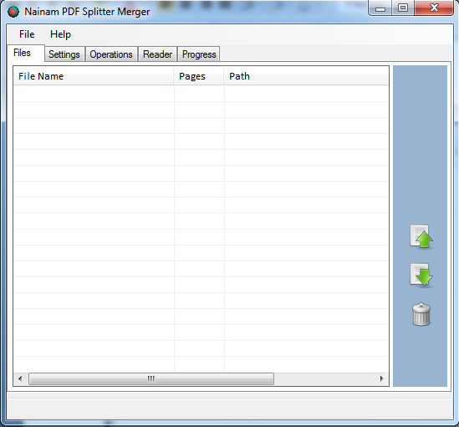
Files
Tab
Settings
Tab
Remove Button
Down Button
Up Button
List View
Files Tab

Installation:

Double click on setup.exe.

Usage:

- Adding Files for operation

Click on File > Open PDF to add files. You can add more than one file at a time.
You can add files by drag and drop. Just drag pdf files and drop on the list view.

- Up-down file position :

Select a file and click up Button for up and down Button for down. To remove a file from list first click on it then click on remove icon.

- Read pdf file:

Select a file from list.
Select Reader Tab. You can see the pdf file and bookmarks if it has bookmarks.
You can minimize the bookmark of a pdf file by clicking hide button.

- Settings:

Click on settings tab.
Set default folder , file name prefix and replacing option you want.
These settings are optional.

Operation:

- Splitting:

- Single page splitting:
Click Operations> Split>Split Into Single Pages.

- Split By Range:
Click Operations> Split
Select From and To from dropdown menu.

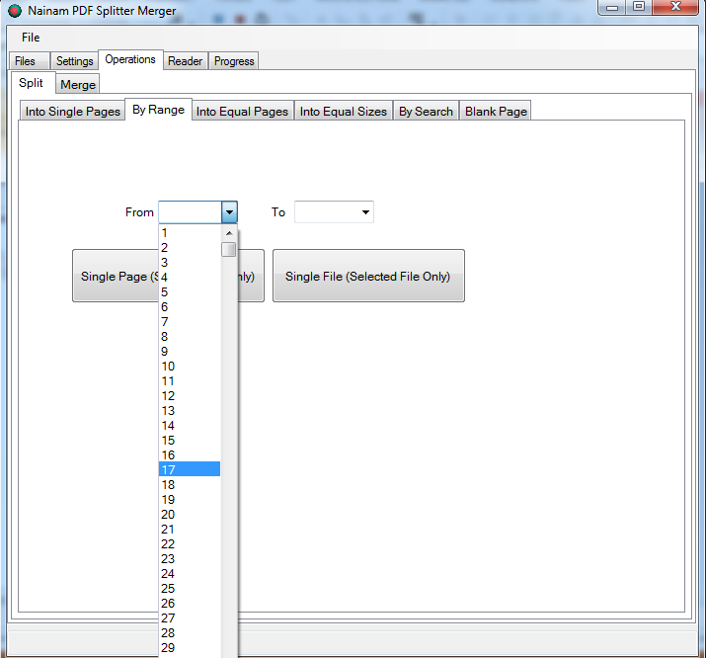

Click Single Page or Single File as you want.

- Split by equal page:
Click Operations> Split

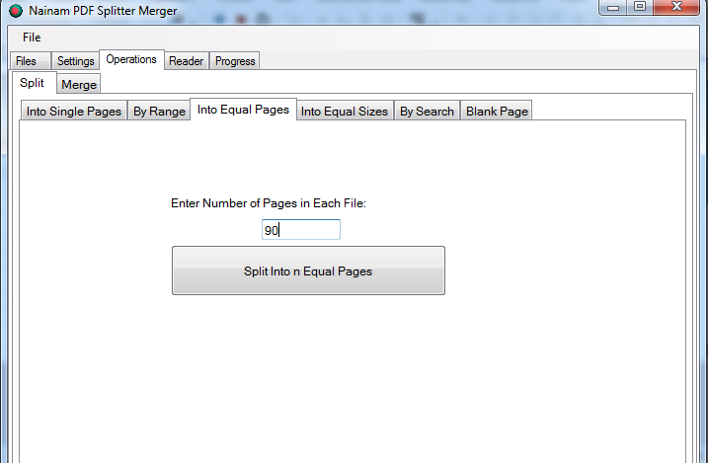

Enter the number of page per file into box and click Split Into n Equal Pages Button.

- Split into equal size:
Click Operations> Split

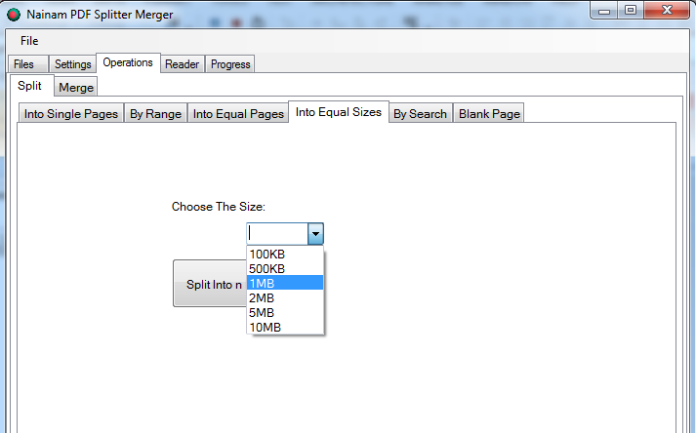
Select your desired file size from drop down menu. Then click Split Into n Equal Size Button.

- Split By Search:
Click Operations> Split

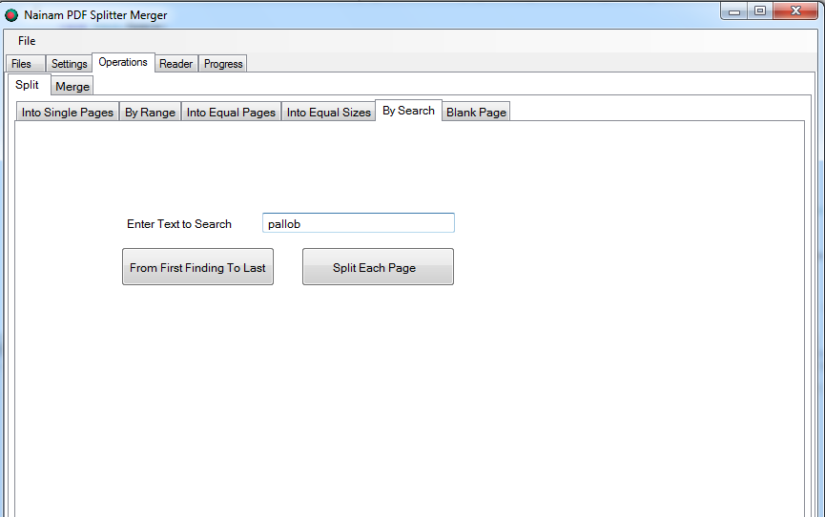

Enter the text you want to search and press button.
“From first finding to last” if you want a single file on search range.
“Split each page” if you want every page containing your word in a single page pdf.

- Split by blank page:
you can remove blank page from your pdf file. Select Operations> Split> Remove all Blank Page.

- Split by bookmark:
Select Reader Tab and you can see the bookmark. If you do not see the bookmark then click on leftmost button to see bookmark. Right click on any bookmark> Set from by clicking left mouse button on from menu> select To> Then select Single File or Single Page. Single file means all pages into a single file. And single page means each page as a pdf file.

- Keyboard Shortcut:

You can use keyboard to split Single page.
Select the page you want to split. You can select any page by entering page number in the page number box which is located upper side of reader.
Click Reader Tab> Press space key from keyboard.

- Merge:
Click Operations > Merge > Merge Button.

- View Progress:
Select Progress Tab. You can see the operations progress and status.

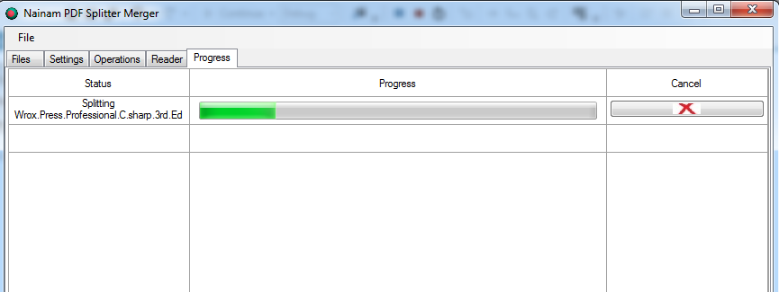

- Cancel Operation:
You can cancel any running operation by clicking the cancel button located right side of progress bar of that operation.

