

**Student Performance Matrix**

**Course Code CSE450**

**Daffodil International University**

Moriom Chowdhury Kumu

[**kumu2439@diu.edu.bd**](mailto:kumu2439@diu.edu.bd) --131-15-2439

Amirul Islam Mahadi

[**amirul2267@diu.edu.bd131**](mailto:amirul2267@diu.edu.bd131) --131-15-2267

Nishat Halim Sharif

[**nishat2330@diu.edu.bd**](mailto:nishat2330@diu.edu.bd) --131-15-2330

Md. Shahriar Parvez Tameem

[**tameemshahriar@diu.edu.bd**](mailto:tameemshahriar@diu.edu.bd) --131-15-2488

**Foreword**

We are pleased to present the Department of Computer Science (CSE) 2016 Data Mining Report. Our topic is “Student performance Matrix”. Our project meets the Act’s definition of data mining. The Daffodil International University Students have worked closely with the research discussed in this report to ensure that they employ data mining in a manner that both supports the Department’s mission to ensure the appropriate analysis of “Student Performance Matrix”.

To

Prof. Syed Akhter Hossain

Head Of the Dept. of CSE

Daffodil International University

**Executive Summary**

BACKGROUND:

Improving the educational performance of students is critical for nation’s future social and economic prosperity. A quality education gives the students skills they need to participate as productive, creative and responsible members of society. The outcomes of the research will ensure,

OUTCOMES:  
-Improve educational outcomes for the students.

-Better curriculum and assessment for the students.

-Support motivational learning with effective technology.

**OBJECTIVES:**

Student performance matrix project has 4 objectives.

-To determine whether a student has a good competency in English.

-Using better communication with teacher for better learning.

-To ensure the effective use technology in education.

-Effective self-study for better performance.

**Data Collection & preprocessing**

**Data Collection:**

First of all we prepared a set of questions based on “Student Performance “ data. We made the questionnaires including a set of section from A to E. Then we create a google form with the questionnaires. We used 5-likert scale, multiple objective, multiple options and descriptive short questions. We go to some classroom and request the students to fill it. We go to some teachers to ask their students to fill it. Last but not least we shared it in facebook and some groups of the university. We got responses from all groups. Finally we got 253 responses.

**Data preprocessing :**

Then we collect the data as .CSV format from the google form. As the data is too noisy and there is also some missing values. So we need to preprocess the data. For preprocessing, we replaced all string data comes for the use of likert scale with numeric values. We decided to divide the questionnaires into four sets such as Students

*English competency

*Using technology

*Communication & interaction

*Self Study.

We added a class attribute to each sets. We defined the class attributes with binomial target variables as 1 for positive and 0 for negative.

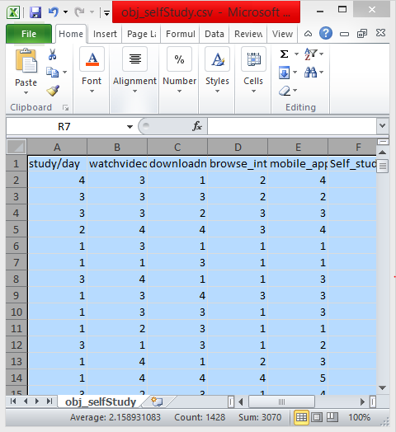

**Implementation issues & solution**

Our target is to visualize the student performance by analyzing the data . By analyzing we can know in which side students are weak and in which side they are strong. Which side needs to be more focused? Which activity can provide better learning?

**Visualization**

**English Competecncy**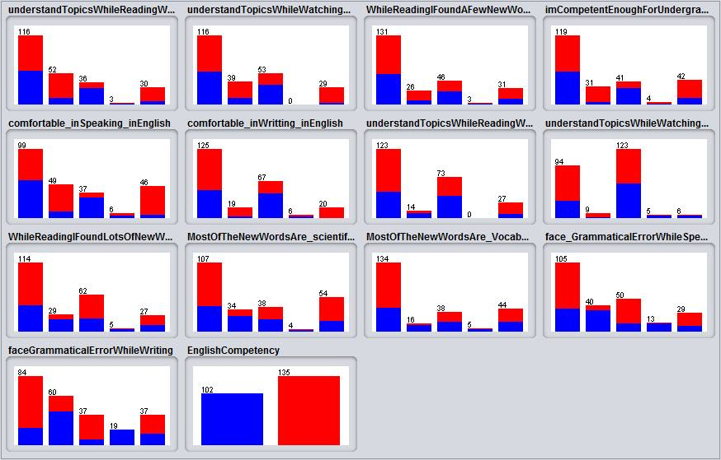

**Using Tecnology**

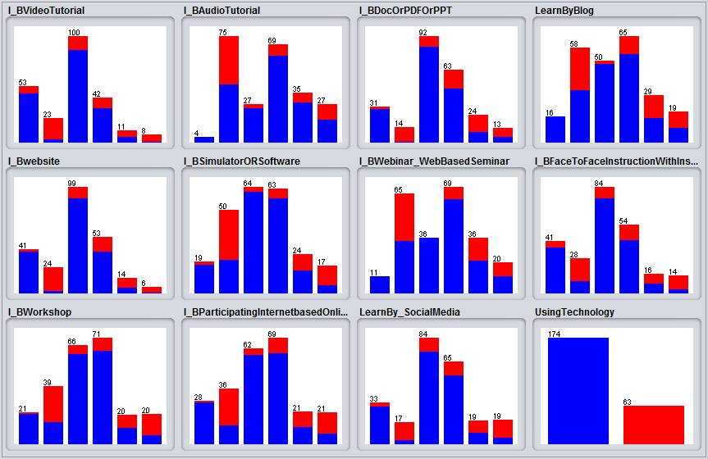

**Communication**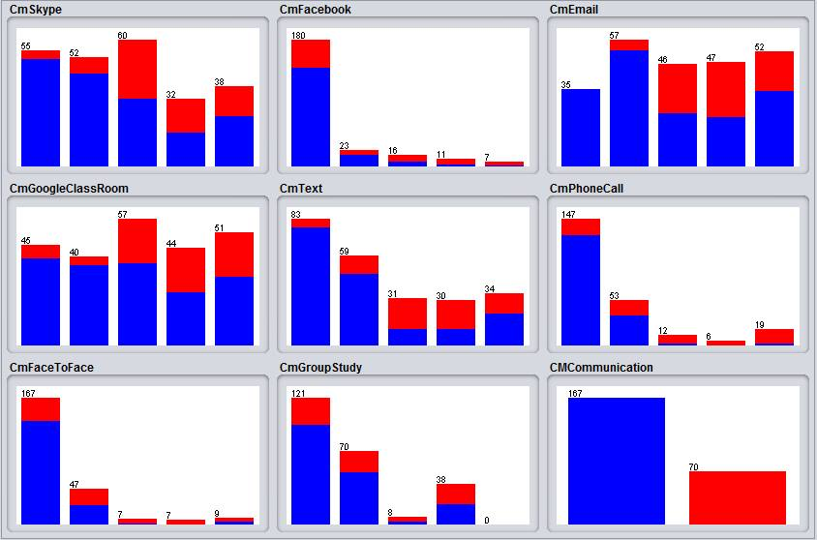

**Self Study**

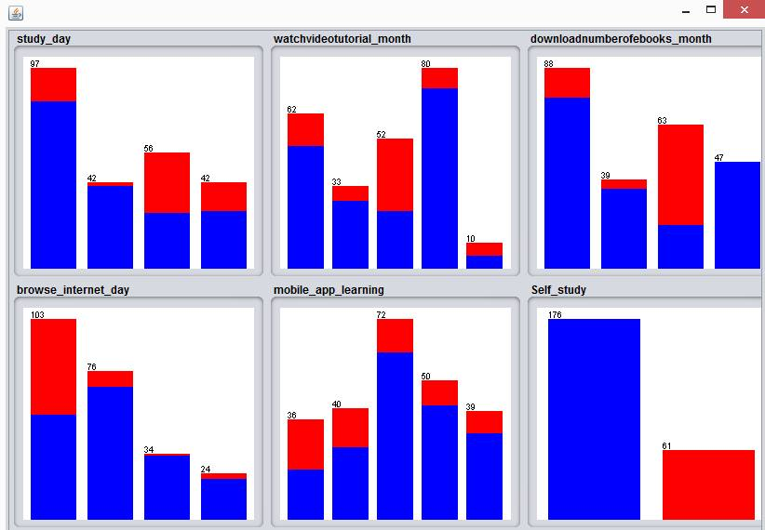

**Classification**

We use C4.5 algorithm using J48 for classification.

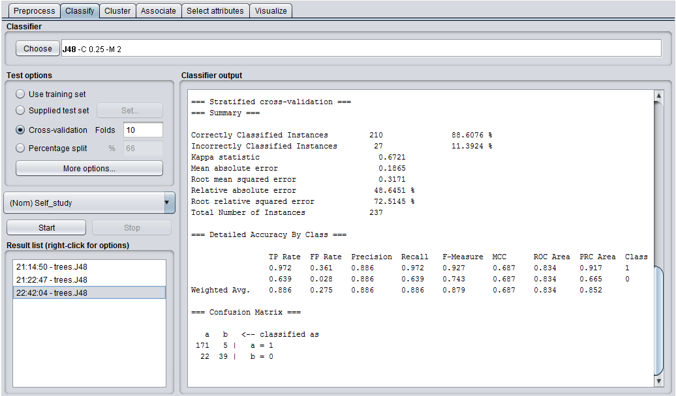

We applied classification algorithms with this dataset in WEKA. The Figure shows the decision tree of the dataset.(Self Study tree)

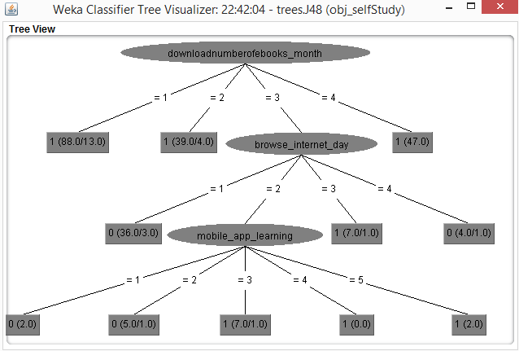

**Accurecy Anlaysis:**

This the accurecy analysis for “English Competency”

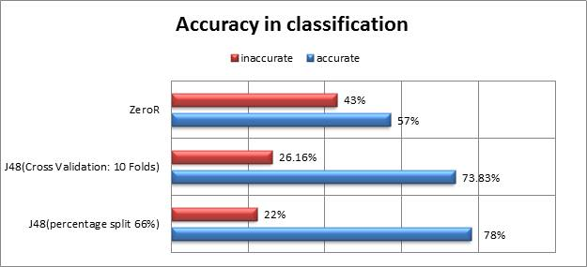

This the accurecy analysis for “Using Technology”

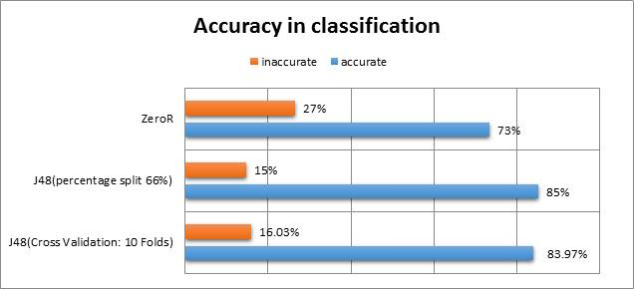

This the accurecy analysis for “Communication and Interaction”

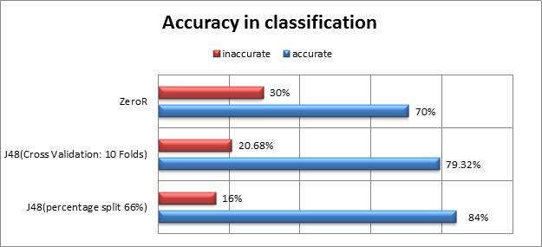

This the accurecy analysis for “Self Study”

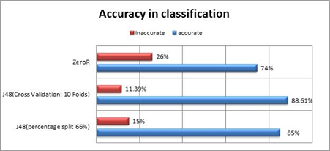

**Learning experience:**

We learn Data Mining Technology effectively.  
1. We learcn how to collect data and preprocess the data.

2. We learn how to convert string to nominal for getting nominal value in result.

3.We learn the weka tool .  
4. We learn several data ming techniques, in this project we follow classification.

5.We learn how to use C4.5 algorithm using J48 for classification.  
6. We learn to get accuracy analysis form a huge bunch of data and get a nominal result.

**Future Scope:**

**We can research furthuer on this topic. The heart of a good education is effective learning with quality teaching. We can also work with theacher performence matrix.Based on how students are performing we can work on , what needs to be done to support them in achieving their full potential. So, there is a huge opportunity of researching this project of “Student performenc matrix”.**

**-we can work on assesting teachers and parents understand progress in student learning.**

**-we can work on providing information of currentstudent ativity.**

**-We can also work with students parents and university community to ensure common understanding.**

**Reference:**

1.[Assessment and Reporting: Improving Student Performance - acara](https://www.google.com.bd/url?sa=t&rct=j&q=&esrc=s&source=web&cd=2&cad=rja&uact=8&ved=0ahUKEwiz0Pm2utDOAhULP48KHfHTDfoQFggnMAE&url=http%3A%2F%2Fwww.acara.edu.au%2F_resources%2FAssessment__Reporting_-_Improving_Student_Performance.pdf&usg=AFQjCNHtXi4xgCfK3xX2BByu5zDbbRf2sg&bvm=bv.129759880,d.c2I)

### 2.[Reporting Student Progress: Policy and Practice - Ministry of Education](https://www.bced.gov.bc.ca/classroom_assessment/09_report_student_prog.pdf)

3.<http://www.ascd.org/publications/educational_leadership/oct94/vol52/num02/Talking_With_Parents_About_Performance-Based_Report_Cards.aspx>

4.<http://createwp.customer.mheducation.com/wordpress-mu/success-academy/creating-student-performance-reports/>