I'm using MySQL 8  
I go through the initial requirements, which are the most important ones:

- Merge the two Laravel projects onto a single one

- Make sure the ADMIN controls the FRONTEND, and that they are CONNECTED through a single database, permissions & settings!

- Create the database structure for all the required information we will use to store WEBSITE information

- Create an external connection that will fetch information from an EXTERNAL database (the game bot's database)

- Implement payment gateways: PayPal & Lemon Squeezy (information must be stored on the website in a customizable area)

- User ranks: free user, bronze, silver, gold, admin + additional ranks based on custom packages we will create

- Add the ability to add pages dynamically, where I can define what each page shows

- Make sure the backend controls the UI presented in the front-end (including menus, dropdowns, etc)

- When a transaction is completed, log the transaction's details on the local database with all the info + bot's database for the summarized data (starting date, ending date, tier level)

- Login via Discord EXCLUSIVELY (NO registration or any other login methods such as Google/Facebook/Apple/whatever)  
- Add the ability to setup queries in advance for the remote bot database and name them so I can call them on a custom page and display specified top lists

- Settings should update values in the database directly

- Use caching wherever possible for it to make sense

- Please keep me updated on progress made + screenshots, I would love if you could document progress via GitHub or GitLab (send me the link)

- I sincerely ask for regular updates, if possible, as I would like to have avoid multiple iterations as much as possible in order to save time. I am always available if something isn't clear

- You may use demo data for now, I will provide the bot's database structure soon, but it's still under development so please make sure you make it dynamically adjustable to changes. I always expand the bot's functionality and this is why it's so important for me to keep it MODULAR, DYNAMIC and COMPACT.

Yes that's fine. For now if possible to make sure the two projects are connected as backend/frontend, Discord login features, account panel, ability to control the landing page / menus from the admin panel, ability to create custom pages (and assign them in the navigation bar / menu at the top - controllable through the admin panel)

That would be incredible!

Also payment gateway logic + logging

1. Remove blog related routes
2. Remove login/signup page, Login with Discord option thakbe just
3. Remove these two pages 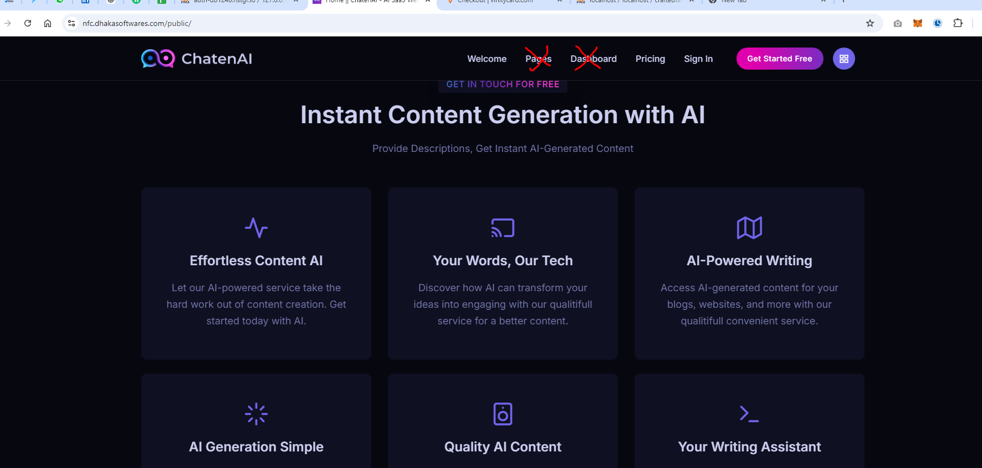
4. Project ar vitore doc folder a , admin page guli routing kora ache, project ta merge korben 