*Create Database:

CREATE DATABASE Bookish;

1. **Create Author Table:**

CREATE TABLE Author

(

Author_ID INT AUTO_INCREMENT PRIMARY KEY,

Author_Name VARCHAR(200) NOT NULL,

Birth_Year INT NOT NULL,

No_Of_Books INT NULL,

No_Of_Awards INT NULL

);

**INSERT data into Author table:**

INSERT INTO Author VALUES (1, 'Rabindranath Thakur', 1861, 171, 50);

INSERT INTO Author VALUES (2, 'Zahir Raihan', 1935, 8, 5);

INSERT INTO Author VALUES (3, 'Satyajit Ray', 1921, 145, 30);

INSERT INTO Author VALUES (4, 'Sir Arthur Conan Doyle', 1859, 15, 12);

INSERT INTO Author VALUES (5, 'Anthony Mascarenhas', 1928, 3, null);

INSERT INTO Author VALUES (6, 'Jahanara Imam', 1929, 25, 10);

INSERT INTO Author VALUES (7, 'Sufia Kamal', 1911, 10, 3);

INSERT INTO Author VALUES (8, 'Robert Frost', 1874, null, null);

1. **Create Book Table:**

CREATE TABLE Book

(

Book_No INT AUTO_INCREMENT PRIMARY KEY,

Book_Name VARCHAR(200) NOT NULL,

Genre VARCHAR(200) NOT NULL,

Language VARCHAR(200) NOT NULL

);

**Insert data into Book table:**

INSERT INTO Book VALUES (1, 'Shesher Kobita', 'Drama', 'Bangla');

INSERT INTO Book VALUES (2, 'Noukadubi', 'Drama', 'Bangla');

INSERT INTO Book VALUES (3, 'GolpoGuccho', 'Short Stories', 'Bangla');

INSERT INTO Book VALUES (4, 'Chokher Bali', 'Drama', 'Bangla');

INSERT INTO Book VALUES (5, 'Gitanjali', 'Poetry', 'Bangla');

INSERT INTO Book VALUES (6, 'Hajar Bochor Dhore', 'Drama', 'Bangla');

INSERT INTO Book VALUES (7, 'Borof Gola Nodi', 'Drama', 'Bangla');

INSERT INTO Book VALUES (8, 'Shesh Bikeler Meye', 'Drama', 'Bangla');

INSERT INTO Book VALUES (9, 'Shonku Samagra', 'Science Fiction', 'Bangla');

INSERT INTO Book VALUES (10, 'Golpo 101', 'Short Stories', 'Bangla');

INSERT INTO Book VALUES (11, 'Hottyapuri', 'Detective', 'Bangla');

INSERT INTO Book VALUES (12, 'Chinnomostar Ovishap', 'Detective', 'Bangla');

INSERT INTO Book VALUES (13, 'A study in Scarlet', 'Detective', 'English');

INSERT INTO Book VALUES (14, 'The Case-Book of Sherlock Holmes', 'Detective', 'English');

INSERT INTO Book VALUES (15, 'Bangladesh: A Legacy of Blood', 'History', 'English');

INSERT INTO Book VALUES (16, 'Ekattorer Dinguli', 'History', 'Bangla');

INSERT INTO Book VALUES (17, 'Ekattorer Diary', 'History', 'Bangla');

INSERT INTO Book VALUES (18, 'Kobita Somogro', 'Poetry', 'Bangla');

INSERT INTO Book VALUES (19, 'Mountain Interval', 'Poetry', 'English');

1. **Create Characters Table:**

CREATE TABLE Characters

(

Character_ID INT AUTO_INCREMENT PRIMARY KEY,

Character_Name VARCHAR(200) NOT NULL,

Age INT NULL

);

**Insert data into Characters table:**

INSERT INTO Characters VALUES (1, 'Amit Ray', 26);

INSERT INTO Characters VALUES (2, 'KetakI', 22);

INSERT INTO Characters VALUES (3, 'Labanya', 20);

INSERT INTO Characters VALUES (4, 'Ramesh', 27);

INSERT INTO Characters VALUES (5, 'Hemnalini', 24);

INSERT INTO Characters VALUES (6, 'Nalinaksha', 30);

INSERT INTO Characters VALUES (7, 'Kamala', 20);

INSERT INTO Characters VALUES (8, 'Nirupoma', 15);

INSERT INTO Characters VALUES (9, 'Postmaster', 24);

INSERT INTO Characters VALUES (10, 'Ratan', 10);

INSERT INTO Characters VALUES (11, 'Fotik', 10);

INSERT INTO Characters VALUES (12, 'Kadombini', 18);

INSERT INTO Characters VALUES (13, 'Mahendra', 25);

INSERT INTO Characters VALUES (14, 'Binodini', 18);

INSERT INTO Characters VALUES (15, 'Bihari', 23);

INSERT INTO Characters VALUES (16, 'Tuni', 18);

INSERT INTO Characters VALUES (17, 'Montu', 21);

INSERT INTO Characters VALUES (18, 'Mokbul', 45);

INSERT INTO Characters VALUES (19, 'Moriyom', 23);

INSERT INTO Characters VALUES (20, 'Mahmud', 28);

INSERT INTO Characters VALUES (21, 'Kashed', 27);

INSERT INTO Characters VALUES (22, 'Jahanara', 24);

INSERT INTO Characters VALUES (23, 'Professor Shonku', 59);

INSERT INTO Characters VALUES (24, 'Nokur Chandra Biswas', 49);

INSERT INTO Characters VALUES (25, 'Abinash Chandra Majumder', 53);

INSERT INTO Characters VALUES (26, 'Tarini Charan Banerjee', 65);

INSERT INTO Characters VALUES (27, 'Nyapla', 11);

INSERT INTO Characters VALUES (28, 'Bonku Babu', 48);

INSERT INTO Characters VALUES (29, 'Professor Hijibijbij', null);

INSERT INTO Characters VALUES (30, 'Feluda', 26);

INSERT INTO Characters VALUES (31, 'Jotayu', 48);

INSERT INTO Characters VALUES (32, 'Topshe', 16);

INSERT INTO Characters VALUES (33, 'Lakshman Bhattacharya', 35);

INSERT INTO Characters VALUES (34, 'Mahesh Choudhury', 70);

INSERT INTO Characters VALUES (35, 'Sherlock Holmes', 30);

INSERT INTO Characters VALUES (36, 'Dr. Watson', 32);

INSERT INTO Characters VALUES (37, 'Brigham Young', 33);

INSERT INTO Characters VALUES (38, 'Adelbert Gruner', 35);

INSERT INTO Characters VALUES (39, 'Grace Dunbar', 27);

INSERT INTO Characters VALUES (40, 'Rumi', 21);

INSERT INTO Characters VALUES (41, 'Sharif', 40);

1. Book_Character_Relationship Table:

CREATE TABLE Book_Character_Relationship

(

Character_ID INT NULL,

Book_No INT NULL,

CONSTRAINT Book_Character_Relationship__fk

FOREIGN KEY (Character_ID) REFERENCES Characters (Character_ID),

FOREIGN KEY (Book_No) REFERENCES Book (Book_No),

CONSTRAINT CombinePrimaryKey PRIMARY KEY (Character_ID,Book_No)

);

**Insert data into Book_Character_Relationship:**

INSERT INTO Book_Character_Relationship VALUES (1, 1);

INSERT INTO Book_Character_Relationship VALUES (2, 1);

INSERT INTO Book_Character_Relationship VALUES (3, 1);

INSERT INTO Book_Character_Relationship VALUES (4, 2);

INSERT INTO Book_Character_Relationship VALUES (5, 2);

INSERT INTO Book_Character_Relationship VALUES (6, 2);

INSERT INTO Book_Character_Relationship VALUES (7, 2);

INSERT INTO Book_Character_Relationship VALUES (8, 3);

INSERT INTO Book_Character_Relationship VALUES (9, 3);

INSERT INTO Book_Character_Relationship VALUES (10, 3);

INSERT INTO Book_Character_Relationship VALUES (11, 3);

INSERT INTO Book_Character_Relationship VALUES (12, 3);

INSERT INTO Book_Character_Relationship VALUES (13, 4);

INSERT INTO Book_Character_Relationship VALUES (14, 4);

INSERT INTO Book_Character_Relationship VALUES (15, 4);

INSERT INTO Book_Character_Relationship VALUES (16, 6);

INSERT INTO Book_Character_Relationship VALUES (17, 6);

INSERT INTO Book_Character_Relationship VALUES (18, 6);

INSERT INTO Book_Character_Relationship VALUES (19, 7);

INSERT INTO Book_Character_Relationship VALUES (20, 7);

INSERT INTO Book_Character_Relationship VALUES (21, 8);

INSERT INTO Book_Character_Relationship VALUES (22, 8);

INSERT INTO Book_Character_Relationship VALUES (23, 9);

INSERT INTO Book_Character_Relationship VALUES (24, 9);

INSERT INTO Book_Character_Relationship VALUES (25, 9);

INSERT INTO Book_Character_Relationship VALUES (26, 10);

INSERT INTO Book_Character_Relationship VALUES (27, 10);

INSERT INTO Book_Character_Relationship VALUES (28, 10);

INSERT INTO Book_Character_Relationship VALUES (29, 10);

INSERT INTO Book_Character_Relationship VALUES (30, 11);

INSERT INTO Book_Character_Relationship VALUES (31, 11);

INSERT INTO Book_Character_Relationship VALUES (32, 11);

INSERT INTO Book_Character_Relationship VALUES (33, 11);

INSERT INTO Book_Character_Relationship VALUES (30, 12);

INSERT INTO Book_Character_Relationship VALUES (31, 12);

INSERT INTO Book_Character_Relationship VALUES (32, 12);

INSERT INTO Book_Character_Relationship VALUES (34, 12);

INSERT INTO Book_Character_Relationship VALUES (35, 13);

INSERT INTO Book_Character_Relationship VALUES (36, 13);

INSERT INTO Book_Character_Relationship VALUES (37, 13);

INSERT INTO Book_Character_Relationship VALUES (35, 14);

INSERT INTO Book_Character_Relationship VALUES (36, 14);

INSERT INTO Book_Character_Relationship VALUES (38, 14);

INSERT INTO Book_Character_Relationship VALUES (39, 14);

INSERT INTO Book_Character_Relationship VALUES (40, 16);

INSERT INTO Book_Character_Relationship VALUES (41, 16);

1. **Create Publisher Table:**

create table Publisher

(

Publisher_ID INT AUTO_INCREMENT PRIMARY KEY,

Publisher_Name VARCHAR(200) NOT NULL,

Country VARCHAR(200) NOT NULL

);

**Insert data into Publisher Table:**

INSERT INTO Publisher VALUES (1, 'Baatighar', 'Bangladesh');

INSERT INTO Publisher VALUES (2, 'Suchoyoni Publishers', 'Bangladesh');

INSERT INTO Publisher VALUES (3, 'Bishwasahitto Vobon', 'Bangladesh');

INSERT INTO Publisher VALUES (4, 'The Sky Publishers', 'Bangladesh');

INSERT INTO Publisher VALUES (5, 'Muktodhara', 'Bangladesh');

INSERT INTO Publisher VALUES (6, 'Dip Prokason', 'India');

INSERT INTO Publisher VALUES (7, 'Kalantor Prokashani', 'Bangladesh');

INSERT INTO Publisher VALUES (8, 'Anupom Prokashani', 'Bangladesh');

INSERT INTO Publisher VALUES (9, 'Ananda Publishers', 'India');

INSERT INTO Publisher VALUES (10, 'Nowroze Kitabistan', 'Bangladesh');

INSERT INTO Publisher VALUES (11, 'Little Scholarz Books', 'India');

INSERT INTO Publisher VALUES (12, 'Rupa Publications', 'India');

INSERT INTO Publisher VALUES (13, 'Hodder And Stoughton', 'India');

INSERT INTO Publisher VALUES (14, 'Charulipi Prokashon', 'Bangladesh');

INSERT INTO Publisher VALUES (15, 'Sondhani Prokashoni', 'Bangladesh');

INSERT INTO Publisher VALUES (16, 'Hawlder Prokashoni', 'Bangladesh');

INSERT INTO Publisher VALUES (17, 'Henry Holt', 'America');

1. **Create Author_Book_Relationship Table:**

CREATE TABLE Author_Book_Relationship

(

Book_No INT NULL,

Author_ID INT NULL,

CONSTRAINT Author_Book_Relationship__fk

FOREIGN KEY (Book_No) REFERENCES Book (Book_No),

FOREIGN KEY (Author_ID) REFERENCES Author (Author_ID),

CONSTRAINT CombinePrimaryKey PRIMARY KEY(Book_No,Author_ID)

);

**Insert data into Author_Book_Relationship Table:**

INSERT INTO Author_Book_Relationship VALUES (1, 1);

INSERT INTO Author_Book_Relationship VALUES (2, 1);

INSERT INTO Author_Book_Relationship VALUES (3, 1);

INSERT INTO Author_Book_Relationship VALUES (4, 1);

INSERT INTO Author_Book_Relationship VALUES (5, 1);

INSERT INTO Author_Book_Relationship VALUES (6, 2);

INSERT INTO Author_Book_Relationship VALUES (7, 2);

INSERT INTO Author_Book_Relationship VALUES (8, 2);

INSERT INTO Author_Book_Relationship VALUES (9, 3);

INSERT INTO Author_Book_Relationship VALUES (10, 3);

INSERT INTO Author_Book_Relationship VALUES (11, 3);

INSERT INTO Author_Book_Relationship VALUES (12, 3);

INSERT INTO Author_Book_Relationship VALUES (13, 4);

INSERT INTO Author_Book_Relationship VALUES (14, 4);

INSERT INTO Author_Book_Relationship VALUES (15, 5);

INSERT INTO Author_Book_Relationship VALUES (16, 6);

INSERT INTO Author_Book_Relationship VALUES (17, 7);

INSERT INTO Author_Book_Relationship VALUES (18, 7);

INSERT INTO Author_Book_Relationship VALUES (19, 8);

1. Create Book_Publisher_Relationship table:

CREATE TABLE Book_Publisher_Relationship(

Book_No int NOT NULL,

Publisher_ID int NOT null,

Price int NOT null,

No_of_Pages int null,

FOREIGN KEY (Book_No) REFERENCES Book(Book_No),

FOREIGN KEY (Publisher_ID) REFERENCES Publisher(Publisher_ID)

);

Insert data into table:

INSERT into book_publisher_relationship VALUES

(1, 1 ,182, 134),

(1 ,2 ,90 ,78),

(2 ,3 ,150, 156),

(2 ,4 ,200 ,193),

(3, 3 ,300 ,720),

(3, 2 ,245, 704),

(3 ,4 ,413 ,668),

(4, 3 ,165, 156),

(4, 5 ,176, 184),

(5, 6, 360, 264),

(5, 7 ,238, 192),

(5 ,4 ,132, 95),

(6 ,8 ,90 ,64),

(7, 8 ,140, 110),

(8, 8 ,114 ,80),

(9, 9, 855, 645),

(10, 9, 1133, 768),

(11, 9, 180, 73),

(11, 10, 123, 79),

(12, 9 ,180, 90),

(12, 10, 90, 80),

(13, 11 ,233 ,120),

(14, 12, 270, 217),

(15, 13, 450, 186),

(16, 14, 298, 312),

(16, 15 ,255, 300),

(17 ,16 ,225, 208),

(18, 16, 375, 301),

(19, 17 ,390, null),

(6,15,123,90),

(7,15,150,112),

(8,14,165,100),

(13,13,255,150),

(17,12,238,205);

Update character table:

UPDATE characters SET Age=20 WHERE Character_ID=17;

UPDATE characters SET Age=49 WHERE Character_ID=18;

UPDATE characters SET Age=49 WHERE Character_ID=28;

UPDATE characters SET Age=21 WHERE Character_ID=30;

2.0:

SELECT book.Book_Name,book.Genre FROM book WHERE Language='Bangla';

Output:

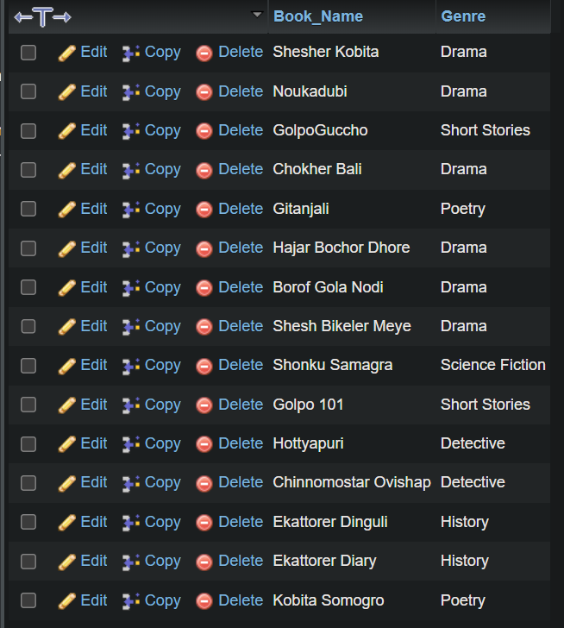

2.1:

SELECT Book_No,MIN(Age) FROM book_character_relationship,characters WHERE book_character_relationship.Character_ID=characters.Character_ID GROUP BY Book_No;

Output:

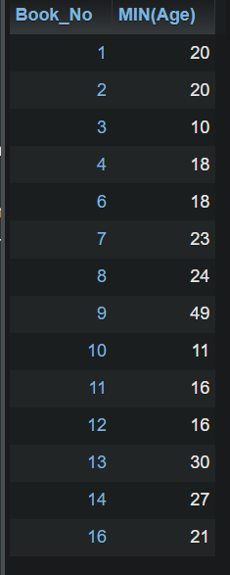

2.2:

SELECT Book_Name,characters.Character_Name,MIN(characters.Age) FROM book LEFT JOIN book_character_relationship ON book.Book_No=book_character_relationship.Book_No LEFT JOIN characters ON book_character_relationship.Character_ID=characters.Character_ID GROUP BY book_character_relationship.Book_No;

Output:

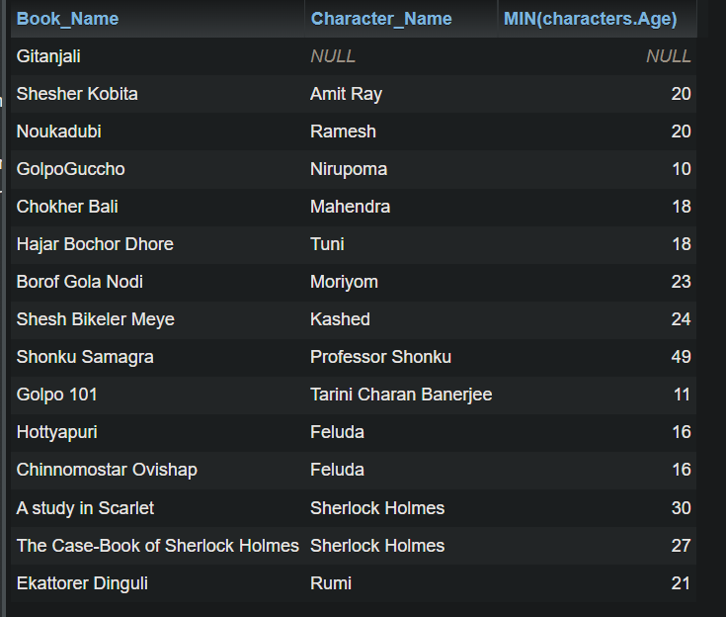

17.2(iii): Query: SELECT DISTINCT Genre,COUNT(Book_No) FROM book GROUP BY Genre;

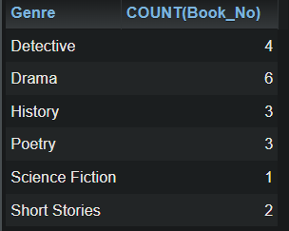

17.2(iv):

Query: SELECT Book_Name,Genre,Price FROM book_publisher_relationship,book WHERE book_publisher_relationship.Book_No=book.Book_No AND book_publisher_relationship.Price=(SELECT MAX(Price) FROM book_publisher_relationship);

Ouput:

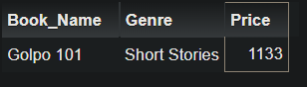

[SELECT](http://localhost/phpmyadmin/url.php?url=https://dev.mysql.com/doc/refman/8.0/en/select.html) book.Book_Name, book.Genre, Table1.Price FROM ([SELECT](http://localhost/phpmyadmin/url.php?url=https://dev.mysql.com/doc/refman/8.0/en/select.html) Genre, [MAX](http://localhost/phpmyadmin/url.php?url=https://dev.mysql.com/doc/refman/8.0/en/aggregate-functions.html%23function_max)(Price) AS Price from Book_Publisher_Relationship JOIN book WHERE book.Book_No = Book_Publisher_Relationship.Book_No GROUP BY Genre) as Table1 JOIN Book_Publisher_Relationship JOIN book WHERE Table1.Price = Book_Publisher_Relationship.Price [AND](http://localhost/phpmyadmin/url.php?url=https://dev.mysql.com/doc/refman/8.0/en/logical-operators.html%23operator_and) Table1.Genre = book.Genre [AND](http://localhost/phpmyadmin/url.php?url=https://dev.mysql.com/doc/refman/8.0/en/logical-operators.html%23operator_and) Book_Publisher_Relationship.Book_No = book.Book_No;