1.1 Create Movie info database

SQL:

CREATE DATABASE Movie_Info;

1.2 Create director table

SQL:

CREATE TABLE Director (

Person_Id int PRIMARY KEY,

Director_Name varchar(200) NOT NULL,

Birth_Year int NOT NULL,

No_Of_Films int NOT NULL,

No_Of_Awards int NOT NULL

);

1.3 Data Entry

SQL:

INSERT INTO Director (

Person_ID,

Director_Name,

Birth_Year,

No_Of_Films,

No_Of_Awards

) VALUES (

1,

'Zahir Raihan',

1935,

5,

5

);

INSERT INTO Director (Person_Id, Director_Name, Birth_Year, No_Of_Films, No_Of_Awards)

VALUES

(6, 'Goutam Ghose', 1950, 12, 8),

(7, 'Aparna Sen', 1945, 12, 7),

(8, 'Kaushik Ganguly', 1968, 23, 30);

1.4 Create Movie table

SQL:

CREATE TABLE Movie (

Movie_Id int PRIMARY KEY,

Movie_Name varchar(200) NOT NULL,

Genra varchar(100) NOT NULL,

Year int NOT NULL,

IMDB_Rating float,

FOREIGN KEY (Director_Id) REFERENCES Director (Person_Id)

);

1.5 Insert movie data

SQL:

INSERT INTO movie VALUES(1,'Pather Panchali','Drama',1955,8.5,3);

INSERT INTO movie VALUES(2,'Noukadubi','Drama',2011,7.6,5);

INSERT INTO movie VALUES(3,'Abohomaan','Drama',2009,7.3,5);

INSERT INTO movie VALUES(4,'Joi Baba Felunath','Thriller',1979,8.0,3);

INSERT INTO movie VALUES(5,'Jibon Theke Neya','Drama',1970,9.4,1);

INSERT INTO movie VALUES(6,'Moner Manush','Bioghaphy',2010,8.0,6);

INSERT INTO movie VALUES(7,'Apur Panchali','Bioghaphy',2013,8.2,8);

INSERT INTO movie VALUES(8,'Goynar Baksho','Comedy',2013,7.1,7);

INSERT INTO movie VALUES(9,'Byomkesh O Agnibaan','Thriller',2017,7.4,4);

INSERT INTO movie VALUES(10,'Byomkesh Bakshi','Thriller',2010,7.4,4);

INSERT INTO movie VALUES(11,'PK','Fiction',2014,8.2,2);

2.1 Create Actor Table

SQL:

CREATE TABLE Actor(

Person_ID int PRIMARY KEY,

Actor_Name varchar(200),

Birth_Year int NOT NULL,

No_Of_Films int NOT NULL,

No_Of_Awards int

);

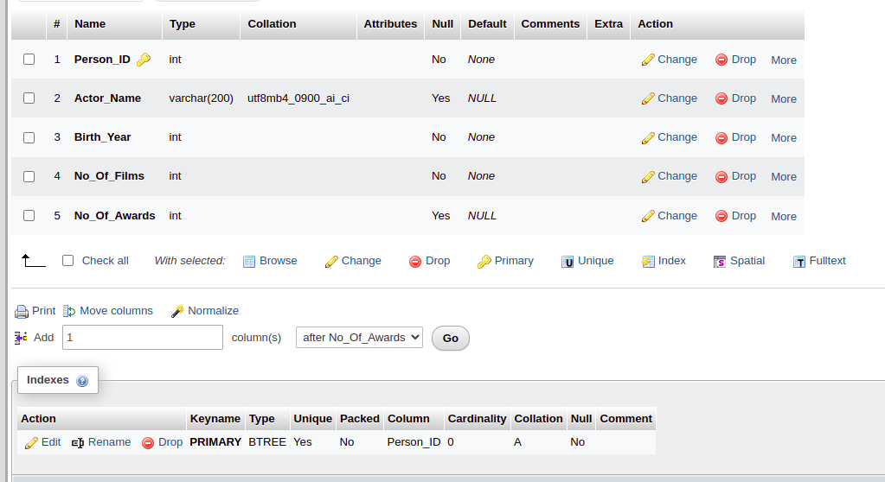

## Create Movie_Characters table:

CREATE TABLE Movie_Characters ( Character_ID int PRIMARY KEY, Character_Name varchar(50), Age int );

## Insert data in Movie_Character table:

INSERT INTO movie_characters VALUES (1, 'Apu', 7);

INSERT INTO movie_characters VALUES (2, 'Durga', 10);

INSERT INTO movie_characters VALUES (3, 'Harihar', 42);

INSERT INTO movie_characters VALUES (4, 'Sarbajaya', 35);

INSERT INTO movie_characters VALUES (5, 'Ramesh', 28);

INSERT INTO movie_characters VALUES (6, 'Hemnalini', 25);

INSERT INTO movie_characters VALUES (7, 'Nalinaksha', 30);

INSERT INTO movie_characters VALUES (8, 'Kamala', 20);

INSERT INTO movie_characters VALUES (9, 'Shikha', 21);

INSERT INTO movie_characters VALUES (10, 'Apratim', 26);

INSERT INTO movie_characters VALUES (11, 'Feluda', 25);

INSERT INTO movie_characters VALUES (12, 'Maganlal Meghraj', 35);

INSERT INTO movie_characters VALUES (13, 'Jatayu', 45);

INSERT INTO movie_characters VALUES (14, 'Topshe', 18);

INSERT INTO movie_characters VALUES (15, 'Ruku', 6);

INSERT INTO movie_characters VALUES (16, 'Faruk', 22);

INSERT INTO movie_characters VALUES (17, 'Bithi', 19);

INSERT INTO movie_characters VALUES (18, 'Sathi', 24);

INSERT INTO movie_characters VALUES (19, 'Lalon', null);

INSERT INTO movie_characters VALUES (20, 'Kaluah', 25);

INSERT INTO movie_characters VALUES (21,'Siraj Saain', 45);

INSERT INTO movie_characters VALUES (22, 'Komli', 25);

INSERT INTO movie_characters VALUES (23, 'Subir Banerjee', null);

INSERT INTO movie_characters VALUES (24, 'Ashima', 24);

INSERT INTO movie_characters VALUES (25, 'Rashmoni', null);

INSERT INTO movie_characters VALUES (26, 'Somalata', 24);

INSERT INTO movie_characters VALUES (27, 'Chaitali', 18);

INSERT INTO movie_characters VALUES (28, 'Byomkesh Bakshi', 26);

INSERT INTO movie_characters VALUES (29, 'Ait', 27);

INSERT INTO movie_characters VALUES (30, 'Malati', 16);

INSERT INTO movie_characters VALUES (31, 'Debkumar', 50);

INSERT INTO movie_characters VALUES (32, 'Doctor Anukul', 45);

INSERT INTO movie_characters VALUES (33, 'Prabhat', 27);

INSERT INTO movie_characters VALUES (34, 'Satyabati', 22);

INSERT INTO movie_characters VALUES (35, 'Anadi Babu', 55);

INSERT INTO movie_characters VALUES (36, 'PK', null);

INSERT INTO movie_characters VALUES (37, 'Jaggu', 26);

INSERT INTO movie_characters VALUES (38, 'Sarfaraz', 29);

INSERT INTO movie_characters VALUES (39, 'Tapasvi Maharaj', 50);

## create Movie_Character_Relationship table:

CREATE TABLE Movie_Character_Relationship(

Character_ID int NOT NULL,

Movie_ID int NOT NULL,

CONSTRAINT PK_Person PRIMARY KEY (Character_ID,Movie_ID),

FOREIGN KEY(Character_ID) REFERENCES movie_characters(Character_ID),

FOREIGN KEY(Movie_ID) REFERENCES movie(Movie_ID)

);

## Insert data into Movie_Character_Relationship table:

INSERT INTO movie_character_relationship VALUES(2 ,1);

INSERT INTO movie_character_relationship VALUES(3, 1);

INSERT INTO movie_character_relationship VALUES(4 ,1);

INSERT INTO movie_character_relationship VALUES(5 ,2);

INSERT INTO movie_character_relationship VALUES(6 ,2);

INSERT INTO movie_character_relationship VALUES(7, 2);

INSERT INTO movie_character_relationship VALUES(8 ,2);

INSERT INTO movie_character_relationship VALUES(9, 3);

INSERT INTO movie_character_relationship VALUES(10, 3);

INSERT INTO movie_character_relationship VALUES(11, 4);

INSERT INTO movie_character_relationship VALUES(12, 4);

INSERT INTO movie_character_relationship VALUES(13, 4);

INSERT INTO movie_character_relationship VALUES(14, 4);

INSERT INTO movie_character_relationship VALUES(15 ,4);

INSERT INTO movie_character_relationship VALUES(16 ,5);

INSERT INTO movie_character_relationship VALUES(17 ,5);

INSERT INTO movie_character_relationship VALUES(18 ,5);

INSERT INTO movie_character_relationship VALUES(19 ,6);

INSERT INTO movie_character_relationship VALUES(20 ,6);

INSERT INTO movie_character_relationship VALUES(21 ,6);

INSERT INTO movie_character_relationship VALUES(22 ,6);

INSERT INTO movie_character_relationship VALUES(23 ,7);

INSERT INTO movie_character_relationship VALUES(24 ,7);

INSERT INTO movie_character_relationship VALUES(25 ,8);

INSERT INTO movie_character_relationship VALUES(26 ,8);

INSERT INTO movie_character_relationship VALUES(27 ,8);

INSERT INTO movie_character_relationship VALUES(28 ,9);

INSERT INTO movie_character_relationship VALUES(28 ,10);

INSERT INTO movie_character_relationship VALUES(29 ,9);

INSERT INTO movie_character_relationship VALUES(29 ,10);

INSERT INTO movie_character_relationship VALUES(30 ,9);

INSERT INTO movie_character_relationship VALUES(31 ,9);

INSERT INTO movie_character_relationship VALUES(32 ,9);

INSERT INTO movie_character_relationship VALUES(33 ,10);

INSERT INTO movie_character_relationship VALUES(34 ,9);

INSERT INTO movie_character_relationship VALUES(34 ,10);

INSERT INTO movie_character_relationship VALUES(35 ,10);

INSERT INTO movie_character_relationship VALUES(36 ,11);

INSERT INTO movie_character_relationship VALUES(37 ,11);

INSERT INTO movie_character_relationship VALUES(38 ,11);

INSERT INTO movie_character_relationship VALUES(39 ,11);

2.1 Insert Data to Actor Table

SQL:

INSERT INTO actor VALUES(11, 'Uttam Kumar', 1926, 190, 150);

INSERT INTO actor VALUES(12, 'Razzak', 1942, 120, 100);

INSERT INTO actor VALUES(7, 'Aparna Sen', 1945, 73, 43);

INSERT INTO actor VALUES(6, 'Goutam Ghose', 1950, 3, 1);

INSERT INTO actor VALUES(8, 'Kaushik Ganguly', 1968, 22, 7);

INSERT INTO actor VALUES(10, 'Soumitra Chatterjee', 1935, 250, 220);

INSERT INTO actor VALUES(4, 'Anjan Dutt', 1953, 39, 10);

