**Level-1:**

**1.1: Find the name,genre,Imdb rating and release year of all movie.**

**1.2: Display all the distinct movie-genres.**

**1.3: Find the name and current age of all the actors.**

**1.4: Find the name,Imdb rating and the name of the director of all the movies.**

**1.5: Find the name , Imdb rating ,release year and director-name of all the movies of drama genre whose Imdb rating is greater than or equal to 8.0**

**Level-2**

**1.6: Find the name and genre of all the movies that contains on ‘A’ or a ‘J’ as the first character of its name.**

**1.7: Find the name and numbers of awards of the those directors whose name contais on ‘a’ as the second character**

**1.8: Find the name, genre and release year of all the movies that contain the term ‘Byomkesh’ in the anywhere of its name.**

**1.9: Find the name and Imdb rating of those movies whose name consists of only two characters.**

**1.10: Find the name, genre and Imdb rating of all the movies that contain at least 3 characters in its name.**

**1.11: Find the name ,Imdb rating and the name of the directors of all movies that contain at most 10 characters in its name.**

**Solution:**

**1.1: Find the name,genre,Imdb rating and release year of all movie.**

* 1. **SQL: SELECT Movie\_Name, Genre, IMDB\_Rating,Year FROM movie;**

**Output:**

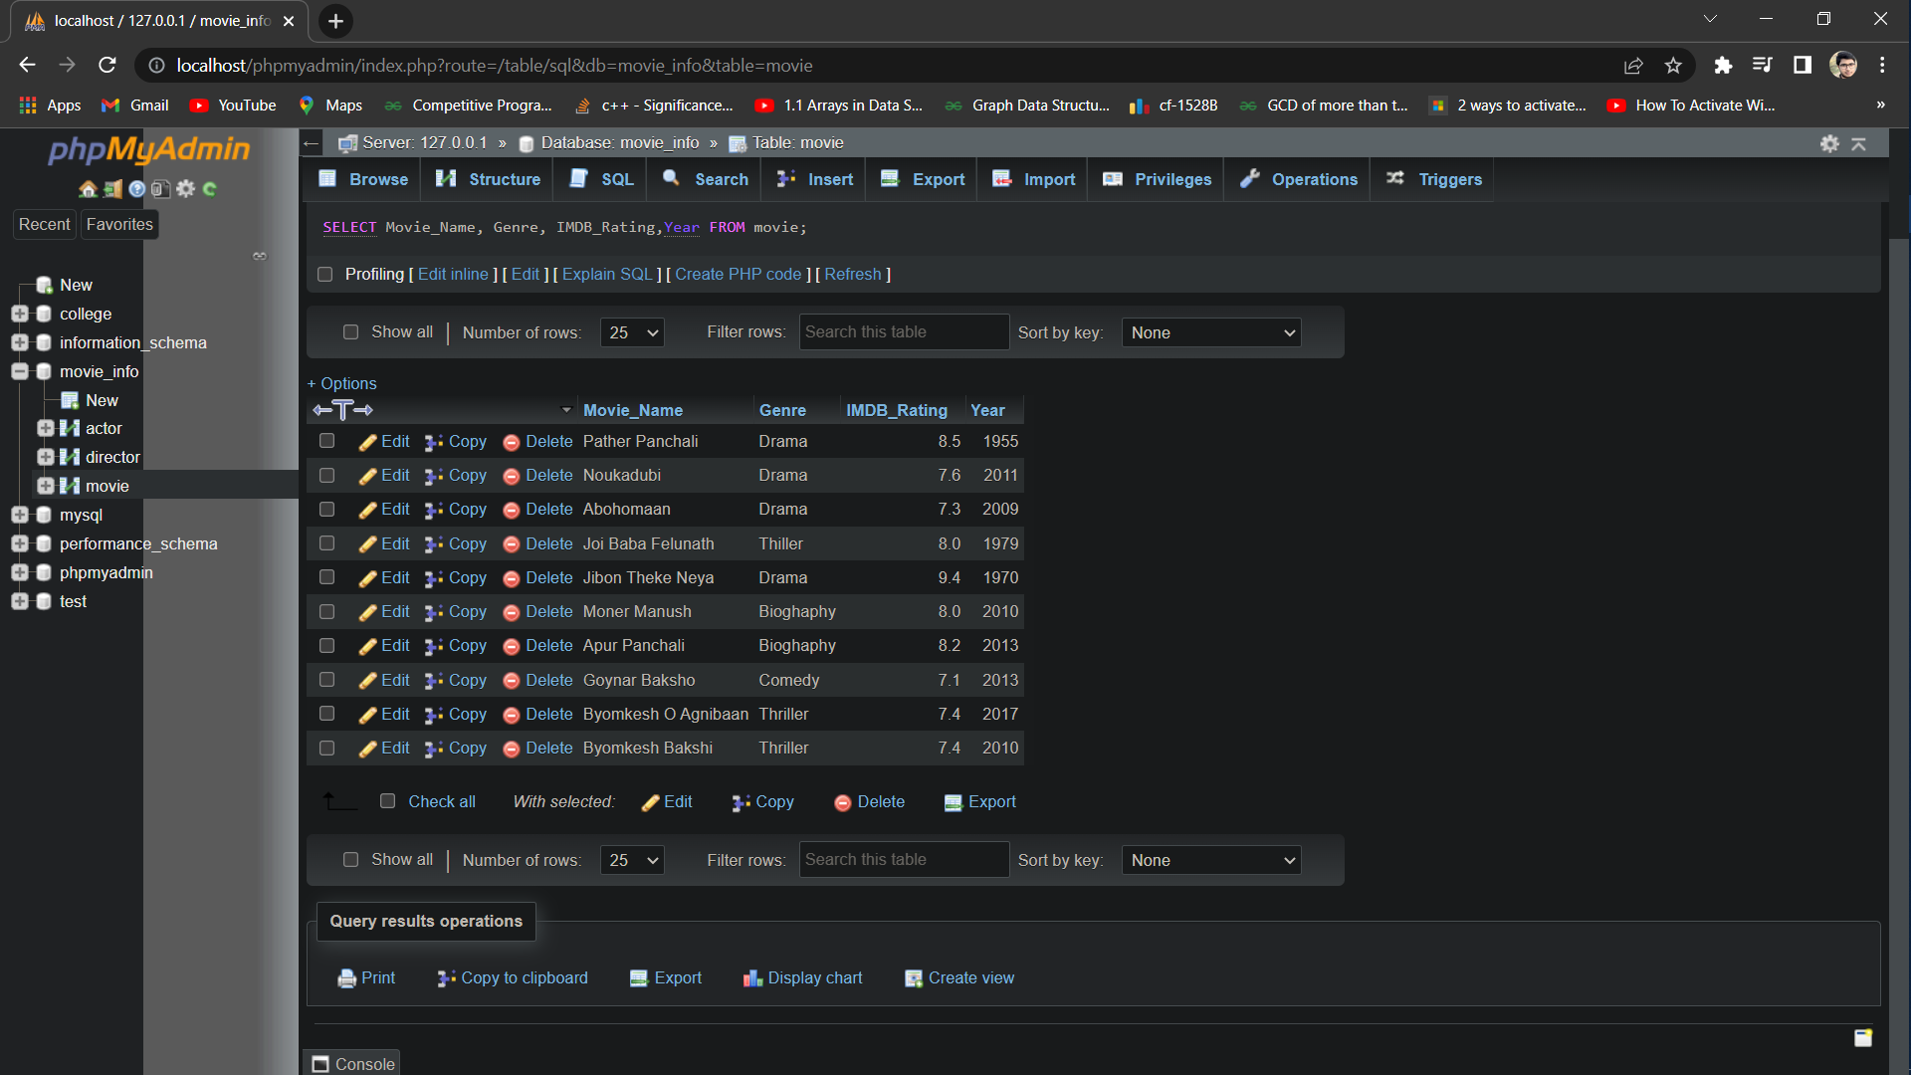

**1.2: Display all the distinct movie-genres.**

**1.2: SQL: SELECT DISTINCT Genre FROM movie;**

**Output:**

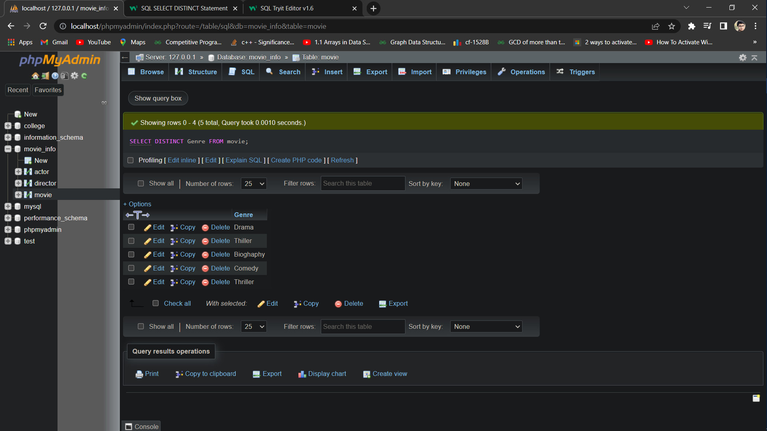

**1.3: Find the name and current age of all the actors.**

**1.3: Command: SELECT Actor\_Name,2022-Birth\_Year AS 'Current Age' FROM actor;**

**Or,**

**SELECT Actor\_Name,Year(CURRENT\_DATE)-Birth\_Year as Current\_Age FROM actor;**

**Output:**

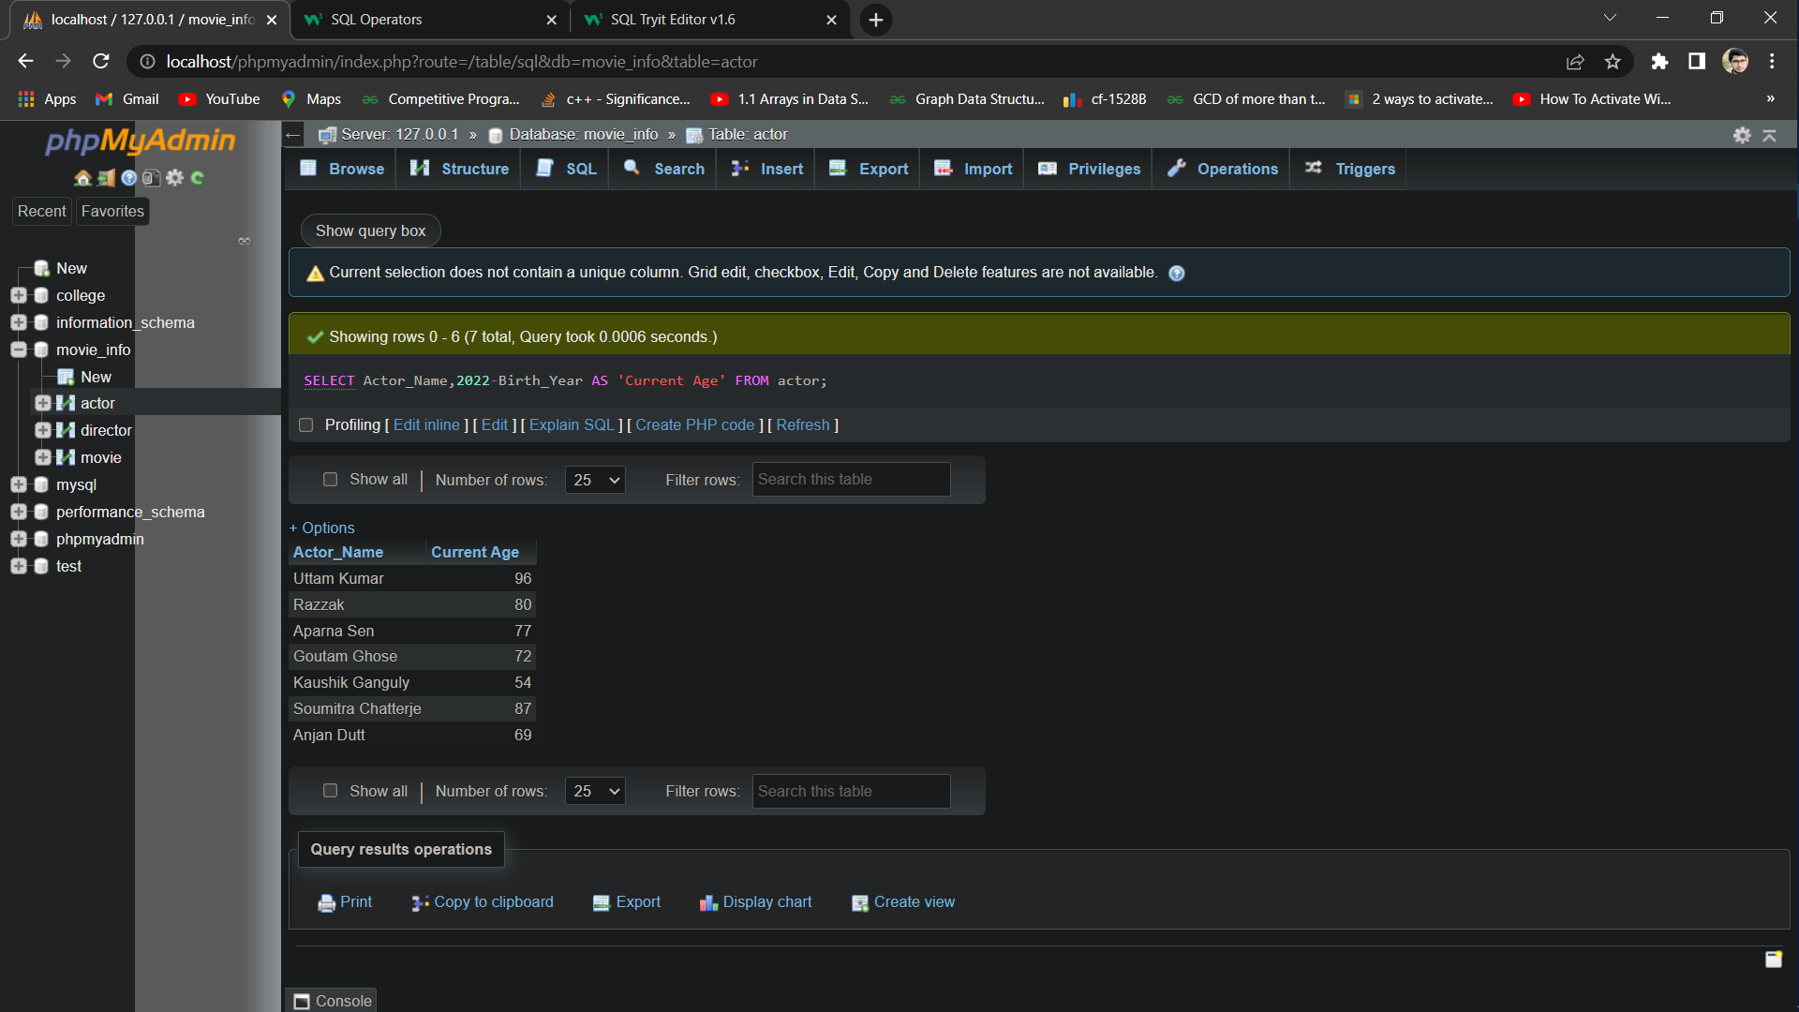

**1.4: Find the name,Imdb rating and the name of the director of all the movies.**

**1.4: SQL:**

**SELECT Movie\_Name,IMDB\_Rating,Director\_Name FROM movie,director WHERE movie.Director\_ID=director.Person\_ID;**

**Output:**

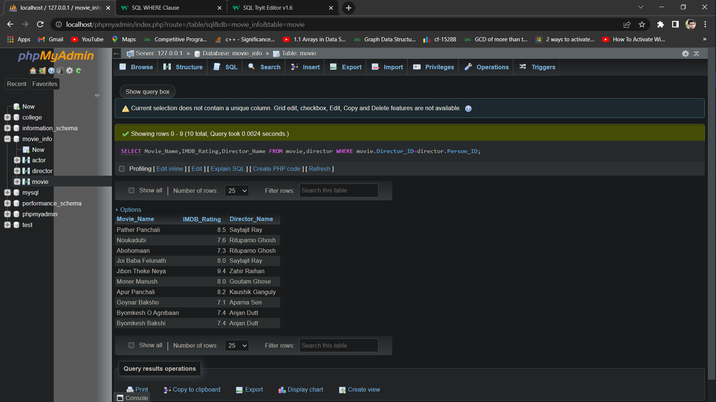

**1.5: Find the name , Imdb rating ,release year and director-name of all the movies of drama genre whose Imdb rating is greater than or equal to 8.0**

**1.5: SQL:**

**SELECT Movie\_Name,IMDB\_Rating,Year,Director\_Name FROM movie,director WHERE movie.Director\_ID=director.Person\_ID AND Genre='Drama' AND IMDB\_Rating>=8.0;**

**Output:**

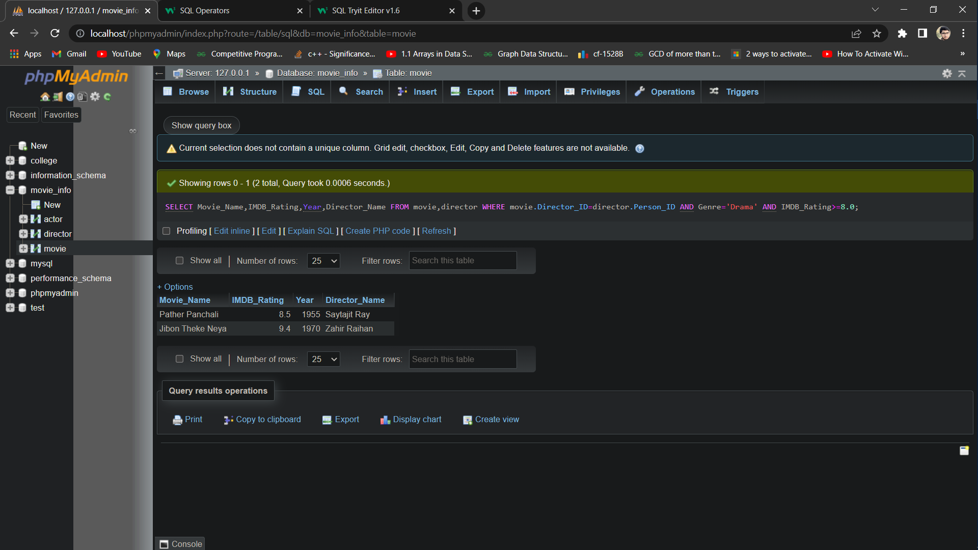

**1.6: Find the name and genre of all the movies that contains on ‘A’ or a ‘J’ as the first character of its name.**

**1.6: SQL:**

**SELECT Movie\_Name,Genre FROM movie WHERE Movie\_Name LIKE'A%' OR Movie\_Name LIKE'J%';**

**Output:**

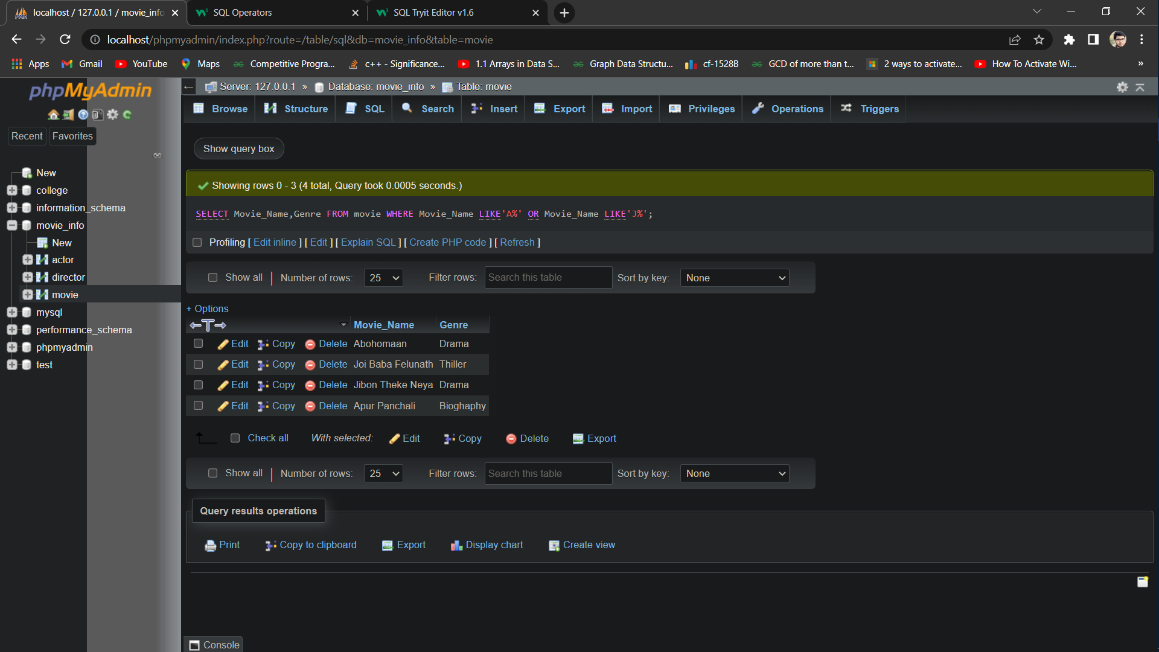

**1.7: Find the name and numbers of awards of the those directors whose name contais on ‘a’ as the second character**

**1.7: SQL:** [SELECT](http://localhost/phpmyadmin/url.php?url=https://dev.mysql.com/doc/refman/8.0/en/select.html) Director\_Name,No\_Of\_Awards FROM director WHERE Director\_Name [LIKE](http://localhost/phpmyadmin/url.php?url=https://dev.mysql.com/doc/refman/8.0/en/string-comparison-functions.html%23operator_like" \t "mysql_doc)'\_a%';

**Output:**

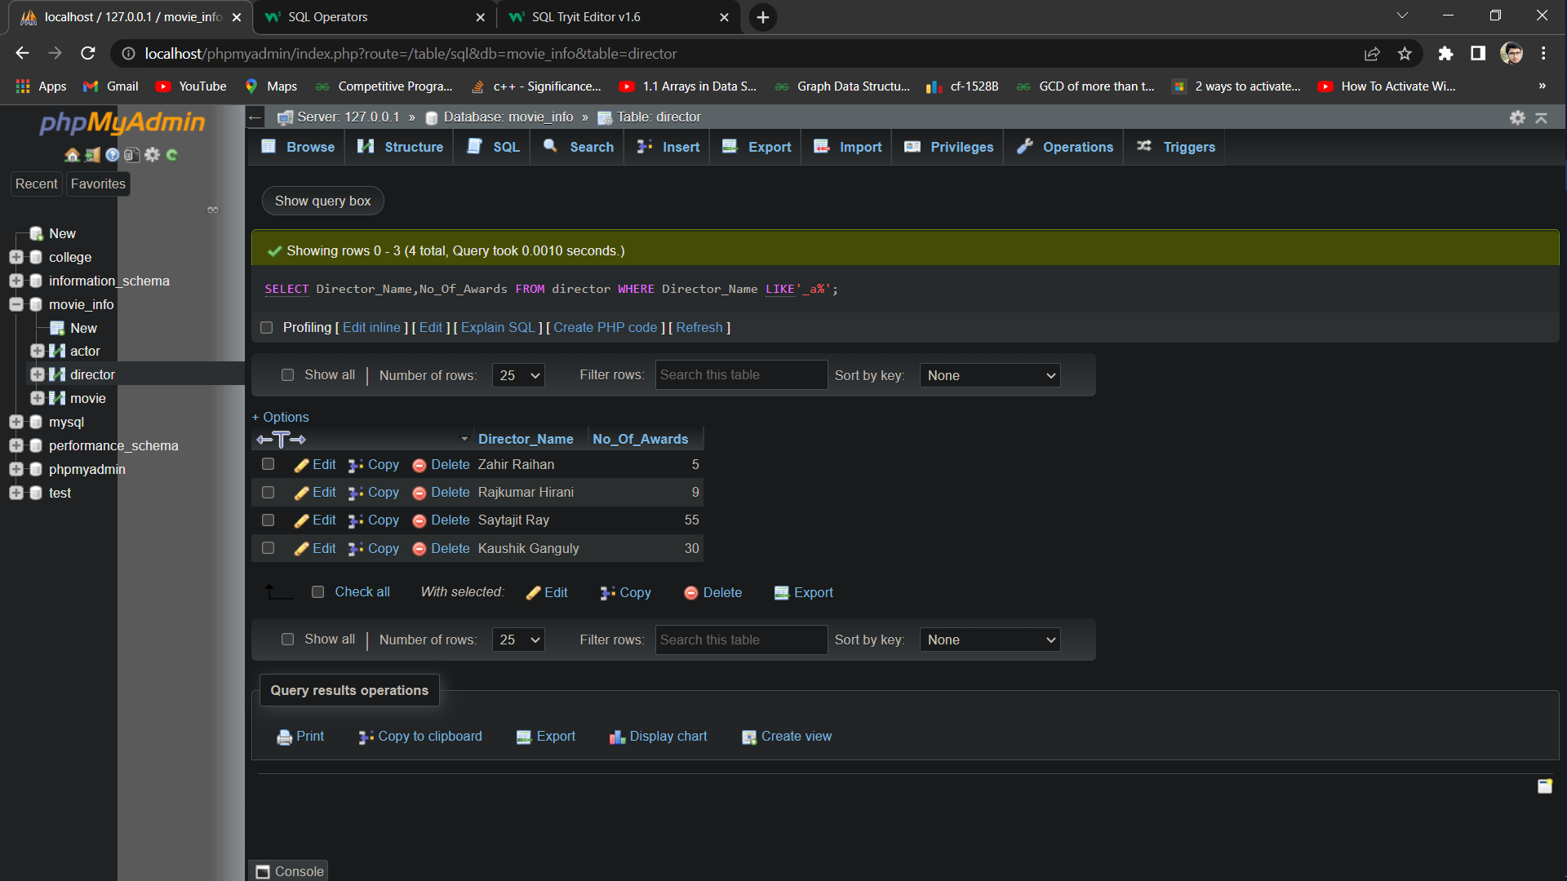

**Query -1.8: Find the name, genre and release year of all the movies that contain the term ‘Byomkesh’ in anywhere of its name.**

**1.8: SQL:**

**SELECT Movie\_Name,Genre,Year FROM movie WHERE Movie\_Name LIKE'%Byomkesh%';**

**Output:**

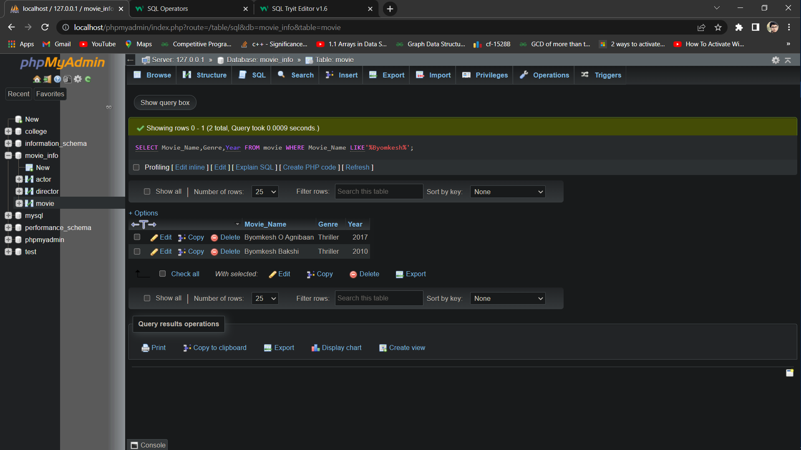

**Query-1.9: Find the name and IMDb rating of those movies whose name consists of only 2 characters.**

**1.9: SQL:**

**SELECT Movie\_Name,IMDB\_Rating FROM movie WHERE Movie\_Name LIKE '\_\_';**

**Output:**



**Query-1.10: Find the name, genre and IMDb rating of all the movies that contain at least 3 characters in its name.**

**1.10: SQL:**

**SELECT Movie\_Name,Genre,IMDB\_Rating FROM movie WHERE Movie\_Name LIKE '\_\_\_%';**

**Or,**

**SELECT Movie\_Name,Genra,IMDB\_Rating FROM movie WHERE Movie\_Name NOT LIKE '\_\_';**

**Or,**

**SELECT Movie\_Name,Genre,IMDB\_Rating FROM movie WHERE length(Movie\_Name)>=3;**

**Output:**

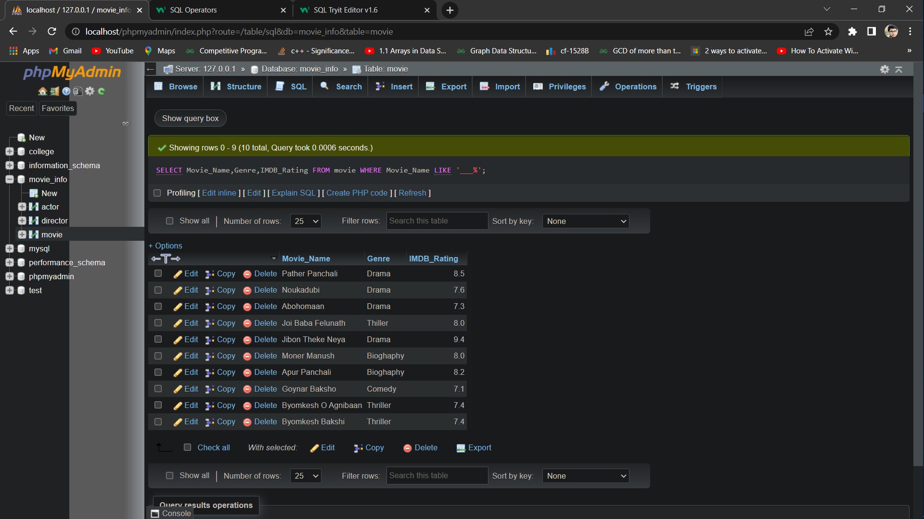

**Query-1.11: Find the name, IMDb rating and the name of the directors of all the movies that contain at most 10 characters in its name.**

**1.11: SQL:**

SELECT Movie\_Name,IMDB\_Rating,Director\_Name FROM movie,director WHERE movie.Director\_ID=director.Person\_ID AND Movie\_Name NOT LIKE '\_\_\_\_\_\_\_\_\_\_\_%';

Or,

SELECT Movie\_Name,IMDB\_Rating,Director\_Name FROM movie,director WHERE movie.Director\_ID=director.Person\_ID AND length(Movie\_Name)<=10;

**Output:**

